Online Resource 1

Neighborhood Material Deprivation and Days at Home After Glioblastoma Diagnosis
Journal of Neuro-Oncology
Jasleen Saini, MD; Christopher Lozano, MB, BCh, BAO; Vishwathsen Karthikeyan, MD; Husain Shakil, MD PhD; Armaan K. Malhotra, MD PhD; Yingshi He, MSc; Jenna Sykes, MMath; Mary Jane Lim-Fat, MD MSc; Jetan Badhiwala, MD PhD; Jefferson R. Wilson, MD PhD; Saira B. Alli, MBBS, PhD
Corresponding author: Jasleen Saini, MD
Division of Neurosurgery, Department of Surgery, University of Toronto, Toronto, Ontario, Canada
Email: jas.saini@mail.utoronto.ca

Supplemental Tables and Figures
Table S1. Diagnostic and Procedural Codes
Table S2. Data Sources
Table S3. Treatment Ascertainment Algorithms
Table S4. Full Adjusted DAH-365 Model
Table S5. Adjusted Associations Across DAH Horizons
Table S6. Observed DAH Across Horizons
Table S7. Conventional Cox Model
Table S8. Proportional Hazards Diagnostics
Fig. S1. Directed Acyclic Graph
Fig. S2. Measurement of Days at Home
Fig. S3. DAH Distributions
Fig. S4. Kaplan-Meier Survival Curves
Fig. S5. Conventional Cox Model Estimates
Abbreviations: DAH, days at home; CI, confidence interval; IQR, interquartile range; HR, hazard ratio; Q, material deprivation quintile; GBM, glioblastoma. DAH-90, DAH-180, DAH-365, and DAH-730 refer to DAH within 90, 180, 365, and 730 days after diagnosis.

Table S1. Diagnostic and Procedural Codes
Category | Coding system | Code | Description
Glioblastoma identification | ICD-O-3 morphology | 9440/3 | Glioblastoma, NOS
 | ICD-O-3 morphology | 9441/3 | Giant cell glioblastoma
 | ICD-O-3 topography | C71.0 | Cerebrum
 | ICD-O-3 topography | C71.1 | Frontal lobe
 | ICD-O-3 topography | C71.2 | Temporal lobe
 | ICD-O-3 topography | C71.3 | Parietal lobe
 | ICD-O-3 topography | C71.4 | Occipital lobe
 | ICD-O-3 topography | C71.5 | Ventricle, NOS
 | ICD-O-3 topography | C71.6 | Cerebellum, NOS
 | ICD-O-3 topography | C71.7 | Brain stem
 | ICD-O-3 topography | C71.8 | Overlapping lesion of brain
 | ICD-O-3 topography | C71.9 | Brain, NOS
Tumour resection | CCI | 1AN87SEAG | Excision partial, brain, burr-hole technique for access with laser
 | CCI | 1AN87SEAZ | Excision partial, brain, burr-hole technique for access with ultrasonic aspirator
 | CCI | 1AN87SEGX | Excision partial, brain, burr-hole technique for access with device NEC
 | CCI | 1AN87SZAG | Excision partial, brain, craniotomy/flap technique for access with laser
 | CCI | 1AN87SZAZ | Excision partial, brain, craniotomy/flap technique for access with ultrasonic aspirator
 | CCI | 1AN87SZGX | Excision partial, brain, craniotomy/flap technique for access with device NEC
 | CCI | 1AE87SZGX | Excision partial, thalamus and basal ganglia using open approach and device NEC
 | CCI | 1AC87DAAG | Excision partial, ventricles of brain, endoscopic approach with laser
 | CCI | 1AC87DAAZ | Excision partial, ventricles of brain, endoscopic approach with ultrasonic aspirator
 | CCI | 1AC87DAGX | Excision partial, ventricles of brain, endoscopic approach with device NEC
 | CCI | 1AC87SZAG | Excision partial, ventricles of brain, open approach with laser
 | CCI | 1AC87SZAZ | Excision partial, ventricles of brain, open approach with ultrasonic aspirator
 | CCI | 1AC87SZGX | Excision partial, ventricles of brain, open approach with device NEC
 | OHIP | N103 | Craniotomy plus excision, supratentorial
 | OHIP | N153 | Craniotomy plus lobectomy
Tumour biopsy | CCI | 2AN71SE | Biopsy, brain using burr-hole approach
 | CCI | 2AN71SZ | Biopsy, brain using open craniotomy or craniectomy/flap approach
 | CCI | 2AC71DA | Biopsy, ventricles of brain using endoscopic approach through burr hole/fontanelle
 | CCI | 2AC71SZ | Biopsy, ventricles of brain using open craniotomy or craniectomy/flap approach
 | CCI | 2AE71DA | Biopsy, thalamus and basal ganglia using endoscopic approach through burr hole
 | CCI | 2AE71SE | Biopsy, thalamus and basal ganglia using burr-hole technique for access
 | CCI | 2AE71SZ | Biopsy, thalamus and basal ganglia using open craniotomy/flap approach
 | OHIP | Z813 | Burr hole plus needling of brain for biopsy

CCI indicates Canadian Classification of Health Interventions; ICD-O-3, International Classification of Diseases for Oncology, Third Edition; NOS, not otherwise specified; NEC, not elsewhere classified; OHIP, Ontario Health Insurance Plan. Surgery was ascertained from 30 days before through 60 days after diagnosis using linked hospital and physician records.

Table S2. Data Sources
Database | Description and use in the study
Ontario Cancer Registry (OCR) | Population-based registry of incident cancer diagnoses in Ontario containing information on cancer diagnosis, pathology, treatment-related activity, surgery, and death. Used to identify patients with incident glioblastoma.
Canadian Institute for Health Information Discharge Abstract Database (CIHI-DAD) | Contains patient-level information on acute-care hospitalizations, including diagnoses and procedures coded using ICD-10-CA and Canadian Classification of Health Interventions codes. Used to ascertain hospitalizations, comorbidity, surgical treatment, and healthcare utilization contributing to DAH.
Ontario Health Insurance Plan (OHIP) Claims Database | Contains physician billing claims for insured healthcare services in Ontario, including diagnostic and procedure codes. Used to ascertain healthcare utilization and treatment-related services.
Ontario Marginalization Index (ON-Marg) | Area-level index characterizing marginalization across Ontario dissemination areas. The material deprivation dimension was used as the primary exposure and categorized into quintiles, with Q1 representing the least materially deprived and Q5 the most materially deprived neighborhoods.
Activity Level Reporting (ALR) | Contains patient-level radiation therapy and outpatient oncology activity. Used here to ascertain radiation therapy within 90 days after diagnosis.
Registered Persons Database (RPDB) | Contains demographic and vital-status information for individuals eligible for Ontario health insurance, including dates of birth and death. Used to ascertain demographic characteristics, follow-up, and mortality.
Continuing Care Reporting System (CCRS) | Contains information on continuing and complex-care utilization in Ontario. Used to identify institutional healthcare utilization contributing to the calculation of DAH.
National Rehabilitation Reporting System (NRS) | Contains information on inpatient rehabilitation episodes. Used to identify rehabilitation utilization contributing to the calculation of DAH.
Postal Code Conversion File (PCCF) | Used to link residential postal codes to neighborhood-level characteristics and derive geographic measures, including rurality and distance to the nearest regional cancer center.
Johns Hopkins Adjusted Clinical Groups (ACG) System | Population-based health administrative data used to derive measures of frailty and comorbidity burden for risk adjustment.

Primary DAH measurement used acute hospital, rehabilitation, and continuing/complex-care records plus vital status. The 2021 Ontario Marginalization Index was linked using postal codes at diagnosis. ICD-10-CA indicates International Statistical Classification of Diseases and Related Health Problems, Tenth Revision, Canada.

Table S3. Treatment Ascertainment Algorithms
Treatment variable | Data source | Definition
Chemotherapy | OHIP | Within 90 days after diagnosis: Receipt of ≥1 chemotherapy administration identified using OHIP fee codes G281, G345, G359, G381, G382, or G388, in association with an eligible neurologic diagnosis code:  191 – “brain”  345 – “epilepsy”  225 – “brain, spinal cord, peripheral nerves”  780 – “convulsions, ataxia, vertigo, headache, except tension headache and migraine”  192 – “cranial nerves, spinal cord, other parts of nervous system”
Radiation therapy | ALR | Within 90 days after diagnosis: Receipt of ≥1 radiation therapy treatment in which the visit date was non-missing and the body-region code indicated brain (“BRAI”), with an eligible activity-type code: 500, 501, 503, 510, 511, 512, 519, 520, 521, 522, 523, 524, 525, 526, 527, 528, 529, 530, 531, 532, 533, 534, 535, 536, 537, 538, 539, 540, 541, 542, 543, 544, 548, 549, 561, 563, 565, 566, 568, 570, 571, 572, 573, 574, 575, 576, 577, 581, 582, 590, 591, 592, 593, 594, 595, 596, 597, 598, 599.

OHIP indicates Ontario Health Insurance Plan; ALR, Activity Level Reporting. Chemotherapy and radiotherapy were ascertained within 90 days after diagnosis. Chemotherapy ascertainment used administration claims and specified diagnostic codes; this definition may incompletely capture oral temozolomide.

Table S4. Full Adjusted DAH-365 Model
Variable | Adjusted β coefficient, days | 95% CI | P value
Material deprivation
Q1 (least deprived) | Reference | — | —
Q2 | −8.8 | −19.6 to 2.0 | .103
Q3 | −14.8 | −27.0 to −2.6 | .017
Q4 | −18.3 | −29.4 to −7.2 | .001
Q5 (most deprived) | −36.2 | −51.5 to −20.9 | <.001
Age group
<65 years | Reference | — | —
65–74 years | −142.3 | −156.8 to −127.8 | <.001
75–84 years | −215.7 | −229.0 to −202.4 | <.001
≥85 years | −256.7 | −271.4 to −242.0 | <.001
Sex
Male | Reference | — | —
Female | −2.0 | −9.3 to 5.3 | .590
Elixhauser comorbidity category
Prior hospitalization, no identified comorbidities | Reference | — | —
Prior hospitalization, ≥1 identified comorbidity | −15.1 | −28.5 to −1.7 | .027
No prior hospitalization | +6.8 | −1.8 to 15.4 | .123
Frailty
No | Reference | — | —
Yes | −48.4 | −60.0 to −36.8 | <.001
Rurality
Urban | Reference | — | —
Rural | −9.6 | −21.4 to 2.2 | .112
Year of diagnosis | +3.5 per year | +2.7 to +4.3 | <.001

Adjusted conditional median differences in DAH-365; N = 8234. Reference categories are shown. CIs used bootstrap standard errors from 1000 resamples. The diagnosis-year coefficient represents a 1-year increase. DAH indicates days at home; CI, confidence interval; Q, quintile.

Table S5. Adjusted Associations Across DAH Horizons
Material deprivation quintile | DAH-90, β (95% CI) | P value | DAH-180, β (95% CI) | P value | DAH-365, β (95% CI) | P value | DAH-730, β (95% CI) | P value
Q1 (least deprived) | Reference | — | Reference | — | Reference | — | Reference | —
Q2 | −0.7 (−1.8 to 0.5) | .261 | −2.2 (−4.5 to 0.1) | .065 | −8.8 (−19.6 to 2.0) | .103 | −17.9 (−38.8 to 2.9) | .092
Q3 | −2.0 (−3.1 to −0.8) | <.001 | −4.9 (−7.6 to −2.1) | <.001 | −14.8 (−27.0 to −2.6) | .017 | −29.4 (−48.7 to −10.1) | .003
Q4 | −2.1 (−3.4 to −0.7) | .003 | −6.1 (−9.8 to −2.4) | .001 | −18.3 (−29.4 to −7.2) | .001 | −32.6 (−51.8 to −13.5) | <.001
Q5 (most deprived) | −5.5 (−7.8 to −3.1) | <.001 | −13.4 (−19.0 to −7.9) | <.001 | −36.2 (−51.5 to −20.9) | <.001 | −54.2 (−73.4 to −35.1) | <.001

Adjusted differences in conditional median DAH versus Q1 from separate median quantile regressions at each horizon, adjusted for age, sex, comorbidity category, frailty, rurality, and diagnosis year. CIs used bootstrap standard errors from 1000 resamples. DAH-365 N = 8234. Eligibility required the full horizon to fall within follow-up through December 31, 2023; DAH-365 and DAH-730 included diagnoses through December 31, 2022, and December 31, 2021, respectively. DAH indicates days at home; CI, confidence interval; Q, quintile.

Table S6. Observed DAH Across Horizons
Outcome, median (IQR) | Overall | Q1 | Q2 | Q3 | Q4 | Q5 | P value*
DAH-90, days | 74 (33–82) | 76 (41.25–83) | 75 (39.75–83) | 74 (36–82) | 72 (28–82) | 66 (18–81) | <.001
DAH-180, days | 145 (47–170) | 156 (64–171) | 151 (54–170) | 143 (50.25–170) | 138 (42–169) | 115 (24–166) | <.001
DAH-365, days | 200 (49–346) | 249 (67–350) | 229 (56.75–347) | 194.5 (52–344) | 180.5 (43–340) | 138 (27–332) | <.001
DAH-730, days | 203 (49–493) | 254 (68–546.75) | 232 (57–529.25) | 195 (52–478.75) | 183.5 (43–446.25) | 138 (27–417) | <.001

Values are median (IQR). DAH indicates days at home; IQR, interquartile range; Q, quintile. P values use Kruskal-Wallis tests across quintiles. Eligibility required a fully observable administrative window for each horizon.

Table S7. Conventional Cox Model
Variable | Adjusted HR | 95% CI | P value
Material deprivation quintile
Q1 (least deprived) | Reference | — | —
Q2 | 1.028 | 0.959–1.101 | .434
Q3 | 1.087 | 1.013–1.166 | .021
Q4 | 1.141 | 1.063–1.226 | <.001
Q5 (most deprived) | 1.154 | 1.071–1.242 | <.001
Age group
<65 years | Reference | — | —
65–74 years | 1.685 | 1.596–1.780 | <.001
75–84 years | 2.707 | 2.532–2.895 | <.001
≥85 years | 4.338 | 3.784–4.975 | <.001
Sex
Male | Reference | — | —
Female | 0.921 | 0.879–0.966 | <.001
Elixhauser comorbidity category
Prior hospitalization, no identified comorbidities | Reference | — | —
Prior hospitalization, ≥1 identified comorbidity | 1.129 | 1.048–1.217 | .001
No prior hospitalization | 0.921 | 0.876–0.968 | .001
Frailty
No | Reference | — | —
Yes | 1.304 | 1.209–1.407 | <.001
Rurality
Urban | Reference | — | —
Rural | 1.086 | 1.016–1.162 | .015
Year of diagnosis
Per 1-year increase | 0.973 | 0.969–0.977 | <.001

Conventional Cox model: N = 8202; 7307 deaths. Because proportional hazards assumptions were violated, the main manuscript emphasizes the piecewise model. HR indicates hazard ratio; CI, confidence interval; Q, quintile.

Table S8. Proportional Hazards Diagnostics
Variable | χ² | df | P value
Neighborhood material deprivation | 15.265 | 4 | .004
Age group | 91.423 | 3 | <.001
Sex | 5.381 | 1 | .020
Elixhauser comorbidity category | 14.890 | 2 | <.001
Frailty | 31.425 | 1 | <.001
Rural residence | 0.029 | 1 | .865
Year of diagnosis | 10.690 | 1 | .001
Global | 136.926 | 13 | <.001

Scaled Schoenfeld residual tests assessed the conventional Cox model. Significant tests indicated nonproportionality for deprivation and several covariates. Follow-up was subsequently split at 365 days. df indicates degrees of freedom.

Fig. S1. Directed Acyclic Graph
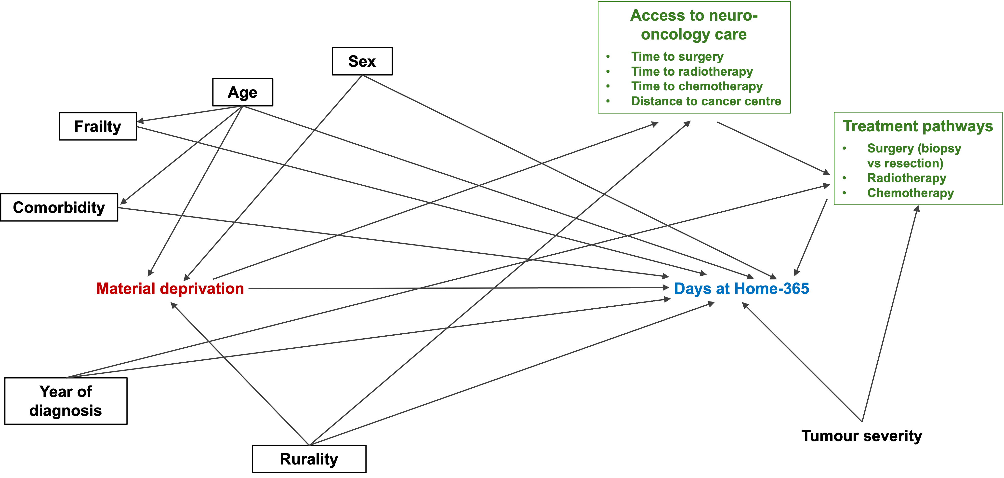
The directed acyclic graph informed covariate selection. Treatment and access variables were conceptualized as potential mediators; adjustment included age, sex, comorbidity, frailty, rurality, and diagnosis year. Tumor severity was not measured. The graph represents assumptions, not empirically established pathways. DAH indicates days at home.

Fig. S2. Measurement of Days at Home
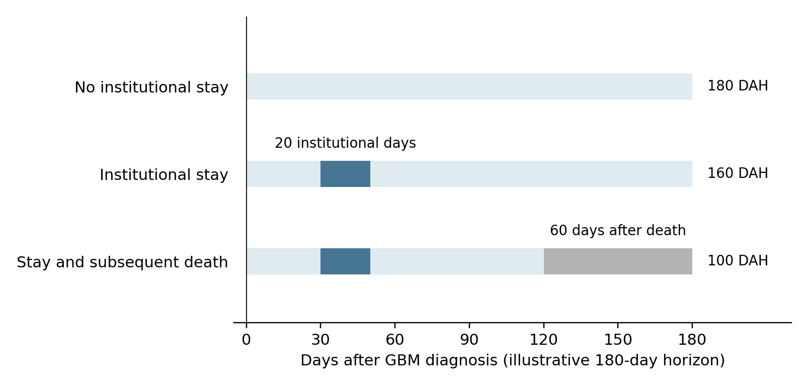
Illustrative 180-day calculations, not patient observations. DAH equals the horizon minus days in captured institutions and days after death. Examples show 180 DAH with no institutional stays; 160 DAH with 20 institutional days; and 100 DAH with 20 institutional days plus 60 days after death. Time starts at GBM diagnosis. Overlapping institutional stays and same-day transfers were counted once per calendar day. The death date counted as a home day if no institutional stay was recorded; subsequent days contributed zero DAH.

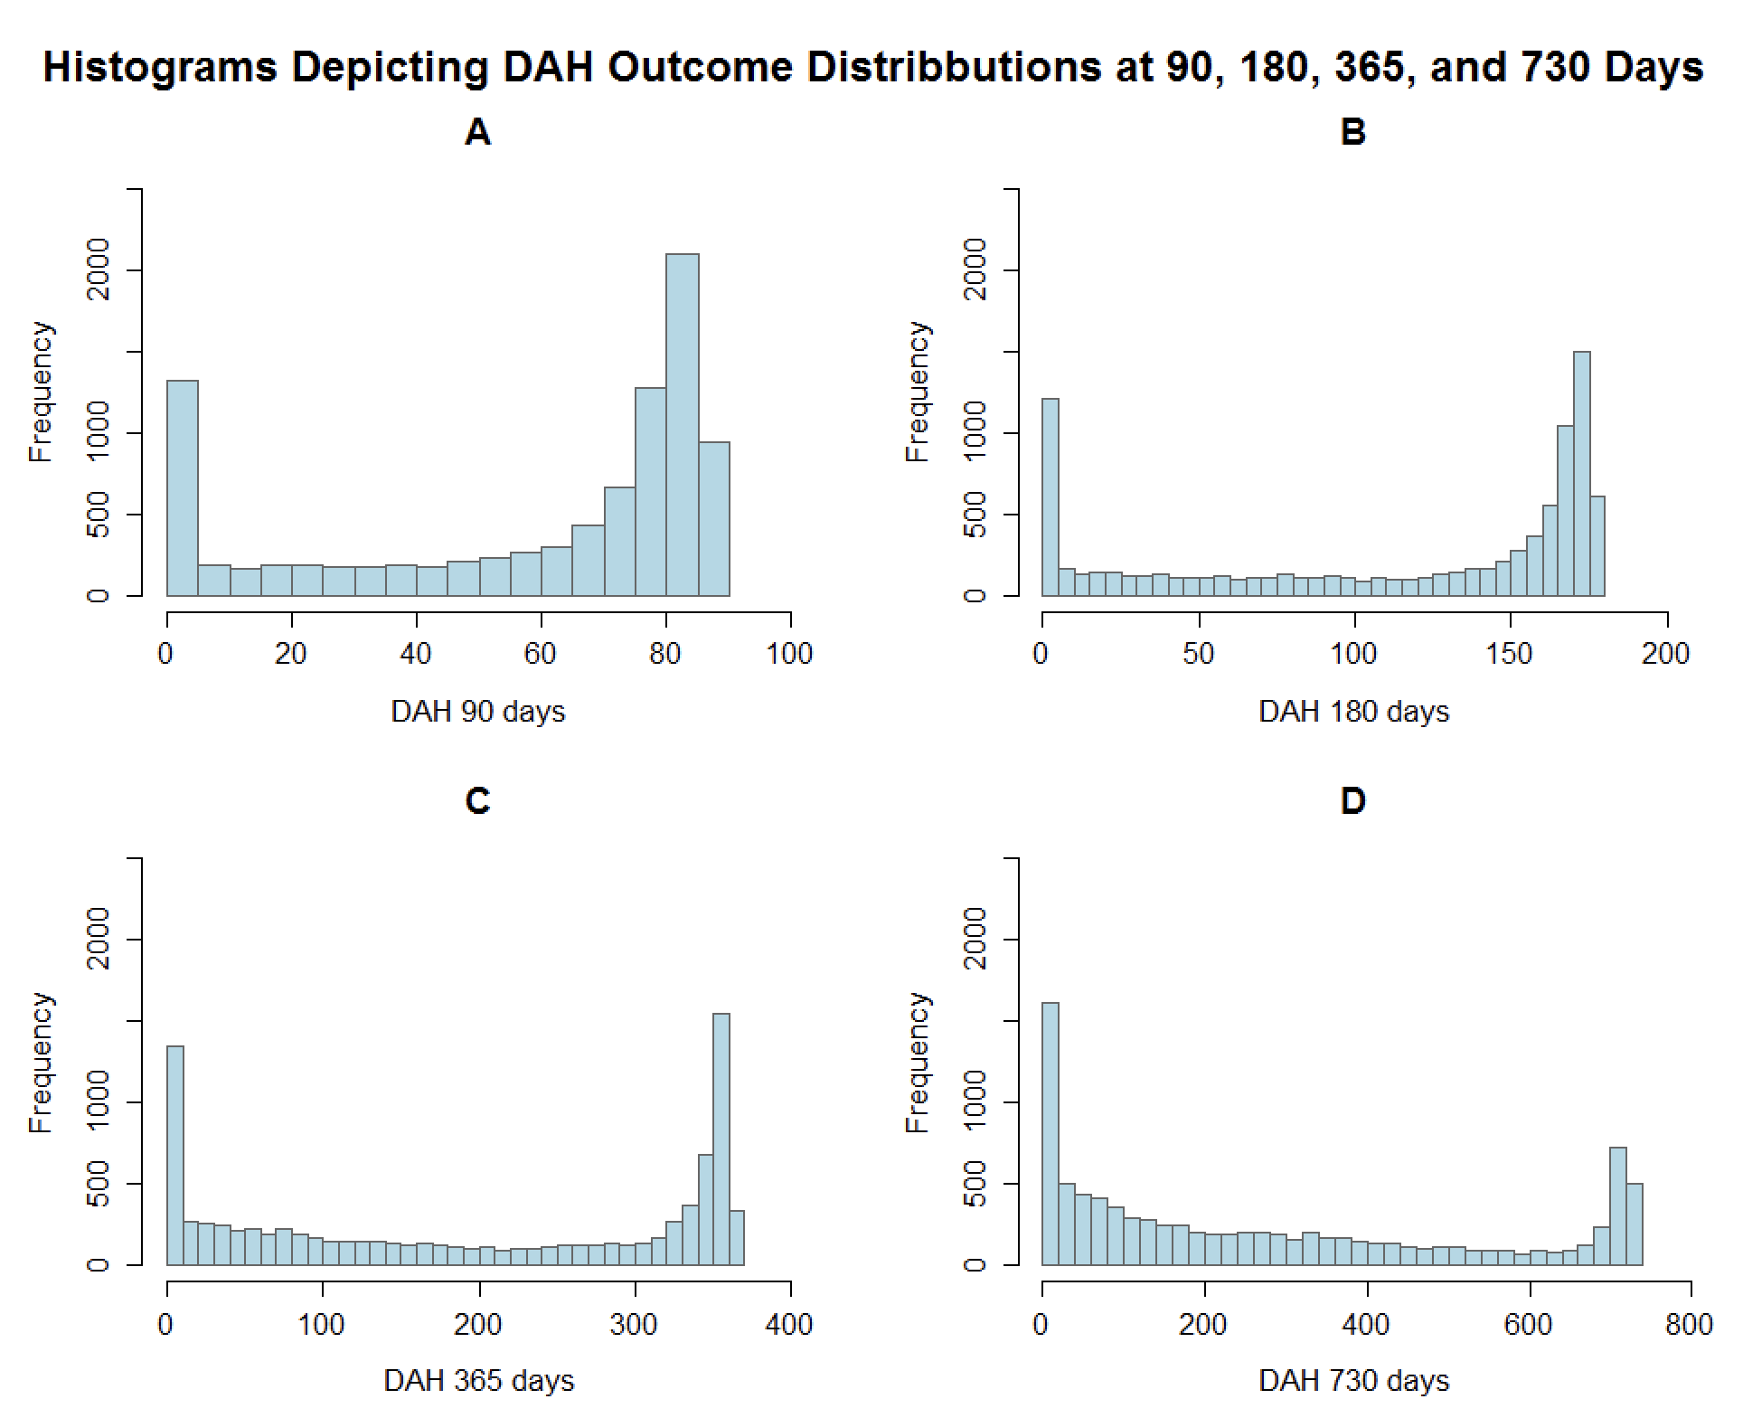
Fig. S3. DAH Distributions

Observed DAH distributions at 90, 180, 365, and 730 days after diagnosis. DAH indicates days at home.

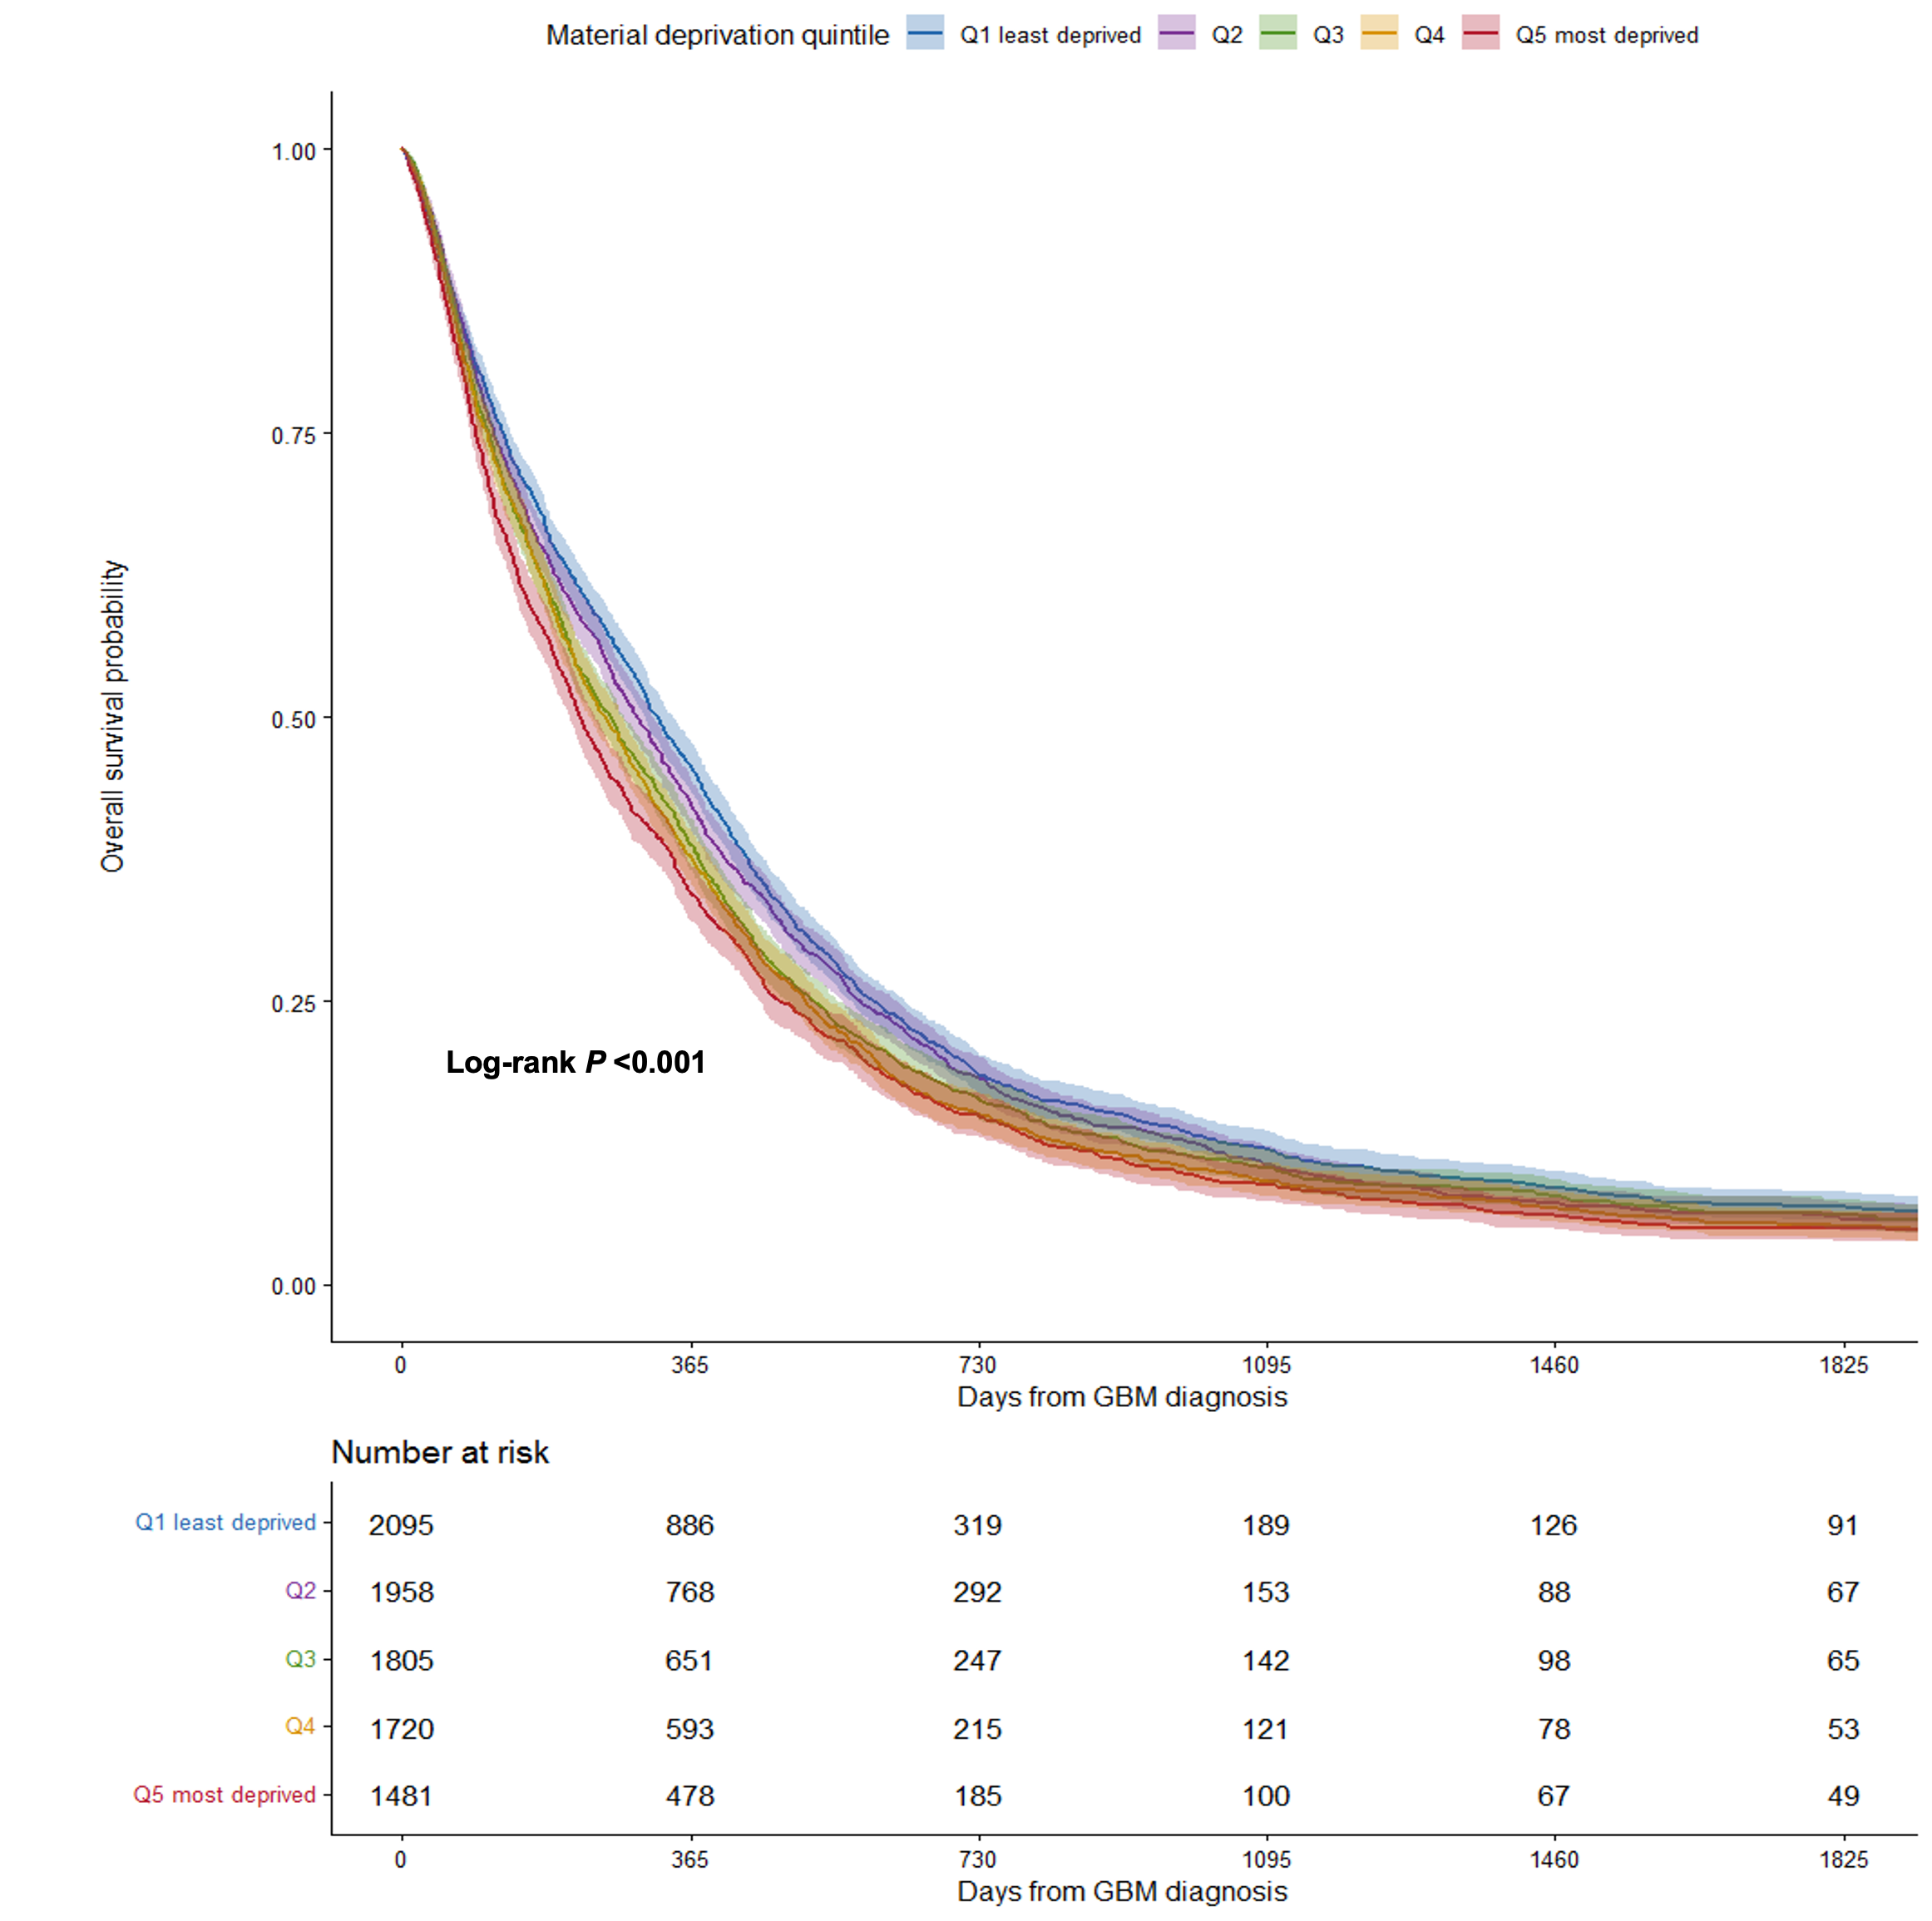
Fig. S4. Kaplan-Meier Survival Curves

Kaplan-Meier curves with 95% CIs and numbers at risk. The quintile-specific starting counts sum to 9059. Patients without a recorded death were censored on December 31, 2023. CI indicates confidence interval; GBM, glioblastoma; Q, quintile.

Fig. S5. Conventional Cox Model Estimates
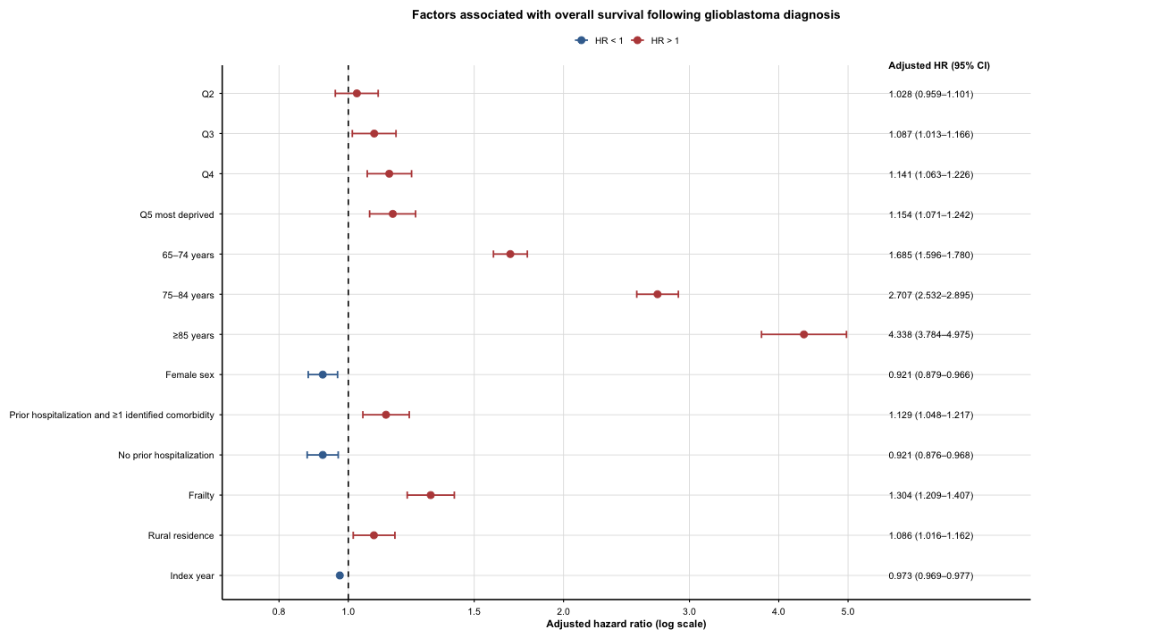
Forest plot of the conventional Cox model; N = 8202 and 7307 deaths. Proportional hazards assumptions were violated; the piecewise estimates are presented in the main manuscript. Reference categories are Q1, age younger than 65 years, male sex, prior hospitalization without identified comorbidity, no frailty, and urban residence. HR indicates hazard ratio; CI, confidence interval; Q, quintile.

