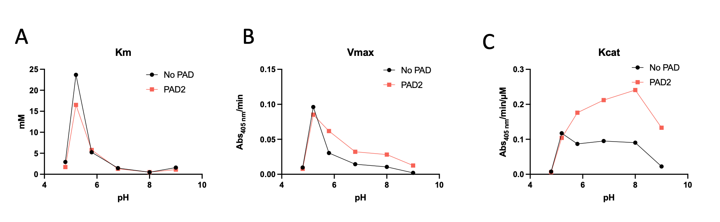
Figure S1. Citrullination of bovine trypsin enhances proteolytic activity without altering Km across varying pH. (A) Km (B) Maximum Velocity (C) Kcat.
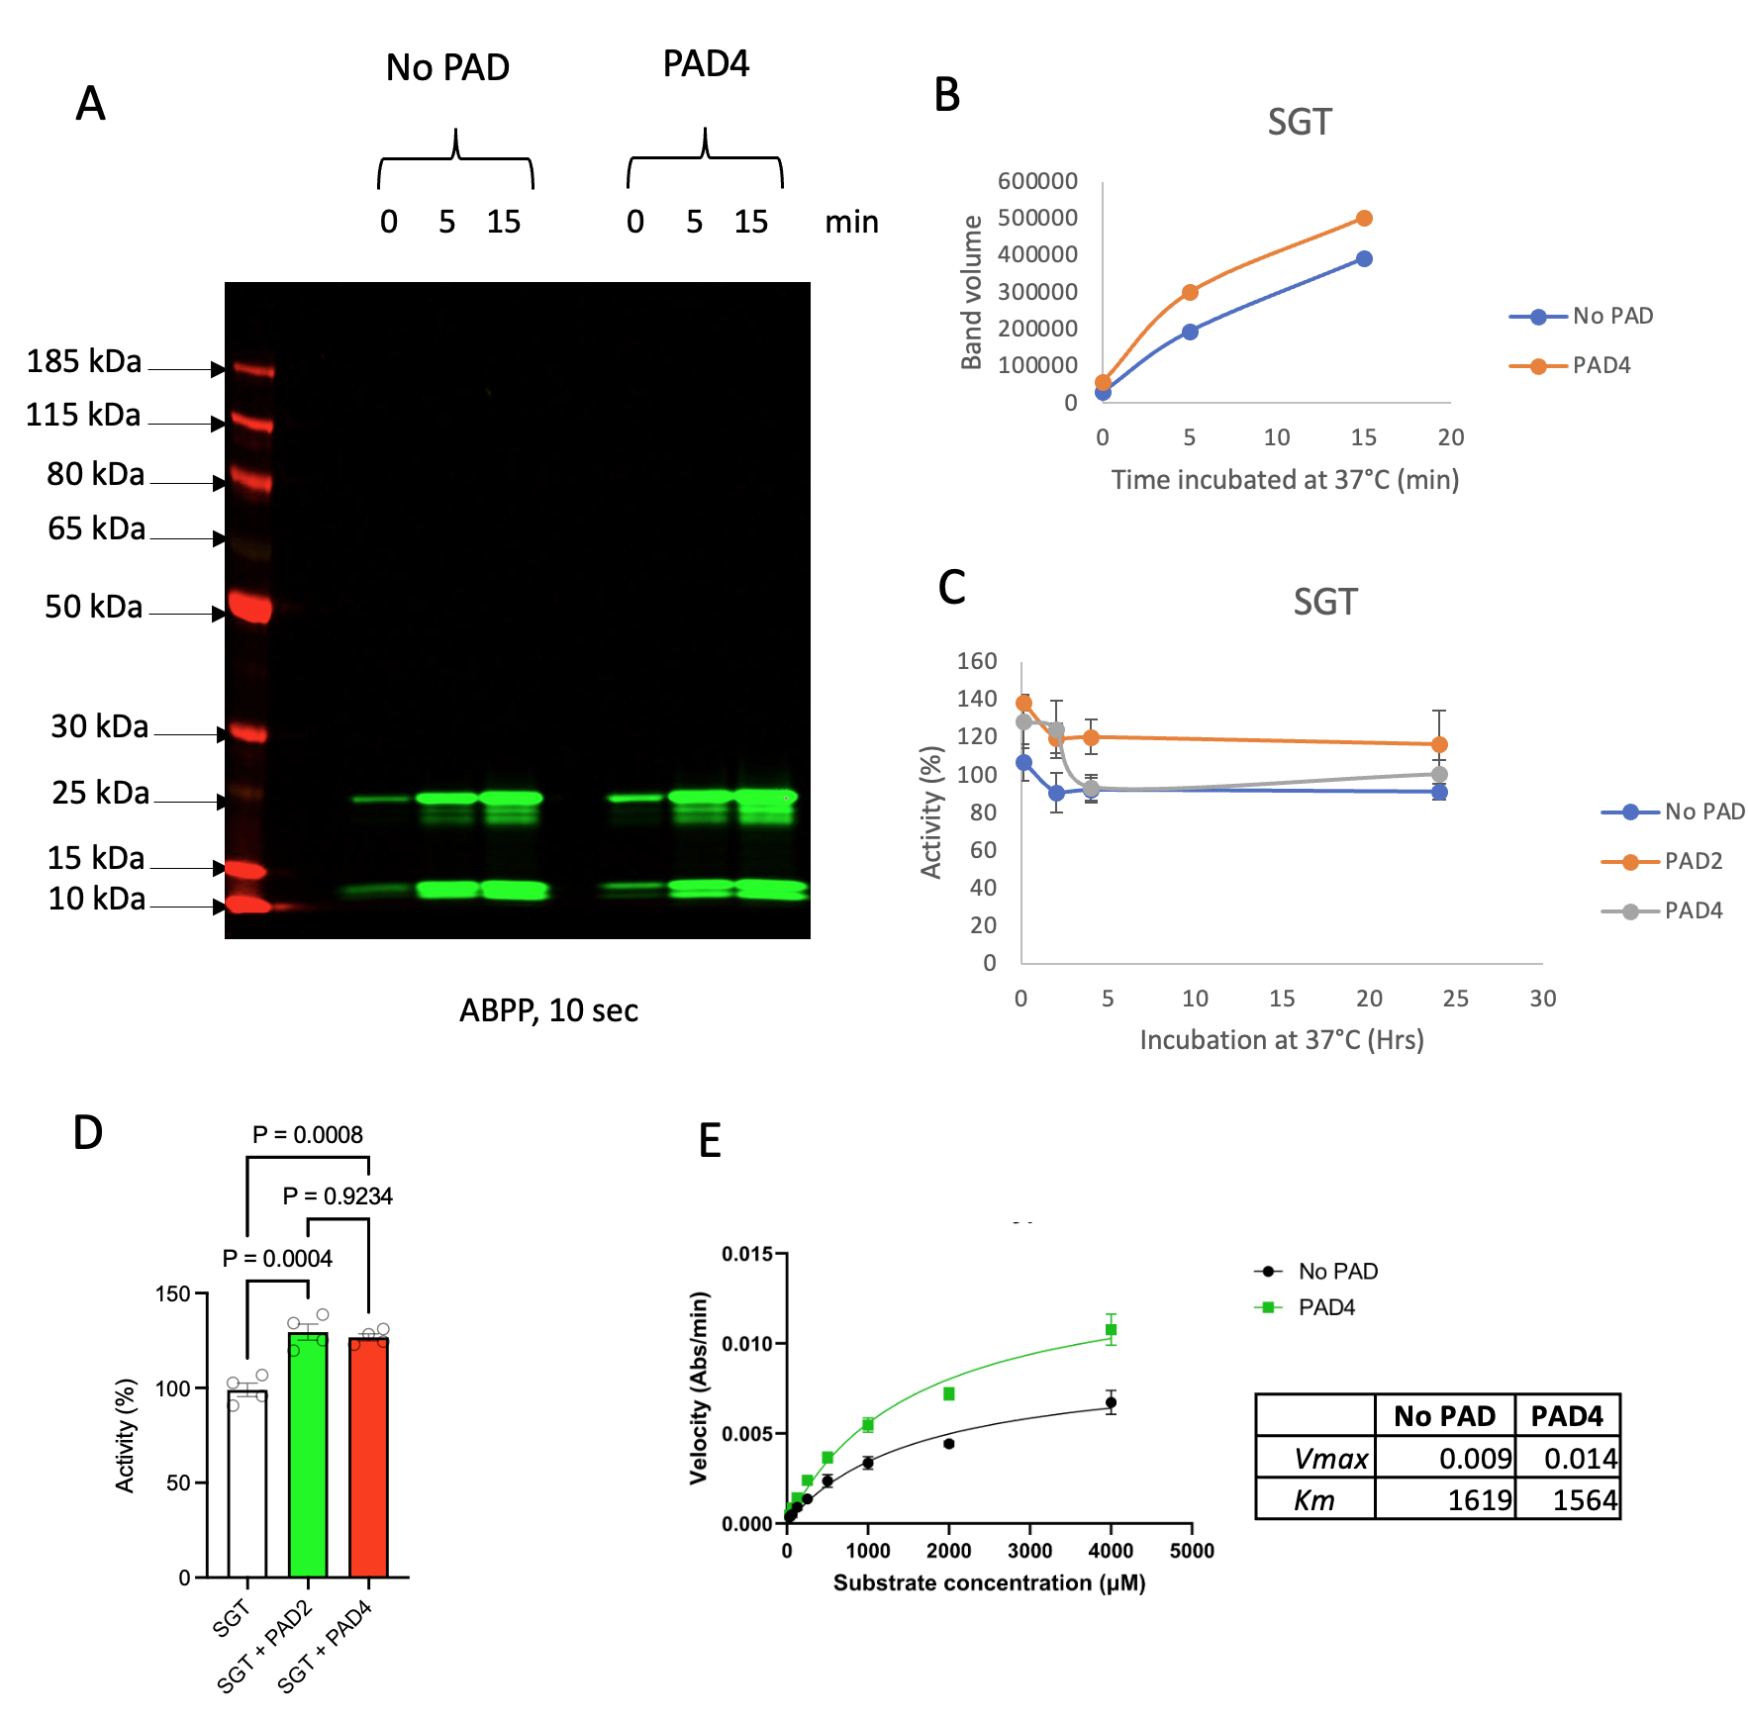 Figure S2. Citrullination of sequence grade trypsin (SGT) enhances proteolytic activity across PAD2 and PAD4 isoforms. (A) Activity of SGT assessed by TAMRA-FP (B) with band density quantification (C) Stability in vitro of SGT for up to 24h. (D) Increased activity of SGT with both PAD2 and PAD4 treatment. (E) Michaelis-Menten kinetic analysis of PAD4-citrullinated SGT compared to untreated controls, with derived kinetic parameters. Data shown as mean ± SEM from ≥3 independent experiments.

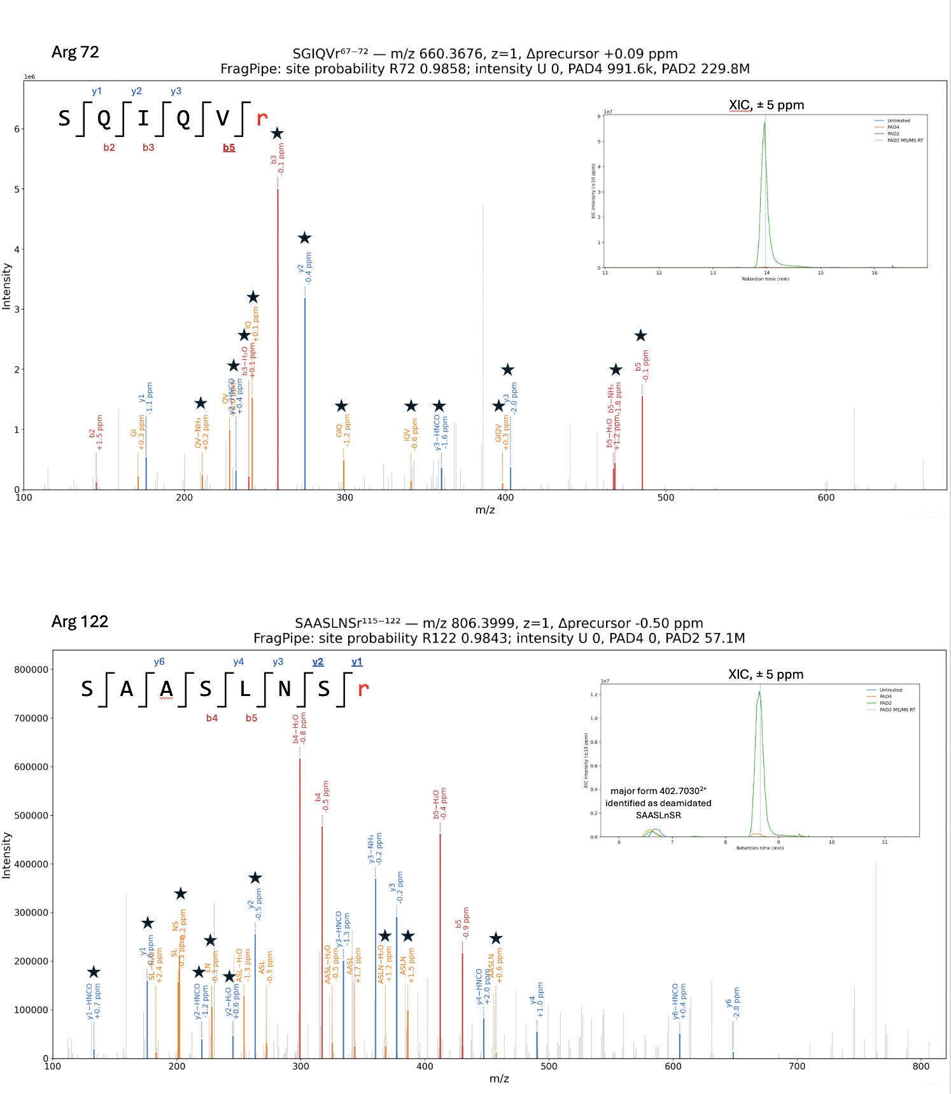Figure S3. Annotated MS/MS spectrum of the citrullinated bovine trypsin. Peptide-spectrum matches (PSMs) for citrullinated trypsin peptides SGIQVr (Arg72), SAASLNSr (Arg122), and LKSAASLNSr (Arg122). Only fragment ions matching theoretical masses within ±3 ppm are annotated and ions supporting site localization are marked with an asterisk. XICs were extracted using a ±5 ppm window around the theoretical monoisotopic precursor mass and support the absence of corresponding citrullinated peptide signals in the untreated reference sample. Precursor m/z, charge state, precursor mass deviation, PTMProphet site probabilities, and IonQuant intensities are shown. The deamidated peptide SAASLnSR was detected at comparable abundance in untreated and PAD-treated samples and could be clearly distinguished from SAASLNSr by its fragmentation pattern, retention time, and charge-state distribution. SAASLnSR showed a strong preference for z = 2, whereas the citrullinated peptide showed approximately equal z = 1 and z = 2 signal, consistent with the expected shift toward lower charge states following loss of the strongly basic Arg guanidinium group upon citrullination.
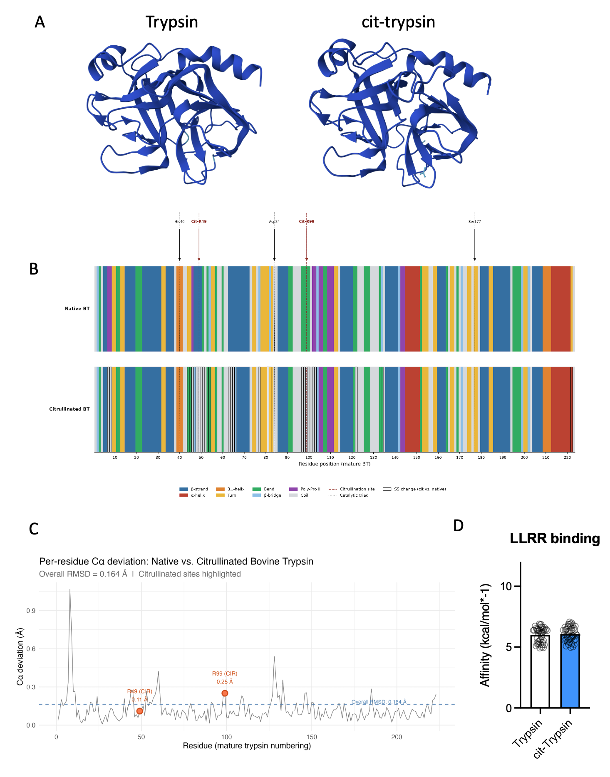

Figure S4. Structural modelling of citrullinated trypsin. (A) Three-dimensional structural representation of trypsin and cit-trypsin (B) Secondary structure analysis (Define Secondary Structure of Proteins) with citrulline sites marked in red and dotted boxes around any changes in structure. (C) Global structural superposition of native and citrullinated bovine trypsin AlphaFold3 models demonstrating similar backbone conformations (Cα RMSD = 0.164 Å), indicating that citrullination does not induce gross structural rearrangement. (D) GNINA docking analysis of a tetrapeptide substrate to both native and citrullinated trypsin (R49 and R99 modified). Analyzed by Mann-Whitney U test (p=ns).

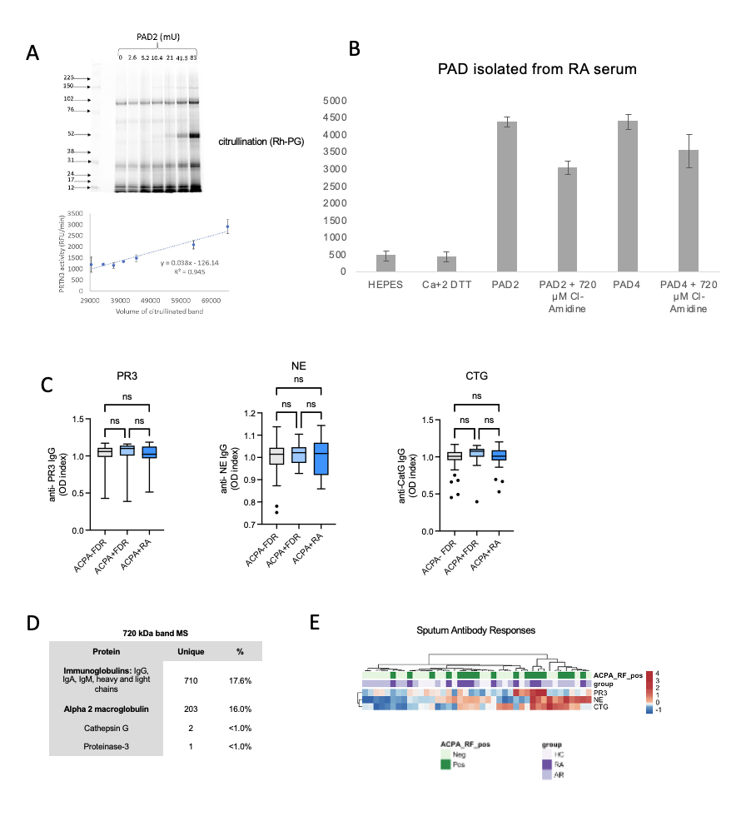
Figure S5. (A) Correlation between PAD2-citrullination signal and proteolytic activity of PR3 across the PAD2 concentration series (R²=0.945, p<0.0001). (B) NSP proteolytic activity following citrullination with PAD2 and PAD4 isolated from RA patient serum, demonstrating enhanced activity consistent with findings using recombinant PAD enzymes. (C) IgG autoantibody reactivity to non-citrullinated NE, PR3, and CTG across ACPA- FDR, ACPA+ FDR, and ACPA+ RA groups; no significant differences were observed between groups. Data shown as mean ± SEM from ≥3 independent experiments. (D) Mass spectrometry data from excised 720 kDa band (select protein IDs only). (E) Hierarchical clustering of protease activity in sputum from at-risk RA cohort.
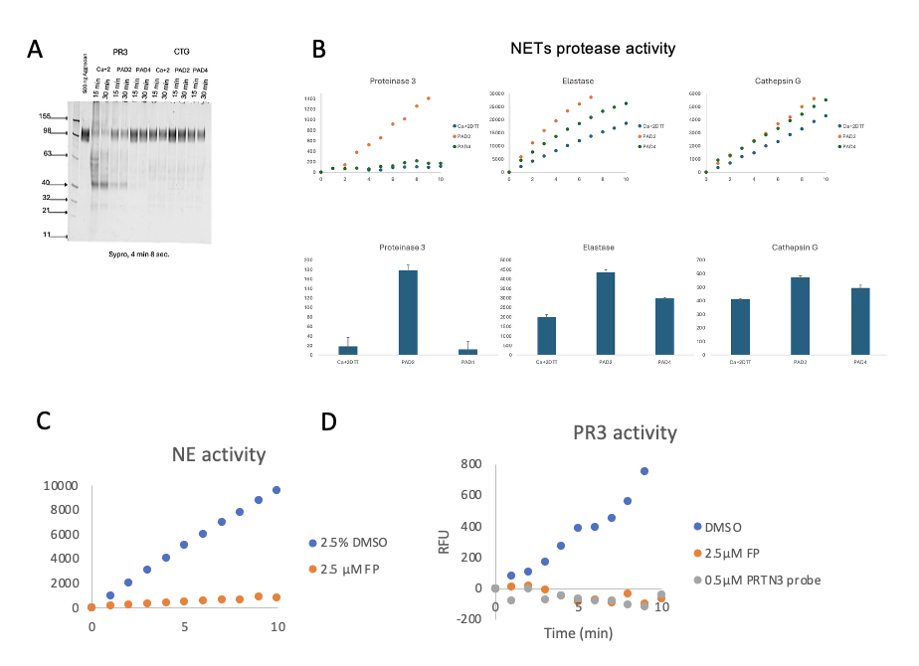Figure S6: (A) Aggrecan degradation by PAD2- or PAD4-citrullinated recombinant PR3 or CTG assessed by SDS-PAGE with Sypro Ruby staining at 15 and 30 minutes. (B) Serine hydrolase activity in PAD2- and PAD4-citrullinated NETs. (C) NE activity in NETs with or without incubation FP-biotin probe. (D) PR3 activity in NETs with or without FP-biotin or PR3 probe.
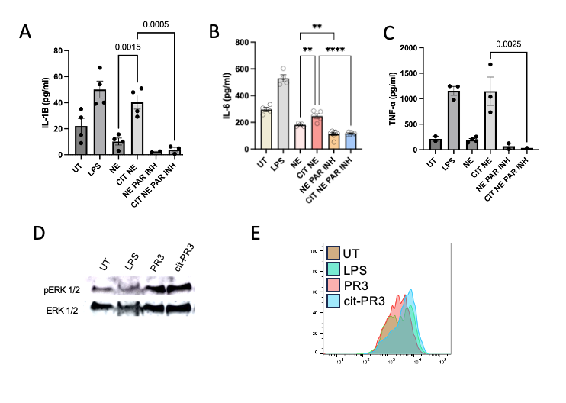
Figure S7: Levels of IL-1β (A), IL6 (B) and TNF-α (C) comparing NE and cit-NE treated FLS with and without PAR2 inhibition. (D) pERK1/2 western blot from FLS stimulated with UT, LPS, native PR3, or cit-PR3 with total ERK1/2 (tERK1/2) shown as loading control. (E) Flow cytometric analysis of intracellular pERK1/2 in FLS stimulated with UT, LPS, native PR3, or cit-PR3 (5 min).

