Superior mesenteric artery syndrome associated with recurrent aspiration and difficult ventilator liberation in a post-trauma patient: a case report
Reda Ibrahim¹, Safouq Al-Anazi¹
¹ Department of Critical Care Medicine, Al Hammadi Hospital, Riyadh, Saudi Arabia
Corresponding author: Reda Ibrahim, Department of Critical Care Medicine, Al Hammadi Hospital, Riyadh, Saudi Arabia

Abstract
Background: Superior mesenteric artery syndrome (SMAS) is an uncommon cause of proximal intestinal obstruction caused by compression of the third portion of the duodenum between the superior mesenteric artery and the aorta. Recurrent vomiting can result in aspiration and respiratory deterioration. We report SMAS as a potentially reversible gastrointestinal contributor to recurrent aspiration and repeated difficulty in ventilator liberation in a critically ill post-trauma patient.
Case presentation: A 19-year-old Saudi male with severe traumatic brain injury after a road traffic accident was transferred for prolonged ventilatory care after craniectomy, ventriculoperitoneal shunt placement, right elbow fixation, and tracheostomy. At transfer, his Glasgow Coma Scale score was 7/15; height was 167 cm and weight 70 kg (BMI 25.1 kg/m²). During approximately 12 months of ventilator dependence, five attempts to transition from pressure-regulated volume control (PRVC) to continuous positive airway pressure (CPAP) failed after episodes of vomiting followed by aspiration pneumonia, documented by new chest-radiographic opacity and increased ventilatory requirements. Chest and abdominal radiographs demonstrated marked gastric distension. Contrast-enhanced abdominal CT in November demonstrated compression of the third part of the duodenum at the aortomesenteric region with severe proximal gastroduodenal dilatation. Retrospective review showed a narrowed aortomesenteric angle of approximately 20–25° and a minimum aortomesenteric distance of approximately 7 mm. Approximately one week after diagnosis, a jejunal extension was placed endoscopically through the existing PEG (PEG-J) beyond the obstructed segment. Vomiting ceased, and the patient was liberated from mechanical ventilation within one week. He remained off ventilator support for one year of follow-up, with no recurrence of vomiting.
Conclusions: In neurologically impaired or post-trauma patients with persistent vomiting, marked gastric distension, recurrent aspiration, or otherwise unexplained difficulty in ventilator liberation, SMAS should be considered among reversible extrapulmonary contributors. An enlarged stomach on routine chest radiography is nonspecific but may prompt definitive abdominal imaging. In selected patients, post-pyloric feeding through a PEG-J can bypass the obstruction and control vomiting. The temporal association between cessation of vomiting and durable ventilator liberation in this case supports contribution from SMAS but does not establish sole causality.
Keywords: superior mesenteric artery syndrome; aspiration pneumonia; mechanical ventilation; ventilator weaning; post-pyloric feeding; PEG-J; critical care

Background
Superior mesenteric artery syndrome (SMAS), also termed Wilkie syndrome, is an uncommon form of proximal intestinal obstruction in which the third portion of the duodenum is compressed between the superior mesenteric artery (SMA) anteriorly and the aorta posteriorly. Loss of the intervening mesenteric fat pad, prolonged catabolic illness, immobility, trauma, and neurologic injury can narrow the aortomesenteric angle and distance and predispose to duodenal obstruction [1, 2]. Clinical manifestations include postprandial discomfort, early satiety, nausea, recurrent vomiting, gastric distension, and weight loss. Recurrent vomiting is clinically important in respiratory and critical care practice because it can precipitate aspiration pneumonia and respiratory deterioration [1, 7, 8].
Diagnosis requires correlation between the clinical picture and imaging. Contrast-enhanced computed tomography (CT) or CT angiography can demonstrate proximal gastroduodenal dilatation and compression of the third portion of the duodenum at the aortomesenteric plane; reduced aortomesenteric angle and distance support the diagnosis when measured [1, 2]. Initial management is generally conservative and includes gastric decompression, correction of fluid and electrolyte abnormalities, positional measures, and nutritional rehabilitation. Feeding beyond the obstructed duodenum using a nasojejunal, PEG-jejunal, or jejunostomy route can provide enteral nutrition while bypassing the obstruction. Surgery, most commonly duodenojejunostomy, is reserved for persistent or refractory disease [1, 2].
The educational value of this case lies in recognizing an upper gastrointestinal obstructive process as a potentially reversible extrapulmonary contributor to recurrent aspiration and difficult ventilator liberation. The initial clue was marked gastric distension on a routine chest radiograph during prolonged ventilatory care; definitive abdominal imaging subsequently demonstrated SMAS.

Case presentation
A 19-year-old Saudi male, previously reported as healthy before the trauma, was transferred to our critical care service for prolonged ventilatory support following a severe road traffic accident with traumatic brain injury. Previous management included craniectomy, placement of a ventriculoperitoneal shunt, right elbow fracture fixation, and tracheostomy. At transfer, his Glasgow Coma Scale score was 7/15. He was hemodynamically stable, with blood pressure 107/64 mmHg, temperature 37°C, and oxygen saturation 100% while receiving 5 L/min oxygen. He had a tracheostomy with thick secretions and clear, equal bilateral air entry. Height was 167 cm and weight was 70 kg, corresponding to a BMI of 25.1 kg/m². Pre-illness weight and the magnitude of preceding weight loss were not documented. An existing PEG tube was present, but recurrent vomiting and substantial gastric drainage had led to interruption of gastric enteral feeding; an NG tube was draining gastric contents.
The respiratory course was characterized by prolonged ventilator dependence. Over approximately 12 months, five attempts were made to transition from pressure-regulated volume control (PRVC) ventilation to continuous positive airway pressure (CPAP). Each attempt was interrupted after recurrent vomiting followed by clinically documented aspiration pneumonia, evidenced by a new pulmonary opacity on chest radiography together with an increase in ventilatory requirements. Detailed numerical spontaneous-breathing-trial, arterial blood gas, FiO₂, PEEP, and pressure-support values for each historical attempt were not available in the reviewed record.
During routine critical care review, the chest radiograph showed marked gastric fundal/gaseous distension below the left hemidiaphragm (Figure 1). This was treated as a nonspecific clue to an upper gastrointestinal obstructive process rather than as a diagnostic sign of SMAS. A subsequent supine abdominal radiograph demonstrated severe gastric dilatation occupying a large portion of the upper abdomen (Figure 2). In the setting of persistent vomiting and feeding intolerance, dedicated abdominal imaging was pursued.
Contrast-enhanced CT of the abdomen performed in November demonstrated severe proximal gastroduodenal dilatation with narrowing/compression of the third part of the duodenum where it traversed the aortomesenteric region (Figures 3 and 4). Retrospective review of the archived CT demonstrated a narrowed aortomesenteric angle of approximately 20–25° and a minimum aortomesenteric distance of approximately 7 mm. These measurements were interpreted as supportive rather than independently diagnostic, in conjunction with the clinical presentation, proximal dilatation, and D3 compression.
The differential diagnosis included critical-illness or neurologic-injury-related gastric dysmotility, gastric outlet obstruction, PEG-related dysfunction, and other causes of proximal small-bowel obstruction. The combined clinical and CT findings supported SMAS as the principal mechanical obstructive process.
Approximately one week after the CT diagnosis, gastroenterology established post-pyloric enteral access by advancing a jejunal extension endoscopically through the existing PEG and positioning it distal to the obstructed duodenal segment (PEG-J). Enteral feeding was resumed through the jejunal limb. Vomiting ceased after PEG-J placement, feeding was tolerated, and no further vomiting-associated aspiration episodes were observed.
Respiratory status subsequently improved, and the patient was successfully liberated from mechanical ventilation within one week after PEG-J placement, after five previous unsuccessful PRVC-to-CPAP weaning attempts during the preceding 12 months. He remained free from ventilator support throughout one year of follow-up, with no recurrence of vomiting. This sequence supports SMAS-related vomiting and aspiration as important contributors to prolonged ventilator dependence, while not proving that SMAS was the sole cause of difficult weaning.

Clinical timeline
Time/phase | Clinical event
Initial trauma | Severe road traffic accident with traumatic brain injury; craniectomy, VP shunt, right elbow fixation, and tracheostomy.
Prolonged ventilatory course (~12 months) | Ventilator dependence; five attempts to transition from PRVC to CPAP. Each failed after vomiting followed by aspiration pneumonia with new CXR opacity and increased ventilatory requirements.
November | Contrast-enhanced abdominal CT demonstrated severe gastroduodenal dilatation and D3 compression at the aortomesenteric region; retrospective angle ~20–25° and distance ~7 mm.
~1 week after CT diagnosis | PEG-J established by advancing a jejunal extension through the existing PEG beyond the obstructed segment.
After PEG-J | Vomiting ceased; jejunal feeding tolerated; no further vomiting-associated aspiration episodes.
Within 1 week after PEG-J | Successfully liberated from mechanical ventilation.
1-year follow-up | Remained off ventilator support with no recurrence of vomiting.

Discussion
This case illustrates an important intersection between gastrointestinal obstruction and respiratory critical care. In a patient with severe post-traumatic neurologic impairment, recurrent vomiting and aspiration may readily be attributed to dysphagia, impaired airway protection, delayed gastric emptying, medications, or critical-illness-related dysmotility. SMAS is less common but should remain in the differential diagnosis when vomiting, marked gastric distension, or persistent enteral feeding intolerance is present. The 2023 review by Oka et al. emphasized that recurrent vomiting in SMAS can lead to aspiration pneumonia or respiratory depression and that early diagnosis is important [1]. A contemporary review similarly supports CT-based diagnosis and initial nutritional rehabilitation with post-pyloric feeding, reserving surgical bypass for failure of conservative management [2].
Neurologic trauma is a recognized clinical context for SMAS. Pedoto et al. reported two adults with traumatic brain injury who developed SMAS during rehabilitation and highlighted acute weight loss, prolonged recumbency, and spasticity as relevant risk factors; extension of feeding beyond the obstruction formed part of conservative therapy [3]. SMAS has also been described in the wider trauma population [4]. In spinal cord injury rehabilitation, Desai et al. reported two traumatic cervical cord injury cases in which CT demonstrated duodenal obstruction with gastric distension; both were treated without surgery through decompression and nutritional optimization, including jejunal feeding in one patient [5]. In the present case, the pre-illness weight was not documented, so the contribution of preceding weight loss cannot be quantified despite the prolonged post-trauma course.
The respiratory course provides the central clinical observation. Five attempts to transition from PRVC to CPAP over approximately 12 months were interrupted by vomiting followed by aspiration pneumonia, with new chest-radiographic opacity and increased ventilatory requirements. Lai and Mahmood described a 16-year-old male with marked gastroduodenal dilatation and aspiration pneumonia in whom nasojejunal feeding was used after stabilization [6], while Akel et al. reported a fatal case of aspiration pneumonia associated with SMAS [7]. In our patient, vomiting ceased after PEG-J feeding and durable ventilator liberation followed within one week. This close temporal sequence supports a clinically meaningful contribution from SMAS-related vomiting and aspiration; however, a single case cannot establish causality.
Alternative explanations for difficult ventilator liberation remain important. Severe traumatic brain injury with a GCS of 7/15, impaired airway protection, tracheostomy secretion burden, recurrent infection, prolonged immobility, deconditioning or ICU-acquired weakness, nutritional compromise, and critical-illness gastrointestinal dysmotility could all have contributed. The interpretation is therefore not that SMAS was the sole cause of prolonged ventilation, but that it represented a reversible extrapulmonary barrier whose treatment coincided with cessation of vomiting, absence of further aspiration episodes, and sustained liberation from mechanical ventilation.
The diagnostic pathway also has a practical teaching point for intensivists. Marked gastric distension was first recognized on a routine chest radiograph. Chest radiography is neither specific nor diagnostic for SMAS; an enlarged stomach should instead prompt consideration of an upper gastrointestinal obstructive or dysmotility process when supported by the clinical context. In this patient, the abdominal radiograph confirmed severe gastric dilatation and contrast-enhanced CT demonstrated D3 compression at the aortomesenteric plane. Retrospective measurements showed an aortomesenteric angle of approximately 20–25° and distance of approximately 7 mm. Numeric thresholds should support, not replace, clinicoradiologic correlation [1, 2].
Conservative management aims to interrupt the cycle of obstruction, vomiting, inadequate nutrition, further loss of mesenteric fat, and worsening compression. Decompression and nutritional rehabilitation are central. When gastric feeding is not tolerated, delivering nutrition distal to the obstructed duodenal segment can be particularly useful [1, 2, 5, 6]. In this patient, a jejunal extension was advanced through the existing PEG (PEG-J) and positioned beyond the obstruction. This approach controlled vomiting and permitted enteral feeding without immediate surgery. If symptoms persist despite adequate conservative therapy, operative treatment—most commonly duodenojejunostomy—should be considered [2, 9–11].
This report has limitations inherent to its retrospective single-case design. Pre-illness weight and percentage weight loss were not documented, preventing quantitative assessment of the proposed loss-of-fat-pad mechanism. Exact numerical ventilator settings, arterial blood gases, and formal spontaneous-breathing-trial parameters for each of the five historical weaning attempts were unavailable. The CT measurements were obtained on retrospective review and should be interpreted with the overall CT morphology and clinical presentation. In addition, the patient's severe neurological injury and prolonged critical illness provide plausible competing contributors to difficult weaning. Nevertheless, the repeated sequence of vomiting, aspiration and respiratory deterioration before treatment, followed by cessation of vomiting, successful liberation within one week of PEG-J placement, and one year without ventilator support, strengthens the clinical inference that SMAS was an important reversible contributor.

Conclusions
SMAS should be considered in post-trauma or neurologically impaired patients with persistent vomiting, marked gastric distension, recurrent aspiration, or otherwise unexplained difficulty in ventilator liberation. Marked gastric distension on a routine chest radiograph is a nonspecific clue that may justify dedicated abdominal imaging. In selected patients, post-pyloric feeding through a PEG-J can bypass the obstructed duodenal segment, restore enteral nutrition, and control vomiting without immediate surgery. In this case, cessation of vomiting after PEG-J placement was followed by successful ventilator liberation within one week and sustained freedom from ventilator support for one year, supporting SMAS as a potentially reversible contributor rather than a proven sole cause of difficult weaning.

List of abbreviations
CPAP — continuous positive airway pressure
CT — computed tomography
PEG — percutaneous endoscopic gastrostomy
PEG-J — percutaneous endoscopic gastrostomy with jejunal extension
PRVC — pressure-regulated volume control
SMA — superior mesenteric artery
SMAS — superior mesenteric artery syndrome

Declarations

Ethics approval and consent to participate
Ethical approval for this case report was obtained from the institutional ethics committee. The case was prepared and submitted in accordance with institutional ethical requirements and with protection of patient confidentiality. The full committee name and approval/reference number should be inserted from the institutional approval record if required by the journal before resubmission.

Consent for publication
Informed consent for publication of this case report and the accompanying anonymized radiologic images was obtained from the patient's father as the patient's representative in view of the patient's severe neurological impairment. No patient name, identifying number, or other directly identifying personal information is included in the manuscript or figures.

Availability of data and materials
All data supporting the conclusions of this case report are included within the article. Additional de-identified clinical information may be available from the corresponding author on reasonable request, subject to institutional policy and patient privacy.

Competing interests
The authors declare that they have no competing interests or conflicts of interest.

Funding
No funding, grant, or other financial support was received for the preparation or publication of this case report.

Authors' contributions
R.I. and S.A. are Consultant Intensivists who directly supervised the patient's critical care and participated in the multidisciplinary team responsible for the patient's management. R.I. reviewed the complete clinical record and available case files, performed the literature review, prepared and wrote the main manuscript, and completed the final revision. S.A. reviewed the clinical records and available files, contributed to multidisciplinary clinical review, critically reviewed the manuscript, and approved its final content. Both authors reviewed and approved the final manuscript and agree to be accountable for the accuracy and integrity of the work.

Acknowledgements
Not applicable.

Authors' information
R.I. and S.A. are Consultant Intensivists in the Department of Critical Care Medicine, Al Hammadi Hospital, Riyadh, Saudi Arabia. Both authors directly supervised the patient's intensive care and participated in the multidisciplinary management team.

Reporting guideline
This case report was prepared in accordance with the CARE guidelines.

References
1. Oka A, Awoniyi M, Hasegawa N, Yoshida Y, Tobita H, Ishimura N, Ishihara S (2023) Superior mesenteric artery syndrome: diagnosis and management. World J Clin Cases 11(15):3369-3384. doi:10.12998/wjcc.v11.i15.3369.
2. Martinez Santos M, Farooqui A, Osman H, Kong J, Logarajah S, Jomy A, Jeyarajah DR (2026) Superior mesenteric artery syndrome: a contemporary review of diagnosis and surgical management. J Gastrointest Surg 30(9):102506. doi:10.1016/j.gassur.2026.102506.
3. Pedoto MJ, O'Dell MW, Thrun M, Hollifield D (1995) Superior mesenteric artery syndrome in traumatic brain injury: two cases. Arch Phys Med Rehabil 76(9):871-875. doi:10.1016/S0003-9993(95)80555-9.
4. Smith BM, Zyromski NJ, Purtill MA (2008) Superior mesenteric artery syndrome: an underrecognized entity in the trauma population. J Trauma 64(3):827-830. doi:10.1097/01.ta.0000223942.26704.91.
5. Desai MH, Gall A, Khoo M (2015) Superior mesenteric artery syndrome - a rare presentation and challenge in spinal cord injury rehabilitation: a case report and literature review. J Spinal Cord Med 38(4):544-547. doi:10.1179/2045772314Y.0000000241.
6. Lai YK, Mahmood RD (2016) Clinics in diagnostic imaging (168). Singapore Med J 57(5):274-278. doi:10.11622/smedj.2016093.
7. Akel R, Daou I, Jamal D, Hobeika E, Aoun R, Nawfal G (2024) Deadly aspiration pneumonia secondary to superior mesenteric artery syndrome. Case Rep Gastrointest Med 2024:5055948. doi:10.1155/2024/5055948.
8. Ben Ismail I, Yaich K, Sghaier M, Rebii S, Zenaidi H, Zoghlami A (2026) Post-traumatic superior mesenteric artery syndrome following lumbar spine stabilization: a case report and literature review. Trauma Case Rep 64:101404. doi:10.1016/j.tcr.2026.101404.
9. Kim IY, Cho NC, Kim DS, Rhoe BS (2003) Laparoscopic duodenojejunostomy for management of superior mesenteric artery syndrome: two cases report and a review of the literature. Yonsei Med J 44(3):526-529.
10. Sun Z, Rodriguez J, McMichael J, et al (2015) Minimally invasive duodenojejunostomy for superior mesenteric artery syndrome: a case series and review of the literature. Surg Endosc 29(5):1137-1144.
11. Jain N, Chopde A, Soni B, et al (2021) Superior mesenteric artery syndrome: management perspective with laparoscopic duodenojejunostomy and long-term results. Surg Endosc 35(5):2029-2038.

Figure legends
Figure 1. Chest radiograph showing marked gastric distension. Routine chest radiograph demonstrates a markedly prominent gastric fundal/gaseous shadow below the left hemidiaphragm. This nonspecific finding prompted further abdominal evaluation.
Figure 2. Supine abdominal radiograph showing marked gastric dilatation. Severe gaseous distension of the stomach occupies a large portion of the upper abdomen.
Figure 3. Contrast-enhanced CT showing severe proximal gastroduodenal dilatation. Coronal CT demonstrates marked gastric dilatation in association with the proximal obstructive process.
Figure 4. Contrast-enhanced CT demonstrating the aortomesenteric relationship and duodenal compression. The CT demonstrates narrowing/compression of the third part of the duodenum at the aortomesenteric region. Retrospective review showed an aortomesenteric angle of approximately 20–25° and a minimum distance of approximately 7 mm, supportive of SMAS in the appropriate clinicoradiological context.
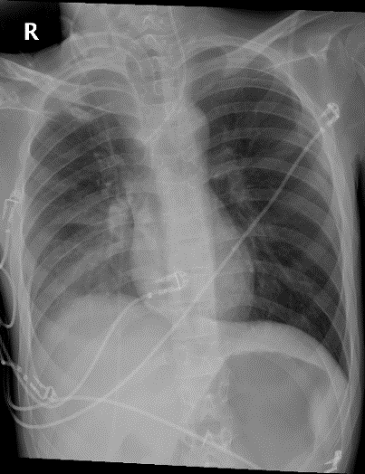
Figure 1
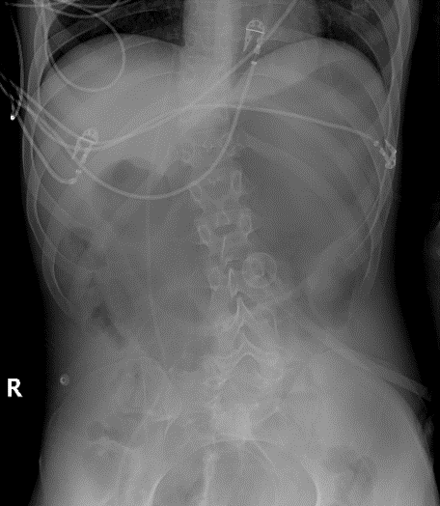
Figure 2
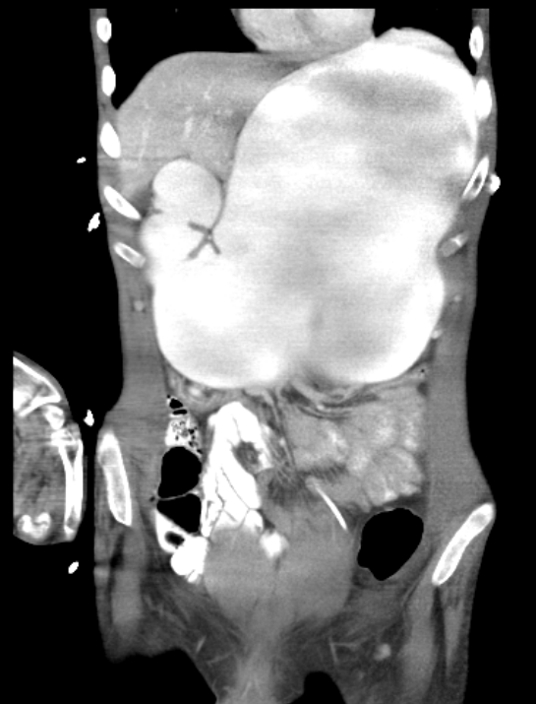
Figure 3
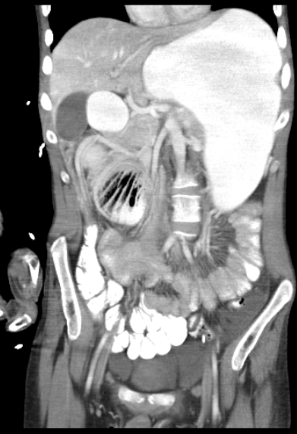
Figure 4

