Cross-Platform Evaluation of Long-Read Sequencing for DNA Methylation and Portability of Methylation Predictors

Supplementary Table 1. Number of CpG sites detected at sequencing depth ≥10x by ONT and PacBio platforms in PEGS samples, including individual and pooled samples (ONTpool and PacBiopool), and their overlaps with the Illumina EPIC array.
ID | ONT | PacBio | ONTpool | PacBiopool | Overlap with EPIC Array
 |  |  |  |  | ONT | PacBio | ONTpool | PacBiopool
DD1 | 27875183 | 27834168 | 5573560 | 3787522 | 816345 | 783572 | 316713 | 79671
DD3 | 27900096 | 27963821 | 5613856 | 5330628 | 816487 | 790614 | 320812 | 110972
DD4 | 27908827 | 27919741 | 7458450 | 6560432 | 816892 | 787056 | 421050 | 141919
DD5 | 27821324 | 27557647 | 6748911 | 6177168 | 815001 | 775328 | 387021 | 131407
DD6 | 27666528 | 27990101 | NA | NA | 808563 | 789552 | NA | NA
DD7 | 27849105 | 27800332 | 7082848 | 7136918 | 815485 | 785819 | 404433 | 163544
DD8 | 27462169 | 28121605 | NA | NA | 802482 | 791744 | NA | NA
DD9 | 27885907 | 27917762 | 5002805 | 7944042 | 815660 | 788079 | 277032 | 184134
DD10 | 27852047 | 27954519 | 6724108 | 9078212 | 815679 | 788955 | 383298 | 213983

Supplementary Table 2. Number of CpG sites detected at sequencing depth ≥10x by ONT, PacBio Revio, and PacBio Sequel2e in All of Us duplicate samples.
Sample ID | Number of CpG
Sample ID | ONT | PacBio Revio | PacBio Sequel2e
1230263 | 28426464 | 27955750 | —
1064642 | 28496602 | 28104394 | —
1145498 | 28187950 | 28109009 | —
1097363 | 28464939 | 28122166 | —
1141272 | 28527116 | 28139645 | —
1522944 | 28447095 | 28229670 | —
1522688 | 28128077 | 28232138 | —
1005412 | 28444215 | 28244162 | —
1161199 | 28534304 | 28248614 | —
1150124 | 28463390 | 28251991 | —
1477881 | 28469625 | 28402689 | —
1516310 | 28373316 | 28417691 | —
1182052 | 28328957 | 28441268 | —
1515674 | 28483887 | 28467118 | —
1179333 | 28475712 | 28530669 | —
1188421 | 28237816 | — | 28635139
1172371 | 28343513 | — | 28616846
1165054 | 28415265 | — | 28505489
1476956 | 28415416 | — | 28570144
1003224 | 28425580 | — | 28519066
1025484 | 28442526 | — | 28389662
1240973 | 28453704 | — | 28594361
1162347 | 28469878 | — | 28527694
1042914 | 28476599 | — | 28515110
1488658 | 28478883 | — | 28548765
1081825 | 28503414 | — | 28730556
1175280 | 28579875 | — | 28591569
1289466 | — | 28488963 | 28535117

Supplementary Table 3. Cross-platform Pearson correlations of DNA methylation predictor scores between duplicate pairs in PEGS and All of Us cohorts, with the number of CpGs required by each predictor model. PEGS correlations are based on nine paired samples; the AoU ONT-PacBio correlations are based on 27 paired participants.
Predictor | PEGS |  |  |  | AoU | Required CpGs
Predictor | ONT_PacBio | ONT_EPIC | PacBio_EPIC |  | ONT_PacBio | Required CpGs
PCADM | 0.87 | 0.87 | 0.85 |  | 0.99 | 78464
PCB2M | 0.74 | 0.75 | 0.86 |  | 1.00 | 78464
PCCystatinC | 0.98 | 0.89 | 0.84 |  | 1.00 | 78464
PCDNAmTL | 0.93 | 0.88 | 0.81 |  | 0.97 | 78464
PCGDF15 | 0.97 | 0.88 | 0.86 |  | 1.00 | 78464
PCGrimAge | 0.88 | 0.94 | 0.90 |  | 0.99 | 78464
PCHannum | 0.52 | 0.44 | -0.14 |  | 0.97 | 78464
PCHorvath1 | 0.91 | 0.51 | 0.31 |  | 0.98 | 78464
PCHorvath2 | 0.70 | 0.81 | 0.68 |  | 0.98 | 78464
PCLeptin | 0.79 | 0.61 | 0.81 |  | 1.00 | 78464
PCPACKYRS | 0.69 | 0.94 | 0.80 |  | 0.84 | 78464
PCPAI1 | 0.79 | 0.57 | 0.79 |  | 0.85 | 78464
PCPhenoAge | 0.71 | 0.36 | 0.32 |  | 0.97 | 78464
PCTIMP1 | 0.99 | 0.88 | 0.87 |  | 1.00 | 78464
cAge | 0.42 | 0.14 | 0.75 |  | 0.89 | 3225
bAge | 0.92 | 0.96 | 0.89 |  | 0.99 | 2334
bAge_Years | 0.92 | 0.96 | 0.89 |  | 0.99 | 2334
Body.Mass.Index | 0.25 | 0.07 | 0.12 |  | 0.42 | 1109
DamAge | -0.22 | -0.14 | 0.69 |  | 0.52 | 1089
GrimAgeV1 | 0.24 | 0.73 | 0.41 |  | 0.92 | 1030
GrimAgeV2 | 0.47 | 0.67 | 0.23 |  | 0.88 | 1030
AdaptAge | 0.21 | -0.13 | -0.20 |  | 0.35 | 999
Body.Fat.. | 0.30 | 0.07 | 0.22 |  | 0.26 | 968
HDL.Cholesterol | 0.26 | 0.42 | 0.56 |  | 0.26 | 737
DNAmFEV1_wAge | 0.56 | 0.89 | 0.43 |  | 0.84 | 627
DNAmFitAge | 0.41 | 0.66 | 0.77 |  | 0.83 | 627
DNAmGait_noAge | 0.54 | 0.62 | 0.67 |  | 0.46 | 627
DNAmGait_wAge | 0.25 | 0.23 | -0.06 |  | 0.95 | 627
DNAmGrip_noAge | 0.07 | 0.20 | 0.55 |  | 0.79 | 627
DNAmGrip_wAge | 0.04 | 0.77 | 0.18 |  | 0.99 | 627
DNAmVO2max | 0.36 | 0.26 | 0.52 |  | 0.65 | 627
CausAge | -0.16 | 0.22 | 0.07 |  | 0.66 | 585
GARPC | 0.23 | 0.27 | 0.10 |  | 0.27 | 558
GACPC | -0.31 | -0.21 | 0.51 |  | 0.27 | 546
ENPP7 | 0.78 | 0.96 | 0.70 |  | 0.50 | 514
PhenoAge | 0.48 | 0.28 | 0.05 |  | 0.60 | 513
Alcohol | 0.33 | 0.67 | -0.04 |  | 0.28 | 450
Aminoacylase.1 | -0.40 | -0.48 | 0.34 |  | 0.03 | 395
GARRPC | 0.11 | 0.45 | 0.46 |  | -0.18 | 395
Horvath2 | 0.57 | 0.72 | 0.35 |  | 0.88 | 391
pcgtAge | 0.61 | 0.02 | 0.13 |  | 0.42 | 385
CCL17 | 0.13 | 0.21 | -0.81 |  | 0.12 | 364
HorvathAge | 0.83 | 0.36 | 0.08 |  | 0.51 | 353
B2.microglobulin | 0.42 | 0.14 | 0.29 |  | 0.27 | 311
MiAge | 0.37 | 0.16 | -0.05 |  | 0.83 | 268
Complement.C5a | 0.34 | 0.22 | 0.40 |  | 0.57 | 263
MMP.1.1 | -0.14 | 0.35 | 0.46 |  | 0.24 | 262
SERPIN.A3 | 0.23 | 0.35 | 0.60 |  | 0.22 | 258
MMP.12 | -0.17 | 0.01 | 0.37 |  | 0.39 | 257
BohlinGAge | 0.01 | 0.25 | 0.02 |  | 0.36 | 251
Smoking | -0.63 | 0.75 | -0.10 |  | 0.18 | 233
Waist.Hip.Ratio | 0.38 | 0.71 | -0.19 |  | 0.12 | 226
DNAmPAI1 | 0.44 | 0.10 | -0.10 |  | 0.00 | 211
CXCL10 | 0.00 | -0.14 | 0.13 |  | 0.26 | 196
CXCL10.soma | -0.10 | 0.39 | 0.04 |  | 0.66 | 194
DNAmLeptin | -0.25 | 0.11 | -0.33 |  | 0.10 | 187
DNAmADM | 0.03 | -0.11 | 0.34 |  | 0.49 | 186
LFT | -0.11 | -0.05 | -0.76 |  | 0.13 | 186
THBS2 | 0.26 | -0.12 | 0.83 |  | 0.31 | 183
Osteomodulin | -0.14 | -0.26 | 0.03 |  | 0.55 | 180
GPIba | 0.55 | 0.33 | 0.54 |  | 0.04 | 179
CXCL11 | 0.13 | 0.50 | 0.60 |  | 0.40 | 176
PACE | -0.61 | 0.16 | 0.47 |  | 0.08 | 173
DNAmPACKYRS | 0.10 | 0.89 | -0.15 |  | 0.37 | 172
CD209.antigen | 0.39 | 0.19 | 0.22 |  | 0.37 | 163
FCER2 | 0.48 | 0.61 | 0.64 |  | 0.50 | 163
TNSC | 0.30 | -0.23 | 0.12 |  | 0.26 | 163
TNSC2 | 0.30 | -0.23 | 0.12 |  | 0.26 | 163
SLITRK5 | 0.46 | 0.43 | 0.58 |  | 0.10 | 161
VEGFA | 0.27 | -0.04 | 0.26 |  | 0.03 | 159
EN.RAGE | 0.08 | -0.25 | 0.74 |  | 0.14 | 156
HGFI | -0.31 | 0.00 | 0.28 |  | 0.21 | 156
CD163 | 0.82 | 0.74 | 0.83 |  | 0.36 | 151
KnightGAge | -0.29 | -0.08 | 0.09 |  | 0.20 | 148
NRTK3 | -0.09 | 0.20 | -0.47 |  | 0.55 | 148
DNAmTL | 0.15 | 0.54 | 0.53 |  | 0.36 | 140
DNAmGDF15 | -0.30 | 0.03 | -0.06 |  | 0.51 | 137
DNAmlogCRP | -0.05 | -0.21 | -0.07 |  | 0.39 | 132
ICAM5 | 0.53 | 0.85 | 0.67 |  | 0.42 | 132
CDL5 | 0.19 | -0.13 | -0.13 |  | 0.28 | 127
Epigenetic.Age.Zhang | 0.33 | -0.18 | 0.39 |  | 0.94 | 126
OSM | 0.52 | 0.25 | 0.79 |  | 0.30 | 125
LY9 | 0.59 | 0.34 | 0.63 |  | 0.11 | 124
NCAM.120 | 0.14 | 0.55 | 0.32 |  | 0.23 | 121
IGFBP.1 | 0.37 | 0.21 | 0.23 |  | 0.47 | 120
CCL18 | -0.46 | 0.17 | 0.18 |  | 0.65 | 119
NTRK3 | -0.44 | 0.09 | 0.60 |  | -0.17 | 118
RARRES2 | 0.67 | 0.50 | 0.11 |  | -0.14 | 117
CHIT.1 | 0.01 | 0.02 | 0.24 |  | 0.58 | 111
SMPD1 | 0.04 | 0.53 | 0.73 |  | 0.28 | 110
Complement.c9 | 0.12 | 0.15 | 0.13 |  | 0.12 | 109
GHR | -0.16 | 0.42 | 0.45 |  | 0.19 | 108
CLEC11A.e1 | -0.07 | 0.26 | -0.15 |  | -0.10 | 107
Tryptase.beta.2 | 0.43 | 0.43 | 0.51 |  | 0.19 | 106
FGF.21 | -0.17 | 0.00 | 0.37 |  | 0.32 | 103
Granzyme.A | 0.49 | 0.21 | 0.47 |  | 0.41 | 103
TNFRSF17 | -0.19 | 0.36 | -0.33 |  | -0.16 | 103
FCGR3A | 0.57 | 0.55 | 0.90 |  | 0.47 | 102
CRP | 0.65 | -0.07 | -0.18 |  | 0.34 | 100
TGF.alpha | -0.46 | -0.41 | 0.68 |  | 0.19 | 100
LGALS3BP | -0.11 | 0.05 | -0.31 |  | 0.02 | 99
CCL21 | -0.51 | -0.03 | -0.13 |  | 0.57 | 98
MMP.9 | 0.33 | 0.01 | 0.13 |  | 0.40 | 96
PedBE | 0.27 | 0.78 | 0.12 |  | 0.54 | 94
DNAmB2M | -0.01 | 0.25 | 0.54 |  | 0.77 | 91
DNAmCystatinC | 0.00 | -0.46 | 0.62 |  | 0.65 | 87
DNAmlogA1C | 0.68 | 0.20 | 0.52 |  | 0.32 | 86
TNFRSF1B | 0.22 | 0.05 | 0.33 |  | 0.31 | 83
CLEC11A.e2 | -0.20 | 0.52 | -0.44 |  | 0.17 | 82
Ectodysplasin.A | 0.21 | 0.26 | -0.12 |  | 0.23 | 82
Interleukin.19 | 0.40 | 0.72 | 0.59 |  | 0.35 | 81
G.CSF | 0.11 | 0.44 | 0.12 |  | 0.19 | 79
FAP | -0.03 | -0.03 | 0.22 |  | 0.45 | 74
HGF | -0.45 | -0.40 | 0.55 |  | 0.30 | 72
IGFBP.4 | -0.06 | 0.15 | 0.27 |  | 0.48 | 72
HannumAge | -0.60 | 0.42 | -0.61 |  | 0.77 | 71
MIA | 0.06 | 0.50 | 0.22 |  | 0.21 | 69
SHBG | 0.35 | 0.15 | 0.11 |  | 0.03 | 68
SKR3 | 0.23 | -0.15 | 0.03 |  | 0.20 | 68
Alpha.L.iduronidase | -0.18 | -0.41 | 0.31 |  | 0.07 | 67
BMP.1 | 0.40 | 0.11 | 0.40 |  | 0.23 | 67
Lymphotoxin.abeta | 0.14 | 0.60 | 0.36 |  | 0.36 | 67
WFIKKN2 | 0.33 | -0.05 | 0.04 |  | 0.56 | 66
CRTAM | 0.58 | 0.62 | 0.84 |  | 0.43 | 64
Testican.2 | -0.24 | 0.43 | -0.13 |  | 0.10 | 62
Stanniocalcin.1 | -0.08 | 0.41 | 0.47 |  | 0.21 | 61
CCL25.C.C | 0.71 | 0.41 | 0.64 |  | -0.07 | 59
Galectin.4 | -0.42 | 0.04 | 0.28 |  | 0.28 | 58
PAPP.A | 0.29 | 0.45 | 0.44 |  | 0.14 | 58
CXCL9 | 0.20 | 0.62 | 0.79 |  | 0.40 | 56
ESM.1 | 0.21 | -0.46 | -0.94 |  | 0.16 | 55
Granulysin | 0.57 | -0.11 | 0.02 |  | 0.44 | 52
HCII | -0.06 | 0.21 | -0.05 |  | 0.35 | 52
ADAMTS | -0.06 | -0.24 | 0.76 |  | 0.54 | 51
CXCL11.soma | 0.42 | 0.47 | 0.86 |  | 0.54 | 51
Insulin.receptor | -0.29 | 0.61 | 0.28 |  | -0.16 | 51
L.selectin | 0.58 | 0.70 | 0.86 |  | 0.18 | 51
Semaphorin.3E | 0.32 | 0.22 | 0.05 |  | 0.16 | 51
N.CDase | 0.46 | 0.38 | 0.14 |  | 0.49 | 50
CCL11 | 0.37 | 0.67 | 0.57 |  | 0.35 | 45
Contactin.4 | -0.11 | 0.22 | 0.00 |  | -0.03 | 45
NMNAT1 | 0.77 | 0.49 | 0.66 |  | -0.13 | 44
DNAmTIMP1 | 0.10 | 0.26 | 0.29 |  | 0.90 | 42
CD6 | -0.18 | 0.16 | 0.19 |  | 0.66 | 41
TPO | 0.32 | 0.64 | 0.46 |  | 0.61 | 41
Adiponectin | 0.03 | 0.19 | 0.46 |  | -0.07 | 39
FcRL2 | -0.27 | -0.26 | -0.16 |  | 0.45 | 38
Afamin | 0.13 | 0.51 | 0.43 |  | 0.31 | 37
CCL22 | -0.02 | 0.19 | 0.07 |  | 0.19 | 36
Myeloperoxidase | -0.33 | -0.04 | 0.63 |  | 0.34 | 35
MMP.1 | 0.59 | 0.66 | 0.79 |  | 0.08 | 34
NEP | -0.52 | -0.22 | 0.42 |  | 0.36 | 34
NOTCH1 | -0.18 | -0.23 | 0.23 |  | 0.59 | 33
EZR | 0.61 | 0.26 | 0.44 |  | 0.45 | 32
VCAM1 | 0.09 | 0.48 | 0.38 |  | 0.46 | 32
GDF.8 | 0.37 | 0.09 | 0.15 |  | 0.28 | 29
SIGLEC1 | 0.35 | 0.58 | 0.36 |  | 0.51 | 28
PIGR | 0.78 | -0.28 | -0.01 |  | 0.28 | 27
S100.A9 | -0.04 | 0.01 | -0.28 |  | 0.76 | 27
Coagulation.factor.VII | -0.22 | 0.05 | -0.19 |  | 0.51 | 26
Trypsin.2 | -0.11 | 0.13 | 0.14 |  | 0.11 | 25
Resistin | 0.08 | 0.07 | -0.02 |  | 0.31 | 21
Frailty | 0.70 | -0.41 | -0.24 |  | 0.06 | 20
HGFA | 0.29 | -0.06 | -0.11 |  | -0.16 | 20
CD48.antigen | 0.37 | 0.44 | 0.82 |  | 0.35 | 17
Complement.C4 | -0.29 | 0.32 | 0.59 |  | 0.08 | 17
MRC2 | 0.21 | -0.24 | 0.44 |  | 0.74 | 17
GZMA | 0.25 | 0.22 | 0.21 |  | 0.60 | 13
E.selectin | 0.23 | -0.16 | 0.45 |  | 0.19 | 10
Zhang10CpG | 0.29 | 0.63 | 0.40 |  | 0.42 | 10
BCAM | 0.62 | 0.45 | 0.28 |  | 0.26 | 1
Lysozyme.C | 0.03 | 0.78 | 0.13 |  | 0.13 | 1
MMP.2 | 0.12 | -0.32 | 0.04 |  | 0.30 | 1

Supplementary Figure 1. Representative CpG-level methylation beta value concordance plot between ONT and PacBio (Revio or Sequel2e) for cross-platform duplicate pairs in the All of Us dataset.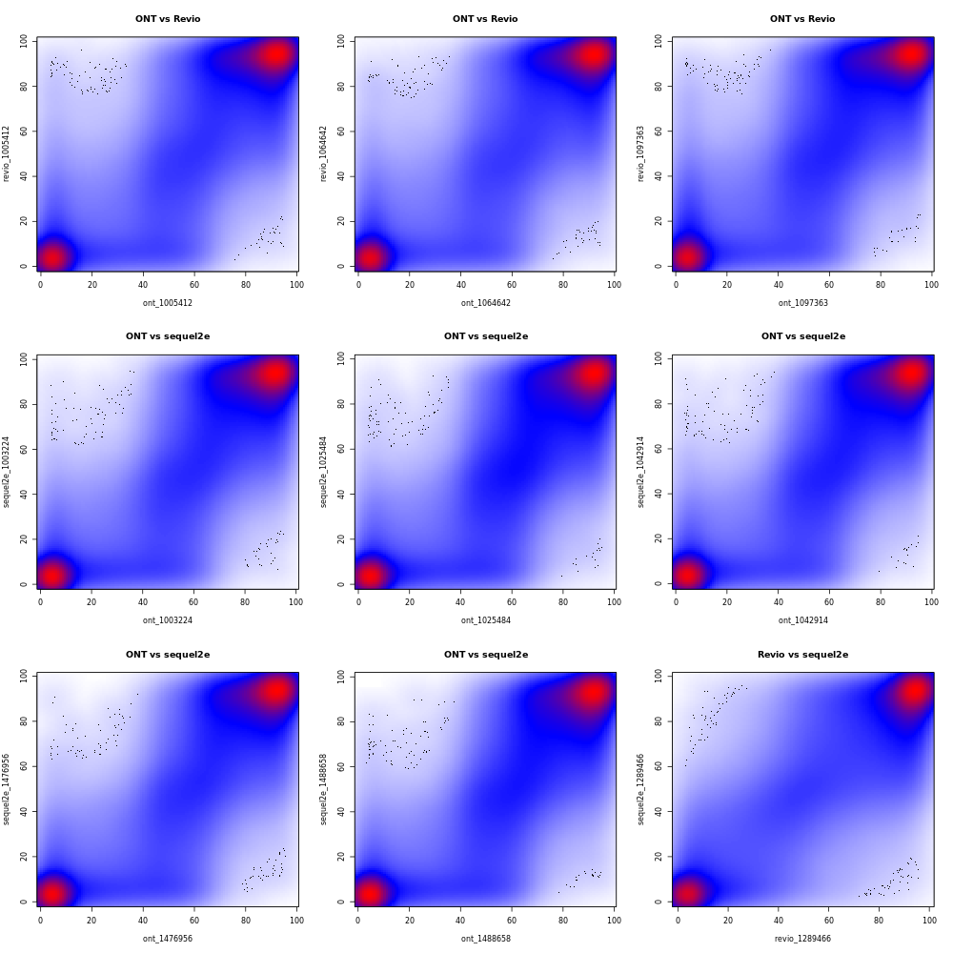

Supplementary Figure 2. Representative CpG-level methylation beta value concordance plot for cross-platform (ONT, PacBio, and Illumina EPIC) duplicate pairs in the PEGS dataset.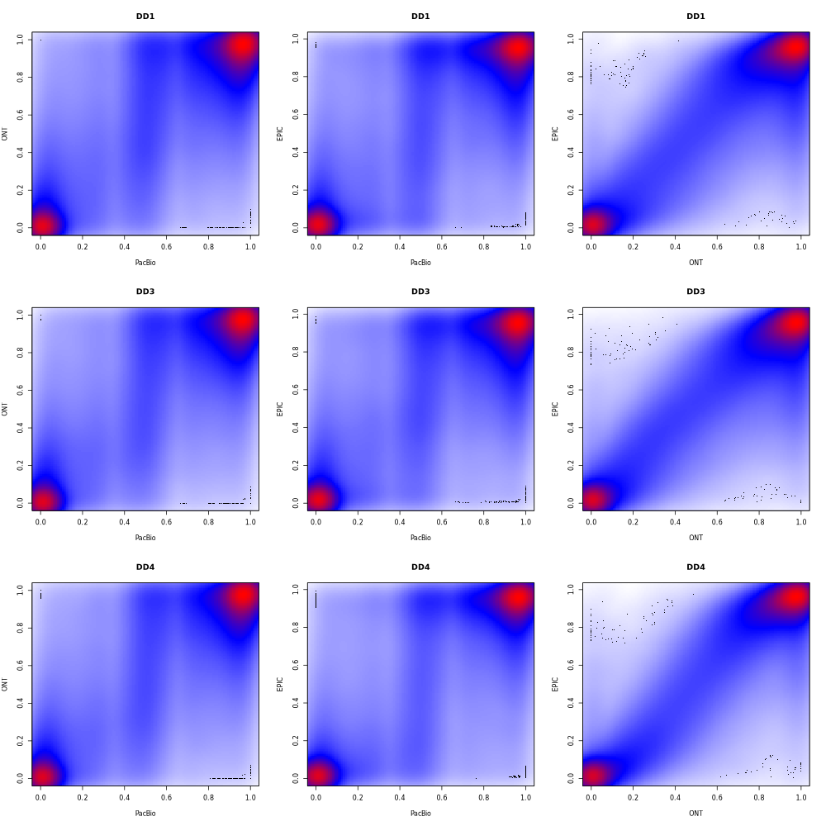

Supplementary Figure 3. (A) Ordinary Pearson correlation and (B) mean-centered Pearson correlation of methylation beta values for duplicate and non-duplicate ONT-PacBio pairs in PEGS.
- Peason’s correlation
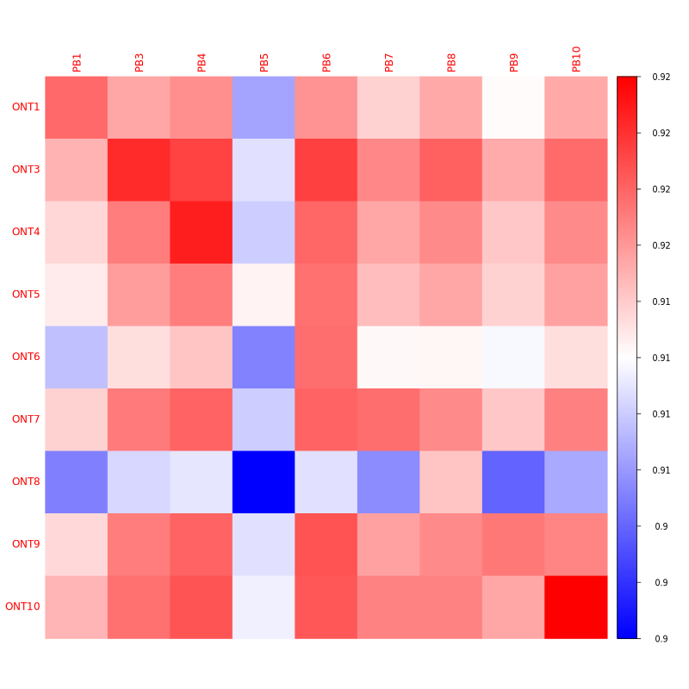
- Mean-centered correlation
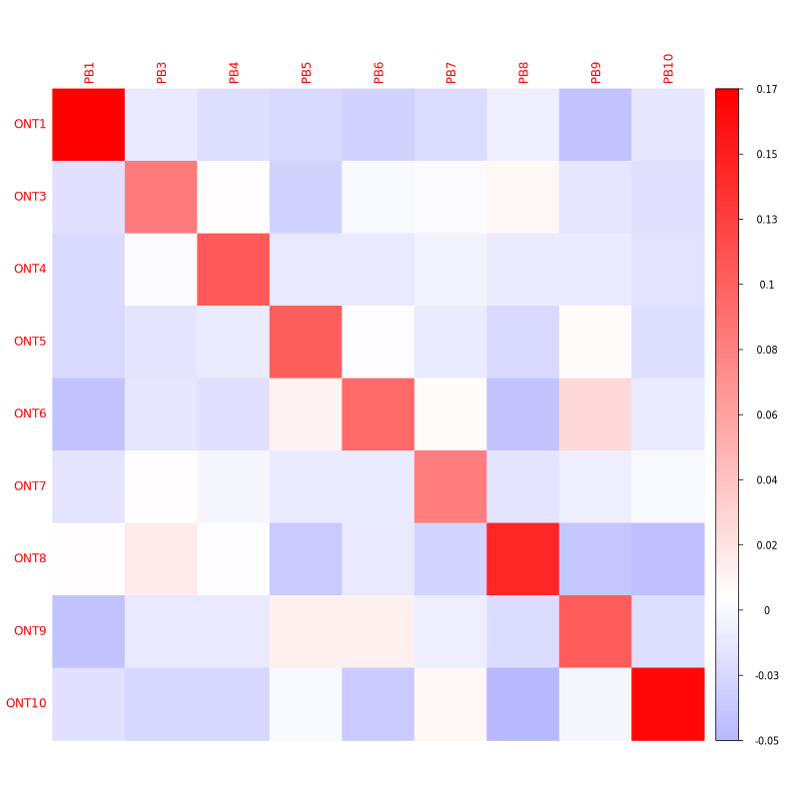

Supplementary Figure 4. CpG-level read-depth distributions for PEGS ONT and PacBio data: (A) CpGs overlapping the EPIC array, (B) all retained CpGs in individual-sample long-read data, and (C) all retained CpGs in pooled-sample data.
- Distribution of read depth for EPIC overlapped CpGs
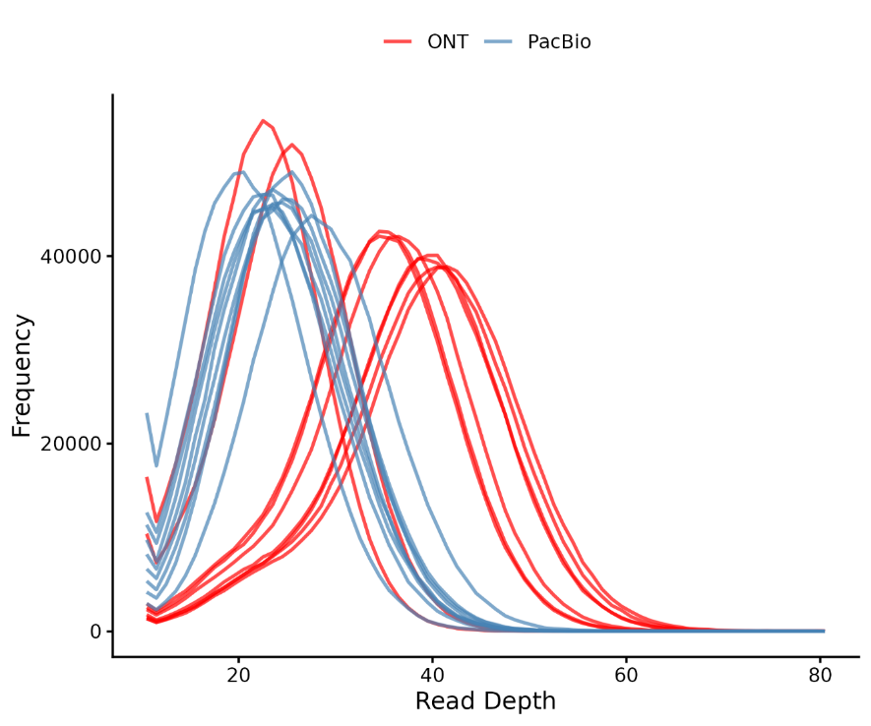
- Distribution of read depth for all CpGs in long read sequencing data
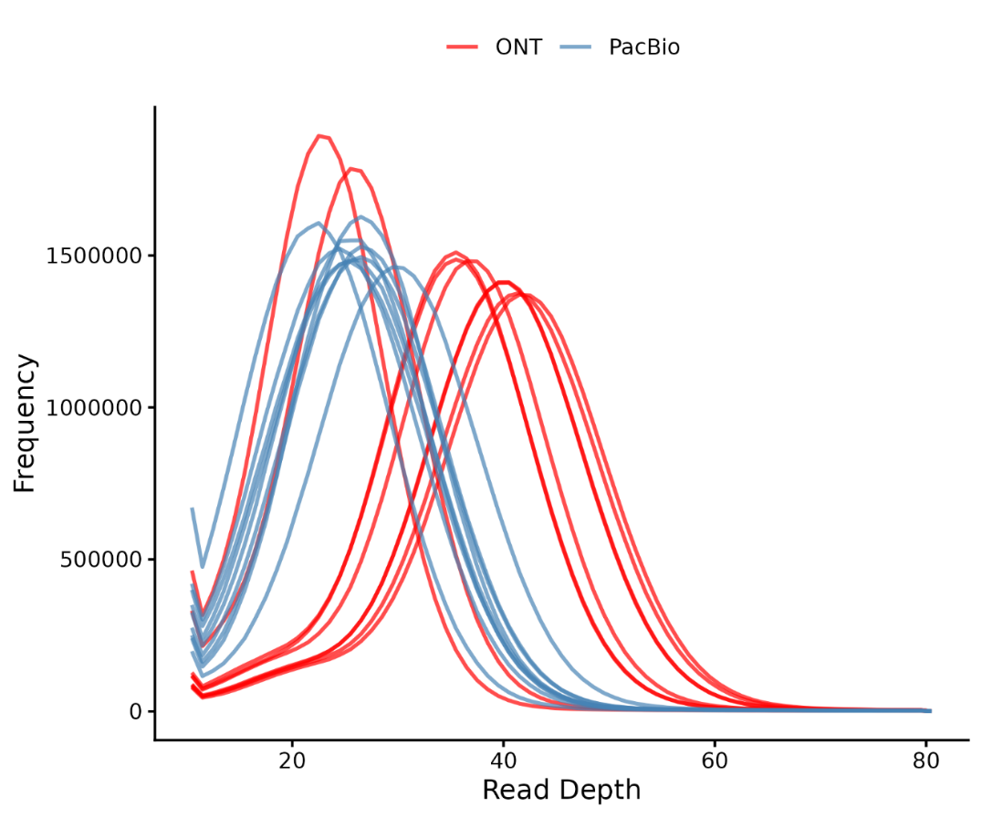

- Distribution of read depth for all CpGs in pooled sample sequencing data
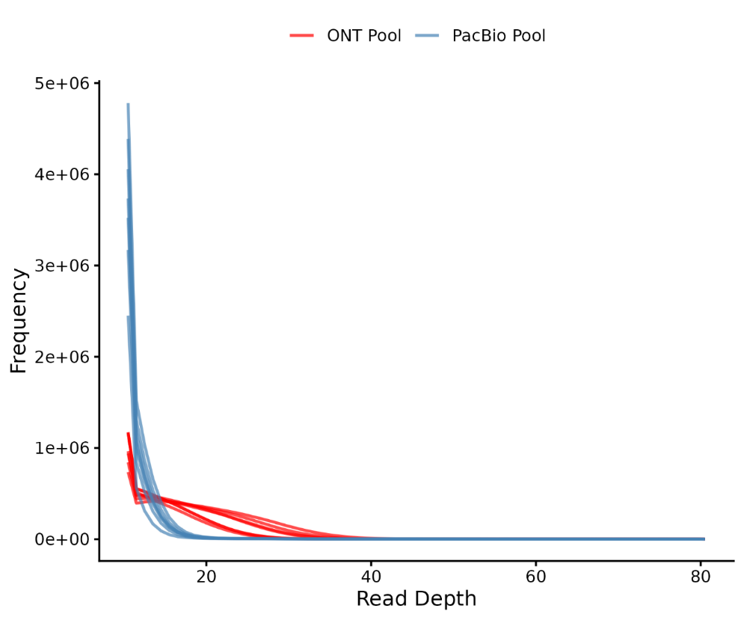

Supplementary Figure 5. Chronological age versus methylation-predicted age for PEGS participants using Illumina EPIC-array data.