Supplementary Material for TransFarm: A Farm-scale Tool Evaluating Trade-offs in Agroecological Transitions

Annexure 1: Primary Data collection and calculations

2a. Survey Instrument
Farmer level Questionnaire
Date
Serial number
Farmer name
Unique farmer ID
Gram Panchayath
Village name
Ph Number
Farmer Age
Gender
Highest education level
Total members in your household
How many of them are available for agri labour
Male members
Female members
Members <18 years
Members >60 years
What is your primary occupation? ( A Agricultur; B Livestock; C Wage Labour; D Salaried employment; E Others)
What is the total landholding (in acres) ?
Do you keep livestock/ poultry?
If yes, what type of livestock ?
Initial herd size
Final herd size
How many units were bought last year ?
How many sold per year?
Self consumption
Number of births/year
Natural death
Purchase cost per unit (Rs)
Selling price price unit (Rs)
Quantity of feed given per year ( Kg per entire herd )
Price of feed per Kg (Rs)
Average medical/vaccination costs per year (Rs)
Other costs per year (Rs)
Water requirement(per day per unit) (L)
Qty of egg/milk( Self consumption + sales)
Price per egg/milk (per litre or per number) (Rs)
Qty of manure (from entire herd in Kgs)
Manure price per kg (Rs)
Do you have any other sources of off farm or non farm incomes by members of the household ?
In the last year, have you recieved any complimentory benefits or inputs as part of agreements with companies or government
Have you suffered any losses last year e.g. to drought, fire, pests etc.
How many plots do you have?

Plot Level Questionnaire
Plot ID
Plot size (acres)
Do you own your land or have you leased it from someone?
In case of leased land, how much is the lease amount of your land per annum (in INR/annum)?
What are the crops trees grown in the plot?
Season( Kharif/Rabi/Zaid/Perinnial)
Crop Type ( Main crop, intercrop, border crop )
Age( no of years since planting)
Seed qty (In Kg) - only in case of broadcasting of seeds
Number of lines
Saplings per line
Number of saplings - product of Number of lines and saplings per line or as told by farmers
Number of trees ( in case of trees)
Plot Category ( A/B/C/D/E)
How long has he/she been cultivating in this cropping pattern category? (years)
Source of Irrigation(other than rainfed)
Flood irrigated/drip irrigated/Sprinkler irrigated
Motor HP
Depth of borewell (ft)
Irrigation frequency
[ Duration or trips] hours per annum per plot
Land preparation costs
Seed/ sapling costs
Manure in tractor load
Manure costs
Fertiliser
Pesticide / weedicide
Labour sowing - Hired
Labour sowing - Own
Labour weeding - Hired
Labour weeding - Own
Labour harvesting - Hired
Labour harvesting - own
Labour inputs and irrigation - Hired
Labour Land prep, inputs and irrigation - Own
Prunung costs
others
Have you used your own livestock/poultry manure in the plots ?
If yes, What type of manure ?
If purchased from outside, how much have you spent for the manure in each plot ?
Crop Loss % ( last year)
What was the yield last year for each crop? ( Yields in Kgs)
How much of the total quantity produced is used for self-consumption? (kgs)
How much of the total quantity produced is used for livestock consumption from each plot ? (In KGs)
Marketable surplus
Price (Rs per kg)
Per tree for timber
How much crop residue you will get from each crop?
(tractor load)
What do you do with the crop residue? Do you use it for feeding livestock/poultry?
If yes, for how many days it would last ?
If sold, for how much rupees ?

2b. Estimation of Income, Water and Carbon stock (Primary)
The output variables are estimated from the primary data collected as follows:
Net Farmer Incomes
Net farmer income is calculated based on following formulae as the sum of net crop incomes and net livestock incomes.
1. Net Crop Income (NCI) for a single crop:
NCI_i = (Yield_i * Price_i + CropResidueSold_i * SellingPrice_i) - (LandPreparationCost_i + SeedCost_i + FertilizerCost_i + PesticidesCost_i + LaborCost_i)
Here, the subscript "i" represents a specific crop.

2. Net Plot Income (NPI) for a plot with "n" crops:
NPI = Σ NCI_i, where i ranges from 1 to n.
This equation sums up the Net Crop Incomes for all the crops in the plot.

3. Net Livestock Income (NLI)

NLI = (LivestockSold * SellingPrice + EggMilkSold * SellingPrice + ManureSold * SellingPrice) - (CostOfMaintainingLivestock)

4. Net Farmer Income (NFI): NFI = NPI + NLI
In these equations:
- NCI_i represents the Net Crop Income for a specific crop.
- NPI represents the Net Plot Income, which is the sum of Net Crop Incomes for all crops in the plot.
- NLI represents the Net Livestock Income, which is the difference between Livestock Revenue and the Cost of Maintaining Livestock.
- NFI represents Net Farmer Income, which is the sum of Net Plot Income and Net Livestock Income.
Additional Water requirement
Additional water requirement is the sum of irrigation water used and the water used for livestock in addition to the rainfall.
The irrigation water required is calculated using the following formulae:
In case of borewell or step well, where a motor pump is used:
The irrigation water discharge, Q = Water horsepower * 3960/(0.264*TDH*SG)
Where,
Q is water discharge in Litres per minute
Water horsepower is the motor HP
TDH is the depth of the borewell in ft
And SG is the specific gravity of water, that is 1.
The annual water demand for the entire herd reported by farmers is recorded as the livestock water requirement.

Accumulated Carbon sequestered
For carbon, both Soil Organic Carbon and biomass carbon are estimated.
Soil Organic Carbon
The soil organic carbon (in tonnes per acre) is estimated using the formula:
Carbon sequestered (Soil) in tonnes per acre = (SOC %* bulk density of fine particles*depth of the core(30 cm)*0.1* 4.047*10^7)/ 10^6
Carbon sequestered (Soil) in tonnes = Area in hectares*Depth in meters*Bulk density in grams per cubic meter*(SoC%/100)*0.0001
The SOC% and bulk density are measured with the help of the soil lab in GKVK extension campus in Chintamani.
Following methodology is adopted for the collection of soil samples:
Step 1. For taking one sample: Use the soil augur and ensure the soil is collected from 30 cm depth and ensure no soil is lost from the cylliner. Clean the soil core after one sample.
Step 2. Take 5 such soil samples from 5 places in the plot ( 4 corners and the middle) for less than 3 acres and 10 soil samples if more than 3 acres
Step 3. Mix all the samples well and remove the pebbles and external materials
Step 4. Take 500 grams of sub sample by taking random samples from the mixed sample
Step 5. Put it in the plastic cover and stick / add a label with plot ID.
Step 6. Close the cover airtight by tying
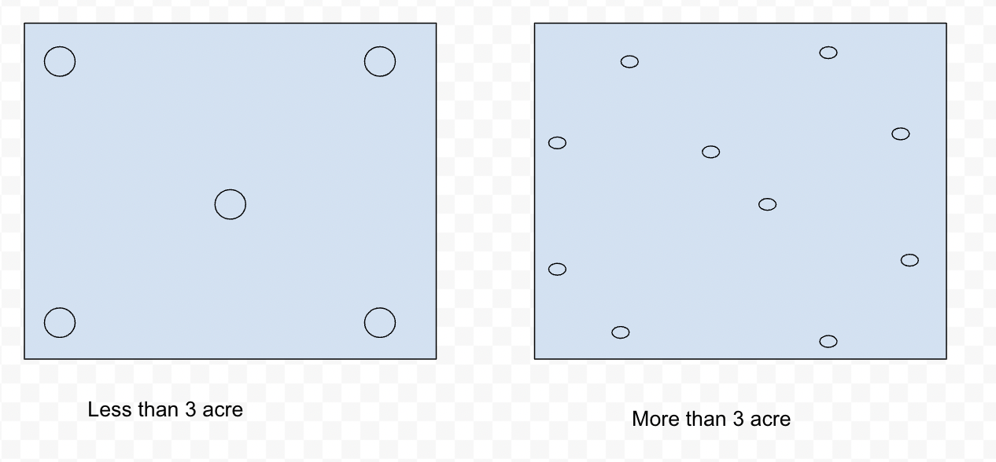

Fig A2: Soil sampling methodology

Biomass carbon measurement
The above and below ground biomass carbon is estimated using volumetric equations for each species.
For example, if V = a + bDH is the species-specific equation, the following parameters of the trees need to be measured.
D, Diameter need to measure at 1.3m above the ground (this is called the Girth at breast height or GBH)
It is done for trees > 10cm GBH (> 3-4 cm diameter) (girth at breast height) – above-ground biomass for woody vegetation
WD, Wood density (g/cubic cm) = Usually 0.5-0.6 (species-specific)
AGB, Above-ground biomass = V x WD
Root-to-shoot ratio = BGB/AGB; usually 0.2-0.3 (species-specific)
BGB (roots etc.) = Root-to-shoot ratio x AGB Total biomass
Total Biomass carbon = (AGB+BGB)* 0.5 If the stems are > 10 cm girth, and there are multiple stems originating below 1.3 m , then girths of all branches need to be measured.

Following is the methodology adopted for biomass girth and height measurements:
Step 1: If it is a plantation, do tree measurements only in a sample plot.
Sample plot can be 30*30 m area if the plot size is less than 3 acres and 50m*50m if the plot size is more than 3 acres. Ensure all tree species are covered in one sample plot.
Step 2: Take Tree diameter at 1.3 meter height ( Use 1.3 m PVC pipe and measuring tape for the same).
Step 3: Measure the height of the tree either using the 5 m length stick or yardstick method
Step 4: Note down all measurements
Step 5: Note down plot details including plot location, sample location, plot area, sample plot area etc

Annexure 2A: Farm-scale trade of assessment tool - User guidelines
The proposed tool framework is developed to an excel based tool. The steps given here can be followed by the user for effective use of the farm-scale trade off assessment tool.
Tool prototype link: TransFarm Prototype V1.0 and https://doi.org/10.5281/zenodo.15494218
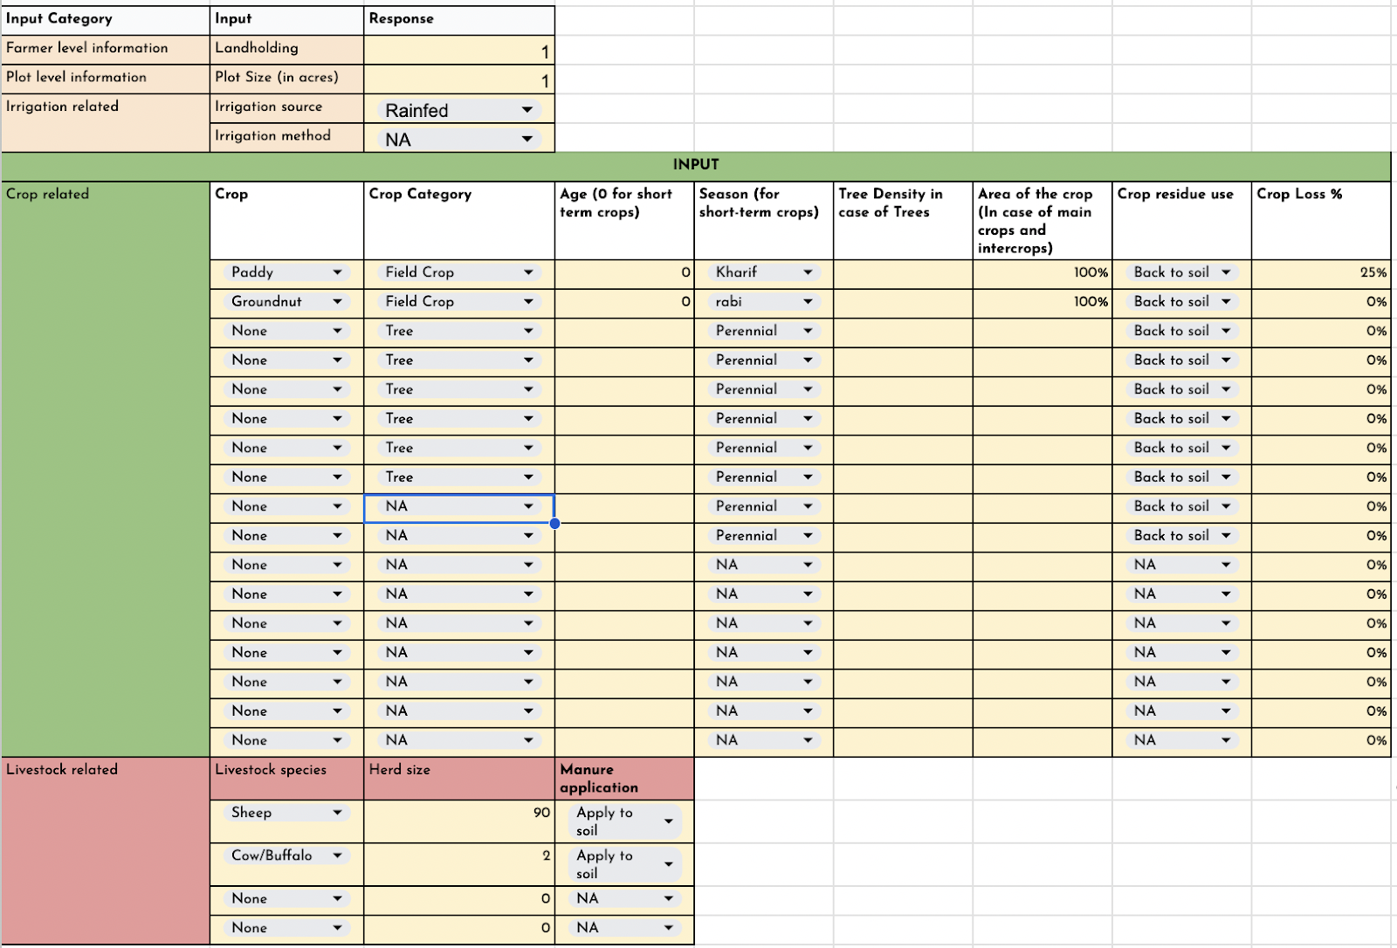
Fig A3: Tool input interface
Step 1: Input the values or select from drop downs in yellow highlighted cells for baseline farm design
- Farmer level information like farmer landholding, plot size, irrigation source and irrigation methods need to be filled in.
- Crop details needs to be filled in for all the crops in the plot including crop type, age, season, tree density, area %, crop residue use and crop loss % ( expected)
- Livestock related data needs to be filled including herd size and manure application.
Step 2: The tool will generate per acre values for farmer income, annual water demand, fodder available, fodder required, manure available and carbon sequestered.
Step 3: Iteratively change the input parameters including crop choices, crop area %, tree density, livestock distribution etc to achieve desired outcome based on the objective; for example increase income and reduce the water demand for use case objective 1 ( Increase water productivity).

Annexure 2B: Farm-scale trade of assessment tool - Assumptions and References
Crop reference table assumptions

Crop | Field crop / Tree | Yield/ acre or Yield per tree | AVG Net farmer Income ( Rs per acre/ Rs per tree) | Crop Residue ( Kg per acre)  Litter (Kg/tree) | Annual irrigation water requirement ( in Ltrs) - If season is Kharif | Annual irrigation water requirement ( in Ltrs) - If season is Rabi | Annual irrigation water requirement ( in Ltrs) - If season is Zaid
None | Field Crop | 0 | 0 | 0 | 0
Paddy | Field Crop | 1943 | 10440 | 3070 | 4920660 | 6625595 | 7014453
Ragi | Field Crop | 1255 | -153 | 2632 | 0 | 1005039 | 1393898
Groundnut | Field Crop | 495 | 9847 | 233 | 604073 | 2309008 | 2697867
Bajra/ Pearl Millet | Field Crop | 468 | -356 | 1171 | 266840 | 1971775 | 2360633
Arhar/Tur/ Red gram/ Pigeon pea | Field Crop | 270 | 1876 | 192 | 0 | 1409719 | 1798578
Horsegram | Field Crop | 354 | 6762 | 251 | 0 | 398019 | 786878
Cowpea (Lobia) | Field Crop | 155 | 5479 | 110 | 0 | 1409719 | 1798578
Jowar | Field Crop | 446 | 345 | 1089 | 379251 | 2084186 | 2473044
Onion | Field Crop | 2156 | 19828 | 3234 | 0 | 1634541 | 2023400
Sunflower | Field Crop | 406 | 13306 | 381 | 1503362 | 3208297 | 3597156
Maize | Field Crop | 1510 | 9713 | 3790 | 0 | 1454684 | 1843542
Little millet | Field Crop | 522 | 6687 | 1326 | 0 | 1005039 | 1393898
Brinjal | Field Crop | 24291 | 28340 | 30364 | 91478 | 1796413 | 2185272
Watermelon | Field Crop | 16194 | 20243 | 40486 | 604073 | 2309008 | 2697867
Mulberry | Field Crop | 6126 | 19000 | 0 | 604073 | 2309008 | 2697867
Mango | Tree | 25 | 391 | 100 | 840
Tamarind | Tree | 75 | 360 | 100 | 0
Cashew | Tree | 10 | 869 | 100 | 1507
Guava | Tree | 75 | 63 | 100 | 312
Coconut | Tree | 60 | 360 | 100 | 2440
Silver Oak | Tree |  | 0 | 175 | 0
Milia dubia | Tree |  | 0 | 175 | 0
Teak | Tree |  | 0 | 175 | 0
Mahagony | Tree |  | 0 | 175 | 0
Eucalyptus | Tree |  | 0 | 175 | 0
Jamun | Tree | 63 | 281 | 65 | 0
Banana | Tree | 15 | 473 | 65 | 980
Beans | Field Crop | 14230 | 119503 | 17788 | 0 | 1409719 | 1798578
Beetroot | Field Crop | 15000 | 45200 | 15000 | 154428 | 1859364 | 2248222
Bottle gourd | Field Crop | 16194 | 47773 | 40486 | 0 | 1409719 | 1798578
Cabbage | Field Crop | 30364 | 70243 | 37955 | 0 | 1589577 | 1978436
Capsicum | Field Crop | 7287 | 38462 | 9109 | 64500 | 1769435 | 2158293
Carrot | Field Crop | 6073 | 46409 | 6073 | 0 | 1594073 | 1982932
Chilli | Field Crop | 8907 | 25911 | 11134 | 783931 | 2488866 | 2877724
Coriander | Field Crop | 35223 | 22267 | 35223 | 0 | 1589577 | 1978436
Custard apple | Tree | 60 | 64 | 65 |  | 0 | 0
Dayancha | Field Crop | 18219 | -6478 | 54656 | 379251 | 2084186 | 2473044
Foxtail millet | Field Crop | 181 | 6849 | 453 | 0 | 1005039 | 1393898
Geddekosu/Nool Kosu/Kohlrabi/German Turnip | Field Crop | 5500 | 96703 | 9625 | 0 | 1522130 | 1910989
Napier | Field Crop | 24291 | -7692 | 85020 | 1953006 | 3657941 | 4046800
Niger seeds | Field Crop | 247 | 4629 | 247 | 0 | 1409719 | 1798578
Pongamia | Tree |  | 0 | 100 | 0 | 0 | 0
Potato | Field Crop | 8577 | 46643 | 8577 | 604073 | 2309008 | 2697867
Pumpkin | Field Crop | 623 | 52099 | 1558 | 379251 | 2084186 | 2473044
Ridge gourd | Field Crop | 49000 | 154000 | 122500 | 0 | 1409719 | 1798578
Snake gourd | Field Crop | 4617 | 73626 | 11541 | 379251 | 2084186 | 2473044
Subabul | Tree |  |  | 65 | 0 | 0 | 0
Suppotta | Tree | 40 | 185 | 65 | 225 |  | 0
Tomato | Field Crop | 20243 | 15789 | 35425 | 154428 | 1859364 | 2248222
Sweet corn | Field Crop | 1510 | 9713 | 3775 | 0 | 1454684 | 1843542
Arka/ Kodo Millet | Field Crop | 522 | 6849 | 1305 | 0 | 1005039 | 1393898
Yellow Chrysanthemum | Field Crop | 8097 | 139676 | 14170 | 379251 | 2084186 | 2473044
Methi/Fenugreek | Field Crop | 405 | -4251 | 405 | 0 | 1589577 | 1978436
Hyacinth Beans | Field Crop | 320 | 31790 | 1170 | 0 | 1409719 | 1798578

Livestock reference table

Livestock species | Net income per unit | Water requirement per unit per day | Dry fodder requirement | Green fodder requirement | Fodder requirement per year | Manure per year (kg) | Purchase price | Sales price
None | 0 | 0 | 0 | 0 | 0 | 0 | 0 | 0
Goat | 5522.6 | 5 | 730 | 2190 | 2920 | 456.25 | 6049 | 7917
Sheep | 1203.2 | 5 | 730 | 2190 | 2920 | 456.25 | 6049 | 7917
Cow/Buffalo | 23414 | 74 | 1825 | 7300 | 9125 | 8760 | 29313 | 40734
Poultry | 138.6 | 0.3 |  |  |  | 11 | 396 | 1002

References:
- https://www.thepharmajournal.com/archives/2021/vol10issue9S/PartH/S-10-9-81-195.pdf
- https://agritech.tnau.ac.in/horticulture/horti_cost%20of%20cultivation.html
- https://agritech.tnau.ac.in/horticulture/horti_cost%20of%20cultivation.html
- https://horticulture.tg.nic.in/HFarm/Downloads/G.O.No.31%20-%2019.07.2017%20-%20Land%20Acquisition.pdf
- https://www.agrifarming.in/mango-farming-project-report-cost-and-profit-analysis
- https://agritech.tnau.ac.in/horticulture/horti_spice%20crops_tamarind.html
- https://www.agrifarming.in/tamrind-cultivation-income-cost-yield-project-report
- https://farmer.gov.in/imagedefault/handbooks/BooKLet/MAHARASHTRA/20141110124058_Improved%20Practices%20for%20Cashew%20Production.pdf
- https://horticulture.tg.nic.in/HFarm/Downloads/G.O.No.31%20-%2019.07.2017%20-%20Land%20Acquisition.pdf
- https://nhb.gov.in/report_files/guava/GUAVA.htm
- http://www.agritech.tnau.ac.in/expert_system/coconut/coconut/coconut_cost_of_cultivation.html
- https://www.agrifarming.in/jamun-cultivation-income-alla-neredu-project-report#:~:text=Farmer%20can%20bag%20up%20to,from%20one%20acre%20of%20land.
- https://agritech.tnau.ac.in/horticulture/horti_cost%20of%20cultivation.html
- https://agritech.tnau.ac.in/horticulture/horti_cost%20of%20cultivation.html
- https://kapricom.karnataka.gov.in/storage/pdf-files/KAPCAnnualReport2021-22Part1.pdf
- https://www.krishimaratavahini.kar.nic.in/MainPage/DailyMrktPriceRep2.aspx?Rep=Com&CommCode=78&VarCode=4&Date=01/03/2018&CommName=Tomato%20/%20%E0%B2%9F%E0%B3%8A%E0%B2%AE%E0%B3%8D%E0%B2%AF%E0%B2%BE%E0%B2%9F%E0%B3%8A&VarName=Hybrid%20/%20%E0%B2%B9%E0%B3%88%E0%B2%AC%E0%B3%8D%E0%B2%B0%E0%B2%BF%E0%B2%A1%E0%B3%8D
- https://des.karnataka.gov.in/storage/pdf-files/AGS/2020-21%20District%20wise%20Final%20Estimates.pdf
- https://iihr.res.in/varieties-crop-name/brinjal
- https://www.agrifarming.in/yelakki-banana-farming-in-india-production-and-cultivation-management-practices
- https://raitamitra.karnataka.gov.in/english
- https://www.uasbangalore.edu.in/
- https://www.icar.gov.in/
- https://eands.dacnet.nic.in/Plot-Level-Summary-Data.htm
- Champaneri, Dushyant & Patel, Naren & Desai, Chirag & Bhupendrabhai, Tandel. (2020). Economics of Indian Bean [Lablab purpureus (L.) Sweet] Production Influenced by Application of Novel Organic Liquid Nutrient and Novel Plus Organic Liquid Nutrient. Asian Journal of Agricultural Extension, Economics & Sociology. 10.9734/AJAEES/2020/v38i930414.
- Heuzé V., Tran G., Sauvant D., Renaudeau D., Bastianelli D., Lebas F., 2016. Lablab (Lablab purpureus). Feedipedia, a programme by INRAE, CIRAD, AFZ and FAO. https://www.feedipedia.org/node/297 Last updated on February 19, 2016, 11:2
- https://academicjournals.org/article/article1380902370_Nyambati%20et%20al.pdf
- https://indiawris.gov.in/wris/#/rainfall
- Zanne, A.E., Lopez-Gonzalez, G.*, Coomes, D.A., Ilic, J., Jansen, S., Lewis, S.L., Miller, R.B., Swenson, N.G., Wiemann, M.C., and Chave, J. 2009. Global wood density database. Dryad. Identifier: http://hdl.handle.net/10255/dryad.235.
- https://fsi.nic.in/isfr-2021/refference-annxure-contribute.pdf
- https://webline.co.in/fsi-result/technical-information-series-vol2-no1-2020.pdf
- https://www.cabidigitallibrary.org/doi/10.1079/cabicompendium.50389
- doi: 10.1111/gcb.12629
- https://www.researchgate.net/publication/237339477_Wood_Densities_of_Tropical_Tree_Species
- https://des.karnataka.gov.in/storage/pdf-files/AGS/2020-21%20District%20wise%20Final%20Estimates.pdf
- http://www.agritech.tnau.ac.in/expert_system/cattlebuffalo/Fodder%20Production.html#Legume
- https://eands.dacnet.nic.in/fhprice/FHP%20Publication%202021-22.pdf
- https://www.feedipedia.org/node/744
- https://kapricom.karnataka.gov.in/storage/pdf-files/Assured%20Price%20&%20Stable%20Market%20Report%202018.pdf
- https://www.fao.org/fileadmin/user_upload/energy/befs/natural_resources/external/Agricultural_Residues__tool_2.0.xlsm
- https://www.fao.org/3/X0490E/x0490e0b.htm
- https://www.manage.gov.in/stry&fcac/Project%20Report%20on%20Goat%20Farming.pdf
- https://agritech.tnau.ac.in/banking/nabard_pdf/Animal%20husbandry/5.Sheep_Farming.pdf
- https://www.dairyknowledge.in/dkp/content/10-crossbred-cow-farm
- https://www.agrifarming.in/country-chicken-farming-project-report-cost-and-profit#google_vignette
- https://www.entomoljournal.com/archives/2019/vol7issue3/PartG/6-6-95-692.pdf
- https://www.sciencedirect.com/topics/earth-and-planetary-sciences/manure-production

Annexure 3: Error correction

Crop Incomes
Fig A4 shows the error distribution of crop incomes compared between tool generated results and crop income calculated from primary data for the same set of 100 plots. Here, a negative error means that the tool generated results are lesser than the actual crop incomes and positive error means tool generated crop incomes are higher than the actual incomes.

The median error before price correction was -58 % and this was considering an average price for calculating the tool generated income. The huge variations in the price of many crops, especially the horticulture crops was one of the reasons for the error. To address this challenge, the tool output included a range of crop income rather than an average value, considering the minimum and maximum price of the crops for the last 3 years. This has reduced the error considerably and the median error % has become 0%.
The category wise error % is plotted below. Except for the Category A - monoculture, all the other categories had 0% as the median error.

Annual Crop Water demand

The Fig A4 shows the error distribution of annual crop water demand compared between tool generated results and annual crop water demand calculated from primary data for the same set of 100 plots. Here, a negative error means that the tool generated results are lesser than the actual crop water demands and positive error means tool generated crop water requirements are higher than the actual irrigation requirements. There could be multiple reasons for this error;
- Over irrigation: Farmers tend to irrigate more than what is required by the crop. The negative deviation from the median error/ negative outliers are representing the case of over irrigation.
- Variations in primary data: The annual crop water demand is calculated by multiplying the duration of irrigation in a year (hrs) and the pump water discharge per hour. The water discharge values are calculated based on motor HP and borewell depth. There could be accuracy issues in these values as the yield of the borewell is also a factor to be considered.
- Seasonality: Moreover the groundwater levels vary across the year(s). Hence, there would be variation in the discharge value of a borewell whereas what we considered for calculation of irrigation water usage is a single value estimated using the formula.
Among these potential reasons, one of the factors that can be corrected is the error in primary data. Because the irrigation water requirement in the primary data is the product of frequency of irrigation and discharge rate which is calculated using depth of borewell and Motor HP. But this calculation could give inaccurate results due to difference in ground water yields and seasonality of the groundwater levels. But an average error % in primary data was derived by comparing the calculated data and measured data for a sample of borewells. A correction factor is applied based and the deviation of the tool generated results from the corrected primary data is the error% after corrections.
Even though this correction has reduced the errors considerably, still there are some outliers. To understand the outliers better, we would look at the category wise error distribution. We could see that except for category A, there are mainly negative outliers. This could be due to over irrigation by farmers as the tool generated results are based on crop water requirements and in reality farmers may not go by crop water requirements.
And there are not many positive outliers, except 3-4 plots in category A; out of which Maize/sweet corn is a common factor in 3 of them and tomato is a common factor in 2 of the outlier plots.
More importantly, the median error % is 0% in all the categories and overall for crop water demand.

Carbon sequestration

The soil organic carbon values are estimated in the tool using the Maillard and Angers formula (y = 7.4+0.0812 x, where x = annual manure added) for carbon stock difference added to the baseline SOC in tonnes per acre (FAO database,2020).

The carbon estimation comes up with a few assumptions and hence the error % is expected to be greater than that of income and water demand.

- Potential error in Baseline SOC : The baseline SOC is based on the Soil organic carbon GIS dataset by FAO in 2020. It is the first most comprehensive soil organic carbon dataset, but has a resolution of 1km * 1km. This means there could be accuracy issues associated with the baseline SOC considered.
- Low significance of Maillard and Angers formula: The maillard and Angers formula has a lower significance as per the literature, which means the linearship represented by the formula also might have a lower confidence level
- Time required to reach the steady state: The carbon content corresponding to the organic matter applied in one year is used in the Maillard and Angers formula. Even if we consider that the organic matter is applied in 2020, there is only a gap of 3 years from baseline and the assessment year. But the organic matter may require a longer period of time to reach a steady state and get converted to organic carbon in the soil. This also might have caused some errors in the estimation of tool generated results.
- Not accounting other agricultural practices:: The only factors considered for estimating soil organic carbon here is the organic matter added to the soil including the crop residue. All other practices including tiling and any other land management practices are assumed to be the same in all the plots and hence doesn’t have any contribution towards soil organic carbon increase.
- Varying carbon content: There are different types of soil organic matter that get added to the soil and the potential carbon content of the organic matter varies from 16%-45% of the organic matter depending upon the type of organic matter. This could also lead to variations.

The box plots in Fig A4 the error distribution before and after the corrections. Potential error in baseline SOC is addressed by a range of minimum and maximum SOC values from the GIS dataset. Still, it doesn’t address the inaccuracies associated with the resolution, which is quite high in this case. With a baseline SOC range derived from a dataset with a better resolution. Error % can be further reduced.
But more importantly, the primary SOC data from 100 plots could be taken as the baseline data and the tool could estimate the SOC% in steady state more accurately.

Similarly, the carbon content in the organic matter added can vary between 16%-45 % as per literature. This variation is also addressed in the correction process.
With the correction process, median error % has reduced from 34.36% to 0%.

The median error % for different categories are 0%, -1.78%, -5.30%, 3.95% and 0% respectively for categories A, B, C,D and E. Similarly the median error % for plots without integrated livestock systems and plots with integrated livestock systems are both 0%. The error distributions for different categories and with/without livestock scenarios are shown in the charts below.

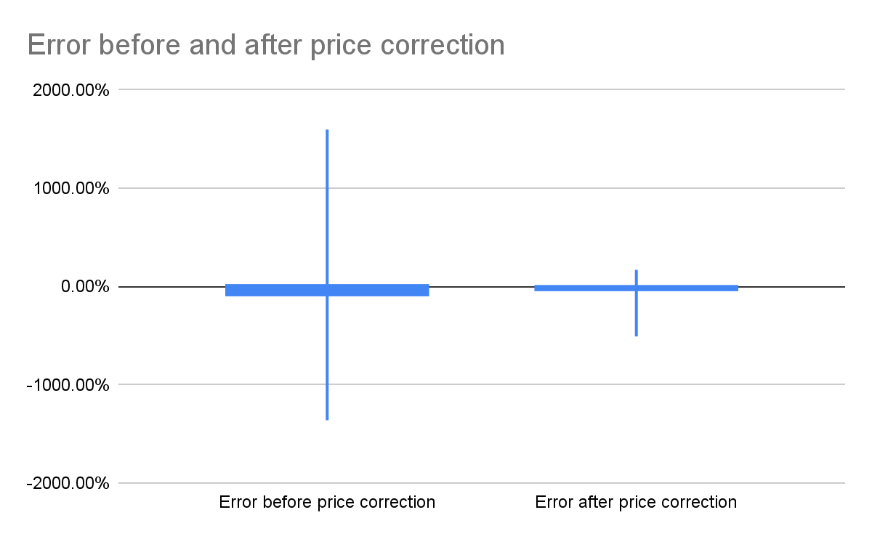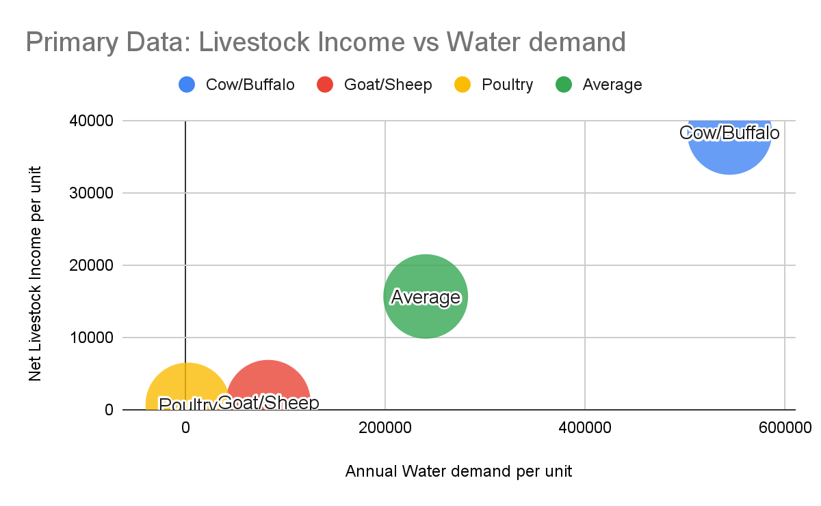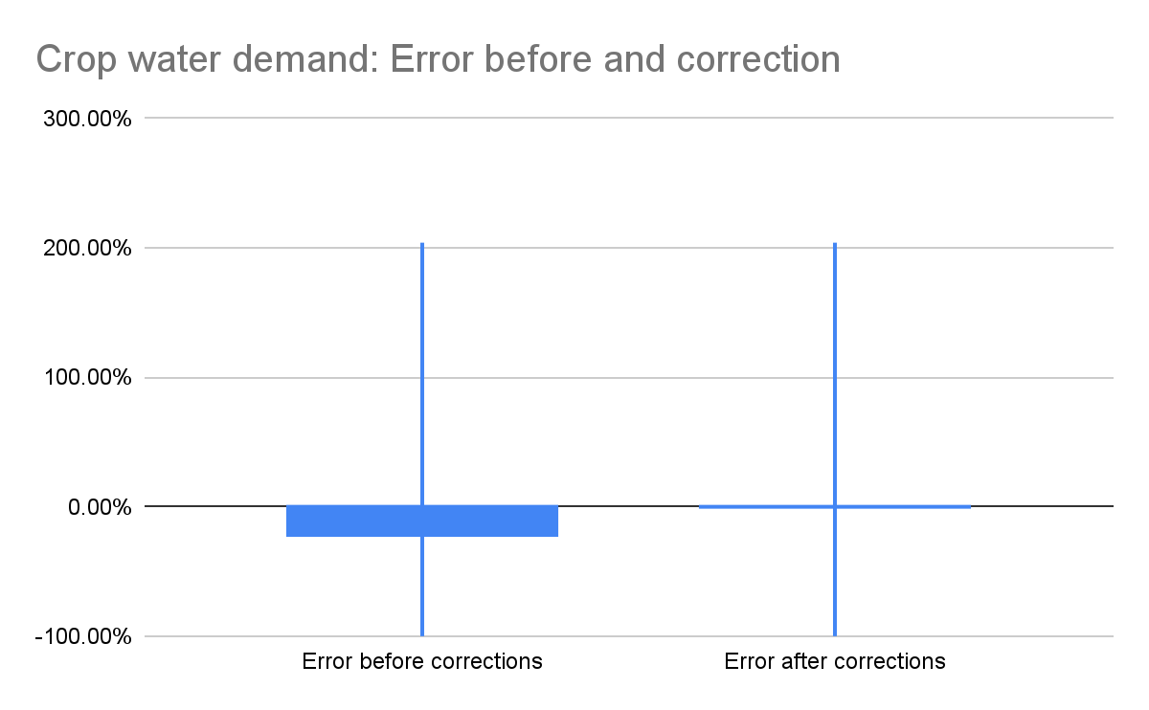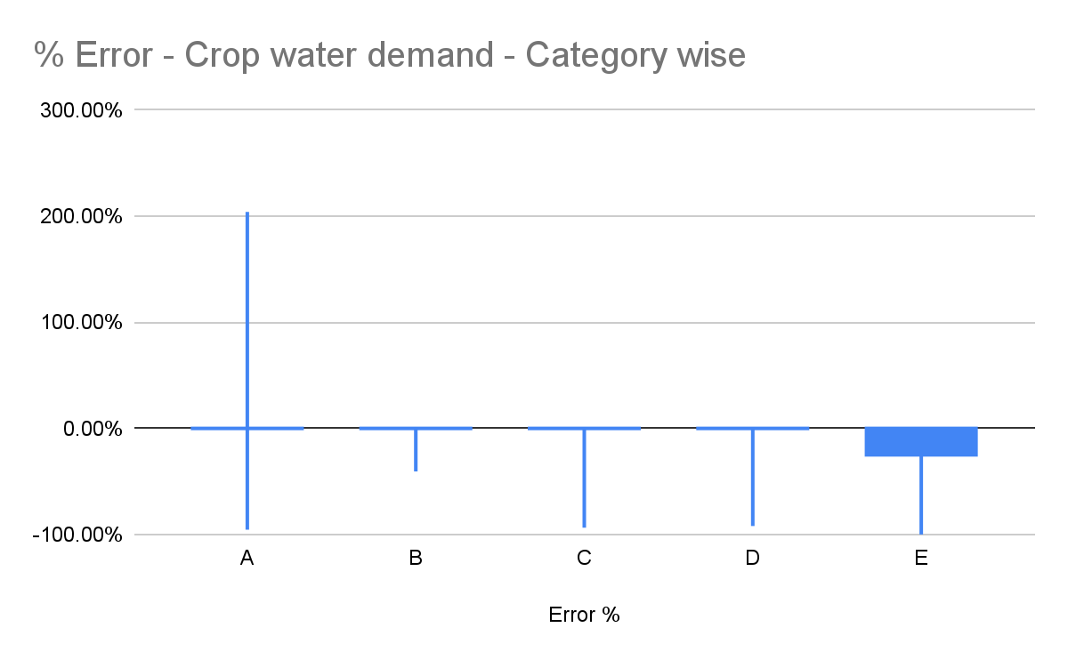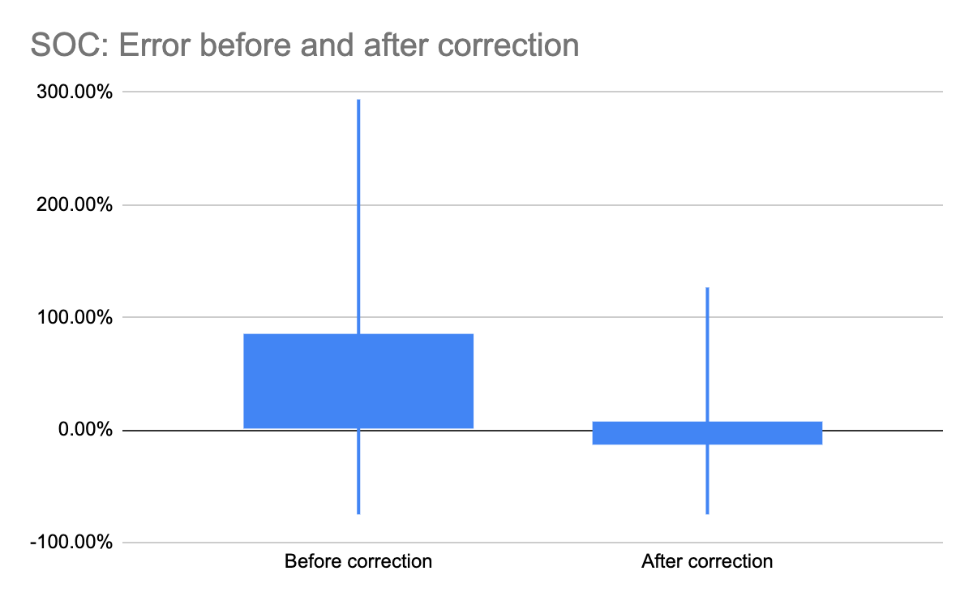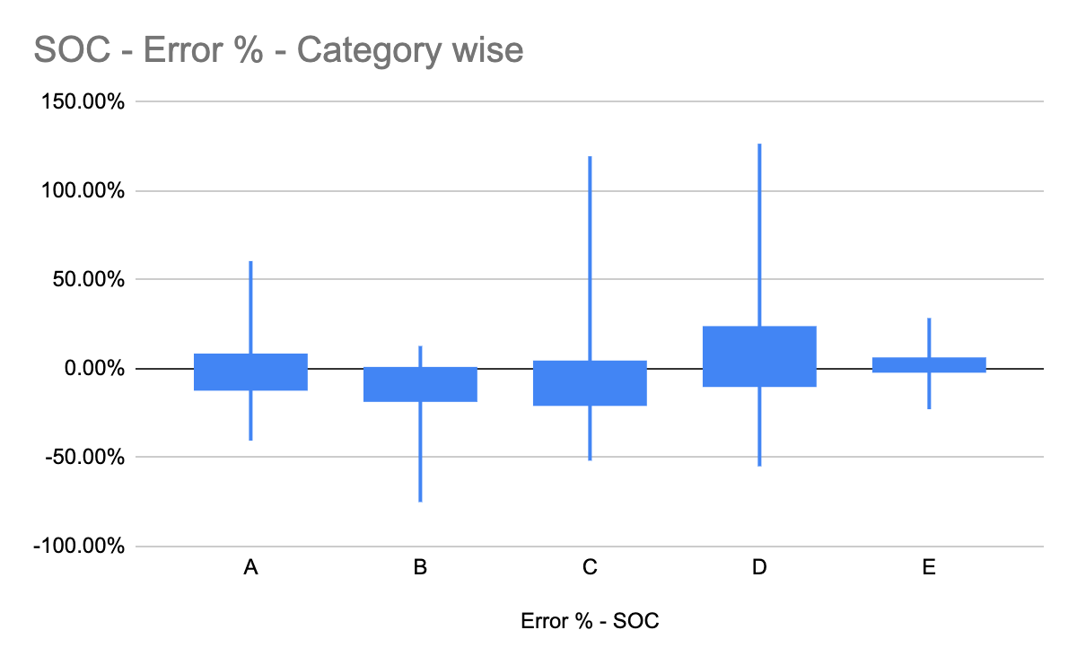
Fig A4: Distribution of error between tool generated results and output variables estimated from primary data ( Income, water and soil organic carbon respectively)

Annexure 4: Spearman-rank analysis of continuous variables

Variable 1 | Variable 2 | Spearman-rank rho | p | S
Crop Income | Plot size | 0.3183761 | 0.000881 | 135292
Crop Income | Crop diversity | -0.126955 | 0.1947 | 223684
Crop Income | Crop area % | 0.2749164 | 0.0001524 | 765137
Crop Income | Tree density | 0.1879604 | 0.05604 | 152225
Crop Income | Crop loss % | 0.1303604 | 0.02777 | 3355191
Crop Water demand | Plot size | 0.06553958 | 0.2693 | 3643363
Crop Water demand | Crop diversity | 0.1961656 | 0.04387 | 159549
Crop Water demand | Crop area % | 0.5853201 | < 2.2e-16 | 437587
Crop Water demand | Tree density | 0.1494106 | 0.1301 | 159451
Crop Water demand | Crop loss % | -0.06575746 | 0.2685 | 4111841
Livestock Income | Herd size | -0.08234945 | 0.4649 | 95853
Livestock annual water demand | Herd size | -0.09685969 | 0.3897 | 97138
Crop Income | timber tree density | 0.04750404 | 0.6287 | 189056
Crop Income | Fruit tree density | 0.2967918 | 0.002006 | 139576
Biomass carbon | Plot size | 0.4770492 | 2.34E-07 | 103798
Biomass carbon | timber tree density | 0.1871411 | 0.05474 | 161340
Biomass carbon | Fruit tree density | 0.8008756 | < 2.2e-16 | 39523
Biomass carbon | Crop diversity | -0.2495416 | 0.009889 | 248015
Crop water demand | fruit tree density | -0.158683 | 0.1042 | 229981
Crop water demand | timber tree density | 0.1546206 | 0.1135 | 167795
Livestock income | Livestock annual water demand | 0.546816 | 1.28E-07 | 40134
Crop Income | Tree Age | 0.1770469 | 0.00285 | 3075854
Crop Water demand | Tree Age | -0.2258892 | 0.0001302 | 4581860

