SUPPLEMENTAL MATERIALS

Latent Class Analysis Results

Before running our latent class analysis, we confirmed that our categorized and dichotomized indicator variables were not strongly associated by calculating Cramér’s V statistics (Supplemental Table 1).

Supplemental Table 1: Cramér’s V Statistic Between Indicator Variables in our Latent Class Analysis Model
VARIABLES | Displaced | Russian Occupation | Educational Attainment | Air Strikes | Distance Relocated | Physical Assault | Sexual Assault

Displaced
Russian Occupation | 0.27
Education | 0.27 | 0.07
Air Strikes | 0.46 | 0.19 | 0.15
Distance Relocated | 0.30 | 0.21 | 0.04 | 0.38
Physical Assault | 0.12 | 0.10 | 0.12 | 0.21 | 0.21
Sexual Assault | 0.17 | 0.18 | 0.06 | 0.22 | 0.12 | 0.28

Cramér’s V values: 0 (no association) – 1.0 (perfect association)
Values > 0.5 suggest strong association

Supplemental Table 2 provides goodness-of-fit statistics and relative entropy values for models with 1 to 6 classes. Our elbow tests for AIC and BIC across these models are plotted in Supplemental Figure 1.
Supplemental Table 2: Goodness-of-Fit Statistics for Models with 1-6 Classes
CLASSES | AIC | BIC | Likelihood Ratio (G²) | Chi-Square (X²) | Maximum  Log- likelihood | Relative Entropy
1 | 3,209.70 | 3,246.90 | 558.17 | 1,166.47 | -1,594.85 | -
2 | 3,013.08 | 3,091.21 | 339.56 | 678.33 | -1,485.54 | 0.87
3 | 2,990.62 | 3,109.67 | 295.10 | 462.11 | -1,463.31 | 0.78
4 | 2,973.07 | 3,133.04 | 255.55 | 540.05 | -1,443.54 | 0. 82
5 | 2,964.33 | 3,165.23 | 224.81 | 451.57 | -1,428.17 | 0.86
6 | 2,972.65 | 3,214.47 | 211.13 | 399.31 | -1,421.33 | 0. 80

Supplemental Figure 1: AIC and BIC Trends Based on the Number of Classes Specified in Each Model

Supplemental Figure 2 shows the predicted class population shares and outcome probabilities for a model fit with 2 classes. The probabilities represent the likelihood that a member of this class would exhibit each particular outcome. For example, among FSWs who belong in Class 2, there was a 0% probability of them responding “Yes” to being displaced since the onset of the invasion or having ever lived under Russian invasion. Meanwhile, among FSWs who belong in Class 1 would have and 66% likelihood of responding “Yes” to being displaced since the onset of the invasion. FSWs in this class also had high likelihoods of experiencing a higher volume of air strikes in 2022 or traveling a further distance (80% and 70%, respectively).
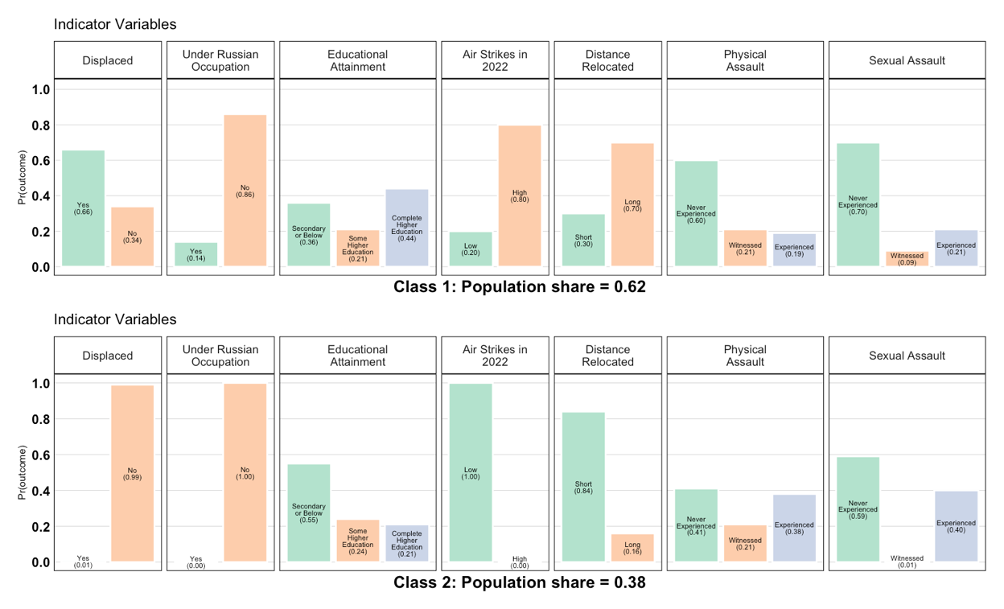

Supplemental Figure 2: Class Population Shares and Outcome Probabilities for a Latent Class Model Fit with Two Classes

Standard Deviation Ellipses
FSWs’ cities of origins and the number of FSWs from each city are plotted by class and new city of residence (Supplemental Figures 3-6).
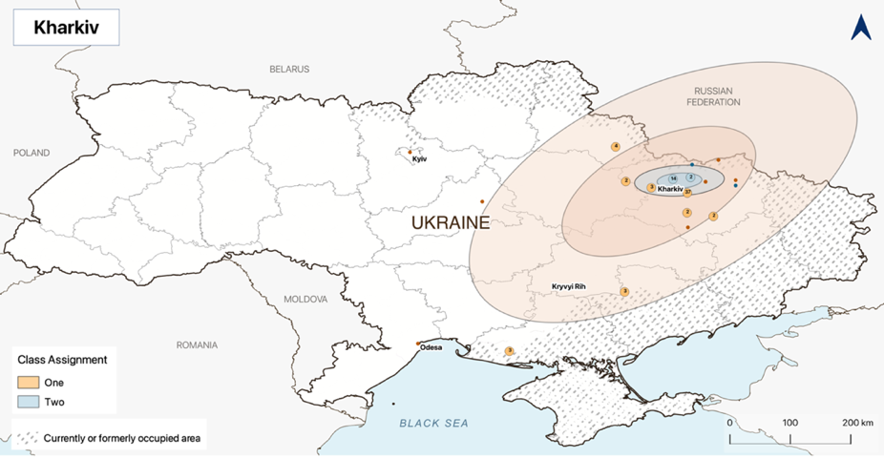
Supplemental Figure 3: Standard Deviation Ellipses for Class 1 and Class 2 Members now Living in Kharkiv

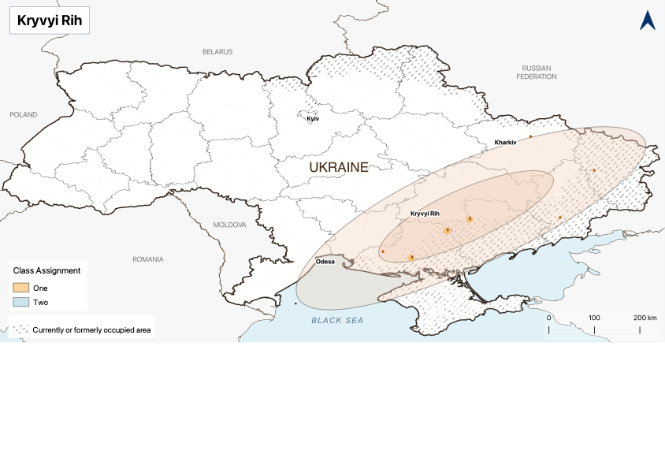
Supplemental Figure 4: Standard Deviation Ellipses for Class 1 and Class 2 Members now Living in Kryvyi Rih
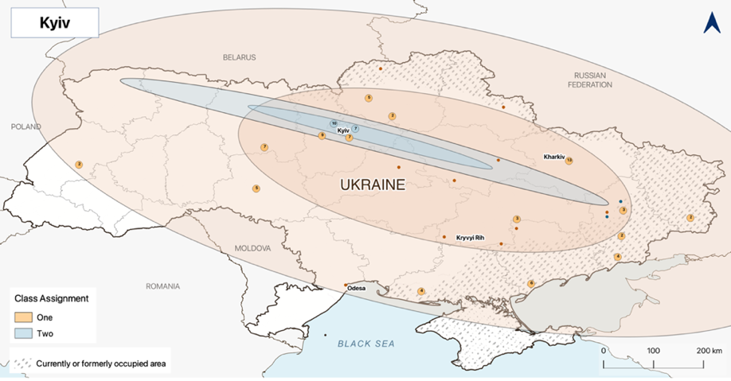
Supplemental Figure 5: Standard Deviation Ellipses for Class 1 and Class 2 Members now Living in Kyiv

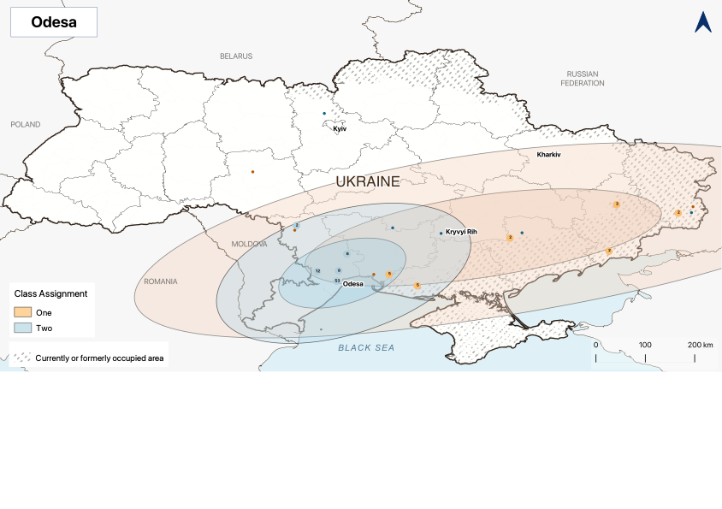
Supplemental Figure 6: Standard Deviation Ellipses for Class 1 and Class 2 Members now Living in Odesa

While SDEs are conventionally interpreted as encompassing approximately 68% and 95% of observations, the exact percent encompassed by each SDE varied slightly. The exact percentages of points contained within each ellipse can be found in Supplemental Table 3.

Supplemental Table 3: Percent of FSWs Cities of Origins Captured by Each Standard Deviation Ellipse
CITY | CLASS ASSIGNMENT | STANDARD DEVIATION LEVEL | PERCENT INSIDE
Kharkiv | One | 1 | 79.4%
Kharkiv | One | 2 | 90.5%
Kharkiv | One | 3 | 98.4%
Kharkiv | Two | 1 | 88.9%
Kharkiv | Two | 2 | 88.9%
Kharkiv | Two | 3 | 100%
Kryvyi Rih | One | 1 | 75%
Kryvyi Rih | One | 2 | 100%
Kryvyi Rih | One | 3 | 100.0%
Kyiv | One | 1 | 63.1%
Kyiv | One | 2 | 100%
Kyiv | One | 3 | 100%
Kyiv | Two | 1 | 73.7%
Kyiv |  | 2 | 89.5%
Kyiv |  | 3 | 100%
Odesa | One | 1 | 69.6%
Odesa | One | 2 | 95.7%
Odesa | One | 3 | 100.0%
Odesa | Two | 1 | 91.9%
Odesa | Two | 2 | 96.5%
Odesa | Two | 3 | 97.7%

Regression Results
Supplemental Table 4: Full Results from Adjusted Sexual Health Outcome Regressions
 | MODEL 1  Adjusted Odds of  Starting Sex Work After Russian Invasion | MODEL 2  Adjusted Odds of  Perceiving Sexual  Behavior Riskier Since Russian Invasion | MODEL 3  Adjusted Odds of  Inconsistent Condom Use in Last 30 Days | MODEL 4  Adjusted Rate Ratios for  Number of Sexual Partners  in Last 30 Days
Migration Group
Non-Relocated (Ref) | 1 | 1 | 1 | 1
Class 1: Conflict Adversity | 14.00 (7.51, 26.71)* | 1.57 (1.13, 2.18)* | 0.54 (0.38, 0.76)* | 1.14 (1.05, 1.23)*
Class 2: Personal Adversity | 0.95 (0.38, 2.11) | 1.04 (0.70, 1.53) | 2.83 (1.72, 4.66)* | 0.90 (0.82, 0.99)*
City
Kharkiv (Ref) | 1
Kryvyi Rih | 0.87 (0.18, 3.47)
Kyiv | 1.76 (0.70, 5.04)
Odesa | 15.44 (6.55, 43.28)*
Age
Per year | 0.92 (0.88, 0.96)* | 1.00 (0.98, 1.01) | 1.00 (0.98, 1.01) | 1.00 (0.99, 1.00)*
Employment
Other (Ref) |  | 1 | 1 | 1
Permanent Position |  | 0.22 (0.15, 0.33)* | 0.62 (0.43, 0.90)* | 0.90 (0.84, 0.97)*
Sex Work Only |  | 0.97 (0.79, 1.21) | 1.50 (1.19, 1.88)* | 1.24 (1.18, 1.31)*
Finding Clients
Through other clients (Ref) |  | 1 | 1 | 1
Transit/public spaces |  | 0.74 (0.49, 1.12) | 1.21 (0.79, 1.85) | 1.83 (1.66, 2.02)*
Recreational spaces |  | 0.21 (0.14, 0.32) | 0.42 (0.28, 0.62)* | 0.85 (0.78, 0.92)*
Online or by phone |  | 1.29 (0.98, 1.71) | 0.71 (0.53, 0.96)* | 1.11 (1.03, 1.18)*
Through others in profession |  | 0.71 (0.56, 0.91)* | 2.06 (1.63, 2.60)* | 0.99 (0.93, 1.05)
Housing Instability
No (Ref) |  | 1 | 1 | 1
Yes |  | 0.88 (0.71, 1.09) | 2.06 (1.63, 2.60)* | 0.98 (0.93, 1.04)
Injection Drug Use
Never (Ref) |  | 1 | 1 | 1
>30 days ago |  | 0.58 (0.39, 0.86)* | 2.40 (1.54, 3.74)* | 0.87 (0.80, 0.96)*
Within the last 30 days |  | 0.94 (0.65, 1.35) | 1.19 (0.82, 1.72) | 0.84 (0.77, 0.91)*
Air Strikes Within Last 30 Days
Per 10 strikes |  |  | 1.27 (1.18, 1.35)* | 1.11 (1.09, 1.12)*
*P-value < 0.05

