Supplementary Information
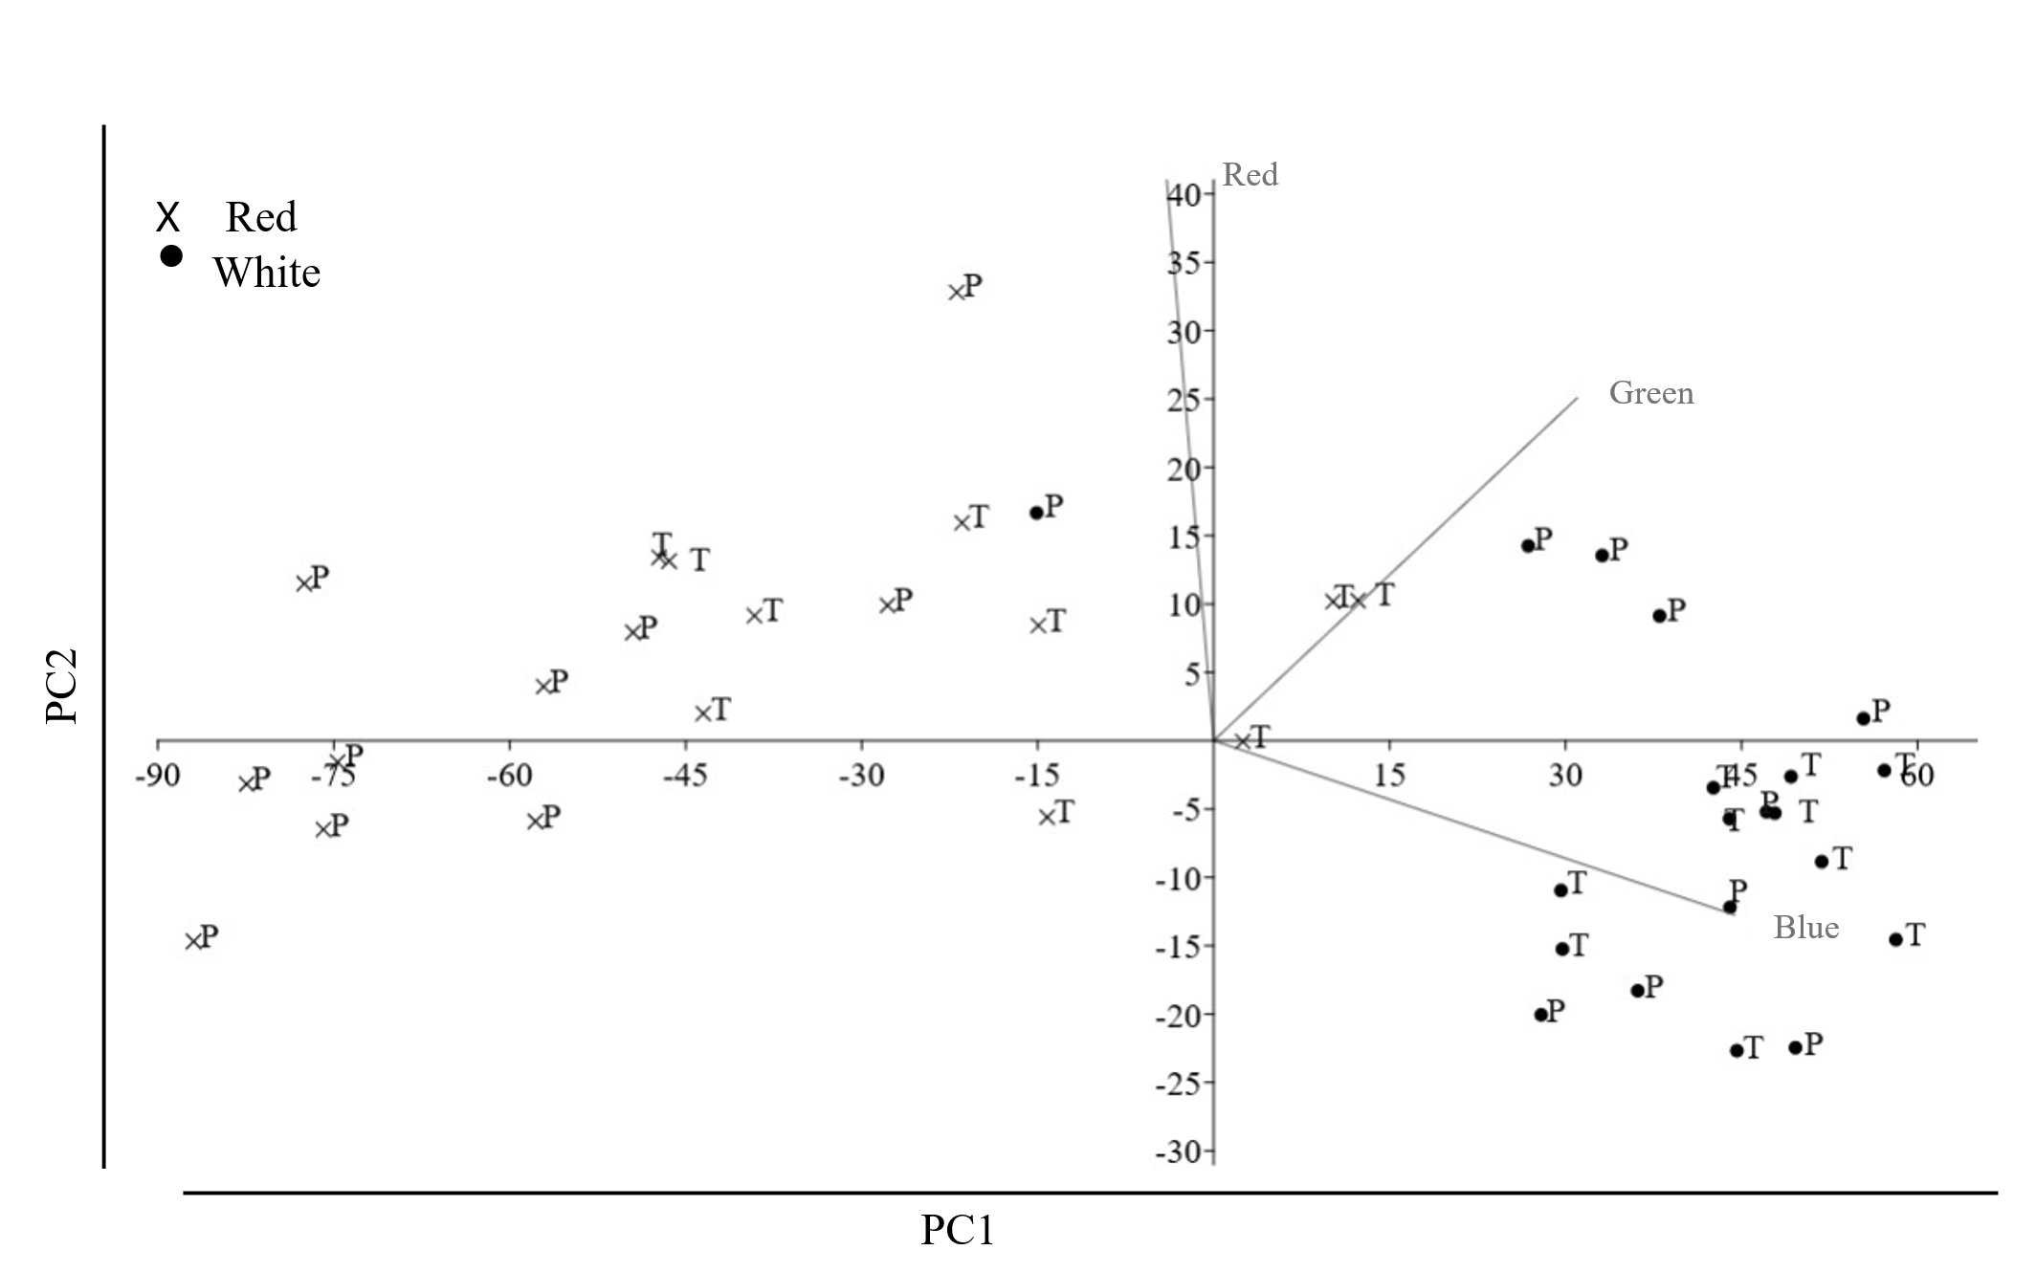
S. Fig. 1 Principal Component Analysis (PCA) plot of the first two principal components (PC1, PC2) for the colour data (Red, Green and Blue channels). The vectors indicate the loading and direction of each original variable. Dots (•) represent white individuals, while crosses (×) indicate red individuals of both species (Podarcis peloponnesiacus, P; Podarcis thais, T)

S. Table 1 Pairwise post hoc comparisons of aggression scores (Mann-Whitney U test) following a significant Kruskal-Wallis test (p < 0.001). Bold p-values indicate statistically significant differences (p < 0.05) between groups defined by species, colour morph (R=Red, W=White), and fighting type
Kruskal-Wallis test p-value = 5.89 x 10⁻¹¹ | INTRASPECIFIC BATTLES |  |  |  |  |  |  |  | INTERSPECIFIC BATTLES
Kruskal-Wallis test p-value = 5.89 x 10⁻¹¹ | P. pelop. W | P. thais R | P. thais W | P. pelop. R Painted | P. pelop. W Painted | P. thais R Painted | P. thais W Painted | P. pelop. R |  | P. pelop. W | P. thais R | P. thais W
INTRASPECIFIC BATTLES
P. pelop. R | 1.0000 | 0.0055 | 0.0004 | 1.0000 | 1.0000 | 0.0003 | 0.0516 | 1.0000 |  | 1.0000 | 0.0004 | 0.0005
P. pelop. W |  | 0.0037 | 0.0003 | 1.0000 | 1.0000 | 0.0002 | 0.0363 | 1.0000 |  | 1.0000 | 0.0003 | 0.0004
P. thais R |  |  | 1.0000 | 0.0022 | 0.3878 | 1.0000 | 1.0000 | 0.5798 |  | 1.0000 | 1.0000 | 1.0000
P. thais W |  |  |  | 0.0002 | 0.0581 | 1.0000 | 1.0000 | 0.1147 |  | 0.9330 | 1.0000 | 1.0000
P. pelop. R Painted |  |  |  |  | 1.0000 | 0.0995 | 0.0233 | 1.0000 |  | 1.0000 | 0.0002 | 0.0002
P. pelop. W Painted |  |  |  |  |  | 0.0416 | 1.0000 | 1.0000 |  | 1.0000 | 0.0339 | 0.0430
P. thais R Painted |  |  |  |  |  |  | 1.0000 | 0.0864 |  | 0.7397 | 1.0000 | 1.0000
P. thais W Painted |  |  |  |  |  |  |  | 1.0000 |  | 1.0000 | 1.0000 | 1.0000
INTERSPECIFIC BATTLES
P. pelop. R |  |  |  |  |  |  |  |  |  | 1.0000 | 0.0607 | 0.0748
P. pelop. W |  |  |  |  |  |  |  |  |  |  | 0.4645 | 0.5534
P. thais R |  |  |  |  |  |  |  |  |  |  |  | 1.0000

S. Table 2 χ² square (goodness-of-fit test results for associations between specific aggressive behaviours among colour morphs within Podarcis peloponnesiacus and Podarcis thais, based on pairwise comparisons of fighting types and grouped into sets of 10 fights. Fight types are coded as follows: P = P. peloponnesiacus, T= P. thais , R = R morph, W = white morph, with an additional letter denoting experimentally modified trials. The first element of the code in the first column identifies the focal group, while the second identifies the opponent, thereby defining the fighting type. Statistically significant results (p < 0.05) are shown in bold
AGGRESSION
GROUP | TYPE OF BATTLE | TOTAL AGGRESSIVE BEHAVIOURS | X^2 | P VALUE
1 | PRxPR | 80.0 | 3.86 | 0.0490
1 | PRxPW | 57.0 | 3.86 | 0.0490
2 | PWxPW | 51.0 | 7.23 | 0.0072
2 | PWXPR | 82.0 | 7.23 | 0.0072
3 | PRxPW | 57.0 | 4.49 | 0.0340
3 | PWxPR | 82.0 | 4.49 | 0.0340
4 | PRxPR | 80.0 | 6.42 | 0.0110
4 | PWxPW | 51.0 | 6.42 | 0.0110
5 | PRWxPRW | 51.0 | 1.47 | 0.2254
5 | PRWxPWR | 64.0 | 1.47 | 0.2254
6 | PWRxPWR | 50.5 | 1.6 | 0.206
6 | PWRxPRW | 39.0 | 1.6 | 0.206
7 | PRWxPWR | 64.0 | 6.068 | 0.0138
7 | PWRxPRW | 39.0 | 6.068 | 0.0138
8 | PRWxPRW | 51.0 | 0 | 1
8 | PWRxPWR | 50.5 | 0 | 1
9 | PRxPR | 80.0 | 6.42 | 0.0113
9 | PRWxPRW | 51.0 | 6.42 | 0.0113
10 | PRxPW | 57.0 | 0.405 | 0.524
10 | PRWxPWR | 64.0 | 0.405 | 0.524
11 | PWxPW | 51.0 | 0 | 1
11 | PWRxPWR | 50.5 | 0 | 1
12 | PWxPR | 82.0 | 15.28 | 0.0001
12 | PWRxPRW | 39.0 | 15.28 | 0.0001
13 | TRxTR | 1.5 | 2.7800 | 0.0955
13 | TRxTW | 7.0 | 2.7800 | 0.0955
14 | TWxTW | 4.0 | 1.3300 | 0.2482
14 | TWxTR | 8.0 | 1.3300 | 0.2482
15 | TRxTW | 7.0 | 0.0670 | 0.7963
15 | TWxTR | 8.0 | 0.0670 | 0.7963
16 | TRxTR | 1.5 | 0.6670 | 0.4140
16 | TWxTW | 4.0 | 0.6670 | 0.4140
17 | TRWxTRW | 15.0 | 0.7140 | 0,39802
17 | TWRxTWR | 19.5 | 0.7140 | 0,39802
18 | TWRxTWR | 19.5 | 0.0950 | 0.7576
18 | TWRxTRW | 22.0 | 0.0950 | 0.7576
19 | TRWxTWR | 3.0 | 14.4400 | 0.0001
19 | TWRxTRW | 22.0 | 14.4400 | 0.0001
20 | TRWxTRW | 15.0 | 8.0000 | 0.0047
20 | TRWxTWR | 3.0 | 8.0000 | 0.0047
21 | TRxTR | 1.5 | 9.9400 | 0.0016
21 | TRWxTRW | 15.0 | 9.9400 | 0.0016
22 | TRxTW | 7.0 | 1.6000 | 0.2059
22 | TRWxTWR | 3.0 | 1.6000 | 0.2059
23 | TWxTW | 4.0 | 10.6670 | 0.0011
23 | TWRxTWR | 19.5 | 10.6670 | 0.0011
24 | TWxTR | 8.0 | 6.5330 | 0.0106
24 | TWRxTRW | 22.0 | 6.5330 | 0.0106
25 | PRxTR | 25.0 | 1.103 | 0.294
25 | PWxTW | 33.0 | 1.103 | 0.294
26 | PRxTW | 98.0 | 22.4 | <0.00001
26 | PWxTR | 42.0 | 22.4 | <0.00001
27 | PRxTR | 25.0 | 41.17 | <0.00001
27 | PRxTW | 98.0 | 41.17 | <0.00001
28 | PWxTW | 33.0 | 1.08 | 0.2987
28 | PWxTR | 42.0 | 1.08 | 0.2987
29 | TRxPR | 1.0
29 | TWxPW | 0.0
30 | TRxPW | 0.0
30 | TWxPR | 2.0
31 | TWxPW | 0.0
31 | TWxPR | 2.0
32 | TRxPR | 1.0
32 | TRxPW | 0.0
33 | PRxPR | 80.0 | 28.8100 | <0.00001
33 | PRxTR | 25.0 | 28.8100 | <0.00001
34 | PRxPW | 57.0 | 10.8450 | 0.0010
34 | PRxTW | 98.0 | 10.8450 | 0.0010
35 | PWxPW | 51.0 | 3.8570 | 0.4953
35 | PWxTW | 33.0 | 3.8570 | 0.4953
36 | PWxPR | 82.0 | 12.9030 | 0.0003
36 | PWxTR | 42.0 | 12.9030 | 0.0003
37 | TRxTR | 1.5 | 0.3330 | 0.5637
37 | TRxPR | 1.0 | 0.3330 | 0.5637
38 | TRxTW | 7.0
38 | TRxPW | 0.0
39 | TWxTW | 4.0
39 | TWxPW | 0.0
40 | TWxTR | 8.0 | 3.6 | 0.0578
40 | TWxPR | 2.0 | 3.6 | 0.0578
41 | PRxPW | 57.0 | 39.062 | <0.00001
41 | TRxTW | 7.0 | 39.062 | <0.00001
42 | PRWxPWR | 64.0 | 55.537 | <0.00001
42 | TRWxTWR | 3.0 | 55.537 | <0.00001
43 | PWxPR | 82.0 | 60.844 | <0.00001
43 | TWxTR | 8.0 | 60.844 | <0.00001
44 | PWRxPRW | 39.0 | 4.738 | 0.02951
44 | TWRxTRW | 22.0 | 4.738 | 0.02951

S Table 3 χ²square goodness-of-fit test results for associations between submissive behaviours among colour morphs within Podarcis peloponnesiacus and Podarcis thais, based on pairwise comparisons of fighting types and grouped into sets of 10 fights. Abbreviations used in the first column are defined in the preceding table. For very small expected frequencies, the χ² goodness-of-fit test could not be performed. Statistically significant results (p < 0.05) are shown in bold
SUBMISSIVENESS
GROUP | TYPE OF BATTLE | TOTAL SUBMISSIVE BEHAVIOURS | X^2 | P VALUE
1 | PRxPW | 151.4 | 0.17 | 0.684
1 | PWxPR | 144.0 | 0.17 | 0.684
2 | PRxPR | 94.0 | 13.26 | 0.0003
2 | PRxPW | 151.4 | 13.26 | 0.0003
3 | PWxPW | 104.6 | 6.11 | 0.0135
3 | PWXPR | 144.0 | 6.11 | 0.0135
4 | PRxPR | 94.0 | 0.61 | 0.4336
4 | PWxPW | 104.6 | 0.61 | 0.4336
5 | PRWxPWR | 71.1 | 6.22 | 0.0130
5 | PWRxPRW | 103.8 | 6.22 | 0.0130
6 | PRWxPRW | 115.3 | 10.41 | 0.0013
6 | PRWxPWR | 71.1 | 10.41 | 0.0013
7 | PWRxPWR | 84.6 | 1.91 | 0.167
7 | PWRxPRW | 103.8 | 1.91 | 0.167
8 | PRWxPRW | 115.3 | 4.50 | 0.0339
8 | PWRxPWR | 84.6 | 4.50 | 0.0339
9 | PRxPR | 94.0 | 2.11 | 0.146
9 | PRWxPRW | 115.3 | 2.11 | 0.146
10 | PRxPW | 151.4 | 28.83 | <0.00001
10 | PRWxPWR | 71.1 | 28.83 | <0.00001
11 | PWxPW | 104.6 | 2.11 | 0.147
11 | PWRxPWR | 84.6 | 2.11 | 0.147
12 | PWxPR | 144.0 | 6.45 | 0.0111
12 | PWRxPRW | 103.8 | 6.45 | 0.0111
13 | TRxTW | 35.0 | 2.65 | 0.1040
13 | TWxTR | 50.0 | 2.65 | 0.1040
14 | TRxTR | 28.8 | 0.56 | 0.4533
14 | TRxTW | 35.0 | 0.56 | 0.4533
15 | TWxTW | 24.5 | 8.33 | 0.0040
15 | TWxTR | 50.0 | 8.33 | 0.0040
16 | TRxTR | 28.8 | 0.30 | 0.5862
16 | TWxTW | 24.5 | 0.30 | 0.5862
17 | TRWxTWR | 44.4 | 2.25 | 0.1330
17 | TWRxTRW | 31.4 | 2.25 | 0.1330
18 | TRWxTRW | 43.3 | 0.01 | 0.9150
18 | TRWxTWR | 44.4 | 0.01 | 0.9150
19 | TWRxTWR | 42.4 | 1.66 | 0.1979
19 | TWRxTRW | 31.4 | 1.66 | 0.1979
20 | TRWxTRW | 43.3 | 0.01 | 0.9140
20 | TWRxTWR | 42.4 | 0.01 | 0.9140
21 | TRxTR | 28.8 | 2.72 | 0.0990
21 | TRWxTRW | 43.3 | 2.72 | 0.0990
22 | TRxTW | 35.0 | 1.03 | 0.3110
22 | TRWxTWR | 44.4 | 1.03 | 0.3110
23 | TWxTW | 24.5 | 4.31 | 0.0380
23 | TWRxTWR | 42.4 | 4.31 | 0.0380
24 | TWxTR | 50.0 | 4.46 | 0.0348
24 | TWRxTRW | 31.4 | 4.46 | 0.0348
25 | PRxTR | 52.5 | 2.845 | 0.0920
25 | PWxTW | 36.7 | 2.845 | 0.0920
26 | PRxTW | 31.7 | 6.150 | 0.0132
26 | PWxTR | 15.0 | 6.150 | 0.0132
27 | PWxTW | 36.7 | 9.308 | 0.0023
27 | PWxTR | 15.0 | 9.308 | 0.0023
28 | PRxTW | 31.7 | 5.190 | 0.0227
28 | PRxTR | 52.5 | 5.190 | 0.0227
29 | TRxPR | 92.0 | 0.050 | 0.824
29 | TWxPW | 89.0 | 0.050 | 0.824
30 | TRxPW | 112.0 | 1.067 | 0.302
30 | TWxPR | 128.0 | 1.067 | 0.302
31 | TWxPW | 89.0 | 7.009 | 0.0081
31 | TWxPR | 128.0 | 7.009 | 0.0081
32 | TRxPR | 92.0 | 1.961 | 0.161
32 | TRxPW | 112.0 | 1.961 | 0.161
33 | PRxPR | 94.0 | 11.4350 | 0.0007
33 | PRxTR | 52.5 | 11.4350 | 0.0007
34 | PRxPW | 151.4 | 77.3830 | <0.00001
34 | PRxTW | 31.7 | 77.3830 | <0.00001
35 | PWxPW | 104.6 | 32.5630 | <0.00001
35 | PWxTW | 36.7 | 32.5630 | <0.00001
36 | PWxPR | 144.0 | 104.6600 | <0.00001
36 | PWxTR | 15.0 | 104.6600 | <0.00001
37 | TRxTR | 28.8 | 32.8020 | <0.00001
37 | TRxPR | 92.0 | 32.8020 | <0.00001
38 | TRxTW | 35.0 | 40.3300 | <0.00001
38 | TRxPW | 112.0 | 40.3300 | <0.00001
39 | TWxTW | 24.5 | 35.9300 | <0.00001
39 | TWxPW | 89.0 | 35.9300 | <0.00001
40 | TWxTR | 50.0 | 34.1800 | <0.00001
40 | TWxPR | 128.0 | 34.1800 | <0.00001
41 | PRxPW | 151.4 | 72.34 | <0.00001
41 | TRxTW | 35.0 | 72.34 | <0.00001
42 | PRWxPWR | 71.1 | 6.34 | 0.012
42 | TRWxTWR | 44.4 | 6.34 | 0.012
43 | PWxPR | 144.0 | 45.55 | <0.00001
43 | TWxTR | 50.0 | 45.55 | <0.00001
44 | PWRxPRW | 103.8 | 39.47 | <0.00001
44 | TWRxTRW | 31.4 | 39.47 | <0.00001

S. Table 4 χ²square goodness-of-fit test results for associations between visual signals among colour morphs within P. peloponnesiacus and P. thais, based on pairwise comparisons of fighting types and grouped into sets of 10 fights. Abbreviations used in the first column are defined in the preceding table. Statistically significant results (p < 0.05) are shown in bold
VISUAL SIGNS
GROUP | TYPE OF BATTLE | TOTAL VISUAL SIGNS | X^2 | P VALUE
1 | PRxPW | 51.3 | 5.44 | 0.0196
1 | PWxPR | 30.0 | 5.44 | 0.0196
2 | PRxPR | 48.7 | 0.04 | 0.841
2 | PRxPW | 51.3 | 0.04 | 0.841
3 | PWxPW | 20.0 | 2.00 | 0.1573
3 | PWXPR | 30.0 | 2.00 | 0.1573
4 | PRxPR | 48.7 | 12.19 | 0.0005
4 | PWxPW | 20.0 | 12.19 | 0.0005
5 | PRWxPRW | 49.3 | 35.96 | <0.00001
5 | PRWxPWR | 128.6 | 35.96 | <0.00001
6 | PRWxPRW | 49.3 | 0.27 | 0.60413
6 | PWRxPWR | 44.2 | 0.27 | 0.60413
7 | PRWxPWR | 128.6 | 24.34 | <0.00001
7 | PWRxPRW | 61.3 | 24.34 | <0.00001
8 | PWRxPWR | 44.2 | 2.75 | 0.0971
8 | PWRxPRW | 61.3 | 2.75 | 0.0971
9 | PRxPR | 48.7 | 0.00 | 1
9 | PRWxPRW | 49.3 | 0.00 | 1
10 | PRxPW | 51.3 | 33.80 | <0.00001
10 | PRWxPWR | 128.6 | 33.80 | <0.00001
11 | PWxPW | 20.0 | 9.00 | 0.0027
11 | PWRxPWR | 44.2 | 9.00 | 0.0027
12 | PWxPR | 30.0 | 10.56 | 0.0012
12 | PWRxPRW | 61.3 | 10.56 | 0.0012
13 | TRxTW | 70 | 20.17 | <0.00001
13 | TWxTR | 26 | 20.17 | <0.00001
14 | TRxTR | 76 | 0.25 | 0.6195
14 | TRxTW | 70 | 0.25 | 0.6195
15 | TWxTW | 33 | 0.08 | 0.3621
15 | TWxTR | 26 | 0.08 | 0.3621
16 | TRxTR | 76 | 19.96 | 0.0000
16 | TWxTW | 33 | 19.96 | 0.0000
17 | TRWxTWR | 46 | 0.18 | 0.6698
17 | TWRxTRW | 42 | 0.18 | 0.6698
18 | TRWxTRW | 49 | 0.10 | 0.7580
18 | TRWxTWR | 46 | 0.10 | 0.7580
19 | TWRxTWR | 59 | 2.86 | 0.0907
19 | TWRxTRW | 42 | 2.86 | 0.0907
20 | TRWxTRW | 49 | 0.93 | 0.3360
20 | TWRxTWR | 59 | 0.93 | 0.3360
21 | TRxTR | 76 | 5.83 | 0.0157
21 | TRWxTRW | 49 | 5.83 | 0.0157
22 | TRxTW | 70 | 4.97 | 0.0260
22 | TRWxTWR | 46 | 4.97 | 0.0260
23 | TWxTW | 33 | 7.35 | 0.0067
23 | TWRxTWR | 59 | 7.35 | 0.0067
24 | TWxTR | 26 | 3.77 | 0.0523
24 | TWRxTRW | 42 | 3.77 | 0.0523
25 | PRxTR | 30 | 0.00 | 1.000
25 | PWxTW | 30 | 0.00 | 1.000
26 | PRxTW | 40 | 11.36 | 0.001
26 | PWxTR | 15 | 11.36 | 0.001
27 | PWxTW | 30 | 5.00 | 0.025
27 | PWxTR | 15 | 5.00 | 0.025
28 | PRxTR | 30 | 1.43 | 0.232
28 | PRxTW | 40 | 1.43 | 0.232
29 | TRxPR | 83 | 61.94 | <0.00001
29 | TWxPW | 220 | 61.94 | <0.00001
30 | TRxPW | 35 | 105.88 | <0.00001
30 | TWxPR | 189 | 105.88 | <0.00001
31 | TWxPW | 220 | 2.35 | 0.125
31 | TWxPR | 189 | 2.35 | 0.125
32 | TRxPW | 35 | 19.53 | <0.00001
32 | TRxPR | 83 | 19.53 | <0.00001
33 | PRxPR | 49 | 4.57 | 0.0345
33 | PRxTR | 30 | 4.57 | 0.0345
34 | PRxPW | 51 | 1.33 | 0.2480
34 | PRxTW | 40 | 1.33 | 0.2480
35 | PWxPW | 20 | 2.00 | 0.1570
35 | PWxTW | 30 | 2.00 | 0.1570
36 | PWxPR | 30 | 5.00 | 0.0254
36 | PWxTR | 15 | 5.00 | 0.0254
37 | TRxTR | 76 | 0.31 | 0.5788
37 | TRxPR | 83 | 0.31 | 0.5788
38 | TRxTW | 70 | 11.67 | 0.0006
38 | TRxPW | 35 | 11.67 | 0.0006
39 | TWxTW | 33 | 138.27 | <0.00001
39 | TWxPW | 220 | 138.27 | <0.00001
40 | TWxTR | 26 | 123.58 | <0.00001
40 | TWxPR | 189 | 123.58 | <0.00001
41 | PRxPW | 51 | 2.98 | 0.0841
41 | TRxTW | 70 | 2.98 | 0.0841
42 | PRWxPWR | 129 | 39.37 | <0.00001
42 | TRWxTWR | 46 | 39.37 | <0.00001
43 | PWxPR | 30 | 0.29 | 0.593
43 | TWxTR | 26 | 0.29 | 0.593
44 | PWRxPRW | 61 | 3.51 | 0.0612
44 | TWRxTRW | 42 | 3.51 | 0.0612

S. Table 5 χ²square goodness-of-fit test results for associations between boldness behaviours among colour morphs within Podarcis peloponnesiacus and Podarcis thais, based on pairwise comparisons of fighting types and grouped into sets of 10 fights. Abbreviations used in the first column are defined in the preceding table. Statistically significant results (p < 0.05) are shown in bold
BOLDNESS
GROUP | TYPE OF BATTLE | TOTAL BOLDNESS BEHAVIOURS | Χ^2 | P VALUE
1 | PRxPR | 104.2 | 2.13 | 0.145
1 | PRxPW | 84.0 | 2.13 | 0.145
2 | PWxPW | 77.4 | 5.82 | 0.016
2 | PWXPR | 110.0 | 5.82 | 0.016
3 | PRxPW | 84.0 | 3.49 | 0.062
3 | PWxPR | 110.0 | 3.49 | 0.062
4 | PRxPR | 104.2 | 4.03 | 0.045
4 | PWxPW | 77.4 | 4.03 | 0.045
5 | PRWxPRW | 123.5 | 0.32 | 0.575
5 | PRWxPWR | 133.0 | 0.32 | 0.575
6 | PWRxPWR | 69.0 | 7.82 | 0.005
6 | PWRxPRW | 106.0 | 7.82 | 0.005
7 | PRWxPWR | 133.0 | 3.05 | 0.081
7 | PWRxPRW | 106.0 | 3.05 | 0.081
8 | PRWxPRW | 123.5 | 15.67 | 0.0001
8 | PWRxPWR | 69.0 | 15.67 | 0.0001
9 | PRxPR | 104.2 | 1.75 | 0.185
9 | PRWxPRW | 123.5 | 1.75 | 0.185
10 | PRxPW | 84.0 | 11.07 | 0.001
10 | PRWxPWR | 133.0 | 11.07 | 0.001
11 | PWxPW | 77.4 | 0.44 | 0.508
11 | PWRxPWR | 69.0 | 0.44 | 0.508
12 | PWxPR | 110.0 | 0.07 | 0.785
12 | PWRxPRW | 106.0 | 0.07 | 0.785
13 | TRxTR | 34.3 | 16.036 | 0.0001
13 | TRxTW | 75.7 | 16.036 | 0.0001
14 | TWxTW | 56.7 | 2.980 | 0.084
14 | TWxTR | 40.0 | 2.980 | 0.084
15 | TRxTW | 75.7 | 11.170 | 0.0008
15 | TWxTR | 40.0 | 11.170 | 0.0008
16 | TRxTR | 34.3 | 5.813 | 0.0159
16 | TWxTW | 56.7 | 5.813 | 0.0159
17 | TRWxTRW | 34.3 | 3.048 | 0.0807
17 | TRWxTWR | 50.0 | 3.048 | 0.0807
18 | TWRxTWR | 118.3 | 18.150 | 0.0000
18 | TWRxTRW | 61.0 | 18.150 | 0.0000
19 | TRWxTWR | 50.0 | 1.090 | 0.2965
19 | TWRxTRW | 61.0 | 1.090 | 0.2965
20 | TRWxTRW | 43.5 | 33.802 | <0.00001
20 | TWRxTWR | 118.3 | 33.802 | <0.00001
21 | TRxTR | 34.3 | 1.280 | 0.258
21 | TRWxTRW | 43.5 | 1.280 | 0.258
22 | TRxTW | 75.7 | 5.370 | 0.0205
22 | TRWxTWR | 50.0 | 5.370 | 0.0205
23 | TWxTW | 56.7 | 21.260 | <0.00001
23 | TWRxTWR | 118.3 | 21.260 | <0.00001
24 | TWxTR | 40.0 | 4.366 | 0.0370
24 | TWRxTRW | 61.0 | 4.366 | 0.0370
25 | PRxTR | 113.0 | 0.42 | 0.515
25 | PWxTW | 123.3 | 0.42 | 0.515
26 | PRxTW | 157.0 | 8.27 | 0.0040
26 | PWxTR | 110.0 | 8.27 | 0.0040
27 | PWxTW | 123.3 | 0.73 | 0.394
27 | PWxTR | 110.0 | 0.73 | 0.394
28 | PRxTR | 113.0 | 7.17 | 0.0074
28 | PRxTW | 157.0 | 7.17 | 0.0074
29 | TRxPR | 56.0 | 1.77 | 0.183
29 | TWxPW | 71.1 | 1.77 | 0.183
30 | TRxPW | 52.5 | 4.43 | 0.0353
30 | TWxPR | 77.0 | 4.43 | 0.0353
31 | TWxPW | 71.1 | 0.24 | 0.622
31 | TWxPR | 77.0 | 0.24 | 0.622
32 | TRxPR | 56.0 | 0.08 | 0.774
32 | TRxPW | 52.5 | 0.08 | 0.774
33 | PRxPR | 104.2 | 0.3730 | 0.5410
33 | PRxTR | 113.0 | 0.3730 | 0.5410
34 | PRxPW | 84.0 | 22.1100 | <0.00001
34 | PRxTW | 157.0 | 22.1100 | <0.00001
35 | PWxPW | 77.4 | 10.5800 | 0.0011
35 | PWxTW | 123.3 | 10.5800 | 0.0011
36 | PWxPR | 110.0 | 0.0000 | 1.0000
36 | PWxTR | 110.0 | 0.0000 | 1.0000
37 | TRxTR | 34.3 | 5.3800 | 0.0204
37 | TRxPR | 56.0 | 5.3800 | 0.0204
38 | TRxTW | 75.7 | 4.1010 | 0.0430
38 | TRxPW | 52.5 | 4.1010 | 0.0430
39 | TWxTW | 56.7 | 1.5310 | 0.2159
39 | TWxPW | 71.1 | 1.5310 | 0.2159
40 | TWxTR | 40.0 | 11.7000 | 0.0006
40 | TExPR | 77.0 | 11.7000 | 0.0006
41 | PRxPW | 84.0 | 0.40 | 0.53
41 | TRxTW | 75.7 | 0.40 | 0.53
42 | PRWxPWR | 133.0 | 37.645 | <0.00001
42 | TRWxTWR | 50.0 | 37.645 | <0.00001
43 | PWxPR | 110.0 | 32.67 | <0.00001
43 | TWxTR | 40.0 | 32.67 | <0.00001
44 | PWRxPRW | 106.0 | 12.126 | 0.0005
44 | TWRxTRW | 61.0 | 12.126 | 0.0005

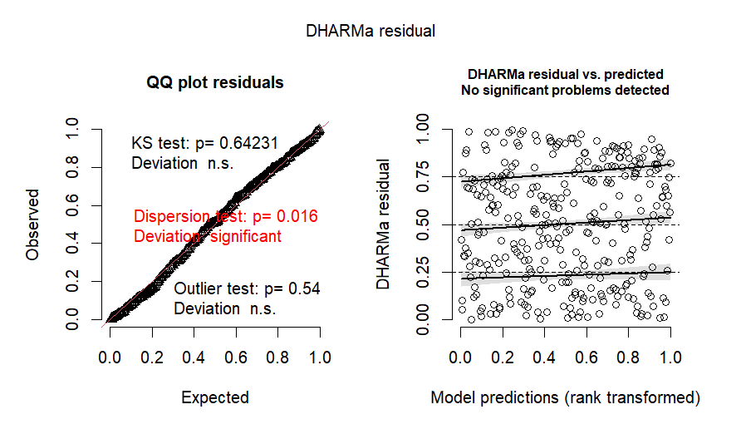
S. Fig. 2 DHARMa residual diagnostics for the negative binomial generalized linear mixed model. The residuals showed a good fit to the expected uniform distribution (Kolmogorov–Smirnov test, p = 0.64), with no evidence of outliers. However, a slight but statistically significant deviation in dispersion was detected (p = 0.016)
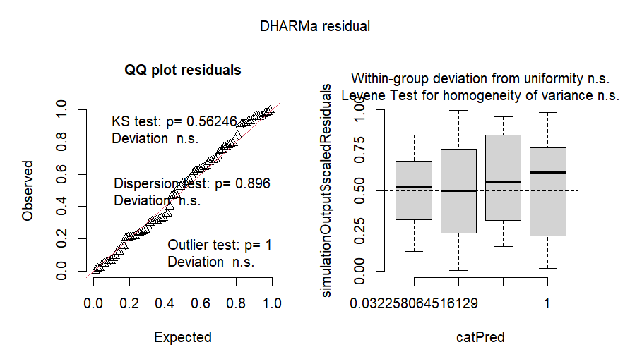
S Fig. 3 DHARMa residual diagnostics for the model testing the association between winning and the outcome of the previous fight. The residuals followed the expected uniform distribution (Kolmogorov–Smirnov test, p = 0.90), with no evidence of dispersion or outliers. No deviations from uniformity or heteroscedasticity were detected among groups
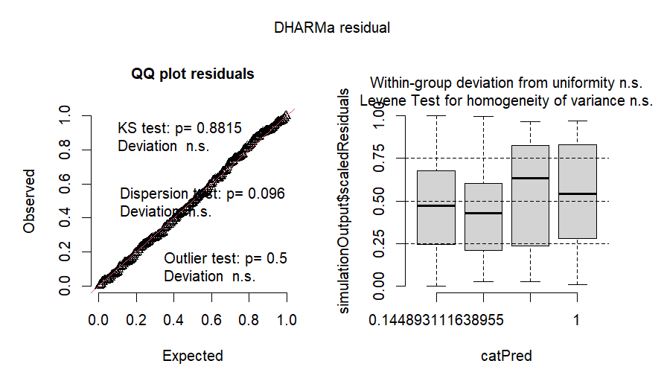
S. Fig. 4 DHARMa residual diagnostics for the model assessing the effect of coloration. The residuals did not deviate from the expected uniform distribution (KS test, p = 0.77), and no evidence of outliers was detected. A slight but statistically significant deviation in dispersion was observed. No evidence of heteroscedasticity among groups was detected

