Supplementary material

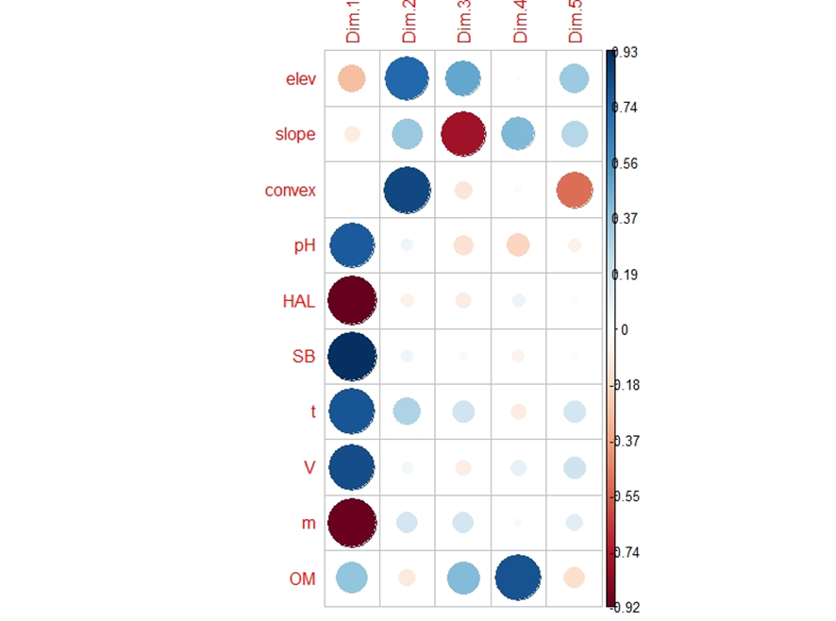

Figure S1. Significance levels are based on Spearman correlation coefficients between soil parameters and principal components of PCA fertility from 200 plots within 2-ha plots in Atlantic Forest, Minas Gerais, Brazil. For analysis, available: elevation (elev), convexity (convex), slope, exchangeable acidity potential (H + Al), aluminum saturation index (m), pH (H₂O), organic matter (OM); effective cation exchange capacity (t = CEC), sum of basic exchangeable cations (SB), bases saturation index (V).

