Online Resource 1
Inflammatory comorbidity and quality-of-life burden in psoriasis with multiple biologic failure: a retrospective cohort study
José Molina-Espinosa, Pedro José Ezomo-Gervilla, Diego Gallego-García, Daniel Robles-Murcia, José Carlos Ruiz-Carrascosa and Ricardo Ruiz-Villaverde
Supplementary figures and tables

Supplementary Figure S1
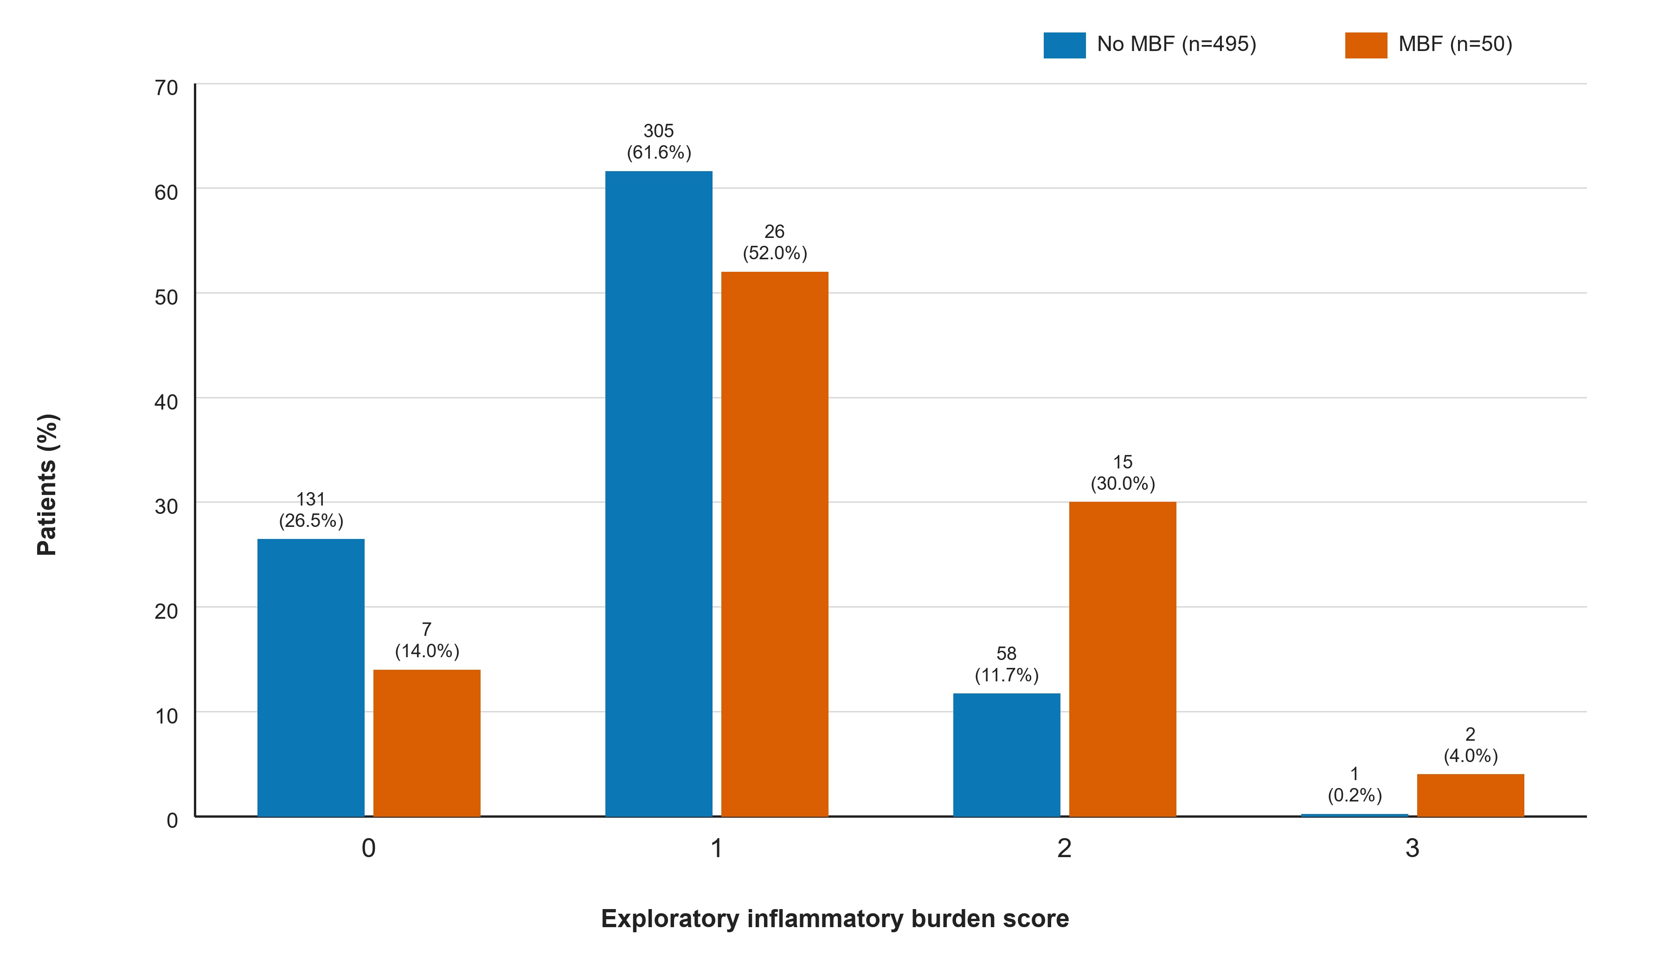
Supplementary Fig. S1 Distribution of the exploratory inflammatory burden score by clinician-recorded multiple biologic failure status. The score assigns one point each for psoriatic arthritis, inflammatory bowel disease and baseline PASI ≥10 (range 0–3). Values above bars are n (% within group).
Note. The score is investigator-developed, combines heterogeneous domains and is descriptive and hypothesis-generating only; it is not a validated predictive or clinical decision tool.

Supplementary Figure S2
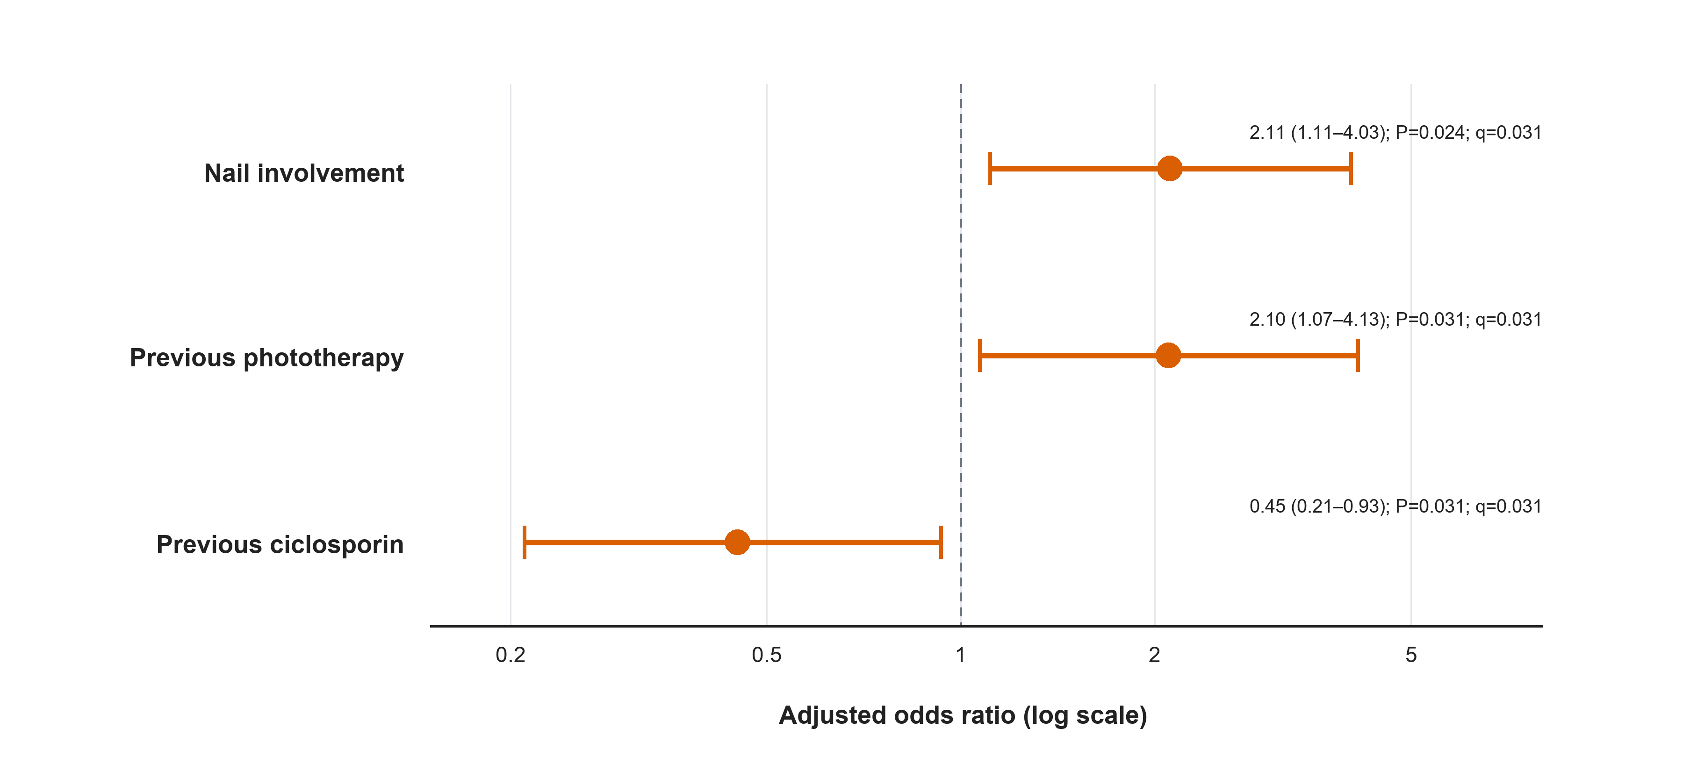
Supplementary Fig. S2 Exploratory adjusted treatment-pathway associations with clinician-recorded multiple biologic failure. Points are adjusted odds ratios and bars are 95% confidence intervals on a logarithmic scale. Benjamini–Hochberg q values were calculated across this three-variable family.
Note. Associations are exploratory and should not be interpreted as causal treatment effects.

Supplementary Table S1
Supplementary Table S1 Exposure-based sensitivity analyses of the clinician-recorded multiple biologic failure outcome.
Outcome definition | Events/N | Covariate | Adjusted OR (95% CI) | P value
Clinician-recorded classification | 50/539 | Age, per 10 years | 0.94 (0.74–1.20) | 0.627
Clinician-recorded classification | 50/539 | Male sex | 0.99 (0.54–1.83) | 0.976
Clinician-recorded classification | 50/539 | Psoriasis duration, per 10 years | 1.28 (1.00–1.62) | 0.046
Clinician-recorded classification | 50/539 | BMI, per 5 kg/m² | 1.05 (0.83–1.33) | 0.675
Clinician-recorded classification | 50/539 | Psoriatic arthritis | 4.17 (2.24–7.77) | <0.001
≥3 declared biologics | 52/539 | Age, per 10 years | 0.99 (0.78–1.26) | 0.933
≥3 declared biologics | 52/539 | Male sex | 1.16 (0.63–2.14) | 0.623
≥3 declared biologics | 52/539 | Psoriasis duration, per 10 years | 1.23 (0.97–1.55) | 0.082
≥3 declared biologics | 52/539 | BMI, per 5 kg/m² | 1.07 (0.85–1.35) | 0.566
≥3 declared biologics | 52/539 | Psoriatic arthritis | 4.17 (2.27–7.67) | <0.001
≥4 declared biologics | 17/539 | Age, per 10 years | 1.10 (0.73–1.66) | 0.647
≥4 declared biologics | 17/539 | Male sex | 0.67 (0.25–1.81) | 0.435
≥4 declared biologics | 17/539 | Psoriasis duration, per 10 years | 1.22 (0.84–1.75) | 0.295
≥4 declared biologics | 17/539 | BMI, per 5 kg/m² | 1.18 (0.83–1.68) | 0.348
≥4 declared biologics | 17/539 | Psoriatic arthritis | 4.68 (1.70–12.91) | 0.003
≥3 reconstructed biologics | 54/539 | Age, per 10 years | 0.99 (0.78–1.25) | 0.933
≥3 reconstructed biologics | 54/539 | Male sex | 1.13 (0.62–2.05) | 0.684
≥3 reconstructed biologics | 54/539 | Psoriasis duration, per 10 years | 1.19 (0.95–1.49) | 0.136
≥3 reconstructed biologics | 54/539 | BMI, per 5 kg/m² | 1.06 (0.85–1.33) | 0.589
≥3 reconstructed biologics | 54/539 | Psoriatic arthritis | 3.88 (2.13–7.08) | <0.001
≥3 mechanisms | 35/539 | Age, per 10 years | 1.01 (0.75–1.37) | 0.946
≥3 mechanisms | 35/539 | Male sex | 1.10 (0.53–2.27) | 0.804
≥3 mechanisms | 35/539 | Psoriasis duration, per 10 years | 1.28 (0.96–1.69) | 0.090
≥3 mechanisms | 35/539 | BMI, per 5 kg/m² | 0.98 (0.74–1.31) | 0.895
≥3 mechanisms | 35/539 | Psoriatic arthritis | 6.93 (3.29–14.58) | <0.001
Note. Each model included age, sex, psoriasis duration, BMI and psoriatic arthritis. Exposure-derived definitions quantify documented exposure and do not establish the reason for treatment discontinuation. BMI, body mass index; CI, confidence interval; OR, odds ratio.

Supplementary Table S2
Supplementary Table S2 Exploratory adjusted treatment-pathway associations.
Variable | Adjusted OR (95% CI) | P value | BH q value
Nail involvement | 2.11 (1.11–4.03) | 0.024 | 0.031
Previous phototherapy | 2.10 (1.07–4.13) | 0.031 | 0.031
Previous ciclosporin | 0.45 (0.21–0.93) | 0.031 | 0.031
Note. The Benjamini–Hochberg family comprised these three adjusted exploratory associations. BH, Benjamini–Hochberg; CI, confidence interval; OR, odds ratio.

Supplementary Table S3
Supplementary Table S3 Completeness of early outcome assessment by group.
Outcome at weeks 12–16 | No MBF (n=495) | MBF (n=50)
PASI available | 475/495 (96.0%) | 45/50 (90.0%)
PASI90 derivable | 473/495 (95.6%) | 44/50 (88.0%)
DLQI available | 476/495 (96.2%) | 45/50 (90.0%)
Note. DLQI, Dermatology Life Quality Index; PASI, Psoriasis Area and Severity Index.

Supplementary Table S4
Supplementary Table S4 Documented treatment-pathway characteristics by group.
Characteristic | No MBF (n=495) | MBF (n=50)
Documented distinct biologics, median [IQR] | 1.00 [1.00–2.00] | 3.00 [3.00–4.00]
Mechanistic classes, mean ± SD | 1.27 ± 0.52 | 2.76 ± 0.59
Current-treatment duration, years, median [IQR] | 4.28 [2.08–6.99] | 4.19 [2.33–5.09]
Documented previous/current agent exposure
Adalimumab | 281/495 (56.8%) | 35/50 (70.0%)
Etanercept | 36/495 (7.3%) | 20/50 (40.0%)
Infliximab | 16/495 (3.2%) | 10/50 (20.0%)
Certolizumab | 12/495 (2.4%) | 4/50 (8.0%)
Ustekinumab | 69/495 (13.9%) | 27/50 (54.0%)
Secukinumab | 49/495 (9.9%) | 16/50 (32.0%)
Ixekizumab | 37/495 (7.5%) | 12/50 (24.0%)
Brodalumab | 24/495 (4.8%) | 8/50 (16.0%)
Bimekizumab | 13/495 (2.6%) | 2/50 (4.0%)
Guselkumab | 36/495 (7.3%) | 14/50 (28.0%)
Risankizumab | 39/495 (7.9%) | 17/50 (34.0%)
Tildrakizumab | 38/495 (7.7%) | 7/50 (14.0%)
Documented previous mechanism exposure
TNF inhibitor | 329/495 (66.5%) | 45/50 (90.0%)
IL-12/23 inhibitor | 69/495 (13.9%) | 27/50 (54.0%)
IL-17 inhibitor | 120/495 (24.2%) | 31/50 (62.0%)
IL-23 inhibitor | 111/495 (22.4%) | 35/50 (70.0%)
Current/last recorded mechanism
TNF inhibitor | 213/494 (43.1%) | 2/50 (4.0%)
IL-12/23 inhibitor | 33/494 (6.7%) | 0/50 (0.0%)
IL-17 inhibitor | 115/494 (23.3%) | 18/50 (36.0%)
IL-23 inhibitor | 128/494 (25.9%) | 29/50 (58.0%)
Non-biologic | 5/494 (1.0%) | 1/50 (2.0%)
Note. Agent indicators represent documented previous or current exposure to each distinct biologic. Current/last mechanism denominators are 494 without MBF and 50 with MBF because one non-MBF record lacked a mechanism. The structured extract did not contain the ordered sequence and duration of every historical line, line-specific discontinuation reasons, or primary versus secondary non-response. CI, confidence interval; IL, interleukin; IQR, interquartile range; MBF, multiple biologic failure; SD, standard deviation; TNF, tumour necrosis factor.

