Supplementary Information

FIRST-PRINCIPLES CALCULATION OF Fe_{1-x} S_{x} LIQUID ALLOYS AT CONDITIONS OF EARTH’S OUTER CORE

A. De Moya^{a,b} , I. Castillo^{b}, A.M. Elena^{c}, M. Blanchard^{d}, G. Morard^{e} and C. Pinilla^{b}

The experimental and theoretical estimates for sulfur content yield IOCB values comparable to the PREM model, inconsistencies remain between the two approaches. (See table 1)

Table 1: Suggested S composition at IOCB conditions estimated by different authors. SW and AIMD stand for shock-wave experiment, embedded atom model and ab initio molecular dynamics respectively.
S concentration wt%S | Authors | Methods
10.8 wt%S ± 2% | Huang et al.¹⁷ | SW
14.4 wt%S | Umemoto et al.³² | AIMD
10.3 ± 0.4 wt%S | Badro et al. ³¹ | AIMD
10.5 wt%S | Ichikawa et al.³⁶ | AIMD
10-11.5wt%S | Fu et al.³⁷ | AIMD
6.3 wt%S | Mahan et al.²⁴ | Zn metal/sil. part. at high pressure
1.7wt%S | Dreibus and Palme¹⁹ | Zn metal/sil. part. at ambient pressure
10wt%S | McDonough et al⁶⁶ | Density constraints
2 wt%S | McDonough et al⁶⁶ | Volatility trend

In order to assess potential effects resulting from the chosen cell size in this study, we conducted structural convergence tests using two cells containing 128 and 64 atoms, respectively, of a liquid Fe-14.9wt%S alloy under conditions of 330GPa and 6000K. The convergence analysis involved comparing the radial distribution functions (RDFs) for both cells, as well as for each Fe-Fe and Fe-S pair separately. Our analysis revealed that the 64-atom cell accurately reproduces the structural characteristics observed in the larger cell, despite being half its size (see Figure 1).

a) 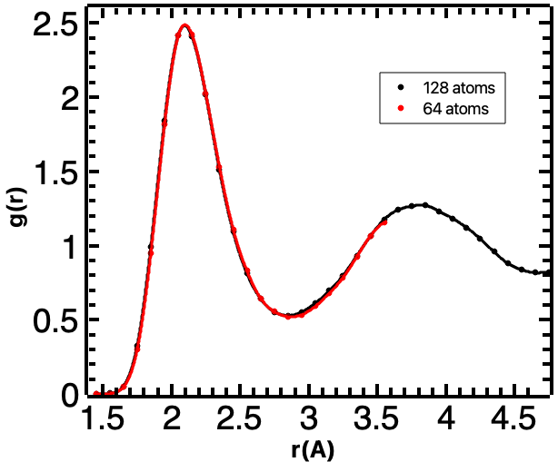 b) 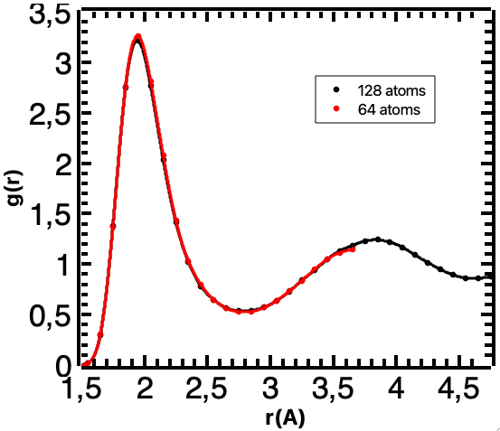
Figure 1: Comparison for a concentration of 14.9wt%S between cell sizes of 64 and 128 atoms at 330GPa and 6000K for pairs a) Fe-Fe, b) Fe-S.

Therefore, for our study, we employed a 64-atom cell, following a similar approach as Umemoto et al. (2014) and Pinilla et al. (2021), or akin to the utilization of a 67-atom cell as demonstrated by Vočadlo et al. (2003).

The state of the systems was further assessed through the analysis of the mean square displacement (MSD) of iron and sulfur atoms. It was observed that both elements within the alloy exhibit continuous movement throughout the AIMD simulation (see Figure 2), as evidenced by the linear increase in MSD over time, a characteristic commonly observed in liquids. Notably, we did not observe a constant behavior typically associated with solid materials or glasses.

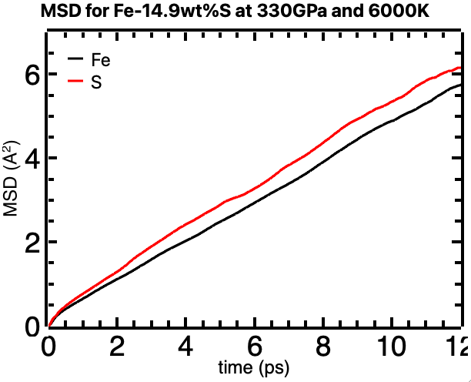
Figure 2: Evolution of the mean square displacement (MSD) for a Fe-14.9wt%S alloy under conditions of the Earth's core.

Cutoff and K-POINTS convergence tests

Now, in order to select the appropriate cutoff energy for our AIMD calculations, the convergence of the energy of the 64-atom cell was analyzed as the cutoff energy value changes. These results are shown in Figure 3, establishing a cutoff energy of 520 eV, where the total energy remains constant.

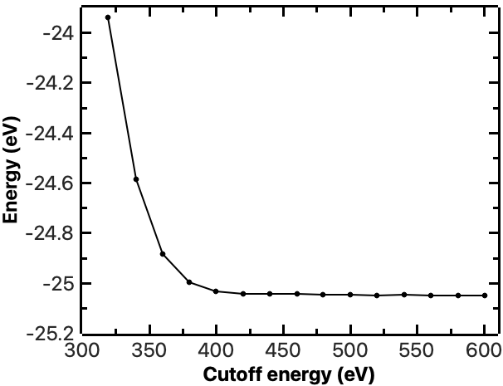
Figure 3. Calculation of cutoff energy, the cutoff energy chosen for this work is 520 eV.

Gamma point calculations where converged in total energy up to 1 meV/atom when compared with a larger 4x4x4 grid.

Initial Configuration of liquid
The initial configuration of the liquid alloys was generated by melting a body-centered cubic (bcc) structure of iron, simulated at a temperature of 10,000 K for 10 ps. The melting of the structure was confirmed by examining the radial distribution function (RDF), which exhibited characteristics typical of a liquid, and by observing that the mean square displacement (MSD) of the Fe atoms increased with time (refer to Figure 3 in Supplement). The initial configurations of the Fe-S liquid alloys were achieved by randomly replacing some Fe atoms with S atoms until the desired S concentration was attained. Subsequently, they were melted at 10,000 K for 10 ps and cooled to the desired temperature. The necessary pressures and temperatures were obtained by employing the NPT simulation methodology outlined in the methods section.

Dynamical properties of Fe-S alloys
The diffusion properties of ions in a liquid system can be described by the self-diffusion coefficient as defined by the Stokes–Einstein relation⁴¹:
$D=\frac{〈{\left|r\left(t+t_{o}\right)-r\left(t_{o}\right)\right|}^{2}〉}{6t},$ (6)
where $\left\langle ∙\right\rangle$ represents a thermodynamic average and ${\left|r\left(t+t_{o}\right)-r\left(t_{o}\right)\right|}^{2}$ is the mean square displacement. Figure 4a shows that Fe and S have similar diffusion behaviour, possibly due to the strong bond formed by Fe and S and the fact that the first solvation shell of a Fe atom is formed by a small portion of S atoms. Furthermore, our results show that the effect on diffusion produced by the addition of S to the system is negligible under these conditions, as the diffusion values found for almost all alloys studied range from $0.35×{10}^{-8}$ to $0.75×{10}^{-8}$ cm²/s. However, when pressure increases, it is seen that diffusion coefficients of Fe and S globally decrease (See Figure 4b). This behaviour is similar to the experimental results reported by Belaschenko et al⁴² and related to a stronger bond leading to a decrease in interatomic distances that results in less space for the atoms movement, thus shortening their diffusion mean path. Our results are on the same line of those obtained by Pozzo et al⁴³ on Fe-Si-O alloys where the atom size can also induce a slower diffusion.
We can use the diffusion coefficients obtained here to estimate the liquid viscosity using the Stokes-Einstein relation (SER):
$Dη=\frac{k_{B}T}{2πr}$, (7)
where, $r´$ is the effective diameter of a particle, $T$ is the absolute temperature, and $k_{B}$ is the Boltzmann’s constant. Figure 4c shows that the viscosity increases with pressure. This evidence implies that seismic wave propagation is stratified throughout the outer core's thickness. Consequently, viscosity gradients likely drive heterogeneous convection patterns at varying depths. Variable viscosity in the outer core could also affect differential convection processes at different depths of the outer core.⁴⁴

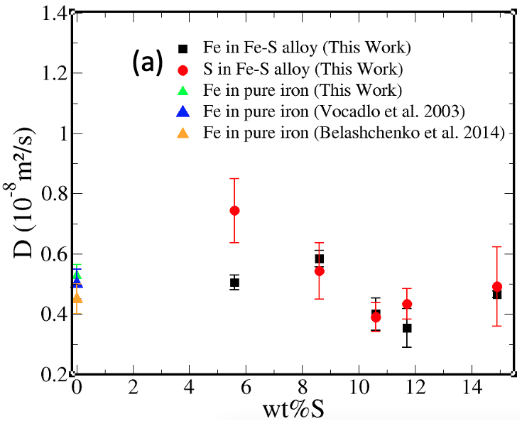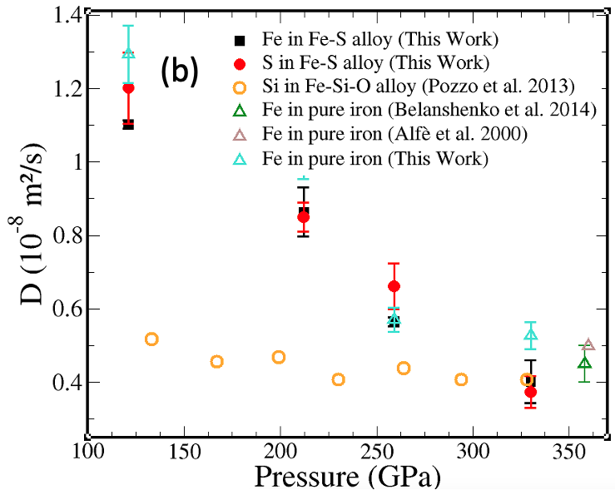
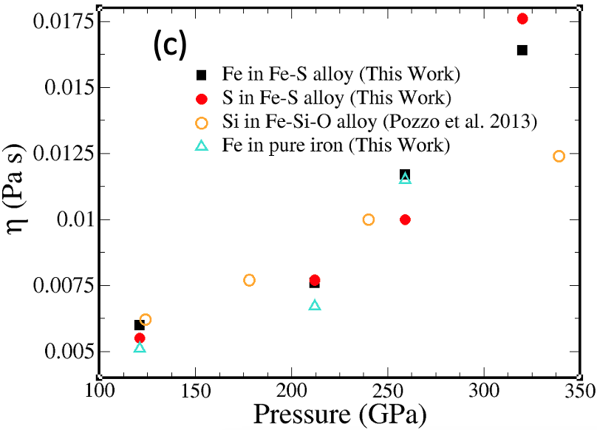
Figure 4: a) Self-diffusion coefficients for Fe (black) and S (red) as a function of sulfur concentration at 330GPa and 6000K. Upper triangles correspond to values estimated for pure iron. b) Self-diffusion coefficients as a function of pressure for a Fe-S alloy at 10.6 wt%S. c) Viscosity coefficients as a function of pressure. Circles correspond to theoretical data for a Si in the Fe-Si-O ternary alloy.⁴³

Figure 5 shows the relationship between ∆E_th and ∆P_th obtained for Fe1-xSx liquid alloys at different S concentration and at a constant reference volume (Vo= 8.58 Å3/atom). The obtained results show a linear relation between ∆E_th and ∆P_th as described by equation (3) and where the slope of this linear relation is proportional to γ/V. For a given composition of the alloy, the fact that the slope value is constant means that the γ parameter has negligible dependence on temperature at constant volume as found earlier for pure Fe34. The relations P(V,T) and E(V,T) obtained in this work have been successfully fitted to the EOS-BM displayed in equations (2) to (5). The discrepancy between the computational results and the fits for all curves is below 1.5%.
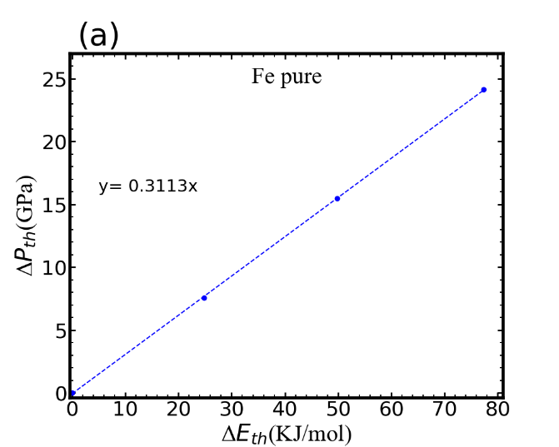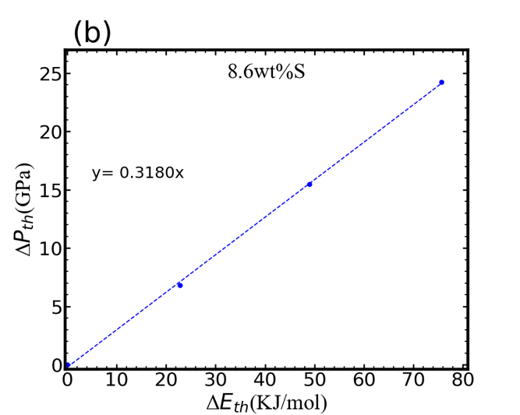
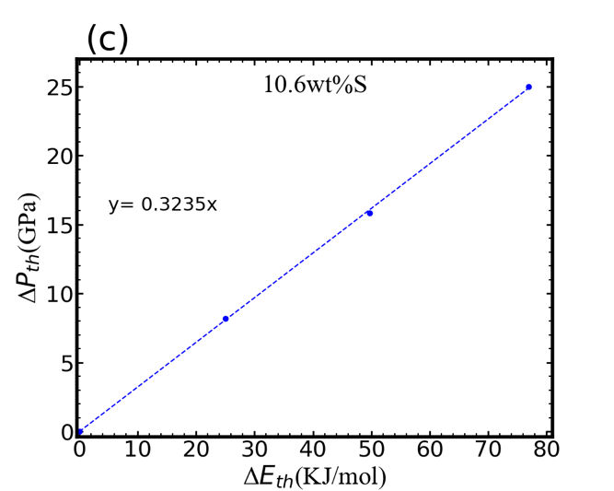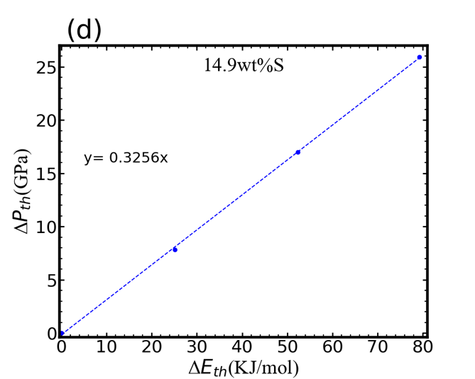

Figure 5: Relationship between total energy and thermal pressure for liquid Fe-S alloys at different S concentrations and a volume of 8.58 Å³/atom.
Other thermodynamic properties for liquid $Fe-S$ alloys are shown in Figures 6–8.
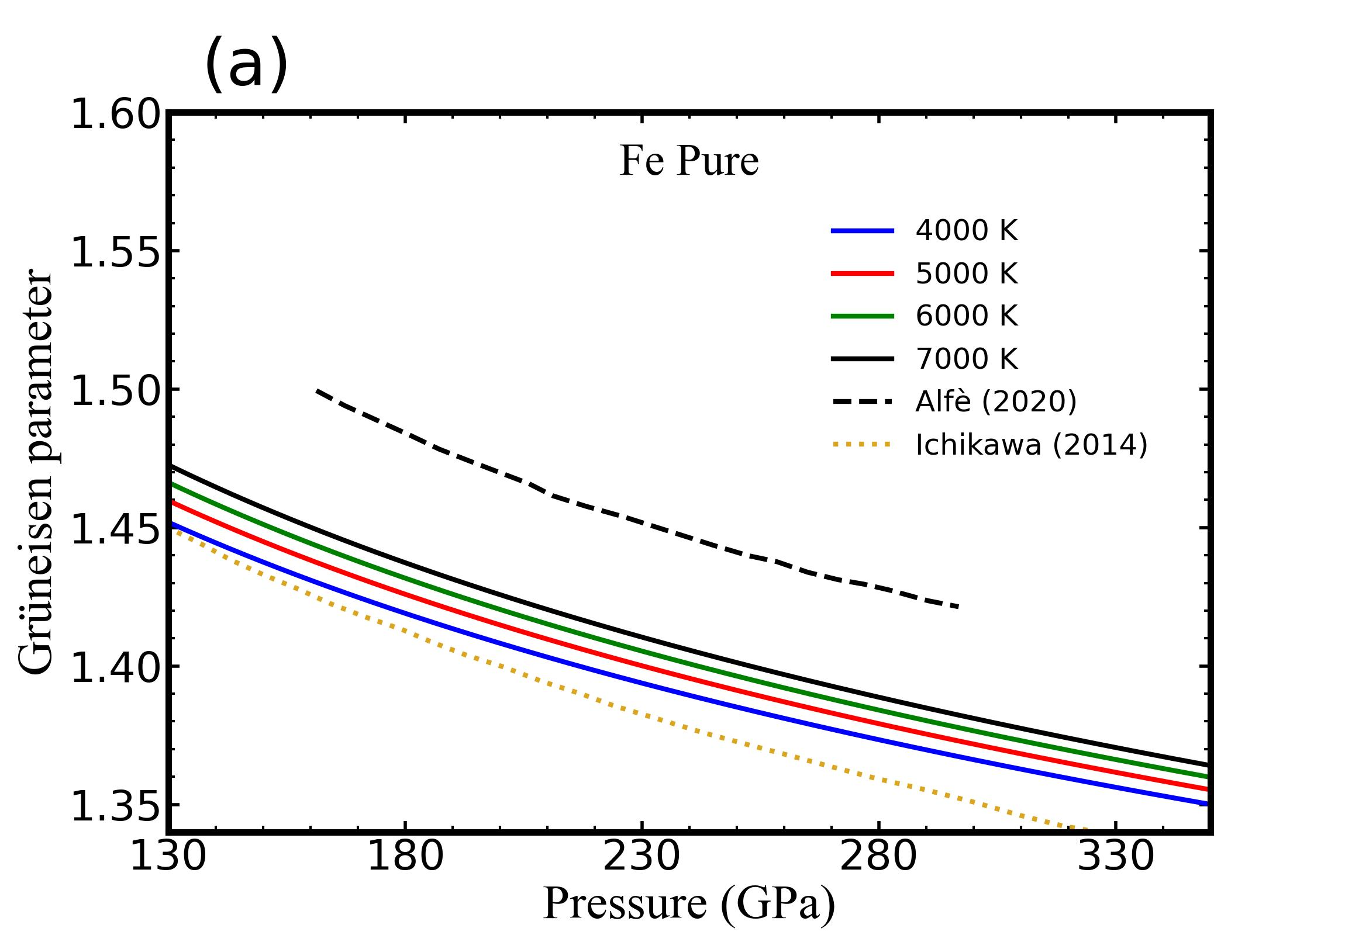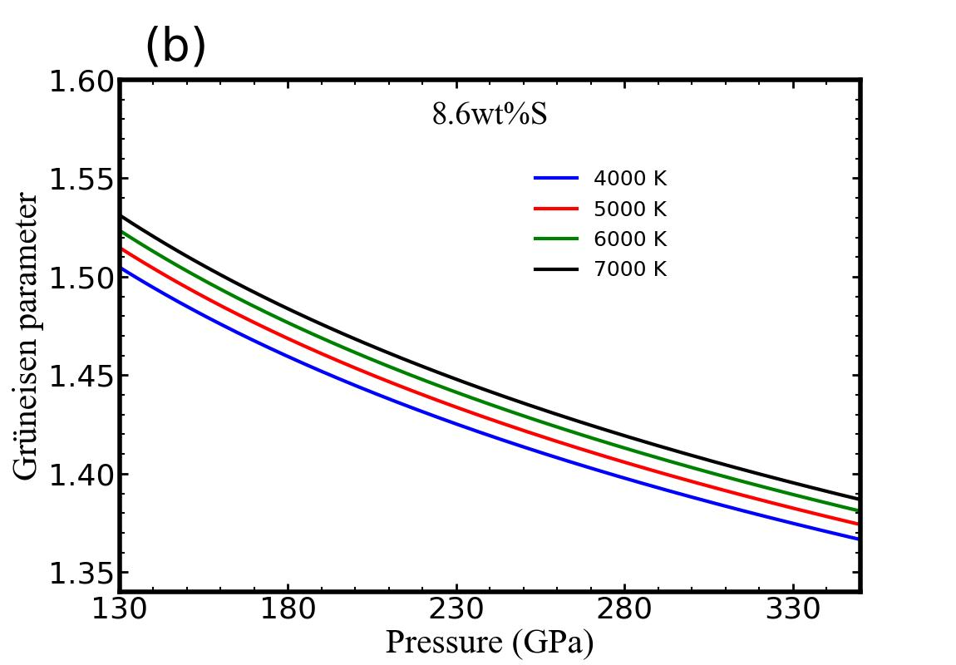
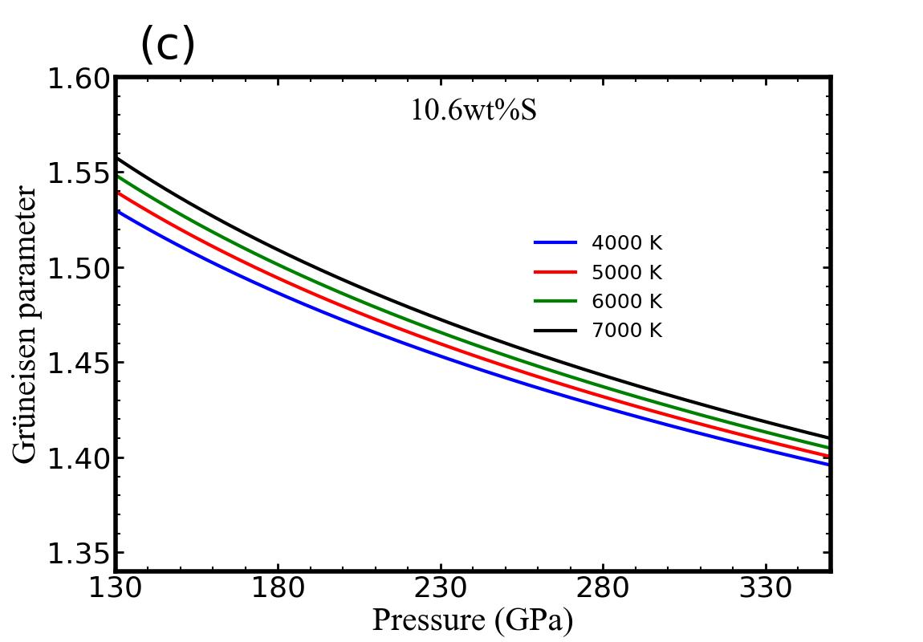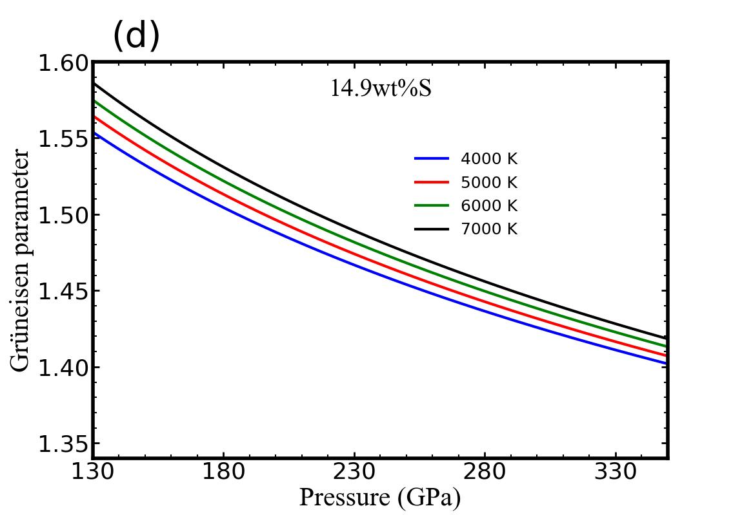

Figure 6: Grüneisen parameter of Fe-S alloys as a function of pressure and temperature for 0wt%S, 8.6wt%S, 10.6wt%S and 14.9wt%S.
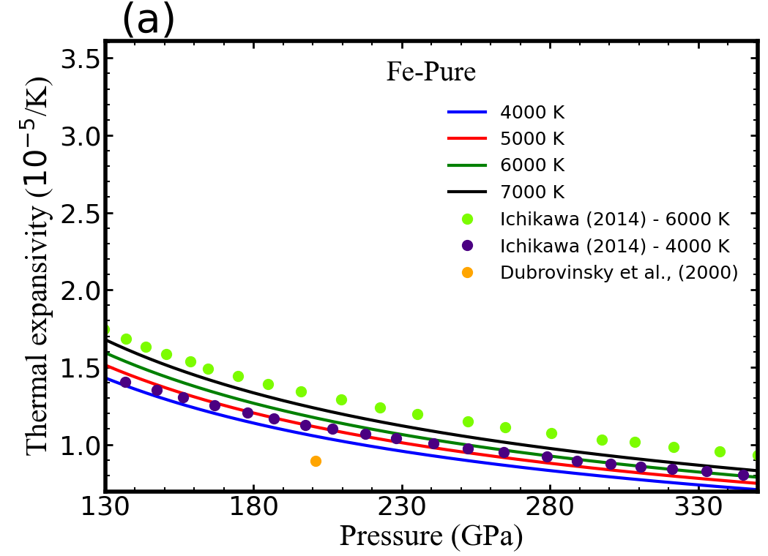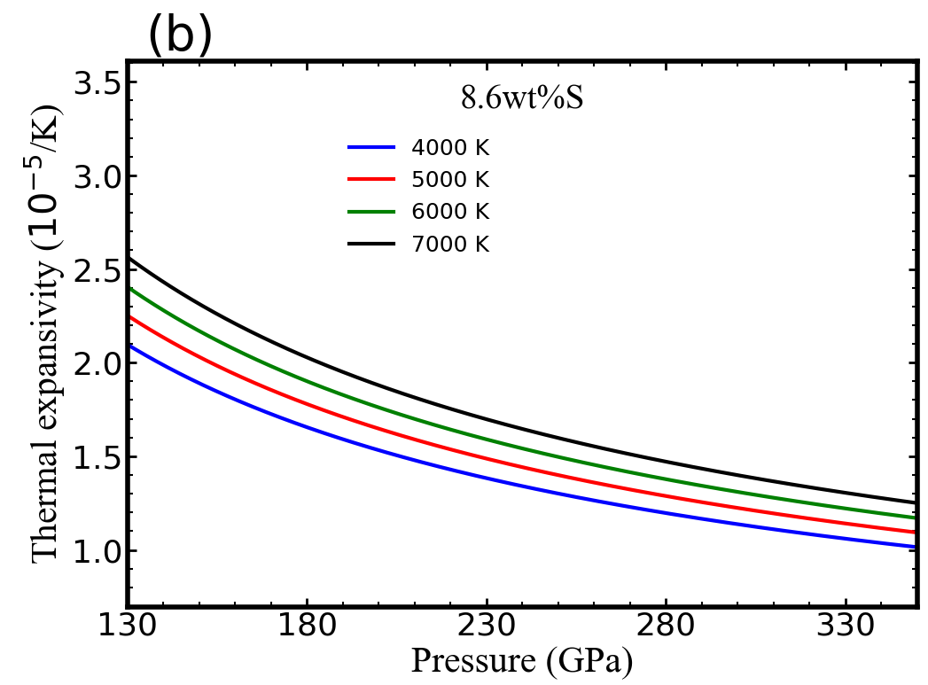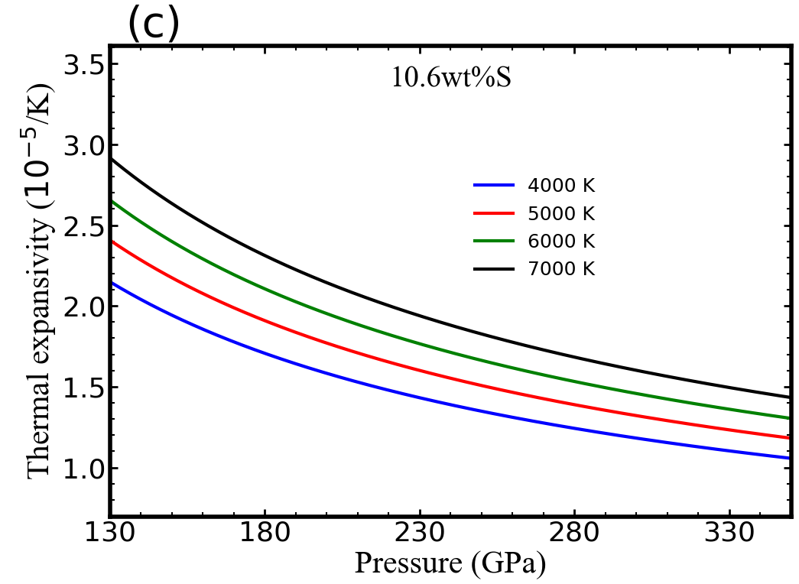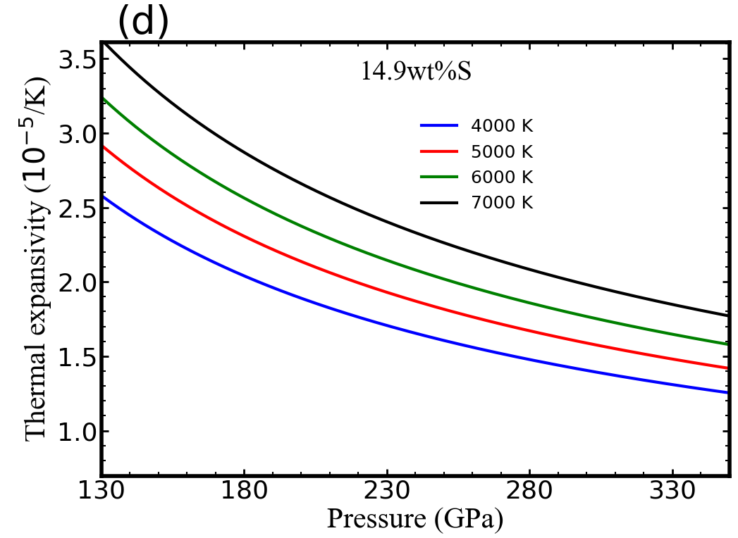
Figure 7: Thermal expansivity of Fe-S alloys as a function of pressure for 0wt%S, 8.6wt%S, 10.6wt%S and 14.9wt%S.
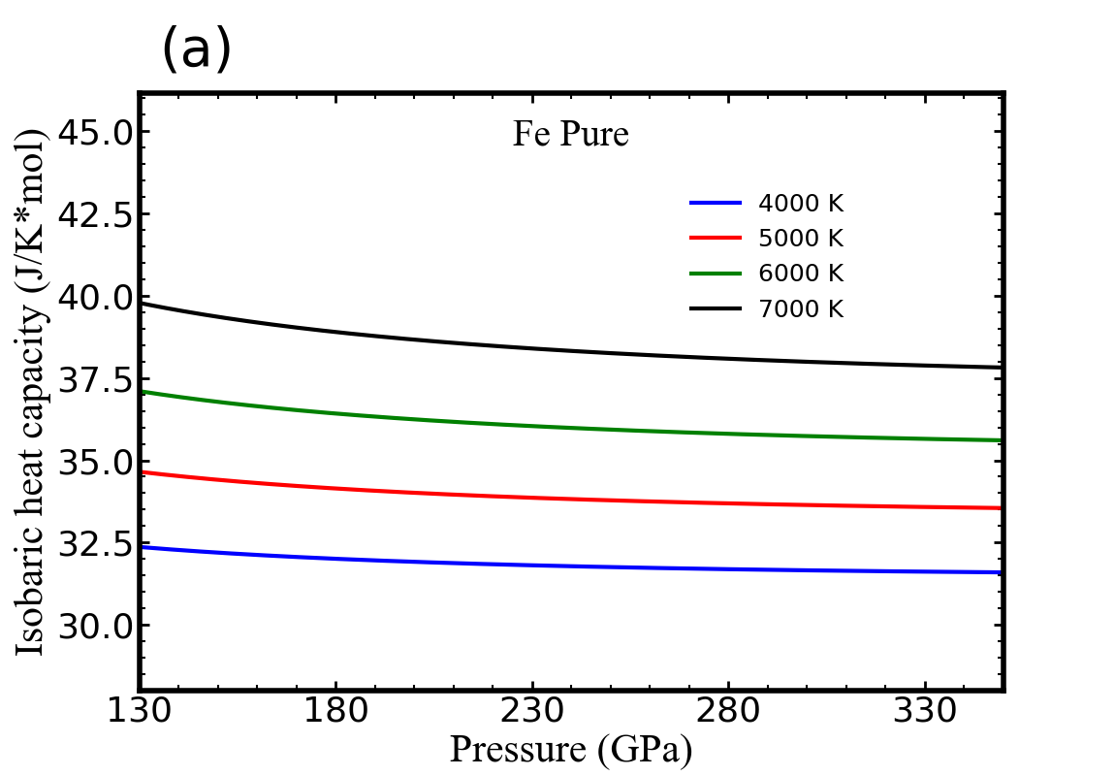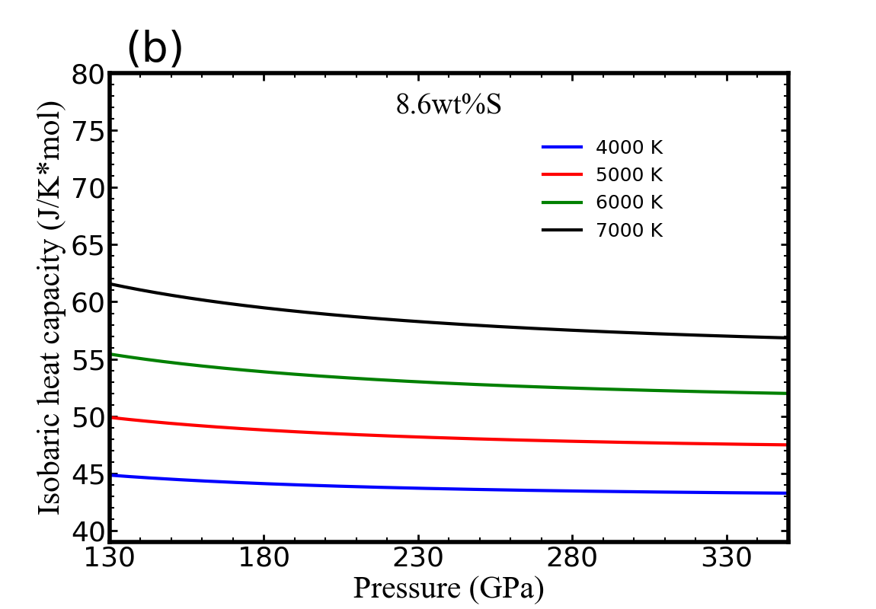
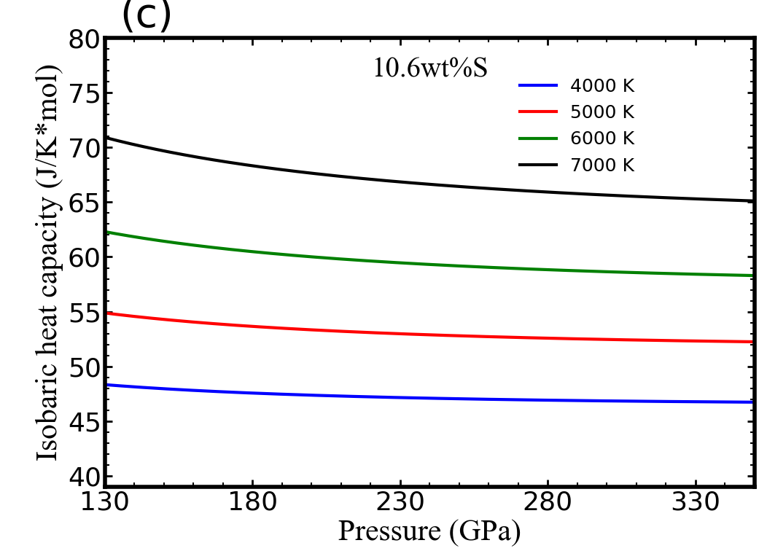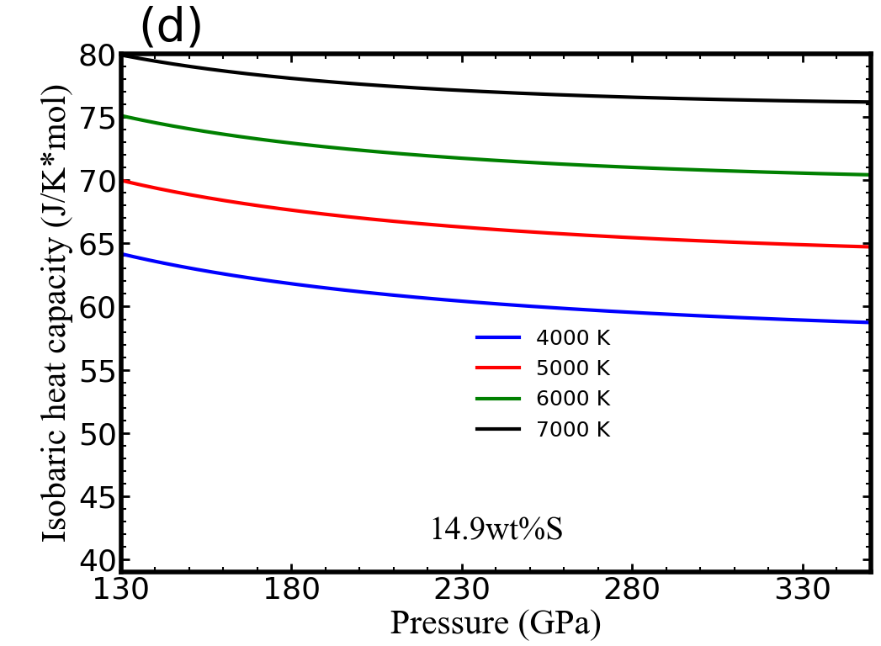
Figure 8. Isobaric heat capacity of Fe-S alloys as a function of pressure for 0wt%S, 8.6wt%S, 10.6wt%S and 14.9wt%S

