Supplementary Material

Mechanistic insights into genotoxicity caused by complex chemical mixtures in drinking water using effect-based assessment and Cell Painting
Colonnello Montero Aline ª*, Jarvius Malin ^{bc}, Rietdijk Jonne ^{bc}, Lapins Maris ^{bc}, Carreras-Puigvert Jordi ^{bc}, Spjuth Ola ^{bc}, Lundqvist Johan ª
ª Department of Animal Biosciences, Faculty of Veterinary Medicine and Animal Science, Swedish University of Agricultural Sciences, 756 51 Uppsala, Sweden
^{b} Department of Pharmaceutical Biosciences, Uppsala University, 752 37 Uppsala, Sweden
^{c} Science for Life Laboratory (SciLifeLab), Uppsala University, 752 37 Uppsala, Sweden
Corresponding Author *
Aline Colonnello Montero - Swedish University of Agricultural Sciences, Department of Animal Biosciences, Uppsala, Sweden; orcid.org/0009-0001-8813-4833; Email: aline.colonnello.montero@slu.se

Content
1. Supplementary materials and methods
  - Water samples preparation and extraction
  - General cell culturing conditions
  - Cell viability and bioactivity testing
  - Cell seeding and staining procedures for Cell Painting assays
  - Image acquisition and feature analysis

2. Supplementary figures and tables
Figure S1. tert-butylhydroquinone (tBHQ) concentration-response curve for oxidative stress induction
Figure S2. Cell viability of TK6 and MCF-7 AREc32 cell lines.
Table S1. Grit scores for water samples in U2-OS, CHO-K1 and MCF-7 cells
Table S2. Cell count for water samples in U2-OS, CHO-K1 and MCF-7 cells
Figure S3. Cell Painting images of water samples, controls and reference compounds in U2-OS cells
Figure S4. Cell Painting images of water samples, controls and reference compounds in CHO-K1 cells
Figure S5. Cell Painting images of water samples, controls and reference compounds in MCF-7 cells
Figure S6. Heatmap for the morphological changes in the top 50 features with feature labels magnification in U2-OS
Figure S7. Heatmap for the morphological changes in the top 50 features with feature labels magnification in CHO-K1
Figure S8. Heatmap for the morphological changes in the top 50 features with feature labels magnification in MCF-7
Figure S9. Radar plots displaying morphological profiles in U2-OS
Figure S10. Radar plots displaying morphological profiles in CHO-K1
Figure S11. Radar plots displaying morphological profiles in MCF-7
Table S3. Classification of correlation strength based on correlation coefficient.
Figure S12. Values of correlations between water samples at the different treatment process steps for U2-OS, CHO-K1 and MCF-7
Table S4. Correlations between water samples and SPECS drug repurposing library compounds with indications of other possible modes of action.
Table S5. Correlations between pilot GAC filtration and SPECS drug repurposing library compounds
Table S6. Correlations between mitomycin C and SPECS drug repurposing library compounds with indications of possible genotoxic modes of action.

- Supplementary materials and methods

  - Water samples preparation and extraction
The samples were collected in sterile polystyrene bottles and were stored at -20°C until extraction was performed. Water samples (900 mL) were extracted using solid phase extraction (SPE) with Oasis PRIME HLB 6 cc (200 mg) extraction cartridges (Waters) operated on an 8-channel automated SPE system (SPE-03 Gen 4, MOD-00P system, Promochrom Technologies). Prior to extraction, the cartridges were conditioned sequentially with 5 mL methanol (CAS 67-56-1, purity 99%, Solveco Sweden) at a flow rate of 5 mL/min, followed by 15 mL ethanol (CAS 64-17-5, purity 95%, Solveco Sweden) at 5 mL/min, and 10 mL Milli-Q water at 5 mL/min. The water samples were then loaded onto the cartridges at a flow rate of 15 mL/min. After sample loading, the cartridges were air-purged with 5 mL air at 10 mL/min to dry the sorbent material. Samples were subsequently eluted with 6 mL ethanol (CAS 64-17-5, purity 99%, Solveco Sweden) at a flow rate of 5 mL/min, followed by a final air purge with 10 mL air at 5 mL/min to ensure complete sample recovery. For sample concentration, the ethanol extracts were evaporated under vacuum using a SpeedVac SPD120 Vacuum Concentrator (Thermo Fisher Scientific) connected to a UVS420 Universal Vacuum System (Thermo Fisher Scientific). Samples were evaporated at 45 °C until reduced to a small volume and were subsequently adjusted with ethanol (99%) to a final volume of 180 µL, resulting in an overall concentration factor of 5000. Water sample concentrations were reported as the relative enrichment factor (REF) and diluted 100-fold in the cell culture medium. The maximum REF for all samples (REF 50) was determined by dividing the SPE enrichment factor by the dilution factor. Additional REF concentrations (25, 12.5, and 6.25) were generated through serial dilutions starting from REF 50.

1.2 General cell culturing conditions
MCF-7 AREc32: The reporter-gene cell line MCF-7 AREc32, was obtained from Ximbio (London, UK). For maintenance procedures, cells were cultured in Dulbecco’s Modified Eagle Medium (DMEM GlutaMAX) with 4.5 g/L D-glucose (Gibco), supplemented with 10% fetal bovine serum (FBS, Gibco), 50 units/ml of penicillin and 50 µg/mL of streptomycin (1% Pen-Strep, Gibco) and 0.8 mg/mL Geneticin (G418) selective antibiotic (Life Technologies). For bioactivity assays, 5,200 cell/well were seeded in white 384 well-plates with transparent bottom (Costar® Corning Incorporated) and transparent 384 well-plates for cytotoxicity testing. Cells were seeded in assay medium consisting of the same components as culture medium but without G418.
TK6: The lymphoblastic cell line was obtained from the American Type Culture Collection (ATCC, Manassas, VA, USA). The cells were cultured in Roswell Park Memorial Institute (RPMI, Gibco) 1640 medium with L-glutamine, supplemented with 10% FBS and 1% Pen-Strep. For genotoxicity and cytotoxicity assessment, 20,000 cell/well were seeded in round-bottom transparent 96 well-plates and directly after seeding, cells were exposed to samples and reference compound.
U2-OS: The osteosarcoma cell line was obtained from ATCC (HTB-96, Manassas, VA, USA). For maintenance procedures, the cells were cultured in DMEM containing 4.5 g/L glucose, L-glutamine, sodium pyruvate, and sodium bicarbonate (Thermo Fischer Scientific), 10% FBS (Thermo Fischer Scientific) and 1% Pen-Strep (Thermo Fischer Scientific). For exposure, 1000 cell/well were seeded in the same medium previously described.
CHO-K1: The Chinese hamster ovary cell line was obtained from ATCC (CCL-61, Manassas, VA, USA). For maintenance procedures, the cells were cultured in DMEM Nutrient Mixture F-12 without phenol red (DMEM-F12, Thermo Fischer Scientific), supplemented with 5% FBS, 2% Pen-Strep (Thermo Fischer Scientific), 100 µg/mL Hygromycin B (InvivoGen) and 200 µg/mL of Zeocin (Invitrogen). For exposure, 1200 cell/well were seeded in assay medium consisting of the same components as culture medium but without Hygromycin B and Zeocin.
MCF-7: The breast cancer cell line was obtained from Sigma (86012803). For maintenance procedures, the cells were cultured in DMEM high glucose, without glutamine and phenol red (Thermo Fischer Scientific), supplemented with 10% FBS and 1% Pen-Strep. For exposure, 1200 cell/well were seeded in the same medium previously described.

  - Cell viability and Bioactivity testing
Oxidative stress: After MCF-7 AREc32 cells were exposed to vehicle control, water samples, tBHQ and DMSO 10% as positive control, cytotoxicity was evaluated using the MTS cell viability method. For this method, 10 µL CellTiter 96 AQueous One Solution Cell Proliferation Assay (Promega) were manually added to each well and incubated for 40 minutes at 37 °C. For bioactivity assessment, cells in white plates were lysed, and luminescence was measured using the Luciferase Assay System reagents (Promega) and the TECAN Microplate Reader with an automatic syringe injector for addition of 10 µL luciferase substrate to each well.
For the oxidative stress, bioactivity was measured by luminescence readings. Concentration–response curves were generated to calculate the Effect Concentration at an Induction Ratio of 1.5 (EC_{IR1.5}) with tert-butylhydroquinone (tBHQ, CAS 1948-33-0, purity 97%, Sigma Aldrich) as the reference compound. Water samples with an induction of ≥1.5-fold change were labelled as bioactive. The calculated EC_{IR1.5} values for tBHQ and water samples were used to derive the BEQ of bioactive samples by dividing tBHQ EC_{IR1.5} by the EC_{IR1.5} of the samples as described in Eq. 1 [1]. The average limit of detection (LOD) was also calculated by dividing tBHQ EC_{IR1.5} value by each REF value and then multiplying by tBHQ molecular weight. Concentration–response curves were generated using simple linear regression. The mean and standard deviation (SD) were calculated using all technical replicates for each concentration across all independent experiments. Such calculations and other plots were generated using the GraphPad Prism software. The reference compound and water samples (REF dilution range from 50 to 6.25) were run in parallel with a vehicle control. DMSO 10% was used as a cytotoxic positive control.
$$Eq. 1 BEQ= (\frac{ECIR1.5 tBHQ}{ECIR1.5 sample})$$
Genotoxicity: After TK6 cells were exposed to vehicle control, water samples and mitomycin C, micronuclei formation (MN) and cell viability were analyzed at the same time by flow cytometry using the FACSVerse 8 color Flow Cytometer (BD BioSciences, Franklin Lakes, NJ, USA), with the BD FacSuite (v 1.0.6) software. Cells were stained with ethidium monoazide or EMA (red dye) to determine cell viability (EMA+), next cells were lysed, and chromatin was stained with SYTOX Green (green dye) as described in the protocol In vitro MicroFlow 96 Well Plate Fromat Kit (Litron Laboratories, NY, USA). MN assessment was carried out with flow cytometry measurements by collecting a maximum of 20 000 gates events per sample. The FITC channel measured the green dye fluorescence and PerCP-Cy5.5 channel for EMA the red dye fluorescence.
The in vitro MN assay was carried out based on the OECD 487 guideline with minor modifications. MN formation was evaluated using flow cytometry
with mitomycin C (CAS 150-07-7, purity ≥ 98%, Sigma Aldrich) as the reference compound. Water samples were analyzed using only REFs 50 and 25 and were also run in parallel with reference compound and vehicle control. For this specific bioassay, no BEQ was calculated as samples were labelled as genotoxic or non-genotoxic based on an ≥3.0-fold induction compared to the vehicle control.
  - Cell seeding and staining procedures for Cell Painting assays
For the Cell Painting assays 30 μL/well of U2-OS, CHO-K1 and MCF-7 cells were manually seeded in black 384 well-plates with transparent bottom (Perkin Elmer) and incubated over night at 37 ̊C humidified environment and 5% CO₂ prior to exposure. The compounds were diluted in medium to 4 times the final concentration, then 10 μL was added to cell plate using an Integra ViaFlow 384 microplate dispenser to a final volume of 40 μlL and incubated for 24 hours under the same conditions. After exposure, the live cells were stained with MitoTracker Deep Red FM (Thermo Fisher Scientific) at a final concentration of 500 nM in prewarmed FluoroBrite (Thermo Fischer Scientific) and incubated for 30 minutes at 37 ̊C. Next, the cells were fixed for 30 minutes at room temperature using Histofix (Histolab) at a final concentration of 2.4%. Staining of nuclei, cytoplasmic RNA/nucleoli, endoplasmic reticulum F-actin cytoskeleton and Golgi apparatus/plasma membrane was carried out by preparing a staining mixture with Hoechst 33342 (Invitrogen) 3.24 μM final concentration, SYTO 14 (Invitrogen) 0.625 µM final concentration, Concanavalin A (Invitrogen) 20 μg/mL final concentration, Wheat Germ Agglutinin (Invitrogen) 3 μg/mL final concentration, Phalloidin (Invitrogen) 6.6 nM final concentration and Triton X-100 (0.1%) in PBS (Thermo Fisher Scientific). The staining mix was then added to the cells, incubated for 30 minutes at room temperature protected from light exposure, before a washing step using 1X PBS (Thermo Fisher Scientific) was performed. Then 100 μL 1X PBS was added, and the plates was sealed using an adhesive aluminum sealer (Thermo Fisher Scientific). Mitotracker solution, Histofix, staining solution and PBS were added to the plate using the Biotek Multiflo FX microplate dispenser (Agilent). The plate was evacuated using a Bluewasher (BluCatBio). Plates were then maintained in PBS, sealed, and stored at 4 °C prior to imaging.
1.5 Image acquisition and feature analysis
High-throughput fluorescence microscopy was performed using a Squid imaging system (Cephla). Nine fields per well were imaged across five fluorescence channels to visualize nuclei, mitochondria, Golgi apparatus/plasma membrane, F-actin cytoskeleton, cytoplasmic RNA/nucleoli, and endoplasmic reticulum. Excitation wavelengths were configured as follows: 377/50 nm for Hoechst, 628/40 nm for MitoTracker, 562/40 nm for Phalloidin and Wheat Germ Agglutinin, 531/40 nm for SYTO 14, and 482/35 nm for Concanavalin A. Corresponding emission filters were set to 447/60 nm, 692/40 nm, 624/40 nm, 593/40 nm, and 536/35 nm, respectively. Image processing and quantitative analysis were carried out using CellProfiler (v 4.3.4), an open-source image analysis platform and CellPose (v 2.0), a generalist algorithm for cellular segmentation, encompassing illumination correction, segmentation, quality control, and feature extraction. Cell segmentation was generated and passed to CellProfiler for downstream feature extraction using a dedicated pipeline (available at: https://doi.org/10.17044/scilifelab.21378906.v2) described in Harrison et al (2023) [2].
Initially, raw images were assessed for image quality using multiple metrics (FocusScore, PowerLogLogSlope, MaxIntensity, MeanIntensity, and StdIntensity) across all channels. Images deviating more than six standard deviations (SD > 6) from the channel mean for any of these metrics were flagged and excluded. Additional exclusion criteria were applied to remove blurred images (PowerLogLogSlope > −1), out-of-focus images (FocusScore > 0.4), and sparsely populated images (StdIntensity < 0.01 or nuclei count < 20). The feature extraction pipeline yielded an approximately 1,500-dimensional feature vector per cell, capturing fluorescence intensity, spatial distribution, granularity, and morphological attributes across cell, nucleus, and cytoplasm compartments. Subsequent analysis was conducted in Python 3. Per-image feature values were summarized as the median across all cells within each image. Features were then normalized against ethanol or DMSO vehicle controls by subtracting the median of the controls and dividing by the median absolute deviation (MAD). Features with near-zero variance in vehicle controls (MAD < 0.0001) were excluded from further analysis.

References:

[1] B.I. Escher, M. Allinson, R. Altenburger, P.A. Bain, P. Balaguer, W. Busch, J. Crago, N.D. Denslow, E. Dopp, K. Hilscherova, A.R. Humpage, A. Kumar, M. Grimaldi, B.S. Jayasinghe, B. Jarosova, A. Jia, S. Makarov, K.A. Maruya, A. Medvedev, A.C. Mehinto, J.E. Mendez, A. Poulsen, E. Prochazka, J. Richard, A. Schifferli, D. Schlenk, S. Scholz, F. Shiraishi, S. Snyder, G. Su, J.Y. Tang, B. van der Burg, S.C. van der Linden, I. Werner, S.D. Westerheide, C.K. Wong, M. Yang, B.H. Yeung, X. Zhang, F.D. Leusch, Benchmarking organic micropollutants in wastewater, recycled water and drinking water with in vitro bioassays, Environ Sci Technol 48(3) (2014) 1940–56. https://doi.org/10.1021/es403899t.

[2] P.J. Harrison, A. Gupta, J. Rietdijk, H. Wieslander, J. Carreras-Puigvert, P. Georgiev, C. Wählby, O. Spjuth, I.M. Sintorn, Evaluating the utility of brightfield image data for mechanism of action prediction, PLoS Comput Biol 19(7) (2023) e1011323. https://doi.org/10.1371/journal.pcbi.1011323.

- Supplementary figures and tables
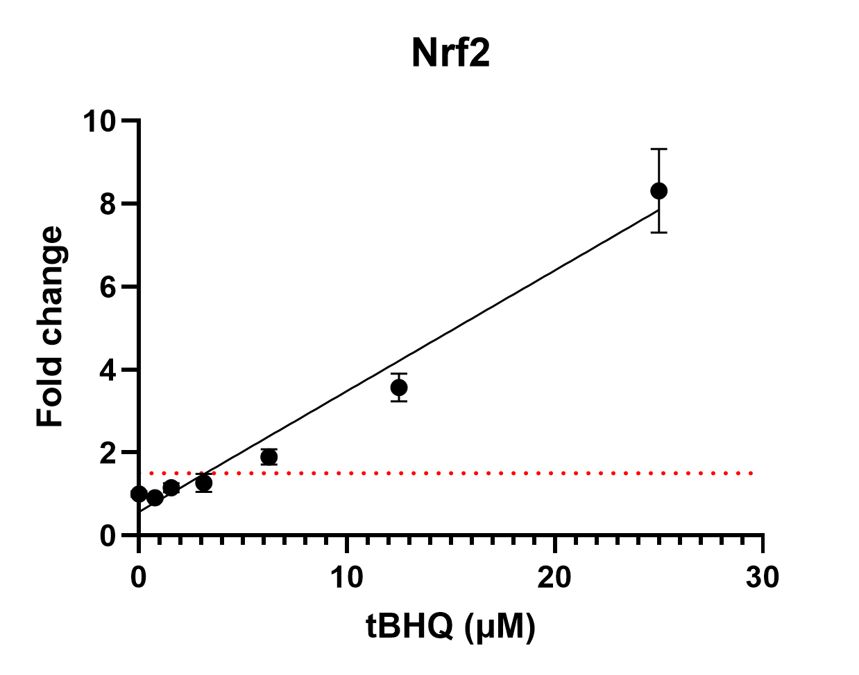

Figure S1. tert-butylhydroquinone (tBHQ) concentration-response curve for oxidative stress induction. The dotted line represents the bioactivity cut-off limit of 1.5-fold change for Nrf2 activity, where the average tBHQ EC_{IR1.5} is 3.2 µM. Data is presented as mean ± SD, n= 8 (two independent experiments with four technical replicates per concentration).

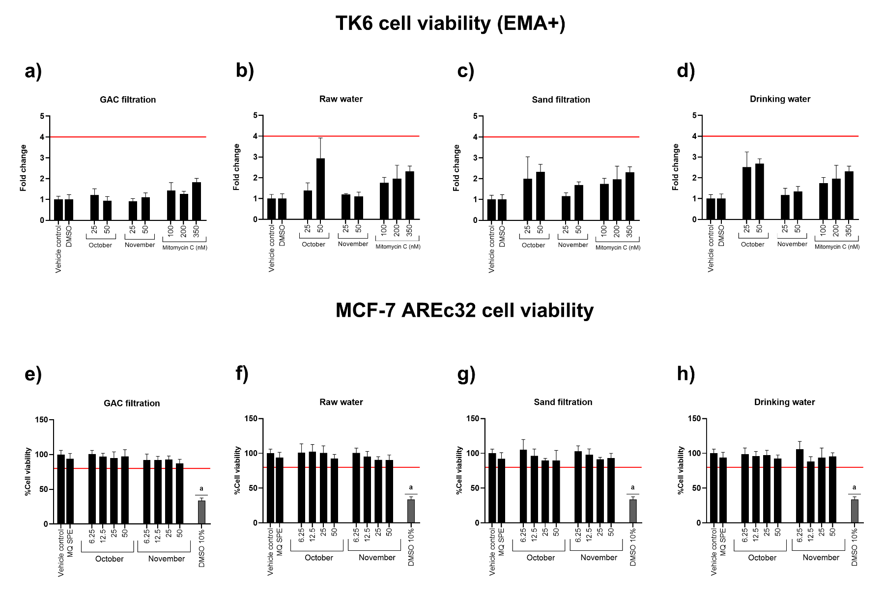
Figure S2. Cell viability of TK6 and MCF-7 AREc32 cell lines. In panels a) - d), cell viability (EMA+) of TK6 cells exposed to water samples and Mitomycin C (100, 200 and 350 nM) for 24 hrs. The line represents the cut-off limit in fold change (≥ 4.0) for defining cytotoxicity. In panels e) – h), cell viability of MCF-7 AREc32 cells exposed to water samples, MQ SPE and DMSO 10% as positive control for 24 hrs. Values lower than 80% viability are presented as a. In both cell lines, samples were categorized as a) & e) GAC filtration, b) & f) Raw water, c) & g) Sand filtration and d) & h) Drinking water. All samples were assessed in October and November of 2024. Sample concentrations are expressed as REF 25-50 for TK6 and REF 6.25 – 50 for MCF-7 AREc32. Data is presented as mean ± SD, n= 8 (two independent experiments with four technical replicates per concentration).

Table S1. Grit scores for water samples by REF concentration, controls and reference compounds for U2-OS, CHO-K1 and MCF-7 cells. Grit scores were calculated for individual images acquired from 3 technical replicates per water sample and reference compounds and 12 technical replicates for controls from a single experiment. Water samples and MQ SPE were normalized against ethanol vehicle control, and reference compounds were normalized against DMSO vehicle control. Data is presented as mean ± SD of all analyzed images per treatment.

Grit scores |  | U2-OS |  | CHO-K1 |  | MCF-7
October |  | REF 25 | REF 50 | REF 25 | REF 50 | REF 25 | REF 50
October | GAC filtration | 1.2 ± 0.5 | 2.2 ± 0.4 | 0.7 ± 0.6 | 1.6 ± 0.8 | 0.7 ± 0.3 | 2.3 ± 0.6
October | Raw water | 2.4 ± 0.5 | 3.8 ± 0.4 | 1.5 ± 0.5 | 2.5 ± 1.0 | 1.5 ± 0.5 | 2.8 ± 0.4
October | Sand filtration | 3.1 ± 0.3 | 4.1 ± 0.5 | 1.3 ± 0.6 | 2.1 ± 0.4 | 3.0 ± 0.8 | 2.9 ± 0.3
October | Drinking water | 4.0 ± 0.6 | 4.3 ± 0.4 | 1.0 ± 0.4 | 2.0 ± 0.6 | 3.2 ± 0.6 | 3.1 ± 0.6
November | GAC filtration | 2.1 ± 0.6 | 2.7 ± 0.6 | 0.8 ± 0.6 | 1.9 ± 0.8 | 0.9 ± 0.4 | 1.8 ± 0.6
November | Raw water | 2.8 ± 0.6 | 4.0 ± 0.4 | 1.5 ± 0.7 | 2.2 ± 0.6 | 3.4 ± 0.6 | 3.1 ± 0.4
November | Sand filtration | 3.6 ± 0.3 | 4.3 ± 0.4 | 1.5 ± 0.3 | 2.2 ± 1.1 | 3.5 ± 0.7 | 3.1 ± 0.3
November | Drinking water | 4.1 ± 0.3 | 4.4 ± 0.4 | 1.3 ± 0.6 | 2.0 ± 0.8 | 3.2 ± 0.7 | 3.0 ± 0.6
Controls | Ethanol 1% | 0.0 |  | -0.2 ± 0.2 |  | 0.0
Controls | MQ SPE | 0.3 ± 0.2 |  | 0.1 ± 0.3 |  | 0.3 ± 0.5
Controls | DMSO 0.5% | 0.3 ± 0.2 |  | 0.3 ± 0.2 |  | 0.2 ± 0.4
Reference compounds | Cytochalasin B  5 µM | 5.2 ± 0.3 |  | 4.3 ± 0.6 |  | 4.3 ± 0.4
Reference compounds | Mitomycin C  350 nM | 2.1 ± 0.6 |  | 3.2 ± 1.3 |  | 0.4 ± 0.4

Table S2. Cell count for water samples by REF concentration, controls and reference compounds for U2-OS, CHO-K1 and MCF-7 cells. Number of cells was calculated for individual images acquired from 3 technical replicates per water sample and reference compounds and 12 technical replicates for controls from a single experiment. Water samples and MQ SPE were normalized against ethanol vehicle control, and reference compounds were normalized against DMSO vehicle control. Data is presented as mean ± SD of all analyzed images per treatment.

Cell count |  | U2-OS |  | CHO-K1 |  | MCF-7
October |  | REF 25 | REF 50 | REF 25 | REF 50 | REF 25 | REF 50
October | GAC filtration | 92 ± 24 | 81 ± 21 | 638 ± 125 | 552 ± 125 | 192 ± 46 | 186 ± 42
October | Raw water | 83 ± 26 | 55 ± 15 | 562 ± 118 | 442 ± 122 | 180 ± 58 | 130 ± 45
October | Sand filtration | 79 ± 27 | 51 ± 16 | 548 ± 159 | 416 ± 105 | 164 ± 53 | 114 ± 39
October | Drinking water | 77 ± 16 | 56 ± 16 | 576 ± 149 | 433 ± 83 | 164 ± 39 | 144 ± 40
November | GAC filtration | 95 ± 20 | 74 ± 21 | 603 ± 108 | 497 ± 93 | 195 ± 48 | 168 ± 57
November | Raw water | 76 ± 22 | 52 ± 18 | 544 ± 116 | 417 ± 97 | 176 ± 36 | 130 ± 27
November | Sand filtration | 82 ± 18 | 54 ± 12 | 559 ± 122 | 409 ± 96 | 155 ± 34 | 116 ± 28
November | Drinking water | 79 ± 15 | 59 ± 17 | 565 ± 113 | 415 ± 90 | 165 ± 38 | 132 ± 34
Controls | Ethanol 1% | 102 ± 26 |  | 622 ± 131 |  | 198 ± 44
Controls | MQ SPE | 104 ± 34 |  | 629 ± 142 |  | 209 ± 51
Controls | DMSO 0.5% | 103 ± 36 |  | 620 ± 143 |  | 201 ± 54
Reference compounds | Cytochalasin B  5 µM | 50 ± 18 |  | 155 ± 32 |  | 74 ± 23
Reference compounds | Mitomycin C  350 nM | 89 ± 31 |  | 489 ± 116 |  | 214 ± 47

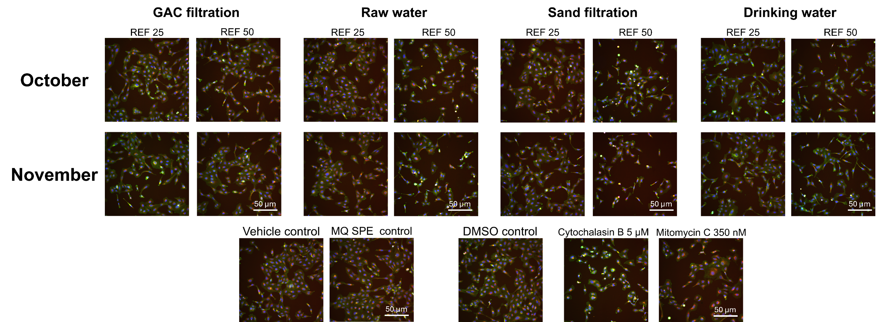
Figure S3. Cell Painting images of water samples at the different treatment process steps in October and November, vehicle control, MQ SPE control, DMSO control, cytochalasin B (5µM) and mitomycin C (350 nM) in U2-OS cells exposed to water samples (REFs 25 and 50), controls and reference compounds for 24 hrs. The images represent merged fluorescence channels of the Hoechst, MitoTracker, Phalloidin/Wheat Germ Agglutinin, SYTO 14, and Concanavalin A staining Scale bar of all images = 50 µm.
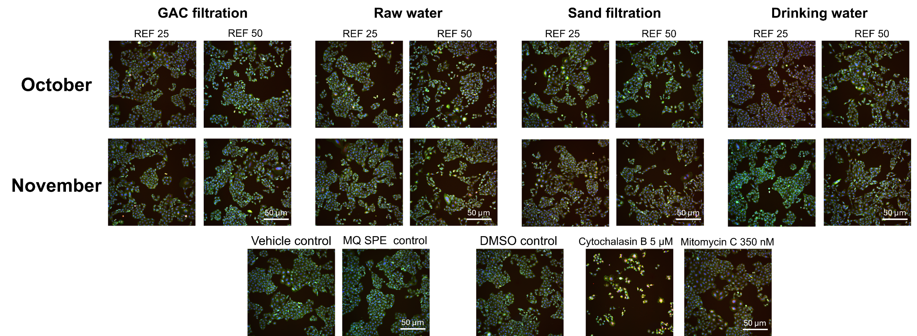
Figure S4. Cell Painting images of water samples at the different treatment process steps in October and November, vehicle control, MQ SPE control, DMSO control, cytochalasin B (5µM) and mitomycin C (350 nM) in CHO-K1 cells exposed to water samples (REFs 25 and 50), controls and reference compounds for 24 hrs. The images represent merged fluorescence channels of the Hoechst, MitoTracker, Phalloidin/Wheat Germ Agglutinin, SYTO 14, and Concanavalin A staining. Scale bar of all images = 50 µm.

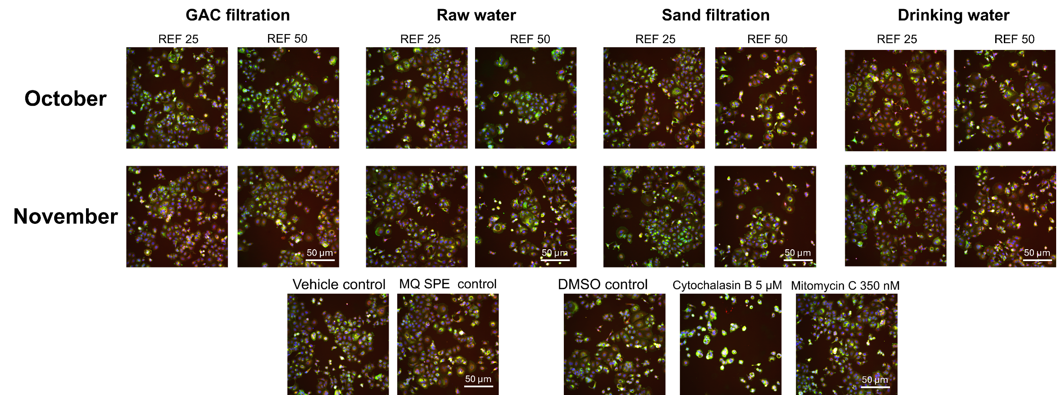
Figure S5. Cell Painting images of water samples at the different treatment process steps in October and November, vehicle control, MQ SPE control, DMSO control, cytochalasin B (5µM) and mitomycin C (350 nM) in MCF-7 cells exposed to water samples (REFs 25 and 50), controls and reference compounds for 24 hrs. The images represent merged fluorescence channels of the Hoechst, MitoTracker, Phalloidin/Wheat Germ Agglutinin, SYTO 14, and Concanavalin A staining. Scale bar of all images = 50 µm.

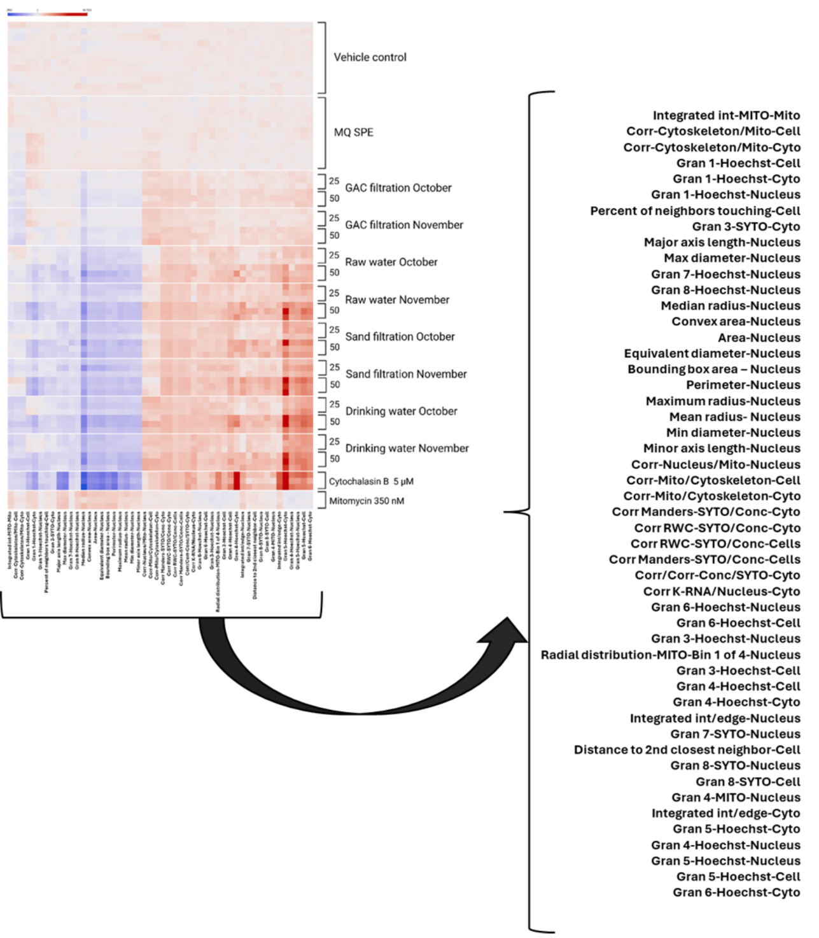
Figure S6. Heatmap for the morphological changes in the top 50 features with feature labels magnification in U2-OS cells exposed to water samples (REFs 25 and 50), MQ SPE, mitomycin C (350 nM) and cytochalasin B (5 µM) for 24 hrs. The heatmap displays a blue–red color scale, where blue indicates lower values (down to −15.6 - dark blue) and red indicates higher values (up to 55.1 - dark red). The black arrow indicates the magnification of the simplified feature list of the top 50 extracted features from the CellProfiler pipeline that resulted from the image analysis. Heatmaps show the individual profiles of the technical replicates obtained in a single experiment (3 for each water sample concentration and reference compound and 12 for vehicle and MQ SPE controls).

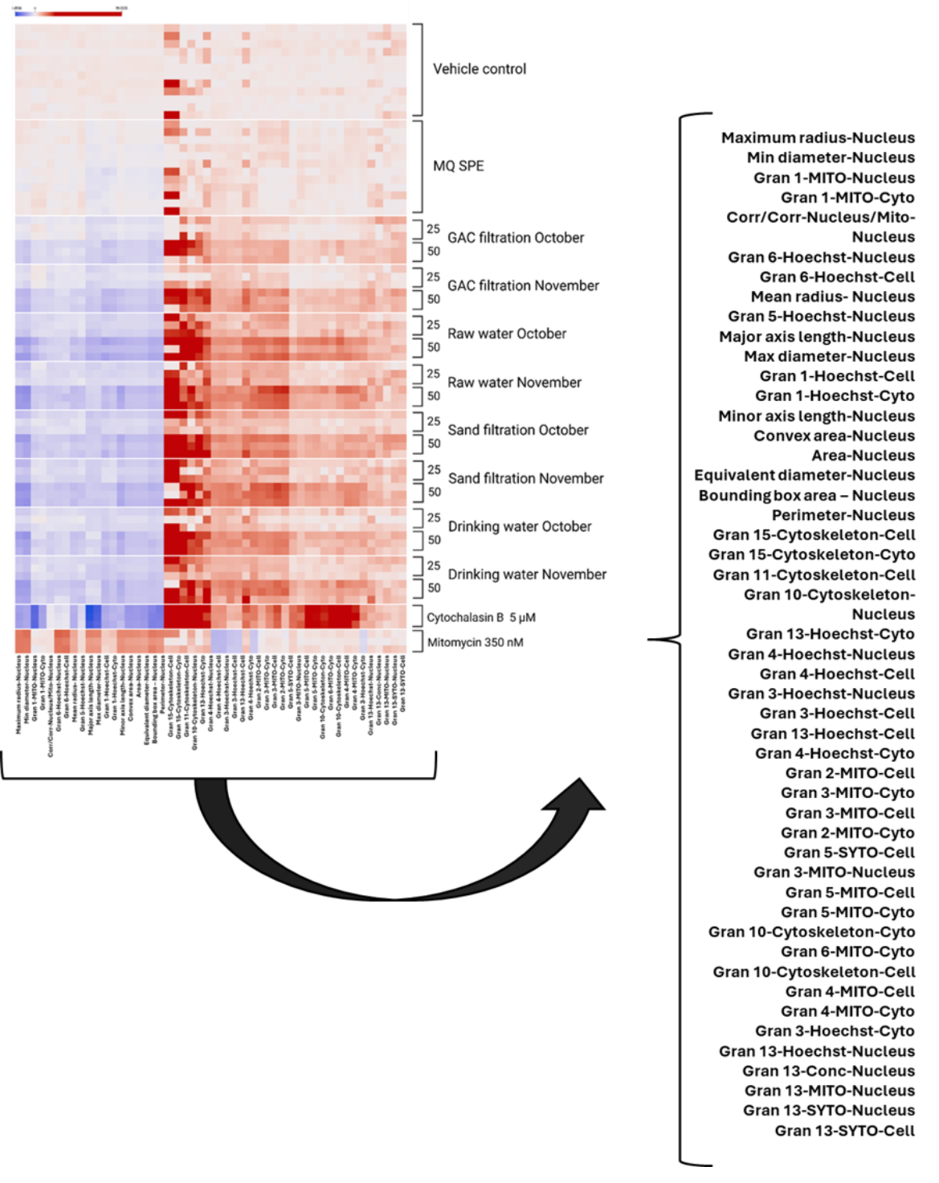
Figure S7. Heatmap for the morphological changes in the top 50 features with feature labels magnification in CHO-K1 cells exposed to water samples (REFs 25 and 50), MQ SPE, mitomycin C (350 nM) and cytochalasin B (5 µM) for 24 hrs. The heatmap displays a blue–red color scale, where blue indicates lower values (down to −15.6 - dark blue) and red indicates higher values (up to 55.1 - dark red). The black arrow indicates the magnification of the simplified feature list of the top 50 extracted features from the CellProfiler pipeline that resulted from the image analysis. Heatmaps show the individual profiles of the technical replicates obtained in a single experiment (3 for each water sample concentration and reference compound and 12 for vehicle and MQ SPE controls).

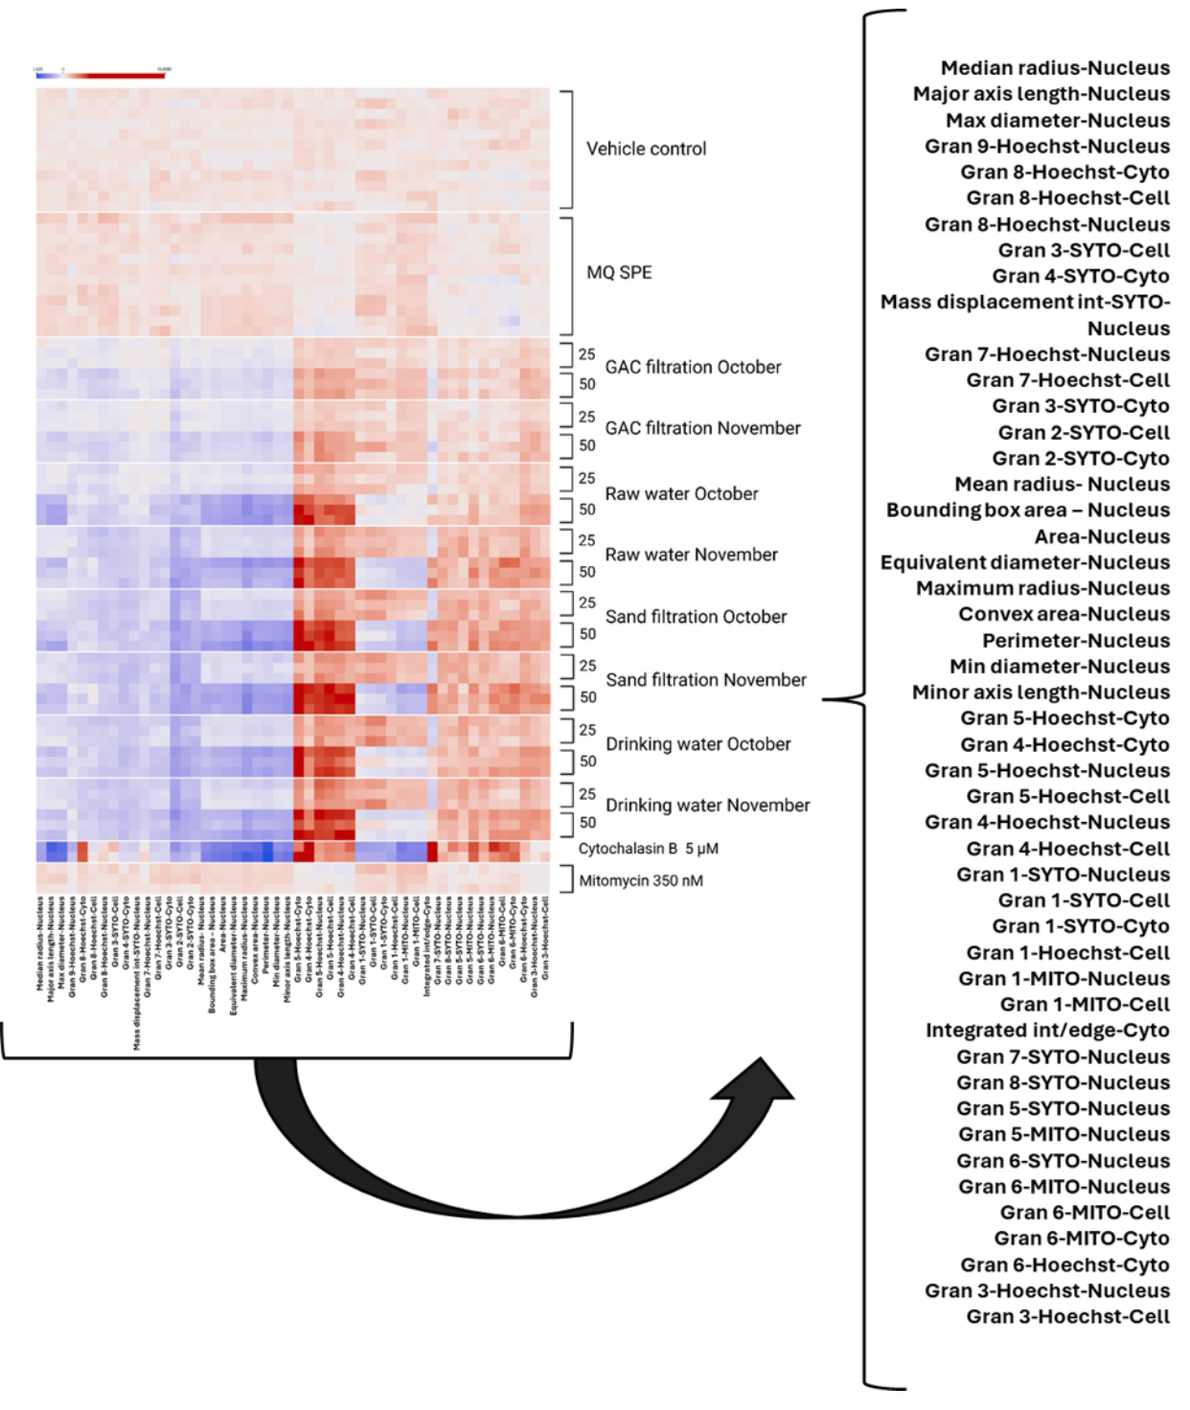
Figure S8. Heatmap for the morphological changes in the top 50 features with feature labels magnification in MCF-7 cells exposed to water samples (REFs 25 and 50), MQ SPE, mitomycin C (350 nM) and cytochalasin B (5 µM) for 24 hrs. The heatmap displays a blue–red color scale, where blue indicates lower values (down to −15.6 - dark blue) and red indicates higher values (up to 55.1 - dark red). The black arrow indicates the magnification of the simplified feature list of the top 50 extracted features from the CellProfiler pipeline that resulted from the image analysis. Heatmaps show the individual profiles of the technical replicates obtained in a single experiment (3 for each water sample concentration and reference compound and 12 for vehicle and MQ SPE controls).

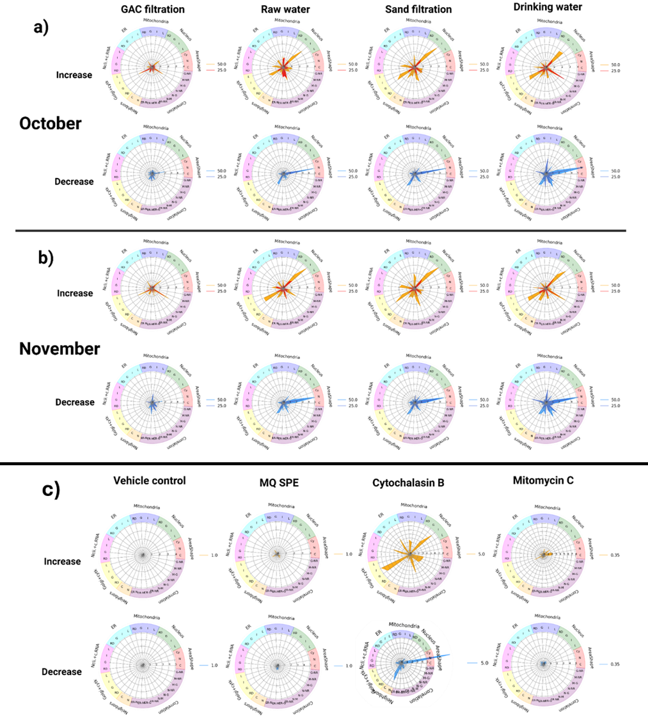
Figure S9. Radar plots displaying morphological profiles in U2-OS cells exposed to water samples (REFs 25 and 50), MQ SPE, mitomycin C (350 nM) and cytochalasin B (5 µM) for 24 hrs. The plots summarize morphological features grouped by cellular compartments, including mitochondria, nucleus, actin cytoskeleton, endoplasmic reticulum, Golgi apparatus/plasma membrane, RNA/nucleoli, as well as correlations and neighboring structures. The radar plots with orange-red colors represent high values and blue colors represent low values for features. Panel a) shows phenotypic profiles from samples comprising October, panel b) shows phenotypic profiles from samples comprising November and panel c) shows fingerprints from vehicle, SPE MQ controls and reference compounds. The radar plots display the merged fingerprint generated from all replicates from the U2-OS top 50 features heatmap.
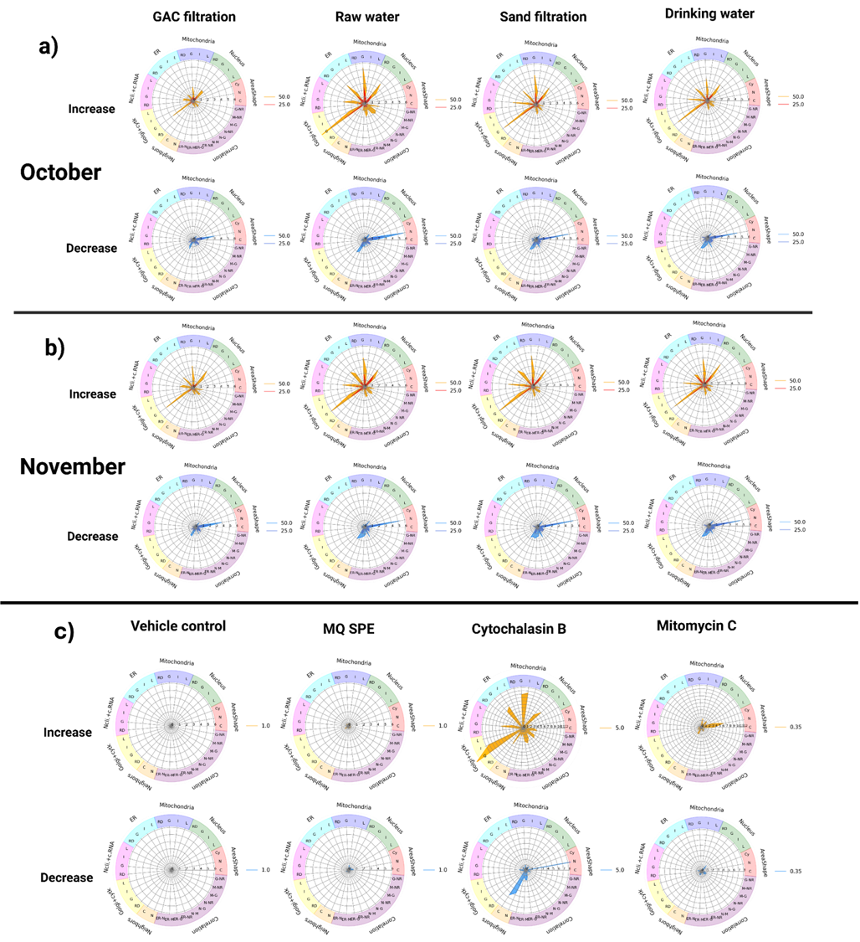
Figure S10. Radar plots displaying morphological profiles in CHO-K1 cells exposed to water samples (REFs 25 and 50), MQ SPE, mitomycin C (350 nM) and cytochalasin B (5 µM) for 24 hrs. The plots summarize morphological features grouped by cellular compartments, including mitochondria, nucleus, actin cytoskeleton, endoplasmic reticulum, Golgi apparatus/plasma membrane, RNA/nucleoli, as well as correlations and neighboring structures. The radar plots with orange-red colors represent high values and blue colors represent low values for features. Panel a) shows phenotypic profiles from samples comprising October, panel b) shows phenotypic profiles from samples comprising November and panel c) shows fingerprints from vehicle, SPE MQ controls and reference compounds. The radar plots display the merged fingerprint generated from all replicates from the CHO-K1 top 50 features heatmap.
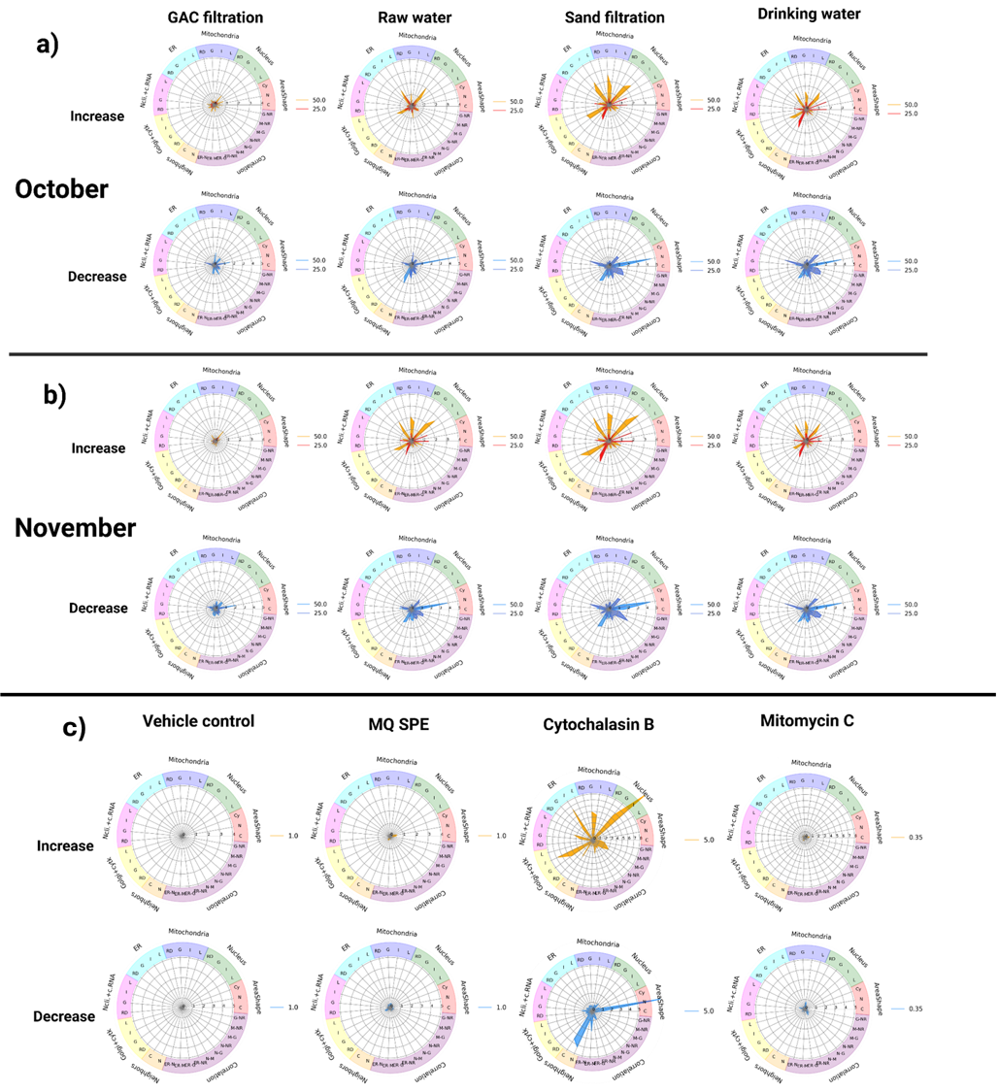
Figure S11. Radar plots displaying morphological profiles in MCF-7 cells exposed to water samples (REFs 25 and 50), MQ SPE, mitomycin C (350 nM) and cytochalasin B (5 µM) for 24 hrs. The plots summarize morphological features grouped by cellular compartments, including mitochondria, nucleus, actin cytoskeleton, endoplasmic reticulum, Golgi apparatus/plasma membrane, RNA/nucleoli, as well as correlations and neighboring structures. The radar plots with orange-red colors represent high values and blue colors represent low values for features. Panel a) shows phenotypic profiles from samples comprising October, panel b) shows phenotypic profiles from samples comprising November and panel c) shows fingerprints from vehicle, SPE MQ controls and reference compounds. The radar plots display the merged fingerprint generated from all replicates from the MCF-7 top 50 features heatmap.

Table S3. Classification of correlation strength based on correlation coefficient. The table displays interval coefficients and relationship levels used to classify relationships between samples and between samples and SPECS drug repurposing set library compounds.

Interval coefficient (r) | Relationship level
0.80 – 1.00 | Very strong
0.60 – 0.79 | Strong
0.40 – 0.59 | Moderate
0.20 – 0.39 | Weak
0.00 – 0.19 | Very weak or NO correlation

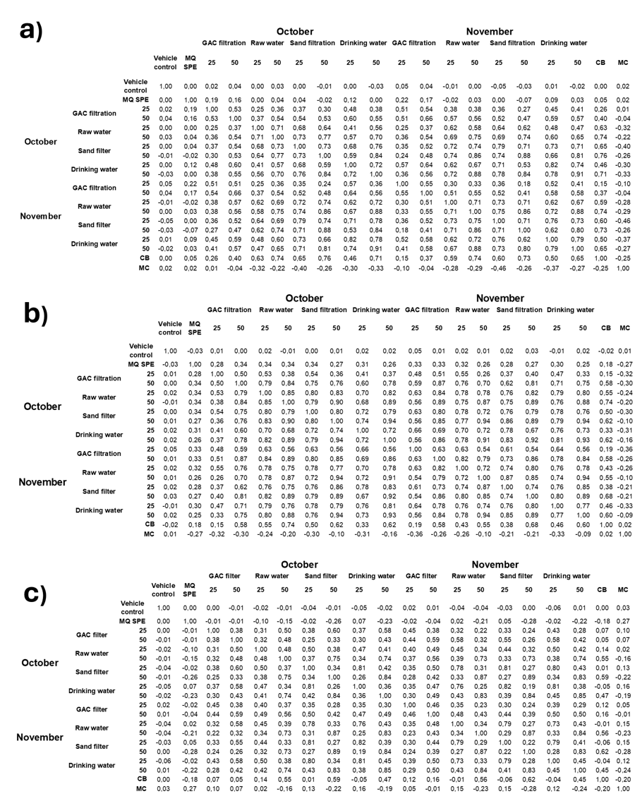
Figure S12. Values of correlations between water samples at the different treatment process steps for U2-OS, CHO-K1 and MCF-7 cells exposed to water samples (REFs 25 and 50), MQ SPE, mitomycin C (MC, 350 nM) and cytochalasin B (CB, 5 µM) for 24 hrs. Pannel a) shows the correlations in U2-OS, b) the correlations in CHO-K1 and c) the correlations in MCF-7 in October and November. The columns display pairwise correlation coefficients between samples based on their morphological profiles. Pairwise correlations were calculated between samples based on the aggregated data from the technical replicates obtained in a single experiment (3 for each water sample concentration and reference compound and 12 for vehicle and MQ SPE controls), with each cell representing the correlation of morphological profiles between two samples.

Table S4. Correlations between water samples and SPECS drug repurposing set library compounds in U2-OS cells with indications of other possible modes of action. The table shows the correlation range of water samples and cytochalasin B with SEPCS drug repurposing set library compounds as well as the mechanistic category and specific mode of action in which the correlations were classified. Correlation are indicated with the ● symbol.

Compound | Mechanistic category | Specific mode of action | Correlation range with water samples | GAC Oct | GAC Nov | RW Oct | RW Nov | SF Oct | SF Nov | DW Oct | DW Nov | Cytochalasin B
EMD-53998 | Cardiac contractility modulation | Phosphodiesterase inhibition & Troponin C calcium sensitization | 0.49 – 0.60  Moderate – Strong |  |  | ● | ● | ● | ● | ● | ●
Spiperone | Neurotransmitter receptor modulation | Dopamine & Serotonin receptor antagonism | 0.42 – 0.74  Moderate – Strong |  |  | ● | ● | ● | ● | ● | ● | ●
3'-fluorobenzylspiperone | Neurotransmitter receptor modulation | Dopamine receptor agonism | 0.48 – 0.62  Moderate – Strong |  |  | ● |  | ● | ● | ● |  | ●
AZD3514 | Receptor and endocrine pathway modulation | AR antagonism | 0.52 – 0.65  Moderate – Strong |  |  |  | ● | ● | ● | ● | ●
Letrozole | Receptor and endocrine pathway modulation | Aromatase inhibitor | 0.53 – 0.57  Moderate |  |  |  | ● | ● | ● | ● | ●
Mefloquine hydrochloride | Receptor and endocrine pathway modulation | Adenosine receptor antagonism | 0.51 – 0.58  Moderate |  |  |  | ● | ● | ● | ● | ● | ●
WAY-207024 | Receptor and endocrine pathway modulation | Gonadotropin releasing factor hormone receptor antagonism | 0.33 – 0.51  Weak - Moderate | ● |  | ● |  | ●
IKK-2-inhibitor-V | Inflammation signaling modulation | IKK inhibition/NFkB pathway inhibition | 0.50 – 0.58  Moderate |  |  |  | ● |  | ● | ● | ● | ●
Y-320 | Inflammation signaling modulation | Interleukin (IL14A) inhibition | 0.52 – 0.53  Moderate |  |  |  | ● |  |  | ●
Dapivirine (TMC120) | Viral polymerase inhibitor | Non-nucleoside reverse transcriptase inhibition | 0.50 – 0.61  Moderate – Strong |  |  | ● | ● | ● | ● |  |  | ●
OSI-027 | Cell growth and survival signaling pathway modulation | mTOR inhibition | 0.49 – 0.56  Moderate |  |  |  | ● |  | ● | ● | ●
AZD8055 | Cell growth and survival signaling pathway modulation | mTOR inhibition | 0.49 – 0.65  Moderate – Strong |  |  |  |  |  | ● | ● | ●
Torin 1 | Cell growth and survival signaling pathway modulation | mTOR inhibition | 0.49 – 0.53  Moderate |  |  |  |  |  |  | ● | ●
LY3023414 | Cell growth and survival signaling pathway modulation | mTOR inhibition | 0.53 – 0.57  Moderate |  |  |  |  |  |  | ● | ●
ITD-1 | Cell growth and survival signaling pathway modulation | TGF beta receptor inhibition | 0.46 – 0.56 |  |  | ● | ● |  |  |  |  | ●
Mibefradil | Ion channel modulation | T-type calcium channel blocking | 0.51  Moderate |  |  |  |  | ● | ●
Oxethazaine | Local anesthetic | Sodium channel blocking | 0.44 – 0.61  Moderate – Strong |  |  | ● | ● |  |  |  |  | ●

Table S5. Correlations between pilot GAC filtration and SPECS drug repurposing set library compounds in U2-OS cells. The table shows the correlation values of GAC filtration in October and November with SEPCS drug repurposing set library compounds as well as the specific mode of action category in which the correlations were classified and the correlation level.

Compound | Specific mode of action | Correlation with GAC water samples |  | Correlation level
 | HDAC inhibition | October | November
TC-H-106 | HDAC inhibition | 0.41 | 0.39 | Moderate
UF-010 | HDAC inhibition | 0.41 | 0.40 | Moderate
SB-657510 | Urotensin receptor antagonism | 0.35 | 0.42 | Weak - Moderate
AR-C155858 | Monocarboxylate transporter inhibition | 0.38 | 0.38 | Weak
CP-640186 (hydrochloride) | Acetyl-CoA carboxylase inhibition | 0.34 | 0.40 | Weak
DHBP | Ryanodine receptor blocking | 0.33 | 0.38 | Weak
ISX-9 | Neural stem cell induction | 0.39 | 0.38 | Weak
Dichlorisone acetate | Glucocorticoid receptor agonism | 0.35 | 0.38 | Weak
Linezolid | Bacterial 50S ribosomal subunit inhibition | 0.34 | 0.36 | Weak
PNU-89843 | Benzodiazepine receptor agonism | 0.35 | 0.39 | Weak
QNZ (EVP4593) | NFkB pathway inhibition | 0.34 | 0.41 | Weak
Phenformin hydrochloride | AMPK activation | 0.34 | 0.40 | Weak
Triamterene | Sodium channel blocking | 0.33 | 0.37 | Weak

Table S6. Correlations between mitomycin C and SPECS drug repurposing set library compounds in U2-OS cells with indications of possible genotoxic modes of action. The table shows the correlation values of mitomycin C with SEPCS drug repurposing set library compounds as well as the specific mode of action and mechanistic category in which the correlations were classified and the correlation level.

Compound | Correlation with Mitomycin C | Specific mode of action | Mechanistic category | Correlation level
Bleomycin sulfate | 0.69 | DNA synthesis inhibition | DNA interaction/disruption | Strong
Enocitabine | 0.68 | DNA synthesis inhibition | DNA interaction/disruption | Strong
Cytarabine | 0.66 | DNA synthesis inhibition | DNA interaction/disruption | Strong
Cyclocytidine hydrochloride | 0.65 | DNA synthesis inhibition | DNA interaction/disruption | Strong
5-Fluoro-2'-deoxycytidine | 0.69 | DNA methyltransferase inhibition | DNA interaction/disruption | Strong
Adefovir Dipivoxil (Preveon, Hepsera) | 0.70 | DNA polymerase inhibition | DNA interaction/disruption | Strong
Decitabine | 0.73 | DNA methyltransferase inhibition | DNA interaction/disruption | Strong
Deferasirox (Exjade) | 0.67 | Chelating agent | DNA interaction/disruption | Strong
Evofosfamide | 0.74 | DNA alkylation | DNA interaction/disruption | Strong
Triglycidyl isocyanurate | 0.73 | DNA inhibition | DNA interaction/disruption | Strong
Etoposide phosphate | 0.73 | Topoisomerase inhibition | DNA replication/transcription modulation | Strong
Irinotecan | 0.72 | Topoisomerase inhibition | DNA replication/transcription modulation | Strong
Etoposide | 0.70 | Topoisomerase inhibition | DNA replication/transcription modulation | Strong
Voreloxin | 0.68 | Topoisomerase inhibition | DNA replication/transcription modulation | Strong
Fludarabine | 0.68 | Ribonucleotide reductase inhibition | DNA replication/transcription modulation | Strong
AZD2461 | 0.76 | PARP inhibition | DNA repair modulation | Strong
Rucaparib (AG-014699,PF-01367338) phosphate | 0.71 | PARP inhibition | DNA repair modulation | Strong
Talazoparib (BMN 673) | 0.71 | PARP inhibition | DNA repair modulation | Strong
Niraparib | 0.70 | PARP inhibition | DNA repair modulation | Strong
CX-5461 | 0.69 | RNA synthesis inhibitor | RNA synthesis/transcription modulation | Strong
Aphidicolin | 0.68 | RNA polymerase inhibition | RNA synthesis/transcription modulation | Strong
BMS-265246 | 0.70 | CDK inhibition | Cell cycle regulation modulation | Strong
SU9516 | 0.68 | CDK inhibition | Cell cycle regulation modulation | Strong
CY208-243 | 0.71 | Adrenergic receptor agonism | Neurotransmitter receptor modulation | Strong
Epinephrine bitartrate | 0.67 | Dopamine receptor agonism | Neurotransmitter receptor modulation | Strong
JTE-607 | 0.70 | Cytokine production inhibition | Inflammation signaling modulation | Strong
Pralatrexate (Folotyn) | 0.66 | Dihydrofolate reductase inhibition | Metabolic enzyme modulation | Strong
UNBS5162 | 0.67 | Chemokine expression inhibition | Signal transduction modulation | Strong
Monobenzone | 0.67 | Melanin inhibition | Other mechanisms | Strong
PX-478 2HCl | 0.70 | Hypoxia inducible factor inhibition | Other mechanisms | Strong

