Additional file 1 – Supplementary statistical methods, tables, and figures
Laparoscopy-first Hartmann strategy for generalized diverticular peritonitis: a national multicenter overlap-weighted cohort study
Study: French national multicenter retrospective cohort of emergency surgery for Hinchey III–IV generalized diverticular peritonitis
Primary comparison: laparoscopy-first Hartmann strategy, with conversions retained, versus protected resection-anastomosis performed by a laparoscopic or open approach
Primary estimand: 12-month absolute difference in the cumulative incidence of recorded stoma closure before death in the measured clinical overlap population
This supplement reports the complete statistical specification, diagnostics, supportive estimates, sensitivity analyses, and reproducibility information.

Supplementary Statistical Methods

Study groups, outcomes, and estimands
The analysis included patients undergoing emergency surgery for sigmoid diverticulitis with Hinchey III or IV generalized peritonitis. The exposure was the initially selected operative strategy. The Hartmann group consisted of operations initiated laparoscopically as a Hartmann procedure; conversions to laparotomy remained in that group. The comparison group was patients who underwent protected resection-anastomosis with a diverting stoma, whether initiated laparoscopically or by laparotomy. The primary contrast is between two pragmatic operative strategies and does not isolate the effect of laparoscopy.
The primary outcome was the first recorded stoma closure after the index operation. Death before closure was treated as a competing event. Time zero was the date of the index operation. Follow-up was administratively restricted to 730 days without creating follow-up time where none was recorded. The prespecified primary estimand was the absolute difference, protected resection-anastomosis minus Hartmann, in the 365-day cumulative incidence of closure in the average treatment effect in the overlap population (ATO). Estimates at 90, 180, and 730 days were supportive. Early postoperative binary outcomes were secondary weighted risk contrasts.

Multiple imputation
Missing baseline covariates and the few missing early binary outcomes were handled by multiple imputation by chained equations (MICE), under a missing-at-random (MAR) assumption, using 20 imputed datasets and 15 iterations per chain (1–3). Age, body mass index, and calendar year were imputed by predictive mean matching; ASA class by proportional-odds regression; and binary variables by classification and regression trees. The early outcomes imputed were overall 90-day morbidity, major morbidity, deep abscess, drainage, hemorrhagic complication, transfusion, reoperation, and intensive care admission. Consistency was enforced after each imputation: a specific or major complication could not be positive when overall morbidity was zero.
The imputation model contained treatment, center, all prespecified propensity-score covariates, the early binary outcomes, and information from the competing-risk outcome. Before MICE, follow-up was adjudicated and administratively restricted to 730 days. Two cause-specific event indicators (stoma closure and death before closure) and two marginal Nelson–Aalen cumulative-hazard summaries, one for each cause, were constructed and used as auxiliary predictors. This incorporates the association between incomplete covariates and the outcome while respecting censoring and competing events (4,5). The 7 patients without usable follow-up were flagged by a separate indicator; their event indicators and hazard summaries were set to zero to note absence of follow-up information. Closure, death, and censoring times were never imputed.
Treatment, center, complete covariates, and survival auxiliaries were predictors but were not imputed. Center was removed only from the equations for body mass index and previous diverticulitis because deterministic or collinear center indicators destabilized those equations. In the initial-laparoscopy sensitivity analysis, center was additionally removed only from the smoking equation after a center indicator was found to be deterministic in that restricted cohort. No other imputation equation or propensity-score specification was altered, and no unresolved MICE logged events remained.
Imputation and construction of the competing-risk auxiliaries were repeated separately in the full cohort and in each restricted sensitivity cohort. Propensity-score estimation and all subsequent analyses were performed separately in every imputed dataset (the “within” approach), as recommended for propensity-score analyses with partially observed covariates (6–8). Chain means and variances were inspected for sustained drift. Observed and imputed distributions were compared for body mass index, smoking, and the early outcome with the most missing observations. Variables with only one missing value were documented numerically in Supplementary Table S1.

Propensity score and overlap weighting
Within each imputed dataset, a logistic propensity score estimated the probability of protected resection-anastomosis from covariates selected before analysis because they could influence operative selection or recovery: age, sex, body mass index, ASA class, neurologic, cardiovascular and pulmonary comorbidities, diabetes, smoking, immunosuppression, anticoagulant and antiplatelet therapy, previous midline laparotomy, previous diverticulitis, surgery on the day of admission, Hinchey IV disease, bowel obstruction, fistula, and calendar year (9). The covariate-selection procedure was not data-driven.
$Z_{i}=1$ denote protected resection-anastomosis and $e_{i}=P\left(Z_{i}=1∣X_{i}\right)$. The unnormalized overlap weight was $w_{i}=e_{i}$ for Hartmann patients and $w_{i}=1-e_{i}$ for protected resection-anastomosis patients (10). Weights were normalized within each imputed dataset by dividing every weight by the overall mean weight (this common scale factor does not change the estimand, balance, or weighted point estimates). Overlap weighting targets patients whose measured covariate profiles made either strategy plausible, bounds the raw weights between zero and one, and limits the leverage of observations with extreme propensity scores (11,12).
Center was deliberately excluded from the primary propensity model. Treatment preference was strongly center-dependent, and several centers used only one strategy; including fixed center indicators in the full-cohort score would therefore encode structural separation rather than create within-center comparisons. The primary analysis instead balanced measured patient-level clinical characteristics and calendar year across all eligible centers. Center was retained as the resampling and robust-variance cluster. This strategy does not control unmeasured center preference and does not repair the absence of a counterfactual strategy within single-strategy centers, so these remain limitations for a proper causal interpretation.

Balance, weight, and effective-sample-size diagnostics
Covariate balance was examined in every imputed dataset using standardized mean differences (SMDs) for continuous and binary covariates, weighted variance ratios for continuous covariates, and weighted Kolmogorov–Smirnov statistics (13). SMD denominators were the unweighted pooled standard deviations within each imputation and were held fixed for the unweighted and weighted comparisons. With overlap weights obtained from the fitted unpenalized logistic model, weighted means of the included score terms are exactly balanced in finite samples. Accordingly, a maximum absolute SMD below 10⁻⁶ was used as a numerical integrity check, not as an empirical acceptance threshold. Variance ratios and Kolmogorov–Smirnov statistics remained substantive diagnostics of dispersion and distributional shape. Unweighted and weighted propensity-score distributions, weight concentration, and extreme normalized weights were also examined.
Effective sample size (ESS) was calculated within treatment group. ESS is not a count of retained participants; it summarizes the information remaining after unequal weighting. ESS, ESS/n, weight percentiles, and the largest normalized weights were reported descriptively; no canonical cutoff was applied. The mechanical checks were limited to raw weights within $\left[0,1\right]$, finite positive normalized weights, and finite positive ESS values. These diagnostics cannot establish balance in unmeasured variables or center-level exchangeability.

Weighted early postoperative outcomes
For binary early outcomes other than mortality, group-specific weighted risks and absolute risk differences were calculated within each imputed dataset using normalized overlap weights; imputed outcomes contributed to these estimates, whereas reported raw event counts remained counts of observed records. Ninety-day mortality was defined from adjudicated vital status and death time. Five discordant records were reviewed clinically: deaths were assigned to postoperative days 43, 104, and 373, while two patients were classified as alive but lost to follow-up. A death was an event only when it occurred by day 90. Patients whose last known alive time preceded day 90 were censored at that time; they were not classified as nondeaths. The 90-day risk was estimated as one minus the overlap-weighted Kaplan–Meier survival probability. The contrast was protected resection-anastomosis minus Hartmann. Uncertainty used the same center-level bootstrap described below, with the propensity score and weights reestimated in every replication. Anastomotic leak was necessarily limited to the anastomosis group and was not treated as a between-strategy outcome.

Weighted Aalen–Johansen analysis
The cumulative incidence of stoma closure was estimated using the weighted Aalen–Johansen estimator, with death before closure as a competing event (14–16). Patients without any usable time-to-event or follow-up time were excluded only from the competing-risk analysis. Closure was counted only when it preceded death and the last recorded follow-up. The primary effect measure was the absolute difference in weighted cumulative incidence at 365 days. This risk-scale contrast was selected before the secondary Fine–Gray analysis because it answers the direct clinical question: by 12 months, how much more often was stoma closure recorded before death under one strategy than the other?

Cluster bootstrap, multiple-imputation pooling, and numerical rules
Within every imputed dataset, 10,000 nonparametric bootstrap replications were requested, corresponding to 200,000 requested replications for each multiply imputed analysis. For the primary analysis, centers were sampled with replacement and all eligible patient records from sampled centers were retained. The propensity-score model, propensity scores, normalization factor, and overlap weights were reestimated in every replication before recalculating the requested weighted estimands. This propagates uncertainty from both clustering and estimated weights (16). The covariance between the two treatment-specific cumulative-incidence estimates within a replication was retained when calculating the variance of the absolute difference. The same resamples yielded the within-imputation variances of the 90-day mortality risks and their absolute difference.
Let ${\hat{Q}}_{m}$ and $U_{m}$ denote the estimate and bootstrap variance in imputation $m$, Q=M-1m​Qm, U=M-1m​Um, and B=M-1-1m​Qm-Q2. The total variance was $T=\overset{‾}{U}+\left(1+M^{-1}\right)B$. Thus, the procedure was an MI Boot Rubin strategy: bootstrap variance was estimated within each imputed dataset and then combined with between-imputation variance using Rubin’s rules (1,17). Confidence intervals and tests used the corresponding fraction of missing information and Barnard–Rubin small-sample adjustment; complete-data degrees of freedom were conservatively set to $G-1$, where $G$ was the number of centers in the analysis (18). Appropriate imputation-model specification is important for this combination, particularly under model uncongeniality or misspecification (19).
A replication was valid only when both groups were represented and the required propensity-score, weight, ESS, and outcome estimates were finite and admissible. Completion rates, propensity-score estimates at numerical boundaries, and minimum group-specific ESS values were examined and reported as numerical diagnostics. All intervals for which the estimand and pooled variance could be calculated were retained. Data were not excluded solely based on strict thresholds such as completion rate, effective sample size (ESS), or normalized weight; instead, all data that could be analyzed were included. Full diagnostic details are in Supplementary Table S8.

Secondary Fine–Gray model
A weighted Fine–Gray proportional subdistribution-hazards model provided a secondary relative summary (20). It was implemented through the Fine–Gray expanded risk-set data and a weighted Cox model with robust sandwich variance clustered by center. The censoring distribution was estimated separately by treatment because follow-up differed materially between groups. Model coefficients and variances were obtained within each imputation and pooled with Rubin’s rules. Proportionality was evaluated in every imputation using weighted Schoenfeld-type residual diagnostics (21). The diagnostic had P<0.05 in 20 of 20 imputations (median P=0.021). Consequently, the pooled subdistribution hazard ratio was retained as a prespecified exploratory average coefficient and was not interpreted as a constant relative effect or a risk ratio; absolute Aalen–Johansen estimates remained primary.

Sensitivity analyses
The first sensitivity analysis was restricted to centers in which both strategies were observed. Baseline covariates and early outcomes were reimputed within that cohort, and fixed center indicators were added to the same clinical propensity model before reestimating overlap weights. This analysis targets a narrower overlap population conditional on dual-strategy centers. Its bootstrap resampled patients within each observed center-by-treatment cell, preserving the observed centers and cell sizes; the resulting 365-day interval is conditional and is not interchangeable with the primary center-bootstrap interval.
The second sensitivity analysis addressed the asymmetry in operative approach by restricting both groups to procedures initiated laparoscopically. Conversions remained assigned to the initially selected strategy. Baseline covariates and early outcomes were reimputed within the restricted cohort, and the clinical propensity model without center, normalized overlap weights, weighted Aalen–Johansen estimator, and center bootstrap were all reestimated. This analysis targets a smaller, route-symmetric overlap population and does not estimate the independent causal effect of laparoscopy. A pooled center-bootstrap interval was calculated for the 365-day risk difference; completion and numerical diagnostics are reported in Supplementary Table S8.

Post hoc analysis according to Hartmann conversion status
A post hoc exploratory analysis was restricted to the laparoscopy-first Hartmann group and described subsequent stoma closure according to whether the index procedure was completed laparoscopically or converted to laparotomy. Conversion was treated as a post-treatment prognostic marker, not as an assigned treatment. No propensity-score weighting, imputation, or Fine–Gray model was applied in this analysis.
The same adjudicated closure, death, and follow-up times as in the primary analysis were used. Unweighted Aalen–Johansen estimators quantified the cumulative incidence of closure at 90, 180, 365, and 730 days, with death before closure treated as a competing event. The descriptive contrast was converted minus completed laparoscopically at 365 days. Its variance was estimated from 10,000 center-bootstrap replications and a 95% interval used the number of Hartmann-contributing centers minus one as the finite-sample degrees of freedom. A replication was valid only when both conversion groups and every requested time returned finite, admissible cumulative incidences. No hypothesis test or causal interpretation was used.

Software, reproducibility, and multiplicity
Analyses used R version 4.6.1, with mice 3.19.0, MatchThem 1.2.1, WeightIt 1.7.0, cobalt 4.6.3, survey 4.5, survival 3.8-9. The random seed was 20260811. All tests were two-sided. The 365-day cumulative-incidence difference was the single primary contrast; no multiplicity adjustment was applied to secondary, supportive, or sensitivity analyses, which should be interpreted descriptively.

Use of artificial intelligence and large language models
Devstral Small 2 (24B; Mistral AI), run locally on an offline hospital computer through Ollama, was used to assist with the development of statistical analysis code. All generated code was reviewed and tested by the authors before use in the final analyses. The authors take full responsibility for the analyses and results.

Supplementary Table S1. Missing variables, imputation methods, and auxiliary variables
Variable | Role | Missing, n (%) | Method | Note
Patient identifier | Identifier or auxiliary variable | 0 (0.0%) | Not imputed; auxiliary predictor | Excluded from all prediction equations
Treatment strategy | Treatment indicator | 0 (0.0%) | Not imputed; auxiliary predictor
Center | Center auxiliary predictor | 0 (0.0%) | Not imputed; auxiliary predictor
Age | Baseline propensity-score covariate | 1 (0.3%) | Predictive mean matching
Male sex | Baseline propensity-score covariate | 0 (0.0%) | Not imputed; auxiliary predictor
Body mass index | Baseline propensity-score covariate | 49 (14.4%) | Predictive mean matching | Center removed from this equation because of deterministic/collinear indicators
ASA class | Baseline propensity-score covariate | 9 (2.6%) | Proportional-odds regression
Neurologic comorbidity | Baseline propensity-score covariate | 0 (0.0%) | Not imputed; auxiliary predictor
Cardiovascular comorbidity | Baseline propensity-score covariate | 10 (2.9%) | Classification and regression tree
Pulmonary comorbidity | Baseline propensity-score covariate | 12 (3.5%) | Classification and regression tree
Diabetes | Baseline propensity-score covariate | 9 (2.6%) | Classification and regression tree
Smoking | Baseline propensity-score covariate | 44 (12.9%) | Classification and regression tree
Immunosuppression | Baseline propensity-score covariate | 10 (2.9%) | Classification and regression tree
Anticoagulant therapy | Baseline propensity-score covariate | 11 (3.2%) | Classification and regression tree
Antiplatelet therapy | Baseline propensity-score covariate | 15 (4.4%) | Classification and regression tree
Previous midline laparotomy | Baseline propensity-score covariate | 15 (4.4%) | Classification and regression tree
Previous diverticulitis | Baseline propensity-score covariate | 15 (4.4%) | Classification and regression tree | Center removed from this equation because of deterministic/collinear indicators
Surgery on admission day | Baseline propensity-score covariate | 9 (2.6%) | Classification and regression tree
Hinchey IV | Baseline propensity-score covariate | 0 (0.0%) | Not imputed; auxiliary predictor
Bowel obstruction | Baseline propensity-score covariate | 1 (0.3%) | Classification and regression tree
Fistula | Baseline propensity-score covariate | 0 (0.0%) | Not imputed; auxiliary predictor
Calendar year | Baseline propensity-score covariate | 1 (0.3%) | Predictive mean matching
Any 90-day morbidity | Early postoperative outcome | 1 (0.3%) | Classification and regression tree
Major morbidity (Clavien–Dindo >II) | Early postoperative outcome | 1 (0.3%) | Classification and regression tree | Constrained to 0 when overall morbidity is 0
Deep abscess | Early postoperative outcome | 5 (1.5%) | Classification and regression tree | Constrained to 0 when overall morbidity is 0
Drainage | Early postoperative outcome | 3 (0.9%) | Classification and regression tree | Constrained to 0 when overall morbidity is 0
Hemorrhagic complication | Early postoperative outcome | 5 (1.5%) | Classification and regression tree | Constrained to 0 when overall morbidity is 0
Transfusion | Early postoperative outcome | 10 (2.9%) | Classification and regression tree | Constrained to 0 when overall morbidity is 0
Reoperation | Early postoperative outcome | 2 (0.6%) | Classification and regression tree | Constrained to 0 when overall morbidity is 0
Intensive care admission | Early postoperative outcome | 5 (1.5%) | Classification and regression tree | Constrained to 0 when overall morbidity is 0
No usable follow-up indicator | Indicator of unusable time-to-event follow-up | 0 (0.0%) | Not imputed; auxiliary predictor | Seven patients; distinguishes absence of follow-up information
Stoma-closure event indicator | Cause-specific event indicator | 0 (0.0%) | Not imputed; auxiliary predictor | Cause-specific event information through day 730
Death-before-closure indicator | Cause-specific event indicator | 0 (0.0%) | Not imputed; auxiliary predictor | Cause-specific event information through day 730
Nelson–Aalen hazard: closure | Cause-specific Nelson–Aalen cumulative hazard | 0 (0.0%) | Not imputed; auxiliary predictor | Marginal cause-specific cumulative hazard through day 730
Nelson–Aalen hazard: death | Cause-specific Nelson–Aalen cumulative hazard | 0 (0.0%) | Not imputed; auxiliary predictor | Marginal cause-specific cumulative hazard through day 730
MICE used 20 imputations and 15 iterations. Early binary outcomes with missing values were imputed jointly with baseline covariates. Event times were not imputed. After imputation, specific and major complications were constrained to zero when overall morbidity was zero. In the initial-laparoscopy sensitivity only, center was also removed from the smoking equation because a center indicator was deterministic; the propensity-score model itself was unchanged.

Supplementary Table S2. Weighted baseline characteristics and balance diagnostics
Characteristic | Lap. Hartmann OW | Protected resection-anastomosis OW
Age, years | 60.0 [49.0, 75.0] | 61.0 [51.0, 71.0]
Male sex | 56.0% | 56.0%
Body mass index, kg/m² | 25.7 [22.5, 28.6] | 25.4 [22.8, 29.4]
ASA class
1 | 28.4% | 28.4%
2 | 50.5% | 50.5%
3 | 17.6% | 17.6%
4 | 3.6% | 3.6%
Neurologic comorbidity | 14.9% | 14.9%
Cardiovascular comorbidity | 35.0% | 35.0%
Pulmonary comorbidity | 16.2% | 16.2%
Diabetes | 6.7% | 6.7%
Smoking history | 28.2% | 28.2%
Immunosuppression | 12.7% | 12.7%
Anticoagulant therapy | 9.4% | 9.4%
Antiplatelet therapy | 11.5% | 11.5%
Previous midline laparotomy | 10.2% | 10.2%
Previous diverticulitis | 26.1% | 26.1%
Operation on admission day | 98.7% | 98.7%
Hinchey IV peritonitis | 28.6% | 28.6%
Bowel obstruction | 5.3% | 5.3%
Fistula | 2.0% | 2.0%
Values are overlap-weighted medians [Q1, Q3] or percentages from the equally weighted stack of 20 imputed datasets. These summaries describe the measured-overlap population targeted by the ATO estimand. Observed cohort characteristics are reported in Table 1 of the main manuscript.

Panel A. Overlap-weighted baseline characteristics

Panel B. Balance diagnostics across imputations
Covariate | Maximum unweighted |SMD| | Maximum weighted |SMD| | Minimum weighted variance ratio | Maximum weighted variance ratio | Maximum unweighted KS | Maximum weighted KS
Surgery on admission day | 0.273 | <0.000001 | — | — | 0.047 | 0.000
Calendar year | 0.188 | <0.000001 | 0.822 | 0.844 | 0.105 | 0.066
Previous diverticulitis | 0.282 | <0.000001 | — | — | 0.125 | 0.000
Age | 0.380 | <0.000001 | 0.797 | 0.851 | 0.218 | 0.099
Body mass index | 0.149 | <0.000001 | 0.969 | 1.266 | 0.113 | 0.103
Neurologic comorbidity | 0.103 | <0.000001 | — | — | 0.037 | 0.000
Immunosuppression | 0.284 | <0.000001 | — | — | 0.098 | 0.000
Antiplatelet therapy | 0.183 | <0.000001 | — | — | 0.059 | 0.000
Anticoagulant therapy | 0.150 | <0.000001 | — | — | 0.044 | 0.000
Hinchey IV | 0.339 | <0.000001 | — | — | 0.152 | 0.000
Fistula | 0.217 | <0.000001 | — | — | 0.039 | 0.000
Previous midline laparotomy | 0.173 | <0.000001 | — | — | 0.051 | 0.000
Cardiovascular comorbidity | 0.031 | <0.000001 | — | — | 0.015 | 0.000
ASA class 1 | 0.176 | <0.000001 | — | — | 0.078 | 0.000
Diabetes | 0.054 | <0.000001 | — | — | 0.015 | 0.000
Bowel obstruction | 0.032 | <0.000001 | — | — | 0.007 | 0.000
Male sex | 0.149 | <0.000001 | — | — | 0.074 | 0.000
Smoking | 0.253 | <0.000001 | — | — | 0.115 | 0.000
ASA class 2 | 0.064 | <0.000001 | — | — | 0.032 | 0.000
ASA class 4 | 0.141 | <0.000001 | — | — | 0.027 | 0.000
Pulmonary comorbidity | 0.146 | <0.000001 | — | — | 0.054 | 0.000
ASA class 3 | 0.219 | <0.000001 | — | — | 0.083 | 0.000
Values are the most extreme diagnostics across 20 imputations. Continuous and binary covariates were standardized using the unweighted pooled standard deviation within each imputation. For score terms, mean balance is exact by construction with unpenalized logistic overlap weighting; weighted |SMD| <10⁻⁶ was therefore an integrity check. Variance ratios are not defined for binary covariates. KS = Kolmogorov–Smirnov statistic.

Supplementary Table S3. Normalized overlap-weight diagnostics
Strategy | n | Minimum | 1st percentile | Median | Group mean | 99th percentile | Maximum | ESS | ESS/n
Hartmann | 136 | 0.29–0.43 | 0.37–0.49 | 1.24–1.30 | 1.25–1.25 | 1.85–1.96 | 1.89–2.09 | 124.3–126.2 | 0.914–0.928
Protected resection-anastomosis | 204 | 0.06–0.14 | 0.11–0.20 | 0.76–0.79 | 0.83–0.83 | 1.67–1.86 | 2.00–2.10 | 170.3–175.0 | 0.835–0.858
Entries are ranges across 20 imputations. Weights were divided by their overall mean within each imputation, so the overall mean was 1 although group-specific means differ. ESS = (sum of weights)²/sum of squared weights. ESS, ESS/n, and weight concentration were descriptive diagnostics; no canonical cutoff was applied.

Supplementary Table S4. Cumulative incidence of stoma closure at prespecified times
Day | Lap. Hartmann, % (95% CI) | Protected resection-anastomosis, % (95% CI) | Absolute difference, percentage points (95% CI) | P value
90 | 9.1 (2.6–15.6) | 28.2 (15.3–41.1) | 19.1 (4.7–33.4) | 0.011
180 | 54.1 (44.5–63.7) | 71.3 (62.7–79.8) | 17.2 (5.7–28.7) | 0.005
365 | 71.7 (62.0–81.4) | 91.5 (85.8–97.2) | 19.8 (10.3–29.4) | <0.001
730 | 77.9 (69.2–86.5) | 94.7 (90.0–99.3) | 16.8 (8.1–25.4) | <0.001
Weighted Aalen–Johansen cumulative incidence with death before closure as a competing event. Difference = protected resection-anastomosis minus Hartmann. Variance combined center-bootstrap and multiple-imputation uncertainty. The 365-day difference was the primary estimand.

Supplementary Table S5. Other early postoperative descriptors
Early postoperative descriptor | Lap. Hartmann OW | Protected resection-anastomosis OW
Postoperative packed red-cell units | 0.0 [0.0, 0.0] | 0.0 [0.0, 0.0]
Postoperative hospital stay, days | 12.0 [8.0, 20.0] | 10.0 [8.0, 16.0]
Overlap-weighted descriptive estimates from the equally weighted stack of 20 imputed datasets. Continuous variables are median [IQR]. No hypothesis tests were performed for these post-treatment variables.

Supplementary Table S6. Dual-strategy-center sensitivity
Day | Lap. Hartmann CIF, mean (range), % | Protected RA CIF, mean (range), % | Absolute difference, mean (range), percentage points | Conditional 95% CI for difference
90 | 6.4 (5.2–6.9) | 24.8 (23.8–26.7) | 18.5 (17.5–21.6) | Not estimated
180 | 53.4 (51.7–54.5) | 71.4 (70.1–74.3) | 18.0 (16.3–20.9) | Not estimated
365 | 67.0 (65.4–67.9) | 89.9 (89.1–91.2) | 22.9 (21.4–24.7) | 10.4 to 35.4
730 | 79.5 (78.0–80.6) | 91.0 (90.0–92.1) | 11.5 (10.2–13.2) | Not estimated
Restricted to 294 patients in 24 centers using both strategies (Hartmann n=106; protected RA n=188). The propensity model included clinical covariates, year, and fixed center indicators. Mean ESS: 62.1 and 78.2. The 365-day interval used the conditional patient bootstrap within observed center-by-treatment cells.

Supplementary Table S7. Sensitivity restricted to procedures initiated laparoscopically
Day | Lap. Hartmann CIF, mean (range), % | Protected RA CIF, mean (range), % | Absolute difference, mean (range), percentage points | Center-bootstrap 95% CI
90 | 9.8 (9.4–10.6) | 40.9 (39.8–42.5) | 31.1 (29.5–32.8) | Not estimated
180 | 58.9 (57.9–59.5) | 74.5 (73.1–75.9) | 15.6 (13.6–17.5) | Not estimated
365 | 76.1 (75.0–77.5) | 92.2 (90.7–93.7) | 16.1 (13.7–18.4) | 3.9 to 28.2
730 | 80.8 (79.9–81.8) | 94.6 (93.4–95.8) | 13.8 (12.2–15.6) | Not estimated
Restricted to 195 patients in 34 centers, all initiated laparoscopically (Hartmann n=136; protected RA n=59). Conversions remained in the initial strategy. Mean ESS: 80.1 and 49.4. The center-bootstrap 95% CI is reported for the 365-day risk difference; numerical diagnostics are in Table S8.

Supplementary Table S8. Bootstrap completion and numerical diagnostics
Component | Resampling unit | Requested replications | Valid replications | Completion, % | Boundary PS refits | Minimum bootstrap ESS | Interval status
90-day mortality | Center | 10,000 | 9990–9999 | 99.90–99.99 | 5,796 | 33.21 | Reported
Competing-risk estimands | Center | 10,000 | 9990–9999 | 99.90–99.99 | 5,796 | 33.21 | Reported
Dual-center sensitivity: conditional center-by-treatment bootstrap | Patient within center-by-treatment cell | 10,000 | 9999–10000 | 99.99–100.00 | 63,842 | 27.83 | Reported at 365 days
Early binary outcomes | Center | 10,000 | 9990–9999 | 99.90–99.99 | 5,796 | 33.21 | Reported
Hartmann conversion prognosis: center bootstrap | Center | 10,000 | 10000–10000 | 100.00–100.00 | — | — | Reported at 365 days
Initial-laparoscopy sensitivity: center bootstrap | Center | 10,000 | 9807–9852 | 98.07–98.52 | 55,163 | 4.83 | Reported at 365 days
Each component requested 10,000 replications per imputation for multiply imputed analyses; the post hoc conversion analysis requested one set of 10,000 replications. A valid replication required both relevant groups and all required propensity-score, weight, ESS, and outcome estimates to be finite and admissible. Propensity scores and weights were reestimated only for weighted analyses. Completion, boundary PS fits, and minimum ESS were reported as numerical diagnostics; no interval was withheld on a fixed completion, ESS, or normalized-weight cutoff alone.

Supplementary Table S9. Stoma-closure incidence according to conversion after a laparoscopy-first Hartmann strategy
Day | Completed laparoscopically, CIF % | Converted to laparotomy, CIF % | Converted minus completed, percentage points | Center-bootstrap 95% CI
90 | 6.6 | 9.4 | 2.8 | Not estimated
180 | 49.3 | 47.0 | -2.3 | Not estimated
365 | 65.3 | 66.3 | 1.0 | -18.6 to 20.6
730 | 68.8 | 76.6 | 7.8 | Not estimated
Post hoc unweighted descriptive analysis of 136 laparoscopy-first Hartmann procedures (68 completed laparoscopically; 68 converted). Time-to-event data were usable for 64 and 67 patients, respectively. Death before closure was a competing event. The 365-day difference is converted minus completed. Its 95% CI used 10,000 valid of 10,000 requested center-bootstrap replications. No P value was calculated.

Supplementary Figure S1. MICE convergence diagnostics
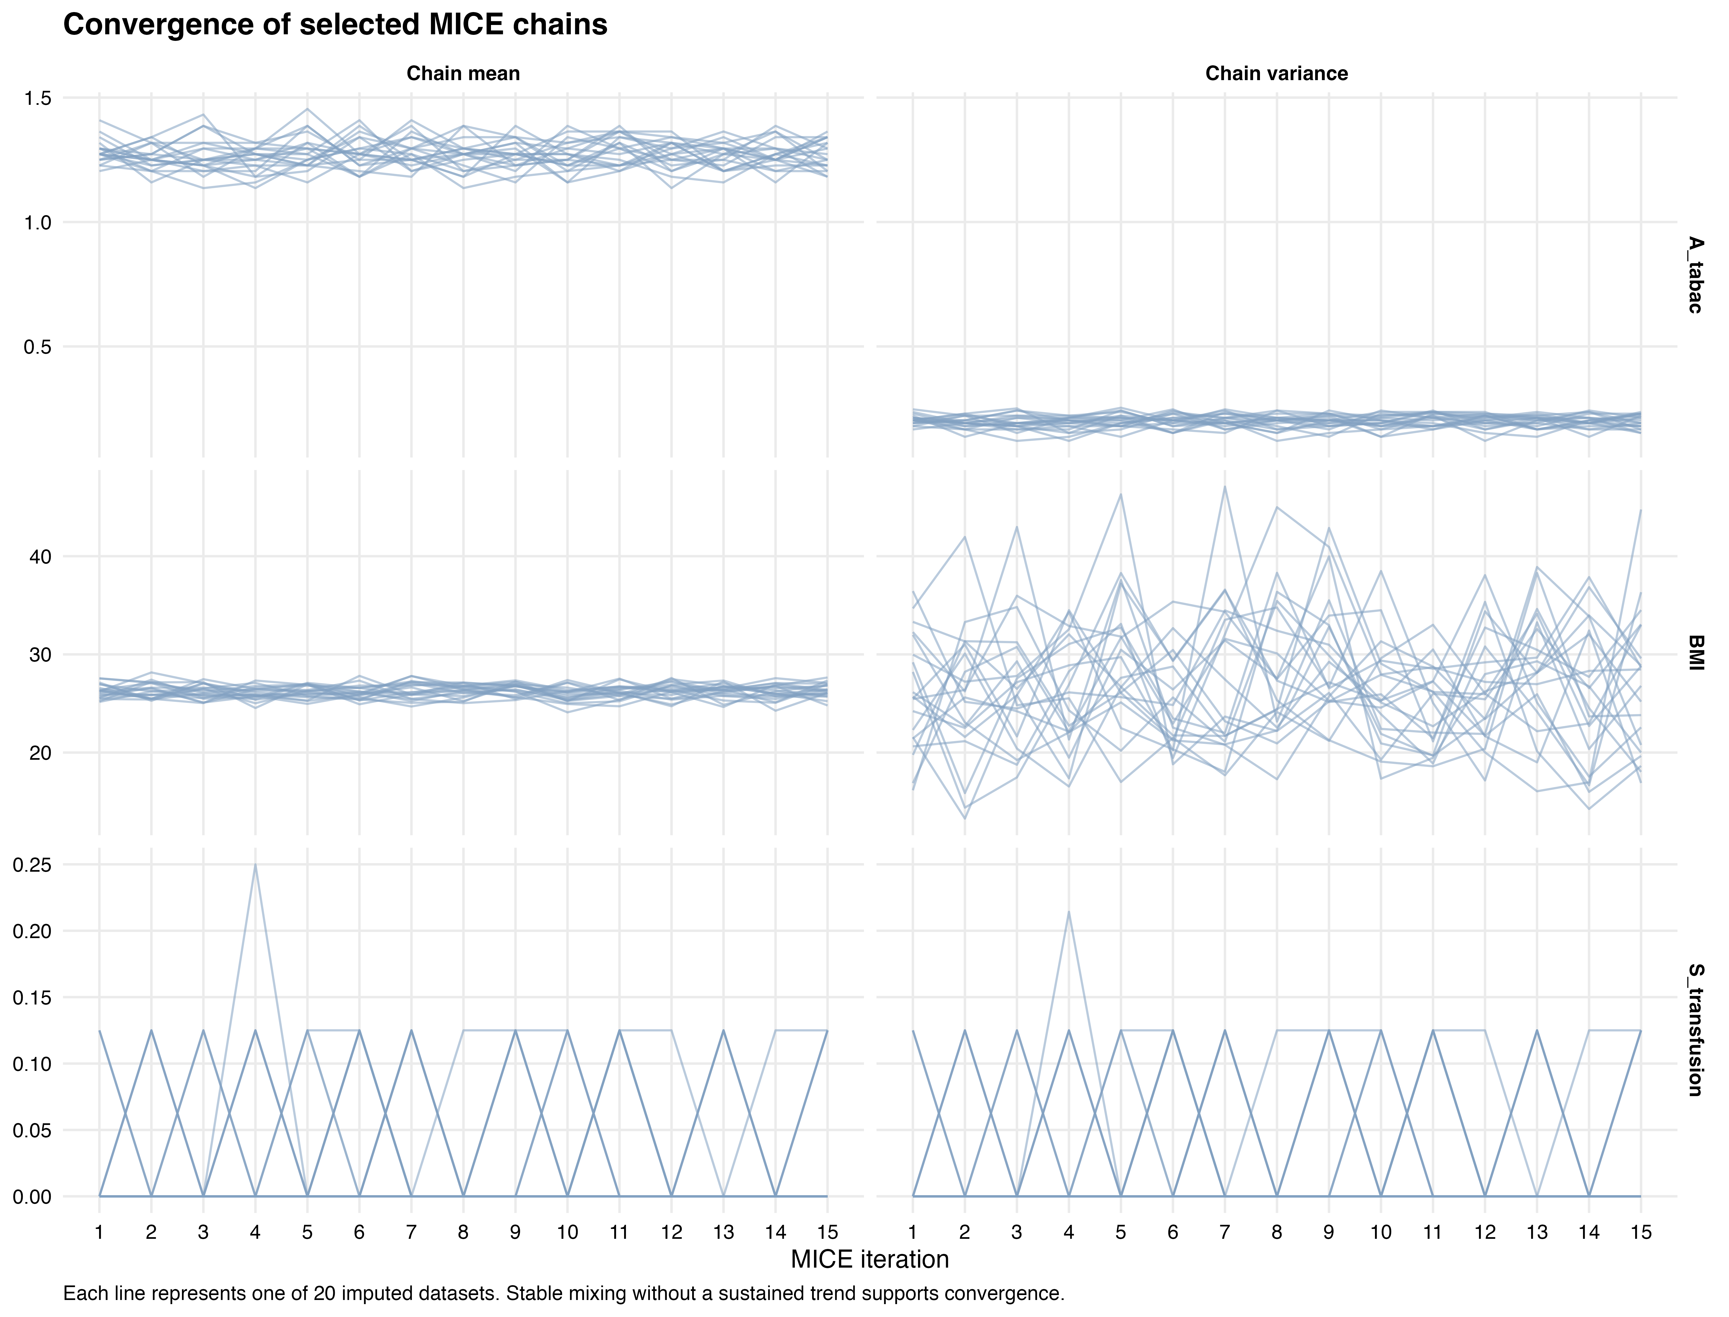
Chain means and variances across 15 MICE iterations and 20 imputations for body mass index, smoking, and the early postoperative outcome with the most missing observations..

Supplementary Figure S2. Observed and imputed distributions
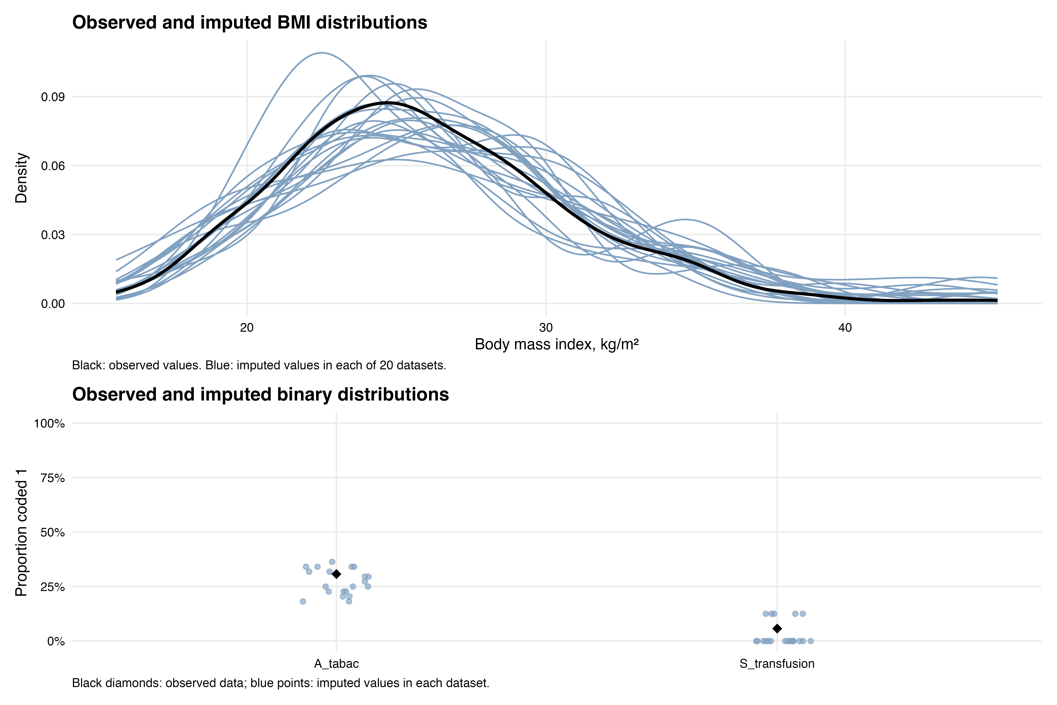
Observed and imputed distributions for body mass index, smoking, and the early postoperative outcome with the most missing observations.

Supplementary Figure S3. Covariate balance
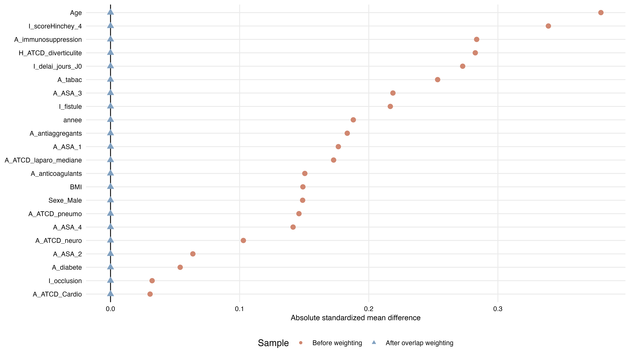
Absolute standardized mean differences before and after overlap weighting. Continuous and binary covariates were standardized using the unweighted pooled standard deviation within each imputation, and each point summarizes the most extreme value across imputations. Weighted mean differences for terms included in the unpenalized logistic propensity model are expected to be zero by construction; the weighted standardized mean differences therefore serve as an integrity check, while distributional diagnostics are reported in Supplementary Table S2.

Supplementary Figure S4. Propensity-score distributions and normalized weights
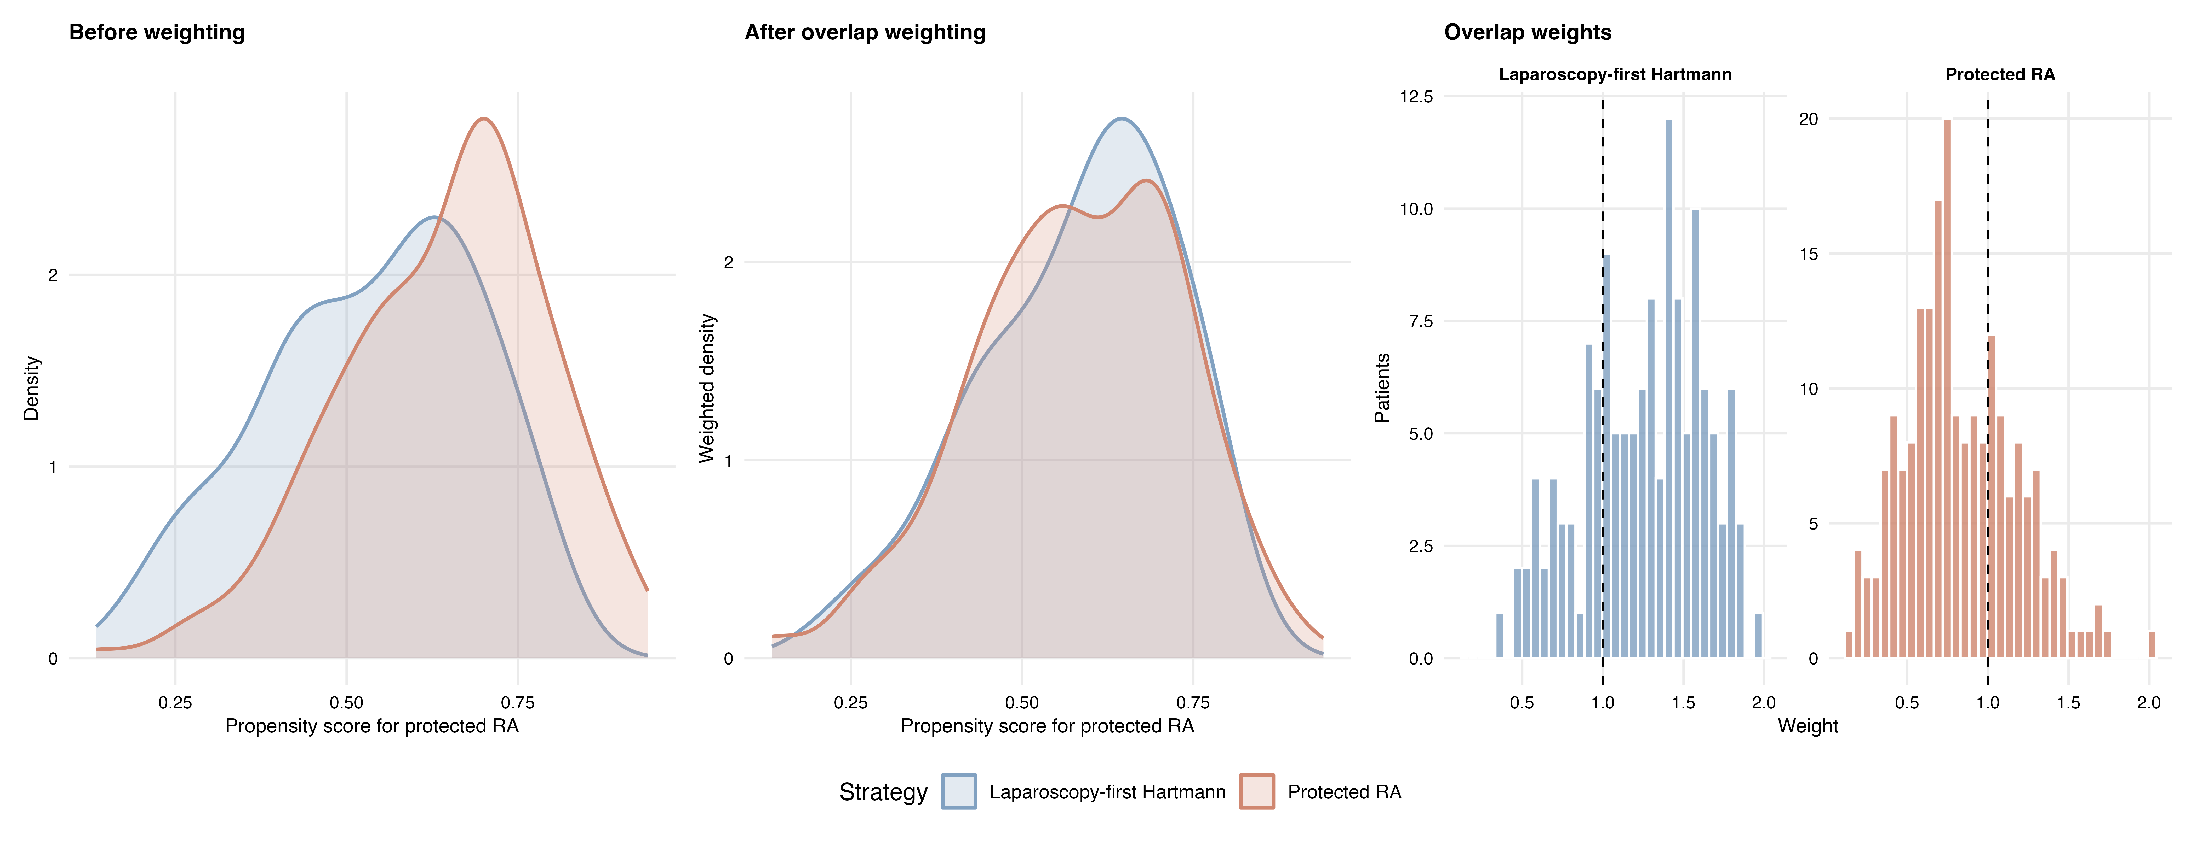
Unweighted and weighted propensity-score distributions and normalized overlap-weight distributions in the first imputed dataset. The score included measured patient-level covariates and calendar year but not center; the figure therefore does not diagnose center-level positivity.

Supplementary Figure S5. Primary analysis and both sensitivity analyses
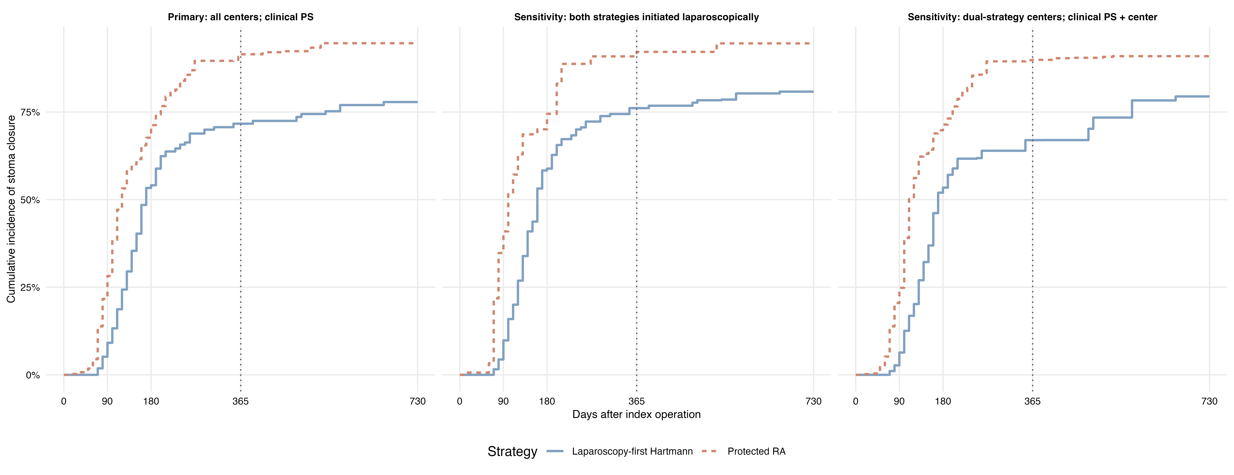
Overlap-weighted cumulative incidence of stoma closure in the primary analysis, the sensitivity restricted to dual-strategy centers, and the sensitivity restricted to procedures initiated laparoscopically in both groups. Conversions remain assigned to their initially selected strategy. Because each panel targets a different overlap population, differences between panels are descriptive and are not formal interaction tests.

Supplementary Figure S6. Stoma closure according to Hartmann conversion status
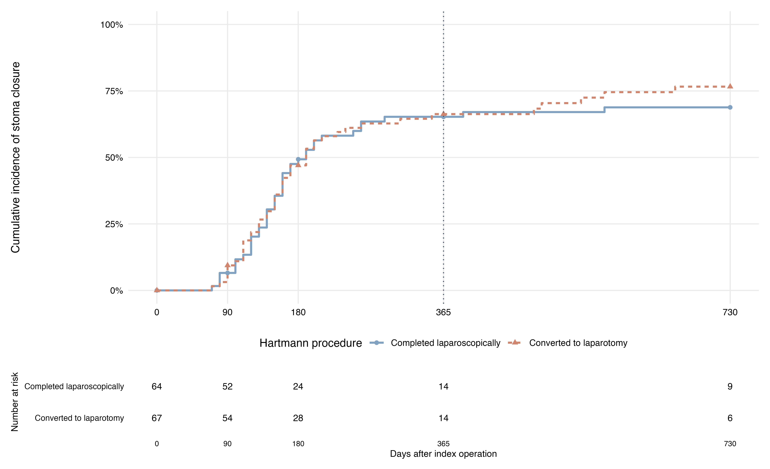
Post hoc unweighted Aalen–Johansen cumulative incidence of stoma closure after a laparoscopy-first Hartmann strategy, stratified by laparoscopic completion or conversion to laparotomy. Death before closure is a competing event. Numbers at risk refer to patients remaining alive without recorded closure.

Supplementary Figure S7. Death before stoma closure
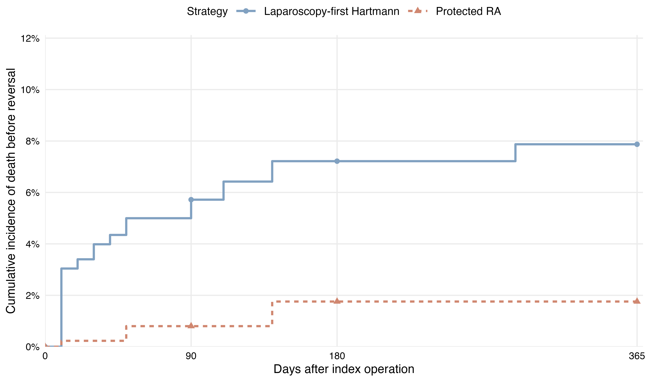
Overlap-weighted Aalen–Johansen cumulative incidence of death before recorded stoma closure in the primary analysis. Death is shown as the competing event for transparency and the stoma-closure curve is not repeated. Follow-up is displayed through the prespecified 365-day primary horizon.

Supplementary References
1. Rubin DB. Multiple imputation for nonresponse in surveys. New York: John Wiley & Sons; 1987.
2. van Buuren S, Groothuis-Oudshoorn K. mice: Multivariate imputation by chained equations in R. Journal of Statistical Software. 2011;45:1–67.
3. White IR, Royston P, Wood AM. Multiple imputation using chained equations: Issues and guidance for practice. Statistics in Medicine. 2011;30:377–399.
4. White IR, Royston P. Imputing missing covariate values for the cox model. Statistics in Medicine. 2009;28:1982–1998.
5. Bartlett JW, Taylor JMG. Missing covariates in competing risks analysis. Biostatistics. 2016;17:751–763.
6. Leyrat C, Seaman SR, White IR, et al. Propensity score analysis with partially observed covariates: how should multiple imputation be used? Statistical Methods in Medical Research. 2019;28:3–19.
7. Granger E, Sergeant JC, Lunt M. Avoiding pitfalls when combining multiple imputation and propensity scores. Stat Med. 2019;38:5120–5132.
8. Pishgar F, Greifer N, Leyrat C, et al. MatchThem:: Matching and Weighting after Multiple Imputation. The R Journal. 2021;13:292–305.
9. Rosenbaum PR, Rubin DB. The central role of the propensity score in observational studies for causal effects. Biometrika. 1983;70:41–55.
10. Li F, Morgan KL, Zaslavsky AM. Balancing covariates via propensity score weighting. Journal of the American Statistical Association. 2018;113:390–400.
11. Li F, Thomas LE, Li F. Addressing extreme propensity scores via the overlap weights. American Journal of Epidemiology. 2019;188:250–257.
12. Thomas LE, Li F, Pencina MJ. Overlap weighting: A propensity score method that mimics attributes of a randomized clinical trial. JAMA. 2020;323:2417–2418.
13. Austin PC, Stuart EA. Moving towards best practice when using inverse probability of treatment weighting using the propensity score to estimate causal treatment effects in observational studies. Statistics in Medicine. 2015;34:3661–3679.
14. Aalen OO, Johansen S. An Empirical Transition Matrix for Non-Homogeneous Markov Chains Based on Censored Observations. Scandinavian Journal of Statistics. 1978;5:141–150.
15. Putter H, Fiocco M, Geskus RB. Tutorial in biostatistics: competing risks and multi-state models. Statistics in Medicine. 2007;26:2389–2430.
16. Austin PC. Variance estimation when using inverse probability of treatment weighting (IPTW) with survival analysis. Statistics in Medicine. 2016;35:5642–5655.
17. Schomaker M, Heumann C. Bootstrap Inference When Using Multiple Imputation. Stat Med. 2018;37:2252–2266.
18. Barnard J, Rubin DB. Small-sample degrees of freedom with multiple imputation. Biometrika. 1999;86:948–955.
19. Bartlett JW, Hughes RA. Bootstrap inference for multiple imputation under uncongeniality and misspecification. Statistical Methods in Medical Research. 2020;29:3533–3546.
20. Fine JP, Gray RJ. A proportional hazards model for the subdistribution of a competing risk. Journal of the American Statistical Association. 1999;94:496–509.
21. Zhou B, Fine J, Laird G. Goodness-of-fit test for proportional subdistribution hazards model. Statistics in Medicine. 2013;32:3804–3811.

