Specific laminin binding to interleukins enhances diabetic wound healing
Author Information
Zonghan Gan^{a,b}, Oana.Dobreª, Xiaowei Lin^{b,g}, Juan.Gonzalez-Valdivieso^{a,e}, Lipeng Mao^{f}, Matthew.Walkerª, Xu Teng^{b}, Penelope M. Tsimbouriª, Fengjin Li^{b}, Matthew.Dalbyª, Ling Qi^{b*}, and Manuel.Salmeron-Sanchez^{a,c,d*}
Affiliations
a. Centre for the Cellular Microenvironment, Advanced Research Centre, University of Glasgow, Glasgow, G12 8QQ, United Kingdom
b. Division of Gastroenterology, Institute of Digestive Disease, the Affiliated Qingyuan Hospital (Qingyuan People’s Hospital), Guangzhou Medical University, Qingyuan, 511518, China
c. Institute for Bioengineering of Catalonia (IBEC), The Barcelona Institute for Science and Technology (BIST), Barcelona, 08028, Spain
d. Institució Catalana de Recerca i Estudis Avançats (ICREA), Barcelona, Spain.
e. University of Valladolid, 47011 Valladolid, Spain
f. Department of Oncology, The First Affiliated Hospital, School of Medicine, Jian University, Guangzhou 510632, China.
g. Department of Medical Laboratory Science, Qingyuan Qingxin District People's Hospital, Qingyuan 511800, China

Supplementary Information

Supplementary Table 1 Sites filtrated from segments by combination of AI docking and physical bond computation. Orange marked sites were identified in previous studies ^{8,9}, to follow the same downstream characterisations with newly discovered ones to revise our state-of-the-art. This was for the first time LAMB & LAMC sites were discovered to bind cytokines.
Code | Chain | Site Window | AA Sequence | Length
A1-01 | LAMA1 | 282-302 | DETTKKLQCQCEHNTCGESC | 20
A1-02 | LAMA1 | 2210-2229 | GNIGSLSVKEMSSNQKSPTA | 20
A1-03 | LAMA1 | 2516-2535 | TTNSSGIILAALGGDVEKRG | 20
A1-04 | LAMA1 | 2734-2745 | RKRLQVQLSIRT | 12
A1-05 | LAMA1 | 2750-2760 | GLIYYVAHQNQM | 12
A2-01 | LAMA2 | 1681-1700 | FIKELARDAEAVNEKAIKLN | 20
A2-02 | LAMA2 | 2015-2034 | TLNDTLGKLSAIPNDTAAKL | 20
A2-03 | LAMA2 | 2067-2086 | KNYNKLADSVAKTNAVVKDP | 20
A2-04 | LAMA2 | 2341-3122 | IQFDGEGYALVSRPIRWYPN | 20
A2-05 | LAMA2 | 2800-2811 | GLLFYMARINHA | 12
A3-01 | LAMA3 | 196-215 | KEFGREANMAVTRDDDVLCV | 20
A3-02 | LAMA3 | 2589-2608 | EPCRRRKEESDKNYFEGTGY | 20
A3-03 | LAMA3 | 2705-2727 | DGEVFDFSTYYLGGIPIAIRERF | 23
A3-04 | LAMA3 | 2932-2951 | PPFLMLLKGSTRFNKTKTFR | 20
A3-05 | LAMA3 | 3031-3043 | KNSFMALYLSKGR | 13
A3-06 | LAMA3 | 3043-3062 | RLVFALGTDGKKLRIKSKEK | 20
A4-01 | LAMA4 | 494-518 | QALNYVRDAEDMNRATAARQRDHEK | 25
A4-02 | LAMA4 | 976-995 | DPEDTVFYVGGVPSNFKLPT | 20
A4-03 | LAMA4 | 1309-1328 | DGLSHFVISSVSPTRYELIV | 20
A4-04 | LAMA4 | 1413-1432 | HKKGKNLSKPKASQNKKGGK | 20
A4-05 | LAMA4 | 1521-1540 | TLFLAHGRLVYMFNVGHKKL | 20
A4-06 | LAMA4 | 1724-1743 | QSLCDGRWHRITVIRDSNVV | 20
A5-01 | LAMA5 | 0378-397 | RASQSLDGTYQGGGVCIDCQ | 20
A5-02 | LAMA5 | 2385-2404 | REALNRAVDATREAQELNSR | 20
A5-03 | LAMA5 | 2834-2855 | DRTLQFGHMSVTVERQMIQETK | 22
A5-04 | LAMA5 | 3300-3330 | TPGLGPRGLQATARKASRRSRQPARHPACML | 31
A5-05 | LAMA5 | 3312-3325 | ARKASRRSRQPARH | 14
A5-06 | LAMA5 | 3345-3356 | GPLPSYLQFVGI | 12
A5-07 | LAMA5 | 3417-3436 | RQRSRPGRWHKVSVRWEKNR | 20
A5-08 | LAMA5 | 3539-3550 | TLPDVGLELEVR | 12
B1-01 | LAMB1 | 68-87 | SHLQEDKKCFICNSQDPYHE | 20
B1-02 | LAMB1 | 169-188 | DCEASFPGISTGPMKKVDDI | 20
B1-03 | LAMB1 | 1567-1586 | DIARAEMLLEEAKRASKSAT | 20
B1-04 | LAMB1 | 1738-1757 | QLLKDLERKYEDNQRYLEDK | 20
B2-01 | LAMB2 | 60-79 | DRLTASSTCGLNGPQPYCIV | 20
B2-02 | LAMB2 | 87-106 | KCFLCDSRRPFSARDNPHSH | 20
B2-03 | LAMB2 | 394-413 | YRDPTKDLRDPAVCRSCDCD | 20
B2-04 | LAMB2 | 1779-1798 | RMRSVLQAINLQVQIYNTCQ | 20
B3-01 | LAMB3 | 42-63 | RASSTCGLTKPETYCTQYGQ | 20
B3-02 | LAMB3 | 59-78 | YGEWQMKCCKCDSRQPHNYY | 20
B3-03 | LAMB3 | 693-712 | LTMYQRKREQFEKISSADPS | 20
B3-04 | LAMB3 | 1046-1065 | LRHQARQQGAEAVQAQQLAE | 20
C1-01 | LAMC1 | 70-89 | GTPPEEYCVQTGVTGVTKSC | 20
C1-02 | LAMC1 | 157-176 | PESFAIYKRTREDGPWIPYQ | 20
C1-03 | LAMC1 | 1371-1390 | KDFDRRVNDNKTAAEEALRK | 20
C1-04 | LAMC1 | 1444-1463 | KAEAERTFAEVTDLDNEVNN | 20
C1-05 | LAMC1 | 1466-1485 | KQLQEAEKELKRKQDDADQD | 20
C1-06 | LAMC1 | 1509-1527 | NSVTSLLSIINDLLEQLGQL | 20
C2-02 | LAMC2 | 598-617 | GGPNCEHGAFSCPACYNQVK | 20
C2-03 | LAMC2 | 971-990 | EAMKRLSYISQKVSDASDKT | 20
C2-04 | LAMC2 | 1044-1063 | KGLASLKSEMREVEGELERK | 20

Supplementary Table 2 SPR summary of association/disassociation constant resulting from LN332 and C1-01 versus ILs/GFs assays. Ka (or kon) is the association rate constant for the speed of binding, Kd (or koff) is the dissociation rate constant for the speed of unbinding, KD is the equilibrium dissociation constant, and KA is the equilibrium association constant. For IL-10 versus LN332 and C1-01 versus IL-10 fitting with the steady-state model, no Ka or Kd could be derived as association and disassociation were too fast. Yet KD and KA were still derived by steady state fitting to evaluate association/disassociation. For the pairs showing minor binding, all four constants were NA.
LN332 protein
Receptor | Ligand | Ka | Kd | KD | KA
LN332 | IFN-γ | 1.082E5 | 0.010705 | 9.936e-8 | 1.01E+07
IL-10 | LN332 | NA | NA | 1.672E-7 | 5.98E+06
LN332 | IL-4 | 722.8 | 0.005937 | 8.213E-6 | 1.22E+05
LAMC-01 Site
C1-01 | IFN-γ | NA | NA | NA | NA
C1-01 | IL-4 | NA | NA | NA | NA
C1-01 | IL-10 | NA | NA | 1.028E-6 | 9.73E+05
C1-01 | VEGF-A165 | NA | NA | NA | NA
C1-01 | PDGF-BB | 2.804E5 | 0.2422 | 8.63E-7 | 1.16E+06
C1-01 | HB-EGF | NA | NA | NA | NA

Supplementary Table 3 Uniprot accession of Laminin chains and PDB accession of ILs employed in molecular docking
Laminin Chains | Uniprot ID | ILs | PDB ID | ILs | PDB ID
LAMA1 | P25391 | IL-1α | 2KKI | IL-12 | 1F45
LAMA2 | P24043 | IL-1β | 9ILB | IL-13 | 1IJZ
LAMA3 | Q16787 | IL-2 | 1M47 | IL-17A | 4HR9
LAMA4 | Q16363 | IL-4 | 2B8U | IL-17F | 6HGO
LAMA5 | O15230 | IL-5 | 3VA2 | IL-18 | 3WO2
LAMB1 | P07942 | IL-6 | 1ALU | IL-19 | 1N1F
LAMB2 | P55268 | IL-8 | 1IL8 | IL-21 | 2OQP
LAMB3 | Q13751 | IL-9 | 7OX6 | IL-22 | 1M4R
LAMC1 | P11047 | IL-10 | 1INR
LAMC2 | Q13753 | IL-11 | 6O4O

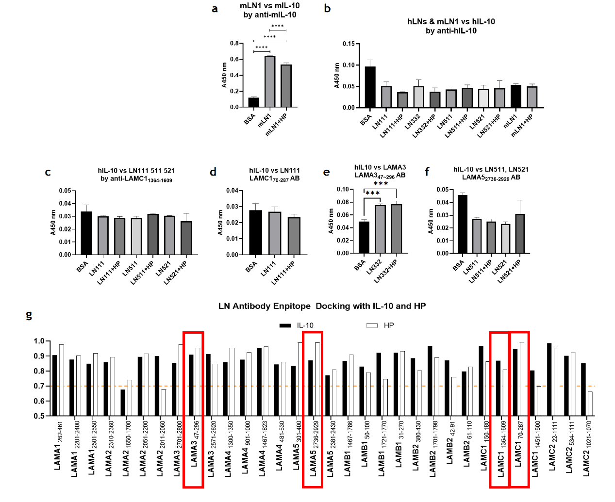
Supplementary Fig 1, inhibition by antibodies in detecting IL-10’s binding with LNs. a~b: Commercial IL-10 Elisa kits (ThermoFisher) to detect IL-10 as ligand in solution when binding with LNs as receptor on surface. c~f: plot of some tested antibodies to detect LNs in solution as ligands when binding with IL-10 on surface as receptor. g Docking between IL-10 or Heparin with LNs’ epitope for commercial available antibodies. In a&b, the binding between murine LN111 and IL-10 was positive while in human was negative. This was not sufficient to negate binding between LN111 and IL-10 in human, as human and murine IL-10 shared >90% common sequence. When applying Ishihara’s method ⁸ employing LAMC1 antibodies to detect LNs as ligands in solution to bind with IL-10 on surface as receptor, LAMC1 antibodies of 2 common epitopes offered negative signal. LAMA3 antibodies tested the binding while LAMA5 antibodies did not show binding. Molecular docking also illustrated that nearly all epitopes of current antibodies potentially interacted with IL-10 and heparin. An orthogonal method was required to identify whether there is binding between LNs and ILs. Error bars report mean ± SEM, n = 3.

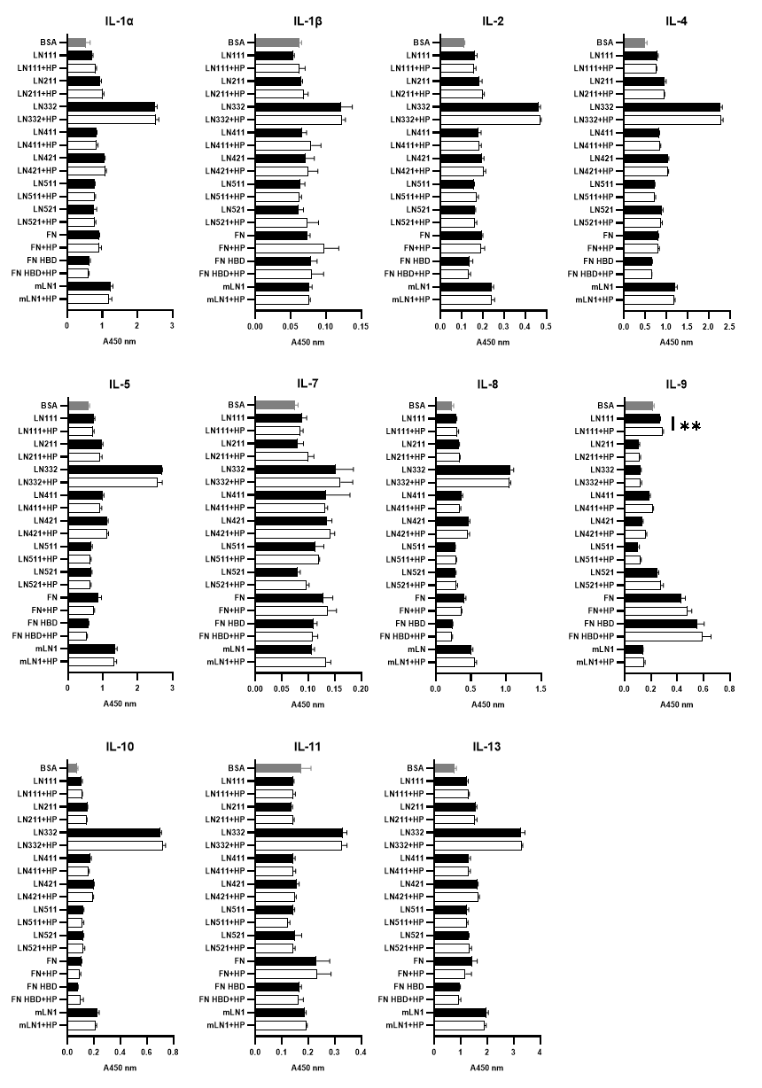
Supplementary Fig 2 Heparin did not significantly affect LN-IL binding. Attempt to inhibit IL-LN binding by excess heparin. ELISA plates were coated with 10nM LNs and then further treated with 10 uM heparin or PBS. Bound of ILs were detected using avidin-HRP for each. Statistical analyses were performed using the Multiple T-test by comparing the HP+ vs HP- condition obtained from the LN/FN-coated wells. ****p < 0.0001, ***p < 0.001, **p < 0.01, *p < 0.05. Three experimental replicates.
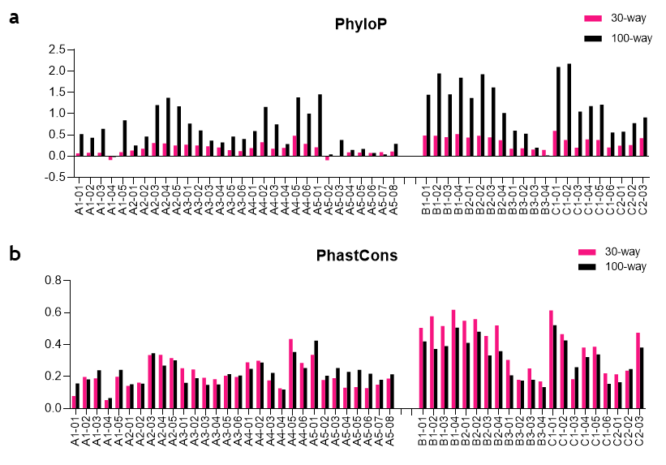
Supplementary Fig 3 Bioinformatics of the Laminin sites. Limited by plot area, A stands for LAMA, B for LAMB, and C for LAMC. a and b evaluated conservation of the sites among species. a PhyloP score of the sites, evaluating the evolving speed of the sites. Thirty-way represented 30 typical mammalians while 100-way represented 100 typical vertebrates. b PhastCons score of the sites, evaluating to which degree can each site be considered as a conservative element.
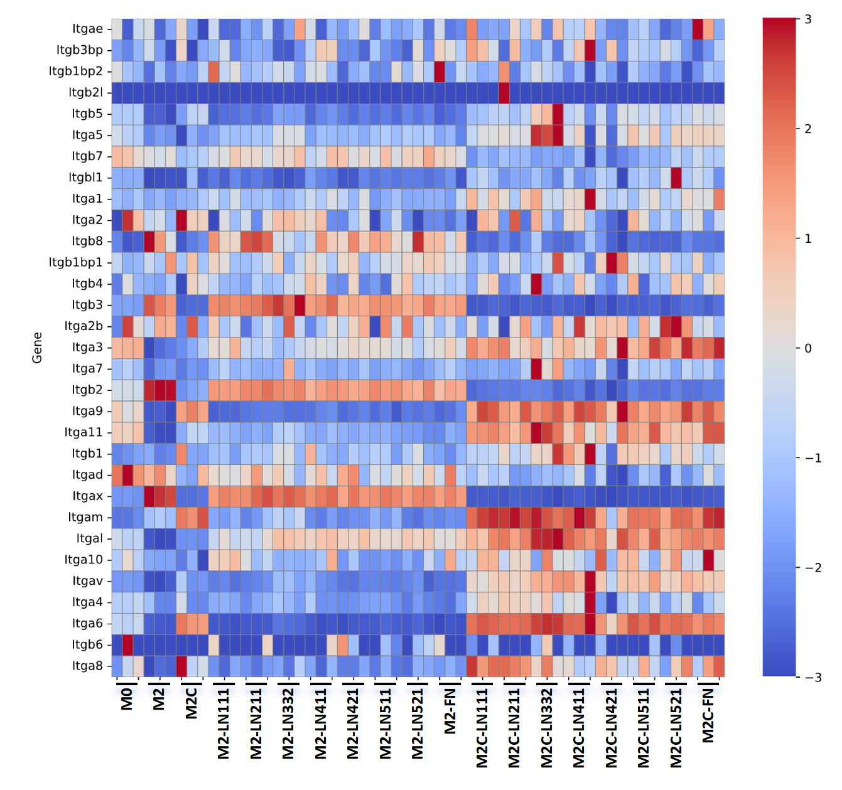
Supplementary Fig 4 Heatmap of integrins’expression in M2 and M2c mBMDM derived on LN isoforms and FN.

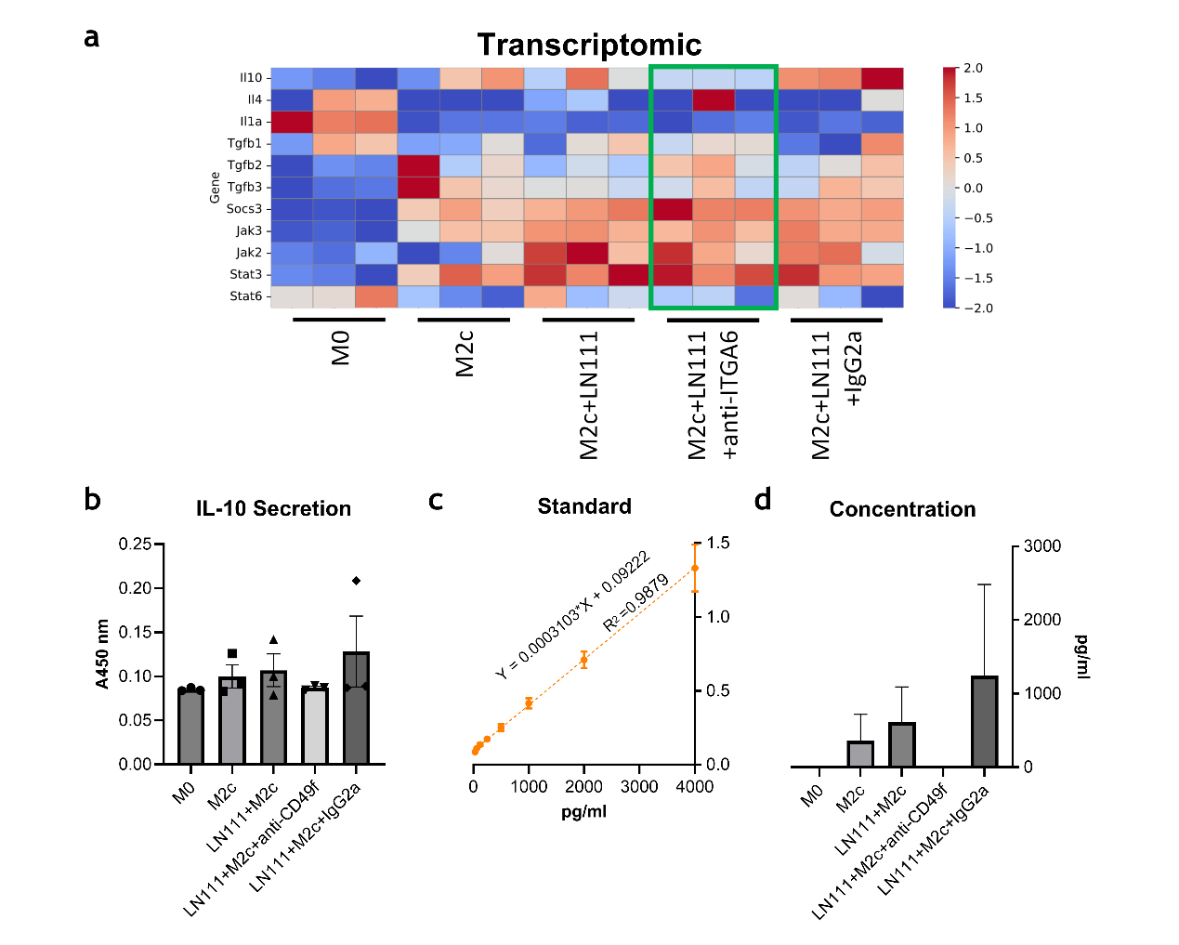
Supplementary Fig 5 mBMDM’s M2c polarization under ITGA-6 neutralization. a Transcriptomic heatmap of most focused M2&M2c distinguishable markers; b~d Elisa characterization of IL-10 secretion post-stimulation. b channel signal; c standard concentration curve; d scaled concentration. ITGA6 neutralization induced significant silence in IL-10 secretion. Interestingly, with existence of isotype control antibody a higher level of IL-10 was derived, compared to the M2c control and with LN111. This also happened in cytometric markers. Error bars report mean ± SEM, n = 3, experiments repeated for twice.

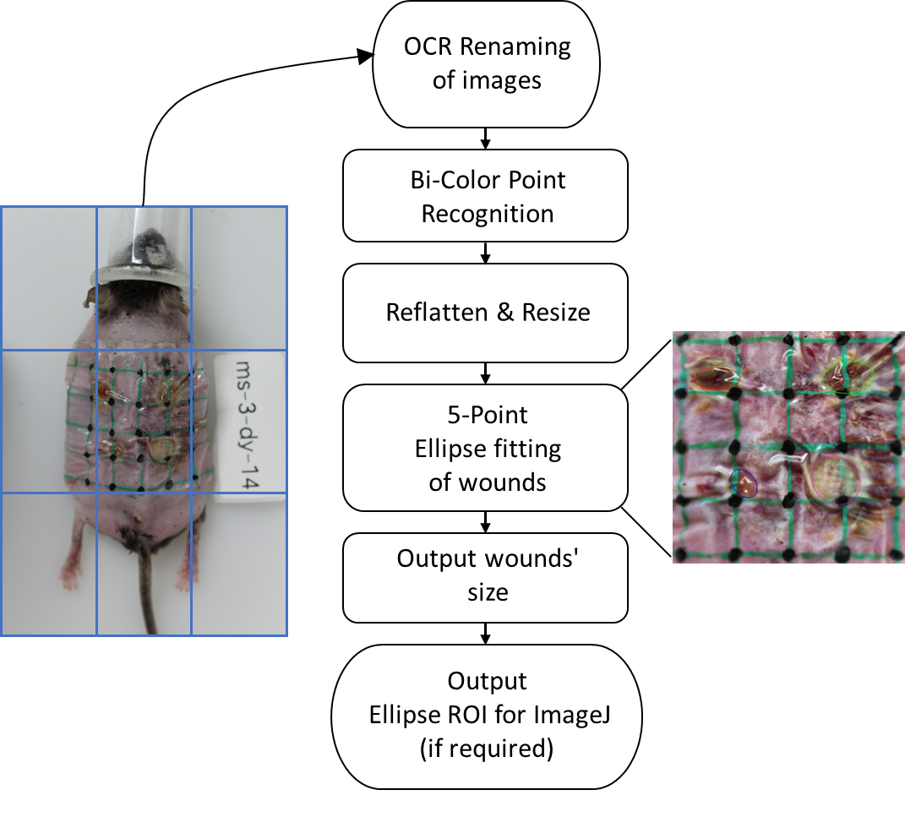
Supplementary Fig 6 Workflow of image analysis with the customized Wound-Shape software. Images were taken at consistent position utilizing the rule of thirds grid. The lattice, marked on the envelope Tegaderm membrane with known size, enabled the double-color point tracking, which was latter used to flatten and resize the wounds. Five points on wounds’ edge were manually labelled and fitted with ellipse function, which was exported to individual .json file and can be imported into ImageJ for downstream analysis with another customized script.

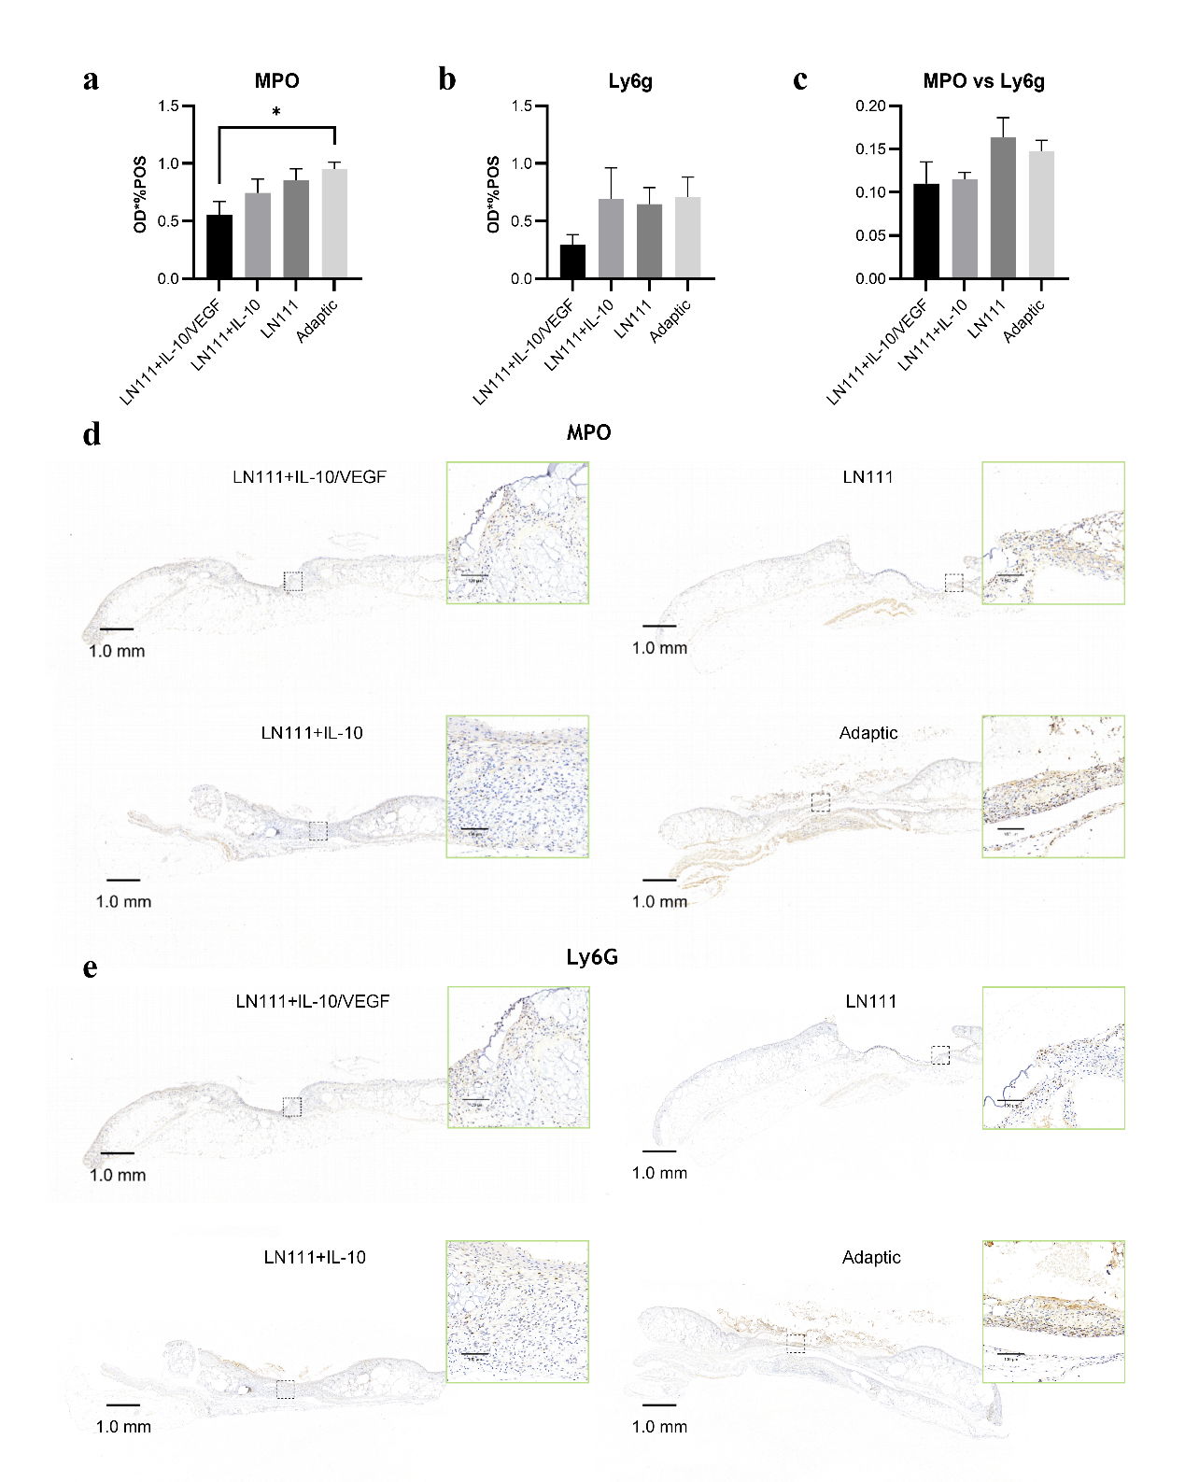
Supplementary Fig 7, Histoimmunostaining of wound samples a Quantification of Neutrophilic marker MPO. b Quantification of Neutrophilic marker Ly6G. c Co-localization ratio of MPO vs Ly6G, showing neutrophils’ NETosis activity. a~c: Error bars report mean ± SEM, n = 10. Statistical analysis was performed using the one-way ANOVA test with Tukey multicomparision. d MPO. e Ly6G. Amplification in cyan frame, Scale bar = 100 μm. Scale bar of full vision = 1 mm.
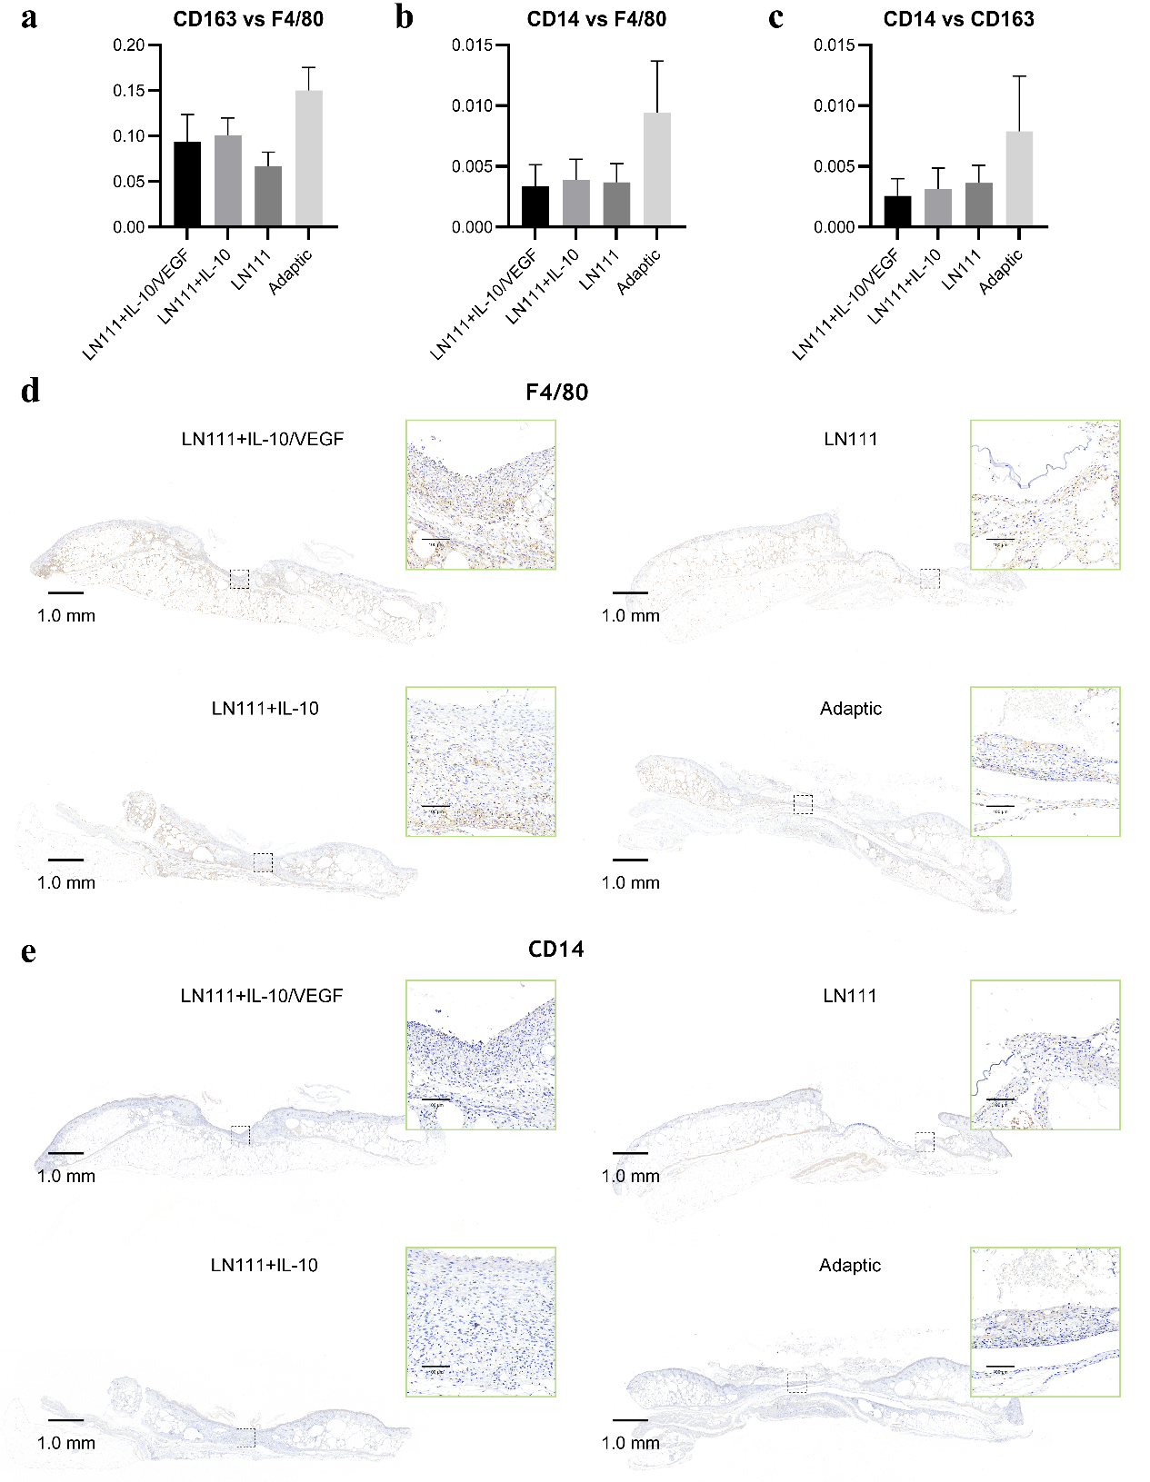
Supplementary Fig 8, Histoimmunostaining of wound samples a Co-localization ratio of CD163 vs F4/80. b Co-localization of CD14 vs F4/80. c Co-localization ratio of CD14 vs CD163. a~c: Error bars report mean ± SEM, n = 10. Statistical analysis was performed using the one-way ANOVA test with Tukey multicomparision. d. Macrophagic marker F4/80. e CD14. Amplification in cyan frame, Scale bar = 100 μm. Scale bar of full vision = 1 mm.

