Additional file 1: Deficit accumulation, plantar pressure-time loading and contact timing in community-dwelling older adults with type 2 diabetes
Supplementary Tables S1-S7 and Figures S1-S6 document deficit coding, PTI outcome construction, sensitivity analyses, IWGDF-based stratified and interaction analyses, missingness, exploratory model outputs, model diagnostics and frailty-index construct auditing. All individual identifiers are excluded from this publication package.

Table S1 Construction of FI33 and FI30
No | Deficit | Scoring rule | FI30 | N
1 | Low physical activity | Activity code 1/2/3/4 → 1, 2/3, 1/3, 0 | Yes | 810
2 | No hobbies | Absent=1; present=0 | Yes | 810
3 | Current smoking | Yes=1; no=0 | Yes | 810
4 | Abnormal BMI | <18.5: 1; 18.5–<25: 0; 25–<30: 0.5; ≥30: 1 | No | 810
5 | ADL impairment | max(0, min(1, (ADL−14)/42)); ADL<14 missing | Yes | 798
6 | Hypertension | Present=1; absent=0 | Yes | 810
7 | Coronary heart disease | Present=1; absent=0 | Yes | 810
8 | Hyperlipidemia | Present=1; absent=0 | Yes | 810
9 | Stroke | Present=1; absent=0 | Yes | 810
10 | COPD | Present=1; absent=0 | Yes | 810
11 | Diabetes duration | <5 years: 0; 5–<10: 0.5; ≥ 10: 1 | No | 808
12 | Elevated HbA1c | <7%: 0; 7–<8%: 0.5; ≥8%: 1 | No | 810
13 | Elevated fasting glucose | <7: 0; 7–<10: 0.5; ≥ 10 mmol/L: 1 | Yes | 810
14 | Elevated triglycerides | <1.7: 0; 1.7–<2.3: 0.5; ≥2.3 mmol/L: 1 | Yes | 810
15 | Elevated total cholesterol | <5.2: 0; 5.2–<6.2: 0.5; ≥6.2 mmol/L: 1 | Yes | 810
16 | Low HDL cholesterol | Men <1.0 or women <1.3 mmol/L: 1; otherwise 0 | Yes | 810
17 | Elevated LDL cholesterol | <3.4: 0; 3.4–<4.1: 0.5; ≥4.1 mmol/L: 1 | Yes | 810
18 | Urine leukocytes | Exported ordinal code / 4 | Yes | 810
19 | Urine bilirubin | Exported ordinal code / 4 | Yes | 810
20 | Microscopic urine WBC | Exported ordinal code / 5 | Yes | 810
21 | Microscopic urine RBC | Exported ordinal code / 4 | Yes | 810
22 | Urine urobilinogen | Exported ordinal code / 4 | Yes | 810
23 | Urine protein | Exported ordinal code / 4 | Yes | 810
24 | Urine glucose | Exported ordinal code / 5 | Yes | 810
25 | Urine ketones | Exported ordinal code / 4 | Yes | 810
26 | Urine occult blood | Exported ordinal code / 4 | Yes | 810
27 | Abnormal blood WBC | <4 or >10 ×10⁹/L: 1; otherwise 0 | Yes | 810
28 | Anemia | Men Hb<130 or women Hb<120 g/L: 1 | Yes | 810
29 | Elevated RDW | Red-cell width field >14.5: 1; otherwise 0 | Yes | 810
30 | Abnormal MCV | <80 or >100 fL: 1; otherwise 0 | Yes | 810
31 | Abnormal MCH | <27 or >34 pg: 1; otherwise 0 | Yes | 810
32 | Low MCHC | <320 g/L: 1; otherwise 0 | Yes | 810
33 | Abnormal platelets | <100 or >400 ×10⁹/L: 1; otherwise 0 | Yes | 810
FI33 includes all 33 listed items and requires ≥27 available items; the observed range is 32–33. FI30 removes BMI, diabetes duration and HbA1c; observed completeness is 29–30. Both indices equal the sum of available scores divided by the number of available items. End-stage renal disease was collected clinically but was not part of the final FI33. Foot-pressure and foot-pathway variables are excluded. Urine denominators were checked against paired exported codes and saved item scores; microscopic WBC /5 and RBC /4 also follow investigator confirmation. Ordinal codes are not laboratory concentrations. Other threshold rules reproduce the supplied construction worksheet; this table does not establish external clinical validation.

Table S2 Outcome definitions and analysis samples
Measure | Definition | Unit | Available / M3 N
Total regional pressure-time integral (T-PTI) | Sum of regional PTI across all 20 bilateral plantar regions | N s/cm2 | 716 / 714
Stance duration | Per foot: max(End Time) − min(Start Time); mean of both feet | ms | 810 / 808
Regional relative CT | 100 × (regional End−Start) / ipsilateral stance; bilateral mean | % | 810 / 808
Foot-flat phase | 100 × (heel-off − latest M1–M5 Start Time) / stance; bilateral mean | % | 805 / 803
Forefoot push-off phase | 100 × (last regional End Time − heel-off) / stance; bilateral mean | % | 805 / 803
Maximum regional peak pressure | Maximum Max P among 10 regions within each foot; mean of both feet | N/cm² | 810 / 808
Heel-off proxy | Later End Time of medial and lateral heel regions | ms | Definition
Rollover validity | First contact ≤ first metatarsal contact ≤ full metatarsal contact ≤ heel-off ≤ last contact; stance >0 | Event order | 5 invalid left; 0 right
Regional timing variables and the Footscan-exported Impulse variable follow the provided acquisition/export description. In this study, regional Impulse was treated as regional PTI. Numerical zeros are retained; incomplete 20-region PTI sums are missing. Bilateral averaging requires both feet. Max P and maximum peak sensor values are reported in N/cm2 according to the supplied acquisition/export description. All reconstructed phases are temporal proxies.

Table S3A PTI completeness by FI33 category
Group | N | Incomplete | Complete | Incomplete, %
Overall | 810 | 94 | 716 | 11.6
Low | 82 | 8 | 74 | 9.76
Intermediate | 577 | 71 | 506 | 12.31
High | 151 | 15 | 136 | 9.93
Complete outcomes require all 20 regional fields. Counts are participant counts.

Table S3B Regional PTI quality control
Region | Blank | Explicit zero | Nonzero
Impulse-Left-Toe 1 | 36 | 17 | 757
Impulse-Left-Toe 2-5 | 7 | 54 | 749
Impulse-Left-Meta 1 | 3 | 3 | 804
Impulse-Left-Meta 2 | 1 | 2 | 807
Impulse-Left-Meta 3 | 1 | 4 | 805
Impulse-Left-Meta 4 | 2 | 5 | 803
Impulse-Left-Meta 5 | 3 | 7 | 800
Impulse-Left-Midfoot | 0 | 3 | 807
Impulse-Left-Heel Medial | 0 | 6 | 804
Impulse-Left-Heel Lateral | 0 | 3 | 807
Impulse-Right-Toe 1 | 43 | 21 | 746
Impulse-Right-Toe 2-5 | 12 | 45 | 753
Impulse-Right-Meta 1 | 0 | 10 | 800
Impulse-Right-Meta 2 | 0 | 1 | 809
Impulse-Right-Meta 3 | 0 | 3 | 807
Impulse-Right-Meta 4 | 0 | 13 | 797
Impulse-Right-Meta 5 | 1 | 15 | 794
Impulse-Right-Midfoot | 0 | 4 | 806
Impulse-Right-Heel Medial | 1 | 4 | 805
Impulse-Right-Heel Lateral | 1 | 0 | 809
The 20 regional counts sum to 16,200 fields. Missing fields are distinguishable from explicit numerical zero in the supplied data.

Table S3C Adjusted association with any missing regional PTI field
Term | Inference | N | OR [95% CI] | P
(Intercept) | HC3 robust Wald z | 808 | 0.01 [0.00, 0.55] | 0.0227
FI10 | HC3 robust Wald z | 808 | 0.94 [0.66, 1.33] | 0.7200
age | HC3 robust Wald z | 808 | 1.01 [0.97, 1.05] | 0.6167
sex2 | HC3 robust Wald z | 808 | 1.48 [0.92, 2.37] | 0.1053
BMI | HC3 robust Wald z | 808 | 1.03 [0.96, 1.11] | 0.3604
duration | HC3 robust Wald z | 808 | 1.00 [0.97, 1.03] | 0.8946
HbA1c | HC3 robust Wald z | 808 | 1.07 [0.86, 1.32] | 0.5480
LOPS | HC3 robust Wald z | 808 | 1.46 [0.93, 2.29] | 0.1015
(Intercept) | Model-based Wald z | 808 | 0.01 [0.00, 0.53] | 0.0211
FI10 | Model-based Wald z | 808 | 0.94 [0.67, 1.31] | 0.7030
age | Model-based Wald z | 808 | 1.01 [0.97, 1.05] | 0.6226
sex2 | Model-based Wald z | 808 | 1.48 [0.94, 2.31] | 0.0891
BMI | Model-based Wald z | 808 | 1.03 [0.97, 1.11] | 0.3284
duration | Model-based Wald z | 808 | 1.00 [0.97, 1.03] | 0.8937
HbA1c | Model-based Wald z | 808 | 1.07 [0.88, 1.29] | 0.5010
LOPS | Model-based Wald z | 808 | 1.46 [0.93, 2.29] | 0.1005
Binomial logistic regression: outcome is at least one missing regional PTI field. FI10 denotes FI30/0.10; sex2 compares women with men. The intercept is not a clinical comparison. HC3 robust Wald z and model-based Wald z results are shown separately. Non-significance does not establish missing completely at random. HC3 robust and model-based Wald results are reported separately; non-significance does not establish a missing-at-random mechanism.

Table S4 FI33 construct-audit diagnostics
Table S4A Summary construct-audit diagnostics
Diagnostic | Result | Interpretation
Analytical cohort | 810 | All participants with calculable FI33
Available FI33 items per participant | 32-33 | Requirement: at least 27 of 33 items
Maximum item missingness | 1.48% | ADL; diabetes duration missingness 0.25%; all other items complete
Deficit prevalence range | 1.73%-68.94% | No item <1% or >80%
FI33 distribution | Mean 0.188 (SD 0.071); median 0.184 | Range 0-0.447
FI33-age association | Spearman rho=0.053 | Restricted age range 62-88 years
FI33-comorbidity count | Spearman rho=0.388 | External clinical-burden association
FI33-diabetes duration | Spearman rho=0.297 | Diabetes duration is an FI33 item but excluded from FI30
FI33-HbA1c | Spearman rho=0.379 | HbA1c is an FI33 item but excluded from FI30
FI33-BMI | Spearman rho=0.186 | BMI is an FI33 item but excluded from FI30
FI33-ADL score | Spearman rho=0.122 | Higher ADL score reflects greater deficit under the study coding
Urinalysis + hematology representation | 16/33 items (48.5%) | Shows laboratory-heavy composition
Inter-item correlations >0.70 | TC-LDL rho=0.844; microscopic urine RBC-occult blood rho=0.727 | Potential redundancy
Exploratory FI31 vs FI33 | Spearman rho=0.981; Pearson r=0.983 | FI31 omits LDL and urinary occult blood; structural audit only
The audit follows recommended frailty-index construction checks for missingness, deficit prevalence, age association and inter-item correlation. It does not establish external construct or criterion validity. The primary FI33 and FI30 definitions were not changed after this audit.

Table S4B Item-level FI33 audit
Deficit | Domain | Available N | Missing % | Any-deficit %
Low physical activity | Lifestyle | 810 | 0.0 | 35.7
No hobbies | Lifestyle | 810 | 0.0 | 62.5
Current smoking | Lifestyle | 810 | 0.0 | 17.2
Abnormal BMI | Anthropometric/function | 810 | 0.0 | 43.0
ADL impairment | Anthropometric/function | 798 | 1.48 | 7.0
Hypertension | Chronic conditions | 810 | 0.0 | 65.2
Coronary heart disease | Chronic conditions | 810 | 0.0 | 14.9
Hyperlipidemia | Chronic conditions | 810 | 0.0 | 29.8
Stroke | Chronic conditions | 810 | 0.0 | 11.4
COPD | Chronic conditions | 810 | 0.0 | 2.1
Diabetes duration | Diabetes/metabolic | 808 | 0.25 | 68.9
Elevated HbA1c | Diabetes/metabolic | 810 | 0.0 | 37.5
Elevated fasting glucose | Diabetes/metabolic | 810 | 0.0 | 55.9
Elevated triglycerides | Diabetes/metabolic | 810 | 0.0 | 36.0
Elevated total cholesterol | Diabetes/metabolic | 810 | 0.0 | 35.4
Low HDL cholesterol | Diabetes/metabolic | 810 | 0.0 | 27.5
Elevated LDL cholesterol | Diabetes/metabolic | 810 | 0.0 | 30.7
Urine leukocytes | Urinalysis | 810 | 0.0 | 31.0
Urine bilirubin | Urinalysis | 810 | 0.0 | 3.5
Microscopic urine WBC | Urinalysis | 810 | 0.0 | 45.2
Microscopic urine RBC | Urinalysis | 810 | 0.0 | 22.7
Urine urobilinogen | Urinalysis | 810 | 0.0 | 1.9
Urine protein | Urinalysis | 810 | 0.0 | 17.0
Urine glucose | Urinalysis | 810 | 0.0 | 35.8
Urine ketones | Urinalysis | 810 | 0.0 | 5.3
Urine occult blood | Urinalysis | 810 | 0.0 | 36.8
Abnormal blood WBC | Hematology | 810 | 0.0 | 6.3
Anemia | Hematology | 810 | 0.0 | 5.7
Elevated RDW | Hematology | 810 | 0.0 | 3.1
Abnormal MCV | Hematology | 810 | 0.0 | 5.3
Abnormal MCH | Hematology | 810 | 0.0 | 3.5
Low MCHC | Hematology | 810 | 0.0 | 22.6
Abnormal platelets | Hematology | 810 | 0.0 | 1.7
Any-deficit prevalence is the proportion of nonmissing observations with a score >0. Rounded percentages are provided for construct auditing; the exact analysis uses the original scored values. ESRD was collected clinically but is not an FI item.

Table S5A Exploratory stratification by IWGDF-based at-risk foot status
Outcome | Risk 0 effect [95% CI]; P | Risk ≥ 1 effect [95% CI]; P | Interaction P | BH q
T-PTI | +3.51% [-2.01, +9.35]; P =0.216 | +6.38% [+0.17, +12.96]; P =0.044 | 0.586 | 0.586
Medial heel relative CT | +1.15 [-0.17, +2.47] pp; P =0.087 | +2.35 [+0.95, +3.76] pp; P =0.001 | 0.094 | 0.188
Lateral heel relative CT | +0.95 [-0.37, +2.27] pp; P =0.159 | +2.08 [+0.70, +3.45] pp; P =0.003 | 0.083 | 0.188
Midfoot relative CT | +1.06 [-0.36, +2.47] pp; P =0.142 | +2.17 [+0.56, +3.77] pp; P =0.008 | 0.366 | 0.439
Foot-flat phase | +0.92 [-1.11, +2.95] pp; P =0.375 | +2.38 [+0.24, +4.51] pp; P =0.029 | 0.251 | 0.377
Forefoot push-off phase | -0.67 [-1.99, +0.64] pp; P =0.315 | -2.30 [-3.72, -0.88] pp; P =0.002 | 0.082 | 0.188
Risk 0 is compared with operational IWGDF risk ≥ 1. Effects are per 0.10 increase in FI30. T-PTI is reported as percentage change; timing outcomes are percentage-point changes. Stratified models adjust for age, sex, BMI, diabetes duration and HbA1c. LOPS is not included because it contributes to risk-group definition and is structurally absent in risk 0. Interaction P values come from full-sample FI30 x at-risk-foot models; BH q values adjust the six interaction tests. Within-stratum P values are not used to infer between-group differences.

Table S5B Exploratory associations across IWGDF-based risk 0, 1 and 2
Outcome | Risk 0 | Risk 1 | Risk 2 | Overall interaction P (q) | Ordinal trend P (q)
T-PTI | +3.51% [-2.01, +9.35] | +4.34% [-4.30, +13.77] | +8.21% [-0.84, +18.08] | 0.706 (0.706) | 0.447 (0.447)
Medial heel relative CT | +1.15 [-0.17, +2.47] pp | +2.24 [-0.06, +4.55] pp | +2.58 [+0.70, +4.45] pp | 0.237 (0.474) | 0.130 (0.259)
Lateral heel relative CT | +0.95 [-0.37, +2.27] pp | +1.54 [-0.55, +3.64] pp | +2.58 [+0.66, +4.50] pp | 0.214 (0.474) | 0.093 (0.259)
Midfoot relative CT | +1.06 [-0.36, +2.47] pp | +1.26 [-1.56, +4.09] pp | +2.85 [+0.81, +4.88] pp | 0.576 (0.691) | 0.296 (0.355)
Foot-flat phase | +0.92 [-1.11, +2.95] pp | +2.29 [-1.15, +5.72] pp | +2.54 [-0.30, +5.38] pp | 0.468 (0.691) | 0.228 (0.342)
Forefoot push-off phase | -0.67 [-1.99, +0.64] pp | -2.03 [-4.24, +0.19] pp | -2.57 [-4.52, -0.61] pp | 0.212 (0.474) | 0.096 (0.259)
Risk 3 (n =1) is described in the main manuscript but excluded from these regression models. Effects are per 0.10 increase in FI30. T-PTI is percentage change; timing outcomes are percentage-point changes. The omnibus interaction treats risk level as categorical; the ordinal interaction tests a linear risk-level score. BH q values adjust the six tests within each interaction family. The descriptive ordering of stratum-specific estimates is not interpreted as a confirmed gradient without interaction evidence.

Table S6A Sensitivity analyses
Outcome | Specification | N | Effect [95% CI] | P
T-PTI (%) | + Callus | 714 | 5.16 [1.00, 9.49] | 0.0147
T-PTI (%) | Trim both 1% tails | 698 | 4.27 [0.40, 8.30] | 0.0305
T-PTI (%) | Ordinal FI33 | 714 | 3.59 [-1.49, 8.94] | 0.1687
Medial heel relative CT (pp) | + Callus | 808 | 1.86 [0.90, 2.82] | 0.0002
Medial heel relative CT (pp) | Trim both 1% tails | 790 | 1.37 [0.51, 2.24] | 0.0019
Medial heel relative CT (pp) | Ordinal FI33 | 808 | 1.78 [0.52, 3.04] | 0.0058
Lateral heel relative CT (pp) | + Callus | 808 | 1.58 [0.63, 2.52] | 0.0011
Lateral heel relative CT (pp) | Trim both 1% tails | 790 | 1.29 [0.42, 2.17] | 0.0037
Lateral heel relative CT (pp) | Ordinal FI33 | 808 | 1.47 [0.24, 2.70] | 0.0189
Midfoot relative CT (pp) | + Callus | 808 | 1.54 [0.48, 2.60] | 0.0044
Midfoot relative CT (pp) | Trim both 1% tails | 790 | 1.03 [0.13, 1.93] | 0.0255
Midfoot relative CT (pp) | Ordinal FI33 | 808 | 1.93 [0.56, 3.30] | 0.0057
Foot-flat phase (pp) | + Callus | 803 | 1.66 [0.19, 3.13] | 0.0265
Foot-flat phase (pp) | Trim both 1% tails | 785 | 0.96 [-0.34, 2.26] | 0.1465
Foot-flat phase (pp) | Ordinal FI33 | 803 | 1.59 [-0.43, 3.62] | 0.1224
Forefoot push-off phase (pp) | + Callus | 803 | -1.51 [-2.48, -0.55] | 0.0022
Forefoot push-off phase (pp) | Trim both 1% tails | 785 | -1.01 [-1.89, -0.13] | 0.0247
Forefoot push-off phase (pp) | Ordinal FI33 | 803 | -1.28 [-2.58, 0.02] | 0.0545
Effects use FI30 per 0.10 except ordinal FI33, which uses one-category increments and changes both composition and scale. CIs use HC3 and residual-df t inference. P values are unadjusted. Callus was coded as present/absent; no callus data were missing in the 810-participant cohort. FFP is less stable; the ordinal FI33 FFPOP CI also includes zero.

Table S6B Influence diagnostics
Outcome | N | Maximum Cook's D | N with Cook's D > 4/n | Maximum leverage
logTPTI | 714 | 0.02801 | 35 | 0.05817
heelMed | 808 | 0.02446 | 42 | 0.04959
heelLat | 808 | 0.02742 | 37 | 0.04959
midCT | 808 | 0.03317 | 37 | 0.04959
FFP | 803 | 0.0201 | 33 | 0.0497
FFPOP | 803 | 0.02173 | 42 | 0.0497
Cook distance threshold is 4/n. These flags do not by themselves justify exclusion.

Table S6C Variance inflation factors
Variable | VIF
FI10 | 1.152
age | 1.013
sex2 | 1.062
BMI | 1.053
duration | 1.123
HbA1c | 1.145
LOPS | 1.004
Computed for the main T-PTI M3 model.

Table S6D Spline specifications
Outcome | N | Knot 1 | Knot 2 | Knot 3 | P for nonlinearity
logTPTI | 714 | 0.08333 | 0.1667 | 0.255 | 0.8068
FFP | 803 | 0.08333 | 0.1667 | 0.255 | 0.9117
FFPOP | 803 | 0.08333 | 0.1667 | 0.255 | 0.4338
Three knots are fixed at full-cohort FI30 percentiles 10, 50 and 90. Nonlinearity is tested with robust covariance.

Table S7 Complete exploratory outcome results
Outcome | N | Effect [95% CI] | P | BH q
Maximum regional peak pressure, change % | 808 | 0.69 [-2.44, 3.91] | 0.6708 | 0.8900
Stance duration, ms | 808 | 61.78 [5.58, 117.99] | 0.0313 | 0.3066
Forefoot PTI share, % | 714 | -0.36 [-1.37, 0.65] | 0.4787 | 0.8532
Midfoot PTI share, % | 714 | 0.09 [-0.23, 0.41] | 0.5677 | 0.8628
Rearfoot PTI share, % | 714 | 0.27 [-0.68, 1.22] | 0.5732 | 0.8628
Hallux + M1 + M2 PTI share, % | 714 | 0.12 [-0.77, 1.01] | 0.7946 | 0.9478
Hallux PTI share, % | 714 | -0.18 [-0.67, 0.31] | 0.4791 | 0.8532
Midfoot contact-area share, % | 808 | 0.32 [-0.07, 0.70] | 0.1045 | 0.4644
Summed contact area, cm² | 808 | -0.50 [-1.94, 0.94] | 0.4931 | 0.8532
Initial contact phase, % | 803 | 0.07 [-0.22, 0.35] | 0.6446 | 0.8784
Forefoot contact phase, % | 803 | -0.23 [-1.26, 0.80] | 0.6631 | 0.8856
Symmetry index for Stance duration, ms | 808 | 1.40 [-1.15, 3.96] | 0.2817 | 0.7365
Symmetry index for regional PTI sum | 714 | 0.54 [-2.40, 3.48] | 0.7199 | 0.9368
Symmetry index for Maximum regional peak pressure | 808 | 2.28 [-0.46, 5.01] | 0.1026 | 0.4644
Symmetry index for Summed contact area, cm² | 808 | -0.29 [-0.90, 0.33] | 0.3593 | 0.7709
Symmetry index for Initial contact phase, % | 762 | -1.84 [-9.43, 5.75] | 0.6342 | 0.8784
Symmetry index for Forefoot contact phase, % | 803 | 5.20 [-0.33, 10.73] | 0.0654 | 0.3804
Symmetry index for FFP | 803 | 1.17 [-2.47, 4.80] | 0.5290 | 0.8624
Symmetry index for FFPOP | 801 | 0.06 [-4.16, 4.28] | 0.9776 | 0.9873
Symmetry index for Forefoot PTI share, % | 714 | 1.04 [-0.35, 2.43] | 0.1432 | 0.5284
Symmetry index for Midfoot PTI share, % | 714 | 1.01 [-3.39, 5.40] | 0.6534 | 0.8784
Symmetry index for Rearfoot PTI share, % | 714 | 2.74 [-0.47, 5.95] | 0.0941 | 0.4644
Symmetry index for Forefoot/rearfoot PTI ratio | 713 | 3.69 [-0.18, 7.56] | 0.0618 | 0.3804
Symmetry index for Hallux + M1 + M2 PTI share, % | 714 | 1.73 [-1.46, 4.92] | 0.2877 | 0.7393
Symmetry index for Hallux PTI share, % | 712 | 1.87 [-3.55, 7.29] | 0.4983 | 0.8532
Symmetry index for Midfoot contact-area share, % | 808 | 0.56 [-0.89, 2.00] | 0.4486 | 0.8532
Contact duration, ms — Hallux | 808 | 71.59 [13.72, 129.46] | 0.0154 | 0.3066
Symmetry index for Contact duration, ms — Hallux | 808 | 1.75 [-1.68, 5.19] | 0.3165 | 0.7517
Relative contact duration, % — Hallux | 808 | 0.91 [-0.84, 2.66] | 0.3097 | 0.7517
Symmetry index for Relative contact duration, % — Hallux | 808 | -0.18 [-3.03, 2.68] | 0.9033 | 0.9838
Derived mean pressure, N/cm² — Hallux | 733 | -0.03 [-0.07, 0.01] | 0.1934 | 0.5848
Symmetry index for Derived mean pressure, N/cm² — Hallux | 731 | -0.81 [-5.81, 4.19] | 0.7514 | 0.9448
Regional PTI, N·s/cm² — Hallux | 733 | 0.02 [-0.06, 0.09] | 0.6417 | 0.8784
Symmetry index for Regional PTI, N·s/cm² — Hallux | 731 | 1.01 [-4.65, 6.68] | 0.7256 | 0.9382
Regional PTI share, % — Hallux | 714 | -0.18 [-0.67, 0.31] | 0.4791 | 0.8532
Symmetry index for Regional PTI share, % — Hallux | 712 | 1.87 [-3.55, 7.29] | 0.4983 | 0.8532
Relative time to peak, % — Hallux | 808 | -0.25 [-2.27, 1.78] | 0.8106 | 0.9478
Symmetry index for Relative time to peak, % — Hallux | 808 | -1.12 [-8.15, 5.91] | 0.7546 | 0.9448
Regional Max P, N/cm² — Hallux | 808 | -0.05 [-0.14, 0.03] | 0.1941 | 0.5848
Symmetry index for Regional Max P, N/cm² — Hallux | 803 | -1.96 [-8.07, 4.14] | 0.5278 | 0.8624
Contact area, cm² — Hallux | 808 | -0.11 [-0.46, 0.25] | 0.5655 | 0.8628
Symmetry index for Contact area, cm² — Hallux | 804 | -0.46 [-6.68, 5.77] | 0.8858 | 0.9826
Load rate, export scale — Hallux | 807 | -0.00203 [-0.01, 0.00105] | 0.1959 | 0.5848
Symmetry index for Load rate, export scale — Hallux | 430 | 8.59 [-4.69, 21.87] | 0.2042 | 0.5922
Contact duration, ms — Toes 2–5 | 808 | 43.53 [-10.56, 97.61] | 0.1146 | 0.4644
Symmetry index for Contact duration, ms — Toes 2–5 | 808 | 4.89 [0.13, 9.65] | 0.0439 | 0.3564
Relative contact duration, % — Toes 2–5 | 808 | -1.45 [-3.45, 0.54] | 0.1536 | 0.5489
Symmetry index for Relative contact duration, % — Toes 2–5 | 808 | 4.44 [-0.03, 8.91] | 0.0514 | 0.3624
Derived mean pressure, N/cm² — Toes 2–5 | 789 | -0.00164 [-0.04, 0.03] | 0.9246 | 0.9838
Symmetry index for Derived mean pressure, N/cm² — Toes 2–5 | 784 | 3.38 [-3.38, 10.15] | 0.3267 | 0.7543
Regional PTI, N·s/cm² — Toes 2–5 | 789 | 0.07 [-0.03, 0.16] | 0.1687 | 0.5709
Symmetry index for Regional PTI, N·s/cm² — Toes 2–5 | 784 | 7.30 [0.45, 14.16] | 0.0368 | 0.3356
Regional PTI share, % — Toes 2–5 | 714 | -0.25 [-0.62, 0.12] | 0.1903 | 0.5848
Symmetry index for Regional PTI share, % — Toes 2–5 | 710 | 5.90 [-1.25, 13.06] | 0.1057 | 0.4644
Relative time to peak, % — Toes 2–5 | 808 | -0.42 [-2.08, 1.24] | 0.6218 | 0.8784
Symmetry index for Relative time to peak, % — Toes 2–5 | 808 | 2.29 [-3.28, 7.86] | 0.4208 | 0.8293
Regional Max P, N/cm² — Toes 2–5 | 808 | 0.00297 [-0.05, 0.06] | 0.9127 | 0.9838
Symmetry index for Regional Max P, N/cm² — Toes 2–5 | 808 | -0.28 [-5.63, 5.06] | 0.9172 | 0.9838
Contact area, cm² — Toes 2–5 | 808 | -0.05 [-0.50, 0.40] | 0.8155 | 0.9478
Symmetry index for Contact area, cm² — Toes 2–5 | 808 | -0.29 [-5.65, 5.08] | 0.9167 | 0.9838
Load rate, export scale — Toes 2–5 | 807 | 0.00193 [-0.00218, 0.01] | 0.3572 | 0.7709
Contact duration, ms — Metatarsal 1 | 808 | 64.24 [8.56, 119.91] | 0.0238 | 0.3066
Symmetry index for Contact duration, ms — Metatarsal 1 | 808 | 3.26 [-0.06, 6.58] | 0.0545 | 0.3664
Relative contact duration, % — Metatarsal 1 | 808 | 0.57 [-0.65, 1.79] | 0.3578 | 0.7709
Symmetry index for Relative contact duration, % — Metatarsal 1 | 808 | 1.29 [-1.51, 4.09] | 0.3674 | 0.7720
Derived mean pressure, N/cm² — Metatarsal 1 | 805 | 0.04 [-0.00318, 0.08] | 0.0693 | 0.3804
Symmetry index for Derived mean pressure, N/cm² — Metatarsal 1 | 805 | 0.08 [-4.47, 4.64] | 0.9709 | 0.9858
Regional PTI, N·s/cm² — Metatarsal 1 | 805 | 0.08 [0.03, 0.14] | 0.0046 | 0.1789
Symmetry index for Regional PTI, N·s/cm² — Metatarsal 1 | 805 | 0.39 [-4.47, 5.24] | 0.8754 | 0.9785
Regional PTI share, % — Metatarsal 1 | 714 | 0.42 [-0.03, 0.87] | 0.0661 | 0.3804
Symmetry index for Regional PTI share, % — Metatarsal 1 | 714 | 0.78 [-4.29, 5.84] | 0.7633 | 0.9448
Relative time to peak, % — Metatarsal 1 | 808 | 0.15 [-1.46, 1.76] | 0.8589 | 0.9686
Symmetry index for Relative time to peak, % — Metatarsal 1 | 808 | -0.47 [-4.52, 3.57] | 0.8182 | 0.9478
Regional Max P, N/cm² — Metatarsal 1 | 808 | 0.06 [-0.01, 0.14] | 0.1111 | 0.4644
Symmetry index for Regional Max P, N/cm² — Metatarsal 1 | 807 | -0.10 [-4.43, 4.24] | 0.9656 | 0.9858
Contact area, cm² — Metatarsal 1 | 808 | -0.09 [-0.31, 0.13] | 0.4138 | 0.8235
Symmetry index for Contact area, cm² — Metatarsal 1 | 808 | -0.34 [-3.32, 2.65] | 0.8251 | 0.9478
Load rate, export scale — Metatarsal 1 | 808 | 0.00385 [-0.01, 0.01] | 0.4659 | 0.8532
Symmetry index for Load rate, export scale — Metatarsal 1 | 546 | -4.41 [-17.01, 8.18] | 0.4915 | 0.8532
Contact duration, ms — Metatarsal 2 | 808 | 62.45 [7.71, 117.20] | 0.0254 | 0.3066
Symmetry index for Contact duration, ms — Metatarsal 2 | 808 | 1.46 [-1.39, 4.30] | 0.3159 | 0.7517
Relative contact duration, % — Metatarsal 2 | 808 | 0.54 [-0.14, 1.22] | 0.1167 | 0.4644
Symmetry index for Relative contact duration, % — Metatarsal 2 | 808 | -0.17 [-1.45, 1.11] | 0.7972 | 0.9478
Derived mean pressure, N/cm² — Metatarsal 2 | 807 | 0.01 [-0.03, 0.06] | 0.6400 | 0.8784
Symmetry index for Derived mean pressure, N/cm² — Metatarsal 2 | 807 | 0.80 [-2.17, 3.77] | 0.5961 | 0.8784
Regional PTI, N·s/cm² — Metatarsal 2 | 807 | 0.06 [-0.00047, 0.12] | 0.0518 | 0.3624
Symmetry index for Regional PTI, N·s/cm² — Metatarsal 2 | 807 | -0.03 [-3.42, 3.36] | 0.9853 | 0.9902
Regional PTI share, % — Metatarsal 2 | 714 | -0.13 [-0.51, 0.25] | 0.5075 | 0.8532
Symmetry index for Regional PTI share, % — Metatarsal 2 | 714 | 1.77 [-1.37, 4.90] | 0.2691 | 0.7365
Relative time to peak, % — Metatarsal 2 | 808 | -0.22 [-1.26, 0.82] | 0.6764 | 0.8916
Symmetry index for Relative time to peak, % — Metatarsal 2 | 808 | 0.10 [-2.60, 2.80] | 0.9401 | 0.9838
Regional Max P, N/cm² — Metatarsal 2 | 808 | 0.02 [-0.08, 0.11] | 0.7369 | 0.9411
Symmetry index for Regional Max P, N/cm² — Metatarsal 2 | 807 | 2.41 [-0.58, 5.40] | 0.1141 | 0.4644
Contact area, cm² — Metatarsal 2 | 808 | 0.03 [-0.09, 0.15] | 0.6468 | 0.8784
Symmetry index for Contact area, cm² — Metatarsal 2 | 808 | 0.000938 [-2.03, 2.03] | 0.9993 | 0.9993
Load rate, export scale — Metatarsal 2 | 808 | 2.19e-05 [-0.00044, 0.000484] | 0.9261 | 0.9838
Symmetry index for Load rate, export scale — Metatarsal 2 | 437 | -2.52 [-17.68, 12.65] | 0.7443 | 0.9444
Contact duration, ms — Metatarsal 3 | 808 | 60.53 [6.17, 114.89] | 0.0291 | 0.3066
Symmetry index for Contact duration, ms — Metatarsal 3 | 808 | 0.33 [-2.55, 3.22] | 0.8200 | 0.9478
Relative contact duration, % — Metatarsal 3 | 808 | 0.47 [-0.16, 1.11] | 0.1417 | 0.5284
Symmetry index for Relative contact duration, % — Metatarsal 3 | 808 | -1.09 [-2.55, 0.37] | 0.1415 | 0.5284
Derived mean pressure, N/cm² — Metatarsal 3 | 807 | 0.02 [-0.04, 0.07] | 0.5085 | 0.8532
Symmetry index for Derived mean pressure, N/cm² — Metatarsal 3 | 807 | -2.77 [-6.19, 0.65] | 0.1128 | 0.4644
Regional PTI, N·s/cm² — Metatarsal 3 | 807 | 0.08 [0.01, 0.14] | 0.0255 | 0.3066
Symmetry index for Regional PTI, N·s/cm² — Metatarsal 3 | 807 | -0.31 [-4.20, 3.59] | 0.8773 | 0.9785
Regional PTI share, % — Metatarsal 3 | 714 | -0.05 [-0.45, 0.36] | 0.8221 | 0.9478
Symmetry index for Regional PTI share, % — Metatarsal 3 | 714 | -1.57 [-5.03, 1.88] | 0.3710 | 0.7720
Relative time to peak, % — Metatarsal 3 | 808 | -0.20 [-1.15, 0.75] | 0.6822 | 0.8935
Symmetry index for Relative time to peak, % — Metatarsal 3 | 808 | -0.67 [-3.33, 1.98] | 0.6179 | 0.8784
Regional Max P, N/cm² — Metatarsal 3 | 808 | 0.06 [-0.06, 0.17] | 0.3388 | 0.7557
Symmetry index for Regional Max P, N/cm² — Metatarsal 3 | 808 | -1.87 [-5.56, 1.81] | 0.3185 | 0.7517
Contact area, cm² — Metatarsal 3 | 808 | -0.04 [-0.13, 0.05] | 0.3727 | 0.7720
Symmetry index for Contact area, cm² — Metatarsal 3 | 808 | 0.17 [-1.55, 1.89] | 0.8449 | 0.9636
Load rate, export scale — Metatarsal 3 | 808 | 8.54e-05 [-0.000414, 0.000585] | 0.7371 | 0.9411
Contact duration, ms — Metatarsal 4 | 808 | 56.23 [2.73, 109.74] | 0.0394 | 0.3356
Symmetry index for Contact duration, ms — Metatarsal 4 | 808 | 1.89 [-0.87, 4.64] | 0.1790 | 0.5848
Relative contact duration, % — Metatarsal 4 | 808 | -0.02 [-0.53, 0.49] | 0.9340 | 0.9838
Symmetry index for Relative contact duration, % — Metatarsal 4 | 808 | 0.70 [-0.56, 1.95] | 0.2770 | 0.7365
Derived mean pressure, N/cm² — Metatarsal 4 | 806 | 0.04 [-0.01, 0.09] | 0.1105 | 0.4644
Symmetry index for Derived mean pressure, N/cm² — Metatarsal 4 | 805 | -1.13 [-5.08, 2.82] | 0.5738 | 0.8628
Regional PTI, N·s/cm² — Metatarsal 4 | 806 | 0.10 [0.02, 0.17] | 0.0088 | 0.1992
Symmetry index for Regional PTI, N·s/cm² — Metatarsal 4 | 805 | -0.13 [-4.47, 4.20] | 0.9516 | 0.9856
Regional PTI share, % — Metatarsal 4 | 714 | 0.12 [-0.27, 0.52] | 0.5421 | 0.8628
Symmetry index for Regional PTI share, % — Metatarsal 4 | 713 | -0.53 [-4.65, 3.59] | 0.7998 | 0.9478
Relative time to peak, % — Metatarsal 4 | 808 | 0.80 [-0.62, 2.21] | 0.2684 | 0.7365
Symmetry index for Relative time to peak, % — Metatarsal 4 | 808 | -1.61 [-5.72, 2.51] | 0.4442 | 0.8532
Regional Max P, N/cm² — Metatarsal 4 | 808 | 0.09 [-0.00257, 0.18] | 0.0568 | 0.3664
Symmetry index for Regional Max P, N/cm² — Metatarsal 4 | 807 | 0.51 [-3.64, 4.65] | 0.8109 | 0.9478
Contact area, cm² — Metatarsal 4 | 808 | -0.09 [-0.19, 0.01] | 0.0686 | 0.3804
Symmetry index for Contact area, cm² — Metatarsal 4 | 808 | 1.68 [-0.36, 3.73] | 0.1066 | 0.4644
Load rate, export scale — Metatarsal 4 | 808 | -0.000376 [-0.000906, 0.000154] | 0.1642 | 0.5650
Symmetry index for Load rate, export scale — Metatarsal 4 | 486 | -4.84 [-17.92, 8.23] | 0.4672 | 0.8532
Contact duration, ms — Metatarsal 5 | 808 | 55.89 [2.65, 109.14] | 0.0397 | 0.3356
Symmetry index for Contact duration, ms — Metatarsal 5 | 808 | 3.51 [0.58, 6.45] | 0.0190 | 0.3066
Relative contact duration, % — Metatarsal 5 | 808 | -0.10 [-0.87, 0.66] | 0.7885 | 0.9478
Symmetry index for Relative contact duration, % — Metatarsal 5 | 808 | 1.79 [0.16, 3.43] | 0.0317 | 0.3066
Derived mean pressure, N/cm² — Metatarsal 5 | 805 | -0.0032 [-0.06, 0.05] | 0.9047 | 0.9838
Symmetry index for Derived mean pressure, N/cm² — Metatarsal 5 | 803 | -1.74 [-6.16, 2.69] | 0.4412 | 0.8532
Regional PTI, N·s/cm² — Metatarsal 5 | 805 | 0.03 [-0.04, 0.09] | 0.4066 | 0.8173
Symmetry index for Regional PTI, N·s/cm² — Metatarsal 5 | 803 | 0.45 [-4.37, 5.28] | 0.8533 | 0.9677
Regional PTI share, % — Metatarsal 5 | 714 | -0.31 [-0.77, 0.15] | 0.1853 | 0.5848
Symmetry index for Regional PTI share, % — Metatarsal 5 | 712 | -0.75 [-5.54, 4.05] | 0.7605 | 0.9448
Relative time to peak, % — Metatarsal 5 | 808 | 1.37 [-0.29, 3.03] | 0.1049 | 0.4644
Symmetry index for Relative time to peak, % — Metatarsal 5 | 808 | -1.59 [-6.57, 3.39] | 0.5310 | 0.8624
Regional Max P, N/cm² — Metatarsal 5 | 808 | -0.00201 [-0.11, 0.11] | 0.9712 | 0.9858
Symmetry index for Regional Max P, N/cm² — Metatarsal 5 | 805 | -0.69 [-5.30, 3.93] | 0.7708 | 0.9478
Contact area, cm² — Metatarsal 5 | 808 | -0.16 [-0.34, 0.03] | 0.0922 | 0.4644
Symmetry index for Contact area, cm² — Metatarsal 5 | 807 | 2.78 [0.05, 5.50] | 0.0463 | 0.3613
Load rate, export scale — Metatarsal 5 | 808 | -0.000712 [-0.00132, -0.0001] | 0.0227 | 0.3066
Symmetry index for Load rate, export scale — Metatarsal 5 | 541 | 10.20 [-1.87, 22.27] | 0.0974 | 0.4644
Contact duration, ms — Midfoot | 808 | 77.80 [23.19, 132.40] | 0.0053 | 0.1789
Symmetry index for Contact duration, ms — Midfoot | 808 | 0.92 [-2.29, 4.14] | 0.5735 | 0.8628
Relative contact duration, % — Midfoot | 808 | 1.58 [0.54, 2.63] | 0.0030 | 0.1789
Symmetry index for Relative contact duration, % — Midfoot | 808 | -0.55 [-2.66, 1.56] | 0.6087 | 0.8784
Derived mean pressure, N/cm² — Midfoot | 808 | 0.01 [-0.01, 0.03] | 0.3173 | 0.7517
Symmetry index for Derived mean pressure, N/cm² — Midfoot | 807 | -2.12 [-5.79, 1.56] | 0.2582 | 0.7279
Regional PTI, N·s/cm² — Midfoot | 808 | 0.06 [0.02, 0.10] | 0.0046 | 0.1789
Symmetry index for Regional PTI, N·s/cm² — Midfoot | 807 | 2.13 [-2.44, 6.70] | 0.3608 | 0.7709
Regional PTI share, % — Midfoot | 714 | 0.09 [-0.23, 0.41] | 0.5677 | 0.8628
Symmetry index for Regional PTI share, % — Midfoot | 714 | 1.01 [-3.39, 5.40] | 0.6534 | 0.8784
Relative time to peak, % — Midfoot | 808 | 0.97 [-0.46, 2.40] | 0.1856 | 0.5848
Symmetry index for Relative time to peak, % — Midfoot | 808 | 1.64 [-1.48, 4.77] | 0.3023 | 0.7517
Regional Max P, N/cm² — Midfoot | 808 | 0.01 [-0.02, 0.04] | 0.5667 | 0.8628
Symmetry index for Regional Max P, N/cm² — Midfoot | 808 | -1.05 [-4.14, 2.04] | 0.5046 | 0.8532
Contact area, cm² — Midfoot | 808 | 0.18 [-0.47, 0.84] | 0.5856 | 0.8741
Symmetry index for Contact area, cm² — Midfoot | 808 | 0.58 [-0.97, 2.13] | 0.4634 | 0.8532
Load rate, export scale — Midfoot | 808 | 1.51e-05 [-0.000621, 0.000651] | 0.9628 | 0.9858
Symmetry index for Load rate, export scale — Midfoot | 559 | 4.10 [-8.92, 17.12] | 0.5365 | 0.8628
Contact duration, ms — Medial heel | 808 | 74.83 [21.17, 128.49] | 0.0063 | 0.1836
Symmetry index for Contact duration, ms — Medial heel | 808 | 0.21 [-3.00, 3.42] | 0.8983 | 0.9838
Relative contact duration, % — Medial heel | 808 | 1.79 [0.85, 2.73] | 0.0002 | 0.0409
Symmetry index for Relative contact duration, % — Medial heel | 808 | -2.02 [-3.85, -0.19] | 0.0309 | 0.3066
Derived mean pressure, N/cm² — Medial heel | 807 | 0.03 [-0.03, 0.10] | 0.2802 | 0.7365
Symmetry index for Derived mean pressure, N/cm² — Medial heel | 807 | 3.80 [0.03, 7.57] | 0.0483 | 0.3624
Regional PTI, N·s/cm² — Medial heel | 807 | 0.11 [0.01, 0.21] | 0.0257 | 0.3066
Symmetry index for Regional PTI, N·s/cm² — Medial heel | 807 | 1.05 [-3.29, 5.39] | 0.6356 | 0.8784
Regional PTI share, % — Medial heel | 714 | 0.26 [-0.24, 0.75] | 0.3117 | 0.7517
Symmetry index for Regional PTI share, % — Medial heel | 714 | 2.44 [-1.20, 6.08] | 0.1885 | 0.5848
Relative time to peak, % — Medial heel | 808 | 0.77 [-0.81, 2.35] | 0.3376 | 0.7557
Symmetry index for Relative time to peak, % — Medial heel | 808 | 2.04 [-2.63, 6.71] | 0.3919 | 0.8024
Regional Max P, N/cm² — Medial heel | 808 | 0.07 [-0.05, 0.18] | 0.2376 | 0.6793
Symmetry index for Regional Max P, N/cm² — Medial heel | 807 | 2.94 [-0.81, 6.68] | 0.1244 | 0.4857
Contact area, cm² — Medial heel | 808 | -0.09 [-0.29, 0.12] | 0.3953 | 0.8024
Symmetry index for Contact area, cm² — Medial heel | 808 | 0.57 [-1.13, 2.27] | 0.5084 | 0.8532
Load rate, export scale — Medial heel | 808 | 0.00207 [-0.01, 0.01] | 0.6199 | 0.8784
Contact duration, ms — Lateral heel | 808 | 72.16 [18.29, 126.03] | 0.0087 | 0.1992
Symmetry index for Contact duration, ms — Lateral heel | 808 | 1.09 [-1.99, 4.16] | 0.4890 | 0.8532
Relative contact duration, % — Lateral heel | 808 | 1.55 [0.62, 2.49] | 0.0011 | 0.1147
Symmetry index for Relative contact duration, % — Lateral heel | 808 | -0.85 [-2.41, 0.70] | 0.2830 | 0.7365
Derived mean pressure, N/cm² — Lateral heel | 807 | 0.02 [-0.04, 0.08] | 0.5609 | 0.8628
Symmetry index for Derived mean pressure, N/cm² — Lateral heel | 807 | 3.85 [0.35, 7.35] | 0.0312 | 0.3066
Regional PTI, N·s/cm² — Lateral heel | 807 | 0.09 [-0.00296, 0.18] | 0.0578 | 0.3664
Symmetry index for Regional PTI, N·s/cm² — Lateral heel | 807 | 0.16 [-3.94, 4.26] | 0.9401 | 0.9838
Regional PTI share, % — Lateral heel | 714 | 0.02 [-0.47, 0.50] | 0.9503 | 0.9856
Symmetry index for Regional PTI share, % — Lateral heel | 714 | 2.26 [-0.87, 5.39] | 0.1564 | 0.5489
Relative time to peak, % — Lateral heel | 808 | 0.34 [-1.09, 1.78] | 0.6394 | 0.8784
Symmetry index for Relative time to peak, % — Lateral heel | 808 | 2.83 [-2.93, 8.58] | 0.3355 | 0.7557
Regional Max P, N/cm² — Lateral heel | 808 | 0.03 [-0.08, 0.14] | 0.6309 | 0.8784
Symmetry index for Regional Max P, N/cm² — Lateral heel | 808 | 2.38 [-1.28, 6.04] | 0.2021 | 0.5922
Contact area, cm² — Lateral heel | 808 | -0.09 [-0.27, 0.09] | 0.3270 | 0.7543
Symmetry index for Contact area, cm² — Lateral heel | 808 | 0.20 [-1.55, 1.94] | 0.8264 | 0.9478
Load rate, export scale — Lateral heel | 806 | -0.00362 [-0.01, 0.01] | 0.5286 | 0.8624
Symmetry index for Load rate, export scale — Lateral heel | 787 | 5.63 [-2.17, 13.43] | 0.1568 | 0.5489
All saved exploratory M3 outcomes are included, including nonsignificant results. Effects are per 0.10 FI30. The logPeak row is percentage change; other rows use the displayed outcome scale. SI = 100 x absolute left-right difference / bilateral mean; SI outcome effects are percentage points, regardless of the underlying measure unit named in the row. One BH family covers the full saved exploratory set, distinct from the six focused outcomes. Derived mean pressure divides regional PTI by contact duration in seconds. Load-rate export units are not documented; retained on the original scale. Regional timing indices use ipsilateral stance. All phase summaries are reconstructed proxies.

Figure S1 Regional PTI missingness
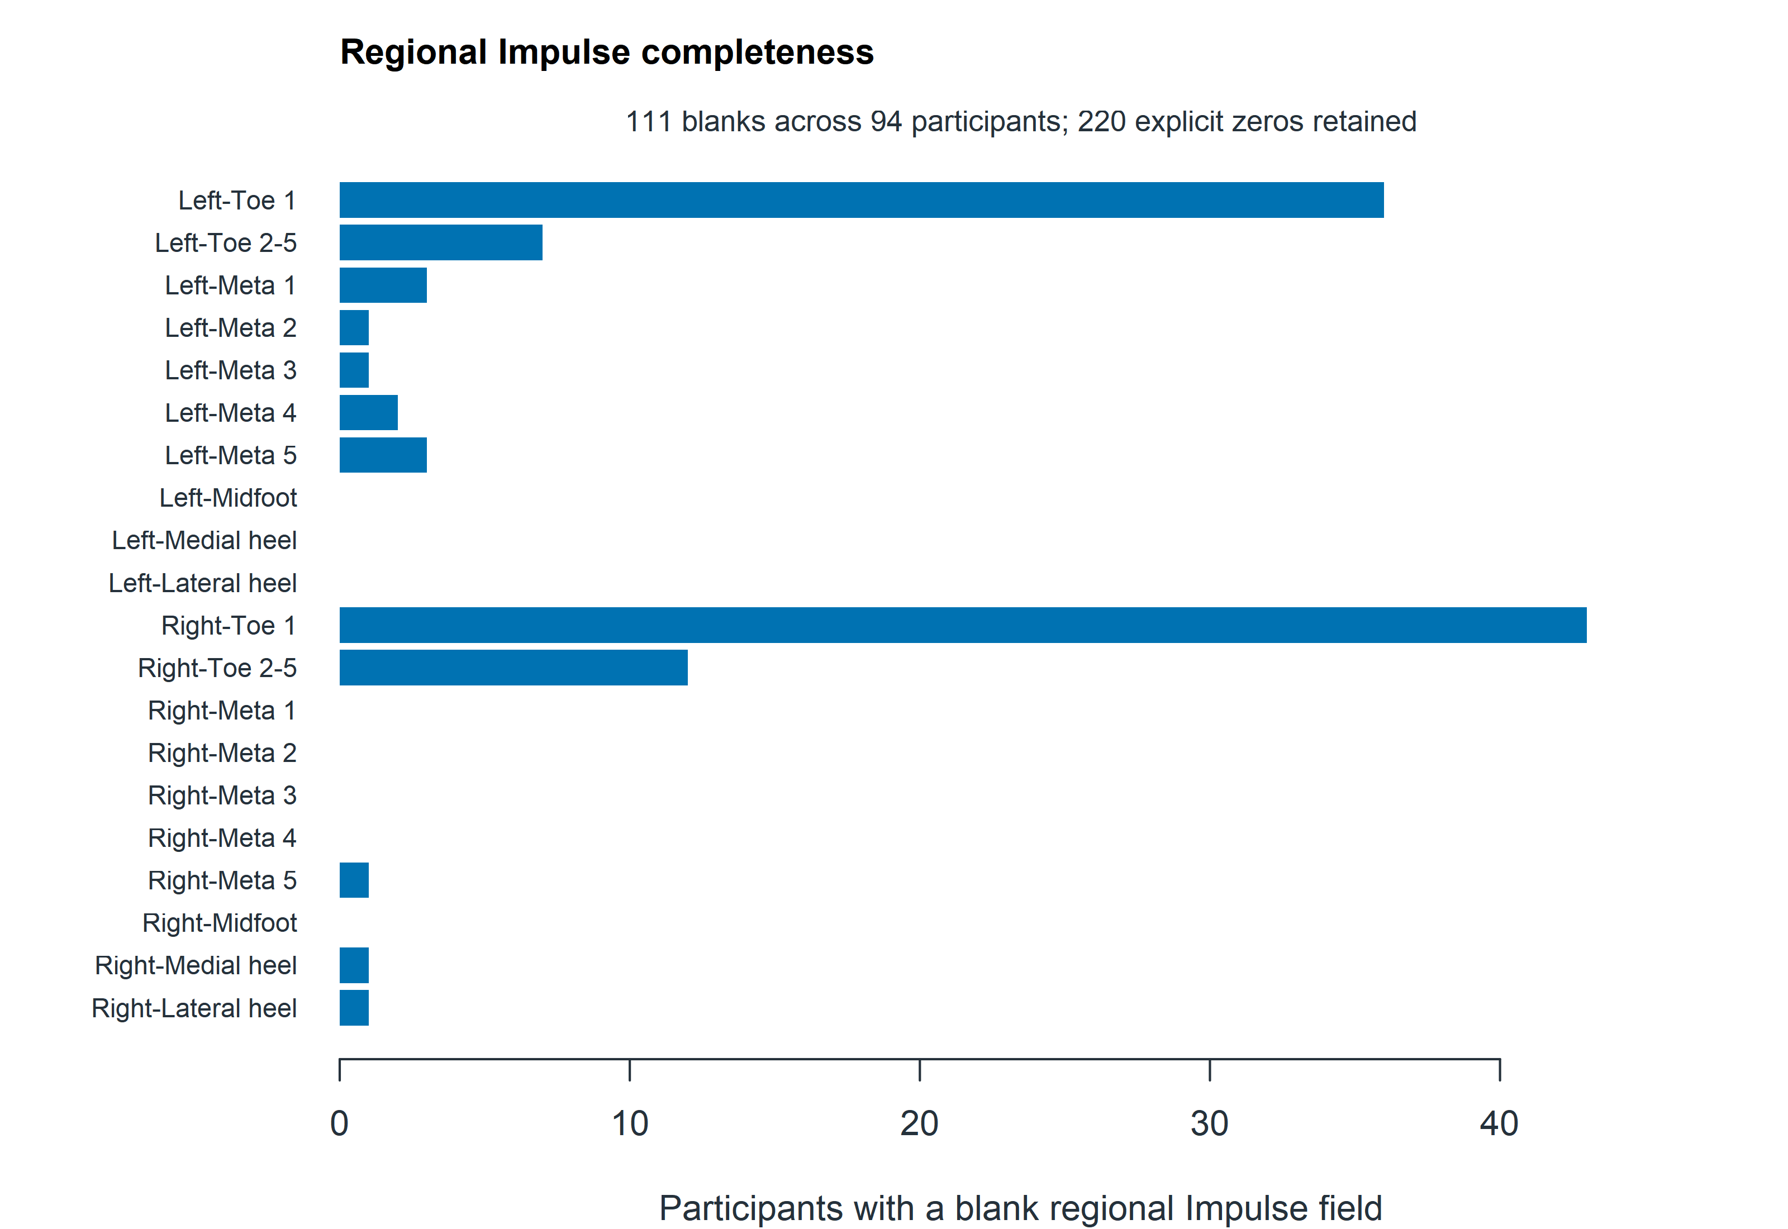
Counts of blank Footscan Impulse fields used to derive regional PTI in the 810-participant cohort. There are 111 blank fields affecting 94 participants, 220 explicit numeric zeros and 15,869 nonzero values. Blank fields are not recoded as zero. A participant may contribute to more than one bar.

Figure S2 Distributions of the focused outcomes by FI33 group
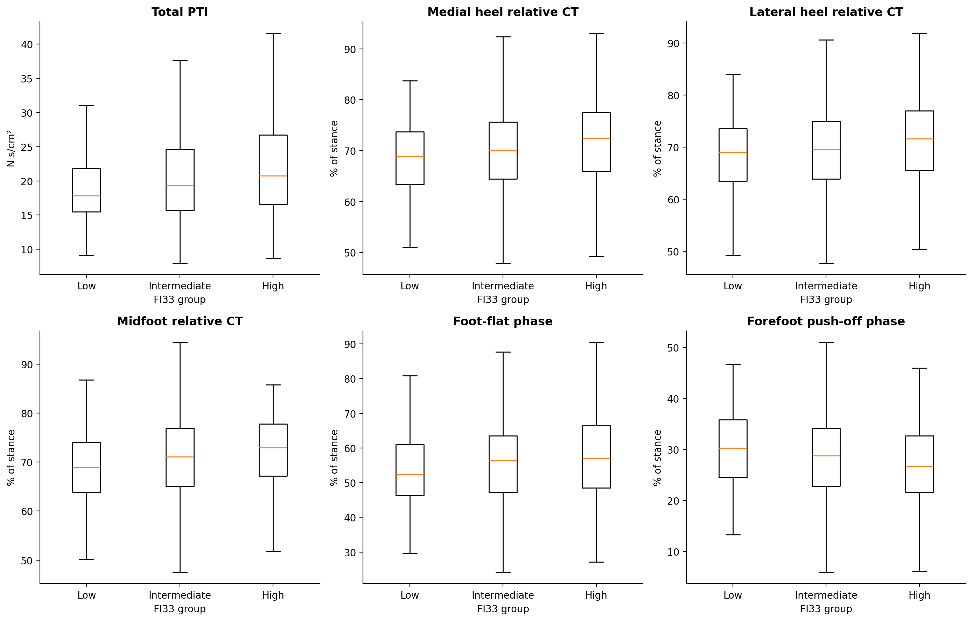
Boxes show the median and interquartile range; whiskers extend to the most extreme values within 1.5 times the IQR. Outlier points are omitted from the display only; all eligible observations contribute to the summaries. Groups are low (<0.10), intermediate (0.10 to <0.25) and high (≥ 0.25) FI33. T-PTI is expressed in N s/cm2; other outcomes are percentages of stance. Outcome-specific sample sizes are shown in Table 2.

Figure S3 Exploratory FI30 associations across IWGDF-based risk 0, 1 and 2
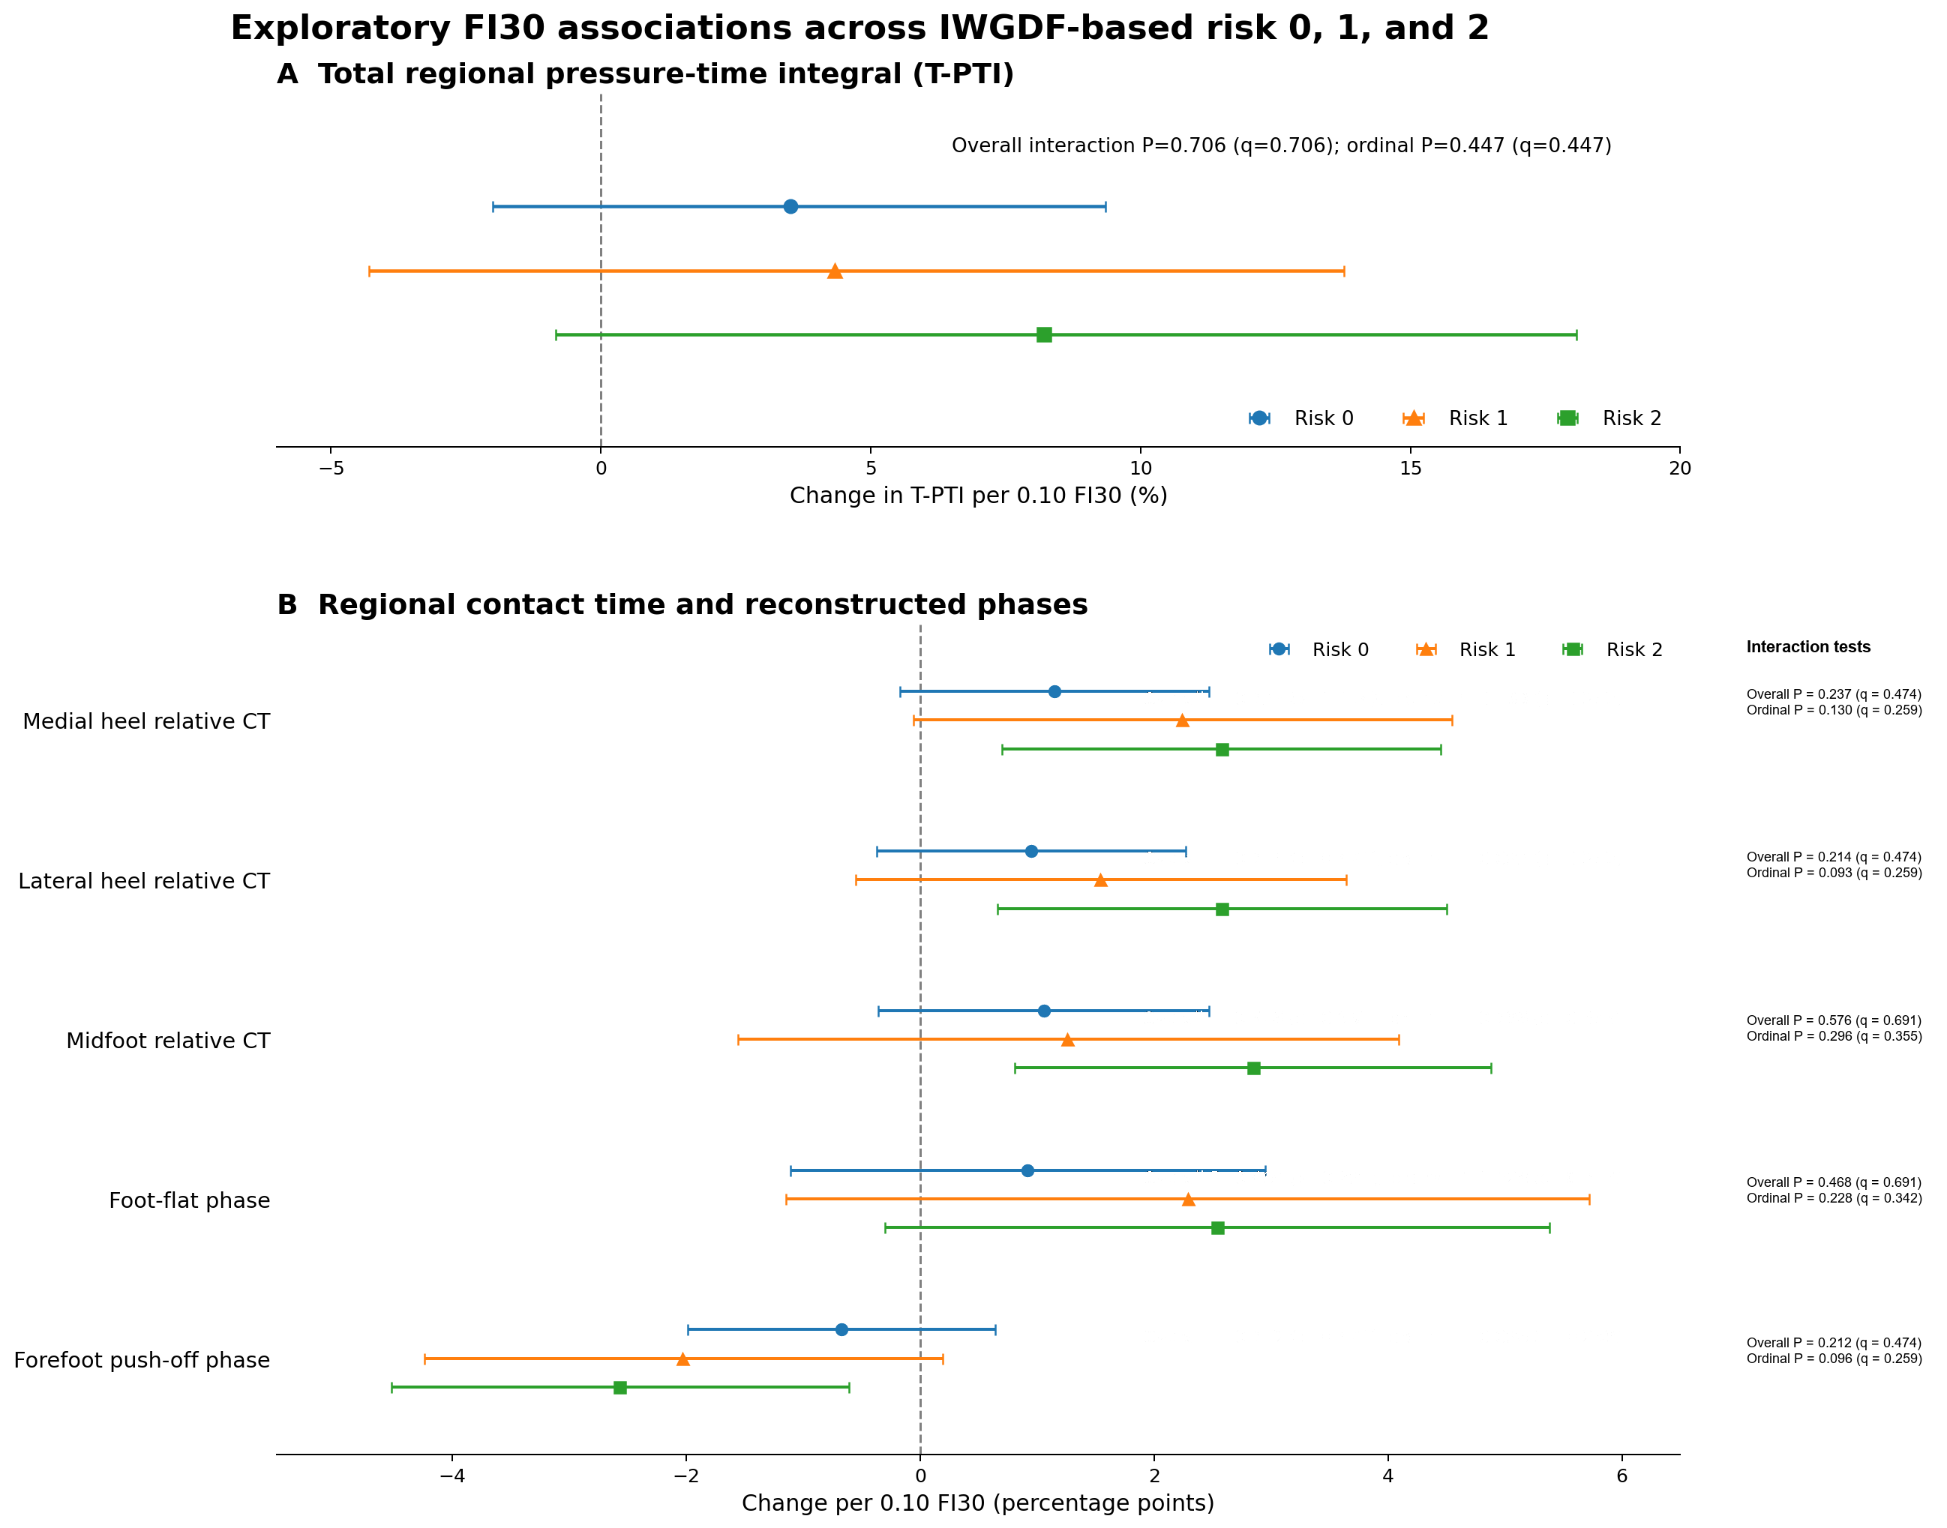
Adjusted effects and 95% confidence intervals per 0.10 increase in FI30 are shown for operational risk 0, 1 and 2. T-PTI is reported as percentage change; timing outcomes are percentage-point changes. Risk 3 (n =1) is excluded from regression. Overall categorical and ordinal trend interactions are shown for each outcome. None provided statistically robust evidence of heterogeneity after BH adjustment; the visual ordering is therefore hypothesis-generating.

Figure S4 Sensitivity analyses for the focused outcomes
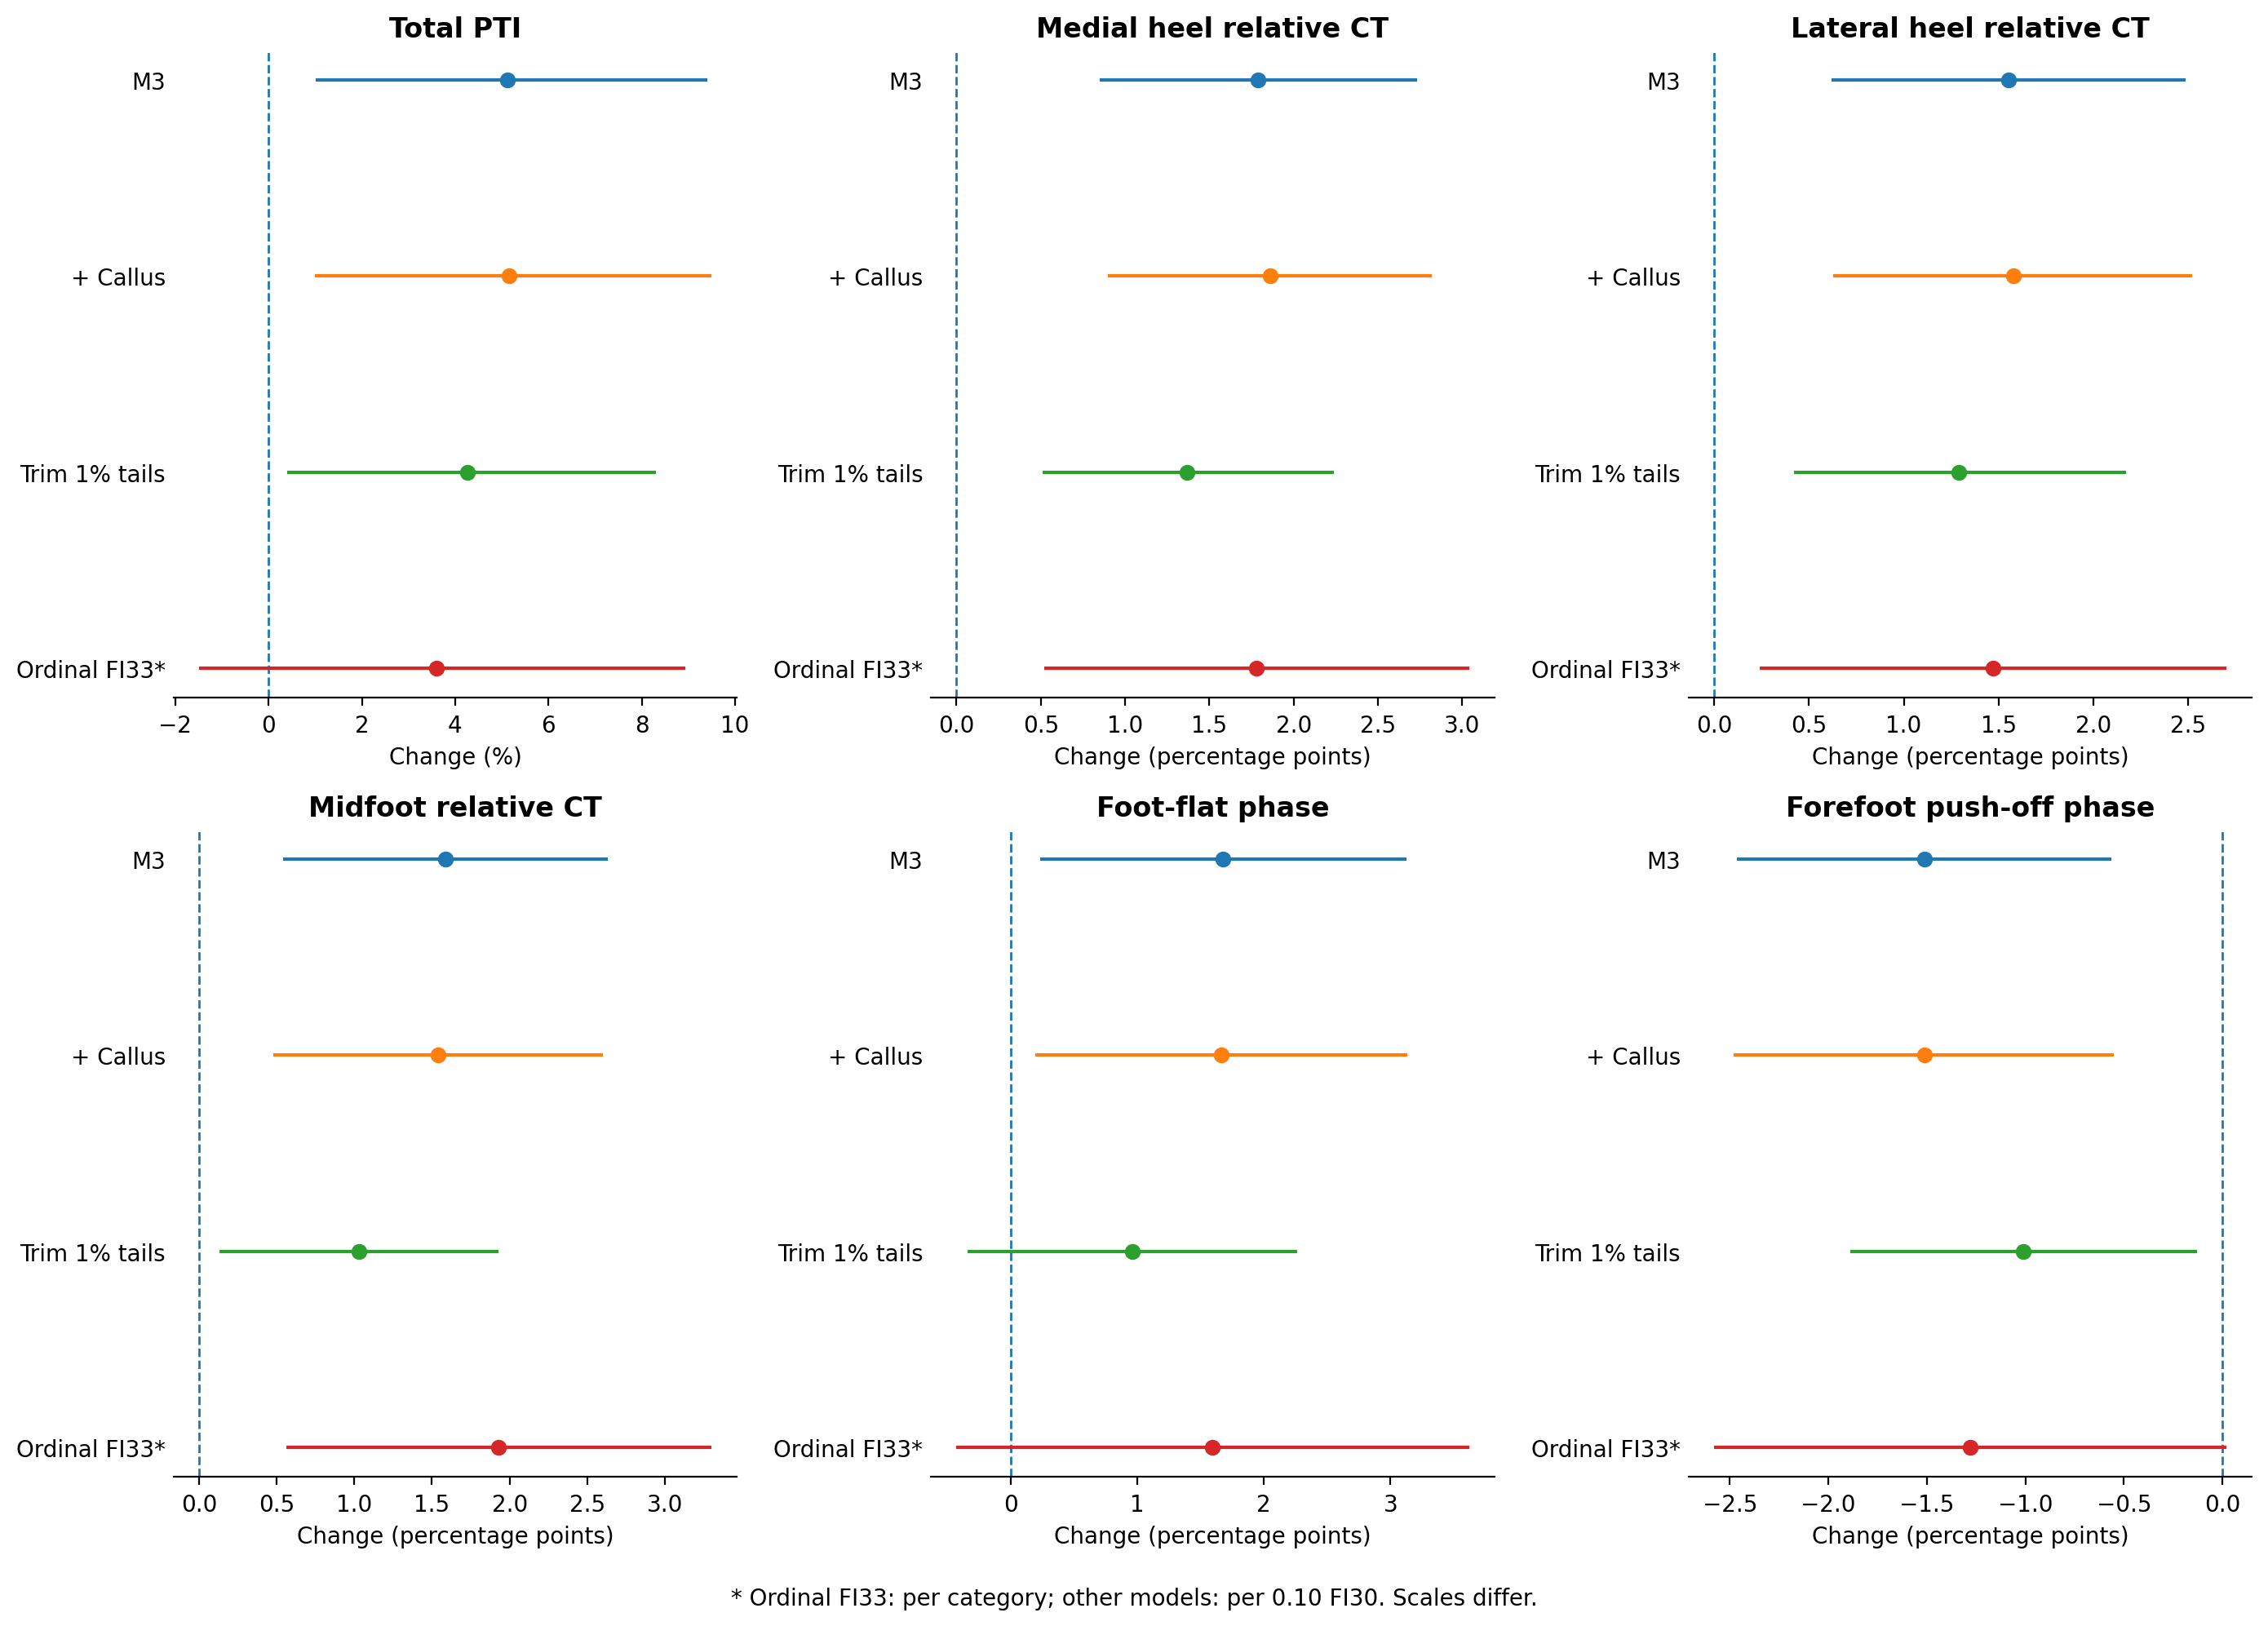
Points and intervals show effects and 95% HC3 confidence intervals. M3, additional callus adjustment and outcome trimming use FI30 per 0.10; ordinal FI33 uses change per category and changes both index composition and exposure scale. Trimming removes the lowest and highest 1% of each outcome. Callus was coded as present/absent; no callus data were missing in the 810-participant cohort. P values for sensitivity models are unadjusted. IWGDF-based subgroup and interaction analyses are tabulated separately in Tables S5A-S5B.

Figure S5 Continuous associations with reconstructed rollover timing
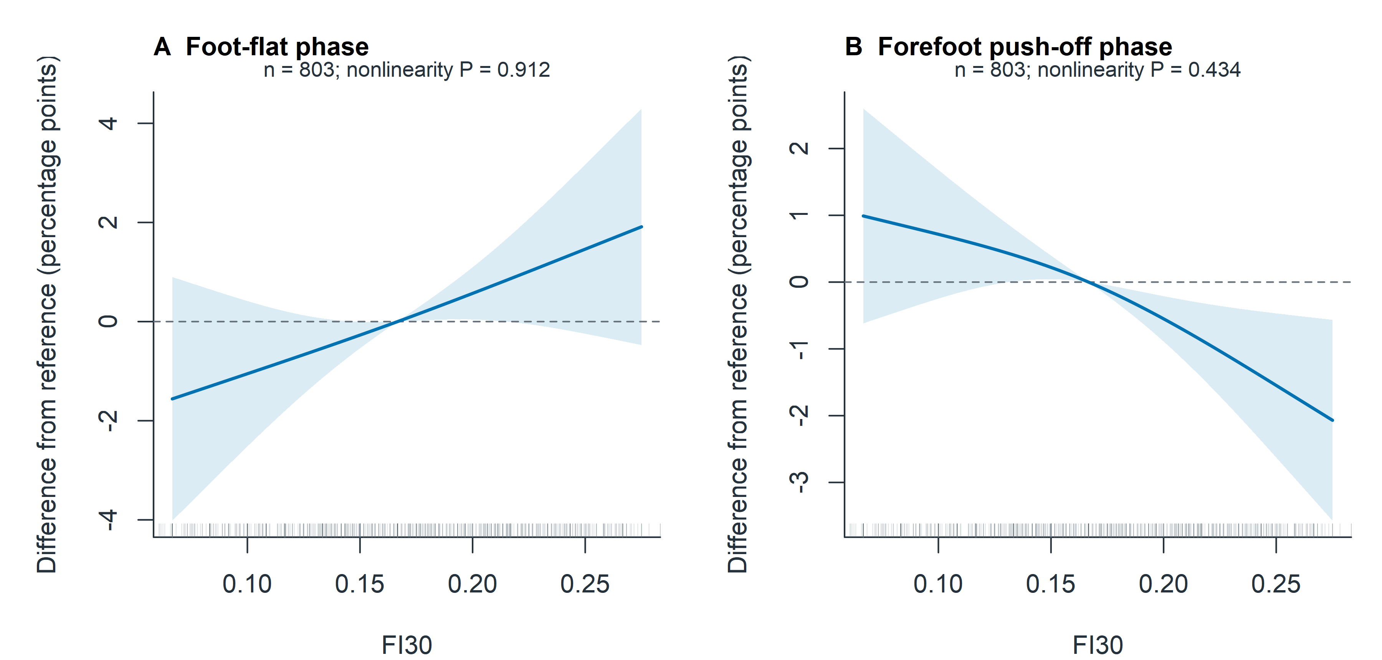
Panels show foot-flat phase and forefoot push-off phase, expressed as percentage-point differences from the model-sample median FI30. Shading indicates pointwise 95% HC3 confidence intervals. N=803 for each panel; P for nonlinearity=0.912 and 0.434, respectively. Knots, adjustment and display range follow Figure 3. These phases are reconstructed from regional summary times, not direct kinematic measurements.

Figure S6 Continuous association between FI30 and total regional pressure-time integral
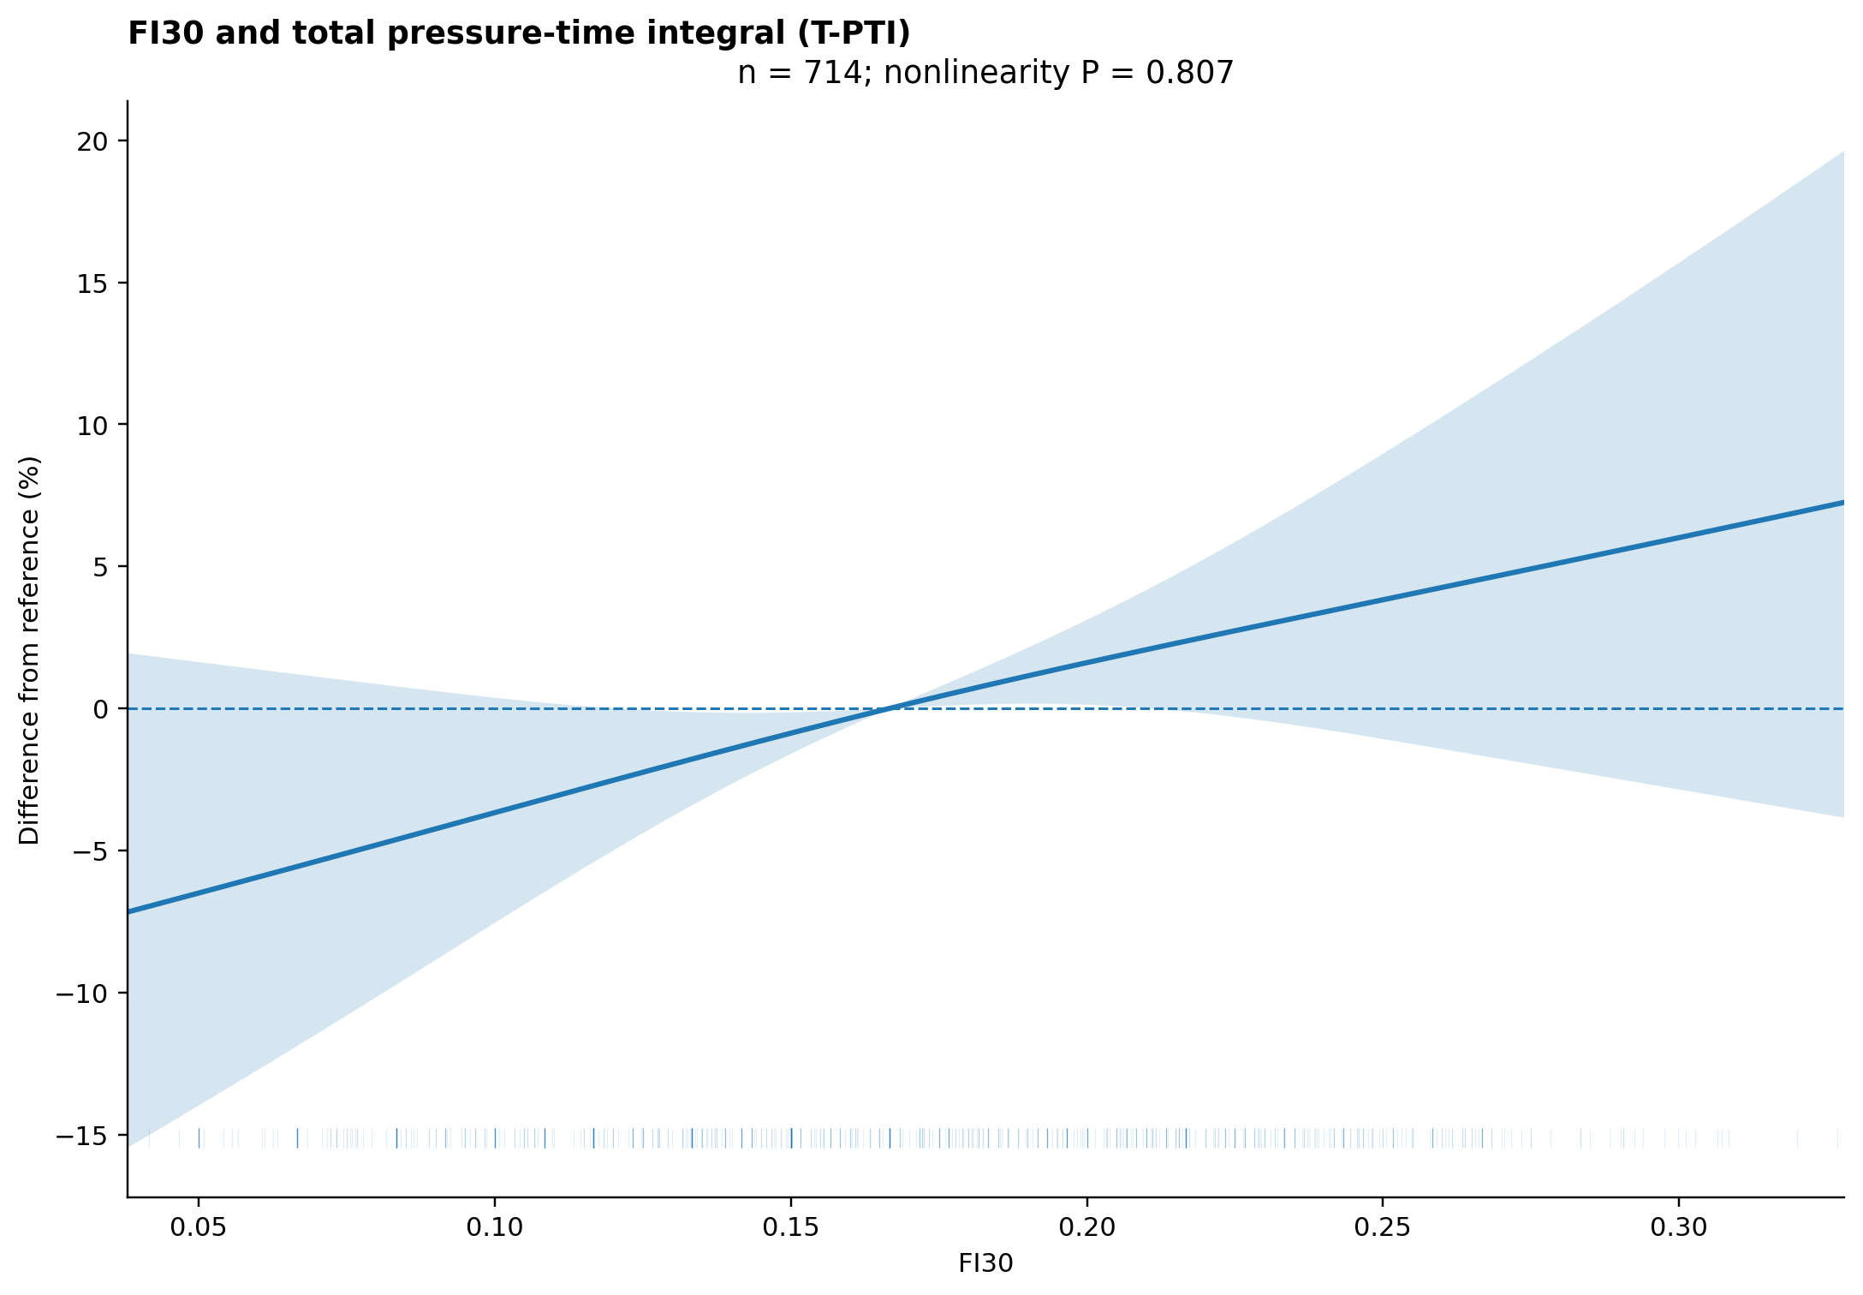
Restricted cubic spline for T-PTI using M3 covariates. Knots were placed at FI30 0.08333, 0.16667 and 0.25500. N=714; P for nonlinearity=0.807. The curve shows percentage difference relative to the model-sample median FI30 with pointwise 95% HC3 confidence intervals. Lack of detected nonlinearity does not establish strict linearity or causality.

