Supplementary Figures and Table

a b
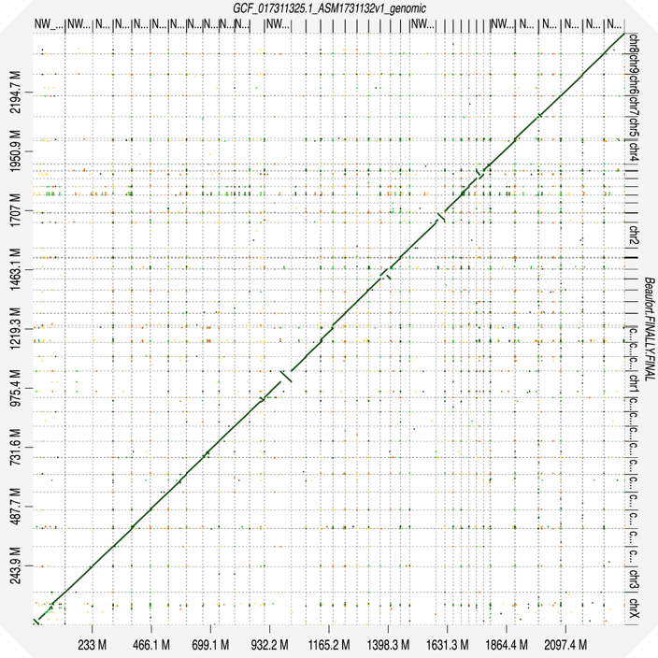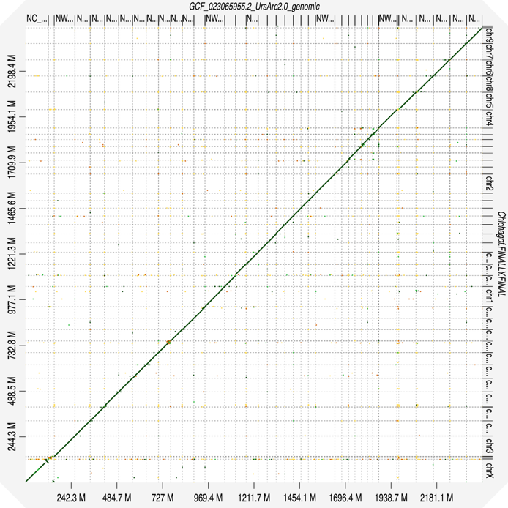
c d
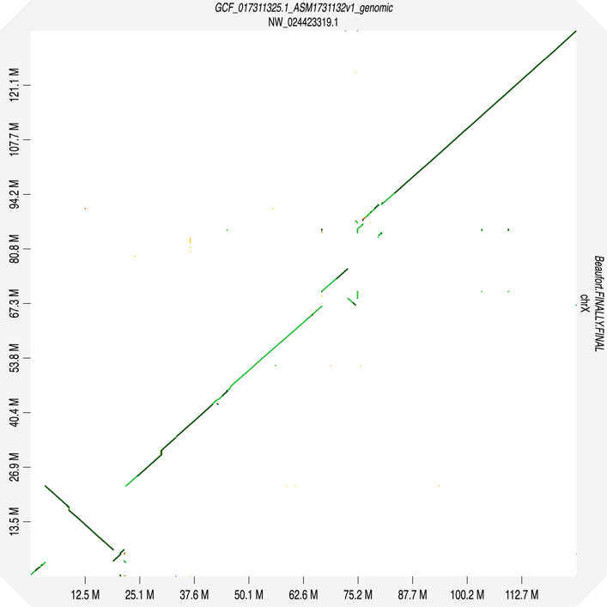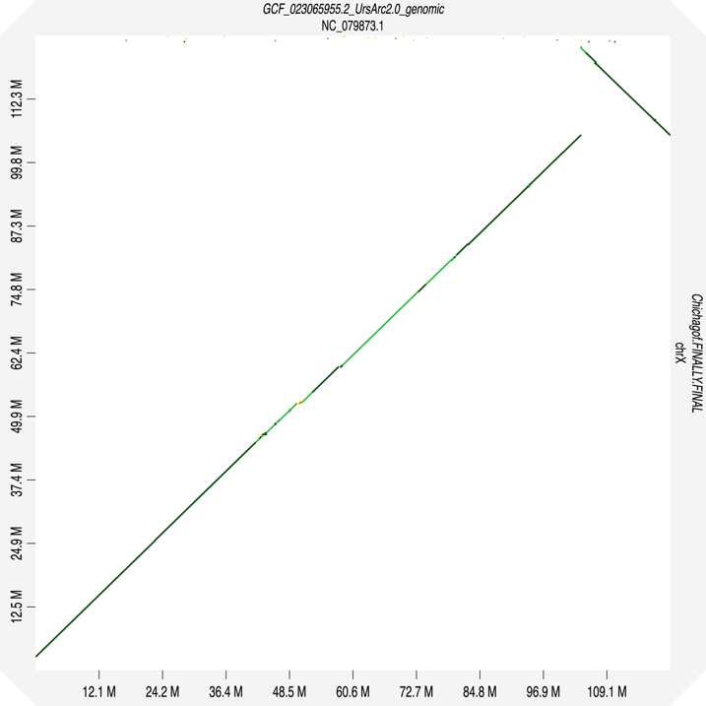

Supplementary Figure S1. D-GENIES syntenic comparison plots. (a) The publicly available polar bear reference genome (GCF_017311325.1) and the new polar bear genome assembly, (b) the publicly available brown bear (GCF_023065955.2) and the new Chichagof brown bear genome assembly, and (c and d) zoom-in of their respective X chromosomes.
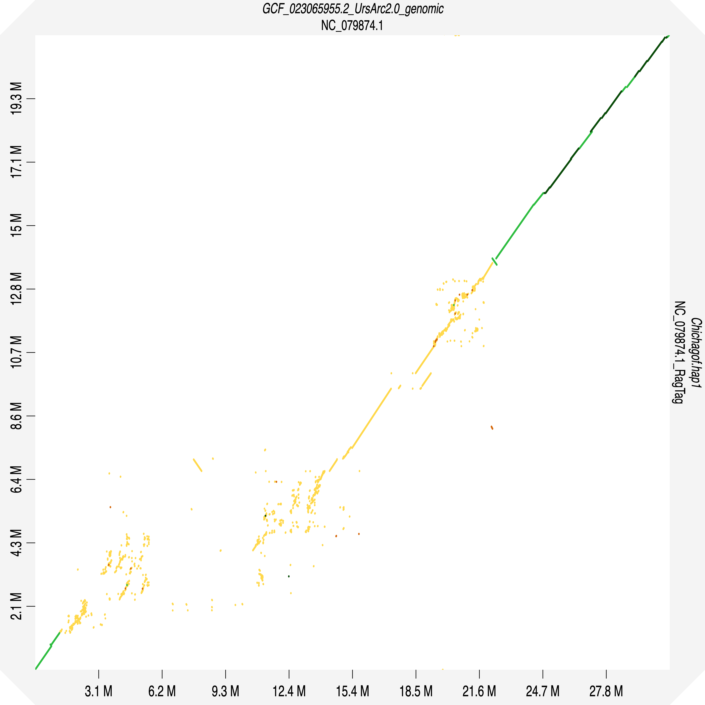

Supplementary Figure S2. D-GENIES comparison plot of Y chromosomes from the publicly available reference brown bear Y chromosome and the new Chichagof brown bear phased haplotype 1 putatively Y chromosome-associated scaffold.

a
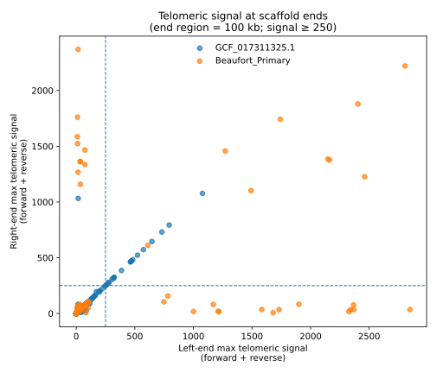
b
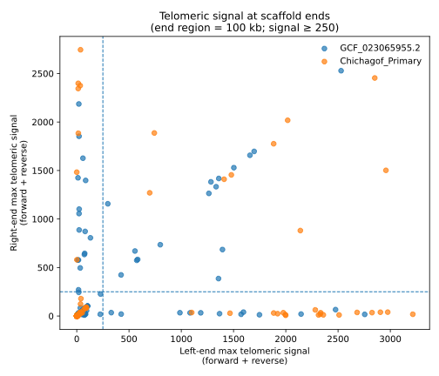
Supplementary Figure S3. Telomeric signal at scaffold ends compared between the new genome assemblies and published references. (a) The new polar bear assembly (blue) is compared to the available polar bear reference genome (GCF_017311325.1; orange). (b) The new brown bear assembly (blue) is compared to the available brown bear reference genome (GCF_023065955.2; orange). Scatter plots show the maximum telomeric repeat signal (forward + reverse) detected by TIDK within the terminal 200 kb of each scaffold. Each point represents one scaffold, with the x- and y-axes indicating the strongest telomeric signal observed at the left and right scaffold ends, respectively. Dashed lines denote a conservative threshold (signal ≥ 250) used to identify strong telomeric enrichment. Scaffolds in the upper-right quadrant exhibit elevated telomeric signal at both ends, consistent with near telomere-to-telomere chromosome representation, whereas scaffolds with signal at only one or neither end likely correspond to truncated chromosome arms or internal fragments.
Supplementary Table S1. Assembly comparison between new bear genomes and current RefSeq assemblies. The new Southern Beaufort polar bear and Chichagof Island brown bear primary assemblies show comparable or increased quality statistics with current public RefSeq genomes through contiguity, completeness, annotation, and chromosome-scale representation metrics.
Metric | New Southern Beaufort  polar bear (primary) | New Chichagof Island  brown bear (primary) | Current polar bear RefSeq  GCF_017311325.1 | Current brown bear RefSeq  GCF_023065955.2
Assembly span / ungapped length | 2.44 Gb | 2.44 Gb | 2.3 Gb | 2.4 Gb
Number of contigs | 353 | 1,675 | 31,011 | 611
Contig N50 | 38.5 Mb | 48.8 Mb | 0.207 Mb | 35.7 Mb
Number of scaffolds | 229 | 1,529 | 3,899 | 361
Scaffold N50 | 73.7 Mb | 72.4 Mb | 72.2 Mb | 72.0 Mb
Scaffold L50 | 14 | 14 | 13 | 14
BUSCO completeness  (carnivora_odb10) | 95.7% | 95.6% | 98.4% | 96.8%
Annotated genes | 33,713 | 30,838 | 33,886 | 30,450
Assembly level | 37 chromosome-length  scaffolds (98.5% of  sequence) | 37 chromosome-length scaffolds (98.03% of sequence) | Scaffold-level record | Chromosome-level record

