Table S1. DNA Sequences of primers, si-RNA and probes.
Names | Sequence (5'-3')
PCR
LINC02532-F | TCCTGGTGCCACTGAGACTGTG
LINC02532-R | AGCCTCCATGATTCCTGCCTCTAG
FOXF2-F | TACTCCAGTGTGTGACAGAAAA
FOXF2-R | TGGTGATGGTGATAATACGACC
SOX7-F | ATGAACGCCTTCATGGTTTG
SOX7-R | GTACTTGTAGTTGGGGTAGTCC
CDH1-F | AGTCACTGACACCAACGATAAT
CDH1-R | ATCGTTGTTCACTGGATTTGTG
CDH2-F | CGATAAGGATCAACCCCATACA
CDH2-R | TTCAAAGTCGATTGGTTTGACC
SNAI2-F | CTGTGACAAGGAATATGTGAGC
SNAI2-R | CTAATGTGTCCTTGAAGCAACC
VIM-F | TGAATGACCGCTTCGCCAACTAC
VIM-R | CTCCCGCATCTCCTCCTCGTAG
GAPDH-F | AGCCACATCGCTCAGACAC
GAPDH-R | GCCCAATACGACCAAATCC
si-RNA
si-LINC02532 #1 | GGAACACAUAUAGCUGGAATT
si-LINC02532 #1 | UUCCAGCUAUAUGUGUUCCTT
si-LINC02532 #2 | GCAGGAAUCAUGGAGGCUUTT
si-LINC02532 #2 | AAGCCUCCAUGAUUCCUGCTT
si-FOXF2 #1 | CAGAGCGTCTGTCAGGATA
si-FOXF2 #2 | GCGTCATGTGAACGGAAAG
si-SOX7 | CGACCAGTATTTGAACACT
si-NC | UUCUCCGAACGUGUCACGUTT
si-NC | ACGUGACACGUUCGGAGAATT
FISH probes
LINC02532 probe1 | AACATGGCTTGAGCACCTCCTTG
LINC02532 probe2 | TCCACTGTAGTACCCATAACCAT
LINC02532 probe3 | CGTAAGTAGCACAGATCCCATC
18S | CTGCCTTCCTTGGATGTGGTAGCCGTTTC

Figure S1. Representative IHC images of SOX7 in GC and normal stomach tissues.

Figure S2
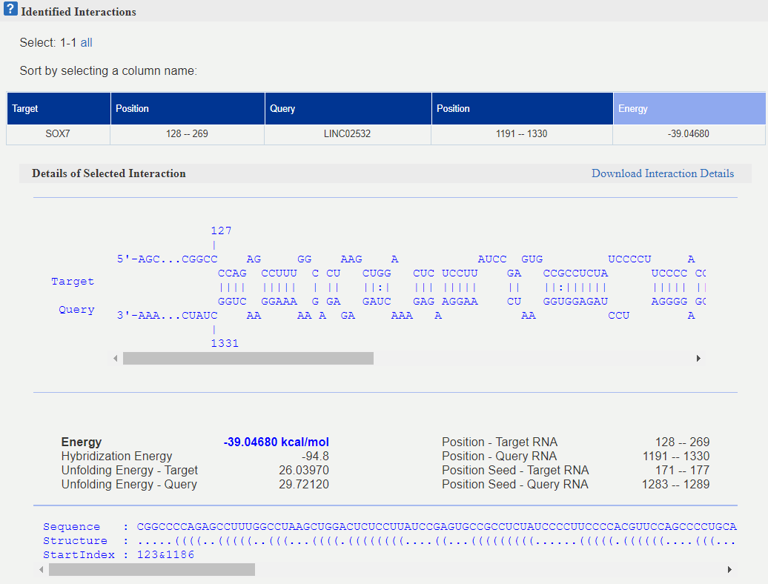
Figure S2. The RNA-RNA interaction binding sites of LINC02532 on the SOX7 mRNA 3’UTR region.

