Rarefaction curves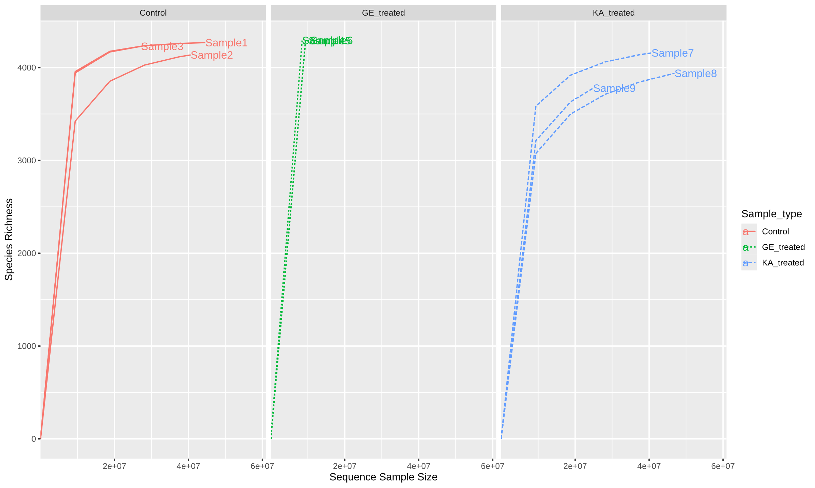
Figure 1: Rarefaction curves showing bacterial taxonomic richness across sequencing depths for Control, GE-treated, and KA-treated samples.

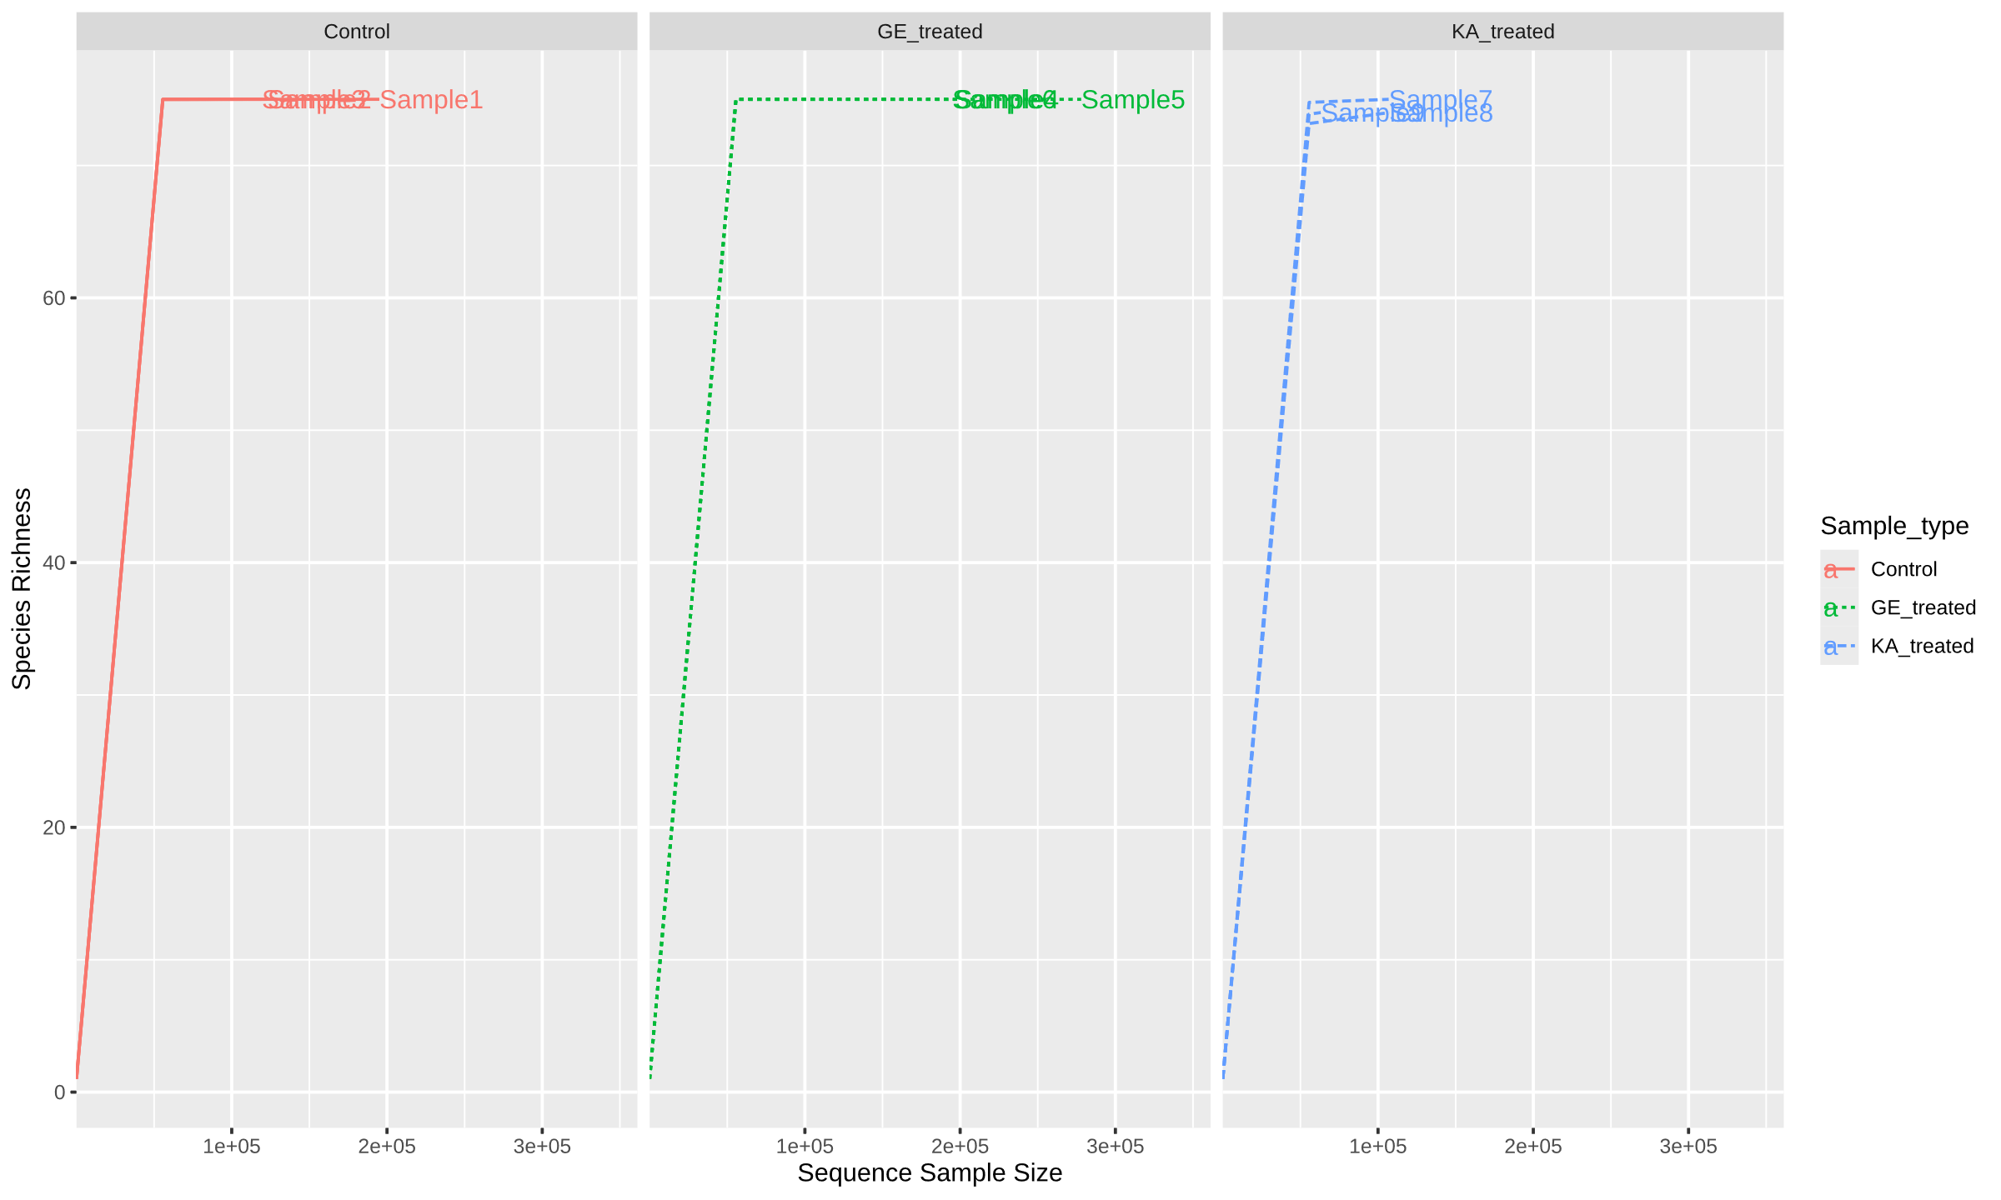
Figure 2: Rarefaction curves showing fungal taxonomic richness across sequencing depths for Control, GE-treated, and KA-treated samples.
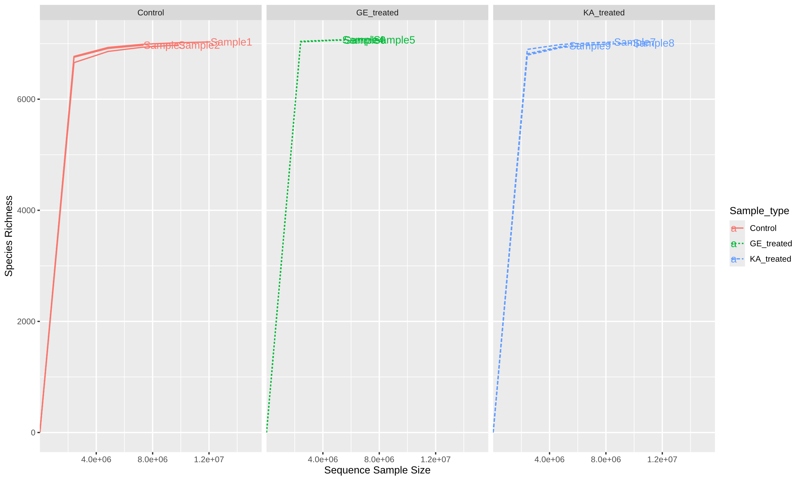
Figure 3: Rarefaction curves showing actinomycetes taxonomic richness across sequencing depths for Control, GE-treated, and KA-treated samples.

