Supplementary Materials
Social isolation, loneliness and functional transitions among middle-aged and older adults with cardiometabolic multimorbidity: a multistate Markov analysis of CHARLS

Supplementary Methods
Methods S1. Construction of the social isolation index and loneliness measure
Methods S2. Death ascertainment and imputation
Methods S3. Model specification, estimation and selection record
Methods S4. Sensitivity analyses and full-sample interaction model

Supplementary Tables
Table S1. Sample selection
Table S2. Model fit: exposure vs no-exposure models
Table S3. Covariate hazard ratios, main model (all transitions; vs reference level)
Table S4. Model-based transition probabilities from independence (state 1), reference covariate profile
Table S5. Expected years spent in each state between ages 60 and 90, starting independent, reference covariate profile
Table S6a. Sensitivity analyses: G4 (dual exposure) vs G1, key transitions
Table S6b. S4 (CVD-inclusive CMM, n=1,089): all groups and transitions (foundse=TRUE)
Table S6c. S6a (baseline age <65, n=1,190): all groups and transitions (foundse=TRUE)
Table S6d. S7 (comorbidity count excluding psychiatric and memory-related disease as potential mediators, n=1,731)
Table S6e. Point-estimate-only sensitivity analyses (S1, S2, S3, S5, S6b)
Table S7. Full-sample interaction analysis (n=13,143): exposure × CMM

Supplementary Figures
Figure S1 Participant selection flow chart
Figure S2 Observed functional-state prevalence by exposure group across survey waves
Figure S3 Observed transition counts between consecutive waves by exposure group
Figure S4 Model-based 5-year transition probabilities from independence by exposure group
Figure S5 Sensitivity analyses: G4 versus G1 hazard ratios across key transitions

Supplementary Methods
Methods S1. Construction of the social isolation index and loneliness measure
Social isolation was measured at baseline (2011) with a four-item index, each item scoring 1 when present:
Item | Source variable (2011) | Coding rule (verified against CHARLS codebooks)
Unpartnered | Harmonized  r1mstat | Married or cohabiting = 0; separated, divorced, widowed or never married = 1
Living alone | Harmonized  h1hhres  (household size) | Household size = 1 → 1; ≥2 → 0
Child contact < weekly | Raw  cd003_x_  (face-to-face),  cd004_x_  (phone/letter), x = 1–14 children | For each participant, the most frequent contact frequency across children (in person and remotely) was derived; if the most frequent contact with any child was less than weekly → 1. Participants with no separate child-contact records (child co-resident or no children, module all missing) scored 0
No social activity | da056s1  –  da056s12  (past-month social activities) | "Interacted with friends" not endorsed and no other activity endorsed (  da056s12  = none) → 1; any activity → 0
The sum ranged 0–4; the sample median was 0 (G1/G2 median 0; G3/G4 median 1, interquartile range 1–1), so high isolation was defined as a score ≥1. The conventional ≥2 cut-point — examined in sensitivity analysis S1 — left high-isolation groups too small (n=73 and 50) for stable estimation of nine transitions.
Loneliness came from the CES-D-10 item “I felt lonely” (dc017; 1 = rarely/never to 4 = most of the time); responses of ≥2 — “some of the time (3–4 days)” or more — were classed as lonely. In 2018 the item sits in the Cognition file, and in 2020 it is renamed dc024; only the 2011 measurement was used.
Crossing isolation (low/high) with loneliness (no/yes) gave four groups: G1, low isolation and no loneliness (n=584, 33.7%); G2, loneliness only (n=220, 12.7%); G3, isolation only (n=599, 34.6%); and G4, dual exposure (n=328, 19.0%).
Methods S2. Death ascertainment and imputation
Vital status and death dates were triangulated across five sources:
Source | Information | Deaths newly dentified
2013 exit interview (exb001_1/_2) | Year/month of death | 55
2020 exit module (exb001_1/_2) | Year/month of death | 71
End-of-life file (raxyear/raxmonth) | Year/month of death (mainly 2011–13) | 0
Wave sample-status files  died flag (2015/2018/2020) | Death indicator | 160
Harmonized  rXiwstat = 4 | Death indicator | 0
In total, 286 participants died (16.5%). The month and year of death were directly recorded for 55 decedents; for the remaining 231 (80.8%), the death date was imputed at the midpoint between the last interview at which the participant was alive and the wave confirming death — the standard handling of interval-censored mortality in surveys with 2–4-year waves.
Methods S3. Model specification, estimation and selection record
We fitted the multistate Markov models with the msm package (1.8.2) in R 4.5.1, using exact age as the time axis (state ~ age) and allowing all nine transitions (1↔2, 1↔3, 1→4, 2↔3, 2→4, 3→4); repeated observations within participants were handled through the panel structure of the likelihood. Transition intensities were log-linear in the covariates, with constant (homogeneous) baseline intensities. Optimisation used BFGS with numerically stabilised step scales (parscale); this does not impair Hessian-based standard errors, and full Wald confidence intervals were obtained for the main model and for sensitivity models S4, S6a and S7.
Model specifications considered and rejected:
Specification | Outcome
Piecewise-constant intensities (split ages 55/65/75) | 4-segment: Hessian not positive-definite (no CIs); 3-segment and hand-supplied initials: numerical overflow — n=1,731 insufficient for piecewise baselines
Baseline age as covariate (continuous /5y) | Optimiser overflow
Baseline age as covariate (quartiles) | Optimiser overflow
Baseline age as covariate (binary ≥65) | Fitted, but 17 parameters degenerate (foundse=FALSE, no CIs)
The root cause was quasi-complete separation: the 2→4 (IADL-limited → death) transition had zero events among participants aged 45–54 at baseline, so any age coefficient on that transition is unidentified. The final specification therefore uses homogeneous intensities on the exact-age time scale with no age covariate; residual age confounding was assessed by the age-stratified sensitivity analysis (S6).
Hazard ratios are exponentiated transition-specific coefficients, and 95% CIs are coefficient-level Wald intervals. Cells with |coefficient| > 20, SE > 2 or a CI width ratio > 500 were flagged NE (not estimable), following standard practice. Expected years in each state between ages 60 and 90 were computed as fixed-window total length of stay (totlos.msm, t = 60, 30-year window) for the reference covariate profile (female, low education, rural residence, no non-cardiometabolic comorbidity, never-smoker, never-drinker). We did not report an infinite-horizon life expectancy: extrapolating homogeneous intensities to extreme ages is not defensible.
Methods S4. Sensitivity analyses and full-sample interaction model
 | Analysis | Specification
S1 | Isolation cut-point ≥2 | Four-item index ≥2 = high isolation (the conventional cut-point)
S2 | Follow-up truncated at 2018 | 2020 wave excluded
S3 | Depressive symptoms adjusted | CES-D-9 excluding the loneliness item, continuous (z-standardised), added as covariate
S4 | CVD-inclusive CMM | ≥1 of heart disease or stroke, plus ≥2 of the five diseases in total (n=1,089)
S5 | ADL disability = ≥2 limitations | State 3 requires ≥2 ADL difficulties instead of any
S6a/b | Age strata | Baseline age <65 (n=1,190) / ≥65 (n=541)
S7 | Mediator-exclusion comorbidity count | Psychiatric/emotional problems (2.1%) and memory-related disease (3.3%) removed from the nine-condition non-cardiometabolic count
The full-sample interaction model included all CHARLS participants aged ≥45 with complete exposure and covariate data (n=13,143: CMM n=1,731; no CMM n=11,412; 57,892 person-wave rows). A model with four-group × CMM interaction terms (162 parameters) was compared with the no-interaction model (135 parameters) by a likelihood ratio test (LRT). The interaction model's Hessian did not permit variance estimation (foundse = FALSE; sparse interaction cells), but the LRT depends only on the difference in −2logL and remains valid. Hazard ratios in the CMM-free stratum are main-effect point estimates from the interaction model and are therefore reported without CIs.
Supplementary Tables
Table S1. Sample selection
Step | n | Excluded at step
CHARLS 2011 baseline participants | 17,596 | —
Aged ≥45 at baseline | 16,831 | 765 aged <45
Cardiometabolic multimorbidity (≥2 of hypertension, dyslipidaemia, diabetes, heart disease, stroke) | 2,177 | 14,654 with <2 diseases
Complete 4-item isolation index | 1,763 | 414 with a missing component
Loneliness item non-missing | 1,731 | 32 missing loneliness
CMM = cardiometabolic multimorbidity (≥2 of hypertension, dyslipidaemia, diabetes, heart disease, stroke). The analytic sample (n=1,731) contributed 7,319 person-wave observations.

Table S2. Model fit: exposure vs no-exposure models
Model | k | −2logL | AIC | BIC
Main model (with group4 exposure) | 126 | 10,321.47 | 10,573.47 | 11,260.99
No-exposure model | 99 | 10,419.03 | 10,617.03 | 11,157.22
Likelihood ratio test χ²=97.56 (27 df, p=6.5×10⁻¹⁰); ΔAIC=−43.56 (favours exposure model); ΔBIC=+103.77 (favours no-exposure model). BIC penalises the 27 added coefficients by 27×ln(1,731)≈201, exceeding the 97.6 deviance improvement (the exposure signal concentrates in a minority of group×transition cells: deterioration-onset, recovery and post-disability mortality).
k = number of parameters. The exposure model adds 27 group×transition coefficients (3 groups × 9 transitions). LRT = likelihood ratio test. AIC favours the exposure model (lower value); BIC favours the no-exposure model (per-parameter penalty 27×ln(1,731)≈201 exceeds the 97.6 deviance improvement), reflecting BIC's heavy penalty under sparse signal allocation rather than absence of association.

Table S3. Covariate hazard ratios, main model (all transitions; vs reference level)
Covariate | 1→2 | 1→3 | 1→4 | 2→1 | 2→3 | 2→4 | 3→1 | 3→2 | 3→4
Female vs male | 1.37 (0.82–2.27) | 1.10 (0.68–1.79) | NE | 2.72 (1.63–4.52)* | 1.04 (0.59–1.83) | 0.14 (0.01–1.68) | 0.31 (0.17–0.59)* | 2.45 (1.11–5.37)* | 0.50 (0.25–0.97)*
Education middle vs low | 1.24 (0.81–1.90) | NE | 0.72 (0.15–3.39) | 1.35 (0.71–2.56) | 9.85 (3.02–32.13)* | NE | 0.81 (0.38–1.73) | 8.62 (2.29–32.48)* | 0.33 (0.13–0.82)*
Education high vs low | 0.90 (0.20–4.04) | 0.51 (0.16–1.62) | NE | 2.70 (0.48–15.16) | 1.27 (0.18–8.80) | NE | NE | 1.09 (0.16–7.28) | 1.44 (0.56–3.73)
Urban vs rural | 0.80 (0.56–1.14) | 0.79 (0.59–1.04) | 0.97 (0.39–2.37) | 1.47 (0.98–2.21) | 0.76 (0.49–1.19) | NE | 0.60 (0.35–1.04) | 1.63 (1.04–2.53)* | 1.43 (1.02–2.00)*
Comorbidity 1 vs 0 | 1.05 (0.71–1.57) | 1.22 (0.86–1.72) | 0.69 (0.11–4.45) | 0.79 (0.48–1.28) | 0.76 (0.46–1.26) | NE | 1.10 (0.68–1.78) | 0.92 (0.51–1.65) | 0.73 (0.50–1.09)
Comorbidity ≥2 vs 0 | 1.06 (0.68–1.64) | 1.90 (1.34–2.69)* | 1.50 (0.56–4.05) | 0.73 (0.46–1.17) | 1.32 (0.82–2.14) | NE | 0.90 (0.54–1.49) | 1.87 (1.09–3.19)* | 0.61 (0.41–0.90)*
Former vs never smoker | 0.89 (0.52–1.50) | 1.87 (1.16–3.00)* | NE | 1.04 (0.55–1.97) | 0.68 (0.35–1.33) | NE | 0.66 (0.37–1.15) | 0.78 (0.31–1.94) | 0.76 (0.39–1.48)
Current vs never smoker | 1.31 (0.78–2.20) | 1.07 (0.69–1.66) | 3.13 (0.38–25.87) | 2.52 (1.42–4.47)* | 0.61 (0.30–1.21) | 0.85 (0.05–14.31) | 0.50 (0.27–0.92)* | 1.11 (0.56–2.18) | 0.83 (0.49–1.41)
Former vs never drinker | 1.07 (0.64–1.78) | 0.66 (0.38–1.13) | 1.11 (0.24–5.23) | 1.00 (0.57–1.74) | 1.59 (0.90–2.82) | 8.31 (0.47–147.29) | 0.54 (0.30–0.96)* | 1.46 (0.78–2.73) | 0.89 (0.52–1.53)
Current vs never drinker | 0.86 (0.52–1.40) | 0.50 (0.28–0.88)* | 0.43 (0.11–1.76) | 1.22 (0.70–2.13) | 2.34 (1.25–4.38)* | NE | 1.28 (0.79–2.09) | 1.20 (0.57–2.51) | 0.79 (0.48–1.29)
HRs (95% Wald CI) for each covariate versus its reference level, from the multistate Markov model with group4 exposure. Age is the time scale (not a covariate). Depressive symptoms were excluded from the main model to avoid overadjustment with the loneliness exposure item; residual confounding was assessed in sensitivity analysis S3. NE = not estimable (sparse transition). *P<0.05.

Table S4. Model-based transition probabilities from independence (state 1), reference covariate profile
2-year horizon:
Group | Independent | IADL-limited | ADL-limited | Dead
G1 | 75.3% | 9.3% | 14.0% | 1.4%
G2 | 61.0% | 14.6% | 22.5% | 1.9%
G3 | 66.4% | 11.1% | 20.8% | 1.6%
G4 | 60.1% | 16.0% | 22.3% | 1.6%

5-year horizon:
Group | Independent | IADL-limited | ADL-limited | Dead
G1 | 60.8% | 9.7% | 24.5% | 5.0%
G2 | 46.2% | 12.4% | 33.9% | 7.5%
G3 | 50.8% | 11.4% | 32.2% | 5.7%
G4 | 40.1% | 13.0% | 38.2% | 8.6%
Probabilities sum to 100% within rounding error. The reference profile is female, low education, rural residence, no non-cardiometabolic comorbidity, never-smoker, never-drinker.

Table S5. Expected years spent in each state between ages 60 and 90, starting independent, reference covariate profile
Group | Independent (HLE) | IADL-limited | ADL-limited | Dead by 90 | % of surviving years independent
G1 | 4.83 | 0.84 | 2.81 | 21.52 | 56.9%
G2 | 2.04 | 0.58 | 1.98 | 25.40 | 44.4%
G3 | 3.89 | 0.95 | 3.20 | 21.97 | 48.4%
G4 | 0.65 | 0.24 | 1.03 | 28.08 | 33.8%
Values are fixed-window state occupancy (not life expectancy at birth); the 30-year window sum is exact by construction. HLE = healthy life expectancy (years in state 1). "% of surviving years independent" = state-1 years divided by the sum of states 1–3.

Table S6a. Sensitivity analyses: G4 (dual exposure) vs G1, key transitions
Analysis | 1→2 | 1→3 | 2→1 | 3→1 | 3→4
Main analysis (n=1,731) | 2.66 (1.62–4.37)* | 1.11 (0.59–2.09) | 1.30 (0.75–2.28) | 0.34 (0.17–0.70)* | 1.57 (1.04–2.39)*
S1 Cut-point ≥2 | 3.55† | NE† | 1.31† | NE† | 1.72†
S2 Stop at 2018 | 0.91† | 1.83† | 0.40† | 1.50† | 1.08†
S3 + CES-D-9 adjusted | 1.82† | 0.95† | 1.24† | 0.39† | 1.63†
S4 CVD-inclusive CMM (n=1,089) | 1.95 (1.00–3.79)* | 1.34 (0.67–2.71) | 0.96 (0.48–1.92) | 0.40 (0.19–0.84)* | 1.07 (0.66–1.73)
S5 ADL ≥2 items | 1.58† | 8.48‡ | 0.85† | 0.21† | 1.60†
S6a Age <65 (n=1,190) | 3.10 (1.57–6.15)* | 0.64 (0.26–1.60) | 1.20 (0.62–2.31) | 0.04 (0.00–0.71)* | 1.35 (0.74–2.48)
S6b Age ≥65 (n=541) | 0.75† | 1.84† | 0.55† | 0.35† | 1.39†
S7 Comorbidity count excluding psychiatric/memory disease | 2.67 (1.64–4.35)* | — | — | 0.34 (0.17–0.68)* | 1.48 (0.96–2.28)
*P<0.05 (Wald CI from converged Hessian). †Point estimate only: sparse transition cells prevented variance estimation (foundse=FALSE). ‡Numerically unstable; not interpretable. NE = collapsed or degenerate cell. S4 (CVD-inclusive CMM, n=1,089) and S6a (age <65, n=1,190) are the two analyses with full estimator precision closest to the main specification. S2 (truncated at 2018) loses one-quarter of follow-up and event counts; it is shown for transparency but is too unstable to serve as a consistency check.

Table S6b. S4 (CVD-inclusive CMM, n=1,089): all groups and transitions (foundse=TRUE)
Transition | G2 | G3 | G4
1→2 | 2.53 (1.09–5.83)* | 1.28 (0.73–2.25) | 1.95 (1.00–3.79)*
1→3 | 2.27 (1.12–4.58)* | 2.20 (1.34–3.61)* | 1.34 (0.67–2.71)
1→4 | NE | 1.45 (0.44–4.72) | 2.89 (0.68–12.35)
2→1 | 1.54 (0.63–3.75) | 1.06 (0.58–1.91) | 0.96 (0.48–1.92)
2→3 | 0.82 (0.37–1.83) | 0.39 (0.18–0.82)* | 1.19 (0.66–2.16)
3→1 | 0.64 (0.30–1.39) | 1.17 (0.68–1.99) | 0.40 (0.19–0.84)*
3→2 | 1.06 (0.56–2.02) | 0.70 (0.38–1.27) | 1.01 (0.54–1.87)
3→4 | 1.23 (0.73–2.07) | 0.60 (0.35–1.03) | 1.07 (0.66–1.73)
CMM here requires heart disease or stroke ≥1 plus ≥2 of the five cardiometabolic diseases. 2→4 was omitted from extraction (sparsest transition). *P<0.05. Expected independent years (60–90 window, reference profile): G1 4.03 versus G4 1.08.
Table S6c. S6a (baseline age <65, n=1,190): all groups and transitions (foundse=TRUE)
Transition | G2 | G3 | G4
1→2 | 1.94 (0.81–4.65) | 1.31 (0.73–2.34) | 3.10 (1.57–6.15)*
1→3 | 2.06 (1.19–3.59)* | 1.78 (1.18–2.68)* | 0.64 (0.26–1.60)
1→4 | 1.73 (0.36–8.22) | 1.27 (0.42–3.79) | NE
2→1 | 0.98 (0.45–2.16) | 0.91 (0.54–1.54) | 1.20 (0.62–2.31)
2→3 | 0.63 (0.18–2.20) | 0.85 (0.36–2.00) | 3.40 (1.13–10.26)*
3→1 | 1.84 (0.79–4.31) | 1.38 (0.66–2.87) | 0.04 (0.00–0.71)*
3→2 | 0.72 (0.29–1.75) | 0.94 (0.49–1.82) | 2.01 (0.84–4.79)
3→4 | 1.17 (0.54–2.53) | 0.58 (0.29–1.20) | 1.35 (0.74–2.48)
*P<0.05. Expected independent years (60–90 window): G1 9.76 versus G4 3.97.
Table S6d. S7 (comorbidity count excluding psychiatric and memory-related disease as potential mediators, n=1,731)
Contrast | Main analysis | S7
G4 1→2 | 2.66 (1.62–4.37)* | 2.67 (1.64–4.35)*
G4 3→1 | 0.34 (0.17–0.70)* | 0.34 (0.17–0.68)*
G4 3→4 | 1.57 (1.04–2.39)* | 1.48 (0.96–2.28)
G2 1→2 | 2.83 (1.09–7.31)* | 2.56 (1.10–5.97)*
G2 1→3 | 2.01 (1.28–3.15)* | 2.14 (1.39–3.27)*
G3 1→3 | 1.85 (1.32–2.62)* | 1.89 (1.34–2.66)*
Deterioration-onset and recovery findings are unchanged to the second decimal. G4 3→4 moves from significant to borderline (HR 1.57→1.48, CI upper bound 2.39→2.28), consistent with a power difference after removing two conditions from the comorbidity count.

Table S6e. Point-estimate-only sensitivity analyses (S1, S2, S3, S5, S6b): all groups
G2 (loneliness only) vs G1:
Analysis | 1→2 | 1→3 | 1→4 | 2→1 | 2→3 | 3→1 | 3→2 | 3→4
S1 | 1.78 | 1.23 | 0.69 | 1.10 | 1.09 | 0.66 | 0.83 | 1.38
S2 | NE | 4.47 | 2.91 | NE | 0.37 | 12.01 | 0.50 | 0.99
S3 | 4.93 | 1.51 | 1.94 | 5.33 | 0.62 | 0.30 | 2.01 | 1.20
S5 | 1.90 | NE | 0.75 | 1.09 | 1.00 | NE | 0.47 | 1.41
S6b | NE | NE | NE | 0.22 | 0.86 | 1.37 | 0.77 | 1.11

G3 (isolation only) vs G1:
Analysis | 1→2 | 1→3 | 1→4 | 2→1 | 2→3 | 3→1 | 3→2 | 3→4
S1 | 1.86 | 1.75 | NE | 1.28 | 0.92 | 1.71 | 0.61 | 0.39
S2 | 0.79 | 2.35 | 1.21 | 0.58 | 0.65 | 3.83 | 0.96 | 0.71
S3 | 1.17 | 1.75 | 1.75 | 1.06 | 0.70 | 1.05 | 1.15 | 0.81
S5 | 1.35 | 5.97 | 1.20 | 0.95 | 0.75 | NE | 0.80 | 0.91
S6b | 1.06 | 2.65 | 0.93 | 1.61 | 0.88 | 0.28 | 1.50 | 1.10

G4 (dual exposure) vs G1:
Analysis | 1→2 | 1→3 | 1→4 | 2→1 | 2→3 | 3→1 | 3→2 | 3→4
S1 | 3.55 | NE | NE | 1.31 | 3.13 | NE | 3.69 | 1.72
S2 | 0.91 | 1.83 | NE | 0.40 | 0.88 | 1.50 | 0.68 | 1.08
S3 | 1.82 | 0.95 | NE | 1.24 | 1.47 | 0.39 | 1.58 | 1.63
S5 | 1.58 | 8.48‡ | 1.56 | 0.85 | 0.88 | 0.21 | 0.55 | 1.60
S6b | 0.75 | 1.84 | NE | 0.55 | 1.06 | 0.35 | 0.78 | 1.39
No CIs available (foundse=FALSE due to sparse transition cells). Values are shown for directional transparency; individual point estimates from sparse cells should not be interpreted as precise effects. S1, S3 and S5 alter exposure or state definitions (re-grouping or re-definition), so numerical matching with the main analysis is not expected. S3 (CES-D-9 adjustment) is the informative column for residual depressive confounding: G4 1→2 1.82, 3→1 0.39, 3→4 1.63 — directions consistent with the main analysis.
Table S7. Full-sample interaction analysis (n=13,143): exposure × CMM
Likelihood ratio test for group4×CMM interaction: χ²=27.61 (27 df, P=0.43)
Transition | G2 | G3 | G4
1→2 | 1.31 | 1.14 | 1.86
1→3 | 1.56 | 1.27 | 1.55
1→4 | 0.86 | 0.94 | 0.95
2→1 | 0.94 | 0.92 | 1.00
2→3 | 1.23 | 0.84 | 1.27
2→4 | 0.81 | 0.49 | NE
3→1 | 0.87 | 0.99 | 0.72
3→2 | 1.12 | 0.66 | 0.86
3→4 | 0.98 | 1.47 | 1.71
CMM=0 stratum (n=11,412): point estimates from the interaction model (162 parameters) without CIs — the Hessian did not converge (foundse=FALSE) because sparse interaction cells prevented variance estimation. The LRT depends only on the −2logL difference and remains valid. CMM=1 stratum reproduces the main analysis (Table 2). Directional consistency across strata supports generalisability rather than CMM-specific effect modification.
Supplementary Figures
Figure S1 Participant selection flow chart
Participant selection from CHARLS 2011 baseline to the analytical sample. CMM = cardiometabolic multimorbidity (≥2 of hypertension, dyslipidaemia, diabetes, heart disease, stroke). Exclusion reasons and counts are shown at each step.

Figure S2 Observed functional-state prevalence by exposure group across survey waves 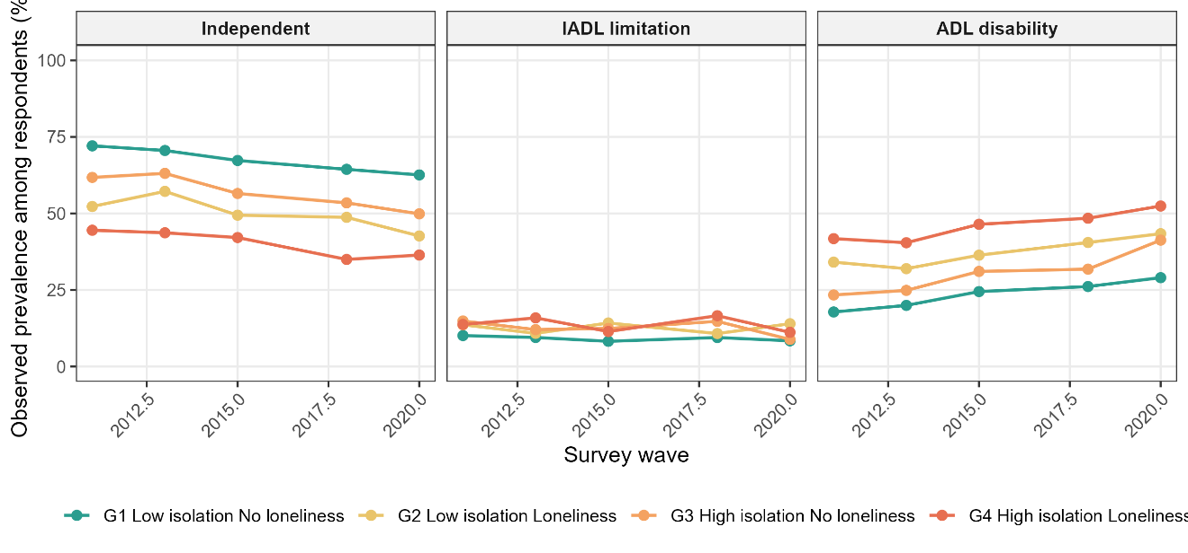
Observed prevalence of independence (left), IADL limitation (centre) and ADL disability (right) by exposure group at each wave (2011, 2013, 2015, 2018, 2020). G1 = low isolation, no loneliness; G4 = dual exposure. These are descriptive, unadjusted proportions.

Figure S3 Observed transition counts between consecutive waves by exposure group
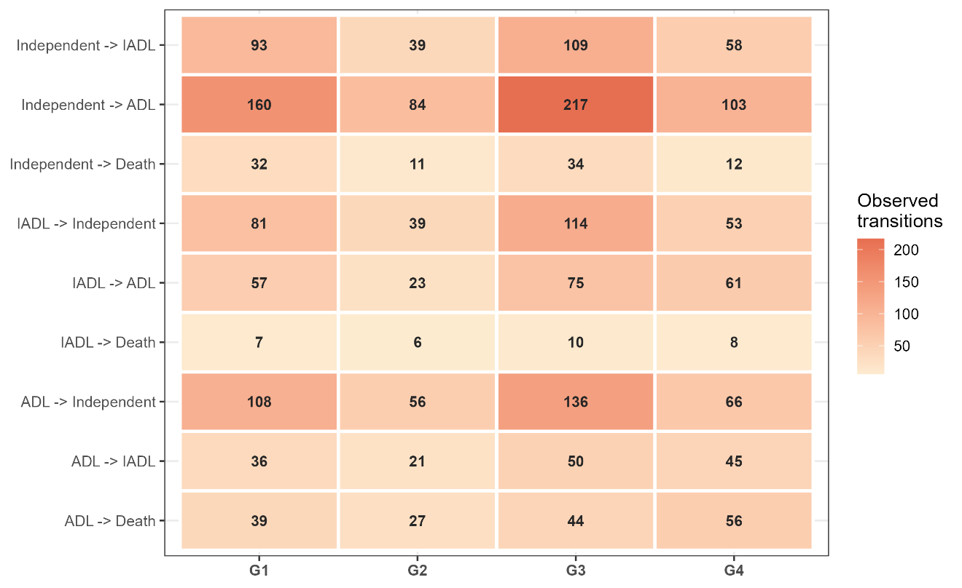
Observed transition counts between consecutive waves, by exposure group. Cell counts are the empirical basis for the hazard ratios in Table 2; pale shading indicates sparse transitions (e.g., 2→4, total n=31 across all groups).
Figure S4 Model-based 5-year transition probabilities from independence by exposure group
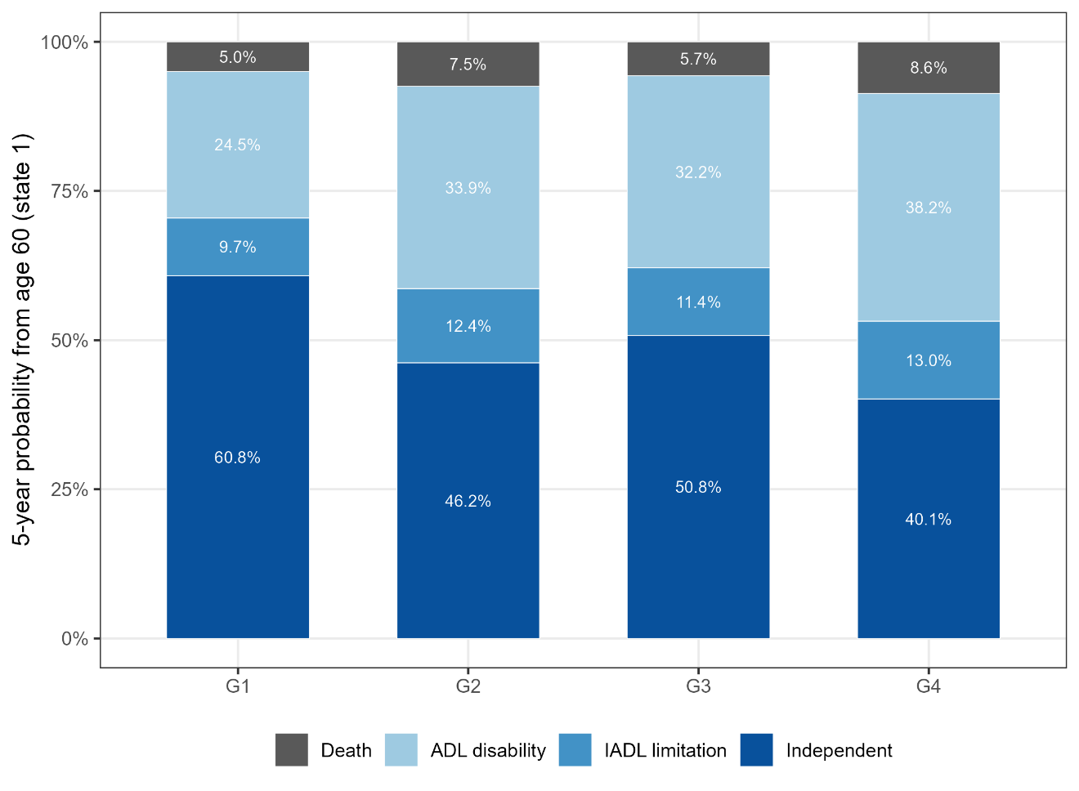
Model-based 5-year transition probabilities from state 1 (independent) by exposure group, for the reference covariate profile (female, low education, rural residence, no non-cardiometabolic comorbidity, never-smoker, never-drinker). Probabilities sum to 100% within rounding error.

Figure S5 Sensitivity analyses: G4 versus G1 hazard ratios across key transitions
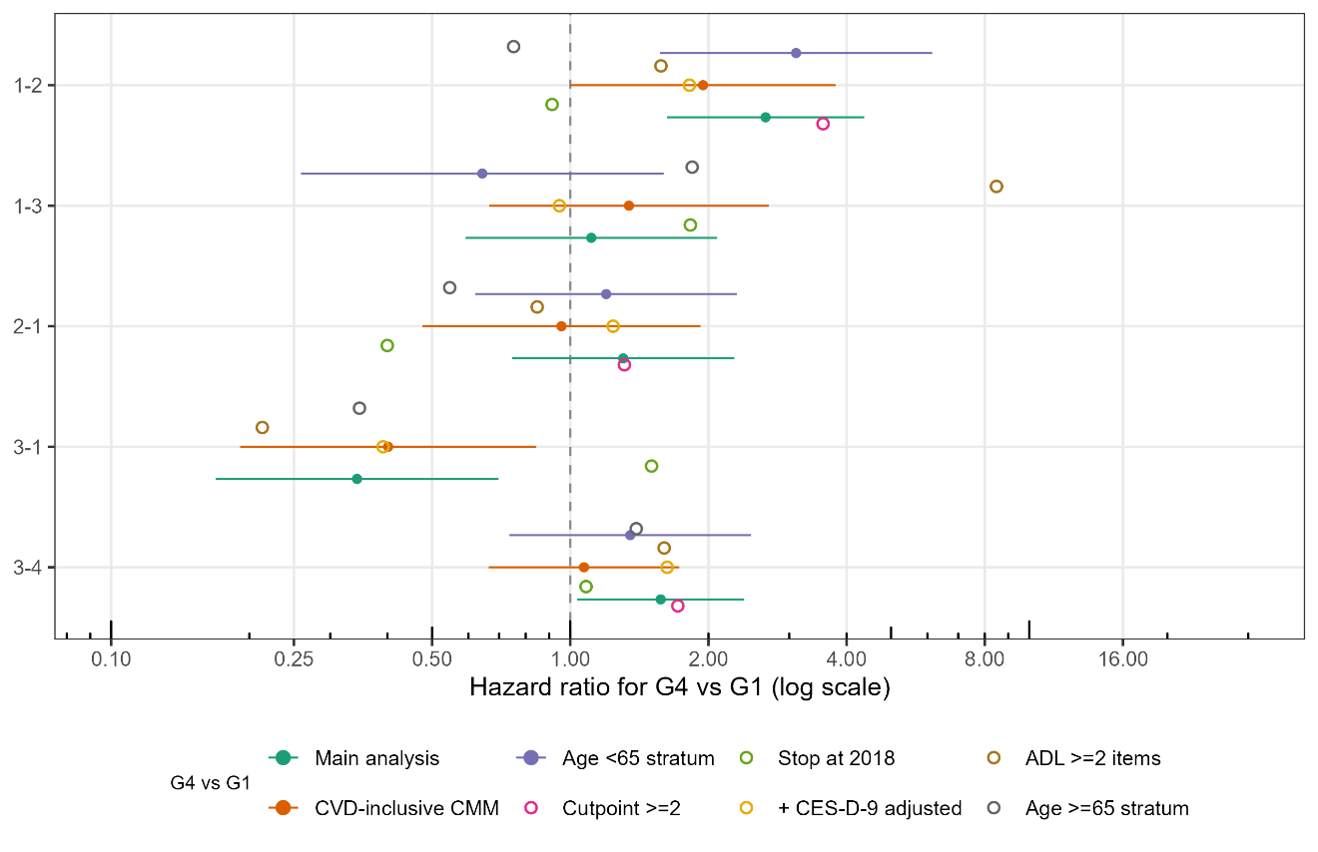
Sensitivity analyses (S1–S6b): hazard ratios for G4 versus G1 by transition. Filled symbols with 95% CIs = analyses with converged Hessian variance (main analysis, S4, S6a); open circles = point estimates without CIs (sparse transition cells prevented variance estimation). The vertical dashed line marks the null (HR=1).

