Supplementary Information for
High-efficiency Wavelength Tunable Monolayer LED with Hybrid Continuous-pulsed Injection

Yi Zhu,^{1, 2, Ϯ} Bowen Wang^{1, Ϯ}, Ziyuan Li,² Jian Zhang,¹ Yilin Tang,¹ Juan F. Torres,¹ Wojciech Lipiński,¹ Lan Fu^{2, 3} and Yuerui Lu¹*
¹ Research School of Electrical, Energy and Materials Engineering, College of Engineering and Computer Science, the Australian National University, Canberra, ACT, 2601, Australia
² Department of Electronic Materials Engineering, Research School of Physics and Engineering, the Australian National University, Canberra, ACT 2601, Australia
³ Australian Research Council Centre of Excellence for Transformative Meta-Optical Systems, Research School of Physics, the Australian National University, Canberra, ACT 2601, Australia
^{Ϯ} These authors contributed equally to this work.
* To whom correspondence should be addressed: Yuerui Lu (yuerui.lu@anu.edu.au).

b
a

Figure S1 | Sample characterization of monolayer WS₂ LED. a Optical microscope image of mechanically exfoliated WS₂ sample on SiO₂/Si substrate (275 nm thermal SiO₂) with gold electrode on the WS₂. b Phase shifting interferometry (PSI) image of the region inside the box indicated by the dashed line shown in a. The measured height difference from WS₂ to substrate is 20.8 nm, which represents as monolayer.¹

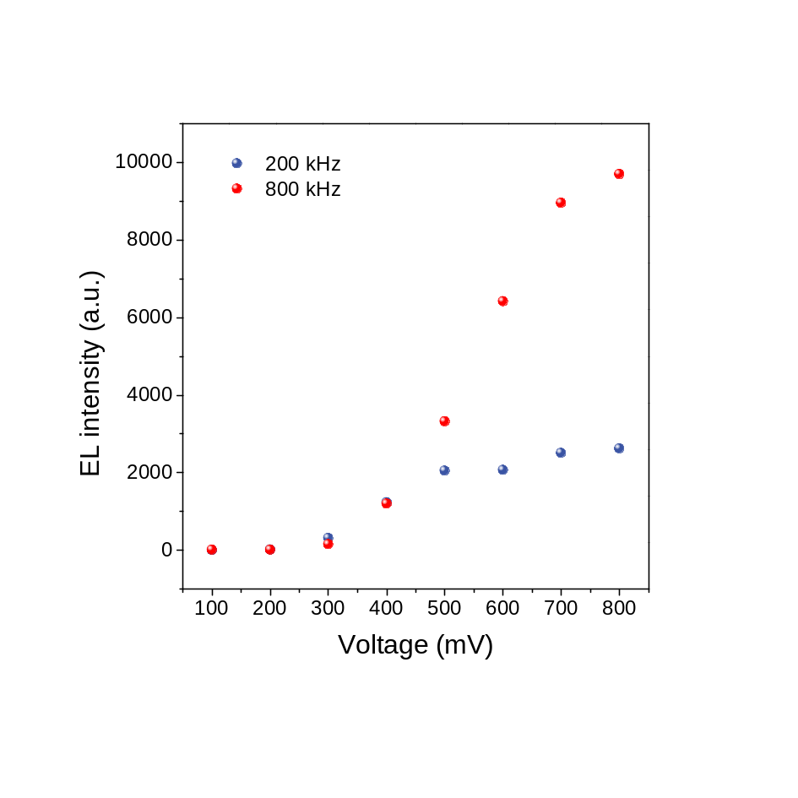
Figure S2 | Room temperature driving voltage dependent EL emission. Red and blue dots represent WS₂ AC LED exciton EL intensity at 800 kHz and 200 kHz, respectively. Both frequencies excitation, the EL intensity would increase with the increase of driving voltage.
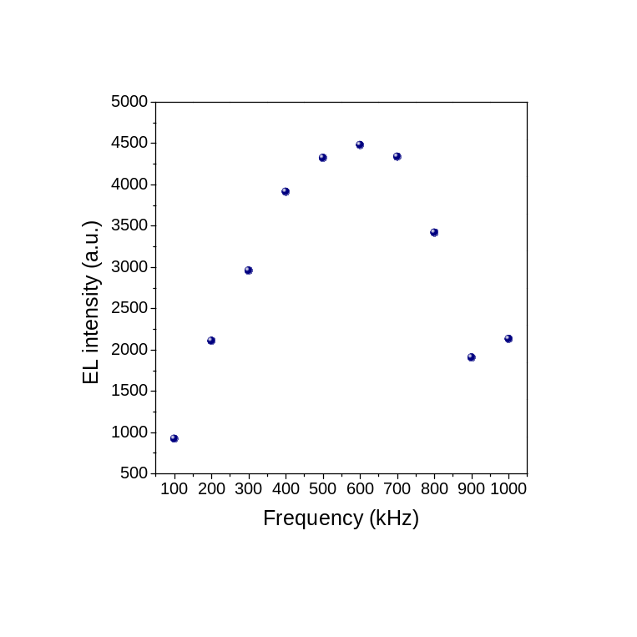
Figure S3 | Room temperature driving frequency dependent EL emission at 500 mV. The WS₂ AC LED exciton EL emission intensity can be tuned with the frequency. The maximum intensity was found for a frequency of 600 kHz.

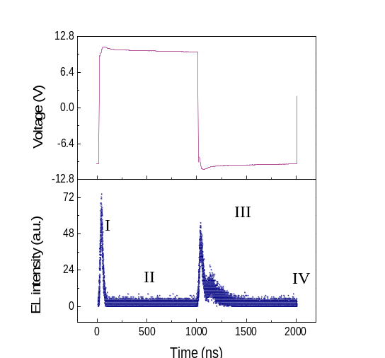
b
a

c

Figure S4 | Control experiment with TREL measurement of WSe₂ LED at room temperature and symmetrical pulsed carrier injection. a EL emission mapping of the WSe₂ AC LED device (V_{ac} = 10 V at 500k Hz). The white dashed line indicates the contacted edge of the gold electrode. Inset: the optical image of this WSe₂ device. b Time-resolved electroluminescence and the corresponding driving voltage trace for WSe₂ AC LED device. Two similar decay behaviors indicate the symmetrical carrier recombination process at two voltage transients. c Schematic band diagrams corresponding to four emission phases labeled as I, II, III and IV in b.

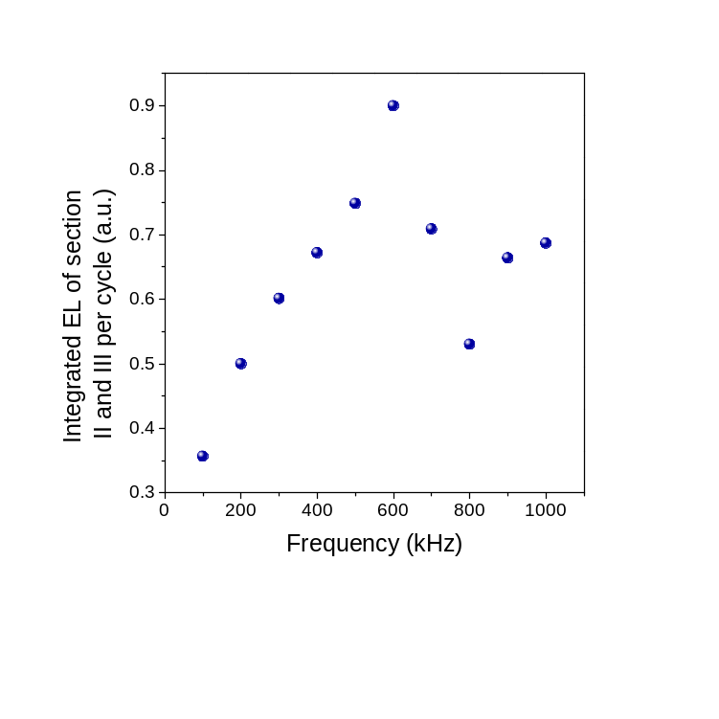
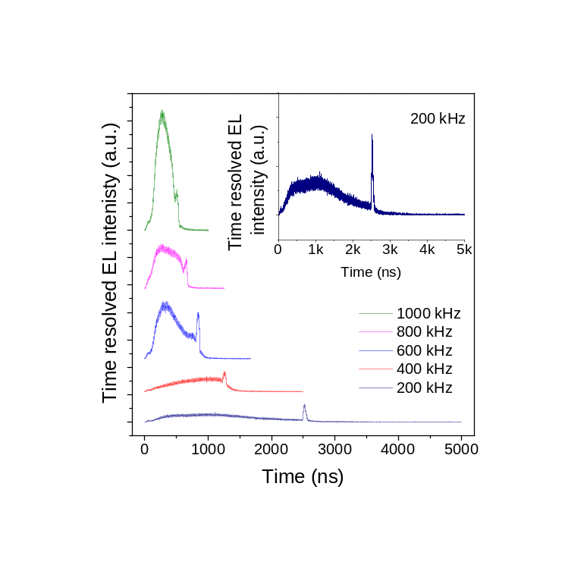
b
a

Figure S5 | Room temperature frequency dependent TREL measurement. a 290K Time-resolved electroluminescence (TREL) for WS2 sample excited by a same square wave of 800 mV. The green, magenta, blue, red and purple lines represent the TREL measurements under 1000 kHz, 800 kHz, 600 kHz, 400 kHz and 200 kHz respectively. With a decrease of AC frequency, the TREL decay could be tuned to obtain a longer decay. b Integrated PL of phases II and III as a function of frequency.

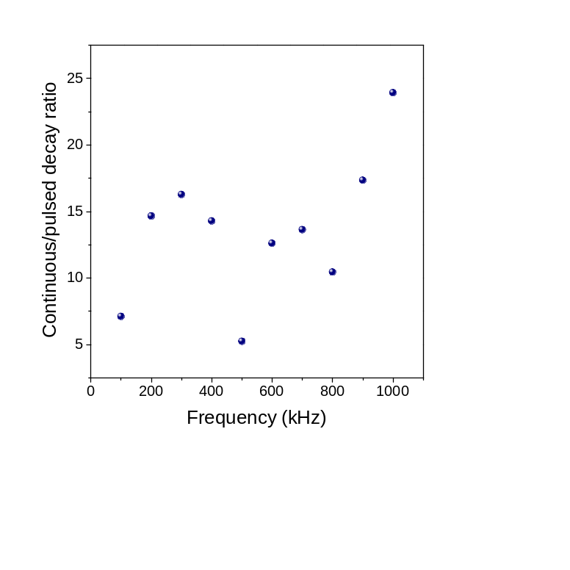
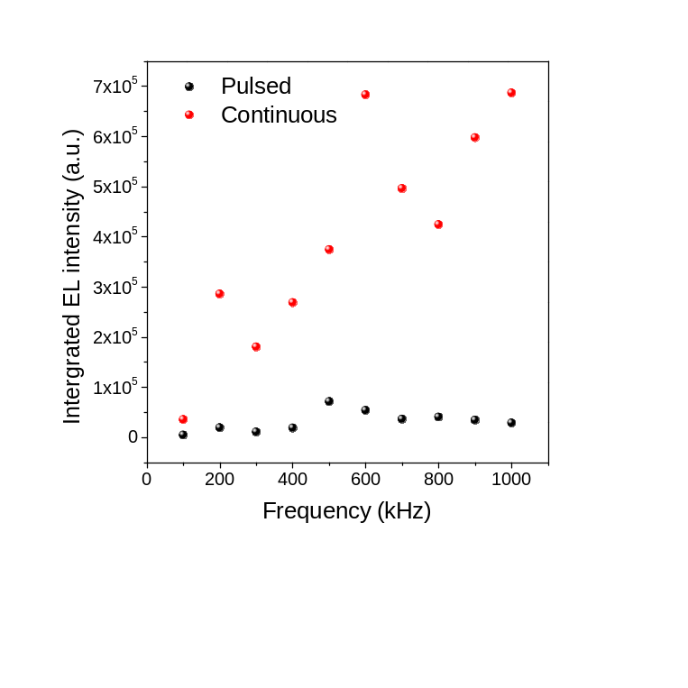
b
a

Figure S6 | Pulsed and continuous decay components in WS₂ AC LED devices at room temperature. a Integrated EL intensities from pulsed and continuous decay components as function of AC frequency. b The ratio of integrated EL intensity from continuous decay to pulsed decay as a function of AC driving frequency.

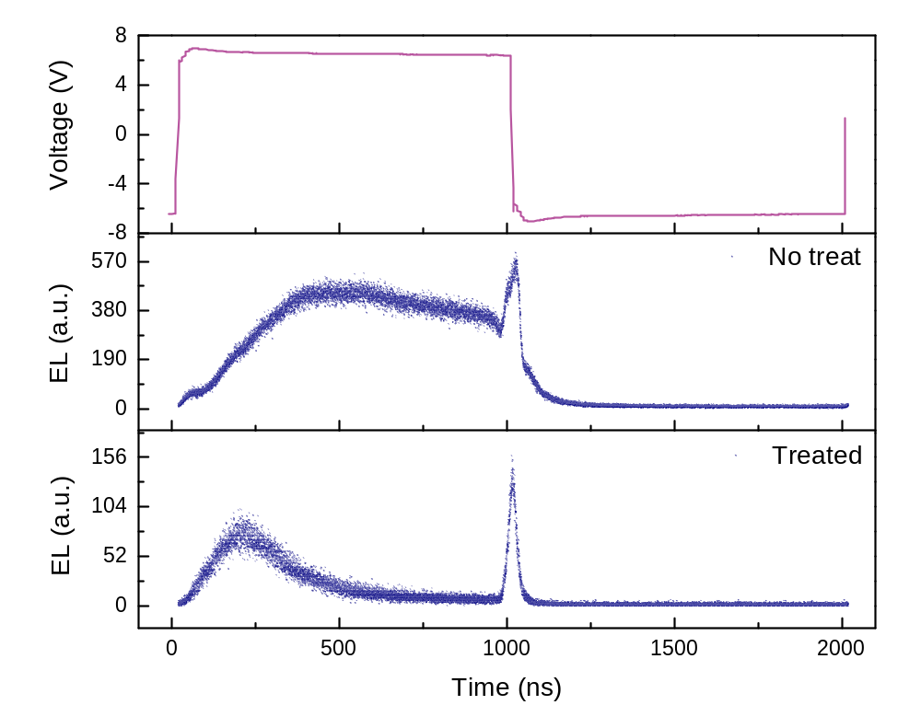
a
b
c
Figure S7 | Room temperature TREL measurement with chemical doped WS₂ AC LED device. a WS₂ AC LED excitation square wave generated by function generator and amplified by amplifier with frequency of 500 kHz. b and c Corresponding TREL for WS₂ AC LED with excitation square wave shown in Fig. S3a, with and without treatment of n-type dopant TCNQ.
Figure S8 | WS₂ AC LED temperature dependent EL emission mapping. Clockwise from top left: 290 K, 260 K, 230 K, 200 K, 170 K, 140 K, 110 K and 80 K. From 290 K to 230 K, the emission length is saturated but with emission intensity from high to low, the saturated emission length may be limited by sample size. With temperature continue decreasing, the emission length decreases significantly.

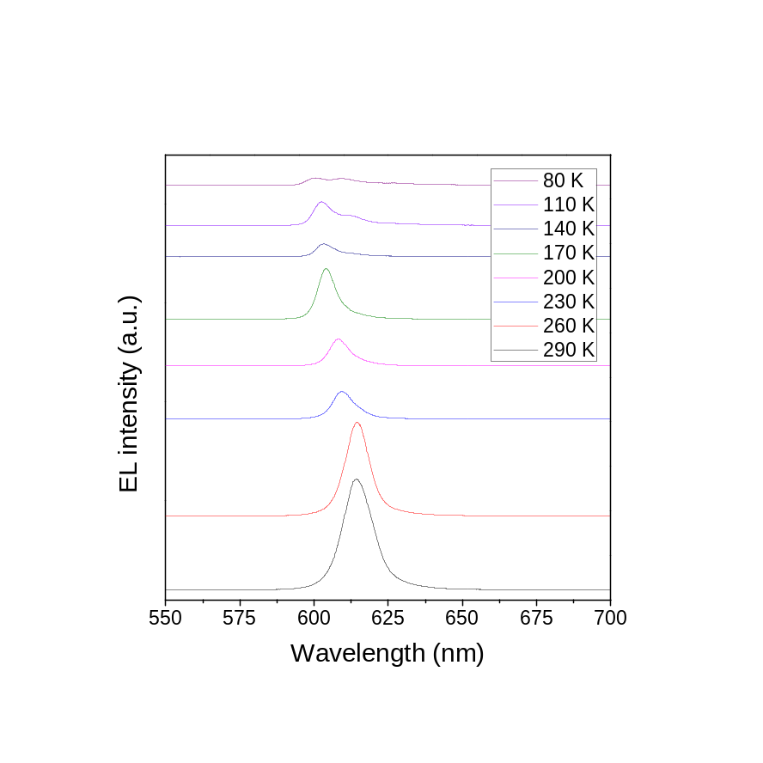
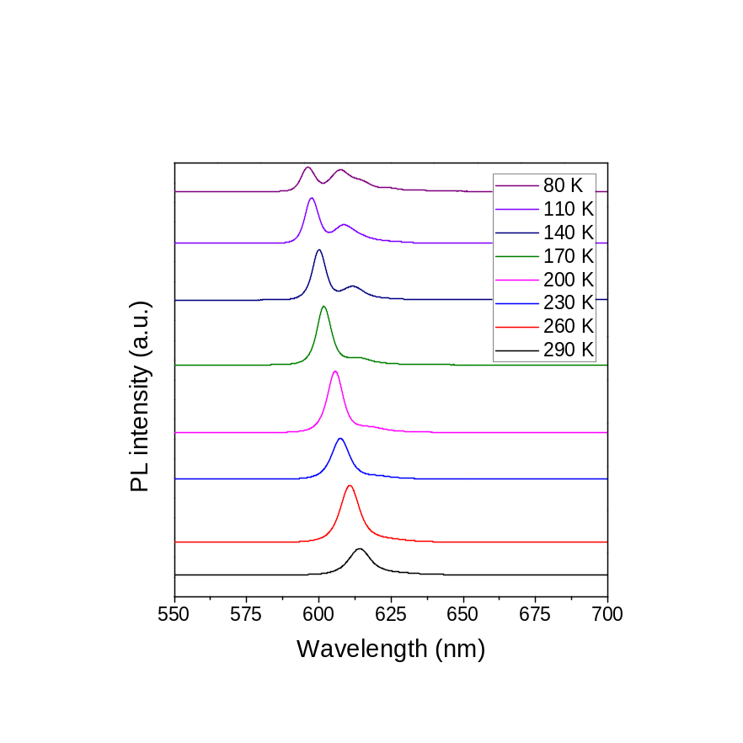
b
a

Figure S9 | Temperature dependent WS₂ AC LED PL and EL spectrum. a WS₂ AC LED PL emission spectrum excited by 0.9 uW 532 nm laser at different temperatures. b WS₂ AC LED EL emission spectra excited by 500 kHz 700 mV square wave at different temperatures.

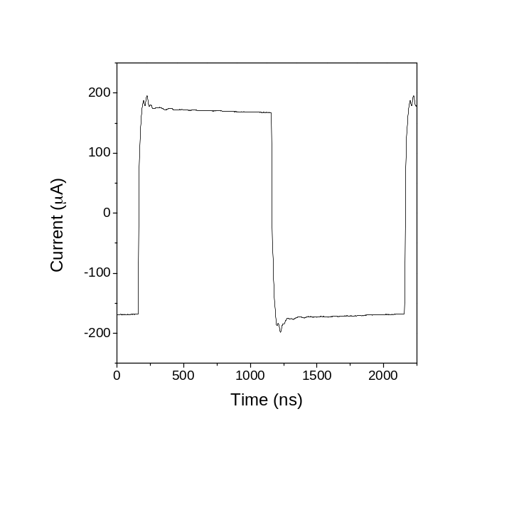
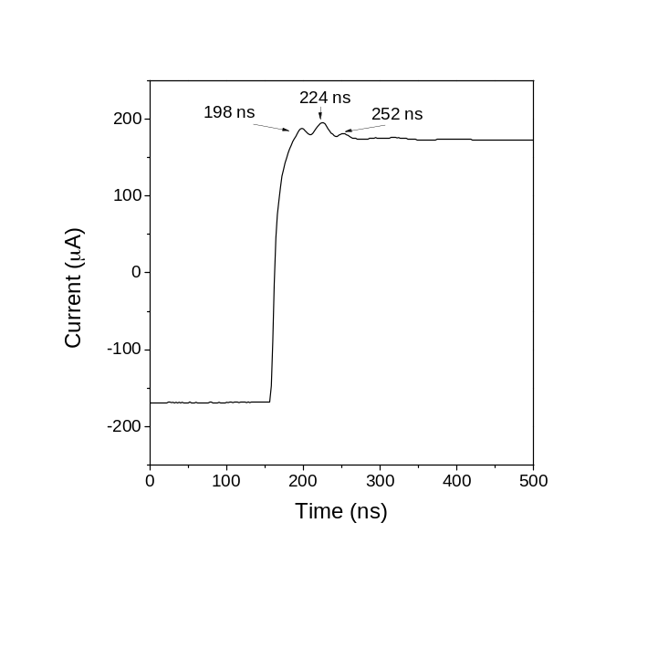

Figure S10 | AC driving current trace showing current oscillation. a AC driving current trace. b Zoomed in image of current oscillation.

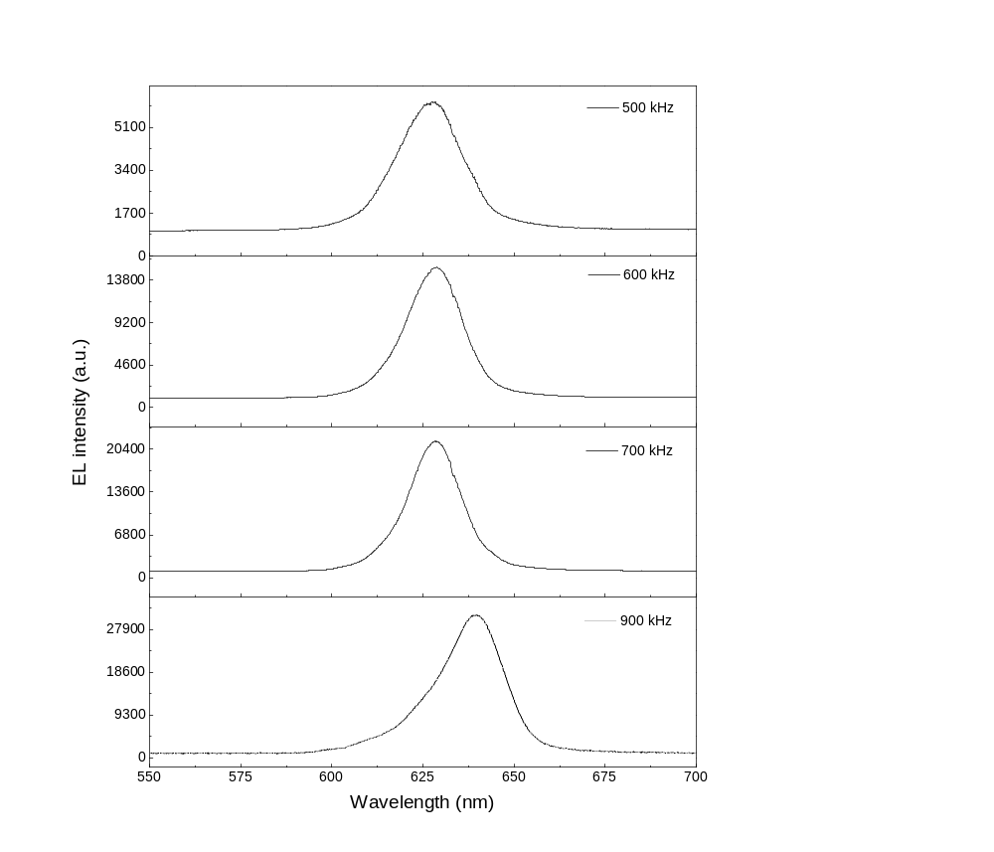

Figure S11 | Frequency dependent defect emission switching from monolayer WS₂ AC LED at 80 K. From top to bottom: EL emission spectra for the driving frequency set to 500, 600, 700 and 900 kHz at 80 K.

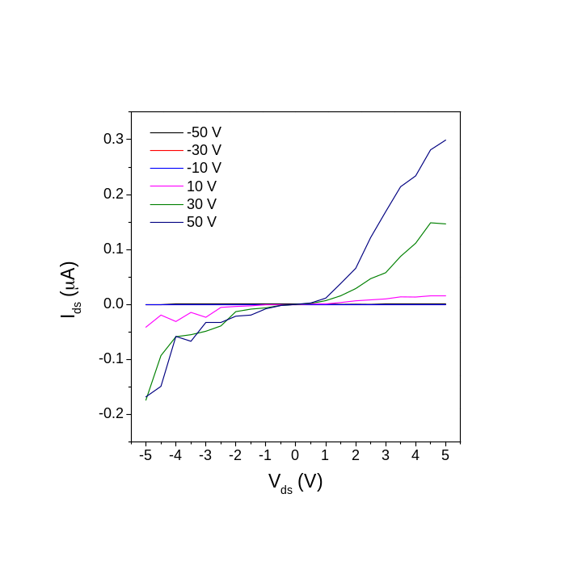
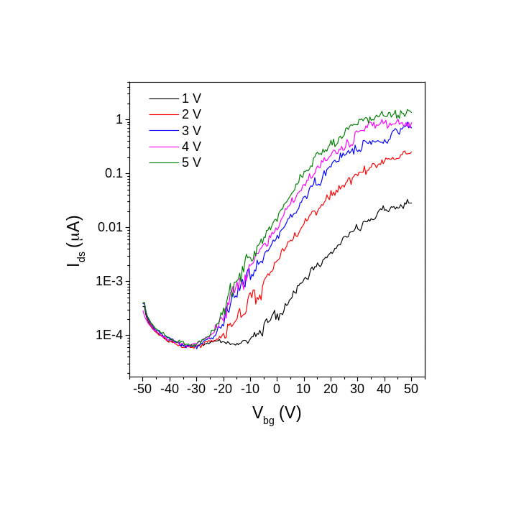
b
a

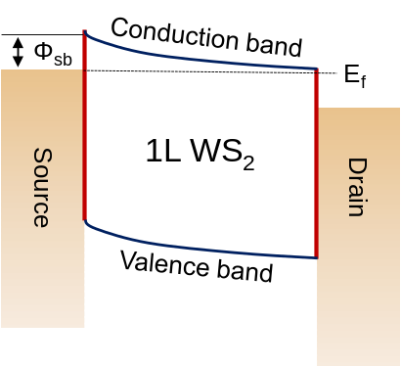
c

Figure S12 | Room temperature monolayer WS₂ FET measurement. a Source-drain current I_{ds} VS. back-gate voltage V_{bg} measured for the 290 K WS₂ FET at a source-drain bias voltage of 1 V to 5 V with 1 V step rate. The black, red, blue, magenta and green lines represent bias of 1 V, 2 V, 3 V, 4 V and 5 V, respectively. All curves are the plot for I_{ds}; in linear scale, the channel is n-type. b I_{ds} as a function of V_{ds} for V_{bg} sweep from –50 V to 50V with 20V step rates. c Band diagram of a WS₂ FET device operating at room temperature with on-state gate voltage. The Fermi level of Au metal is pinned close to the conduction band of 1L WS₂.

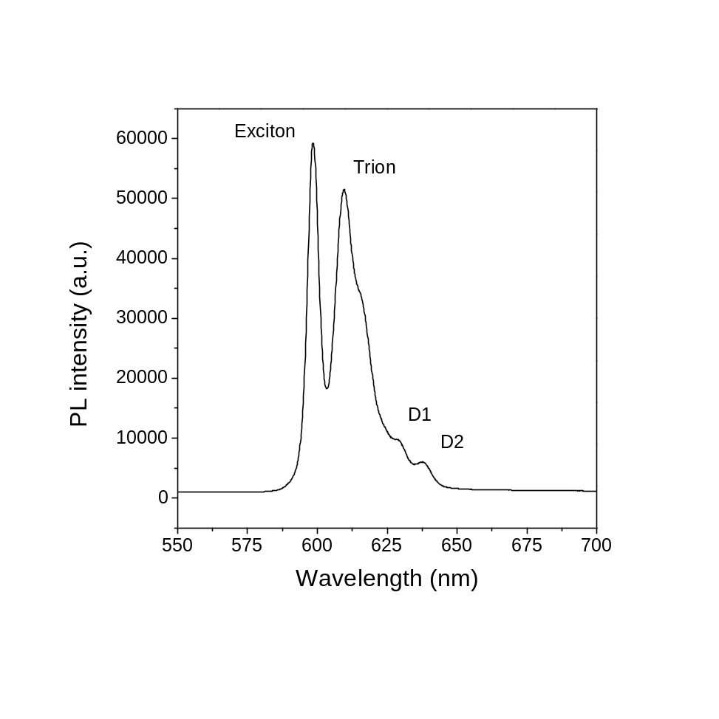

Figure S13 | WS₂ AC LED PL spectrum at 80K. WS₂ AC LED PL spectrum shows four peaks at 80 K, which correspond to exciton, trion, biexciton and two defects.
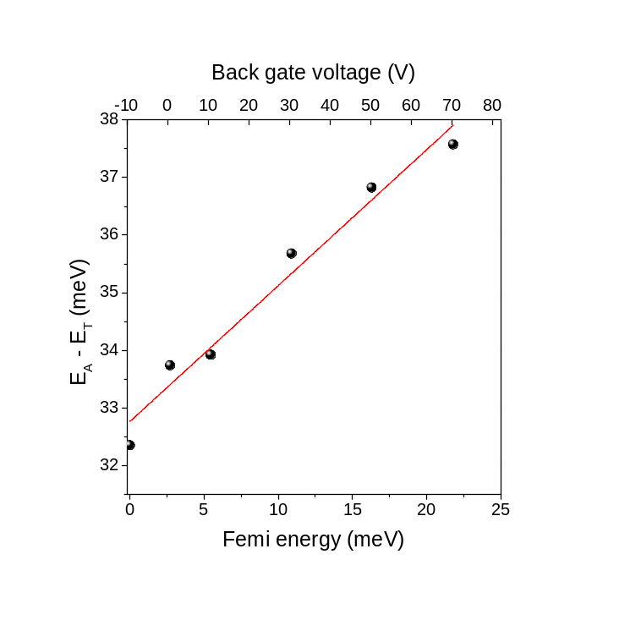
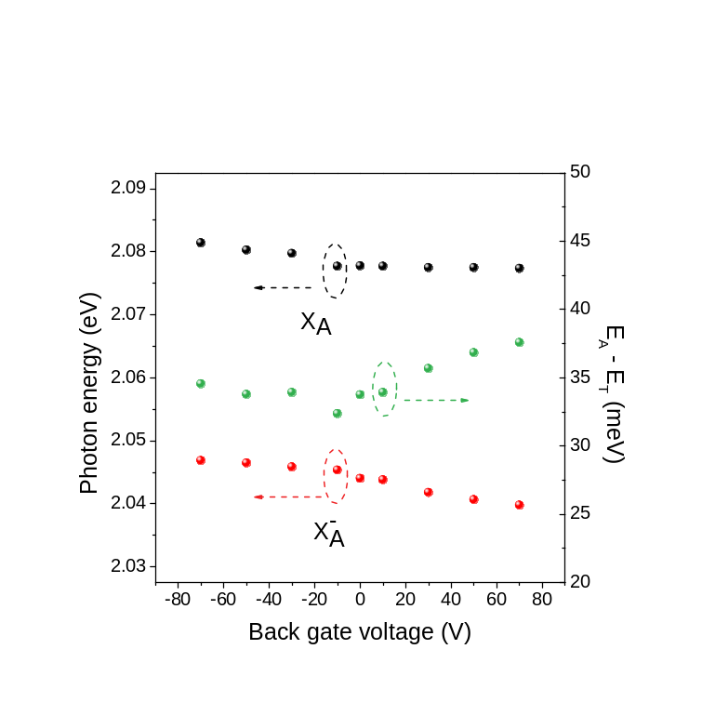

Figure S14 | Electrical doping effect on excitonic emission in 1L WS₂ at 80 K. a Photon energies of A exciton (X_{A}) and trion (X_{A}⁻) (left vertical axis) versus gate voltage; dissociation energy of trion (X_{A}⁻) (right vertical axis) versus gate voltage. b dissociation energy of trion versus femi energy under different back gate voltage.

Figure S15 | CCD spatial image convert to wavelength spectra. a CCD spatial image when spectrometer grating is set to be zero. b EL spectra contain both spatial and wavelength information when convert x axis pixel to wavelength by rotating spectrometer grating to sample wavelength.

Supplementary Note 1
Device fabrication process
The device fabrication includes dry transfer and dry electrode transfer process. Mechanical exfoliation has been employed to prepare clean sample on SiO₂/Si. Then the lithography free dry electrode transfer process is used to make electrode contacts. The details of this method are described here. The 100 nm thickness Au bar shape patterns are deposited onto a bare SiO₂/Si substrate by traditional photolithography following lift-off process. The 1 micro tip diameter tungsten probe is attached to the homemade micromanipulator. The bar shape gold pattern can be scratch into designed length and then be peeled off from original SiO₂/Si. This small section of gold metal is hanging in front of tungsten probe tip wait for drop down to target monolayer samples. Because of electrical static force, when the peeled gold metal moves closely to target substrates, it can be automatically attracted and attached upon target samples. By using this method, the clean interface of monolayer 2D materials can be achieve.

Supplementary Note 2
Estimation of initial doping level of monolayer WS₂ sample
In order to investigate initial doping that originates from material intrinsic defects, monolayer WS₂ metallic oxide semiconductor field effect transistor (MOS) devices were fabricated to obtain the electrically gated PL spectrum. Monolayer MoSe₂ and WSe₂ were exfoliated onto SiO₂/Si substrates from the same matrix crystal to keep the same of the initial doping level. The initial doping level in monolayer TMDs can be extracted by comparing the gate-dependent PL spectra from the MOS devices. Here, monolayer WS₂ was used to quantitively study charge transfer mechanisms. By fitting all of the PL spectra under different gate voltages, the exciton and trion peak energies can be extracted (Fig. S14). Then the Fermi level can be calculated by a function
$E_{a}-E_{T}= E_{F}+E_{binding}$ (1)
where E_{a} is the exciton peak energy, E_{T} is the trion peak energy, E_{F} is the Fermi energy level and E_{binding} is the binding energy of trion.
Equation (1) was used to extract the Fermi level of monolayer WS₂. By plotting the difference of exciton and trion peak energy as a function of gate voltage, a clear linear trend between energy difference and Femi level was observed. For monolayer TMDs, the density of state in the conduction band and valence band is linearly distributed along the energy level². The extracted binding energy of the monolayer WS₂ was 32.76 meV and this is consistent with previously reported experimental results^{3, 4}. To extract the initial doping level of the monolayer WS₂, the following two equations have been used
$E_{F}= \frac{ħπn}{2m_{h}e^{2}}$ (2)
$ne=CV_{g}$ (3)
where h is Planck’s constant, π is the pi constant, n is the electron density, e is the fundamental unit of charge, m_{h} is the effective mass of a hole, C is the back-gate capacitance and V_{g} is the gate voltage.
Equation (2) was used to extract the doping level n of the monolayer TMDs from the Fermi level. Equation (3) was used to convert the gate voltage into the induced hole doping level, where C is the back-gate capacitance C = 1.2 × 10^{–8} F cm^{–2}. As shown in Fig. S12, monolayer WS₂ will approach a zero Fermi level when a -10V back gate voltage is applied. This means monolayer WS₂ is slightly n-type doped with an initial doping level of 7.5 × 10¹¹ cm^{–2} (when no gate voltage is applied).

Supplementary Note 3
TCNQ chemical doping process
The TCNQ chemical doping process includes solution preparation and drop casting solution to sample. The 7,7,8,8-tetracyanoquinodimethane (TCNQ) powder is dissolved in DI Water, with a concentration of 0.02 µmol/mL, which corresponds to a dopant density on the monolayer of approximately 1/nm² after one doping step. The solution was performed using a drop-cast method following by drying up on a hotplate at 60ºC. An approximately 10 μL droplet of the dopant solution was pipetted onto the SiO₂/Si substrate area of 1 cm² where the AC LED devices were prepared. The sequential doping by repeating this procedure was performed.

Supplementary Note 4
1L WS₂ and 1L WSe₂ TREL behaviours analysis
By comparing TREL behaviors in monolayer WS₂ and monolayer WSe₂ samples, we can understand the origin of this hybrid continuous-pulsed processes. It can be contributed from two facts: 1. new injected electrons (or holes) radiatively recombine with the remaining holes (or electrons) that are accumulated in previous cycle; 2. new injected electrons (or holes) recombine with system initial free holes (or electrons). On the one hand, if the initial doping of the material is small, the population of system free carriers becomes small then the first fact dominates EL emission. The TREL decay behaviour is pulsed. On the other hand, if the initial doping of the material is large, the population of initial free carriers is large, leading the EL emission is dominated by the second fact. The TREL decays is continuous.
In order to justify this AC driving continuous-pulsed emission model, we performed two more TREL measurements in this WS₂ LED device to verify the influence of the material’s doping effect. The measurement conditions for those two tests were kept same. After the TREL measurement on the fresh exfoliated WS₂ LED device, then this LED device was treated by the p-type chemical dopant. We used 7,7,8,8 – tetracyanoquinodimethane (TCNQ) as the p-type dopant to modulate initial doping levels in the monolayer WS₂ sample as previously reported.⁵ The TCNQ solution preparation and sequential doping method are described in the Supplementary Note 3. Interestingly, the TREL decay curves can be significantly tuned as elucidated in Fig. S7. When the monolayer WS₂ sample was not been treated by TCNQ, the initial doping is n-type, and the material had more initial electrons. In holes injection side, a long and flat decay curve was obtained. However, this long and flat decay curve from holes injection side has been suppressed after the TCNQ treatment. With the treatment of p-type of dopants, electrons in the monolayer WS₂ were neutralized causing the decrease of initial doping level where free electrons in the system dramatically decrease, leading a strong reduction of EL emission lifetime. This has confirmed that the material’s initial doping is favor for unsymmetrical recombination processes in this AC driving LED structure. This provides an opportunity to enhance EL emission area and EL performance by tuning the material’s doping level.

Supplementary Note 5
Temperature dependent carrier mobility model
In two dimensional materials, the carrier mobility is attributed to two facts: impurity scattering and phonon scattering from crystal lattice. Following Matthiessen’s rule, the total mobility is given by summing all individual rates:
$\frac{1}{µ}= \frac{1}{µ_{i}}+\frac{1}{µ_{s}}$ (4)
$µ_{s}^{-1}= \frac{AT^{\frac{3}{2}}m^{*}}{q}$ (5)
$µ_{i}^{-1}= \frac{BN_{i}m^{*}}{qT^{\frac{3}{2}}}$ (6)
where $µ_{i}^{-1}$ is impurity scattering and $µ_{s}^{-1}$ is phonon scattering. A and B are coefficients, $N_{i}$ is impurity concentration, $m^{*}$ is effective carrier mass. Applying Einstein relationship: $\frac{D}{µ}= \frac{k_{0}T}{q}$ ,
The diffusion coefficient D can be extracted as follows:
$D= \frac{k_{0}T^{\frac{5}{2}}}{BN_{i}m^{*}+AT^{3}m^{*}}$ (7)
$k_{0}$ is Boltzmann constant. The EL emission length under low temperature is related with carrier diffusion ability. Therefore, the temperature dependent EL emission length in Fig. 3g can be fitted by model:
$emission length ∝ L_{p}= C\sqrt{\frac{k_{0}T^{\frac{5}{2}}}{BN_{i}m^{*}+AT^{3}m^{*}}∙τ_{p}}$ (8)
$L_{p}$ is diffusion length of hole and $τ_{p}$ is lifetime of hole. In Fig. 3g, the fitting start from the temperature is 230 K because of our sample size. At the temperature higher than 230 K, the emission length does not change because of reduction of phonon scattering caused mobility increasing. However, when temperature keeps decreasing, the emission length dramatically decreases. This is attributed to carrier mobility decreasing results from enhancement of impurity scattering.

Supplementary Note 6
Thermal-activation model for temperature dependent EL intensity
In our monolayer WS₂ sample, the initial doping level is n-type. There are many thermally activated electrons in the system. For n-type semiconductor, the majority are electrons, and the minority are holes. Under disequilibrium, $Δp≫ p_{0}$, $Δp <n_{0}$, where $Δp$ is the number of the injected holes, $p_{0}$is the number of the initial holes, and $n_{0}$ is the number of the initial electron. Considering the AC driving LED working principle, holes and electrons injection processes are continuous, which means that there will be endless of holes injected into material if it is in holes injection side as an example. Then the population of exciton will follow the equation: $N_{exciton} ∝ B_{r}∙n_{0}$, where $N_{exciton}$ is the population of the formed exciton and $B_{r}$ is the radiative recombination rate. The total exciton population is proportional to the initial free electrons. The population of initial free electrons follow the equation:
$n_{0}={\left(\frac{N_{D}N_{C}}{2}\right)}^{\frac{1}{2}}∙\exp\left(-\frac{ΔE_{D}}{2k_{0}T}\right)=(\frac{N_{D}{(2πm_{*}k_{0}T)}^{\frac{3}{2}}}{2h^{3}})∙\exp\left(-\frac{ΔE_{D}}{2k_{0}T}\right)$. (9)

Here, $N_{D}$ is the concentration of donor, which is substitutional Br in the monolayer WS₂ sample. $m_{*}$ is effective electron mass, which is 0.46 $m_{e}$ for monolayer WS2.⁶ $k_{0}$ and $h$ is Boltzmann and Planck’s constant, respectively. $ΔE_{D}$ is impurity ionization energy. Therefore, the total EL intensity can be fitted by this equation:

$N_{exciton} ∝ B_{r}∙(\frac{N_{D}{(2πm_{*}k_{0}T)}^{\frac{3}{2}}}{2h^{3}})∙\exp\left(-\frac{ΔE_{D}}{2k_{0}T}\right)$. (10)

Supplementary Note 7
Low temperature TREL decay curve oscillation.
The TREL decay curve oscillation has been observed when temperature reduced to 200 K as shown in Fig. 2i. This decay curve oscillation could be attribute to injection current oscillation that generated from function generator. In the TREL curve, there are three dominated oscillation peaks in first decay section. The corresponding times for those three peaks are 162 ns, 326 ns, and 503 ns, respective. Coincidentally, there are also three oscillation peaks appearing in measured current trace as shown in Fig. S8. The times for three peaks are 198 ns, 224 ns, and 252 ns, respectively. The time differences among oscillation peaks in current trace are 26 ns for first and second peaks, 28 ns for second and third peaks. While, those time differences are 164 ns and 177 ns in TREL decay curves. Although, those time difference values are not exactly equal due to system caused delay, the time difference ratios are identically same for current trace of 28/26 = 1.0769 and for TREL decay curve of 177/164 = 1.0792. This confirms that the oscillation observed in TREL decay curve results from the oscillation from injected current.

Supplementary Note 8
Defect internal quantum efficiency.
The internal quantum efficiency can be defined as:
$η= \frac{photons/cycle}{(n_{0}+p_{0})×area}$ , (11)
where $n_{0}$ and $p_{0}$ are the steady-state electron and hole concentrations corresponding to a positive and negative bias.⁷ Here, we modified this equation for the monolayer WS₂ under initial n-type doped. The equation can be written as:
$η= \frac{photons/cycle}{(n_{0}+∆p)×area}$, (12)
where $n_{0}$ is the initial doping concentration of the monolayer WS₂, and $∆p$ is the population of injected holes. Then the ratio of defect intensity to exciton intensity represents the internal quantum efficiency of those two species:
$\frac{η_{defect}}{η_{exciton}} = \frac{{Photons}_{defect}}{{Photons}_{exciton}}$.⁸ (13)
In Fig. 3b, the defect to exciton ratio for D2 is larger than D1, which suggests that the quantum efficiency of D2 defect is much larger than D1 due to the lower energy level of D2. This indicates that the injected free holes are much easier captured by lower energy level defect. In addition, the maximum quantum yield of a defect localized exciton is around 24.5 times larger than that from a free exciton in the WS₂ monolayer.

Reference
1. Yang J, et al. Atomically thin optical lenses and gratings. Light: Science & Applications 5, e16046 (2016).
2. Mak KF, et al. Tightly bound trions in monolayer MoS₂. Nature Materials 12, 207 (2013).
3. Kidd DW, Zhang DK, Varga K. Binding energies and structures of two-dimensional excitonic complexes in transition metal dichalcogenides. Physical Review B 93, 125423 (2016).
4. Zhou W, et al. Intrinsic structural defects in monolayer molybdenum disulfide. Nano Letters 13, 2615-2622 (2013).
5. Mouri S, Miyauchi Y, Matsuda K. Tunable photoluminescence of monolayer MoS₂ via chemical doping. Nano Letters 13, 5944-5948 (2013).
6. Rasmussen FA, Thygesen KS. Computational 2D materials database: electronic structure of transition-metal dichalcogenides and oxides. The Journal of Physical Chemistry C 119, 13169-13183 (2015).
7. Lien D-H, et al. Large-area and bright pulsed electroluminescence in monolayer semiconductors. Nature Communications 9, 1229 (2018).
8. Xu R, et al. Exciton brightening in monolayer phosphorene via dimensionality modification. Advanced Materials 28, 3493-3498 (2016).

