Supplemental Information

A dynamic mechanical framework unmasks the ultrastructural and fluid-solid remodeling during myocardial infarction progression

Luo-Jian Peng¹, Xian-Jun Wu¹, Zhuo Chang^{1,2}*, Guang-Kui Xu^{1,2}*

1. Laboratory for Multiscale Mechanics and Medical Science, Department of Engineering Mechanics, State Key Laboratory for Strength and Vibration of Mechanical Structures, School of Aerospace Engineering, Xi’an Jiaotong University, Xi’an 710049, China;
2. Medical Device Interdisciplinary Mechanics and Health Diagnosis Center, Chengxing Guotou & Xi’an Jiaotong University Union Laboratory, Taizhou 225400, China

* Corresponding Authors: zhuochang@xjtu.edu.cn; guangkuixu@xjtu.edu.cn

Mathematical Derivation of the Hybrid Poro-viscoelastic Framework

1. Normalization of Creep Displacement
To facilitate a universal comparison across different pathological states, the experimental creep displacement δ(t) is normalized into a dimensionless displacement H*(t):
 | 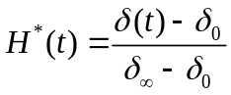 | (1)

2. Constitutive Parameters and Poisson's Ratio
Biological tissues undergo volume changes during indentation due to fluid efflux; thus, the material is not treated as perfectly incompressible. The drained Poisson’s ratio ν_{d} is derived from the indentation ratio, with h(0) the depth at the onset of the hold and h(∞) the depth at which the pore pressure has equilibrated; because the solid skeleton keeps creeping as a power law, h(∞) is taken as h(0) plus the amplitude of the saturating poroelastic term of the joint fit (Section 6), h(∞) = h(0) + A·Δ_{p}:
 | 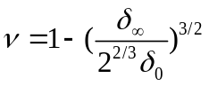 | (2)
The associated shear modulus G is then defined as:
 | 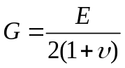 | (3)
Where E is the static elastic modulus of the tissue.

3. Dimensionless Temporal Parameter (T*)
The poroelastic response is governed by a dimensionless time T* = √(2GDt)/a = √(t/τ), which couples fluid transport, material stiffness, and probe geometry through the fluid–solid transition time τ = a²/(2GD) (derivation in Section 7 below):
 | 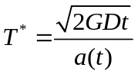 | (4)
D (Hydraulic Permeability): The physical metric describing fluid diffusion through the porous matrix.
a(t): The contact radius of the spherical probe, determined by:
 | 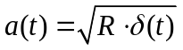 | (5)
where R is the probe radius.

4. Short-term Poroelastic Response (H_{poro})
During the initial phase (t ≪ τ), the mechanical response is dominated by the redistribution of interstitial fluid within the cytoskeletal and ECM pores. This is modeled using a saturation function:
 | 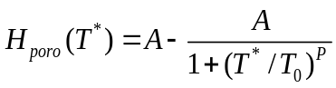 | (6)
Where A is the saturation limit, T₀ is the characteristic dimensionless time, and P is a shape parameter.

5. Long-term Viscoelastic Response (H_{vis})
For timescales exceeding the fluid equilibration point (t ≫ τ), the tissue transitions to a viscoelastic solid regime. The behavior is governed by the slow rearrangement of the solid matrix, captured via power-law rheology:
 | 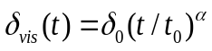 | (7)
 | 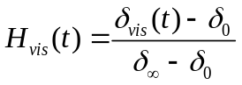 | (8)

6. Coupled Poro-viscoelastic Response
The fluid-dominated and solid-dominated contributions are stated as a single additive response in the creep displacement Δh(t) = h(t) − h(0) measured during the force clamp. The poroelastic term Δ_{p}·H_{poro}(T*) carries the fluid contribution and saturates for t ≫ τ; the power-law term Δ_{v}·(t/τ)^α carries the slow rearrangement of the solid skeleton and does not saturate. Both terms vanish at t = 0, so no reference displacement at infinite time is required. The coupled model reads:
 | $$Δh(t)=Δ_{p}·H_{poro}(T^{*})+Δ_{v}·{(t/τ)}^{α}$$ | (9)
Four parameters (Δ_{p}, τ, Δ_{v}, α) are fitted per indentation by least squares on log Δh over log-spaced time samples from 0.002 s to the end of the 100-s hold, with the master-curve constants of Eq. (6) fixed at A = 0.928, T₀ = 0.772 and P = 2.0837 (Oyen 2008) and six starting points per curve; the permeability follows as D = a²/(2Gτ) with a = √(Rh(0)) and G = E_{corr}/[2(1+ν_{d})] (main text, Section 2.5). Fitting the two terms jointly is necessary because the poroelastic term alone is degenerate on a non-saturating curve: widely different values of D give nearly identical residuals. Over the 85 indentations the root-mean-square log residual has group medians of 0.055, 0.044, 0.068 and 0.072, and the fitted exponent α of the solid term has group medians of 0.44, 0.40, 0.32 and 0.32 (control through week 4); it exceeds the local slope α_{long} measured over 10–100 s because the two terms overlap in the transition region. As a phenomenological alternative, two power laws joined smoothly at a crossover time t_{c}, Δh(t) = A₀ (t/t_{c})^α₁/[1 + (t/t_{c})^(α₁−α₂)], were fitted to the same data. This description gives smaller residuals for 80 of the 85 curves (group medians 0.019, 0.016, 0.024 and 0.035), with t_{c} = 0.064, 0.080, 0.051 and 0.056 s, α₁ = 0.97, 0.91, 0.80 and 0.80 and α₂ = 0.15, 0.12, 0.11 and 0.13. The two descriptions agree on the position of the transition (t_{c} ≈ 0.4–0.6 τ), but the present data do not decide between a poroelastic and a viscoelastic origin of the short-time regime (main text, Section 4).

The model above treats the trigger force as a step load. In the experiment the force rises from first contact to the trigger value over 0.26–0.41 s (interquartile range), a time comparable to τ, so part of the poroelastic transient occurs before the hold begins. To quantify this, the fit was repeated with the measured loading history included by Boltzmann superposition (Galli and Oyen 2009): the force increments ΔFj recorded at times sj during the approach were each assigned the response of Eq. (9) started at sj, Δh(t) = Σj (ΔFj/F0)[Δ_{p}·H_{poro}(√((t − sj)/τ)) + Δ_{v}·((t − sj)/τ)^α] − (same at t = 0), and the four parameters were fitted to the hold displacement as before. Including the loading history halves the log residual (Table S6) and reduces the fitted τ by a factor of about 2–2.5 in control, week-1 and week-2 tissue and about 6 in week-4 tissue, where τ approaches the settling time of the force clamp; the ranking of the infarct groups relative to control is unchanged (the nearly coincident control and week-1 medians interchange). This estimate is approximate: for a spherical contact whose area grows during loading, linear superposition applies to h^(3/2) rather than to h (Lee–Radok solution), and the poroelastic master curve itself is defined for a step load. The comparison therefore quantifies the sensitivity of τ and D to the loading history; it does not provide corrected values, and the step-load parameters of the main text remain the reported effective parameters. Both fits use the same 100-s hold data and the same time sampling.

7. Derivation of the Fluid–Solid Transition Time τ
The transition time follows from Biot consolidation theory in the form adopted by Oyen (2008). (i) Interstitial flow obeys Darcy’s law, vi = −D p,i (main text, Eq. 9). (ii) Indentation pressurizes the pore fluid beneath the contact; the only drainage path is past the contact edge, so the drainage length is the contact radius a = √(Rh). (iii) Substituting Darcy’s law into mass and momentum balance gives a diffusion equation for the pore pressure, ∂p/∂t = c ∇²p, with consolidation coefficient c = 2GD (m² s−1): a stiffer skeleton expels fluid faster and a more permeable network lets it flow faster. (iv) The time for pressure diffusion to traverse the drainage length is therefore τ = a²/(2GD), so that the master-curve time axis is T* = √(2GDt)/a = √(t/τ): for t ≪ τ the load is carried by pressurized fluid, for t ≫ τ by the drained solid skeleton, and T* = 1 marks the transition (≈63% of the poroelastic relaxation completed). Note that τ is not a material constant: it depends on the observation scale through a². In the present data τ is confined to 0.06–0.43 s and its group medians vary 1.6-fold (main text, Section 3.2), whereas E varies six-fold; D = a²/(2Gτ) is therefore governed mainly by a²/G, and its anti-correlation with E is largely a consequence of this relation. Worked example (week-1 indentation #10000): E_{app} = 1.64 kPa → Hertz depth at 20 nN h(0) = 1.68 µm → a = 4.09 µm, χ = a/h_{s} = 0.27 → f(χ) = 1.45 → E_{corr} = 1.13 kPa; poroelastic plateau of the joint fit A·Δ_{p} = 0.32 µm → ν_{d} = 1 − ½[(h(0) + A·Δ_{p})/h(0)]^(3/2) = 0.35 → G = 417 Pa; joint fit τ = 0.25 s → D = a²/(2Gτ) = 80 × 10⁻¹⁵ m⁴ N⁻¹ s⁻¹. Rheological definition of the transition. Independently of the poroelastic model, the transition that τ parameterizes can be defined from the creep curve alone. For power-law creep J ∝ t^n the phase angle of the complex modulus is δ = nπ/2 (Fabry et al. 2001), so a local creep exponent of 1/2 corresponds to tan δ = 1, i.e. equal loss and storage: this is the time-domain counterpart of the G′ = G″ crossover that defines a fluid–solid transition in rheology. On the measured curves the local exponent (seven-point log–log slope of the log-resampled Δh) is 0.80, 0.79, 0.61 and 0.57 at 0.005–0.03 s and 0.16, 0.11, 0.12 and 0.09 at 10–100 s (group medians, control through week 4), i.e. the early response is close to fluid-like and the late response solid-like. The time t½ at which the exponent falls through 1/2 (Table S12) is shorter after scar formation and co-varies with the fitted τ (Spearman ρ = 0.79); it lies at 0.45 τ and 0.43 τ in control and week-1 tissue and at 0.23 τ and 0.24 τ in weeks 2 and 4, whereas the master curve of Eq. (6) alone crosses 1/2 at 0.64 τ; in stiff tissue the solid power-law term contributes more to the early slope and moves the crossover earlier. τ is therefore the model-based estimate of a fluid-like to solid-like crossover that is present in every curve independently of the model; the two candidate origins of the fluid-like regime, pore-fluid drainage (Biot) or a fast relaxation of the solid network, are discussed in the main text (Sections 3.3 and 3.5).

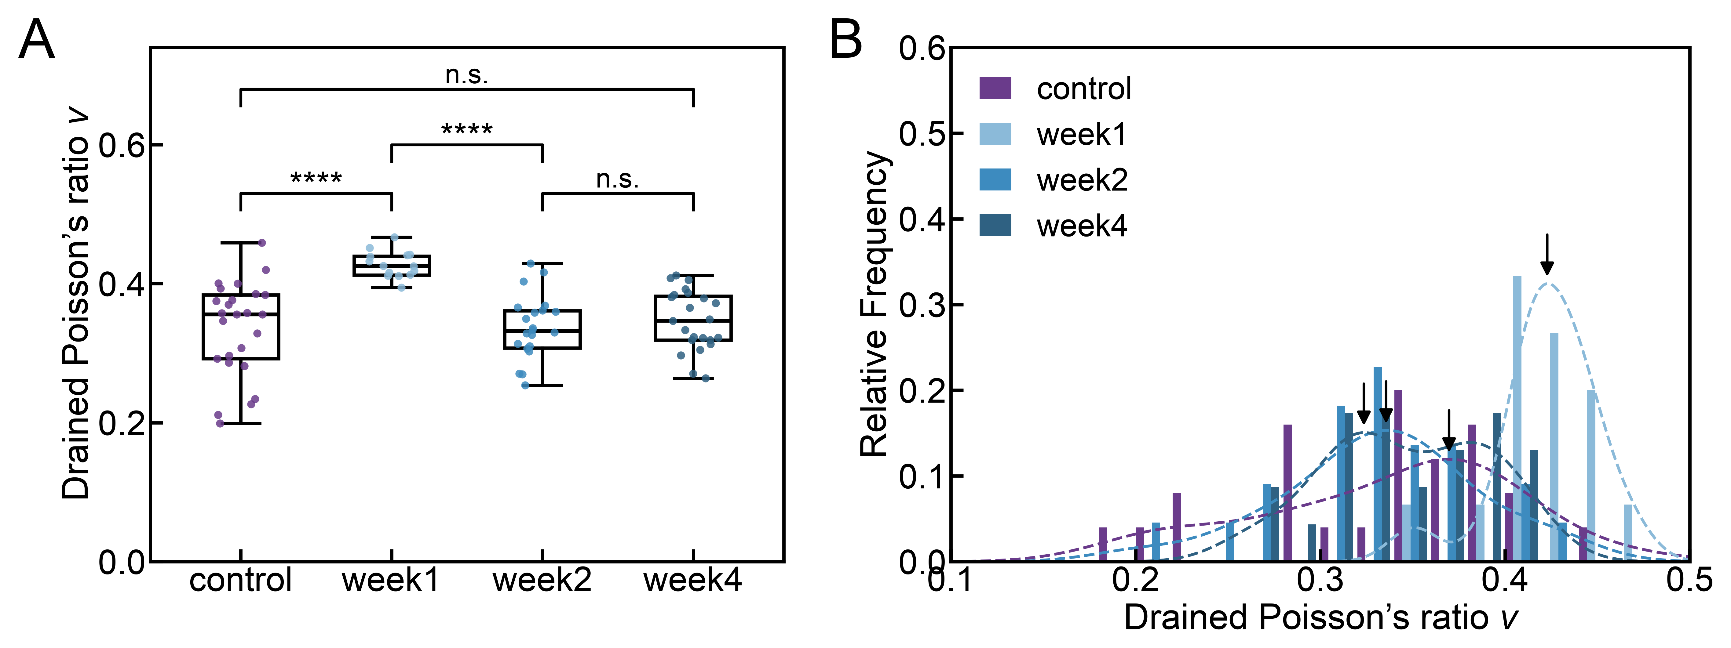
Fig. S1 Drained Poisson’s ratio ν_{d} obtained from Eq. (2) with h(∞) taken as the poroelastic plateau of the joint fit (Section 6). (A) Box and whisker plots (boxes, median and interquartile range; whiskers, 1.5 × interquartile range). Kruskal–Wallis ANOVA followed by Dunn’s pairwise test with the two-stage step-up false-discovery-rate procedure of Benjamini, Krieger and Yekutieli (q = 0.05): **** p < 0.0001; n.s., not a discovery at q = 0.05. N = 25, 15, 22 and 23 indentations from 3 animals per group. (B) Relative-frequency histograms with kernel-density estimates (dashed lines); arrows mark the density peaks.

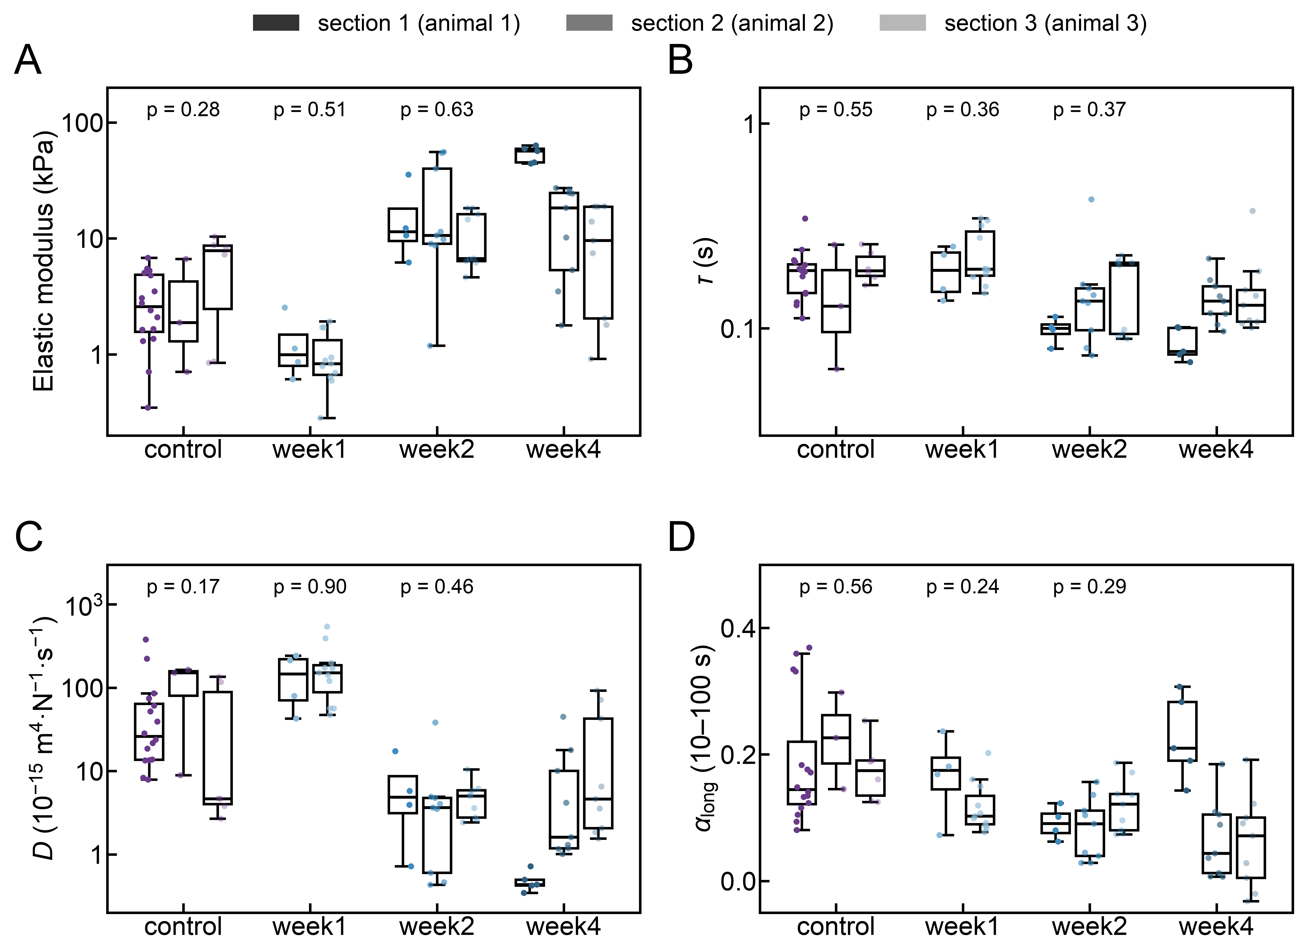
Fig. S2 Sample-independence check: mechanical parameters of each group separated by section (one section per animal; sections identified from the acquisition record). (A) Substrate-corrected elastic modulus E, (B) fluid–solid transition time τ, (C) hydraulic permeability D and (D) long-time exponent α_{long} (10–100 s); boxes, median and interquartile range; whiskers, 1.5 × interquartile range; points, individual indentations shaded by section. The p value above the control, week-1 and week-2 groups is from a Kruskal–Wallis test across their sections (Table S11); sections do not differ systematically within these groups. Only two week-1 sections contributed retained curves. N = 25, 15, 22 and 23 indentations.

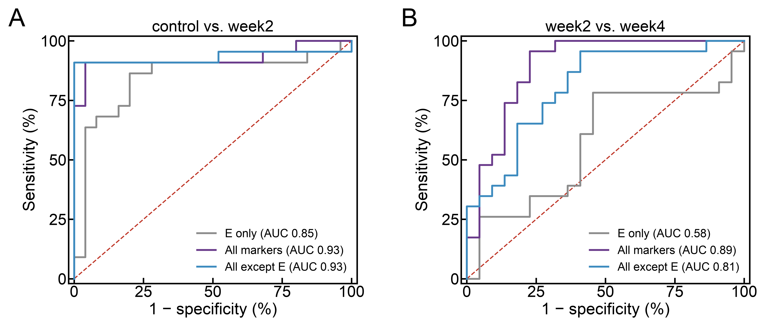
Fig. S3 Receiver operating characteristic (ROC) curves of the classifier for (A) control vs. week 2 and (B) week 2 vs. week 4, with E only (grey), all markers (D, α_{short}, α_{long}, E and ν; purple) and all markers except E (blue); the AUC of each model is given in the legend.

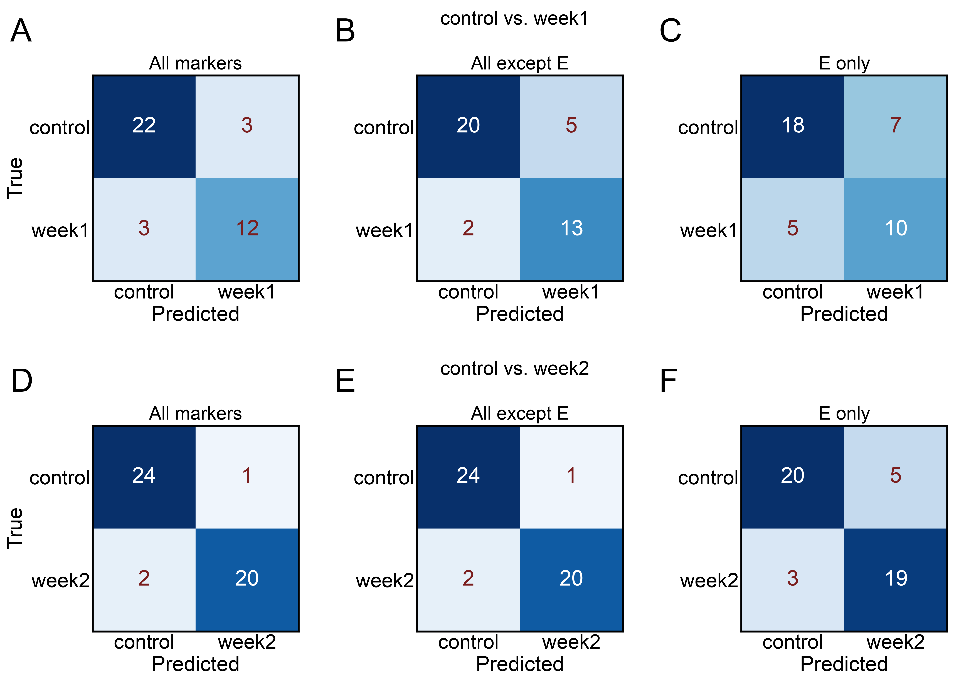

Fig. S4 Confusion matrices (rows, true class; columns, predicted class) of the classifier for control vs. week 1 (A–C) and control vs. week 2 (D–F) trained with (A, D) all markers, (B, E) all markers except E and (C, F) E only. Counts are pooled over the six cross-validation folds.

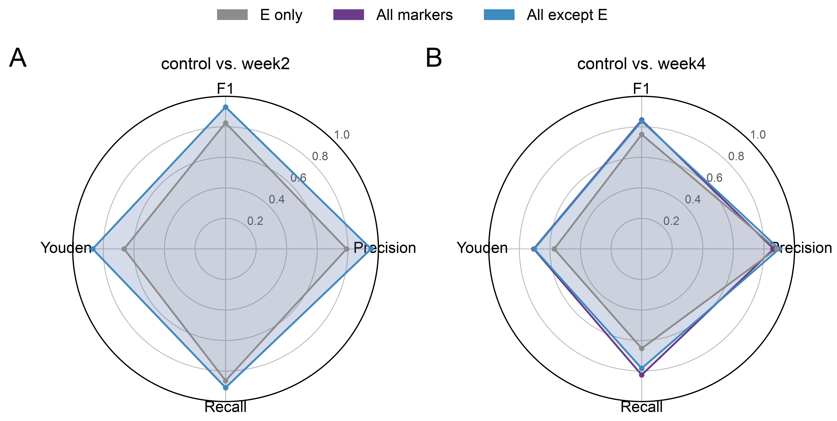
Fig. S5 Radar charts of F1, precision, recall and Youden’s index of the classifier for (A) control vs. week 2 and (B) control vs. week 4, with E only (grey), all markers (purple) and all markers except E (blue).

Table S1 Mean values, standard deviation and coefficients of variation (CV) of the apparent elastic modulus E_{app}, the substrate-corrected elastic modulus E_{corr} (Section 2.4 of the main text) and the creep compliance J(t) in the following groups: control, week1, week2, week4. E values are those of the 85 indentations retained for the poro-viscoelastic analysis.
E_{app} (kPa) | N | Mean | SD | CV
control | 25 | 4.75 | 3.43 | 0.72
week1 | 15 | 1.56 | 0.78 | 0.50
week2 | 22 | 18.98 | 16.95 | 0.89
week4 | 23 | 24.78 | 21.19 | 0.86

E_{corr} (kPa) | N | Mean | SD | CV
control | 25 | 3.76 | 2.93 | 0.78
week1 | 15 | 1.08 | 0.62 | 0.57
week2 | 22 | 16.52 | 15.55 | 0.94
week4 | 23 | 21.90 | 19.43 | 0.89

J(t) (Pa⁻¹) | N | Mean (×10⁻⁴) | SD (×10⁻⁴) | CV
control | 25 | 5.21 | 1.55 | 0.30
week1 | 15 | 4.21 | 1.62 | 0.38
week2 | 21 | 1.79 | 0.73 | 0.41
week4 | 20 | 1.72 | 0.98 | 0.57

Table S2 Mean values, standard deviation and coefficients of variation (CV) of the short-time power-law index α_{short} (fixed 0.01–0.1 s window) and the long-time power-law index α_{long} (fixed 10–100 s window, beyond 20τ for every indentation), and medians with interquartile ranges (IQR) of the hydraulic permeability D from the joint fit (Section 6), in the following groups: control, week1, week2, week4. The corresponding values of α_{long} and D from a single-time-point analysis are given in Table S4.
α_{short} | N | Mean | SD | CV
control | 25 | 0.62 | 0.076 | 0.12
week1 | 15 | 0.65 | 0.12 | 0.19
week2 | 22 | 0.48 | 0.089 | 0.18
week4 | 23 | 0.48 | 0.10 | 0.22

α_{long} | N | Mean | SD | CV
control | 25 | 0.19 | 0.09 | 0.46
week1 | 15 | 0.13 | 0.05 | 0.39
week2 | 22 | 0.10 | 0.04 | 0.45
week4 | 23 | 0.10 | 0.09 | 0.94

D (m⁴N⁻¹s⁻¹) | N | Median (×10⁻¹⁵) | IQR (×10⁻¹⁵) | CV
control | 25 | 23.9 | 8.9–85.7 | 1.34
week1 | 15 | 151.7 | 68.3–206.5 | 0.78
week2 | 22 | 4.0 | 2.6–5.7 | 1.34
week4 | 23 | 1.9 | 1.1–8.3 | 1.84

Table S3 Effect sizes for between-group comparisons (each infarct stage vs. control) of the elastic modulus E, hydraulic permeability D, fluid–solid transition time τ and long-time exponent α_{long}, computed on the 85 analysed indentations (control n = 25, week1 n = 15, week2 n = 22, week4 n = 23); E is the substrate-corrected modulus of Table S1. Fold change is the ratio of group means; Cohen’s d uses the pooled SD; 95% confidence intervals are from 10,000 bootstrap resamples of indentations within each group. Because indentations from the same animal are not independent and the indentation-to-animal mapping was not retained, these intervals describe indentation-level variability only.
Quantity | Comparison | Fold change of means [95% CI] | Cohen’s d [95% CI] | n
E, substrate-corrected (kPa) | week1 vs. control | 0.29 [0.19, 0.44] | −1.14 [−1.63, −0.78] | 25/15
E, substrate-corrected (kPa) | week2 vs. control | 4.39 [2.64, 7.13] | +1.18 [+0.91, +1.64] | 25/22
E, substrate-corrected (kPa) | week4 vs. control | 5.82 [3.57, 9.26] | +1.33 [+0.95, +1.86] | 25/23
D | week1 vs. control | 2.65 [1.43, 5.34] | +1.00 [+0.37, +1.82] | 25/15
D | week2 vs. control | 0.09 [0.04, 0.20] | −0.92 [−1.36, −0.68] | 25/22
D | week4 vs. control | 0.20 [0.06, 0.48] | −0.79 [−1.22, −0.46] | 25/23
τ | week1 vs. control | 1.17 [0.97, 1.42] | +0.53 [−0.13, +1.24] | 25/15
τ | week2 vs. control | 0.79 [0.61, 1.01] | −0.59 [−1.53, +0.02] | 25/22
τ | week4 vs. control | 0.72 [0.58, 0.90] | −0.88 [−1.93, −0.25] | 25/23
α_{long} | week1 vs. control | 0.69 [0.53, 0.89] | −0.79 [−1.33, −0.30] | 25/15
α_{long} | week2 vs. control | 0.53 [0.41, 0.68] | −1.27 [−1.77, −0.87] | 25/22
α_{long} | week4 vs. control | 0.53 [0.33, 0.77] | −0.99 [−1.66, −0.45] | 25/23

Table S4 Comparison of a single-time-point analysis and the present joint fit. In the single-time-point analysis, D was obtained from the normalized displacement at t = 1 s by inverting the master curve of Eq. (6), and α_{long} from a fixed 1–100 s window; in the present analysis D follows from the joint fit of Section 6 with the contact radius a = √(Rh(0)) of each indentation, h(0) being the Hertz depth at the trigger force for the fitted modulus, and α_{long} is the log–log slope of the total creep displacement over the fixed 10–100 s window (main text, Section 2.5). The joint-fit values are used throughout the main text.
Group | N | D, single time point (mean ± SD, ×10⁻¹⁵) | D, joint fit (median [IQR], ×10⁻¹⁵) | α_{long}, 1–100 s window (mean ± SD)
control | 25 | 5.59 ± 1.21 | 23.9 [8.9–85.7] | 0.19 ± 0.07
week1 | 15 | 7.69 ± 1.62 | 151.7 [68.3–206.5] | 0.13 ± 0.04
week2 | 22 | 4.41 ± 1.52 | 4.0 [2.6–5.7] | 0.11 ± 0.04
week4 | 23 | 4.76 ± 1.27 | 1.9 [1.1–8.3] | 0.12 ± 0.07

Table S5 Quality-control metrics of retained and excluded indentation curves (protocol-test curves excluded), computed from the raw force curves: apparent force–indentation exponent n of the approach segment between 20% and 95% of the trigger force (Hertzian value 3/2; values far above it indicate substrate-dominated stiffening), root-mean-square jitter of the hold displacement after detrending, fraction of the 100-s creep displacement accumulated within the first second, and total creep displacement. Medians with interquartile ranges.
Group (retained / excluded) | Exponent n | Hold jitter (nm) | Δh(1 s)/Δh(100 s) | Δh(100 s) (nm)
control retained (n = 25) | 3.8 [2.6–7.0] | 5.9 [4.6–8.5] | 0.44 [0.40–0.47] | 574 [476–691]
control excluded (n = 29) | 2.5 [2.1–4.5] | 8.0 [5.3–11.7] | 0.53 [0.47–0.59] | 432 [353–572]
week1 retained (n = 15) | 3.2 [2.1–4.0] | 2.3 [1.6–3.3] | 0.52 [0.45–0.56] | 406 [295–544]
week1 excluded (n = 6) | 7.5 [5.4–8.4] | 2.9 [1.7–4.3] | 0.73 [0.63–0.80] | 188 [111–266]
week2 retained (n = 22) | 9.7 [7.5–11.9] | 2.6 [2.1–3.1] | 0.53 [0.49–0.59] | 199 [143–284]
week2 excluded (n = 8) | 20.6 [11.4–28.9] | 3.9 [3.5–5.2] | 0.62 [0.60–0.80] | 133 [108–196]
week4 retained (n = 23) | 4.8 [2.7–11.7] | 2.6 [1.5–3.6] | 0.53 [0.44–0.62] | 162 [141–258]
week4 excluded (n = 61) | 3.8 [2.1–6.9] | 2.5 [1.5–3.2] | 0.69 [0.61–0.78] | 111 [60–134]

Table S6 Fluid–solid transition time from the step-load fit of Eq. (9) (main text) and from the same model with the measured loading history included by approximate linear superposition of displacement (ramp-inclusive fit), both on the same 100-s hold data; group medians with interquartile ranges, the median ratio of the two estimates, and the median root-mean-square log residuals of the two fits.
Group | τ, step load (s) | τ, ramp-inclusive (s) | ratio ramp/step | log residual step / ramp
control | 0.191 [0.149–0.211] | 0.088 [0.055–0.105] | 0.46 | 0.055 / 0.027
week1 | 0.195 [0.169–0.264] | 0.082 [0.031–0.118] | 0.43 | 0.044 / 0.016
week2 | 0.124 [0.095–0.194] | 0.042 [0.023–0.099] | 0.37 | 0.068 / 0.030
week4 | 0.118 [0.101–0.149] | 0.016 [0.010–0.049] | 0.16 | 0.072 / 0.034

Table S7 Sample accounting for the robustness analysis. Of 197 recorded curves, eight protocol-test curves were set aside, leaving 189 protocol-conforming curves (85 retained at the original visual quality control, 104 excluded). The automated pipeline of Table S8 failed at the contact-fit stage for 22 curves, for which the free-contact-point Hertz fit placed the contact after the trigger point (non-positive indentation depth at the trigger force), so that no admissible solution for ν_{d}, G and D exists; these are reported as fit failures and excluded from the parameter statistics of Table S8, not from the sample. All remaining 167 curves gave admissible parameters (ν_{d} > −1, D > 0). The last column counts curves whose 10–100 s log–log slope is negative, i.e. whose displacement decreases late in the hold (drift or clamp instability rather than creep); 32 of these 34 curves had been excluded at the original quality control.
Group | Protocol-conforming (retained / excluded) | Contact-fit failures (retained / excluded) | Admissible parameters | Negative 10–100 s slope (retained / excluded)
control | 54 (25 / 29) | 2 (0 / 2) | 52 | 0 (0 / 0)
week1 | 21 (15 / 6) | 0 (0 / 0) | 21 | 3 (0 / 3)
week2 | 30 (22 / 8) | 4 (4 / 0) | 26 | 3 (0 / 3)
week4 | 84 (23 / 61) | 16 (5 / 11) | 68 | 28 (2 / 26)
total | 189 (85 / 104) | 22 (9 / 13) | 167 | 34 (2 / 32)

Table S8 Robustness of the between-group differences to the curve selection. The 189 protocol-conforming curves were re-analysed with one uniform automated pipeline: Hertz fit with a free contact point for E_{app}, per-indentation substrate correction, step-load joint fit for τ and the poroelastic amplitude, ν_{d} from Eq. (2), D = a²/(2Gτ) and α_{long} over 10–100 s. E_{corr}, τ and D are given for the admissible curves of Table S7; α_{long}, which does not depend on the contact fit, is given both for all protocol-conforming curves of the set and for the admissible subset. Because the modulus here comes from the automated fit rather than from the manually set contact points of the main analysis, the absolute values differ from those in the main text; the comparison of interest is between the retained set and the full set within each group. The direction of every between-group difference reported in the main text is preserved; the magnitude of α_{long}, in particular its week-4 mean, depends strongly on the selection because of the negative-slope curves counted in Table S7.
Group (set; n admissible / n) | E_{corr}, median (kPa) | τ, median (s) | D, median (×10⁻¹⁵) | α_{long} 10–100 s, mean (all / admissible)
control (retained; 25 / 25) | 2.16 | 0.191 | 31.5 | 0.189 / 0.189
control (all; 52 / 54) | 1.56 | 0.184 | 76.5 | 0.153 / 0.153
week1 (retained; 15 / 15) | 0.65 | 0.195 | 192.5 | 0.129 / 0.129
week1 (all; 21 / 21) | 0.92 | 0.195 | 106.6 | 0.094 / 0.094
week2 (retained; 18 / 22) | 7.81 | 0.100 | 5.7 | 0.099 / 0.093
week2 (all; 26 / 30) | 8.85 | 0.098 | 5.7 | 0.076 / 0.068
week4 (retained; 18 / 23) | 9.05 | 0.124 | 5.9 | 0.099 / 0.081
week4 (all; 68 / 84) | 18.70 | 0.110 | 2.2 | 0.015 / 0.008

Table S9 Direct tests of whether α_{long} carries information about infarction beyond stiffness (85 retained indentations; indentation level). Matched stiffness: control and infarct indentations within their common range of E_{corr}; Cohen’s d of the infarct group against control with bootstrap 95% CI (10,000 resamples). Regression: ordinary least squares of α_{long} on log E_{corr} with group indicator terms (reference: control); coefficients ± standard error. Classification: leave-one-out logistic regression of control versus infarcted indentations, area under the receiver-operating curve (AUC).
Test | Comparison | n | Estimate | Bootstrap 95% CI
Matched stiffness, α_{long} | control vs. all infarct (0.35–10.4 kPa) | 25 / 33 | medians 0.161 / 0.107; d = −1.08 | [−1.59, −0.62]
Matched stiffness, α_{long} | control vs. week 1 (0.35–2.5 kPa) | 12 / 14 | medians 0.141 / 0.105; d = −0.66 | [−1.54, +0.08]
Matched stiffness, α_{long} | control vs. week 2 (1.19–10.4 kPa) | 20 / 10 | medians 0.153 / 0.116; d = −1.05 | [−1.62, −0.56]
Matched stiffness, α_{long} | control vs. week 4 (0.92–10.4 kPa) | 20 / 9 | medians 0.153 / 0.105; d = −0.89 | [−1.45, −0.40]
Regression α_{long} ~ log E + group | log E coefficient | 85 | 0.000 ± 0.009 | –
 | group terms week 1 / 2 / 4 | 85 | −0.059 ± 0.026 / −0.090 ± 0.025 / −0.090 ± 0.026 | –
 | R² (E only → E + group) | 85 | 0.05 → 0.22 | –
 | residual α_{long} | E, infarct vs. control | 25 / 60 | d = −0.94 | [−1.50, −0.44]
Leave-one-out AUC, control vs. infarct | E / α_{long} / E + α_{long} | 25 / 60 | 0.66 / 0.75 / 0.79 | –
α_{long} between infarct stages | week 1 vs. week 2 | 15 / 22 | d = −0.64 | [−1.33, +0.00]
α_{long} between infarct stages | week 1 vs. week 4 | 15 / 23 | d = −0.38 | [−1.10, +0.19]
α_{long} between infarct stages | week 2 vs. week 4 | 22 / 23 | d = 0.00 | [−0.64, +0.58]

Table S10 Between-group comparisons at the indentation level. Kruskal–Wallis ANOVA across the four groups (H, p) and Dunn’s pairwise comparisons (two-sided p); the false discovery rate is controlled at q = 0.05 by the two-stage step-up method of Benjamini, Krieger and Yekutieli, and pairs that are discoveries at this level are marked with an asterisk. Substrate-corrected E, transition time τ, permeability D, long-time exponent α_{long} (10–100 s) and drained Poisson’s ratio ν_{d}; N = 25, 15, 22 and 23 indentations.
Parameter | Kruskal–Wallis H (p) | ctrl – wk1 | ctrl – wk2 | ctrl – wk4
E | 46.6 (< 10⁻⁴) | 0.03* | 0.0002* | < 10⁻⁴*
τ | 22.1 (< 10⁻⁴) | 0.33 | 0.007* | 0.0010*
D | 46.7 (< 10⁻⁴) | 0.02* | 0.0002* | < 10⁻⁴*
α_{long} | 18.7 (0.0003) | 0.04 | 0.0002* | 0.0002*
ν_{d} | 27.7 (< 10⁻⁴) | < 10⁻⁴* | 0.63 | 0.86
Parameter | wk1 – wk2 | wk1 – wk4 | wk2 – wk4
E | < 10⁻⁴* | < 10⁻⁴* | 0.73
τ | 0.0009* | 0.0001* | 0.60
D | < 10⁻⁴* | < 10⁻⁴* | 0.81
α_{long} | 0.21 | 0.22 | 0.97
ν_{d} | < 10⁻⁴* | < 10⁻⁴* | 0.53

Table S11 Within-group comparison between sections. Each group was measured on three sections, one per animal, identified from the acquisition record; medians per section (n in the header) and the Kruskal–Wallis p value across sections are given for each parameter. Only two week-1 sections contributed retained curves. Sections of the control, week-1 and week-2 groups do not differ systematically in E, τ, D or α_{long} (ν_{d} differs between the control sections and between the week-2 sections, p = 0.02 and 0.03).
Group (n per section) | E (kPa) | τ (s) | D (×10⁻¹⁵) | α_{long} 10–100 s
control (16 / 3 / 6) | 2.58 / 1.88 / 7.84; p = 0.28 | 0.192 / 0.129 / 0.191; p = 0.55 | 26.1 / 151.4 / 4.7; p = 0.17 | 0.145 / 0.227 / 0.175; p = 0.56
week1 (4 / 11) | 0.99 / 0.83; p = 0.51 | 0.192 / 0.195; p = 0.36 | 146.9 / 151.7; p = 0.90 | 0.175 / 0.103; p = 0.24
week2 (4 / 9 / 9) | 11.44 / 10.64 / 6.71; p = 0.63 | 0.100 / 0.136 / 0.204; p = 0.37 | 4.9 / 3.7 / 5.0; p = 0.46 | 0.091 / 0.090 / 0.122; p = 0.29
week4 (5 / 9 / 9) | 56.82 / 18.35 / 9.58 | 0.077 / 0.136 / 0.130 | 0.4 / 1.6 / 4.6 | 0.210 / 0.044 / 0.071
Group (n per section) | ν_{d}
control (16 / 3 / 6) | 0.367 / 0.370 / 0.254; p = 0.02
week1 (4 / 11) | 0.425 / 0.418; p = 0.90
week2 (4 / 9 / 9) | 0.410 / 0.306 / 0.350; p = 0.03
week4 (5 / 9 / 9) | 0.349 / 0.322 / 0.384; p = 0.33

Table S12 Model-free location of the fluid–solid transition. t½ is the time at which the local log–log slope of the creep displacement falls through 1/2 (equal loss and storage, tan δ = 1); medians with interquartile ranges, the number of curves in which the exponent crosses 1/2, the median ratio t½/τ to the fitted transition time, and the median local exponents at 0.005–0.03 s and 10–100 s.
Group (crossing / n) | t½, median [IQR] (s) | t½ / τ, median | Exponent, 0.005–0.03 s | Exponent, 10–100 s
control (25 / 25) | 0.078 [0.068–0.097] | 0.45 | 0.80 | 0.16
week1 (15 / 15) | 0.076 [0.047–0.125] | 0.43 | 0.79 | 0.11
week2 (22 / 22) | 0.030 [0.017–0.051] | 0.23 | 0.61 | 0.12
week4 (21 / 23) | 0.032 [0.018–0.051] | 0.24 | 0.57 | 0.09

