Additional file 5. Prototype posters
Poster #1 – Workshop #2

Canadian Syncope Risk Score based Practice Recommendations
- For use among ED patients who present within 24-hours of their syncope¹
- After initial ED assessment (history, physical exam ± orthostatic vitals and ECG)² if a serious condition is suspected investigate accordingly
- Does not apply to patients who had a serious condition identified in the ED or those who require consultation/hospitalization not related to syncope work-up
- Patients who fulfill ultra-low-risk criteria³ do not require troponin measured and can be assumed as normal

CANADIAN SYNCOPE RISK SCORE
Category | Points
Clinical evaluation
Predisposition to vasovagal symptoms⁴ | -1
History of heart disease⁵ | 1
Any systolic pressure reading <90 or >180 mm Hg⁶ | 2
Investigations
Elevated troponin (>99th percentile); assume as normal if patient is ultra-low-risk | 2
Abnormal QRS axis (<-30 or >100º) | 1
QRS duration >130 milliseconds | 1
Corrected QT interval >480 milliseconds | 2
Diagnosis in emergency department
Vasovagal syncope | -2
Cardiac syncope | 2
Cause unknown | 0
Total score | (-3 to 11)

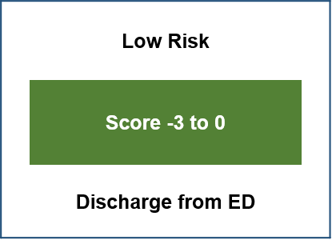
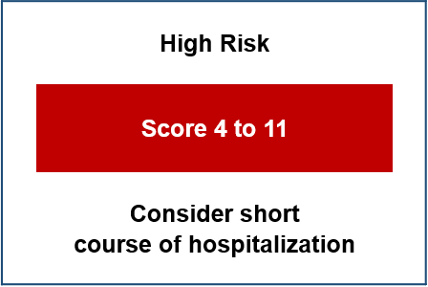
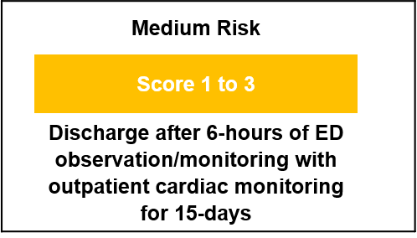

¹Confirm the patient suffered true syncope (sudden transient loss of consciousness with spontaneous complete recovery)
²Routine blood tests (CBC, Chemistry) are generally not useful; pulmonary embolism prevalence is very low 0.6% investigate only if suspected; CT head is not recommended unless focal neurological deficits or head injury with risk factors as per published criteria (e.g., Canadian CT Head Rule)
³Ultra-low-risk criteria:
  - Age ≤ 50 years
  - No heart disease
  - Normal ECG (QRS axis ≥-30° to ≤+100°, QRS ≤130ms, cQT ≤480ms)
  - Clinical impression: non-cardiac syncope
⁴Triggered by being in a warm crowded place, prolonged standing, fear, emotion or pain
⁵Includes coronary or valvular heart disease, cardiomyopathy, congestive heart failure and history of non-sinus rhythm
⁶Includes blood pressure values from triage until disposition from the emergency department.

Poster #2 – Workshop #2

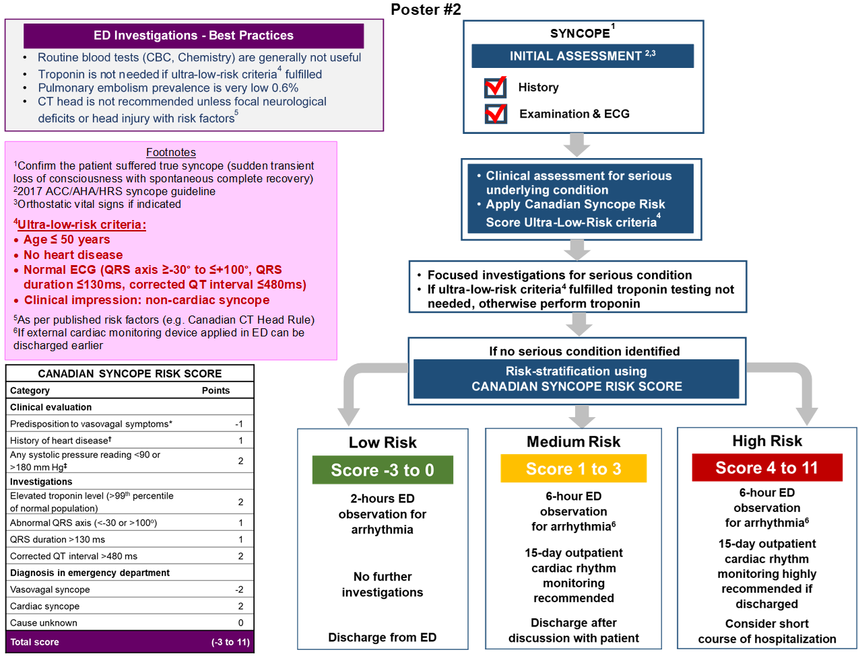

Poster #3 – Workshop #3
