Supplementary Materials

Supplementary Figures
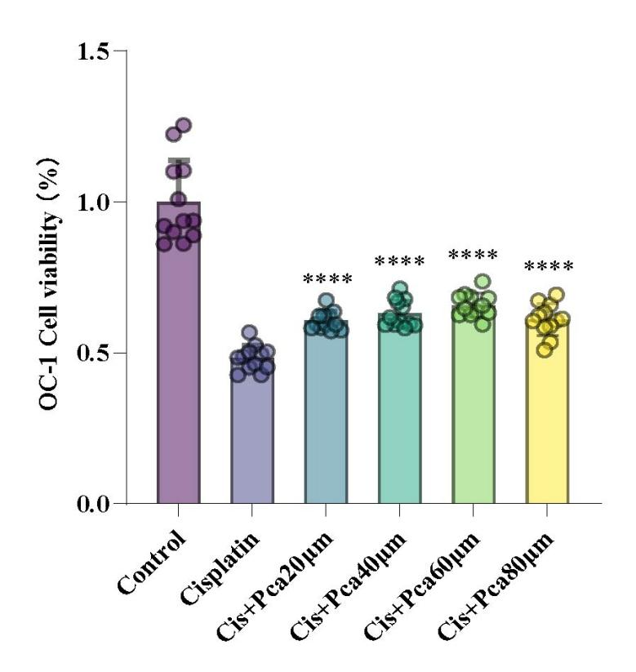
Figure S1. Dose-dependent effect of p-CA on HEI-OC1-cell viability. Cell viability was measured after Control, Cisplatin, or Cisplatin plus p-CA (20, 40, 60, or 80 µM) treatment. Six matched independent experimental batches were analyzed. Prespecified comparisons were Control versus Cisplatin and Cisplatin versus each p-CA concentration. Two-sided paired t tests were used, with Holm adjustment within the dose-response family. Data are mean ± SD. Symbols denote Holm-adjusted P values: *P < 0.05, **P < 0.01, ***P < 0.001, and ****P < 0.0001; ns, not significant.

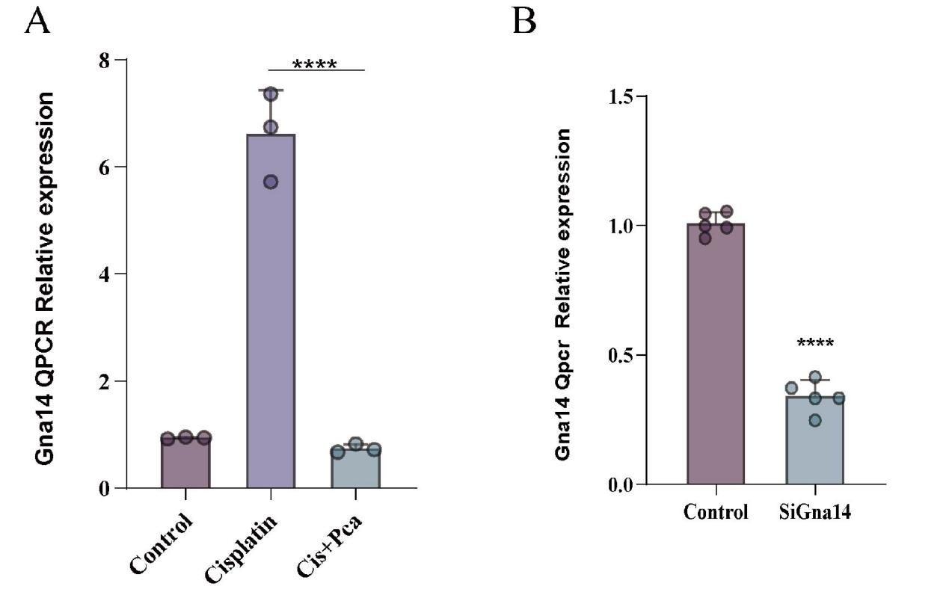
Figure S2. Gna14 transcript responses to cisplatin, p-CA, and Gna14 silencing. (A) Gna14 transcript abundance in Control, Cisplatin, and Cisplatin+p-CA samples. Prespecified comparisons were Control versus Cisplatin and Cisplatin versus Cisplatin+p-CA. (B) Gna14 transcript abundance after control or siGna14 treatment. Inference used ΔCt values from five independently prepared biological samples per group. Independent-group contrasts were analyzed using two-sided Welch t tests, with Holm adjustment within panel A. Data are mean ± SD. Symbols denote Holm-adjusted P values: *P < 0.05, **P < 0.01, ***P < 0.001, and ****P < 0.0001; ns, not significant.
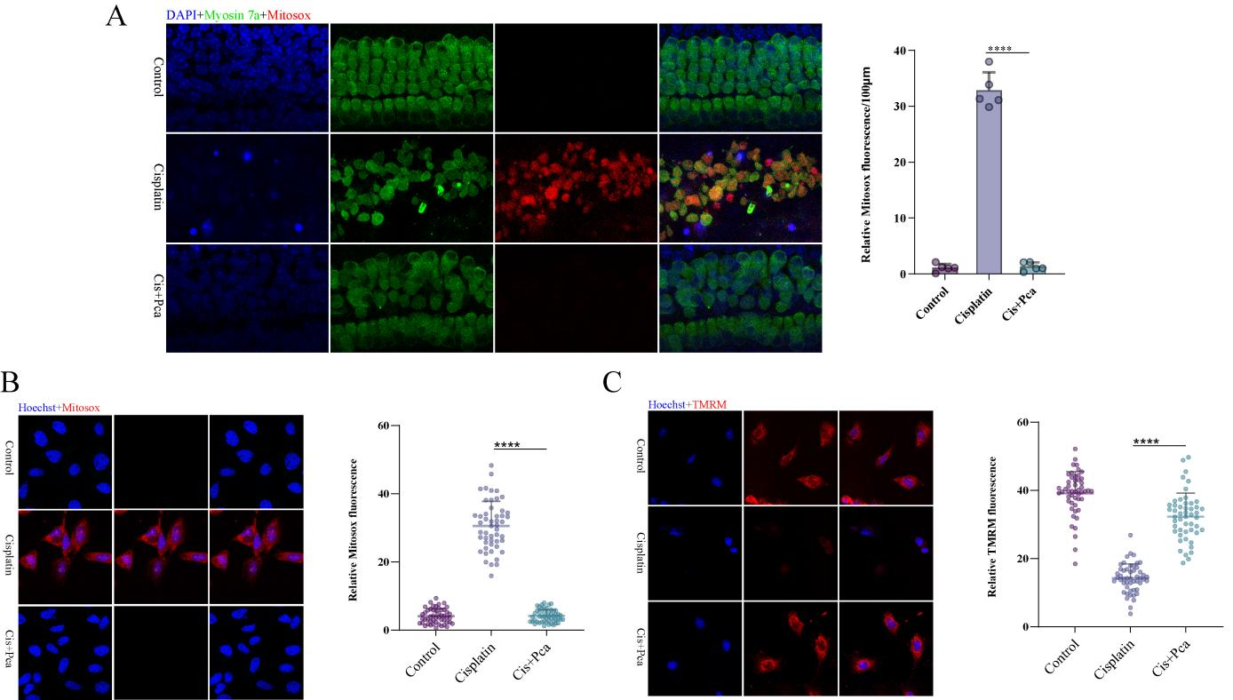
Figure S3. p-CA attenuates mitochondrial oxidative stress and membrane-potential disruption. (A) Representative images and quantification of mitochondrial superoxide (MitoSOX, red) in Myosin7a-positive cochlear hair cells (green; DAPI, blue). (B) Representative images and quantification of MitoSOX in HEI-OC1 cells. (C) Representative images and quantification of mitochondrial membrane potential using TMRM (red) in HEI-OC1 cells; nuclei were counterstained with Hoechst (blue). MitoSOX measurements in cochlear explants used five independent explants per group. HEI-OC1 MitoSOX and TMRM measurements used five matched independent experiments per group, with fields or cells averaged within experiment. Prespecified comparisons were Control versus Cisplatin and Cisplatin versus Cisplatin+p-CA. Explant contrasts used two-sided Welch t tests; matched HEI-OC1 contrasts used two-sided paired t tests. Holm adjustment was applied within each outcome. Data are mean ± SD. Symbols denote Holm-adjusted P values: *P < 0.05, **P < 0.01, ***P < 0.001, and ****P < 0.0001; ns, not significant. Scale bar = 20 µm.
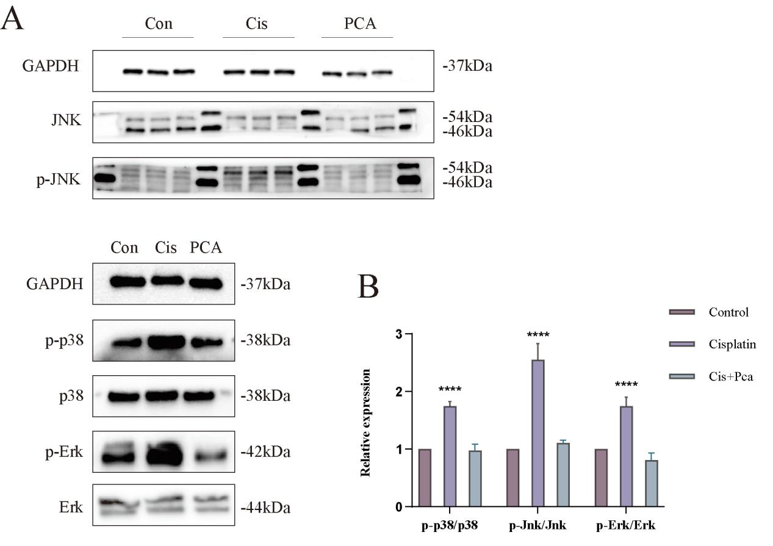
Figure S4. p-CA attenuates cisplatin-associated MAPK activation. (A) Western blots of phosphorylated and total p38, JNK, and ERK in the indicated groups. (B) Quantification of phosphorylated-to-total p38, JNK, and ERK band-intensity ratios. Five independently prepared biological samples were analyzed per group. Prespecified comparisons were Control versus Cisplatin and Cisplatin versus Cisplatin+p-CA. Two-sided Welch t tests were used, with Holm adjustment within each phosphoprotein outcome. Data are mean ± SD. Symbols denote Holm-adjusted P values: *P < 0.05, **P < 0.01, ***P < 0.001, and ****P < 0.0001; ns, not significant. Attenuation of calcium and organelle stress by p-CA was accompanied by reduced MAPK activation.
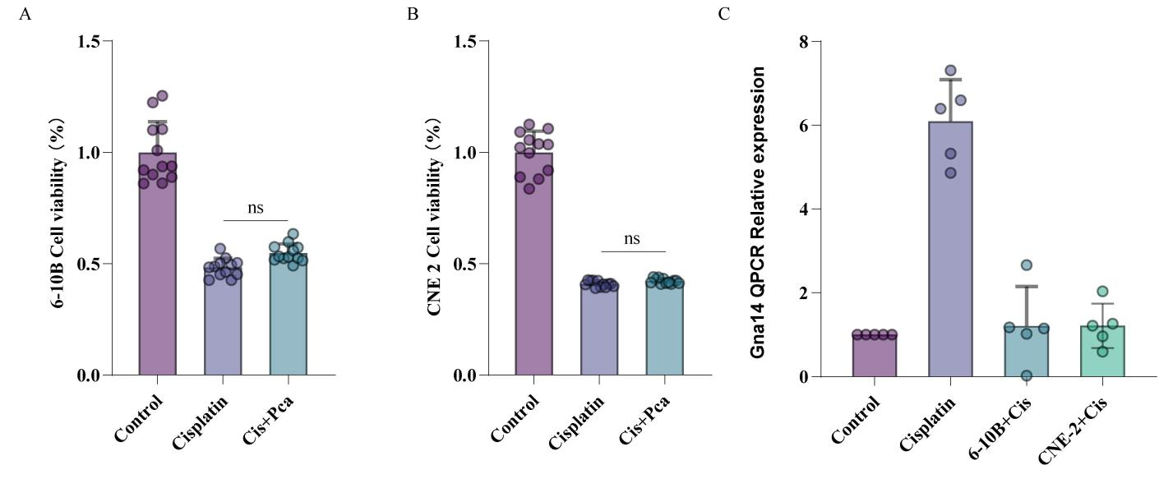
Figure S5. Effects of p-CA and cisplatin in two tested in vitro tumor-cell models. (A,B) Viability of 6-10B and CNE-2 cells after Control, Cisplatin, or Cisplatin+p-CA treatment. Five matched independent experimental batches were analyzed per cell line using two-sided paired t tests. Cisplatin reduced viability, whereas Cisplatin versus Cisplatin+p-CA was not significant in either line; these two nonsignificant comparisons are retained because they directly support the safety interpretation. (C) Gna14 transcript abundance was assessed using ΔCt values from five independent biological samples per group. Cisplatin produced a marked increase in cochlear hair-cell samples and much smaller but statistically detectable changes in 6-10B and CNE-2 cells. Two-sided Welch t tests were used. Holm adjustment was applied within each outcome. Data are mean ± SD. Symbols denote Holm-adjusted P values: *P < 0.05, **P < 0.01, ***P < 0.001, and ****P < 0.0001; ns, not significant.

Supplementary Tables
Table S1. Primer sequences used for quantitative real-time PCR (qPCR).
Gene | Species | Forward primer (5'→3') | Reverse primer (5'→3')
Gna14 | Mouse | CATGGGTCTGGCTACAGT | TGGGCATTTTCCTTATTC
GNA14 | Human | GCTGAGTGTGACAACGAGAAT | TCCTGTTTCGGTCCTGTGTAT
Chop (Ddit3) | Mouse | GCTGTGGTAGTGAGCTGTTGCA | CACAGCCCAGGTATGGAATCA
Atf4 | Mouse | AAACCTCATGGGTTCTCCAG | GGCATGGTTTCCAGGTCATC
Hspa5 (BiP) | Mouse | TGTCTTCTCAGCATCAAGCAAGG | CCAACACTTCCTGGACAGGCTT
Gapdh | Mouse | AGGTCGGTGTGAACGGATTTG | GGGGTCGTTGATGGCAACA
ACTB (β-actin) | Human | CACCATTGGCAATGAGCGGTTC | AGGTCTTTGCGGATGTCCACGT
Gna14/Gapdh, mouse (cochlear explants and HEI-OC1 cells); GNA14/ACTB, human (6-10B and CNE-2 cells).

Table S2. Small interfering RNA (siRNA) sequences.
siRNA | Species | Sense (5'→3') | Antisense (5'→3')
siGna14 (A10001) | Mouse | UGUACUCUCAUCUAAUUAGTT | CUAAUUAGAUGAGAGUACATT
The siGna14 duplex with the highest knockdown efficiency was used for all functional experiments; knockdown efficiency is shown in Figure S2B.

Table S3. Summary of statistical analyses for all prespecified comparisons. Table S3 is provided as a separate Excel file and contains group-level descriptive statistics, assumption diagnostics, test names, test statistics, degrees of freedom where applicable, exact P values, and Holm-adjusted results. It does not contain individual biological-replicate or technical raw data.

