Supplementary Appendix

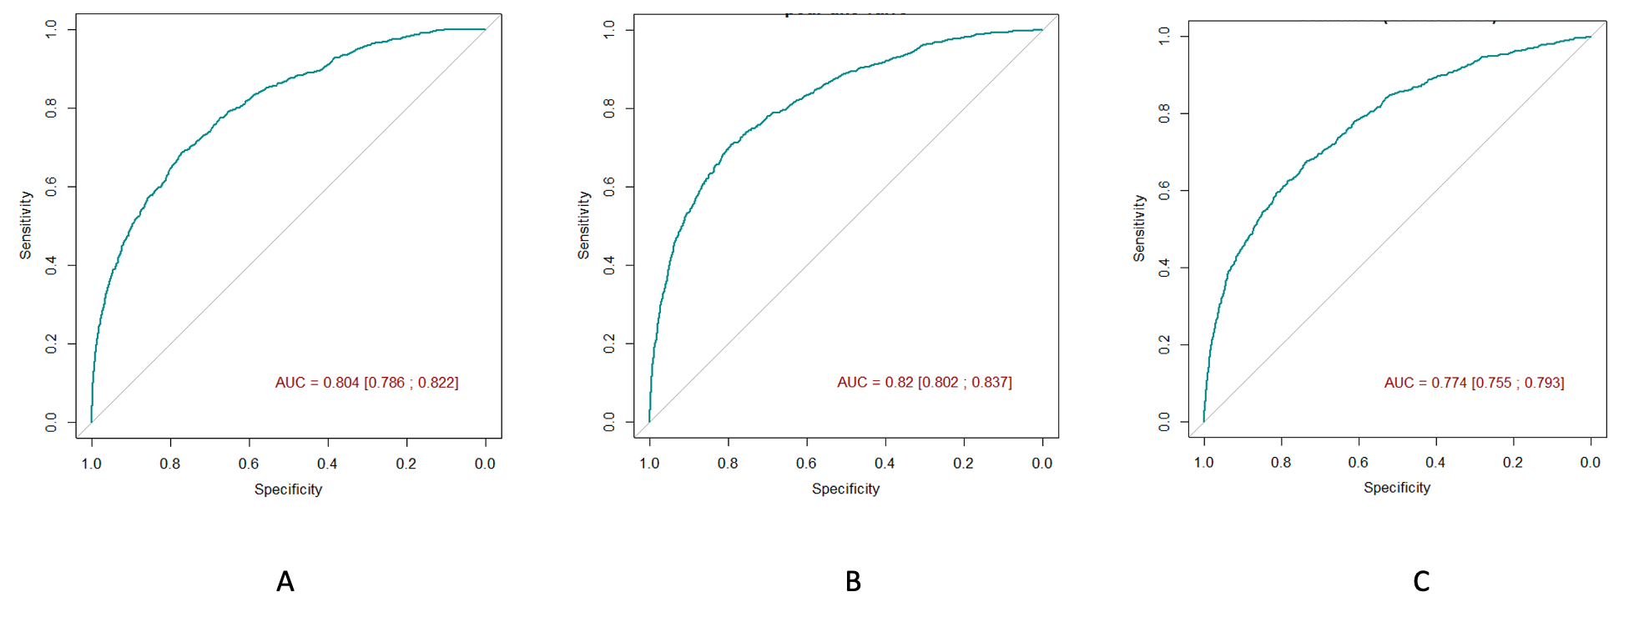
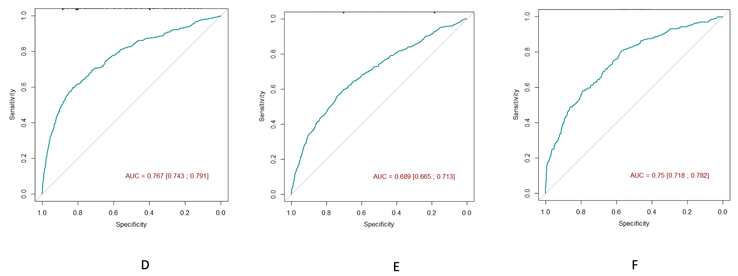
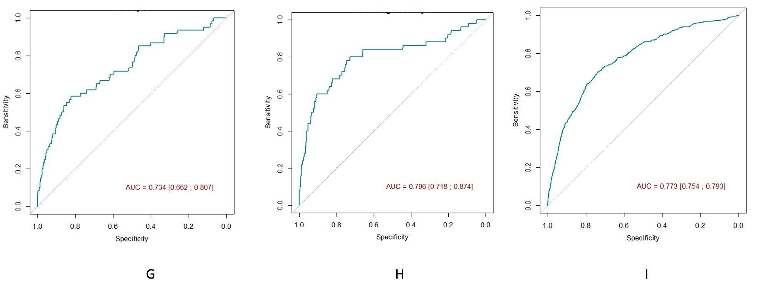

Supplementary Figure 1. Subgroups discrimination with ROC Curve

A. Patients with bypass surgery
B. Patients with single-valve valve surgery
C. Patients with combined valve surgery (double valve)
D. Patients with scheduled aortic surgery or other than dissection
E. Patients with aortic surgery due to aortic dissection
F. Patients with bypass surgery and valve surgery
G. Patients with bypass surgery and aortic surgery
H. Patients with valve surgery and aortic surgery
I. Patients with triple or more procedures

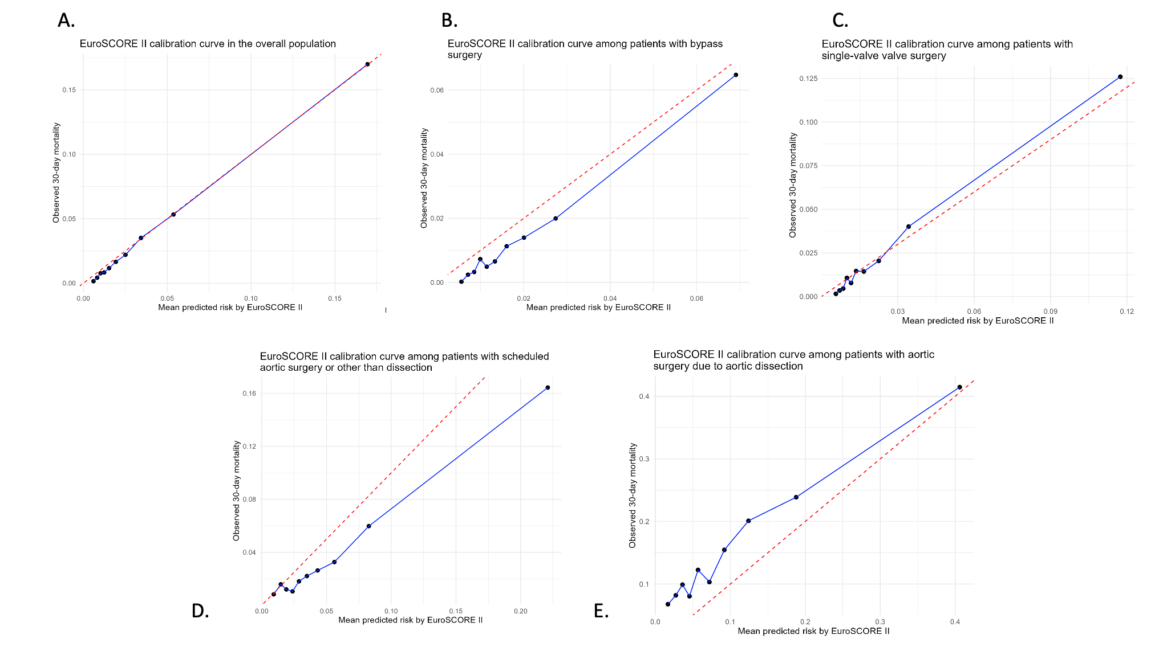

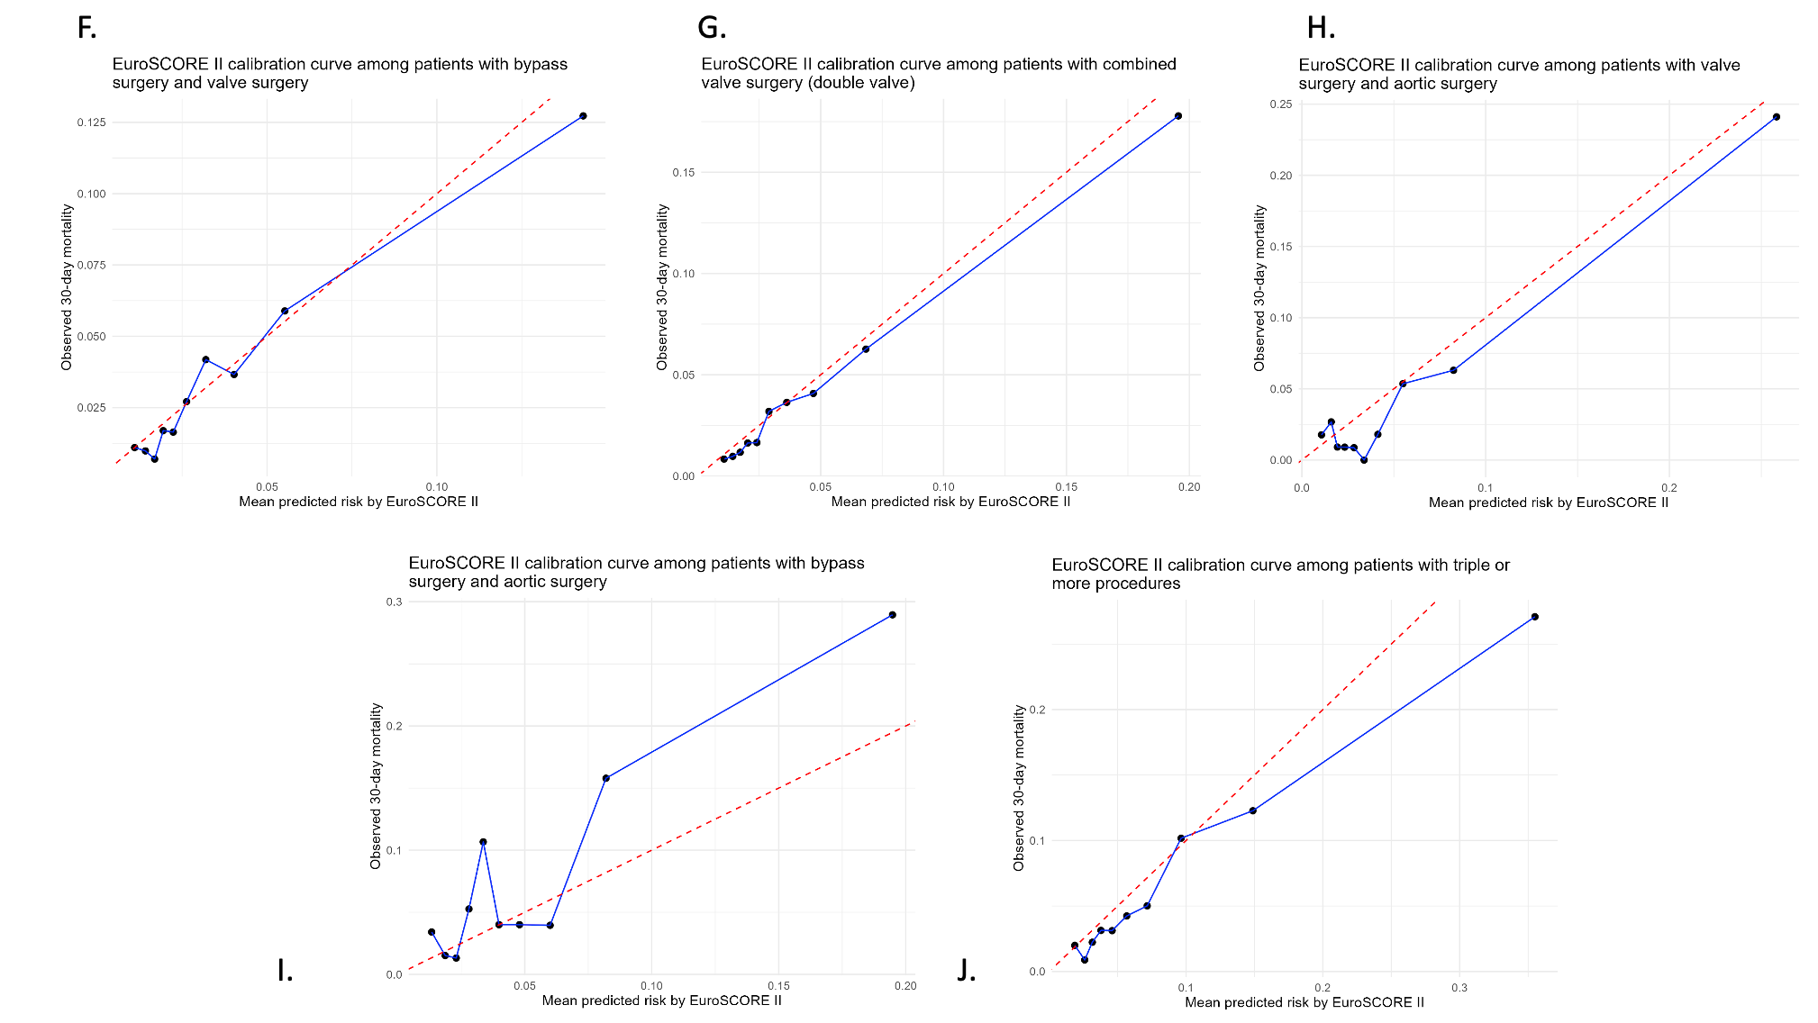

Supplementary Figure 2. Subgroups Calibration Curve
A. Overall Population
B. Patients with bypass surgery
C. Patients with single-valve valve surgery
D. Patients with combined valve surgery (double valve)
E. Patients with scheduled aortic surgery or other than dissection
F. Patients with aortic surgery due to aortic dissection
G. Patients with bypass surgery and valve surgery
H. Patients with bypass surgery and aortic surgery
I. Patients with valve surgery and aortic surgery
J. Patients with triple or more procedures

Supplementary Table 1. Hosmer Lemeshow Test

Groupe | P-value (Hosmer-Lemeshow Test)
Overall population | p < 0.001
Patients with CABG surgery | p < 0.001
Patients with single-valve surgery | p = 0.001
Patients with combined valve surgery (double valve) | p = 0.02*
Patients with scheduled aortic surgery or other than dissection | p < 0.001
Patients with aortic surgery due to aortic dissection | p < 0.001
Patients with CABG surgery and valve surgery | p = 0.21*
Patients with CABG and aortic surgery | p < 0.001
Patients with valve surgery and aortic surgery | p = 0.22
Patients with triple or more procedures | p < 0.001

Supplementary Table 2. Baseline characteristics of patients excluded from the analysis population due to unavailable EuroSCORE II
 | N* | Overall Population  N=108,412  (100%) | N* | Excluded due to unavailable EuroSCORE II  N=10,628
Age, year, median[IQR] | 108,412 | 68.0 [60.0;73.0] | 9,607 | 68.0 [60.0 ; 73.0]
Sex, n(%) Female  Male | 108,412 | 27,334 (25.2)  81,078 (74.8) | 10,437 | 2,371 (22.7)  8,066 (77.3)
BMI (kg/m²), mean ± sd | 108,412 | 26.8 ± 4.5 | 9,263 | 26.9 ± 4.6
GFR, (μmol/l), median[IQR] | 108,412 | 80.0 [62.0;100.0] | 7,162 | 81.0 [64.0 ; 100.0]
Dialysis, n(%) | 108,412 | 1,286 (1.2) | 10,628 | 64 (0.6)
Diabetes n(%) | 108,412 | 24,211 (22.3) | 10,628 | 1,940 (18.3)
BPCO with treatment, n(%) | 108,412 | 5,929 (5.5) | 10,628 | 330 (3.1)
Active endocarditis, n(%) | 108,412 | 4,146 (3.8) | 10,628 | 220 (2.1)
Disabling neurological or musculoskele-tal impairment, n(%) | 108,412 | 2,441 (2.3) | 10,628 | 86 (0.8)
Carotid stenosis > 50% and/or anterior carotid surgery, n(%) | 108,412 | 5,740 (5.3) | 10,628 | 241 (2.3)
Peripheral arterial disease, n(%) | 108,412 | 7,620 (7.0) | 10,628 | 514 (4.8)
Anterior thoracic or abdominal aorta surgery, n(%) | 108,412 | 1,830 (1.7) | 10,628 | 324 (3.0)
Anterior cardiac surgery, n(%) | 108,412 | 5,527 (5.1) | 10,628 | 277 (2.6)
NYHA, n(%)  1  2  3  4 | 108,412 | 37,954 (35.0)  44,928 (41.4)  20,273 (18.7)  5,257 (4.8) | 10,628 | 5,424 (51.0)  3,959 (37.3)  959 (9.0)  286 (2.7)
Rest angina, n(%) | 108,412 | 7,505 (6.9) | 10,628 | 394 (3.7)
Myocardial infarction within 90 days, n(%) | 108,412 | 7,848 (7.2) | 10,628 | 290 (2.7)
Ventricular tachycardia or ventricular fibrillation within 24h before surgery, n(%) | 108,412 | 415 (0.4) | 10,628 | 51 (0.5)
Preoperative inotropic support, n(%) | 108,412 | 2,396 (2.2) | 10,628 | 175 (1.6)
Preoperative intra-aortic balloon pump, n(%) | 108,412 | 620 (0.6) | 10,628 | 42 (0.4)
Preoperative ECMO support, n(%) | 108,412 | 508 (0.5) | 10,628 | 37 (0.3)
Preoperative intubation, n(%) | 108,412 | 1,276 (1.2) | 10,628 | 152 (1.4)
Preoperative cardiopulmo-nary resuscitation, n(%) | 108,412 | 453 (0.4) | 10,628 | 105 (1.0)
LVEF (%), median[IQR] | 108,412 | 60.0 [54.0;65.0] | 9,282 | 60.0 [55.0 ; 65.0]
Systolic pulmonary artery pressure (mmHg), median[IQR] | 108,412 | 25.0 [25.0;32.0] | 2,689 | 25.0 [25.0 ; 33.0]
Urgency state n(%)  Elective  Urgent  Emergency  Salvage | 108,412 | 80,522 (74.3)  21,750 (20.1)  5,561 (5.1)  579 (0.5) | 10,016 | 7,089 (70.8)  1,848 (18.5)  935 (9.3)  144 (1.4)
Procedure Complexity n(%)  Isolated CABG  Single non-CABG procedure  Two-procedure surgery  Three or more concomitant procedures | 108,412 | 42,858 (39.5)  32,945 (30.4)  23,640 (21.8)  8,969 (8.3) | 9,844 | 3,942 (40.0)  3,388 (34.4)  1,961 (19.9)  553 (5.6)
*Number of available records

BMI : body mass index , ECMO : Extracorporeal Membrane Oxygenation ; GFR : glomerular filtration rate, NYHA : New York Heart Association ; LVEF : Left Ventricular Ejection Fraction
Supplementary Table 3. O/E Ratio

Groupe | O (Observed 30-day deaths) | E (Expected (predicted) 30-day deaths) | O/E ratio [IC95%]
Overall population | 3,572 | 3,832.5 | 0.93 [0.90 ; 0.96]
Patients with CABG surgery | 570 | 799.9 | 0.71 [0.66 ; 0.77]
Patients with single-valve surgery | 606 | 615.7 | 0.98 [0.91 ; 1.07]
Patients with combined valve surgery (double valve) | 677 | 759.8 | 0.89 [0.83 ; 0.96]
Patients with scheduled aortic surgery or other than dissection | 490 | 706.5 | 0.69 [0.63 ; 0.76]
Patients with aortic surgery due to aortic dissection | 622 | 423.4 | 1.47 [1.36 ; 1.59]
Patients with CABG surgery and valve surgery | 252 | 272.1 | 0.93 [0.82 ; 1.05]
Patients with CABG and aortic surgery | 60 | 41.0 | 1.46 [1.12 ; 1.88]
Patients with valve surgery and aortic surgery | 50 | 63.5 | 0.79 [0.59 ; 1.04]
Patients with triple or more procedures | 629 | 796.5 | 0.79 [0.73 ; 0.85]

