Supporting Information
Strain Engineering in Amino-Confined CdS Enables Kinetically Coupled Methanol and Ammonia Oxidation for Photocatalytic Formamide Synthesis

Jiale Lv^{1,2,3}, Jing Wang^{1,4}, Hailiang Chu³, Kai Dai¹*, Yong Chen²*

¹ Key Laboratory of Green and Precise Synthetic Chemistry and Applications, Ministry of Education, Huaibei Key Laboratory of Low-Carbon Conversion of Small-Molecule Resources, School of Chemistry and Chemical Engineering, Huaibei Normal University, Huaibei, P. R. China.
² Key Laboratory of Photochemical Conversion and Optoelectronic Materials & CAS-HKU Joint Laboratory on New Materials, Technical Institute of Physics and Chemistry & University of Chinese Academy of Sciences, Chinese Academy of Sciences, Beijing, P. R. China.
³ Guangxi Key Laboratory of Information Materials, School of Materials Science and Engineering Guilin University of Electronic Technology, Guilin, P. R. China.
⁴ School of Physics and Technology, Wuhan University, Wuhan, P. R. China.

These authors contributed equally: Jiale Lv, Jing Wang
* Corresponding authors:
Kai Dai (daikai940@chnu.edu.cn); Yong Chen (chenyong@mail.ipc.ac.cn)

Experimental Section
Chemicals
Chromium(III) chloride 2.5-hydrate, diethylenetriamine, sublimed sulfur, disodium maleate (>99.9%), methanol, aqueous ammonia, cadmium acetate dihydrate, cadmium nitrate tetrahydrate, thioacetamide, formaldehyde, sodium formate, ammonium carbonate, ammonium sulfate, sodium nitrite, sodium nitrate, tetrabutyl titanate, hydrogen fluoride (HF) solution (40 wt.%), ethylenediamine, ethyl alcohol, and thiourea were purchased from Sinopharm Chemical Reagent Co., Ltd. Isopropanol and sodium hydroxide were obtained from Aladdin Reagent Co., Ltd. All reagents were of analytical grade and used as received without further purification.
Synthesis of CdS nanorod
CdS nanorods were fabricated via a modified solvothermal method. Briefly, 2.31 g of CdCl₂·2.5H₂O and 2.31 g of thiourea were dissolved in 30 mL of ethylenediamine. The mixture was sealed in a Teflon lined autoclave and kept at 160 °C for 24 h. After cooling to room temperature, the yellow product was isolated by centrifugation, washed thrice with distilled water and ethanol, and dried at 60 °C for 24 h.
Synthesis of CdS nanowire
CdS nanowires were prepared hydrothermally. In a typical procedure, 1.6 g Cd(NO₃)₂·4H₂O and 1.19 g thiourea were mixed in 50 mL ethylenediamine and stirred for 1 h. The solution was sealed in a 100 mL Teflon lined autoclave and heated at 180 °C for 72 h. After cooling naturally, the product was washed three times with deionized water and absolute ethanol, then dried at 60 °C for 12 h to obtain a yellow solid.

Synthesis of CdS−D
A mixture of 24 mL diethylenetriamine and 12 mL ultrapure water was prepared, followed by the addition of 0.164 g CdCl₂·2.5H₂O and 0.128 g sublimed sulfur. After stirring for 2 h, the suspension was heated in a microwave reactor at 80 °C for 30 min. The resulting product was washed three times with absolute ethanol and ultrapure water, collected by centrifugation, and finally freeze dried.
Synthesis of CdS hexagonal phase
Bare CdS was prepared by removing amine groups from CdS−D via a hydrothermal process. Typically, 50 mg of CdS−D was dispersed in 50 mL of water and transferred into a 100 mL Teflon-lined stainless-steel autoclave. After hydrothermal treatment at 120 °C for 12 h, the mixture was naturally cooled to room temperature. The precipitate was collected by centrifugation, washed with water and ethanol several times, and then freeze dried overnight to obtain pure CdS.
Synthesis of carbon nitride (C₃N₄)
To prepare PCN, 10 g of urea and 3 g of thiourea were thoroughly ground and uniformly mixed in a mortar, then heated to 550 °C in a muffle furnace and maintained for 2 h. The obtained yellow powder was ground to obtain bulk g-C₃N₄. Finally, PCN nanosheets were obtained via ultrasonic exfoliation.
Synthesis of CdSe
CdSe nanorods were fabricated by a microwave-assisted hydrothermal route. Typically, 1 mmol CdCl₂·2.5H₂O and 1 mmol Na₂SeO₃ were dissolved in 36 mL hydrazine hydrate (N₂H₄·H₂O). After stirring vigorously for 4 h, the solution was transferred to a microwave autoclave and reacted at 140 °C for 20 min. The product was collected by centrifugation, washed alternately with absolute ethanol and deionized water, and freeze dried overnight.
Synthesis of TiO₂ nanosheets
For the synthesis of TiO₂ nanosheets, 3 mL of HF solution (40 wt%) was slowly added dropwise to 25 mL of Ti(OBu)₄ under continuous stirring for 2 h until a homogeneous gel was formed. The gel was then transferred into a 50 mL dried Teflon lined autoclave and hydrothermally treated at 180 °C for 36 h. After cooling to room temperature, the product was collected by high speed centrifugation and washed repeatedly with ethanol and distilled water. The powder was further dispersed in 0.1 M NaOH aqueous solution and stirred at room temperature for 8 h. Finally, the product was harvested by centrifugation, washed thoroughly with deionized water and ethanol, and dried at 60 °C for 12 h.

Material characterizations
The phase structure and composition of the as-prepared photocatalysts were investigated by an X-ray diffractometer (XRD, Panalytical Empyrean Diffractometer, Netherlands) with Cu-Kα radiation (λ=0.15418 nm) in the 2θ range from 20° to 80°. Field emission scanning electron microscope (FESEM) images were acquired on a HITACHI Regulus 8220 scanning electron microscope. The surface morphologies of the samples were characterized using a transmission electron microscopy (HRTEM, Talos F200S G2). Fourier transform infrared (FTIR) spectra were conducted on a Thermo Scientific Nicolet iS20 infrared spectrophotometer. In situ FT-IR measurements were conducted using the Bruke Tensor II FTIR NEXUS spectrometer.
Photocatalytic Performance Tests
The photocatalytic synthesis of formamide was carried out in a custom quartz tube. Typically, 5 mg of photocatalyst was ultrasonically dispersed in 20 mL mixed solution with a volume ratio of methanol, ammonia solution and water of 1:2:37. A PLAMAC1005 multi-gas controller was used to purge the system with argon for 20 times. A 300 W xenon lamp (Microsolar 300, Beijing Perfectlight Technology Co. Ltd) was used as the light source with an intensity of 3.17 W·cm⁻². The reaction temperature was kept at 20 ℃ by circulating cooling water during the reaction. After 2 hours of photocatalytic reaction, gas products were analyzed by a Shimadzu GC-2014C gas chromatograph using nitrogen as carrier gas, 5 Å molecular sieve column and thermal conductivity detector. Liquid organic products were qualitatively identified by ¹H nuclear magnetic resonance spectroscopy, and the yield of formamide was quantitatively determined by HPLC.
The calculation formula for formamide yield is as follows:
${yield}_{FA}=\frac{c×V}{M×m_{cat}×t}$​ (1)
where c is the concentration of formamide at time t (mg·L⁻¹), V is the volume of reaction solution (L), M is the molar mass of formamide (45.04 g·mol⁻¹), m​ is the mass of photocatalyst, and t is the reaction time.
The carbon selectivity was calculated according to the following formula:
$C-selectivity\left(\%\right)=\frac{n_{FA-C}}{{\left(n_{{CH}_{3}OH-C }\right)}_{0}-{\left(n_{{CH}_{3}OH-C }\right)}_{t}}×100\%$ (2)
Where n_{FA}-c is the moles of C in the formamide generated at time t (mmol), (nCH₃OH-C)₀ is the moles of C in the initial CH₃OH(mmol), (nCH₃OH-C)_{t} is the moles of C in the remaining CH₃OH after reaction time t (mmol).

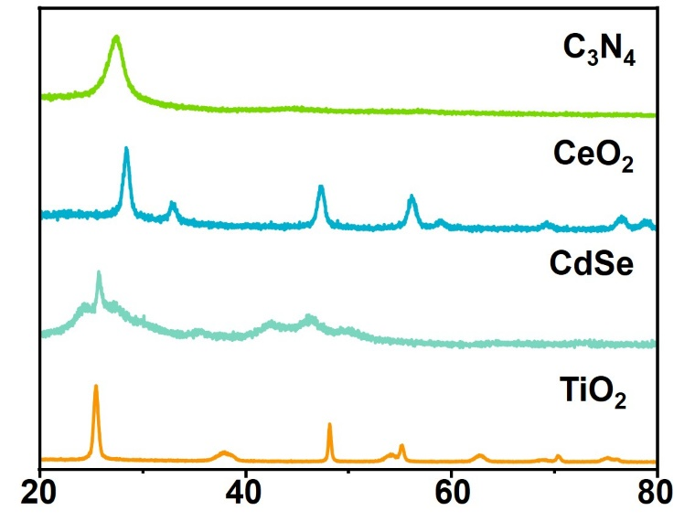
Supplementary Fig. 1 ꟾ XRD patterns of representative photocatalysts used for activity screening.

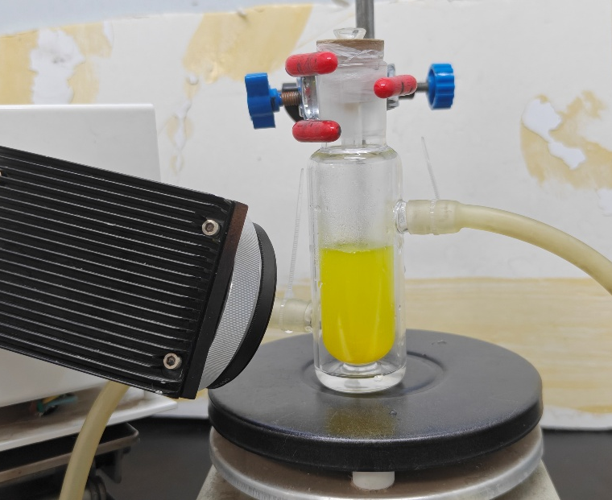
Supplementary Fig. 2 ꟾ Digital image of the photocatalytic reaction system.

Experiments of photocatalytic formamide synthesis were carried out using a 300 W xenon lamp, home built quartz reactor, and circulating cooling water system with the temperature stabilized at 20 °C.

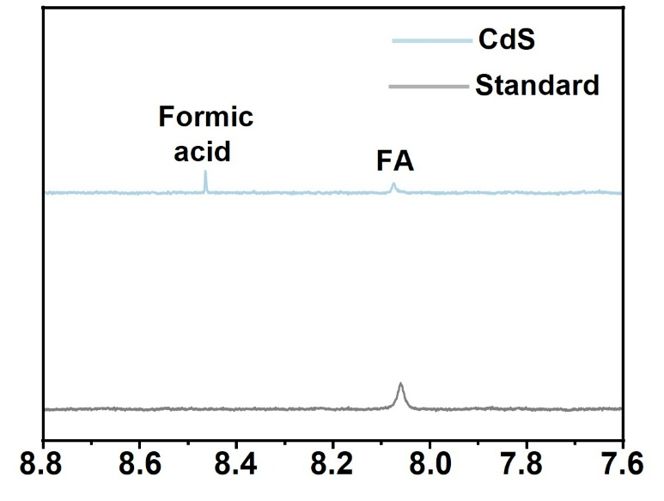
Supplementary Fig. 3 ꟾ ¹H NMR spectra of the standard formamide solution and the solution collected after 2 h of light irradiation over CdS.

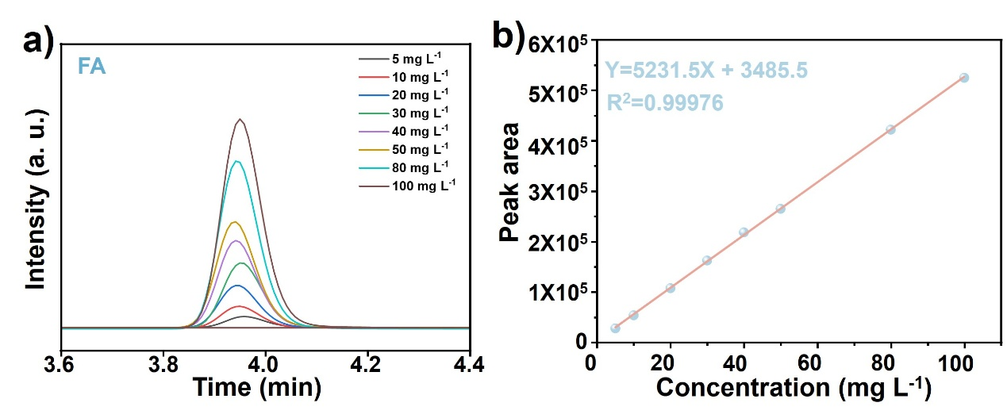
Supplementary Fig. 4 ꟾ HPLC chromatograms (a) and formamide calibration curve (b) over the concentration range of 5−100 mg L⁻¹.

Different amounts of formamide were dissolved in deionized water to configure a series of standard solutions. HPLC analysis revealed a good linear relationship between formamide concentration and corresponding peak area. On this basis, the calibration curve fitting equation can be adopted to calculate the production yield of formamide.

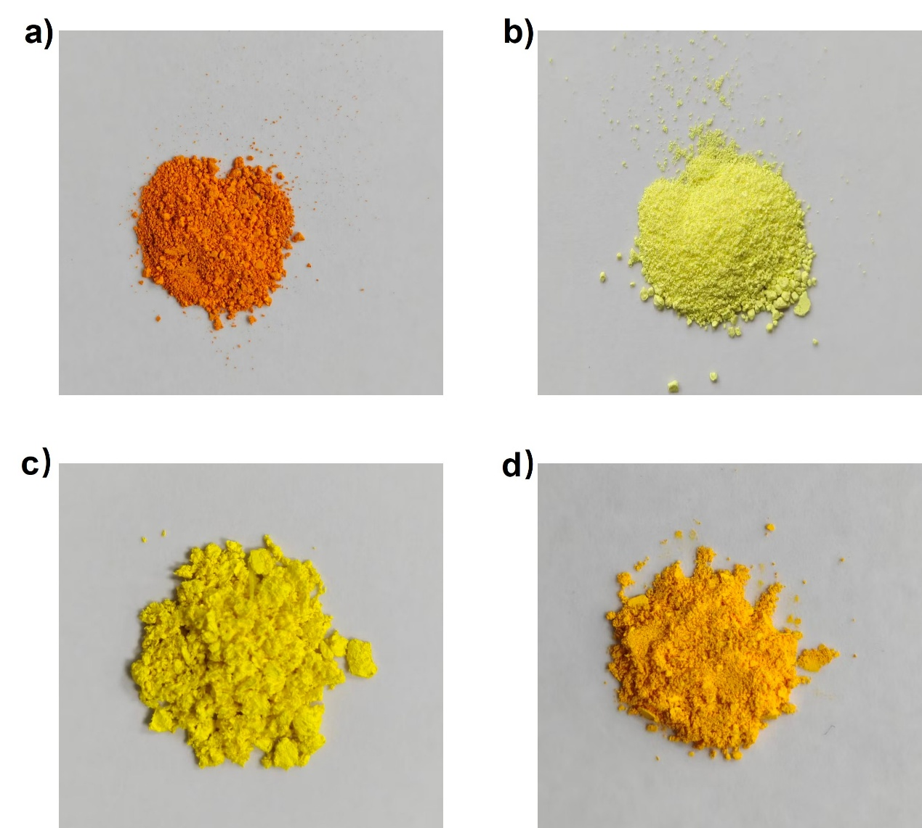

Supplementary Fig. 5 ꟾ Photographs of (a) CdS, (b) CdS−D, (c) CdS nanowires (NW) and (d) CdS nanorods (NR).

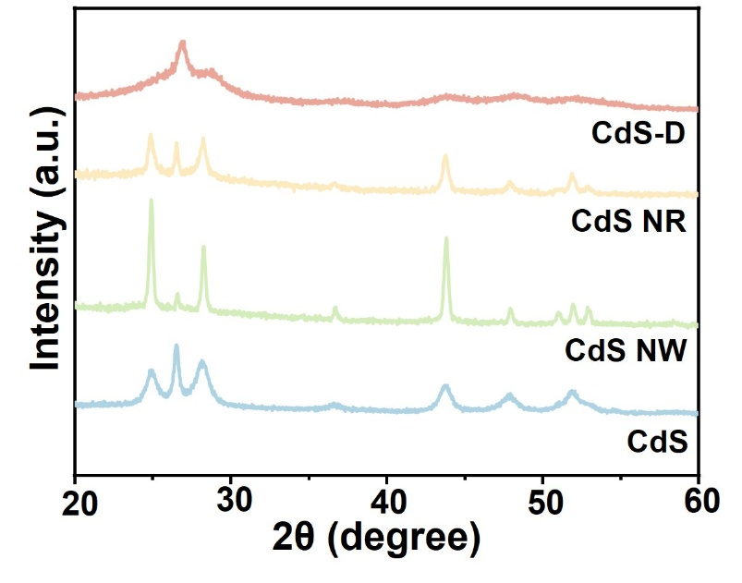
Supplementary Fig. 6 ꟾ XRD patterns of CdS solvent-ligand hybrid materials.

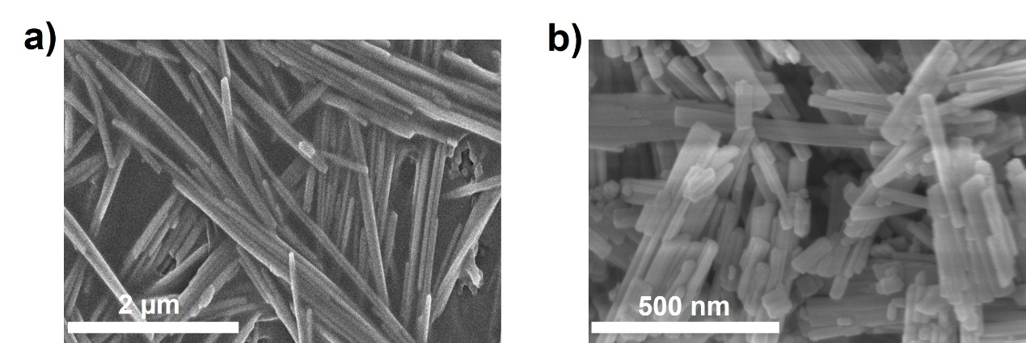

Supplementary Fig. 7 ꟾ SEM images of (a) CdS nanowires and (b) CdS nanorods.

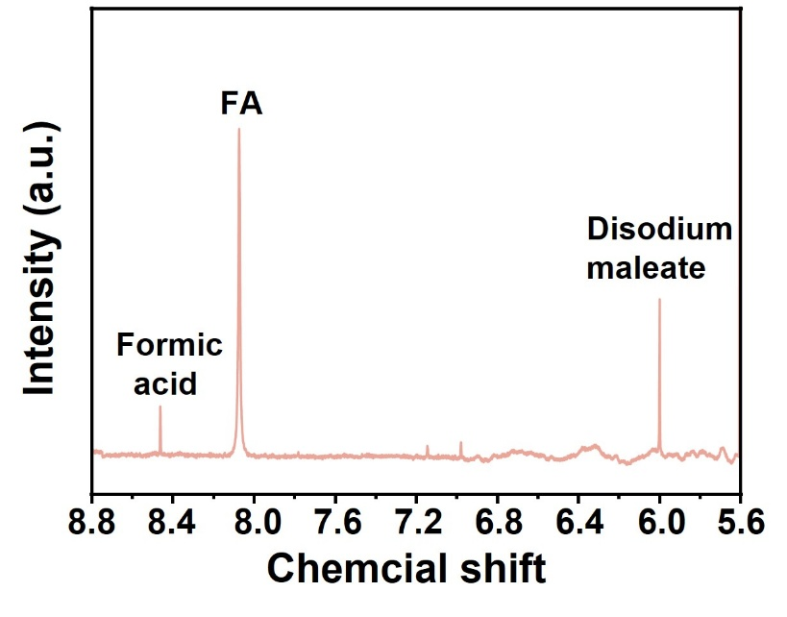
Supplementary Fig. 8 ꟾ ¹H NMR spectrum of the solution recovered after 2 h of light irradiation over CdS−D.

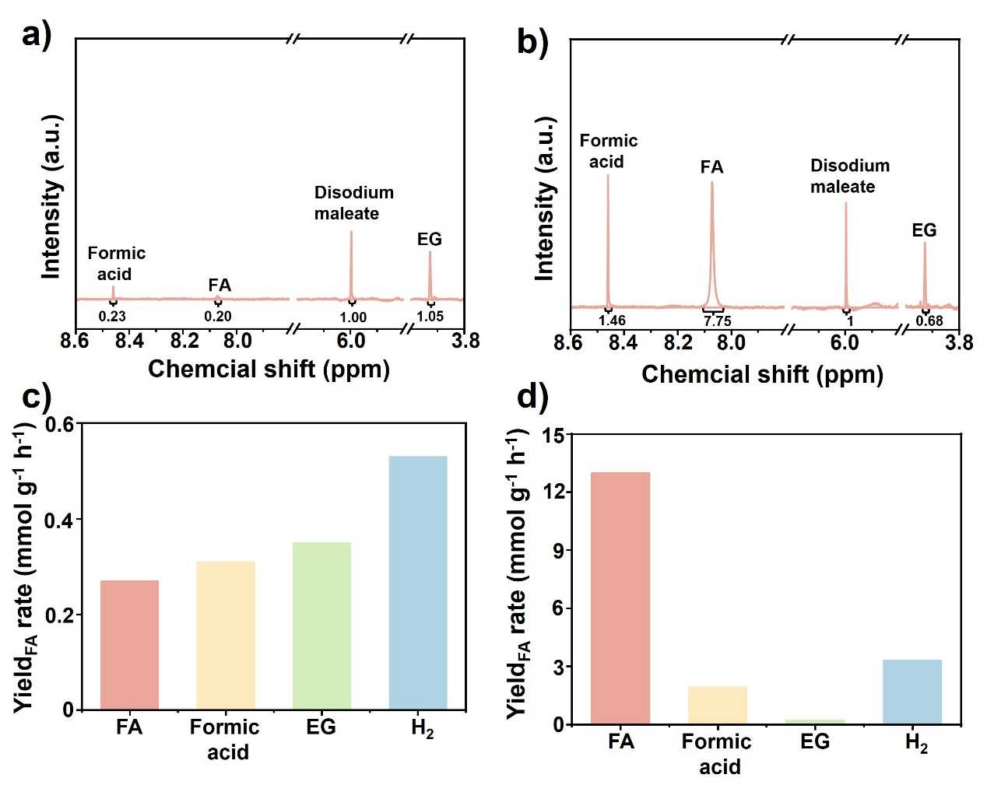
Supplementary Fig. 9 ꟾ ¹H NMR spectra and quantitative analysis of formamide and byproducts during photocatalytic methanol–ammonia conversion over CdS (a, c) and CdS−D (b, d).

Sodium maleate was employed as the internal standard for product quantitative analysis. The characteristic ¹H NMR peaks corresponding to formic acid, formamide and ethylene glycol were well resolved, and the content of each substance was calculated accordingly. The concentration of hydrogen in the system was quantified via gas chromatography.

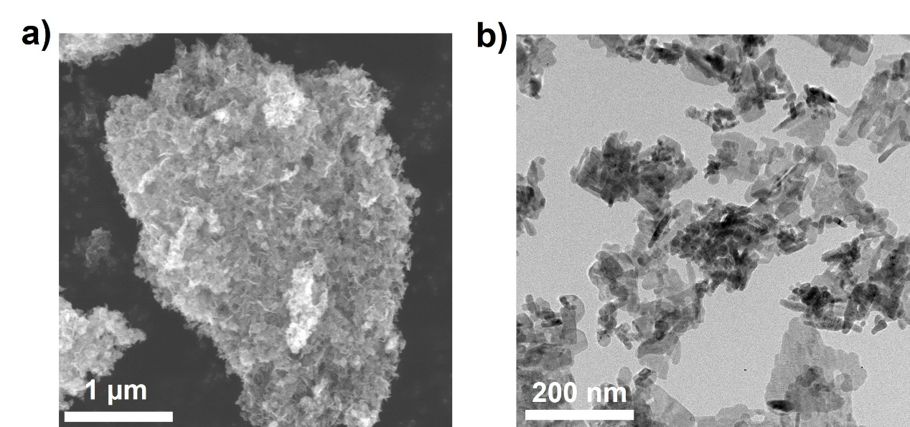

Supplementary Fig. 10 ꟾ SEM (a) and TEM (b) images of pristine CdS.

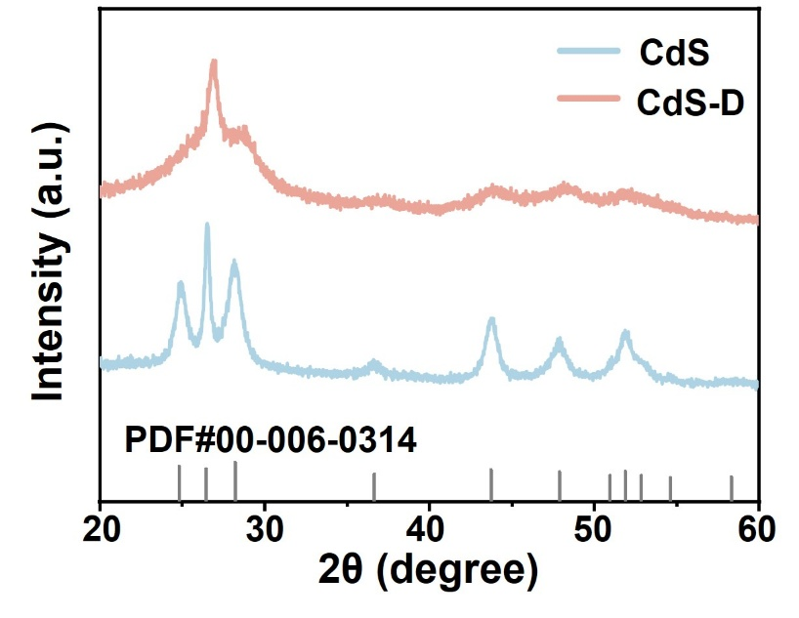
Supplementary Fig. 11 ꟾ XRD patterns of CdS and CdS−D.

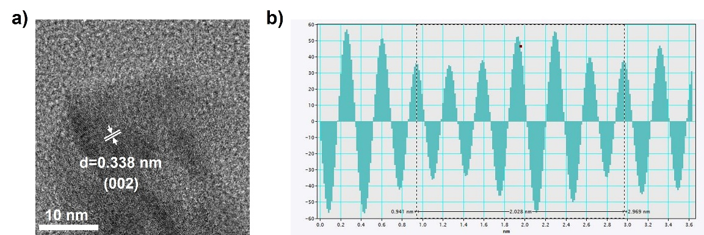
Supplementary Fig. 12 ꟾ High-resolution TEM image of CdS (a) and lattice-resolved intensity profile of the (002) planes (b).

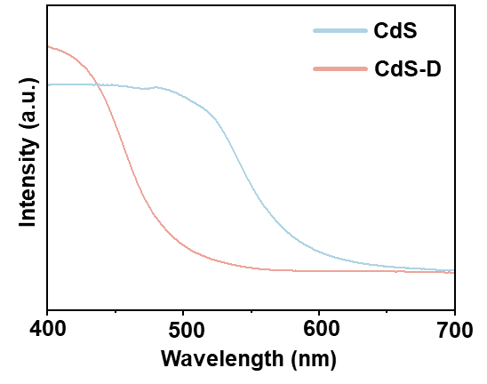
Supplementary Fig. 13 ꟾ UV–vis diffuse-reflectance spectra of CdS and CdS−D.

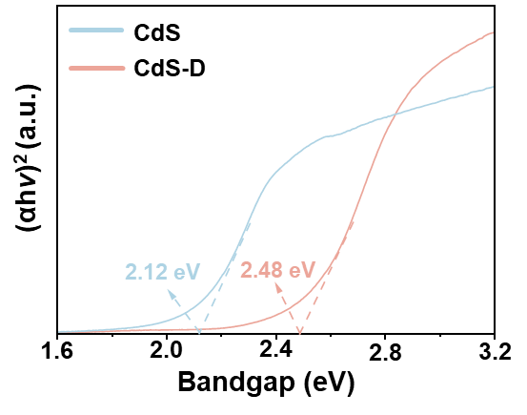
Supplementary Fig. 14 ꟾ Tauc plots derived from the Kubelka–Munk function for CdS and CdS−D.

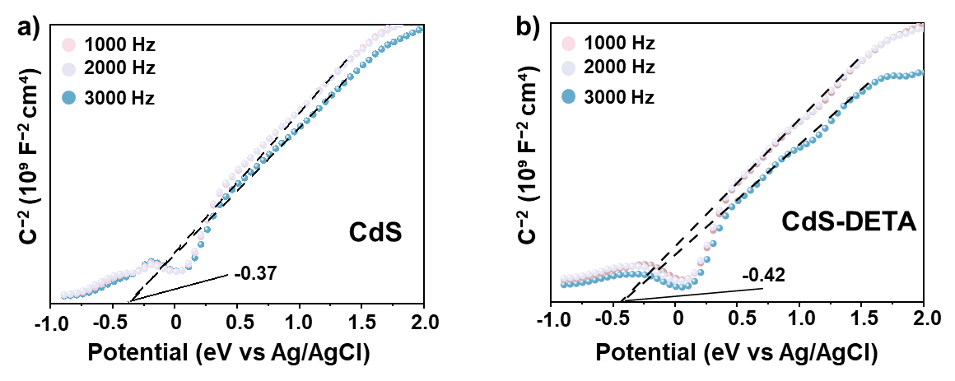
Supplementary Fig. 15 ꟾ Mott–Schottky plots of (a) CdS and (b) CdS−D.

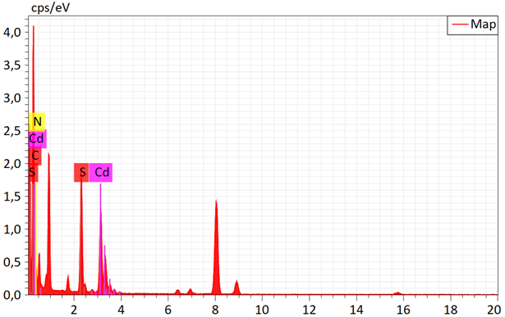
Supplementary Fig. 16 ꟾ EDS spectrum of CdS−D.

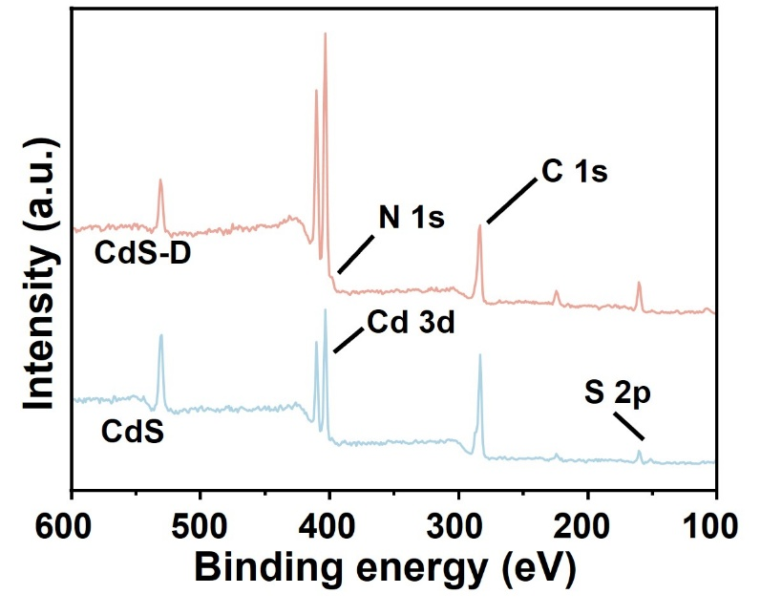
Supplementary Fig. 17 ꟾ XPS survey spectra of CdS−D and CdS.

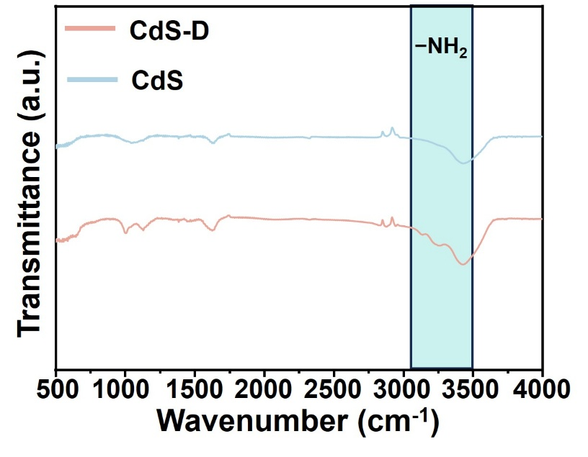
Supplementary Fig. 18 ꟾ FTIR spectra of CdS−D and CdS.
As shown in Figure S18, no characteristic absorption peaks of amino groups were observed for the CdS sample at 3162 cm⁻¹ and 3302 cm⁻¹, indicating that no amino groups existed on its surface after hydrothermal treatment.

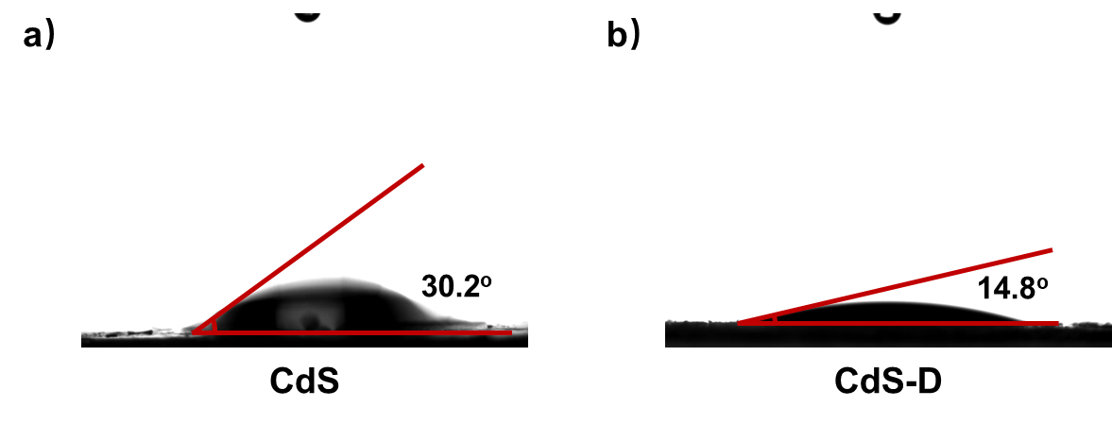
Supplementary Fig. 19 ꟾ Water contact angle photographs of (a) CdS and (b) CdS-D.

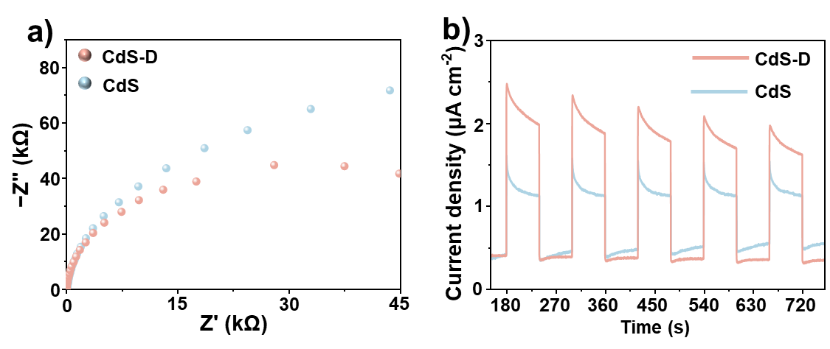
Supplementary Fig. 20 ꟾ EIS Nyquist plots (a) and transient photocurrent responses (b) of CdS and CdS−D.

In EIS spectra and transient photocurrent response spectra, a smaller semicircle diameter and higher photocurrent density of CdS−D than those of CdS can be observed, respectively. These data demonstrate that amino modification facilitates the separation and migration of photogenerated electron-hole pairs in CdS.

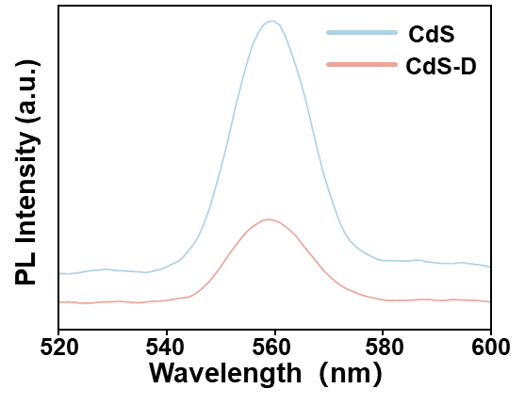
Supplementary Fig. 21 ꟾ Steady-state photoluminescence spectra of CdS and CdS−D.

As shown in Figure S18, the significant quenching of PL in the steady state spectra of CdS-D highlighted the enhanced carrier separation efficiency.

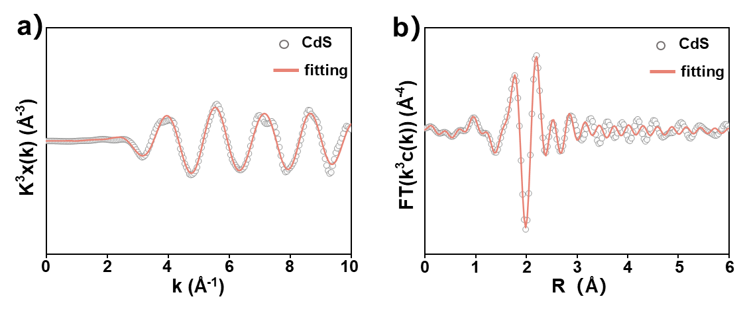

Supplementary Fig. 22 ꟾ Cd K-edge EXAFS analysis of CdS: k³-weighted EXAFS oscillations in k space (a) and Fourier-transformed EXAFS spectrum in R space (b).

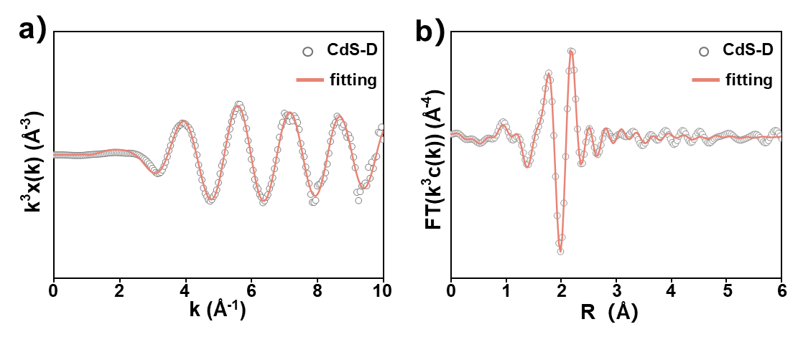
Supplementary Fig. 23 ꟾ Cd K-edge EXAFS analysis of CdS-D: k³-weighted EXAFS oscillations in k space (a) and Fourier-transformed EXAFS spectrum in R space (b).

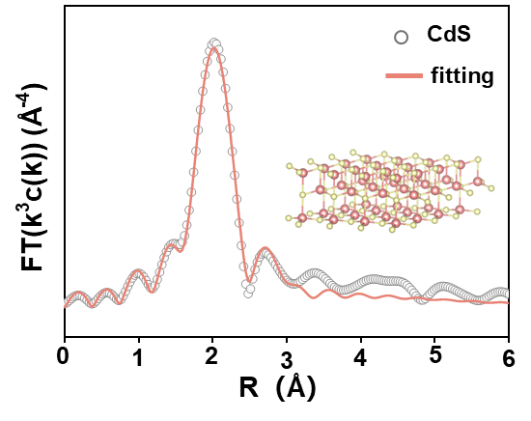
Supplementary Fig. 24 ꟾ Cd L₃-edge EXAFS spectrum (points) and curve fit (line) in R space for CdS.

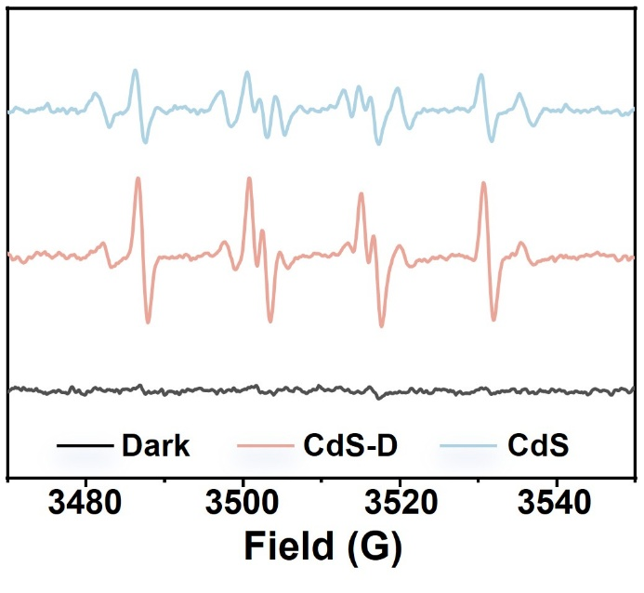
Supplementary Fig. 25 ꟾ Spin-trapping EPR spectra of CdS−D and CdS in the CH₃OH + NH₃ + H₂O system before and after illumination.

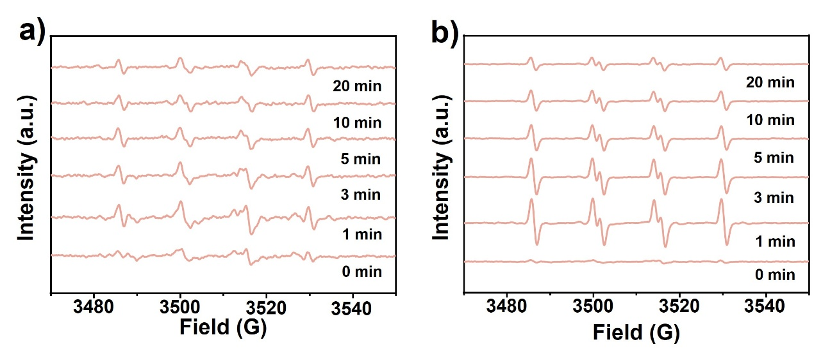
Supplementary Fig. 26 ꟾ Time-dependent EPR spectra of radicals over pristine CdS (a) and CdS−D (b) in methanol solution.

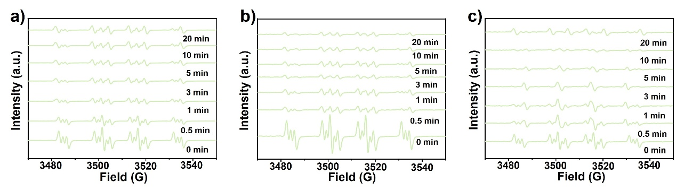
Supplementary Fig. 27 ꟾ Time-dependent EPR spectra of radicals for aqueous ammonia (a), CdS (b) and CdS−D (c) in ammonia solution.

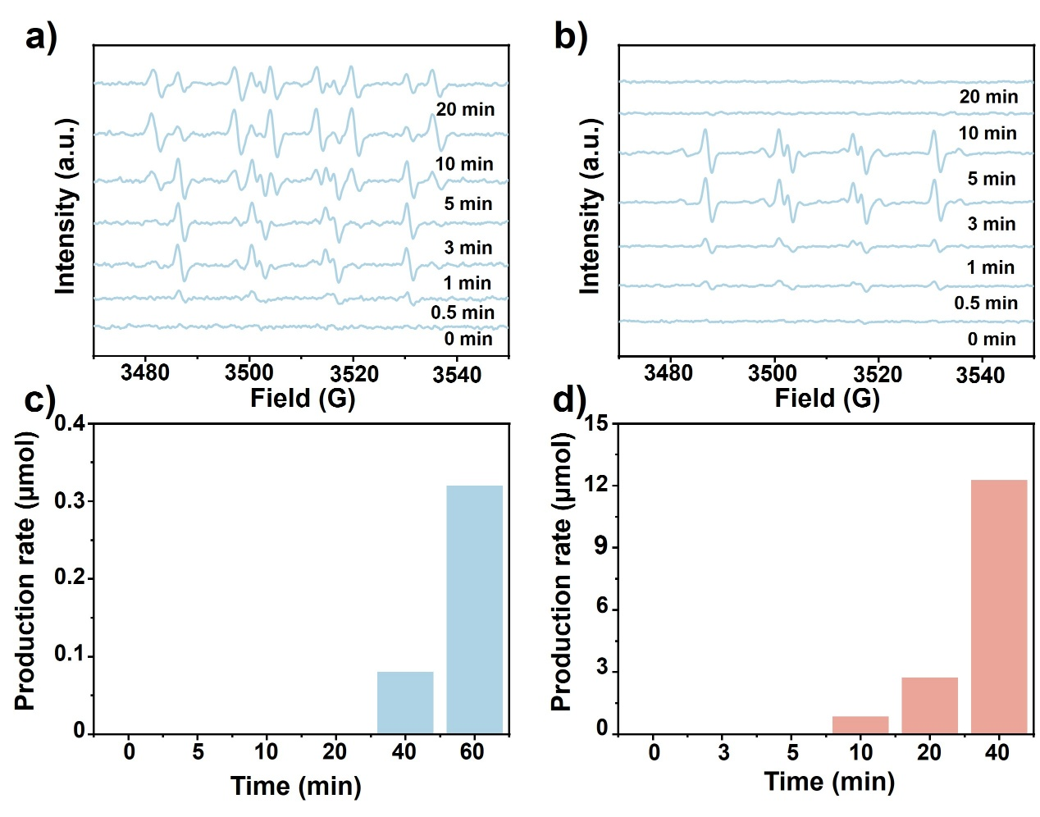
Supplementary Fig. 28 ꟾ Time-dependent radical evolution and formamide production over CdS and CdS−D. Time-dependent EPR spectra of radicals over a), CdS and b), CdS−D in the CH₃OH−NH₃−H₂O mixed reaction system, together with the corresponding time-dependent formamide production over c), CdS and d), CdS−D.

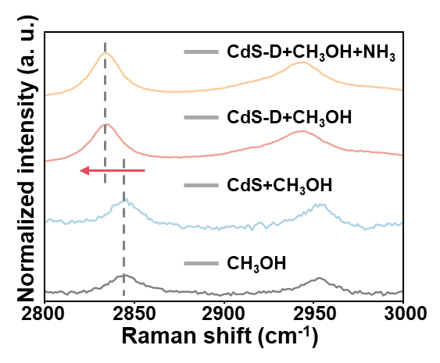

Supplementary Fig. 29 ꟾ Raman spectra of methanol under the indicated conditions.

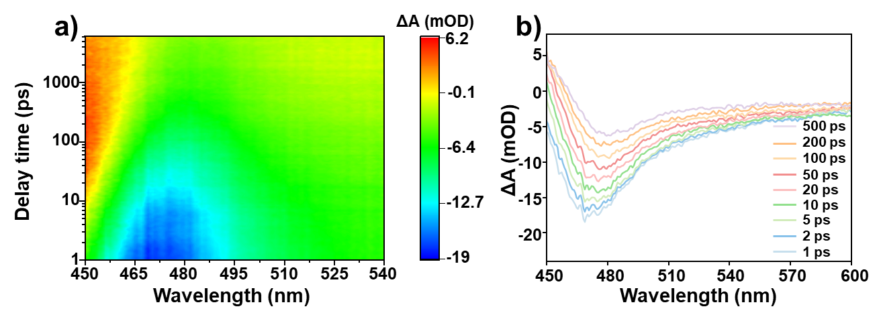
Supplementary Fig. 30 ꟾ (a) TAS data map pumped at 475 nm of CdS-D in H₂O-CH₃OH solution. (b) TAS of CdS-D as a function of time delay between 1 and 500 ps in H₂O-CH₃OH solution.

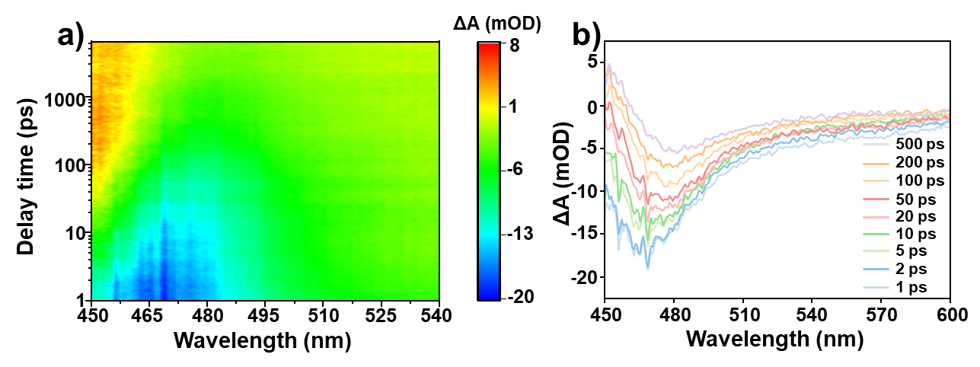
Supplementary Fig. 31 ꟾ (a) TAS data map pumped at 475 nm of CdS-D in H₂O-CH₃OH-NH₃ solution. (b) TAS of CdS-D as a function of time delay between 1 and 500 ps in H₂O-CH₃OH-NH₃ solution.

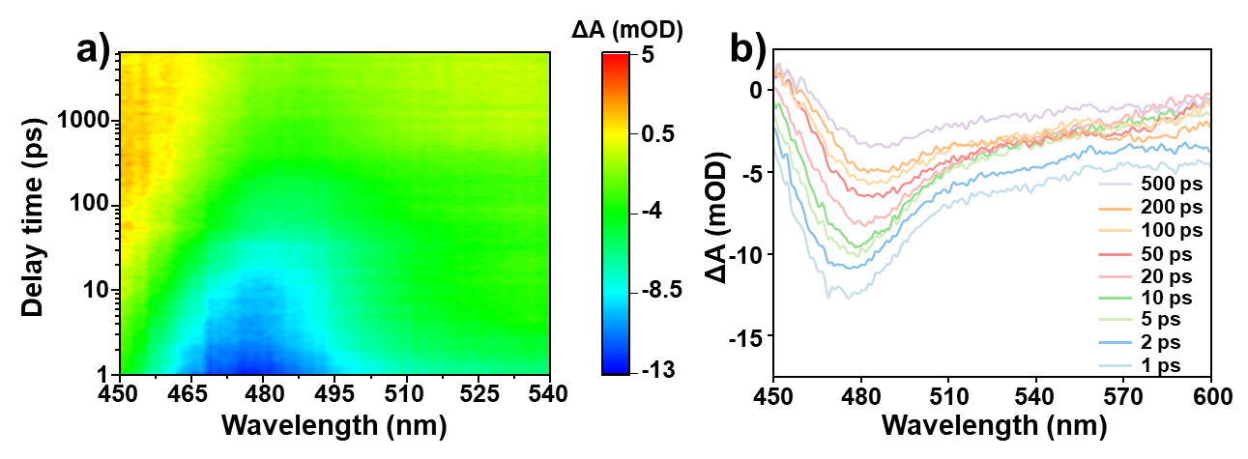
Supplementary Fig. 32 ꟾ (a) TAS data map pumped at 475 nm of CdS-D in H₂O-NH₃ solution. (b) TAS of CdS-D as a function of time delay between 1 and 500 ps in H₂O-NH₃ solution.

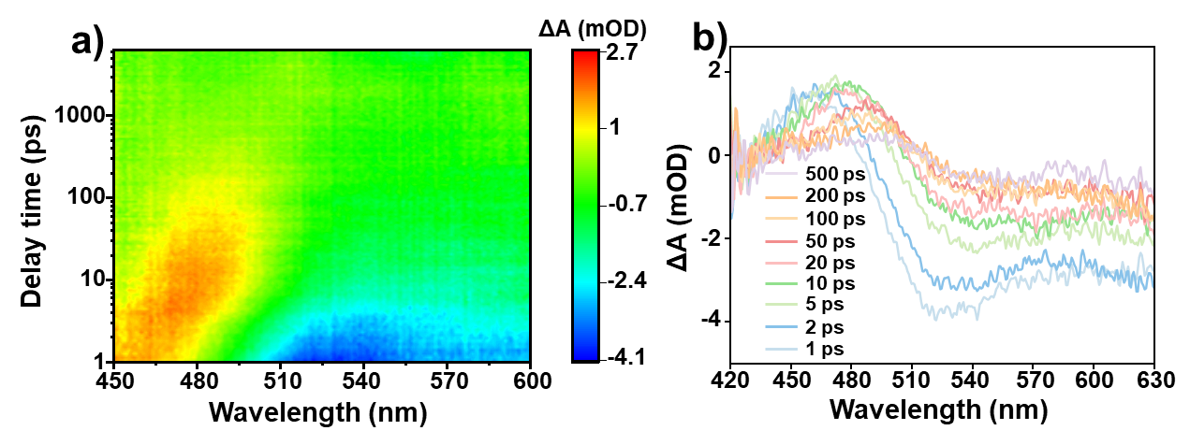
Supplementary Fig. 33 ꟾ (a) TAS data map pumped at 530 nm of CdS in H₂O-CH₃OH solution. (b) TAS of CdS as a function of time delay between 1 and 500 ps in H₂O-CH₃OH solution.

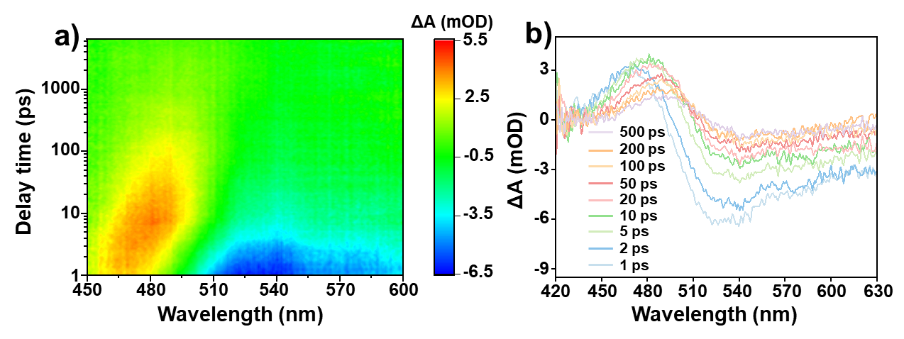
Supplementary Fig. 34 ꟾ (a) TAS data map pumped at 530 nm of CdS in H₂O-CH₃OH-NH₃ solution. (b) TAS of CdS as a function of time delay between 1 and 500 ps in H₂O-CH₃OH-NH₃ solution.

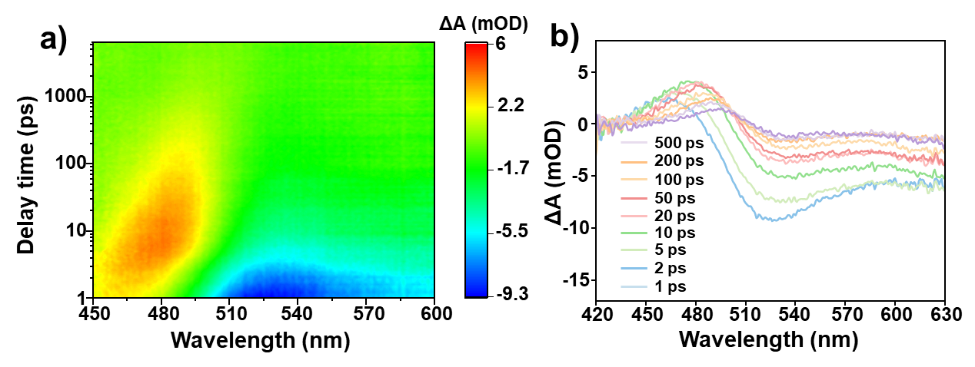
Supplementary Fig. 35 ꟾ (a) TAS data map pumped at 530 nm of CdS in H₂O-NH₃ solution. (b) TAS of CdS as a function of time delay between 1 and 500 ps in H₂O-NH₃ solution.

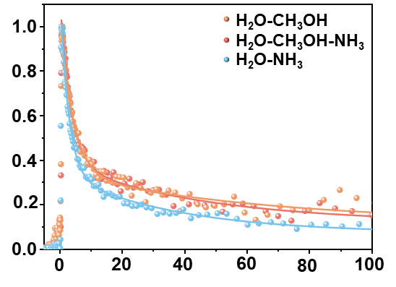
Supplementary Fig. 36 ꟾ Comparison under illumination over CdS−D in H₂O, CH₃OH + H₂O, NH₃ + H₂O, and CH₃OH + NH₃ + H₂O.

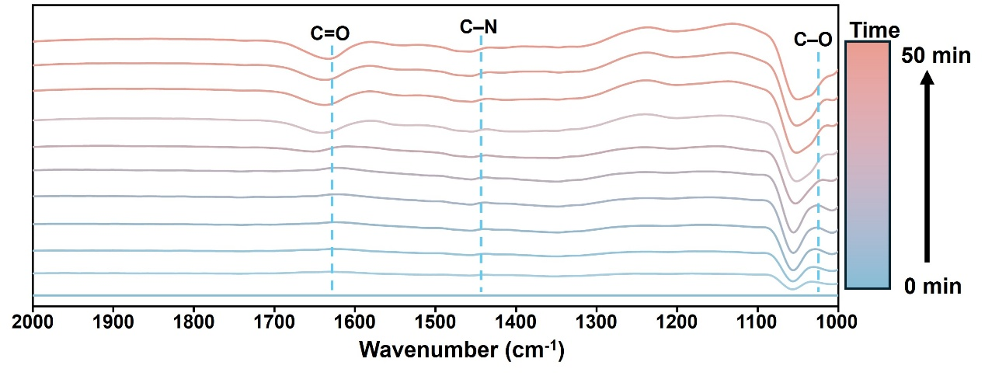
Supplementary Fig. 37 ꟾ In situ ATR-FTIR spectra recorded during the co reaction of methanol and ammonia over CdS catalyst.

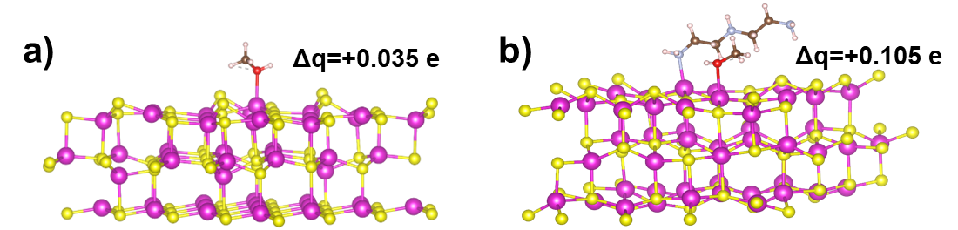

Supplementary Fig. 38 ꟾ Bader effective charges of the CH₃OH molecules on the CdS and CdS-D surface, respectively.

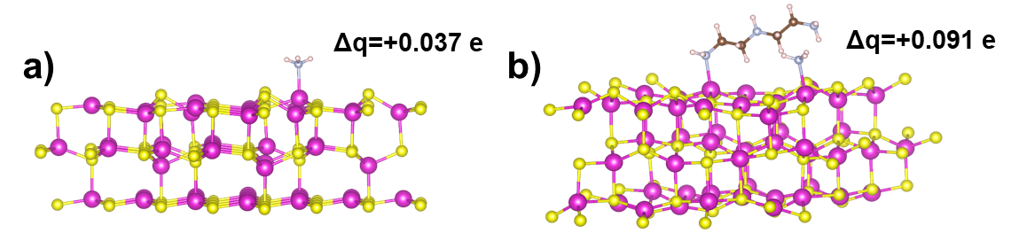

Supplementary Fig. 39 ꟾ Bader effective charges of the NH₃ molecules on the CdS and CdS-D surface, respectively.

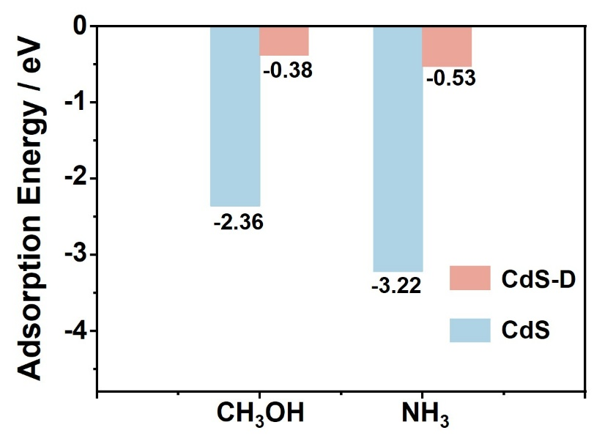
Supplementary Fig. 40 ꟾ Adsorption energy of NH₃ and CH₃OH on the CdS and CdS-D surface, respectively.

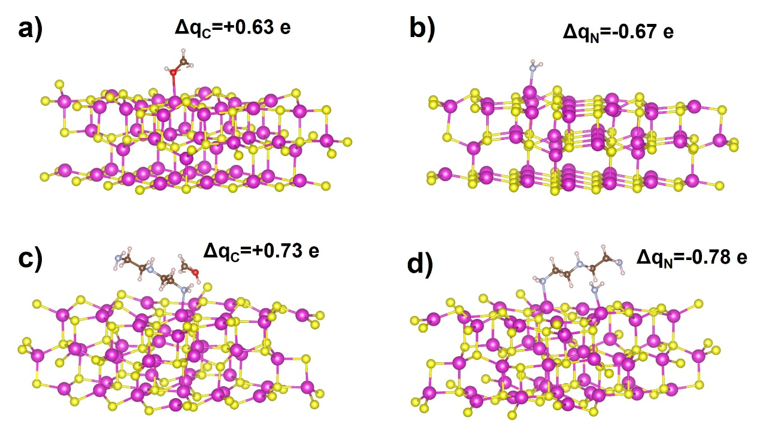
Supplementary Fig. 41 ꟾ Bader effective charges of the *CH₂OH and *NH₂ intermediates on CdS (a, b) and CdS-D (c, d) surfaces.

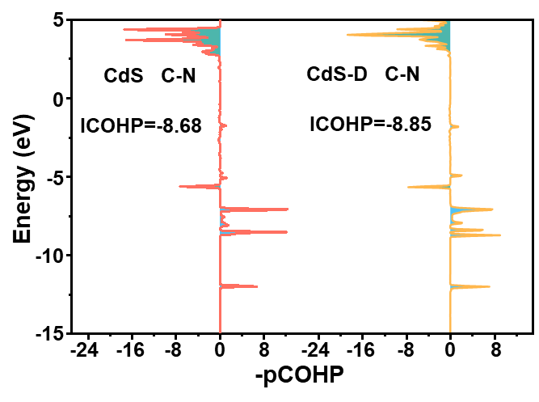
Supplementary Fig. 42 ꟾ −ICOHP values of C─N bonds on CdS and CdS−D, respectively.

The higher absolute values of -ICOHP indicate stronger bond formation.

Supplementary Tables
Supplementary Table 1 ꟾ Cd L₃-edge EXAFS fitting parameters for CdS−D and CdS.

Samples | S₀² | Path | CN | R (Å) | σ² (10⁻³ Å²) | ΔE₀ (eV) | R factor
CdS−D | 0.85 | Cd─N  Cd─S | 1.8  3.1 | 2.23±0.01  2.51±0.01 | 9.3±2.1  3.4±0.3 | 1.53±0.28 | 0.0030
CdS | 0.85 | Cd─S | 2.7 | 2.53±0.01 | 4.4±0.8 | 4.89±0.95 | 0.0041

Supplementary Table 2 ꟾ Carbon and Nitrogen source control experiments.

C Source | N Source | Formamide | Byproducts
HCHO | NH₃·H₂O | YES | Many
HCOONa | NH₃·H₂O | NO | ∕
CH₃OH | NH₃·H₂O | YES | Little
CH₃OH | (NH₄)₂CO₃ | NO | ∕
CH₃OH  CH₃OH | (NH₄)₂SO₄  NaNO₃ | NO  NO | ∕  ∕

Supplementary Table 3 ꟾ Positron lifetime parameters in transient absorption decay curves of CdS−D for different solutions (475nm) by the triple-exponential fitted model.

Sample | A₁ | τ₁ (ps) | A₂ | τ₂ (ps) | τ_{ave.} (ps)
CH₃OH | 0.75 | 4.11 | 0.22 | 65.29 | 54.62
CH₃OH+NH₃ | 0.78 | 3.37 | 0.27 | 44.90 | 37.57
NH₃ | 0.88 | 2.66 | 0.27 | 36.37 | 29.93

The average relaxation lifetime of excited-state electrons was determined by weighting the individual decay components with their respective pre-exponential factors, according to the following relation:
$τ_{ave.}=\frac{∑A_{i}τ_{i}^{2}}{∑A_{i}τ_{i}}$​​
Here, τ_{i​} and A_{i​} (i=1,2) denote the time constant and amplitude of the i-th decay component, respectively.

Supplementary Table 4 ꟾ Assignments of the IR bands observed during the photocatalytic formamide synthesis process on CdS−D.

Wavenumber / cm⁻¹ | Mode of Vibration | Assignment
1640  1436 | v_{as} (C=O)  v_{as} (C─H) | HCONH₂  HCONH₂
1388 | σ (O─H) | ●CH₂OH
1280 | ω (N─H) | NH₂
1102 | v (NC─O) | HOH₂C−NH₂

