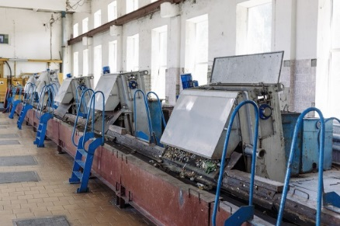
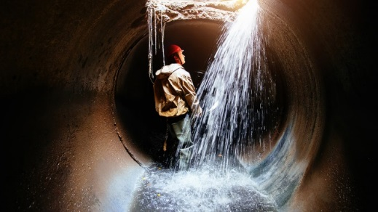
Graphical abstract
WORKPLACES OF WASTEWATER TREATMENT PLANTS (WWTPs)
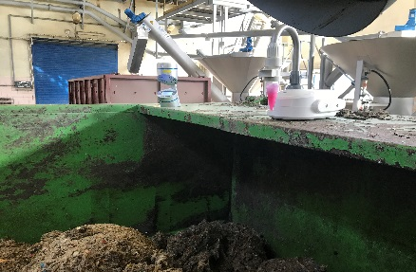
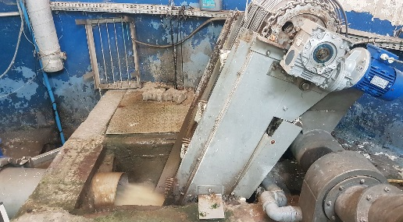

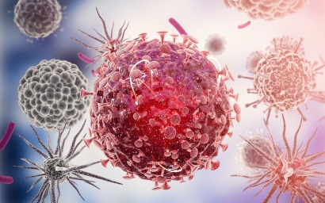
AIR/SURFACE/WASTEWATER MICROBIAL CONTAMINANTS

VIRUSES
(differentiation of intact and disintegrated virions
with v-qPCR/v-RT-qPCR)

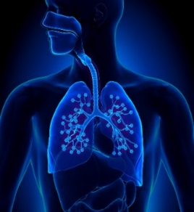
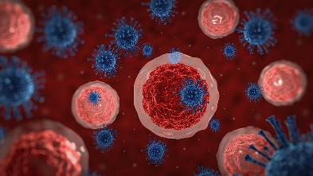

OCCUPATIONAL EXPOSURE OF WWTP WORKERS

