♀ | ♂ | F₁ | ♀ | ♂ | F₁
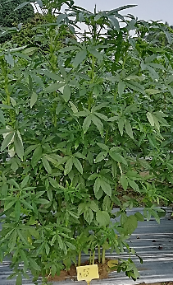 | 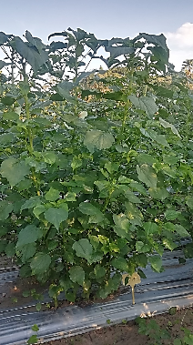 | 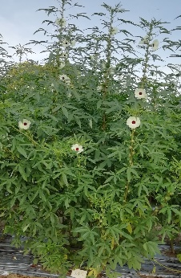 | 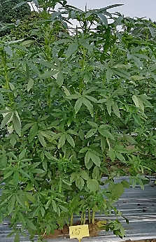 | 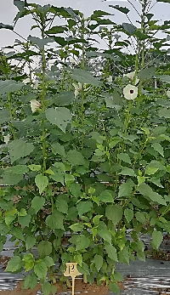 | 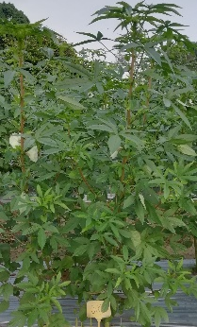
P₁ | P₂ | P₁ x P₂ | P₁ | P₃ | P₁ x P₃
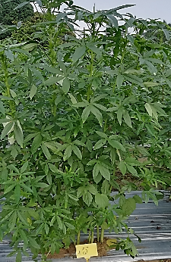 | 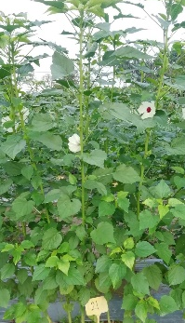 | 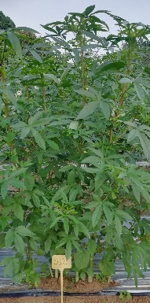 |  | 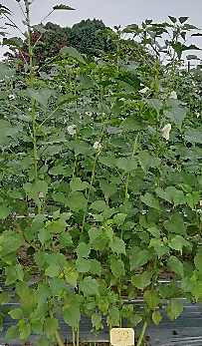 | 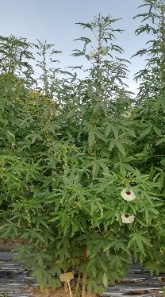
P₁ | P₄ | P₁ x P₄ | P₁ | P₅ | P₁ x P₅
 | 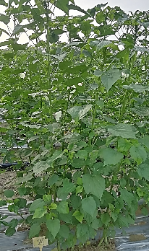 | 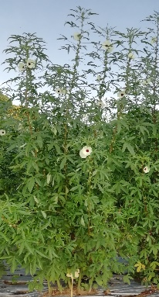 |  | 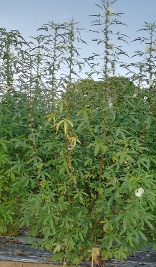 | 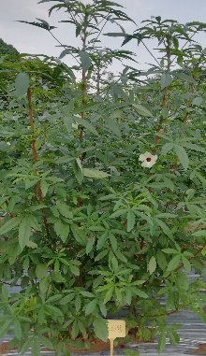
P₁ | P₆ | P₁ x P₆ | P₁ | P₇ | P₁ x P₇

Supplementary figure 1. Comparison of photographs showing stem pigmentation and leaf shape of parents and F₁ population

♀ | ♂ | F₁ | ♀ | ♂ | F₁
 | 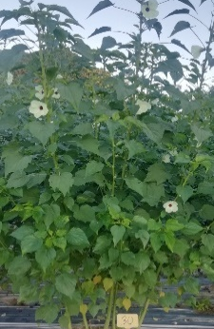 | 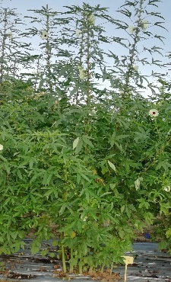 |  | 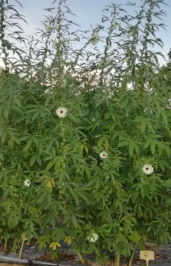 | 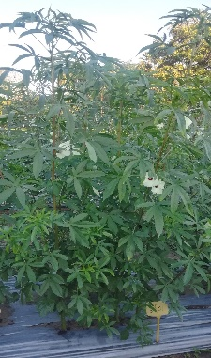
P₁ | P₈ | P₁ x P₈ | P₁ | P₉ | P₁ x P₉
 |  | 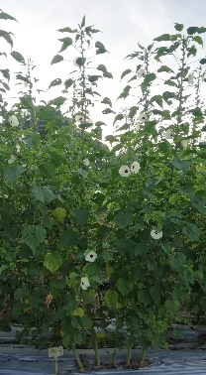 |  |  | 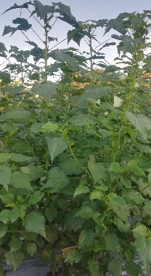
P₂ | P₃ | P₂ x P₃ | P₂ | P₄ | P₂ x P₄
 |  | 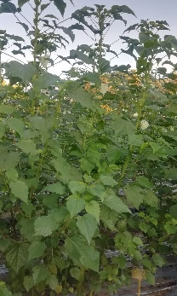 |  |  | 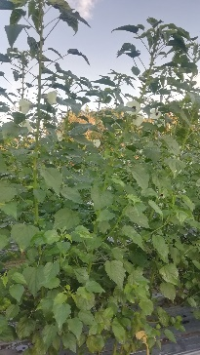
P₂ | P₅ | P₂ x P₅ | P₂ | P₆ | P₂ x P₆

Cont’d. (Supplementary figure 1)

♀ | ♂ | F₁ | ♀ | ♂ | F₁
 |  | 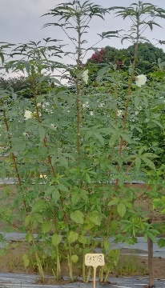 |  |  | 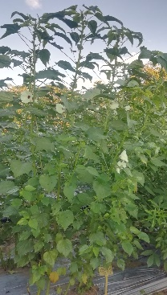
P₂ | P₇ | P₂ x P₇ | P₂ | P₈ | P₂ x P₈
 |  | 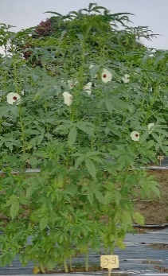 |  |  | 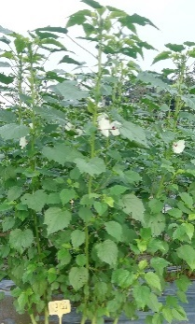
P₂ | P₉ | P₂ x P₉ | P₃ | P₄ | P₃ x P₄
 |  | 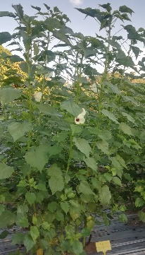 |  |  | 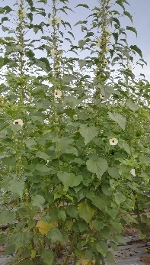
P₃ | P₅ | P₃ x P₅ | P₃ | P₆ | P₃ x P₆

Cont’d. (Supplementary figure 1)

♀ | ♂ | F₁ | ♀ | ♂ | F₁
 |  | 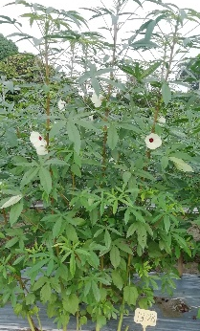 |  |  | 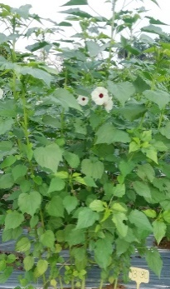
P₃ | P₇ | P₃ x P₇ | P₃ | P₈ | P₃ x P₈
 |  | 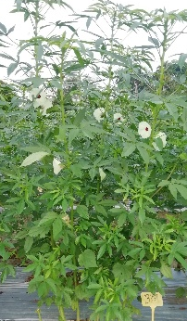 |  |  | 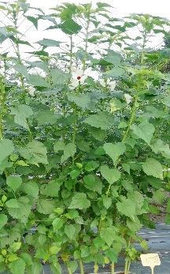
P₃ | P₉ | P₃ x P₉ | P₄ | P₅ | P₄ x P₅
 |  | 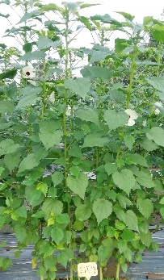 |  |  | 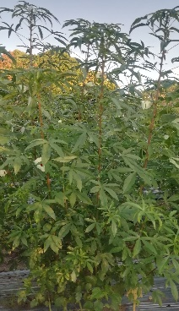
P₄ | P₆ | P₄ x P₆ | P₄ | P₇ | P₄ x P₇

Cont’d. (Supplementary figure 1)

♀ | ♂ | F₁ | ♀ | ♂ | F₁
 |  | 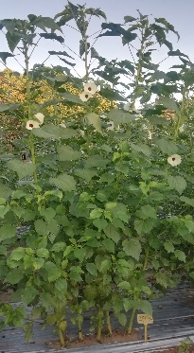 |  |  | 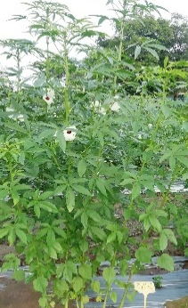
P₄ | P₈ | P₄ x P₈ | P₄ | P₉ | P₄ x P₉
 |  | 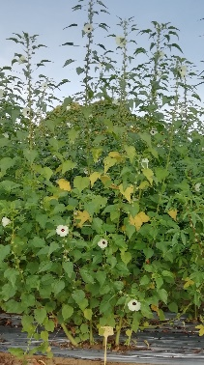 |  |  | 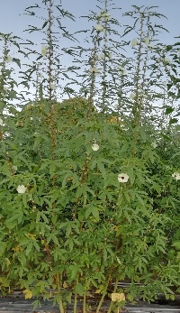
P₅ | P₆ | P₅ x P₆ | P₅ | P₇ | P₅ x P₇
 |  | 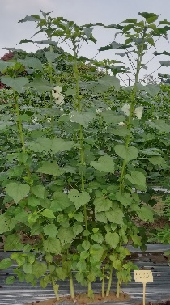 |  |  | 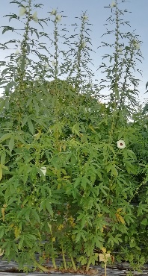
P₅ | P₈ | P₅ x P₈ | P₅ | P₉ | P₅ x P₉

Cont’d. (Supplementary figure 1)

♀ | ♂ | F₁ | ♀ | ♂ | F₁
 |  | 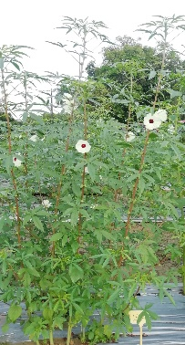 |  |  | 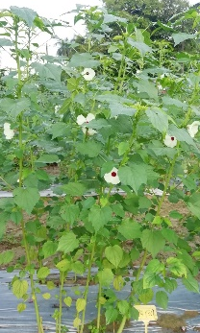
P₆ | P₇ | P₆ x P₇ | P₆ | P₈ | P₆ x P₈
 |  | 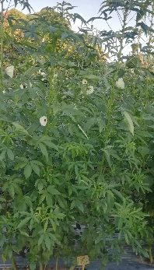 |  |  | 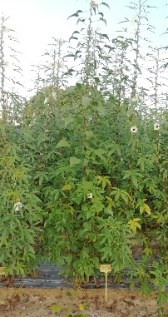
P₆ | P₉ | P₆ x P₉ | P₇ | P₈ | P₇ x P₈
 |  | 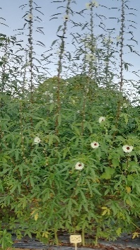 |  |  | 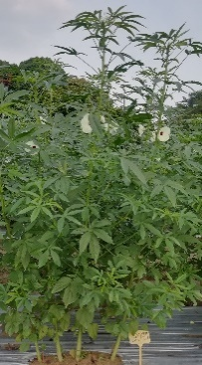
P₇ | P₉ | P₇ x P₉ | P₈ | P₉ | P₈ x P₉

Cont’d. (Supplementary figure 1)

