Overcoming Material Trade-Offs in MEMS Transducers via Lateral Ferroelectric–Piezoelectric Thin-Film Integration

Supplementary Information

Linet Thomas C¹, Praveen Kumar¹, and Gayathri Pillai¹
¹Centre for Nano Science and Engineering, Indian Institute of Science, Bangalore, India, 560012

S1. Measurement Set-up for Mechanical Frequency Response

The mechanical frequency response of the LSR was experimentally characterized using a Laser Doppler Vibrometer (LDV). Figure S1 shows a schematic of the experimental setup of LDV. To evaluate the role of the piezoelectric coefficient on actuation in terms of displacement, the LSR was independently excited through the AlN and PZT regions. Each material was individually activated using AC excitation, enabling a direct comparison of the displacement responses of the ferroelectric (PZT) and piezoelectric (AlN) layers. For displacement measurements, the device was mounted on a vibration isolated stage and electrically excited using an inbuilt controller through probe tips contacting the corresponding electrodes. A sinusoidal AC excitation was applied to the selected AlN or PZT region. A laser beam from LDV was precisely focused and aligned onto the active region of the diaphragm. The resulting out of plane displacement was recorded as a function of excitation frequency, enabling a quantitative comparison of the response magnitudes of the ferroelectric (PZT) and piezoelectric (AlN) actuation.

LDV enables completely non-contact measurement of vibration and displacement, which is essential for MEMS devices where physical probes can significantly alter the mechanical response due to added mass or damping. With nano meter to picometer displacement sensitivity and the ability to capture vibrations from a few hertz to several megahertz, LDV is well suited for characterizing MEMS resonators and ultrasonic transducers. Furthermore, LDV allows direct measurement of resonance frequency, vibration amplitude, phase, mode shapes, and quality factor without relying on indirect electrical transduction models.

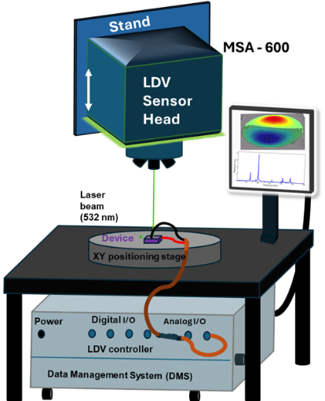

Figure S1: Experimental set up of LDV.

In PMUT, actuation is primarily governed by the transverse piezoelectric coefficient d₃₁. The d₃₁ coefficient of the piezoelectric material represents the electric field applied in the thickness direction and the mechanical strain in the in-plane direction. When an AC voltage is applied across the thickness of the piezoelectric layer (PZT or AlN), an electric field $E_{3}$is generated along the thickness direction. $E_{3}=\frac{V}{t_{p}}$ where $t_{p}$is the piezoelectric film thickness. Due to the d₃₁ coefficient, the thickness-direction electric field produces an in-plane strain in the lateral directions. The film contracts or expands in the plane depending on the polarity of the voltage. The piezoelectric layer is mechanically coupled to a passive elastic layer (e.g., Si, SiO₂, a metal stack, etc.). The bending of the diaphragm occurs when the in-plane stress is away from the neutral line of the whole stake of PMUT. This bending moment produces an out of plane displacement in response to the AC input signal, serving as the primary actuation mechanism of PMUT. An LDV measures the resulting out of plane velocity or displacement at the diaphragm surface: LDV does not directly measure $d_{31}$. It measures displacement resulting from $d_{31}$ induced bending. Larger $d_{31} gives$larger displacement for the same voltage.
S2. Mechanical frequency response of the LSR obtained using LDV

Figure S2 presents the mechanical frequency response of the LSR obtained using LDV. To obtain the actual out-of-plane displacement, measurements were performed using a frequency sweep excitation rather than a periodic chirp, which is typically used to estimate frequency and mode shapes, as shown in Figure 4a of the main manuscript. The PZT and AlN layers were excited individually by applying an AC input signal to see the actual displacement of the second mode. Notably, a higher displacement amplitude was observed when the device was driven through the PZT layer, despite the PZT being unpoled.

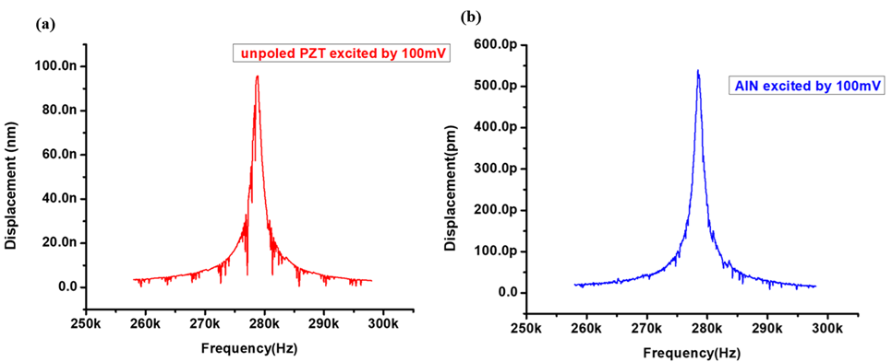
Figure S2: Mechanical frequency response of the second mode of LSR using LDV (a) Displacement profile of the device while exciting at the unpoled PZT side by 100 mV (b) Displacement profile of the device while exciting at the AlN side by 100mV

S3. Measurement Set-up for Electrical Measurements

A lock in amplifier measures the PMUT response at a defined reference (drive) frequency, enabling selective extraction of the signal of interest while effectively rejecting broadband electrical and environmental noise. By sweeping the excitation frequency and recording the lock in output, the electrical frequency response of the PMUT can be accurately obtained, allowing precise identification of resonance and anti-resonance frequencies. The electrical frequency response of the LSR was experimentally characterized using a Zurich MFLI lock in amplifier with the device probed via a probe station. For subsequent investigation of DC bias effects, a power supply and a bias tee were incorporated into the measurement setup. Figure S3 shows a schematic of the electrical experimental setup. Applying a DC electric field to ferroelectric materials induces field assisted alignment of ferroelectric domains along the field direction, thereby modifying the net polarization and influencing the electrical, mechanical, and electromechanical properties. The applied DC bias alters the elastic stiffness of the material, leading to shifts in resonance frequency. These DC bias induced effects are reversible and disappear once the bias is removed. A bias tee enables the simultaneous application of a DC bias and an AC excitation signal to a device under test by combining them onto a single port while electrically isolating the DC and AC paths. In PMUT and ferroelectric MEMS measurements, the bias tee allows a DC electric field to be applied across the piezoelectric layer to study bias dependent behaviour, while the AC signal excites the device for frequency response characterization. This configuration prevents DC components from entering sensitive measurement instruments, such as a lock in amplifier, and avoids loading or distorting the AC signal. Figure S3 illustrates the schematic of the experimental setup used for electrical frequency response measurements, which incorporates a lock in amplifier, a probe station, a DC power supply, and a bias tee for DC bias.

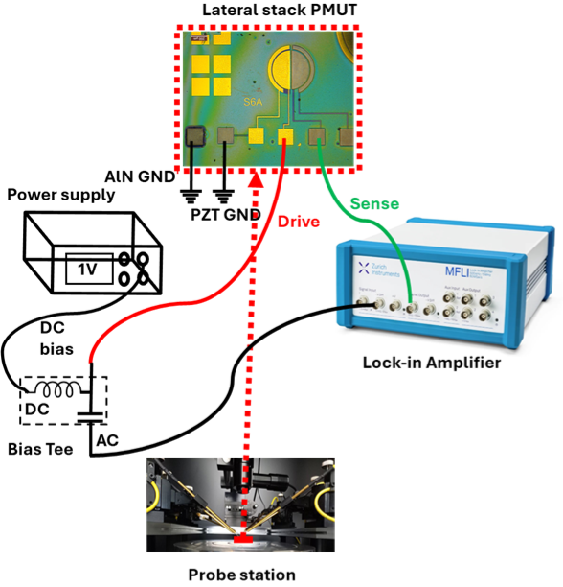

Figure S3: Experimental set-up for electrical frequency response.

S4. Field-dependent behaviour of the ferroelectric material

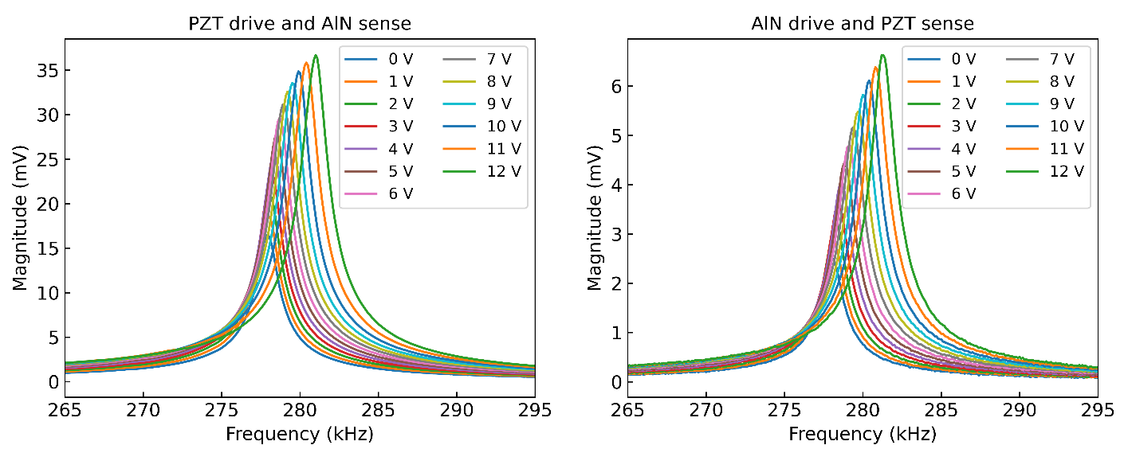

Figure S4: Magnitude and frequency tuning of the LSR due to the application of dc bias to the ferroelectric material in PDAS and ADPS configurations, respectively.

To examine the field-dependent piezoelectric behaviour of the ferroelectric layer, electrical frequency response measurements were performed under DC bias values ranging from 1 V to 12 V. Figure S4 shows the electrical frequency responses for the PZT drive/AlN sense and AlN drive/PZT sense configurations, respectively, with increasing DC bias voltage. For the AlN drive/PZT sense configuration, the response exhibits a maximum magnitude enhancement of 2.66× and a frequency shift of ∆f = 3.2 kHz at a 12 V bias relative to the unbiased case, whereas the reverse configuration shows a 2.27× magnitude increase with a frequency shift of ∆f = 2.9 kHz.

S5. Performance comparison of LSR with conventional standalone PMUTs at High frequency

To compare the LSR response with standalone PZT and AlN PMUTs, we extended the measurements to a wide range frequency sweep, up to 5 MHz, for the PZT drive/AlN sense configuration to examine how the feedthrough level evolves with frequency, given the ferroelectric nature of PZT. Figure S5(a) shows the wideband frequency sweep of the PZT drive/AlN sense configuration up to 5 MHz, which exhibits a consistently low feedthrough level. This behaviour is primarily attributed to sensing through the low permittivity AlN layer and to the inherent bottom electrode patterning resulting from the lateral deposition of the ferroelectric and piezoelectric films in the LSR architecture.

For further comparison, all four configurations were plotted up to 5 MHz to evaluate how their feedthrough levels vary over a broad frequency range, as shown in Figure S5(b). It is clearly observed that, except for the standalone PZT resonator, the other three configurations show minimal changes in feedthrough level, owing to the use of bottom electrode patterning, the intrinsically low permittivity of AlN, or a combination of both. In contrast, the standalone PZT resonator, even with bottom electrode patterning, exhibits a slightly elevated feedthrough level at higher frequencies due to the intrinsically high permittivity of the ferroelectric layer.

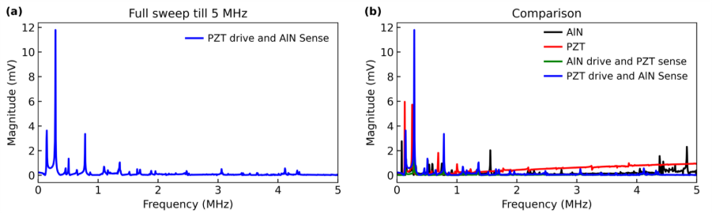
Figure S5: (a) Frequency sweep of the PZT drive/AlN sense configuration of the LSR up to 5 MHz. (b) Comparison of the PZT drive/AlN sense, AlN drive/PZT sense, standalone PZT resonator, and standalone AlN resonator configurations up to 5 MHz.

S6. PMUT Plate Theory

The PMUT consists of a piezoelectric layer sandwiched between two thin top and bottom electrodes. Typically, the PMUT consists of two thick layers in addition to electrode layers: the active layer (piezoelectric, PZT) and the passive layer (Si). The bottom face of the silicon layer is at z =0. The out of plane displacement of the plate is in the negative direction along the z-axis, which is denoted by w (r, t). Since the diameter of a circular PMUT is much larger than its thickness, the equivalent circuit (EQC) model can be settled based on classic plate theory.
For such a multi-layer structure, it has a neutral layer:
$$\begin{aligned}z_{m}=\frac{\sum_{i=1}^{n}{Y_{i}^{'}z_{i}h_{i}}}{\sum_{i=1}^{n}{Y_{i}^{'}}h_{i}}\#\left(1\right)\end{aligned}$$
$$\begin{aligned}Y_{i}^{'}=\frac{Y_{i}}{1-v_{i}^{2}}\#\left(2\right)\end{aligned}$$
where Y_{i}, v_{i}, h_{i}, and z_{i} are Young’s modulus, Poisson’s ratio, thickness, and the middle position of the i^{th} layer.
The vibration equation of the circular diaphragm is:
$$\begin{aligned}D∇^{2}∇^{2}w=q-ρ_{s}\frac{∂^{2}w}{∂t}\#\left(3\right)\end{aligned}$$
where q is the distributed force per unit area acting on the surface of the plate, and the mass density per unit area ρ_{s} is the density multiplied by the thickness. D is the plate flexural rigidity and can be presented as follows:
$$\begin{aligned}D= \sum_{I=1}^{n}{Y_{i}^{'}}\left[I_{i}+Z_{i}^{2}h_{i}\right]\#\left(4\right)\end{aligned}$$
The second moment of inertia and the distance from the neutral axis, z_{m,} to the center of the i^{th} layer are denoted as I_{i} and Z_{i}:
$$\begin{aligned}I_{i}=\frac{h_{i}^{3}}{12}\#\left(5\right)\end{aligned}$$
$$\begin{aligned}Z_{i}=z_{i}-z_{m}\#\left(6\right)\end{aligned}$$
In case of simple harmonic excitation, the displacement w (r, t) is given by:
$$\begin{aligned}w=W\left(r\right)e^{-jωt}\#\left(7\right)\end{aligned}$$
where ω is the angular frequency and W(r) is the shape function of the circular diaphragm when vibrating. Combining (4) and (7), the simplified equation of motion for the membrane vibration can be obtained:
$$\begin{aligned}∇^{2}∇^{2}W+β^{4}W=\frac{q}{D}\#\left(8\right)\end{aligned}$$
The general solution of (8) is as follows:
$$\begin{aligned}W\left(r\right)=-\frac{q}{ω^{2}ρ_{s}}+A_{i}×J_{0}\left(βr\right)+B_{i}×I_{0}\left(βr\right)+ \\ C_{i}×Y_{0}\left(βr\right)+D_{i}×K_{0}\left(βr\right),i∈N\#\left(9\right)\end{aligned}$$
where β is the function of frequency, flexural rigidity, and surface density, and in the following form:
$$\begin{aligned}β^{4}=\frac{ω^{2}ρ_{s}}{D}\#\left(10\right)\end{aligned}$$
and J₀(x), I₀(x), Y₀(x), and K₀(x) are the zero-order Bessel function of the first kind, the modified Bessel function of the first kind, the Bessel function of the second kind, and the modified Bessel function of the second kind, respectively. The coefficients $A_{i}$, $B_{i}$, $C_{i}$ and $D_{i}$ are constants which are determined by boundary conditions.
S7. Simulation
When a MEMS device is driven by continuous excitation, energy is exchanged between mechanical and electrical domains as a function of frequency, reaching a maximum at resonance, where distinct vibration mode shapes are established. To identify these modes and analyse the dynamic behaviour of the PMUT, eigenfrequency and frequency domain simulations were performed using three-dimensional finite element (3D-FEM) modelling in COMSOL Multiphysics. For computational efficiency, only the diaphragm region comprising the elastic silicon layer and the piezoelectric layer was considered in the simulations. The supporting structural layer was omitted to simplify the model and reduce computational complexity. Material parameters taken from the COMSOL materials database. Mechanical behaviour was described using the Solid Mechanics module, while piezoelectric actuation was modelled through Multiphysics coupling with the Electrostatics module. The PMUT diaphragm was assumed to be rigidly clamped, and electrical boundary conditions were defined by applying a 0.5 V excitation to the top electrode with the bottom electrode grounded. All domains were discretized using a fine tetrahedral mesh to ensure numerical accuracy.
To compare the roles of PZT and AlN under equal electrode coverage, this work selected the second vibrational mode for analysis. In the second vibrational mode, the central circular region splits into regions of opposite strain, which are respectively covered by the two piezoelectric materials in LSR design. Compared to standalone AlN and PZT PMUTs, the observed eigenfrequency variations can be attributed to the stiffness contributions of the AlN and PZT materials.
Simulations were performed in which the electrical boundary conditions of the individual piezoelectric layers were independently controlled. By selectively actuating the device with one material while sensing with the other, and vice versa, these approaches were consistently applied as a measurement configuration. Although the simulated response differs in magnitude from the experimental results, the ratio between the PZT drive/AlN sense configuration and the opposite configuration, evaluated across various PMUT radii and device layer thicknesses, exhibits a trend consistent with the experimental observations. The piezoelectric coefficients, permittivity, and PMUT dimensions values are given in Table 1.
Table 1 in the main manuscript presents results demonstrating that the PZT drive/AlN sense configuration consistently outperforms the opposite configuration by a specific factor. Accordingly, the ratio between the PZT drive/AlN sense and AlN drive/PZT sense configurations are reported for different device dimensions and diaphragm thicknesses. A clear trend in this ratio is observed across various device geometries. This variation can be attributed to changes in the effective flexural rigidity of the diaphragm arising from variations in the PMUT thickness and radius, as the rigidity also governs the overall figure of merit of the flexural resonator, along with the piezoelectric coefficient and permittivity (see Eq. 1) of manuscript.
TABLE 1: Piezoelectric properties and actuation voltage.
 | PZT | AlN
Piezoelectric coefficient | 4.5 | 1
Permittivity | 900 | 10
Damping | 0.005 (Q = 100)
Terminal voltage | 0.5 V

TABLE 2: PMUT dimensions and ratio of PZT drive/AlN sense and AlN drive/PZT sense.
Radius of PMUT | Thickness of Diaphragm | Output Voltage Ratio  (Between PDAS and ADPS) |  |  | Radius of PMUT | Thickness  of Diaphragm | Output Voltage Ratio  (Between PDAS and ADPS)
Radius of PMUT | Thickness of Diaphragm | Lock-in | FEM |  | Radius of PMUT | Thickness  of Diaphragm | Lock-in | FEM
500 | 10 | 6.17 | 48 |  | 500 | 5 | 9.46 | 90
500 | 5 | 9.46 | 90 |  | 300 | 5 | 7.97 | 83
Factor of increase |  | 1. 53 | 1.87 |  | Factor of increase |  | 1.18 | 1.08

From simulations, the output voltage for both configurations was extracted, and the corresponding ratio between the PZT drive/AlN sense and AlN drive/PZT sense configurations is reported in Table 2, with the associated plots shown in Figure S6. Furthermore, the variation in this ratio obtained from both measurements and simulations is compared in Table 2, and both exhibit a similar trend with variation in device dimensions.
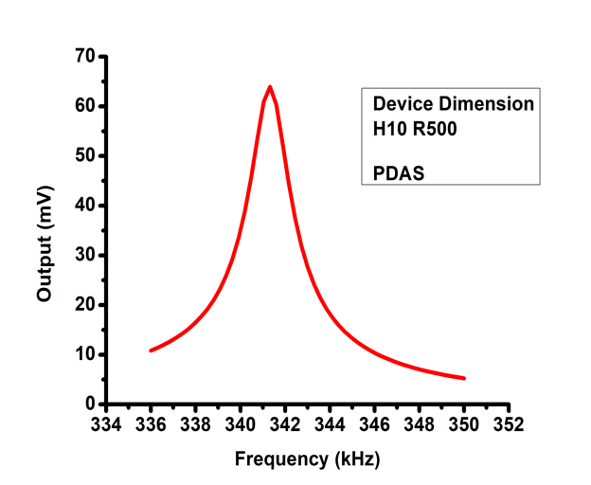
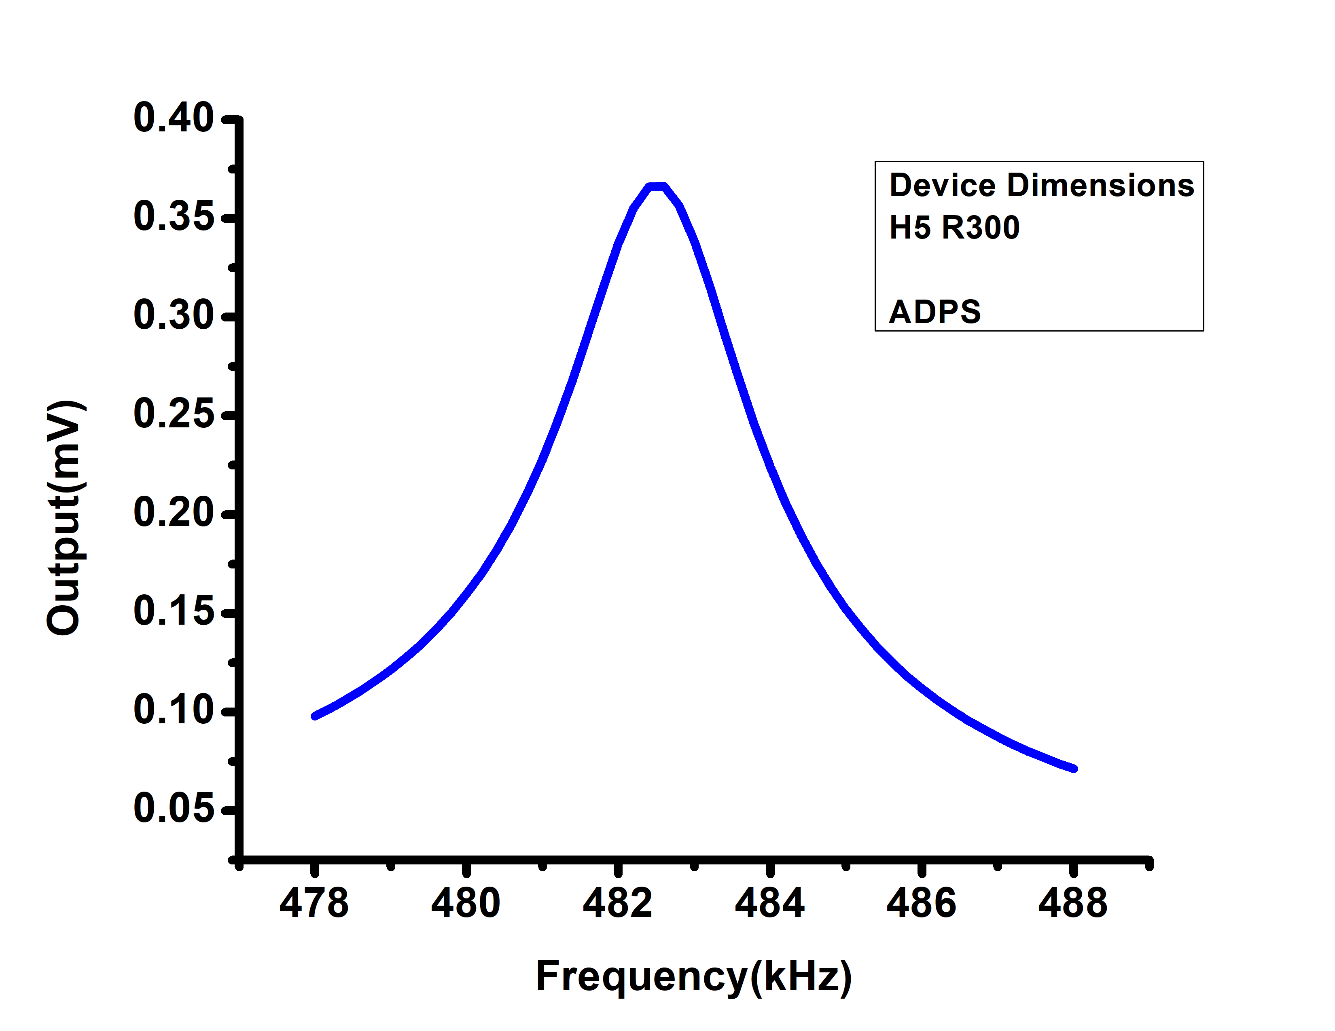
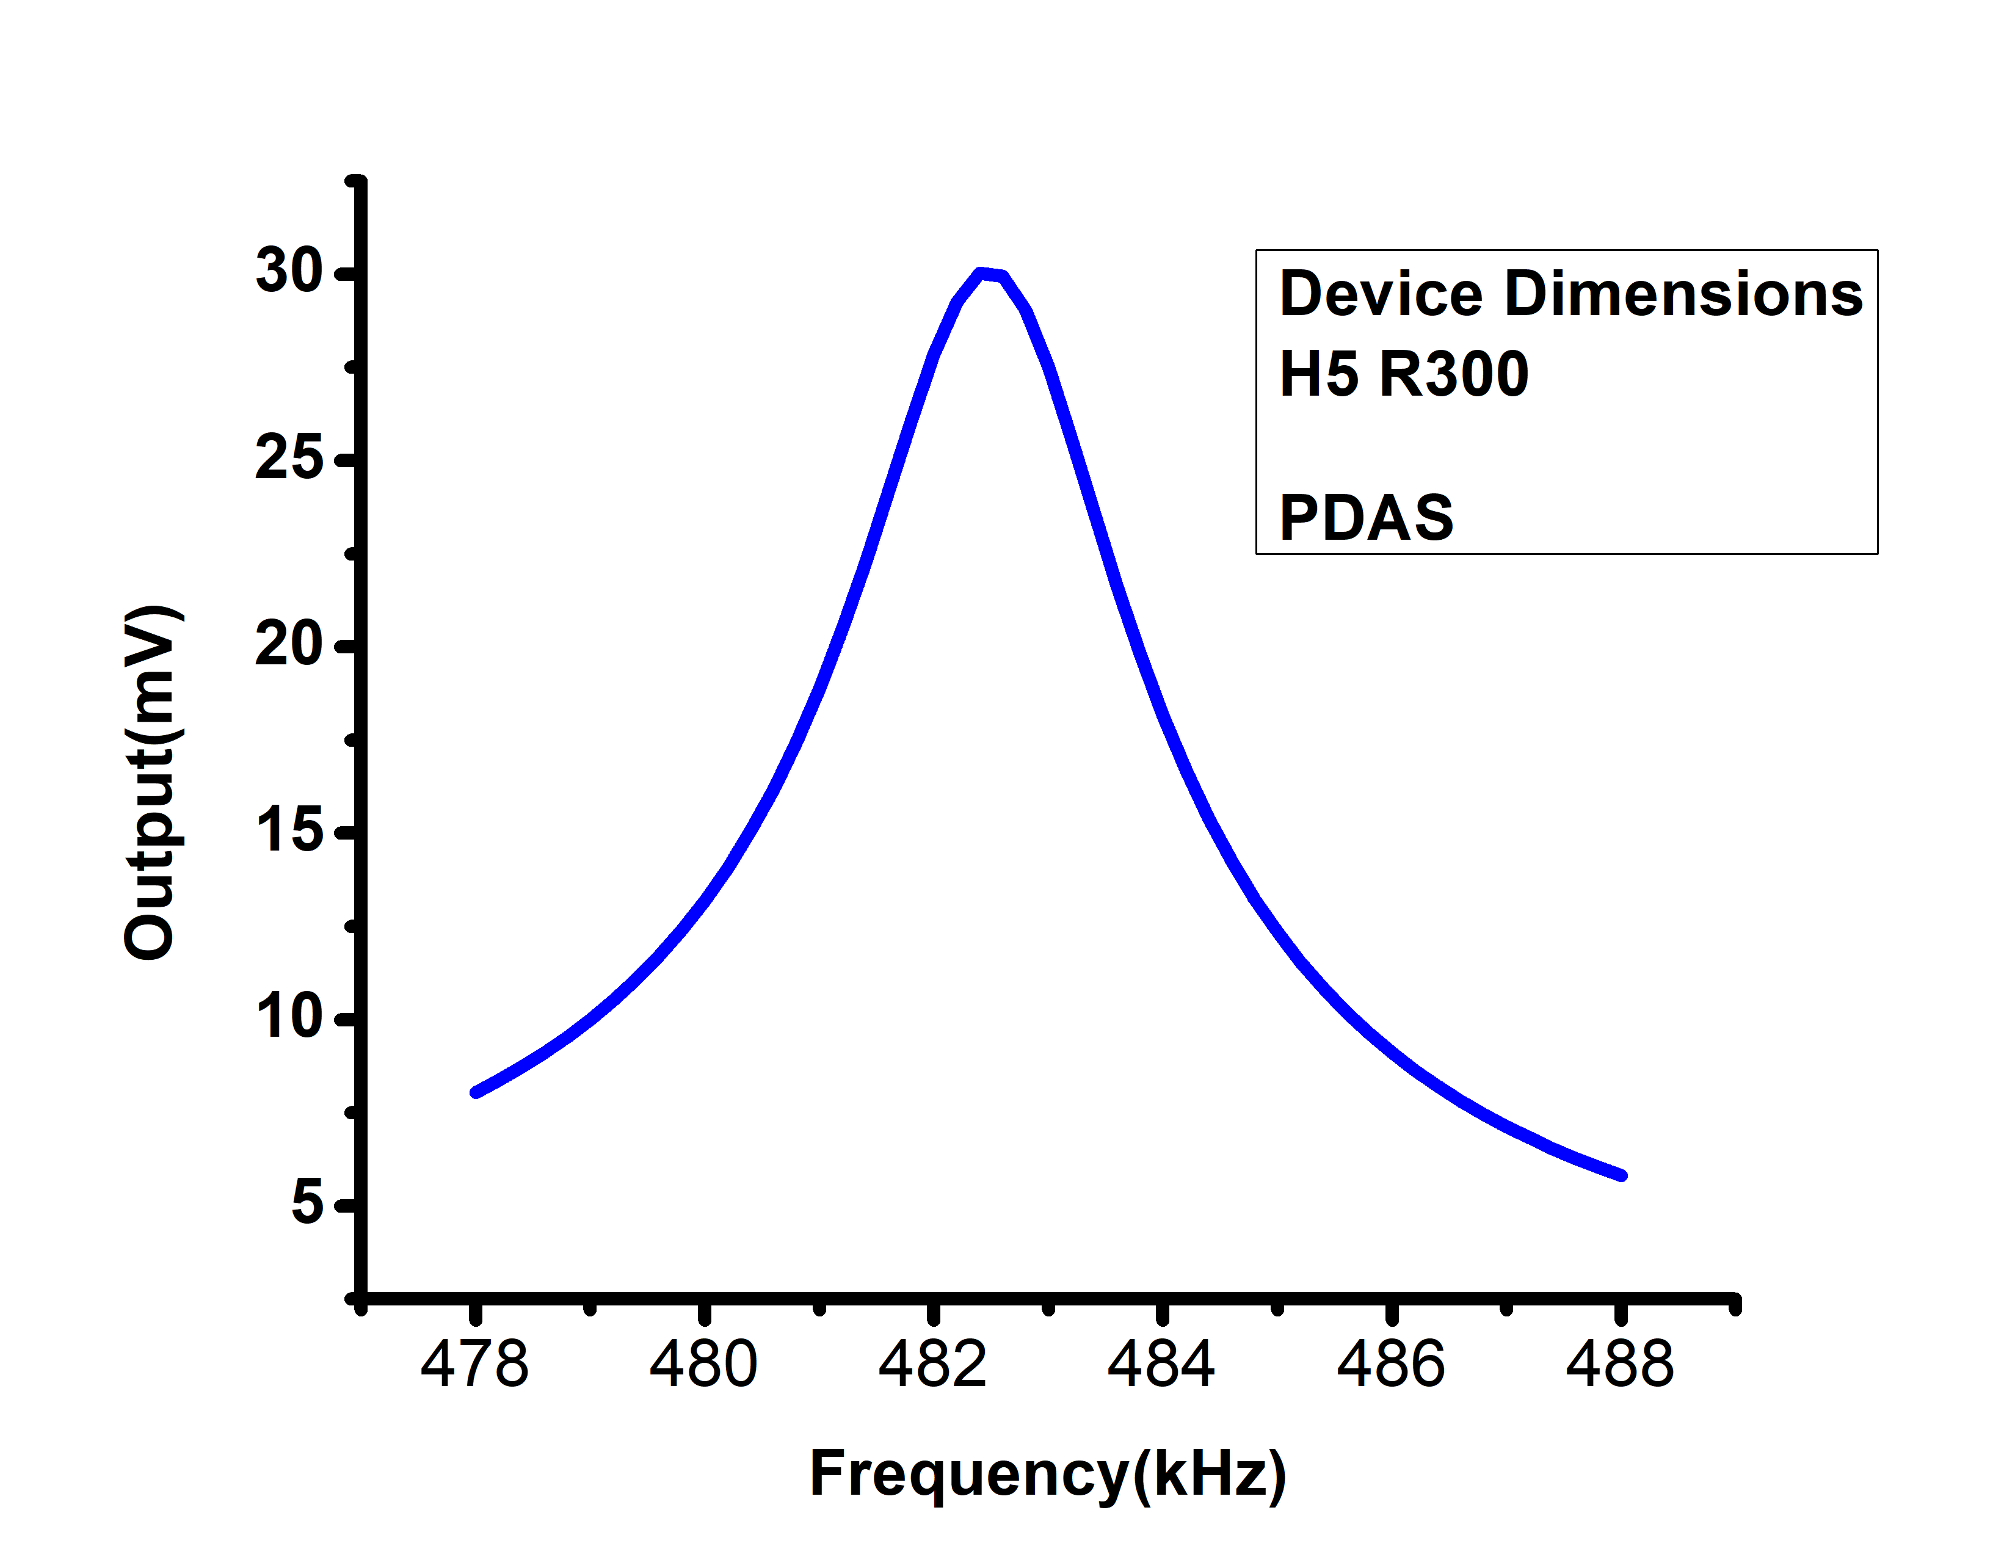
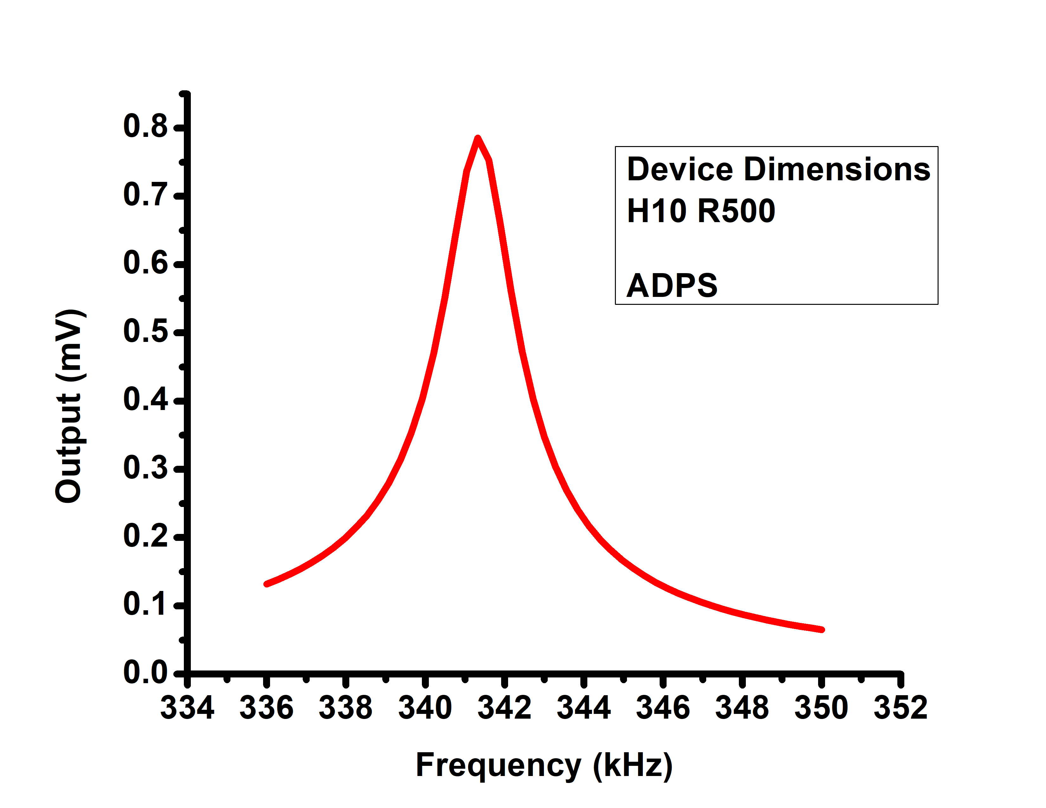
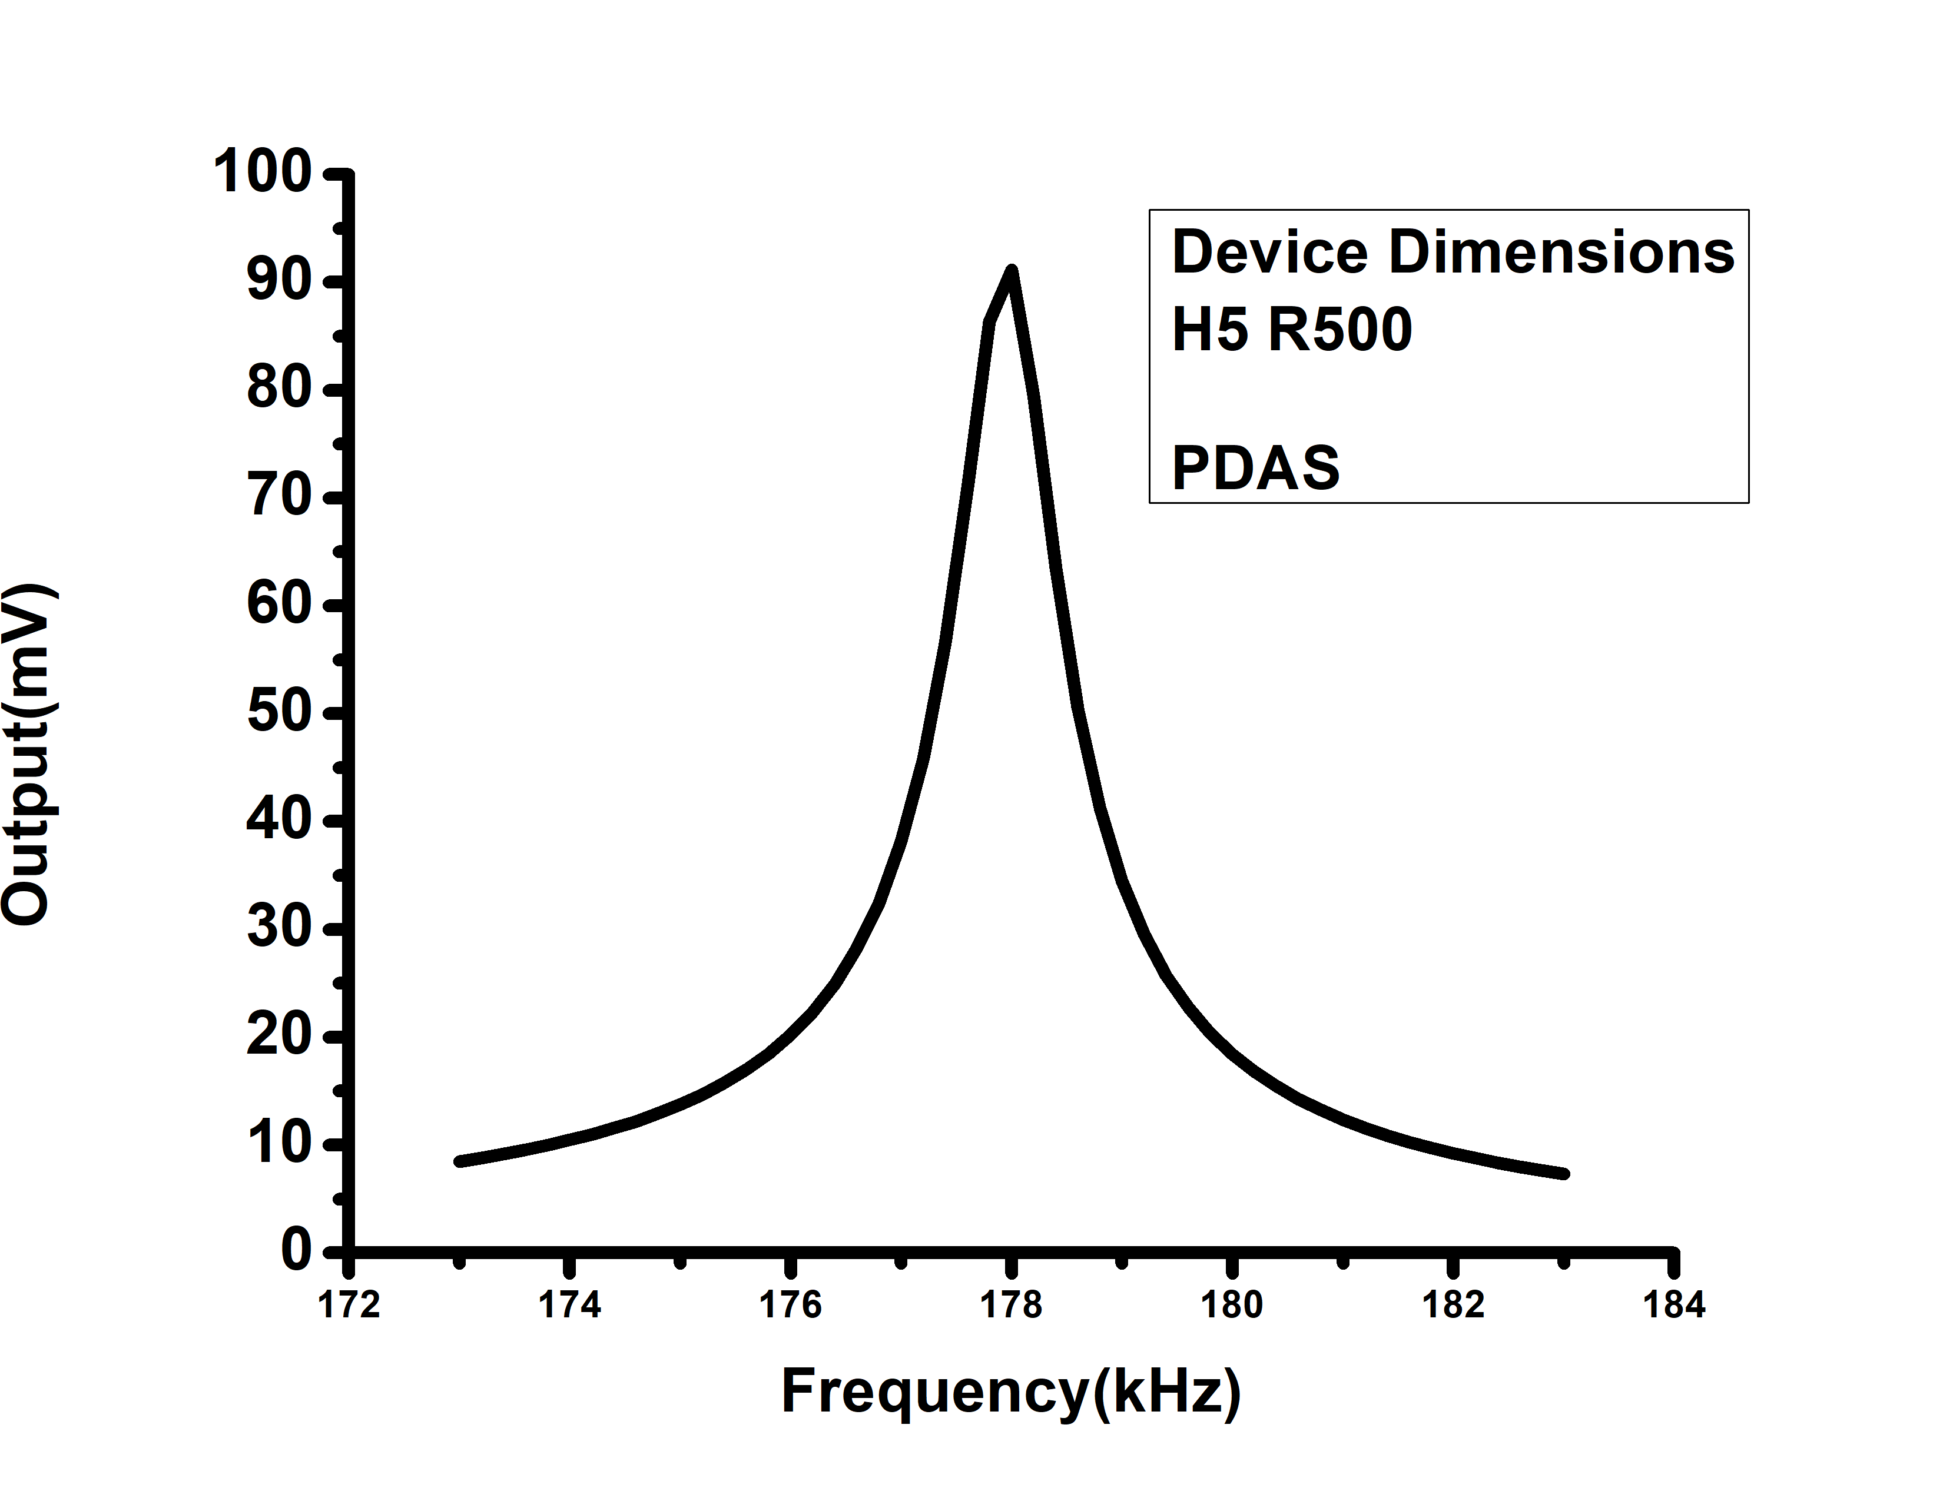
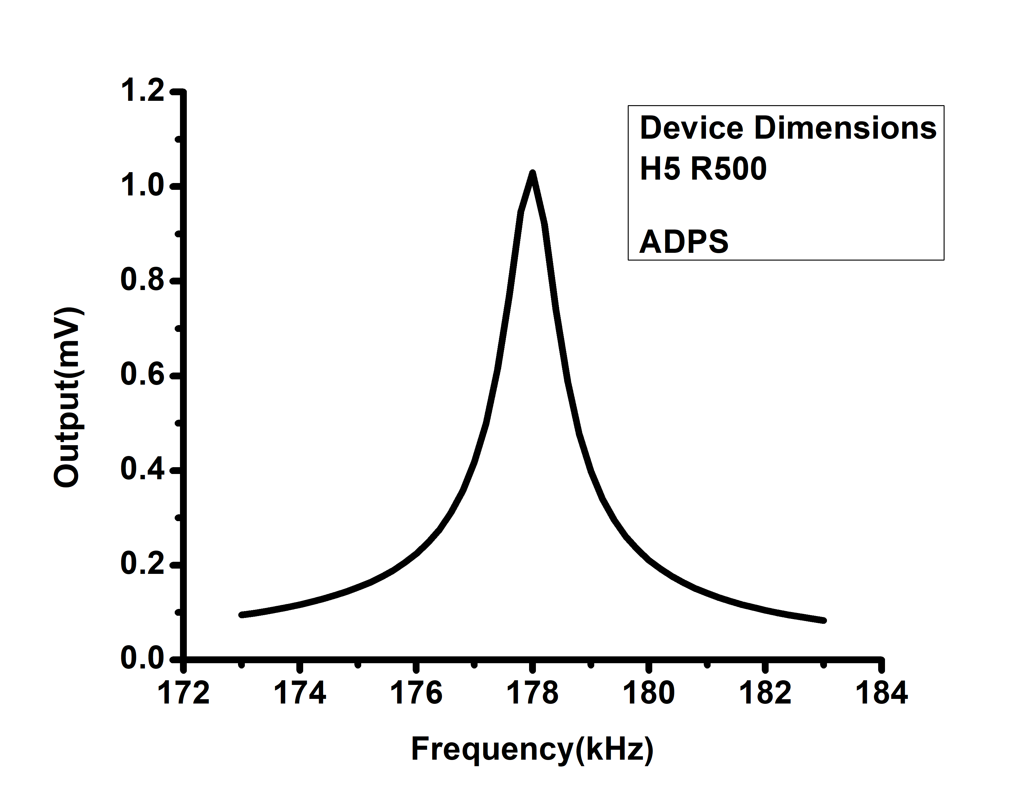

Figure S6: Frequency versus output voltage plot of the PZT drive/AlN sense configuration and vice versa for various device dimensions of the LSR using COMSOL simulation.

References
1.Zhang, Y., Jin, T., Deng, Y., Zhao, Z., Wang, R., He, Q., Luo, J., Li, J., Du, K., Wu, T. and Yan, C., 2024. A low-voltage-driven MEMS ultrasonic phased-array transducer for fast 3D volumetric imaging. Microsystems & Nanoengineering, 10(1), p.128.
2.Bhugra, H. and Piazza, G. eds., 2017. Piezoelectric MEMS resonators (p. 103). New York, NY, USA:: Springer International Publishing.

