Supplementary Information
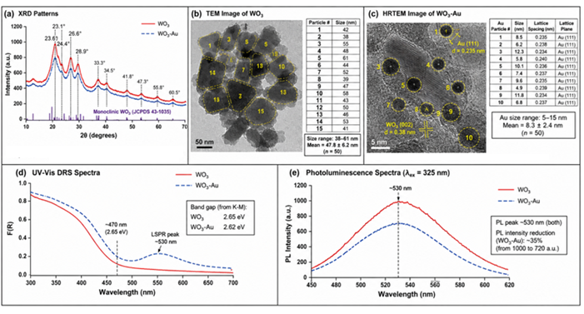
Figure S1. Additional characterization: (a) XRD patterns of WO₃ and WO₃-Au; (b) TEM image of WO₃ (scale bar: 50 nm); (c) HRTEM image of WO₃-Au showing Au lattice fringes (scale bar: 5 nm); (d) UV-Vis DRS spectra (F(R) vs wavelength); (e) Photoluminescence spectra.

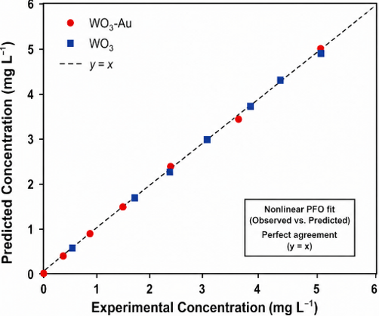
Figure S2. Observed vs predicted C values for nonlinear PFO fit — shows all data points lie on the diagonal line.
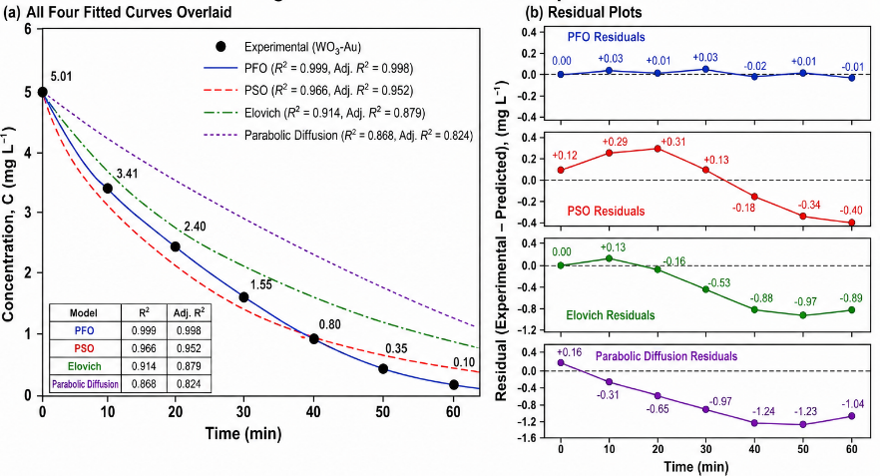
Figure S3. Combined model comparison: (a) All four fitted curves overlaid; (b) Residual plots in 2×2 grid.

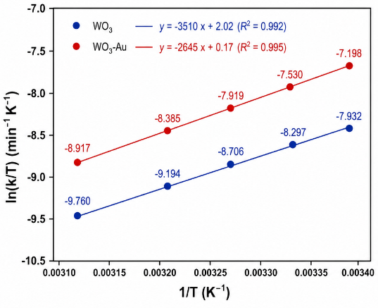
Figure S4. Eyring analysis: ln(k/T) vs 1/T for WO₃ and WO₃-Au with activation parameters (ΔH‡, ΔS‡, ΔG‡).

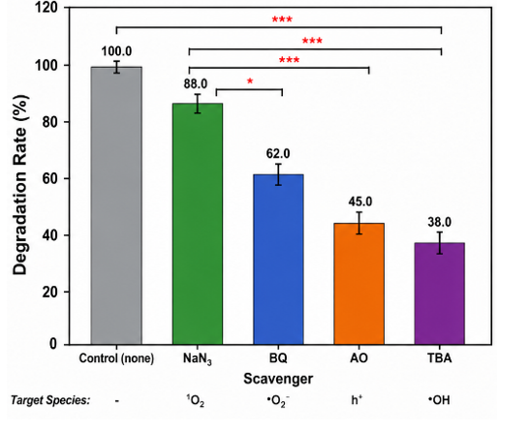

Figure S5. Scavenger tests: Bar chart showing degradation rates with different scavengers (control, TBA, BQ, AO, NaN₃) with statistical significance indicated.

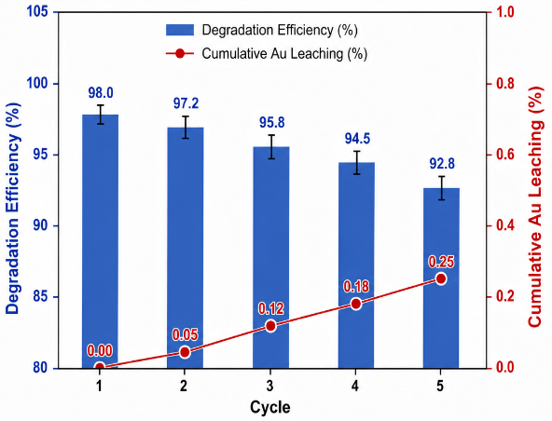
Figure S6. Catalyst reuse: 5 cycles of degradation showing stability.

