A Telemonitoring Programme in Patients with Heart Failure in France: A Cost-Utility Analysis
Additional Material
Additional File 5 Kaplan-Meier survival curves stratified by level of SCAD use
A. Hospitalisation for heart failure
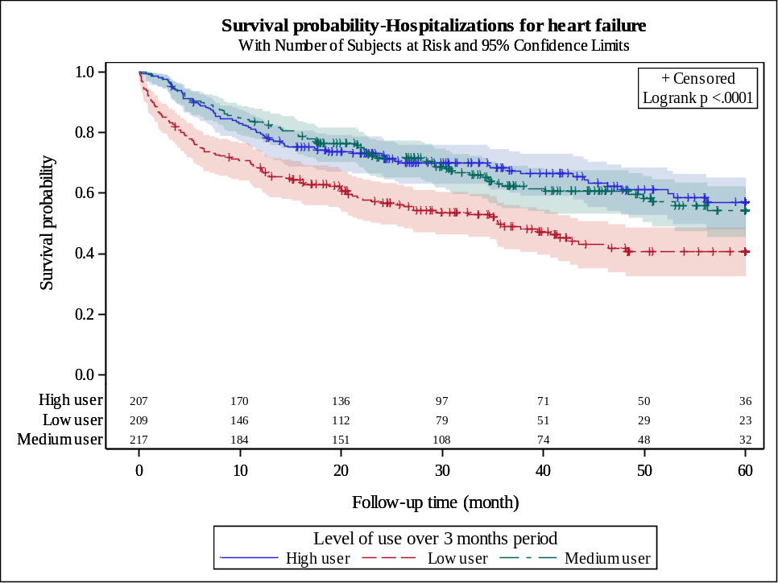
B. Death
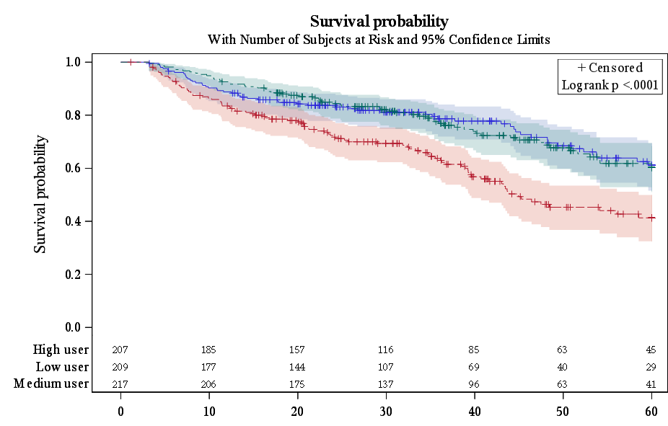
Red curve: low use; turquoise curve: intermediate use; blue curve: high use.

