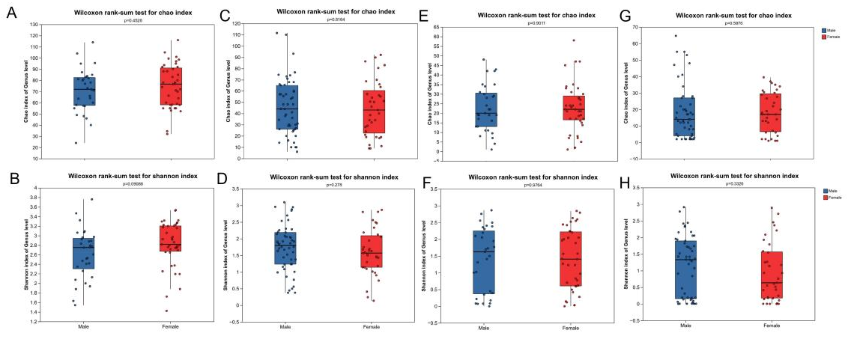
Supplementary Figure 1. Sex-stratified alpha diversity of fecal microbiota in diarrheal patients and healthy controls.
A and B, bacterial richness (Chao1) and diversity (Shannon) by sex in controls. C and D, corresponding bacterial metrics in patients. E and F, fungal richness (Chao1) and diversity (Shannon) by sex in controls. G and H, corresponding fungal metrics in patients. 0.01 < *P ≤ 0.05; 0.001 < **P ≤ 0.01; ***P ≤ 0.001.
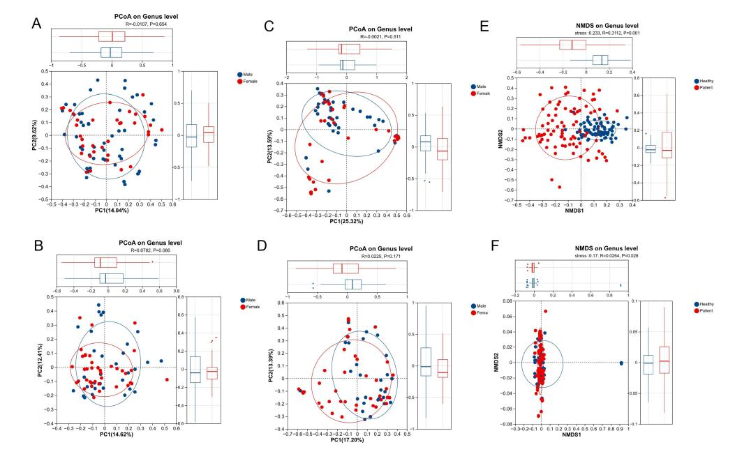
Supplementary Figure 2. Sex-stratified β-diversity and overall community ordinations of fecal microbiota.
A and B, bacterial Bray-Curtis PCoA by sex in patients and controls, respectively. C and D, fungal Bray-Curtis PCoA by sex in patients and controls, respectively. E and F, non-metric multidimensional scaling (NMDS) plots of total bacterial and fungal communities based on Bray-Curtis distances.
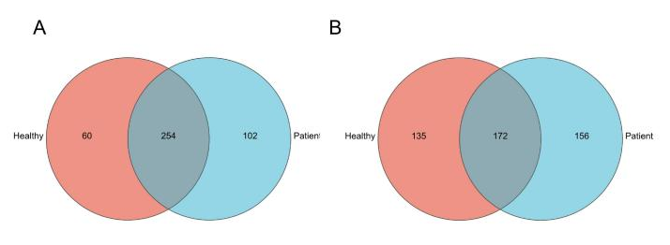
Supplementary Figure 3. Shared and unique fecal microbial genera between diarrheal patients and healthy controls.
A and B, Venn diagrams of shared and exclusive bacterial and fungal genera between cohorts, respectively. Numbers inside regions indicate genus counts.

