Supplementary Material
Table S1. Parameters of DL-HASTE and BLADE sequences
Variable | DL-HASTE | BLADE
TR/TE (ms) | 587/103 | 3000/114
Slice thickness (mm) | 6 | 6
Slice gap (mm) | 1.2 | 1.2
FOV (mm²) | 380 × 380 | 380 × 380
Scan matrix  Flip angle (degrees) | 320 × 320  160 | 320 × 320  180
Acceleration factor | 3 | 2 (GRAPPA)
Partial Fourier factor | 6/8 | N.A.
Motion control scheme | Breath-hold | Respiratory triggered
Total scan time | 12 s × 2 | 2~3mins
Note—DL-HASTE: Deep learning accelerated Half-Fourier Acquisition Single-shot Turbo spin Echo imaging. FOV: Field of View. GRAPPA: GeneRalized Autocalibrating Partial Parallel Acquisition.

Table S2. Likert scale scoring for qualitative imaging features
Variable | Scoring system
Overall image quality | 1. Unacceptable; 2. Poor; 3. Fair; 4. Good; 5. Excellent
Artifact | 1. Unacceptable; 2. Extreme Blur; 3. Moderate Blur; 4. Mild Blur; 5. No Blur
Sharpness of liver margin | 1. Unacceptable; 2. Extreme Blur; 3. Moderate Blur; 4. Mild Blur; 5. No Blur
Hepatic vessel margin | 1. Unacceptable; 2. Extreme Blur; 3. Moderate Blur; 4. Mild Blur; 5. No Blur
Pancreatic duct margin | 1. Unacceptable; 2. Extreme Blur; 3. Moderate Blur; 4. Mild Blur; 5. No Blur
Homogeneity of fat suppression | 1. Unacceptable; 2. Poor; 3. Fair; 4. Good; 5. Excellent
Strength of fat suppression | 1. Unacceptable; 2. Poor; 3. Fair; 4. Good; 5. Excellent
Conspicuity of the liver smallest lesion | 1. Unreadable; 2. Poor; 3. Moderate; 4. Good; 5. Excellent

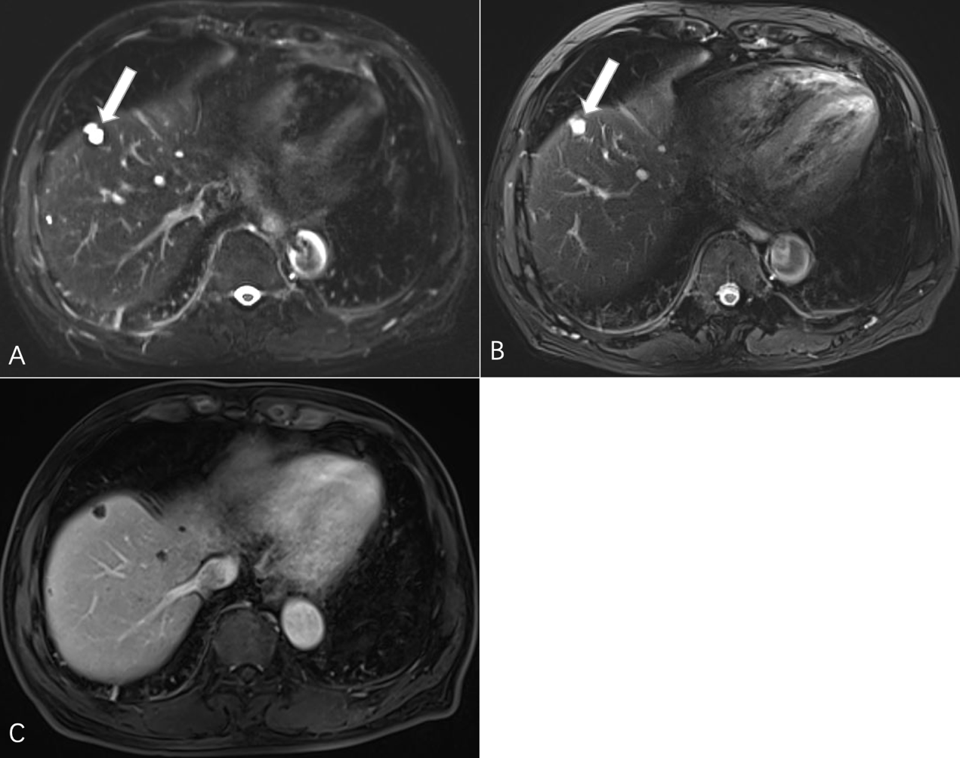
Fig. S1—Characterization of liver cysts in a participant. The T2-weighted DL HASTE axial image (A) shows better conspicuity for small cysts than the BLADE axial image (B); C, enhanced image shows no enhancement of the cysts. The largest cyst (arrow) CNR of the DL HASTE sequence and BLADE sequence are 82.42 and 46.74, respectively. Both readers classified the lesion as markedly hyperintense on both sequences. DL HASTE, half-Fourier acquisition single-shot turbo spin echo using deep learning; CNR, contrast-to-noise ratio.

