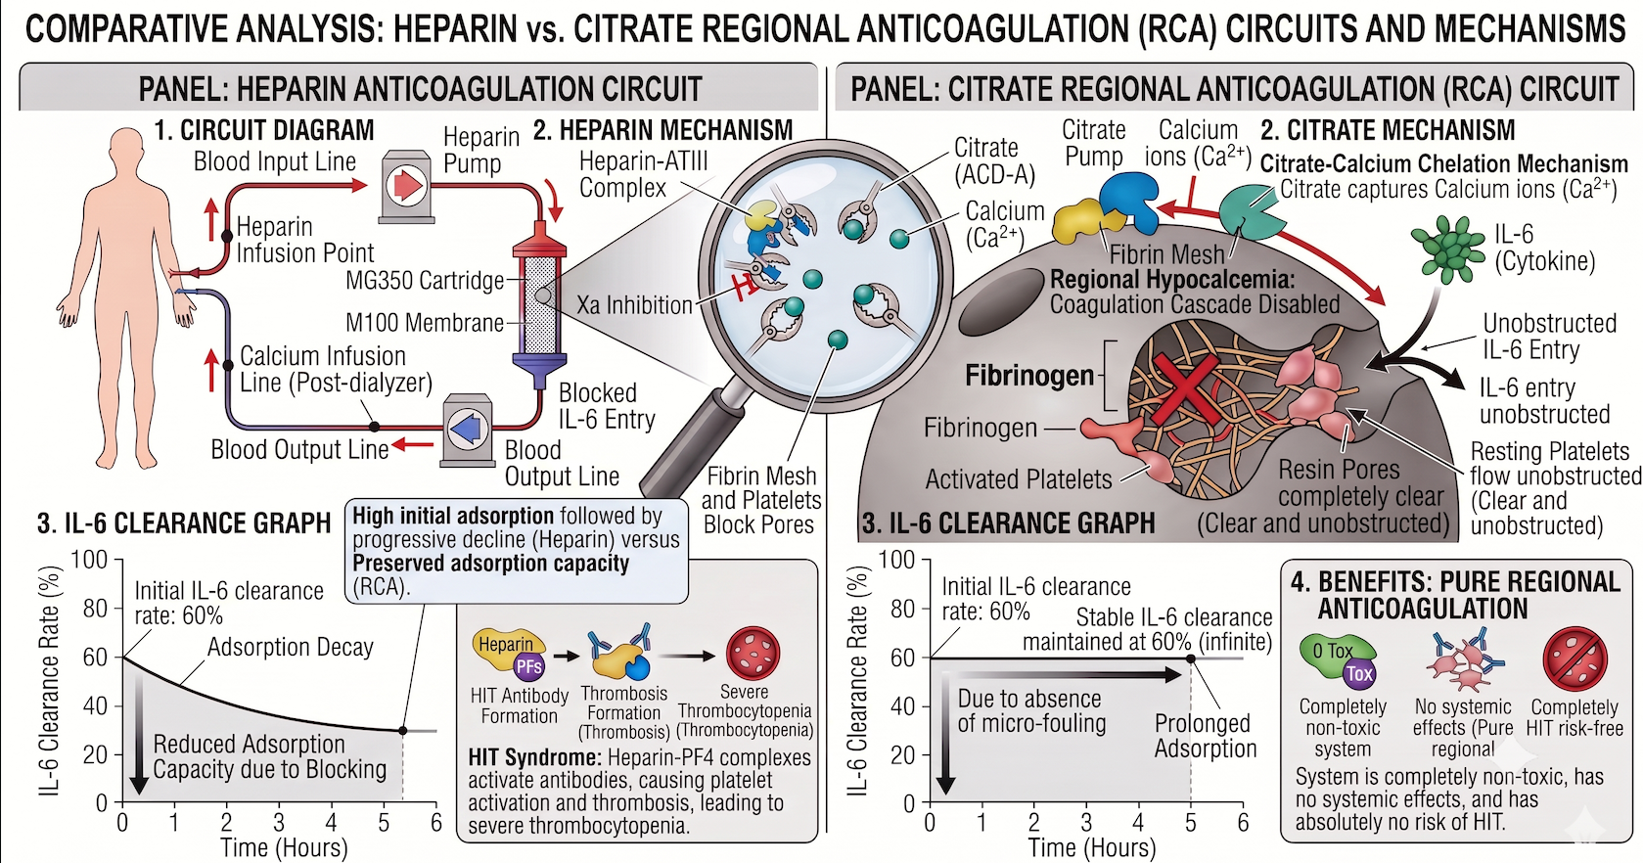

Figure 1: Hypothesized conceptual illustration of hypothesized mechanisms (not based on observed clinical data). Left panel: Hypothesized progressive reduction in adsorption efficiency associated with heparin-related circuit fouling. Right panel: Hypothesized preservation of circuit patency and adsorption performance with RCA. Note: The conceptual illustrations in this figure were drafted with the assistance of Google Gemini. The authors have critically reviewed, modified, and take full responsibility for the scientific accuracy of the final visual content.
The left panel illustrates the Heparin Anticoagulation Circuit:
- Circuit Diagram: Blood is input to the circuit and systemic heparin anticoagulation is applied via a heparin pump. Blood passes through the MG350 cartridge and M100 membrane. Calcium is infused post-dialyzer and blood output line.
- Heparin Mechanism: A magnified view of the cartridge mechanism. The heparin-ATIII complex binds to and blocks Thrombin and Factor Xa. Resin beads are soon blocked by activated platelets and fibrin mesh, preventing free entry of IL-6.
- IL-6 Clearance Graph: The graph shows that IL-6 clearance rate decays rapidly from 60% over time as the resin beads are blocked. Reduced adsorption capacity is due to this blocking, leading to a clearance rate of only 30% at 6 hours.
- HIT Risk: The heparin-induced thrombocytopenia risk process is detailed: Heparin-PF4 complex forms antibodies, causing platelet activation and thrombocytopenia.
The right panel illustrates the Citrate Regional Anticoagulation (RCA) Circuit:
- Circuit Diagram: Blood is input to the circuit, and citrate is infused pre-dialyzer. Blood passes through the cartridge. Calcium is infused post-dialyzer to return the ionized calcium level to normal in the systemic blood output line.
- Citrate Mechanism: A magnified view of the chelation process. Citrate chelates calcium ions (Ca2+), disabling the coagulation cascade and preventing the conversion of fibrinogen to fibrin. Resting platelets flow unobstructedly. Resin pores remain clear, allowing unobstructed entry of IL-6.
- IL-6 Clearance Graph: In the absence of micro-fouling, IL-6 clearance rate is maintained stably at 60% throughout the entire session.
- Benefits: The citrate system offers a toxicity-free process with 0 Tox, has pure regional effects (no systemic effect), and has absolutely no risk of HIT. It maintains the resin's adsorptive capacity and prevents filter lifespan failure.

