SUPPLIMENTARY INFORMATION
Surface Directed Flows and Fluidic diodes: Transforming lateral flow assays into multistep diagnostics devices
Selina Cervantesª, Haydon Hill^{b}, Jacob Dayton^{b}, David AuCoin^{b}, Venumadhav Korampally^{a,*}

ª Department of Electrical Engineering, Northern Illinois University, DeKalb, Illinois, USA
^{b} Department of Microbiology and Immunology, University of Nevada, Reno, Nevada, USA

Cassette Design and Fabrication for housing the fluidic diode integrated two stage LFA:
A custom cassette was designed for the SARS-CoV-2 fluidic diode-integrated LFA device using Autodesk Fusion 360 computer-aided design software. Figure S1 shows the rendered schematic of the cassette design together with the assembled device.
The cassette was designed to house the complete cascaded fluidic diode assembly and the LFA strip within a single enclosure, with individual fluid application ports positioned directly above each source pad of the cascaded diode assembly. It is worth noting that a particularly important design consideration for the cassette was the prevention of fluid overflow from the application ports into the interior of the cassette and onto adjacent device components. Uncontrolled overflow of applied fluid would compromise the sequential reagent delivery scheme by introducing cross-contamination between reagent zones and disrupting the timed flow sequence enforced by the cascaded diode architecture. To mitigate this, each fluid application port was designed with internal press-down stop features consisting of 4 mm × 0.7 mm rectangular protrusions positioned at the front and back of each reservoir on the interior surface of the top case.
For the sample reservoir, two rectangular stops were placed in front of the reservoir and brought down 3.69 mm from the underside of the top case to press the transfer conjugate down enough to maintain fluid flow while also helping prevent overflow, since this sample port was very close to the nitrocellulose membrane. For the buffer reservoir, the stops were 3.29 mm high to control and mitigate fluid coming from the gold conjugate area, with an additional stop placed downstream over the Mylar on the gold conjugate pad, 3.32 mm from the bottom of the top case. These features regulate fluid behavior preventing fluid contact with the Mylar surface, and enforcing channel-directed flow through the device.
The port geometry consists of a lofted reservoir transitioning from a 3 mm × 2 mm opening at the conjugate pad to a 4 mm × 5 mm upper opening for the sample delivery port, and from a 3 mm × 7 mm opening to a 5 mm × 9 mm upper opening for the buffer delivery port, each with a taper height of 4.6 mm. Both reservoirs include filleted internal corners to reduce sharp features, with a fillet radius of 0.5 mm for the sample port and 1 mm for the buffer port.
The cassette also incorporated a viewing window positioned over the test and control line regions of the nitrocellulose membrane to permit visual readout of the assay result without requiring disassembly of the device. Overall cassette outer dimensions were 80 mm × 16 mm × 6.85 mm. The cassette design files were exported from Fusion 360 as STL 3MF files and fabricated through fused deposition modelling (FDM) 3D printing using a Bambu Lab X1 Carbon 3D printer ( Bambu Studio software) with PLA filament at a layer resolution of 400 μm. Following printing, cassette parts were inspected for dimensional accuracy and surface finish and lightly sanded at the mating surfaces as needed to ensure proper seating of the device components within the cassette interior.
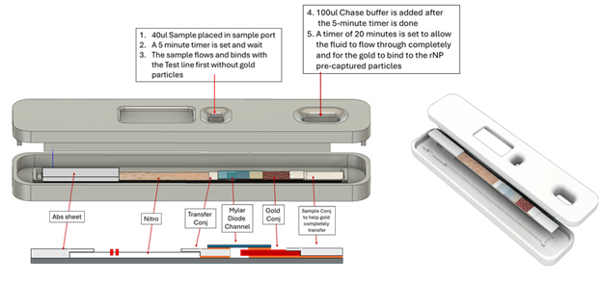

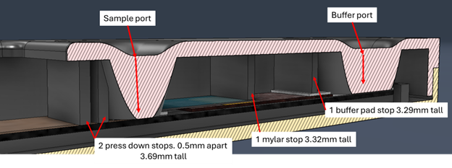
Figure S1: Schematic illustration of the cassette design for housing the fluidic diode integrated two stage LFA.

Image J analysis of the Gray scale values of the test results
Figure S2 shows the image J analysis of the test results
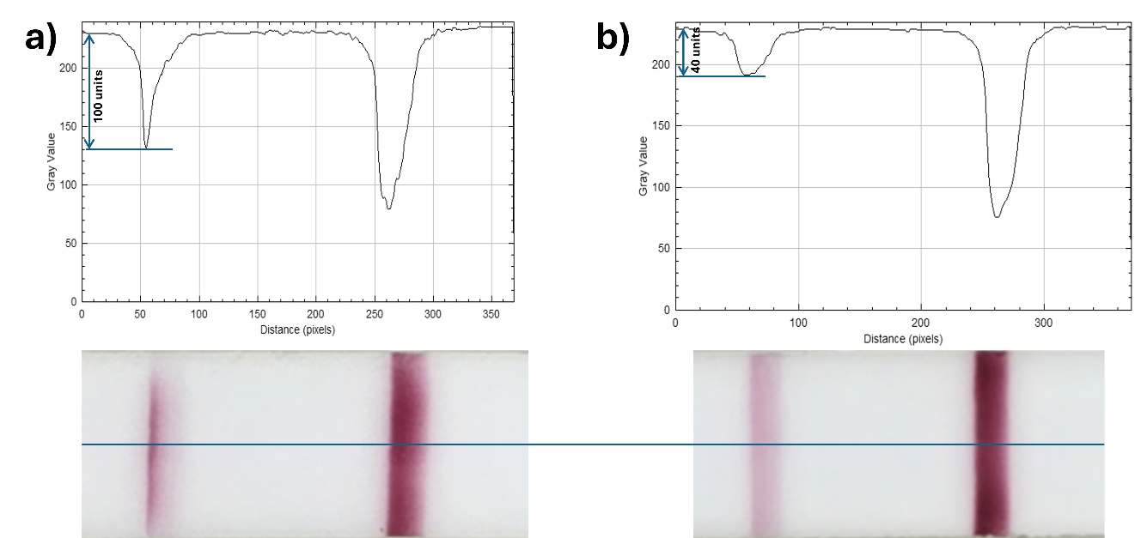

Figure S2: Densitometric analysis of the SARS-CoV-2 test line gray value profiles for a) Two stage LFA and b) Conventional LFA

