Supporting information for Cellulose
Biomass L-Lysine Modified PVDF-TrFE Composite Triboelectric Nanogenerator for High-Efficiency Mechanical Energy Harvesting and Self-Powered Intelligent Sensing
Wei Li ^{a,b *}, Mouyue Zhu ª, Ziliang Xie ª, Hongji Guan ª, Qiyuan Zong ª, Kexin Chen ª, Shenyu Qiu ª, Xuan Peng ^{a,b} and Wenchao Zhai ^{a,b}
ª School of Science, Jiangxi University of Water Resources and Electric Power, Nanchang 330099, People’s Republic of China
^{b} Nanchang Key Laboratory of Photoelectric Conversion and Energy Storage Materials, Nanchang 330099, People’s Republic of China
* Corresponding author. E-mail address: liweidting@juwp.edu.cn (Wei Li).

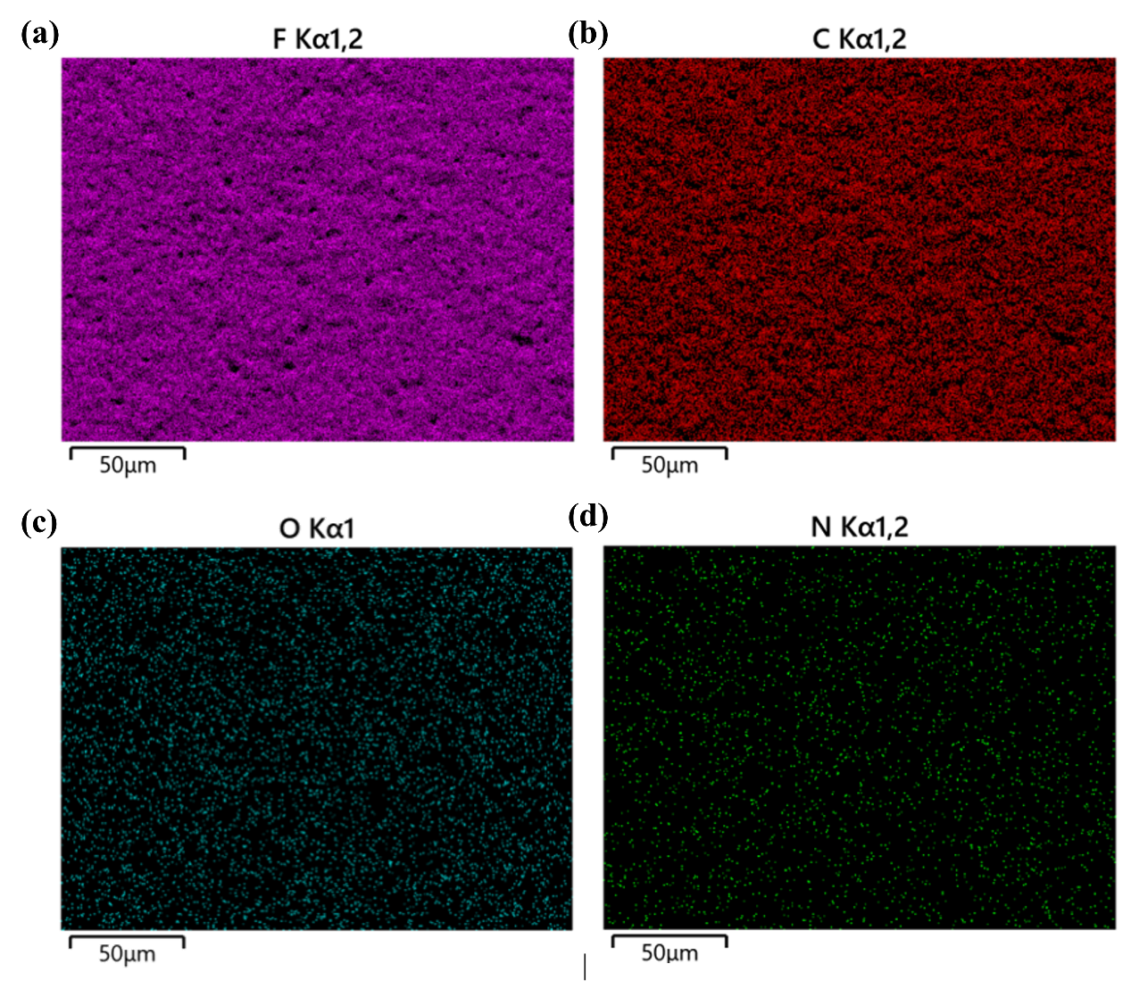
Fig. S1 EDS elemental mapping of the L-lysine/PVDF-TrFE composite film. a Fluorine Kα_{1,2} elemental mapping. b Carbon Kα_{1,2} elemental mapping. c Oxygen Kα_{1,2} elemental mapping. d Nitrogen Kα_{1,2} elemental mapping. The scale bars in all panels correspond to 50μm.
Elemental spatial distribution of the L-lysine/PVDF-TrFE composite film was characterized via energy-dispersive X-ray spectroscopy (EDS) elemental mapping, as shown in Fig. S1. The fluorine signal (Fig. S1a) originates exclusively from the PVDF-TrFE polymer matrix. Homogeneous fluorine distribution over the imaged area confirms a continuous polymer framework with no evident macroscopic phase separation or localized filler aggregation. The carbon signal (Fig. S1b) arises both from the PVDF-TrFE carbon backbone and carbon-containing moieties of doped L-lysine; uniform carbon distribution further validates overall composite homogeneity.
The oxygen signal (Fig. S1c) corresponds to carboxyl (-COOH) groups of L-lysine, while the nitrogen signal (Fig. S1d) originates from amino (-NH₂) groups intrinsic to L-lysine. Both O and N elements show spatially uniform, dispersed signals across the scanned region, without observable local enrichment or signal-depleted domains. Combined with the homogeneous F and C distribution from the polymer matrix, these mapping results demonstrate microscale uniform dispersion of L-lysine within the PVDF-TrFE host matrix, free from severe agglomeration or surface segregation. Such well-distributed microstructure enables full exploitation of intermolecular interactions between L-lysine and PVDF-TrFE molecular chains, which underpins the optimized dielectric, ferroelectric, and triboelectric performance of the composite film.

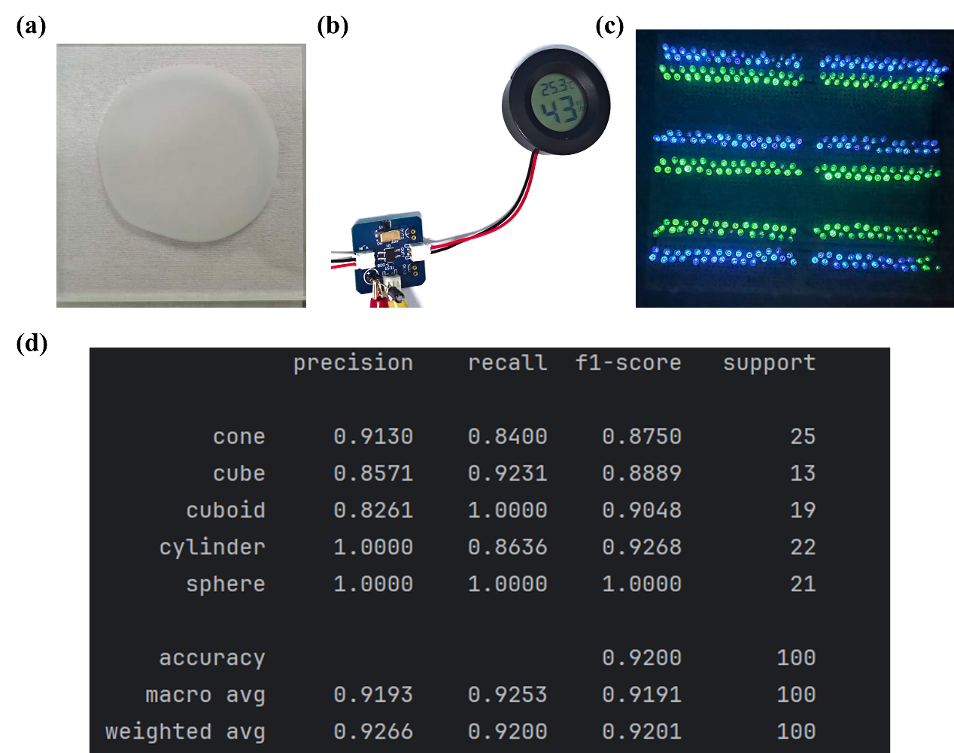
Fig. S2 Digital photographs and deep-learning classification metrics. a Optical photograph of free-standing PVDF-TrFE/L-lysine composite film. b Photograph of a commercial thermo-hygrometer powered by rectified PL-TENG output. c Photograph demonstrating simultaneous illumination of 324 light-emitting diodes (LEDs) driven by PL-TENG. d Classification report (precision, recall, F1-score, support counts) for the CNN-LSTM hybrid model on the geometric-object test dataset, including overall accuracy, macro-average, and weighted-average statistics (total test samples = 100).
Fig. S2d summarizes quantitative classification performance of the CNN-LSTM hybrid network for five geometric-object categories (cone, cube, cuboid, cylinder, sphere) evaluated on 100 test-set samples. The sphere class yields perfect precision, recall, and F1-score (1.0000), indicating zero false-positive and false-negative predictions. The cylinder class achieves a precision of 1.0000 with a recall of 0.8636, revealing that a small subset of cylinder samples are misassigned to alternative categories. By contrast, the cuboid class obtains perfect recall (1.0000) but reduced precision (0.8261), meaning several non-cuboid inputs are incorrectly predicted as cuboid. Cone and cube exhibit balanced intermediate performance with F1-scores of 0.8750 and 0.8889, respectively, constituting the major sources of minor classification error.
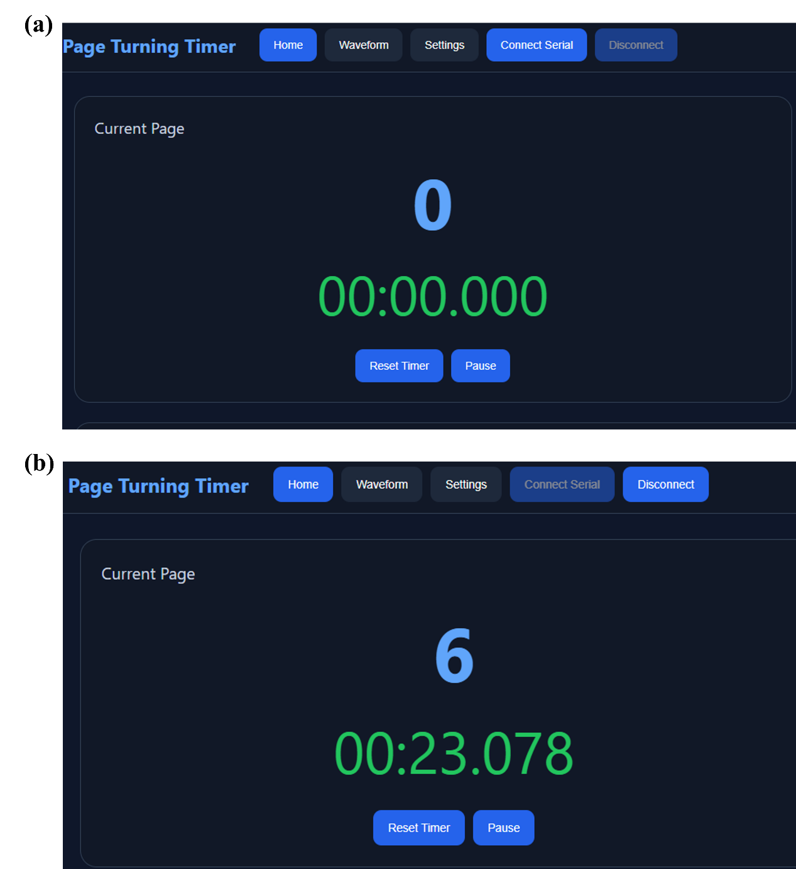
The overall test-set accuracy reaches 0.9200. Macro-average precision, recall, and F1-score are 0.9193, 0.9253, and 0.9191; weighted-average values are 0.9266, 0.9200, and 0.9201. The high, well-balanced average metrics verify that the CNN-LSTM hybrid architecture can effectively extract spatial-amplitude and long-range temporal features from single-channel triboelectric time-series, enabling reliable multi-category tactile-signal recognition with limited inter-class performance deviation.

Fig. S3 Web-based graphical user-interface (GUI) screenshots of the self-powered reading-timing system. a Initial interface state prior to page-turning events (Current Page = 0, timer = 00:00.000). b Updated interface state after three successive page-turning trigger events (Current Page = 6, accumulated reading time = 00:23.078).
Fig. S3 presents representative screenshots of the host web-GUI for the PL-TENG-based reading-timing system. In the initial standby state (Fig. S3a), the page counter is reset to zero and the timer starts from 00:00.000. After three valid page-turning-induced triboelectric trigger events exceeding the preset 3.6 V voltage threshold, the system increments the recorded page number by two for each trigger. Consequently, the page counter updates to “Current Page = 6”, while the timer accumulates real-world reading duration (Fig. S3b). These screenshots visually validate the hardware-software logic: threshold-based event detection, page-count increment, and timing accumulation for real-time reading-behavior logging.
Supplementary Video:
Video V1: Operational demonstration of the self-powered reading-timing system.
Video description: Real-time demonstration showing the PL-TENG sensor responding to manual page-turning gestures. Each valid mechanical contact-separation event generates a triboelectric voltage signal exceeding the 3.6 V threshold, which triggers automatic page-number increment and timer reset within the web-based user interface.

