Appendix 1 Location of analysed wineries in the southern Luberon (south-eastern France). In each winery, one to four vineyards were involved in the study.
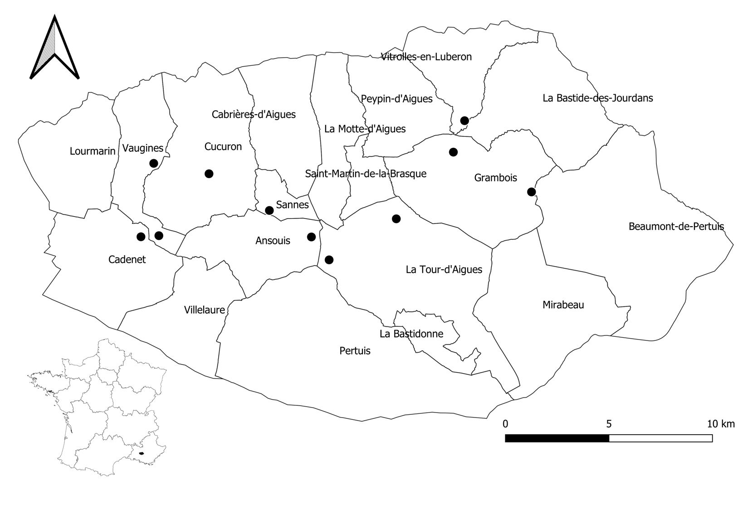

Appendix 2

Classification of arthropods into ecological groups according to their diet. Beetles were identified to the species level in pitfall traps and to the family level on sticky traps.

Appendix 3

Initial conceptual model that was both consistent with our data and made sense biologically. The full model was simplified by stepwise exclusion of non-significant variables until a minimum adequate model was reached. The adequacy of the model was determined by non-significant differences between predicted and observed covariance matrices (chi-squared tests, P > 0.05), low root mean squared error of approximation index (RMSEA < 0.1) and high comparative fit index (CFI > 0.90).
Model writing:
dependent_variable_1 ~ independent_variable_1 + independent_variable_2
dependent_variable_2 ~ independent_variable_1 + independent_variable_2
etc.’

Final model
Plant richness ~ Inter-row management
Flower cover ~ Inter-row management
Vegetation cover ~ Inter-row management

Vegetation cover ~~ Plant richness

Hemiptera_sticky trap ~ Inter-row management

Bees_sticky trap ~ Flower cover + Plant richness + Inter-row management

Plant Feeder Coleoptera_sticky trap ~ Plant richness + Vegetation cover + Inter-row management

Predatory Coleoptera_sticky trap ~ Hemiptera_Pitfall trap + Plant Feeder Coleoptera_sticky trap

Detritivorous Coleoptera_pitfall trap ~ Plant richness + Inter-row management

Hemiptera_Pitfall trap ~ Plant richness

Aranea_pitfall trap ~ Detritivorous Coleoptera_pitfall trap + Plant richness + Plant Feeder Coleoptera_sticky trap + omnivorous Coleoptera

Opiliones_pitfall trap ~ Detritivorous Coleoptera_pitfall trap + Aranea_pitfall trap

Predator Coleoptera_pitfall trap ~ plant feeder Coleoptera_Pitfall trap + Detritivorous Coleoptera_pitfall trap

