Supporting Information (Additional File 1)

for

A novel culture medium for high-density 3D expansion of human induced pluripotent stem cells as free-floating aggregates
William O. S. Salvador^{a,b}, Diogo E. S. Nogueira^{c}, Gerardo A. Castillo^{d}, Jerome V. Karpiak^{d}, Steven D. Rees^{d}, Joaquim M. S. Cabral^{a,b}, Klaus Graumann^{e}, Carlos A. V. Rodrigues^{a,b,*}
ª Department of Bioengineering and iBB – Institute for Bioengineering and Biosciences, Instituto Superior Técnico, Universidade de Lisboa, Av. Rovisco Pais, 1049-001 Lisbon, Portugal
^{b} Associate Laboratory i4HB – Institute for Health and Bioeconomy, Instituto Superior Técnico, Universidade de Lisboa, Av. Rovisco Pais, 1049-001 Lisbon, Portugal
^{c} ISEL – Instituto Superior de Engenharia de Lisboa, Instituto Politécnico de Lisboa, Rua Conselheiro Emídio Navarro 1, 1959-007 Lisbon, Portugal
^{d} Defined Bioscience Inc, 6404 Nancy Ridge Dr, San Diego, CA 92121, USA
^{e} Phoenestra GmbH, Huemerstrasse 3-5, 4020 Linz, Austria
* Corresponding author. E-mail address: carlos.rodrigues@tecnico.ulisboa.pt

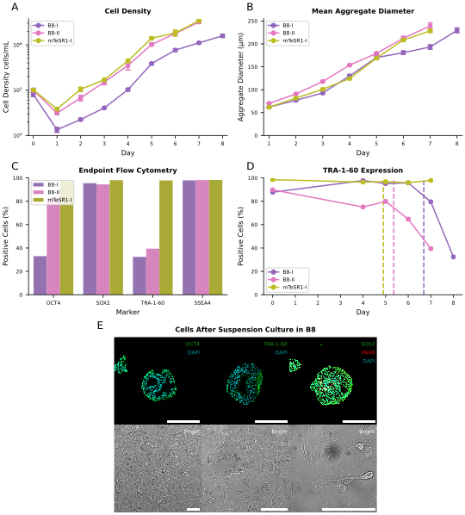
Fig. S1 hiPSCs cultured in a stirred-tank bioreactor as free-floating aggregates with B8 and mTeSR1. Two experiments with distinct bioreactor culture parameters are shown for B8. A Evolution of cell density (log scale). Under certain conditions, B8 matched mTeSR1 in terms of cell proliferation. B Evolution of mean aggregate diameter. Aggregates formed with B8 presented similar size to those formed with mTeSR1. C Flow cytometry analysis of two intracellular (OCT4 and SOX2) and two surface (TRA-1-60 and SSEA4) pluripotency markers at the end of bioreactor culture. Unlike mTeSR1, B8 did not preserve OCT4 and TRA-1-60 expression. D Evolution of TRA-1-60 expression. Dashed lines indicate the moment at which cell density surpassed 1 × 10⁶ cells/mL. TRA-1-60 expression of hiPSCs cultured with B8 dropped significantly once this density was reached and was not observed to be time dependent. E Representative images of aggregates collected at the end of bioreactor culture with B8, sliced (top, scale bars = 200 µm) and one day after plating (bottom, scale bars = 100 µm). Aggregate slices were immunostained for pluripotency (OCT4, TRA-1-60 and SOX2) and neural differentiation markers (SOX2 and PAX6). OCT4 and TRA-1-60 remained expressed only at the periphery of aggregates. SOX2 expression was maintained throughout the entirety of aggregates. Aggregates exhibited localized PAX6 expression. Cells from plated aggregates exhibited non-hiPSC-like morphology and some neuronal-like protrusions were observed. The same did not occur when using mTeSR1.
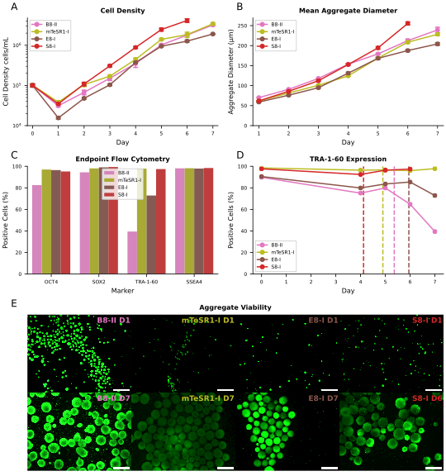
Fig. S2 hiPSCs cultured in a stirred-tank bioreactor as free-floating aggregates with B8, mTeSR1, E8 and S8. The best performing experiment for each media is shown. A Evolution of cell density (log scale). S8 surpassed all other media in terms of cell proliferation. B Evolution of mean aggregate diameter. Aggregates were similar in size for all media, with S8 exhibiting slightly larger aggregates by the end of bioreactor culture. C Flow cytometry analysis of two intracellular (OCT4 and SOX2) and two surface (TRA-1-60 and SSEA4) pluripotency markers at the end of bioreactor culture. Only mTeSR1 and S8 fully preserved the expression of all pluripotency markers. D Evolution of TRA-1-60 expression. Dashed lines indicate the moment at which cell density surpassed 1 × 10⁶ cells/mL. mTeSR1 and S8 exhibited no drop in TRA-1-60 expression after a cell density of 1 × 10⁶ cells/mL was reached, having reached a final cell density of 3.4 × 10⁶ cells/mL and 4.1 × 10⁶ cells/mL, respectively. B8 led to a significant drop in TRA-1-60 expression after surpassing 1 × 10⁶ cells/mL. E8 followed a similar trend to B8, although the drop in TRA-1-60 expression by the end of bioreactor culture was less pronounced. E Representative images of aggregates stained for viable cells using Calcein-AM (green) at the first and last days of bioreactor culture with each media (scale bars = 500 µm). No notable differences in aggregate morphology or viability were observed.
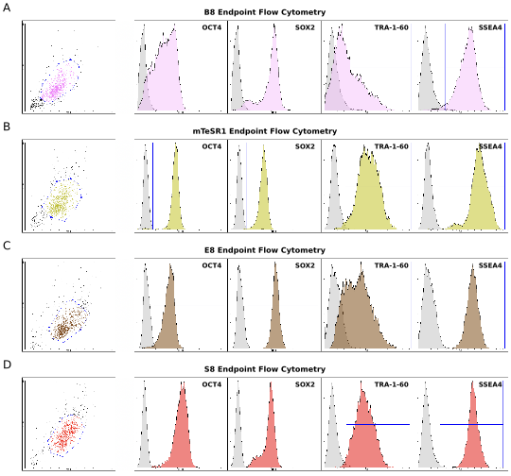
Fig. S3 Flow cytometry population gating and pluripotency marker histograms. Representative images are shown for hiPSCs cultured in a stirred-tank bioreactor as free-floating aggregates with B8, mTeSR1, E8 and S8. Two intracellular (OCT4 and SOX2) and two surface (TRA-1-60 and SSEA4) pluripotency markers were analyzed. Negative controls are shown in gray. A Endpoint flow cytometry results for B8. B Endpoint flow cytometry results for mTeSR1. C Endpoint flow cytometry results for E8. D Endpoint flow cytometry results for S8.

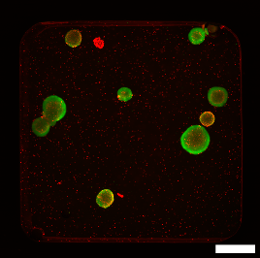
Fig. S4 Live/dead staining control (scale bar = 500 µm). Both calcein AM (green) and ethidium homodimer I (red) properly stain live/dead cells found within large dense hiPSC aggregates. Absence of red staining coupled with green staining within aggregates is indicative that cells residing near the aggregate core remain viable. Cell death was achieved by allowing aggregates to grow overly large and subjecting them to short-term starvation.

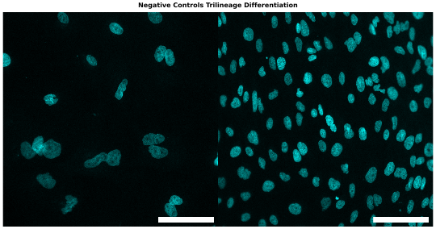
Fig. S5 Negative controls for antibody staining during characterization of trilineage differentiation (scale bars = 100 µm). Cells were incubated with secondary antibody (anti-mouse IgG Alexa Fluor 488) but were not incubated with any primary antibodies. Cell nuclei were stained with DAPI (cyan).

Table S1. Forward and reverse sequences of the primers used for quantitative real-time polymerase chain reaction.
Gene | Forward Sequence 5’ - 3’ | Reverse Sequence 5’ – 3’
GAPDH | CATGAGAAGTATGACAACAGCCT | AGTCCTTCCACGATACCAAAGT
OCT4 | CTGGGTTGATCCTCGGACCT | CCATCGGAGTTGCTCTCCA
NANOG | GCAGAAGGCCTCAGCACCTA | AGGTTCCCAGTCGGGTTCA
SOX2 | GCAATAGCATGGCGAGC | CGGGTGCTGCGGGTA
SOX1 | GCGGAAAGCGTTTTTCTTG | TAATCTGACTTCTCCTCCC
TBXT | CTATTCTGACAACTCACCTGCAT | ACAGGCTGGGGTACTGACT
SOX17 | CTCCGGTGTGAATCTCCCCC | CACGTCAGGATAGTTGCAGTAAT

