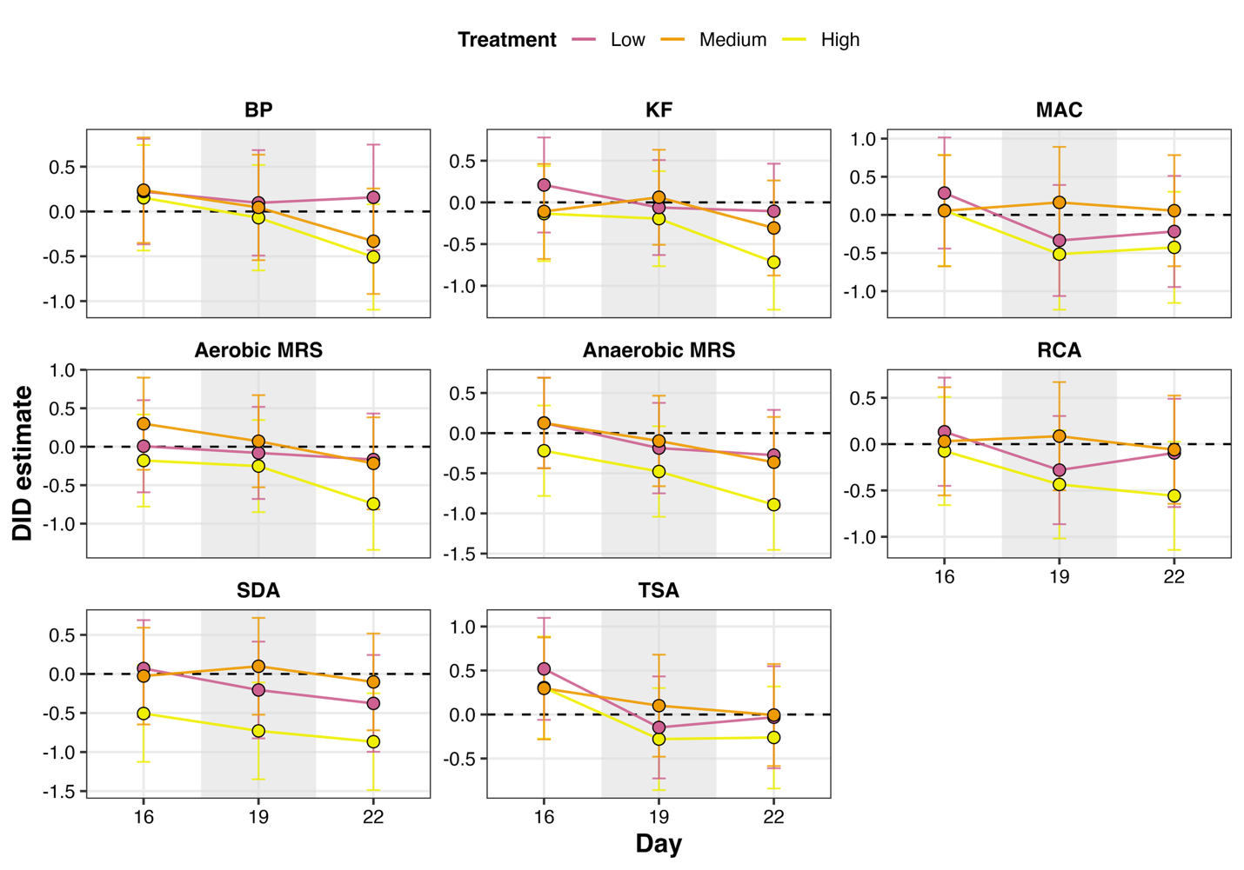
Supplementary Figure S1. Difference-in-differences (DID) analysis of culture-recoverable microbial populations using Day 13 as the reference time point. DID estimates represent the treatment-associated change from Day 13 to Days 16, 19, and 22 relative to the corresponding change in the non-amended Control: (Treatment DayX − Treatment Day13) − (Control DayX − Control Day13). Panels show Baird-Parker (BP), KF, MacConkey (MAC), aerobic MRS, anaerobic MRS, Reinforced Clostridial Agar (RCA), Sabouraud Dextrose Agar (SDA), and Tryptic Soy Agar (TSA). Points and lines represent DID estimates for the Low, Medium, and High amendment treatments, and error bars represent 95% confidence intervals. The horizontal dashed line at DID = 0 represents no difference in temporal change relative to the Control.

