SUPPLEMENTARY APPENDIX S1
Search strategies for each database
Embase
#1 prediabetes$:ab,ti OR 'prediabetic states$':ab,ti OR pre-diabetes$:ab,ti OR 'borderline diabetes$':ab,ti
#2 'impaired fasting glucose$':ab,ti OR 'impaired glucose tolerance$':ab,ti OR 'intermediate hyperglycemia$':ab,ti OR 'non-diabetic hyperglycemia$':ab,ti OR hba1c$:ab,ti OR 'hemoglobin a1c$':ab,ti OR 'glycated hemoglobins$':ab,ti
#3 #1 OR #2
#4 'coronary artery disease$':ab,ti OR 'coronary heart disease$':ab,ti OR 'myocardial ischemia$':ab,ti OR 'ischemic heart disease$':ab,ti OR 'angina pectoris$':ab,ti OR 'unstable angina$':ab,ti OR 'myocardial infarction$':ab,ti OR 'atherosclerotic cardiovascular disease$':ab,ti OR 'percutaneous coronary intervention$':ab,ti
#5 'heart failure$':ab,ti OR 'cardiovascular death$':ab,ti OR 'all-cause mortality$':ab,ti OR 'all-cause death$':ab,ti OR 'major adverse cardiovascular events$':ab,ti OR 'nonfatal stroke$':ab,ti OR 'nonfatal myocardial infarction$':ab,ti OR 'acute myocardial infarction$':ab,ti
#6 #4 AND #5
#7 #3 AND #6
#8 "cohort analysis"/exp OR "longitudinal study"/exp OR "prospective study"/exp OR "retrospective study"/exp
#9 #7 AND #8
#10 #9 AND [2020-2025]/py

PubMed
#1 (((Prediabetic State[MeSH Terms]) OR (hyperglycemia[MeSH Terms])) OR (glycated hemoglobins[MeSH Terms])) OR (Glucose Intolerance[MeSH Terms])
#2 ((((((((((" impaired fasting glucose") OR ("impaired glucose tolerance")) OR (prediabetes)) OR (pre-diabetes)) OR ("borderline diabetes")) OR ("Intermediate hyperglycaemia")) OR ("non-diabetic hyperglycaemia")) OR ("high risk of diabetes")) OR (HbA1C)) OR (hemoglobin A1c)) OR ("prediabetes phase")
#3 #1 OR #2
#4 ((coronary artery diseases[MeSH Terms]) OR (coronary heart diseases[MeSH Terms])) OR (myocardial ischemia[MeSH Terms])
#5 (((((((("Cardiovascular disease") OR ("Cardiocerebrovascular disease")) OR ("coronary artery disease")) OR ("coronary heart disease")) OR ("ischemic heart disease")) OR ("angina pectoris")) OR ("acute coronary syndrome") OR ("unstable angina")) OR ("myocardial infarction")) OR ("Atherosclerotic cardiovascular disease") OR ("Percutaneous coronary intervention") OR (PCI)
#6 #4 OR #5
#7 ((((cardiac death[MeSH Terms]) OR (cardiac death, sudden[MeSH Terms])) OR (mortality[MeSH Terms])) OR (hospital mortalities[MeSH Terms])) OR (heart failure[MeSH Terms]) OR (("major adverse cardiovascular events") OR (MACE)) OR ("nonfatal stroke") OR ("nonfatal myocardial infarction") OR ("acute myocardial infarction") OR ("heart failure") OR ("cardiovascular death") OR ("all-cause mortality") OR ("ischemic cardiovascular events")
#8 #6 AND #7
#9 #3 AND #8
#10 (((((Cohort Studies[MeSH Terms]) OR (Longitudinal Studies[MeSH Terms])) OR (Follow-Up Studies[MeSH Terms])) OR (Prospective Studies[MeSH Terms])) OR (Retrospective Studies[MeSH Terms]))
#11 ("2020/01/01"[Date - Publication] : "2026/01/01"[Date - Publication])
#12 #9 AND #10 AND #11

Web of Science
#1 TS= (prediabetic state* OR prediabetes* OR pre-diabetes* OR prediabetes phase)
#2 TS=(glucose intolerance* OR impaired glucose tolerance* OR impaired fasting glucose* OR Intermediate hyperglycaemia* OR non-diabetic hyperglycaemia* OR glycated hemoglobin* OR hemoglobin A1c)
#3 #1 OR #2
#4 TS=(coronary artery diseases* OR coronary heart diseases* OR myocardial ischemia* OR ischemic heart disease* OR angina pectoris* OR acute coronary syndrome* OR unstable angina* OR Atherosclerotic cardiovascular disease* OR myocardial infarction)
#5 TS=(major adverse cardiovascular events* OR nonfatal stroke* OR nonfatal myocardial infarction* OR acute myocardial infarction* OR heart failure* OR ischemic cardiovascular events* OR cardiovascular death* OR all-cause mortality* OR all-cause death)
#6 #4 AND #5
#7 #3 AND #6
#8 TS=("cohort stud*" OR "cohort analysis" OR "longitudinal stud*" OR "prospective stud*" OR "retrospective stud*" OR "follow-up stud*")
#9 #7 AND #8
#10 #9 AND Timespan: 2020-01-01 to 2026-01-01

Diagnostic thresholds for prediabetes across different criteria
Guideline | Diagnostic measure | Threshold (mmol/L or %)
ADA | Fasting plasma glucose (FPG) | 5.6 - 6.9 mmol/L
 | 2h postload glucose (2h-PG) | 7.8 - 11.0 mmol/L
 | HbA1c | 5.7 - 6.4% (39 - 46 mmol/mol)
WHO | Fasting plasma glucose (FPG) | 6.1 - 6.9 mmol/L
 | 2h postload glucose (2h-PG) | 7.8 - 11.0 mmol/L
IEC | HbA1c | 6.0 - 6.4% (42 - 46 mmol/mol)
Abbreviations: ADA, American Diabetes Assiciation; WHO, World Health Organization; IEC, International Expert Committee; HbA1c, Glycated Hemoglobin.

Risk of bias assessment of included studies
Author (year) | Due to Confounding | Measurement of the Exposure | Selection of Participants into study | Due to Post-exposure Interventions | Due to Missing Data | Measurement of Outcome | Selection of Reported Result
Bjarnason et al., 2020 | Low Risk | Low Risk | High Risk | High Risk | High Risk | Low Risk | High Risk
Wang et al., 2020 | Low Risk | Low Risk | High Risk | Some Concerns | High Risk | Low Risk | High Risk
Yuan et al., 2021 | High Risk | Low Risk | High Risk | Some Concerns | Very High Risk | Low Risk | Low Risk
Kim, Y[1] et al., 2021 | High Risk | Low Risk | High Risk | Some Concerns | High Risk | Low Risk | High Risk
Kim, Y[2] et al., 2021 | High Risk | Low Risk | High Risk | Some Concerns | High Risk | Low Risk | Low Risk
Guo et al., 2021 | Low Risk | Low Risk | High Risk | Some Concerns | High Risk | Low Risk | High Risk
Kim, Y[3] et al., 2021 | High Risk | Low Risk | High Risk | Some Concerns | High Risk | Low Risk | Low Risk
karayiannides et al., 2021 | High Risk | Low Risk | High Risk | Some Concerns | Low Risk | Low Risk | High Risk
Gao et al., 2021 | Low Risk | Low Risk | High Risk | Some Concerns | High Risk | Low Risk | Low Risk
Jin et al., 2021 | Low Risk | Low Risk | Some Concerns | Some Concerns | Low Risk | Low Risk | Some Concerns
Park et al., 2022 | High Risk | Low Risk | High Risk | Some Concerns | Low Risk | Low Risk | Low Risk
XuR et al., 2023 | Some Concerns | Low Risk | High Risk | Some Concerns | High Risk | Low Risk | Some Concerns
Kim et al., 2023 | High Risk | Low Risk | High Risk | Some Concerns | High Risk | Low Risk | High Risk
Cui et al., 2023 | High Risk | Low Risk | High Risk | Some Concerns | Low Risk | Low Risk | Low Risk
Song et al., 2023 | Low Risk | Low Risk | High Risk | Some Concerns | Low Risk | Low Risk | High Risk
Behnoush et al., 2024 | High Risk | Low Risk | High Risk | Some Concerns | Low Risk | Low Risk | Some Concerns
Ferrannini et al., 2024 | High Risk | Low Risk | Low Risk | Some Concerns | Low Risk | Low Risk | Low Risk
Xie et al., 2025 | High Risk | Low Risk | High Risk | Some Concerns | Low Risk | Low Risk | Low Risk
Zhao et al., 2025 | High Risk | Low Risk | High Risk | Some Concerns | High Risk | Low Risk | High Risk
Song et al., 2025 | High Risk | Low Risk | Some Concerns | Some Concerns | High Risk | Low Risk | High Risk

Figure. Meta-analyses of all-cause death, cardiac death, myocardial infarction, and stroke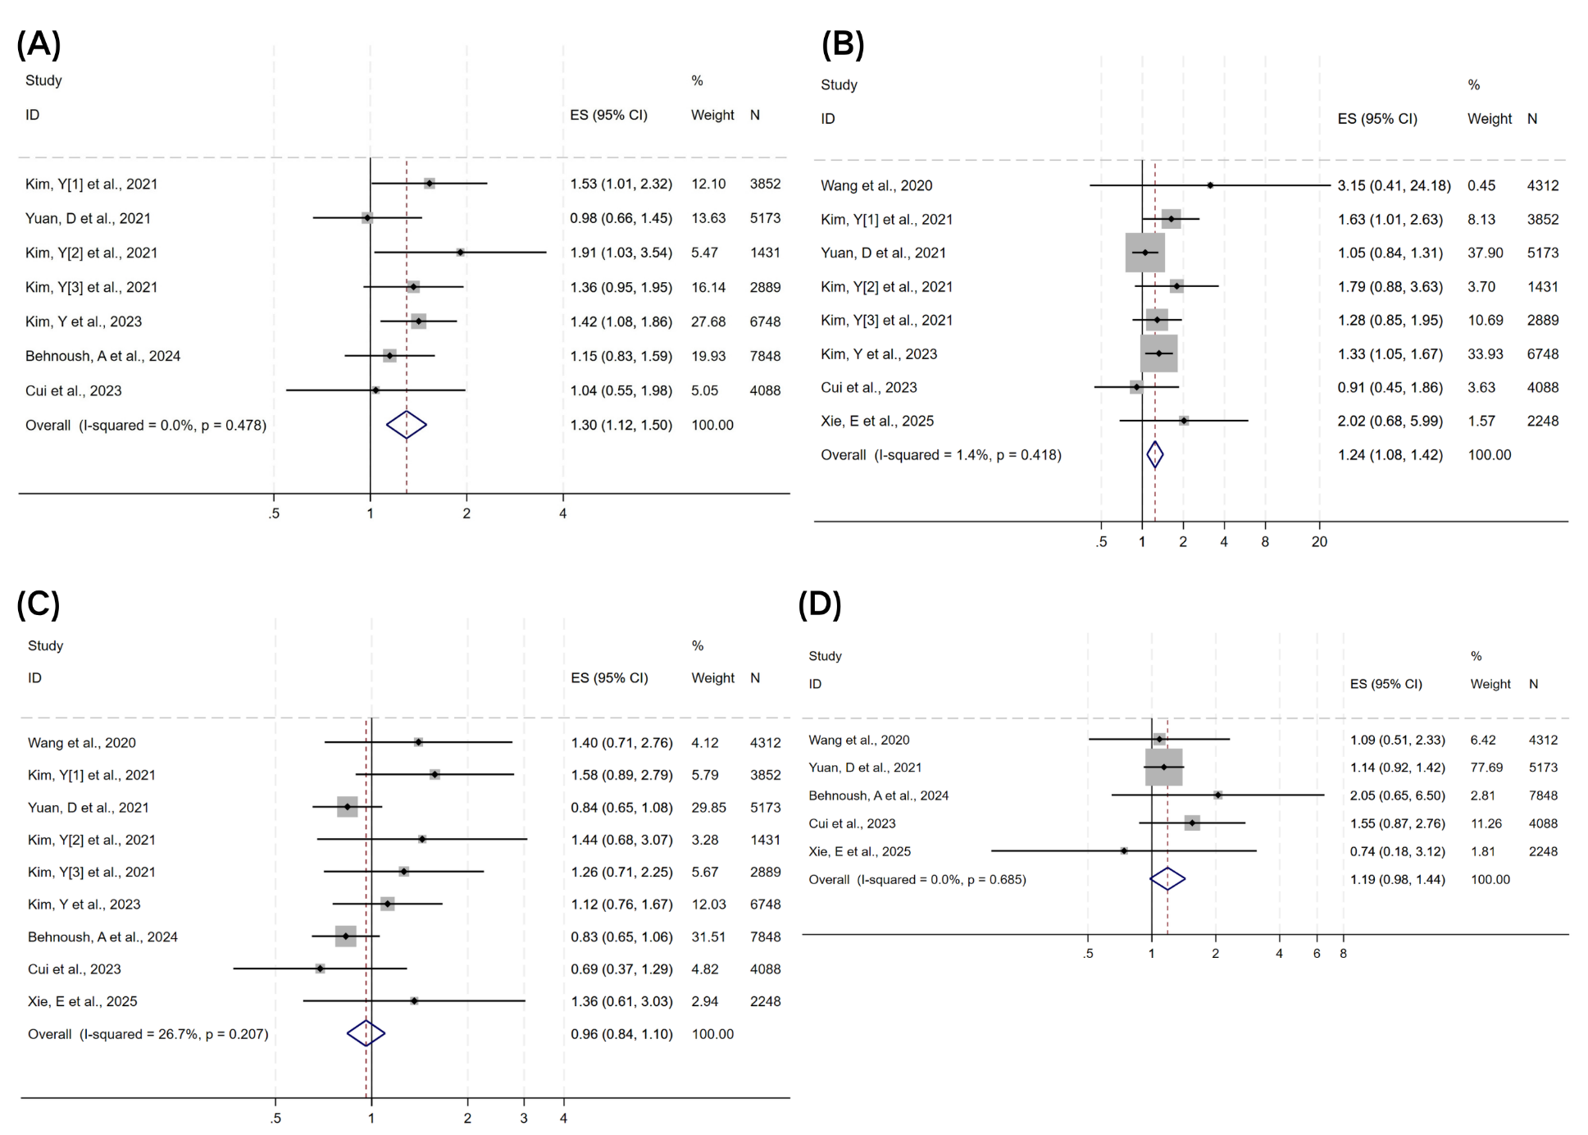
Abbreviations: (A) All-cause death; (B) Cardiac death; (C) Myocardial infarction; (D) Stroke; ES, effect size (pooled hazard ratio from fixed-effects model); 95% Cl, 95% confidence interval; N, sample size.
Figure. Sensitivity analysis of MACE by risk of bias domain
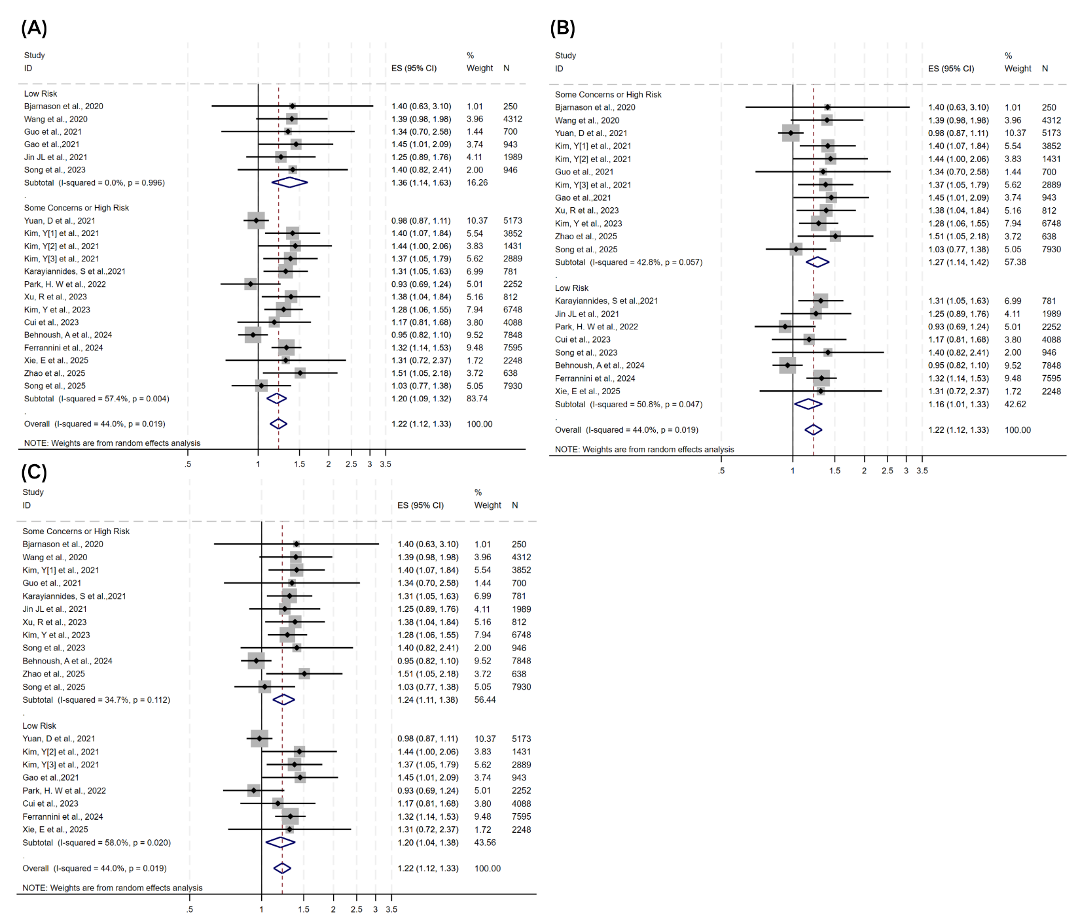
Abbreviations: (A) Confounding bias; (B) Missing Data; (C) Selection of Reported Results; ES, effect size (pooled hazard ratio from random-effects model); 95% Cl, 95% confidence interval; N, sample size.
Figure. Meta funnel plot for MACE

