Supplementary Materials

Calibrated local Gemma agents resist a fallible authority except when it conflicts with peer consensus
All files referenced below are archived in the open data deposit (Zenodo, DOI: 10.5281/zenodo.22798495), hereafter "the deposit".

S1. Pre-registration and dated amendment log
The full pre-registration (2026-08-09) and Amendments 1–5 are provided verbatim in the data deposit (preregistration_prestige_deference_2026-08-09.md, AMENDMENTS.md).

S2. Statistical report

S2.1 Data structure and statistical dependence
Agent-trials are not independent observations. The data hierarchy is: model (2) → condition → session/population (one static session per model × condition; three independent populations per model × evolutionary regime) → round (36 per static session; 12 per generation × 10 generations per population) → agent response (8 subject agents per round). Within a round, all eight agents answer the same item and observe the same transcript prefix (rotated order), so responses are clustered by item; within a population, generations inherit strategies, so trials are clustered by population. Accordingly: static confirmatory contrasts use GEE with exchangeable working correlation clustered by item, triangulated with exact tests and mixed-effects logits with item random intercepts; evolutionary analyses cluster by population (12 clusters) with per-population slope distributions as the primary descriptive unit. Sessions coincide with model × condition cells in the static design and are therefore absorbed by the fixed effects rather than modeled as random. The 14,400 agent-trials are the analysis rows; the effective sample sizes for inference are the numbers of items (static) and populations (evolutionary). Given the small number of population clusters, evolutionary GEE inference is interpreted alongside, rather than independently of, the paired population-level slope analysis.

Table S1. Effect sizes with 95% confidence intervals for the confirmatory static contrasts (qualifying critical trials; Wald intervals, sparse-event caveat)

Contrast | Rates (events/trials) | Risk difference (pp) | Risk ratio | Odds ratio
H4: C4-P vs C4-E | 19/296 = 6.4% vs 7/296 = 2.4% | +4.1 [+0.8, +7.3] | 2.71 [1.16, 6.36] | 2.83 [1.17, 6.84]
H1a: C1 vs C2 | 7/296 = 2.4% vs 2/296 = 0.7% | +1.7 [−0.3, +3.7] | 3.50 [0.73, 16.7] | 3.56 [0.73, 17.3]
H1b: C1 vs C0′ | 7/296 = 2.4% vs 10/296 = 3.4% | −1.0 [−3.7, +1.7] | 0.70 [0.27, 1.81] | 0.69 [0.26, 1.85]

All three H4 estimates exclude the null. H1a is compatible with anything from no effect to a several-fold increase; with 9 events in total its point estimate carries no confirmatory weight, which is why the main text reports it as suggestive at most.

Table S2. Exposure analysis: does deference decline as agents accumulate evidence of Agent-P’s unreliability? (exploratory)
Conformity on qualifying critical trials by block of rounds; trend = GEE logit of conformity on round number, clustered by item.

Condition | Rounds 1–12 | Rounds 13–24 | Rounds 25–36 | Trend β/round (SE), p
C1 prestige | 2/96 = 2.1% | 5/80 = 6.2% | 0/120 = 0.0% | −0.039 (0.036), .28
C4-P conflict-prestige | 8/96 = 8.3% | 10/80 = 12.5% | 1/120 = 0.8% | −0.055 (0.036), .13
C2 peer | 0/96 = 0.0% | 2/80 = 2.5% | 0/120 = 0.0% | +0.003 (0.015), .82
C4-E conflict-peer | 0/96 = 0.0% | 5/80 = 6.2% | 2/120 = 1.7% | +0.031 (0.027), .25
C0′ majority | 0/96 = 0.0% | 8/80 = 10.0% | 2/120 = 1.7% | +0.013 (0.027), .63
Pooled prestige (C1 + C4-P) |  |  |  | −0.050 (0.031), .11

No condition shows a monotonic decline. The mid-session elevation appears in every condition including the controls, indicating a block composition effect (item families qualifying under the §4.4 filter differ across blocks, hence the unequal block sizes) rather than a social dynamic. The near-floor final block in the prestige conditions is compatible with, but not evidence for, learned discounting of Agent-P; the pooled trend is non-significant. We therefore cannot separate resistance from rapid unreliability learning with this design; a condition in which Agent-P’s error rate varies across sessions would be required.

Table S3. Answer-position analysis (exploratory): conformity by position in the response sequence (1 = first subject to answer after Agent-P)

Condition | p1 | p2 | p3 | p4 | p5 | p6 | p7 | p8 | Trend β/position (SE), p
C1 | 0/37 | 2/37 | 0/37 | 1/37 | 0/37 | 3/37 | 0/37 | 1/37 | +0.070 (0.061), .25
C4-P | 3/37 | 2/37 | 3/37 | 4/37 | 3/37 | 1/37 | 3/37 | 0/37 | −0.125 (0.058), .032
In the conflict condition, later-answering agents followed the erroneous authority less, consistent with accumulating correct peer answers in the visible transcript diluting Agent-P’s influence (informational accumulation). No such gradient appears without peer conflict (C1). Exploratory; not pre-registered.

S2.2 Sensitivity triangulation
All confirmatory contrasts were run under three estimators — cluster-robust GEE (item clusters), mixed-effects logit (item random intercepts), and exact Fisher tests — as reported in the main text; full outputs are in the deposit (stats_report.txt).

S3. Calibration traces and model identification
Calibration traces for all evaluated models (screening and 200-item confirmation runs) are provided in the deposit (calibration_frozen.json, calibration_frozen_exclusions.json, CAL*.csv). gemma2:9b and gemma3:4b were run through Ollama; the tag used for the latter is gemma3:latest (4B parameters at the time of the study). Exact model digests are recorded in every run manifest.

S4. Evolved strategy corpus and aggregated trajectories
The complete strategy corpus (all generations, both regimes, all 12 populations; *_evolog.json) is provided in the deposit.

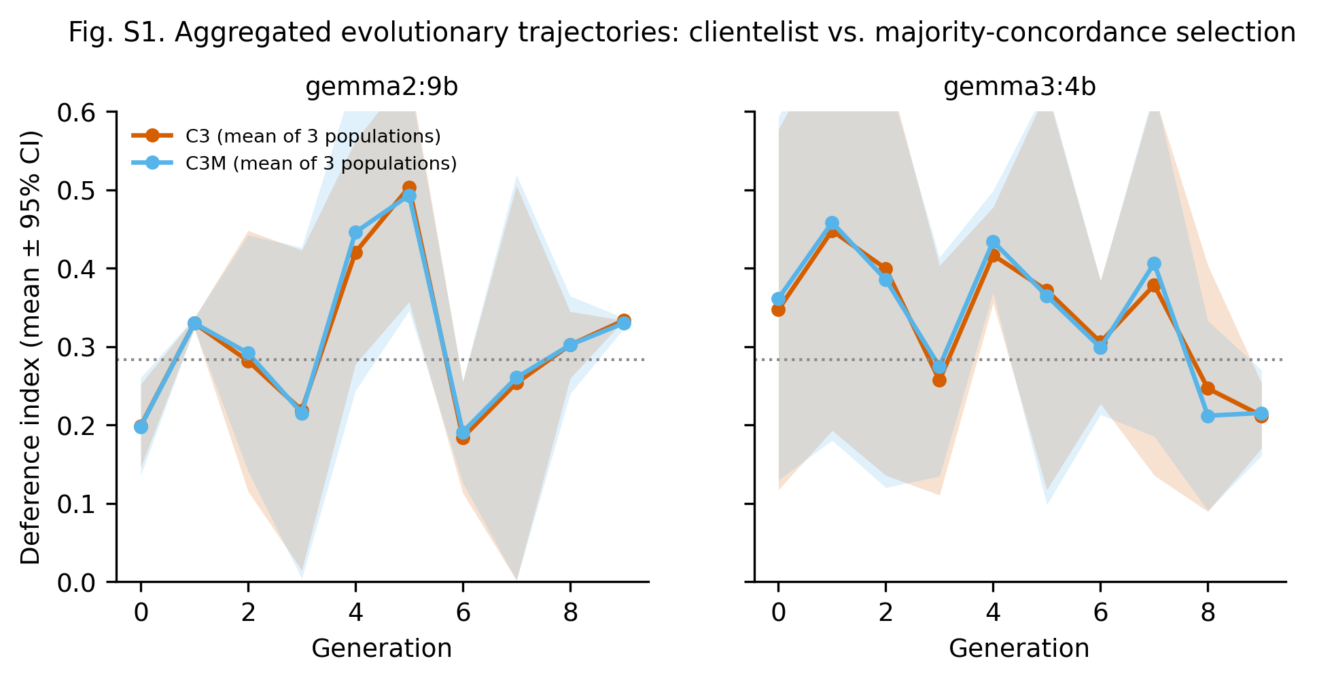Fig. S1. Aggregated evolutionary trajectories
Mean deference index per generation across the three independent populations per cell, with 95% confidence bands, for clientelist (C3) and majority-concordance (C3M) selection, by model. Complements main Fig. 3 (which shows all 12 individual populations) by making the average effect legible: the two regimes are indistinguishable and flat at the level expected from accurate answering. [figure file: figS1_evolution_aggregated.pdf]

S5. Run manifests and perimeter incident (operational details)
Every session carries a manifest (seed, framing hashes, platform version, model digest, server version), included in the deposit.
On 2026-08-11 an off-protocol copy of the platform on a remote server was modified by an external AI-assisted tool (an embedded API key and a cloud model were added) and used for exploratory runs outside the frozen roster. Resolution: SHA-256 digests of all five confirmatory static CSV files were computed on three independent copies (the canonical laptop, a cloud backup, and the remote server) and found identical; the canonical copy was designated by hash; the remote copy was renamed OUT-OF-PROTOCOL and quarantined; the exposed key was revoked; Amendment 4 was logged. No off-protocol run enters any analysis. The scientifically relevant fact — verified null impact on confirmatory data — is stated in the main text; these details are provided for auditability.

S6. Trial-level tidy dataset
master_tidy.csv: 14,400 agent-trials (2,880 static; 11,520 evolutionary) with condition, model, session/population, generation, round, item, family, agent, position, public and private responses, correctness and conformity indicators. Column dictionary in the deposit README.

