Supplementary information

Title: Soil nitrate mediates the responses of plant community production to the frequency of N addition in a temperate grassland: a decadal field experiment

Changchun Song, Yuqiu Zhang, Zhengru Ren, Haining Lu, Xu Chen, Ruoxuan Liu, Jungang Chen, Yunhai Zhang*

State Key Laboratory of Vegetation and Environmental Change, Institute of Botany, Chinese Academy of Sciences, Beijing 100093, China; University of Chinese Academy of Sciences, Yuquan Road, Beijing 100049, China
*Correspondence: E-mail: Yunhai Zhang (zhangyh670@ibcas.ac.cn).
Tel.: +86 10 62836581, Fax: +86 10 82596146.

Supplementary Tables
Table S1 Results of repeated-measures ANOVAs with blocks for the effects of the frequency of N addition, year, and their interaction on aboveground net primary productivity (ANPP) of community, grasses and forbs, and relative ANPP of grasses/forbs (%) across 2019 to 2020. Degrees of freedom (df), F-test values, and P-values are given.
 |  | Community ANPP |  |  | Grasses ANPP |  |  | Forbs ANPP |  |  | Relative ANPP of grasses/forbs
 | df | F | P |  | F | P |  | F | P |  | F | P
Block | 5,15 | 1.8 | 0.1820 |  | 2.4 | 0.0833 |  | 0.7 | 0.6001 |  | 0.9 | 0.5252
N frequency (F) | 3,15 | 6.1 | 0.0066 |  | 11.8 | 0.0003 |  | 0.2 | 0.9041 |  | 0.4 | 0.7475
Year (Y) | 1,20 | 2.5 | 0.1282 |  | 1.5 | 0.2364 |  | 0.2 | 0.6663 |  | 0.1 | 0.7536
F × Y | 3,20 | 1.9 | 0.1635 |  | 0.4 | 0.7894 |  | 1.2 | 0.3457 |  | 0.4 | 0.7360

Table S2 Results of ANOVAs with blocks for the effects of the frequency of N addition on the top 10 cm soil properties, i.e., soil ammonium (NH₄⁺–N), nitrate (NO₃⁻–N), and inorganic N (NH₄⁺–N + NO₃⁻–N) concentrations (mg kg⁻¹ dry soil), soil ammonium/nitrate (NH₄⁺–N/NO₃⁻–N) ratio, soil water content (SWC, %), and soil pH. The soil NH₄⁺–N, NO₃⁻–N, and inorganic N concentrations were natural logarithms transformed. Degrees of freedom (df), F-test values, and P-values were given.
 |  | NH₄⁺–N |  |  | NO₃⁻–N |  |  | Inorganic N |  |  | NH₄⁺–N/NO₃⁻–N ratio |  |  | SWC |  |  | pH
 | df | F | P |  | F | P |  | F | P |  | F | P |  | F | P |  | F | P
Block | 5,15 | 1.9 | 0.1624 |  | 1.3 | 0.3127 |  | 0.5 | 0.7709 |  | 0.9 | 0.5207 |  | 6.5 | 0.0021 |  | 2.8 | 0.0585
N addition frequency | 3,15 | 22.6 | <0.0001 |  | 6.3 | 0.0057 |  | 30.2 | <0.0001 |  | 3.5 | 0.0411 |  | 1.1 | 0.3619 |  | 13.2 | 0.0002

Supplementary Figure Legends
Fig. S1 Nitrogen addition frequency experiment design and location. Randomized complete block design was employed, with six blocks. Control treatment (ambient condition without N addition) and three frequencies of N addition (once per year [1 N addition year⁻¹], twice per year [2 N additions year⁻¹], and monthly [12 N additions year⁻¹], respectively) were set in a temperate grassland in Inner Mongolia, China. Nitrogen (as NH₄NO₃) addition started on September 1, 2010, and reapplied on the first day of each month thereafter for the 12 N additions yaer⁻¹ treatment, started on November 1, 2010, and reapplied on the first day of each June and November thereafter for the 2 N additions year⁻¹, and started on June 1, 2011, and reapplied on the first day of each June thereafter for the 1 N addition year⁻¹. That is, when the monthly N addition in August per year, it is with total annual equal N loadings, 10 g N m⁻² year⁻¹, in each N addition experimental plots.

Fig. S2 Generalized pairs plot showing pairwise relationships between soil and plant production variables: soil ammonium (NH₄⁺–N, mg kg⁻¹ dry soil), nitrate (NO₃⁻–N, mg kg⁻¹ dry soil), and inorganic N concentration (mg kg⁻¹ dry soil), soil NH₄⁺–N/NO₃⁻–N ratio, soil water content (SWC, %), soil pH, and the ANPP (g per 0.5 m²) of grasses, forbs and the whole plant community. Diagonal panels illustrate the density plot of each variable. The lower panels show scatter plots with linear smoothed lines and the upper give Pearson correlation coefficients (r) and their significance. Significant (P < 0.05) correlation lines were displayed, using blue and red to indicate positive and negative relationship, respectively. Asterisks denote significant levels: * < 0.05, ** < 0.01, and *** < 0.001, respectively.

Fig. S3 Initial model of pathway analysis to examine the influence of soil properties on ANPP of grasses and forbs with assumptions that 1) all soil properties were covaried; 2) all soil properties could directly influence ANPP of both grasses and forbs; and 3) ANPP of grasses and forbs were covaried. The soil NH₄⁺–N and NO₃⁻–N concentrations were natural logarithms transformed.

Fig. S1
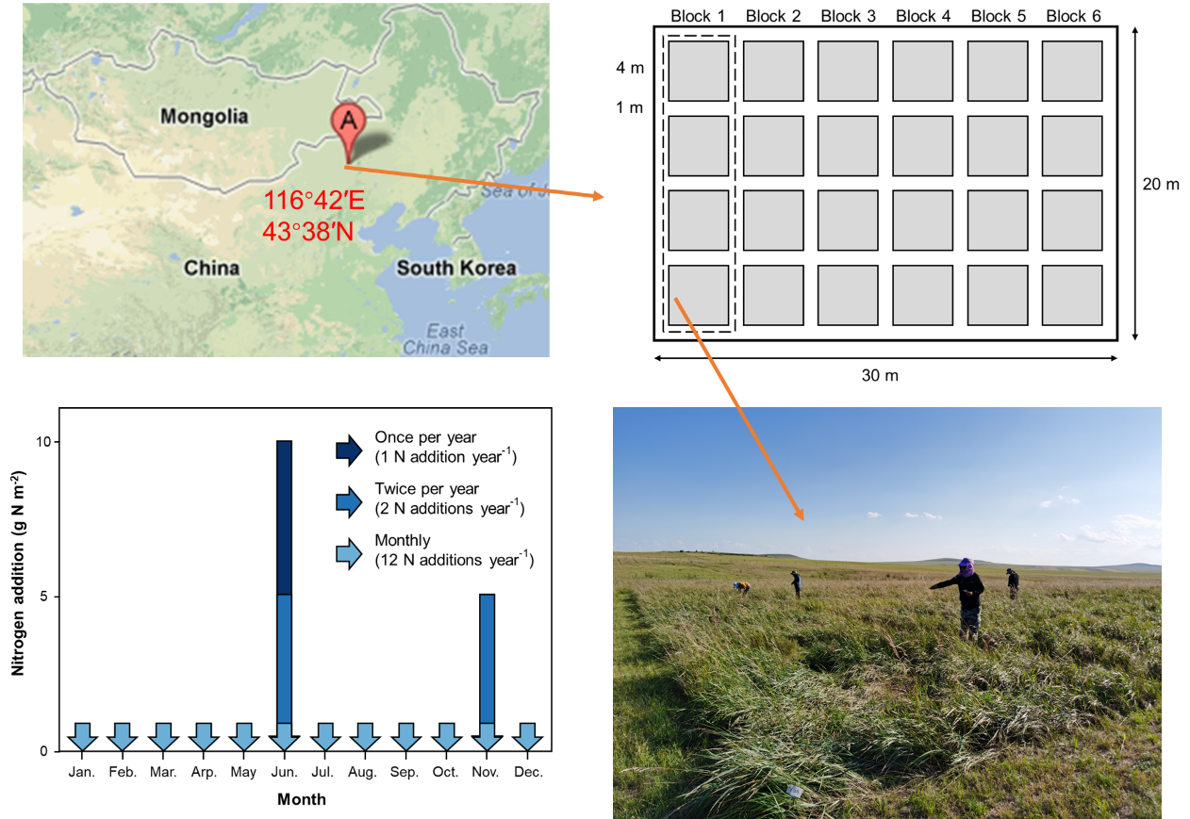

Fig. S2

Fig S3
