Supporting Information
Thrombolytic Research of Biomimetic Nanosystem Co-Loaded with Tenecteplase and DNase-Ⅰ in Acute Stroke with Large Vessel Occlusion
Shuhan Xu, M.D.^{1#}, Caiqi Yang, M.B.^{2#}, Xia Yang, M.B.¹, Liang Zhang, M.D.¹, Min Guan, M.D.¹, Yu Liao, M.D.¹, Jian Dai, M.D.^{2*}, Li’an Huang, M.D.^{1*}
#These authors contributed equally to this work.
*These authors are co-corresponding authors.
Affiliations:
¹ Department of Neurology, The First Affiliated Hospital of Jinan University, Guangzhou, Guangdong, China.
² Key Laboratory of Biomaterials of Guangdong Higher Education Institutes, Engineering Technology Research Center of Drug Carrier of Guangdong, Department of Biomedical Engineering, Jinan University, Guangzhou, Guangdong, China
Corresponding authors:
Li’an Huang, M.D.
Department of Neurology, The First Affiliated Hospital of Jinan University, NO 613 West Huangpu Rd, Tianhe Dt, Guangzhou, Guangdong, China. 510632. Email: huanglian1306@126.com
Jian Dai, M.D.
Key Laboratory of Biomaterials of Guangdong Higher Education Institutes, Engineering Technology Research Center of Drug Carrier of Guangdong, Department of Biomedical Engineering, Jinan University, NO 601 West Huangpu Rd, Tianhe Dt, Guangzhou, Guangdong, China. 510632. Email: daijian@jnu.edu.cn
Supplementary Figures

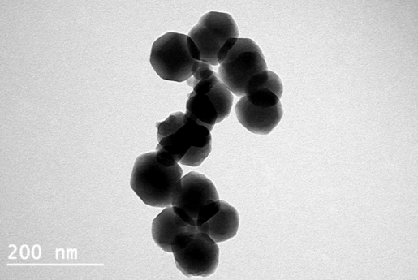
Figure S1 Representative TEM images of T@Z, scale bar = 200 nm;

Figure S2 (A) Size and polydispersity index (PDI) of TD@ZPM in PBS over one week. (B) Long-term stability of TD@Z and TD@ZPM nanoparticles assessed by hydrodynamic diameter measurement in PBS (pH 7.4) over 7 days; (n = 3).

Figure S3. Biocompatibility and cytotoxicity assessment of nanoparticles. (A) Representative images of hemolysis assays for PBS (negative control), TD@ZPM, and ddH₂O (positive control) at 0, 1, 2, 3 h and after centrifugation. (B) Quantitative analysis of hemolysis rates. (C) Relative turbidity changes in platelet-rich plasma following treatment with PBS (negative control), TD@ZPM, and thrombin (positive control). (D) Viability of HUVECs after treatment with ZIF-8 at various concentrations. (E) Viability of HUVECs after treatment with TD@Z at various concentrations, ****P < 0.0001; (n = 3).

Figure S4. In vitro thrombolysis evaluation. (A) Quantitative analysis of residual thrombus weight from AIS-LVO patients. At 60 minutes, pH 7.4: TD@Z vs T@Z, P < 0.0001; TD@ZPM vs TD@Z, P < 0.0001; (B) Quantitative analysis of residual weight for artificial clots. At 60 minutes, pH 7.4: TD@Z vs T@Z, P < 0.01; TD@ZPM vs TD@Z, P < 0.001, (n = 6).

Figure S5. Assessment of cerebral hemorrhage in PTS mice. (A) Representative coronal brain sections at 24 h after administration of TNK (2.5, 5.0, 7.5 mg kg⁻¹) or TD@ZPM (2.5 mg kg⁻¹ TNK equivalent); the 10.0 mg kg⁻¹ TNK group was excluded due to 80% mortality. (B) Quantitative analysis of hemorrhage volumes expressed as percentage of total brain volume, *P < 0.05, **P < 0.01, ****P < 0.0001; (n = 3).
Figure S6. In vivo safety evaluation of TD@ZPM in PTS mice. (A) Serum biochemical parameters (ALT, AST, UA, UREA, CREA) and coagulation profiles (APTT, PT, TT, FIB) measured 7 days after administration. (B) Representative HE-stained images of major organs (heart, liver, spleen, lung, and kidney) collected 7 days post-treatment, *P < 0.05, **P < 0.01; (n = 3).

Table S1 Encapsulation efficiency and drug loading efficiency of T@Z and D@Z
 | T@Z | D@Z
Total mass（mg） | 21.10 | 13.30
Drug input（mg） | 3.00 | 0.27
Encapsulated protein（mg） | 2.20 | 0.22
Encapsulation efficiency（%） | 73.19 | 82.40
Drug loading efficiency（%） | 10.40 | 1.65

