Iridium-Ruthenium Oxide for the Oxygen Evolution Reaction: Correlation between Calcination Temperature–Morphology–Activity Interplay

Claudelle Sybilline Anensong Djadock ^{a*}, Anele Nzimeni ª, Shawn Gouws ^{a*}
ª Department of Chemistry, Nelson Mandela University, Summerstrand, Gqeberha, 6001, South Africa

Corresponding author: shawn.gouws@mandela.ac.za

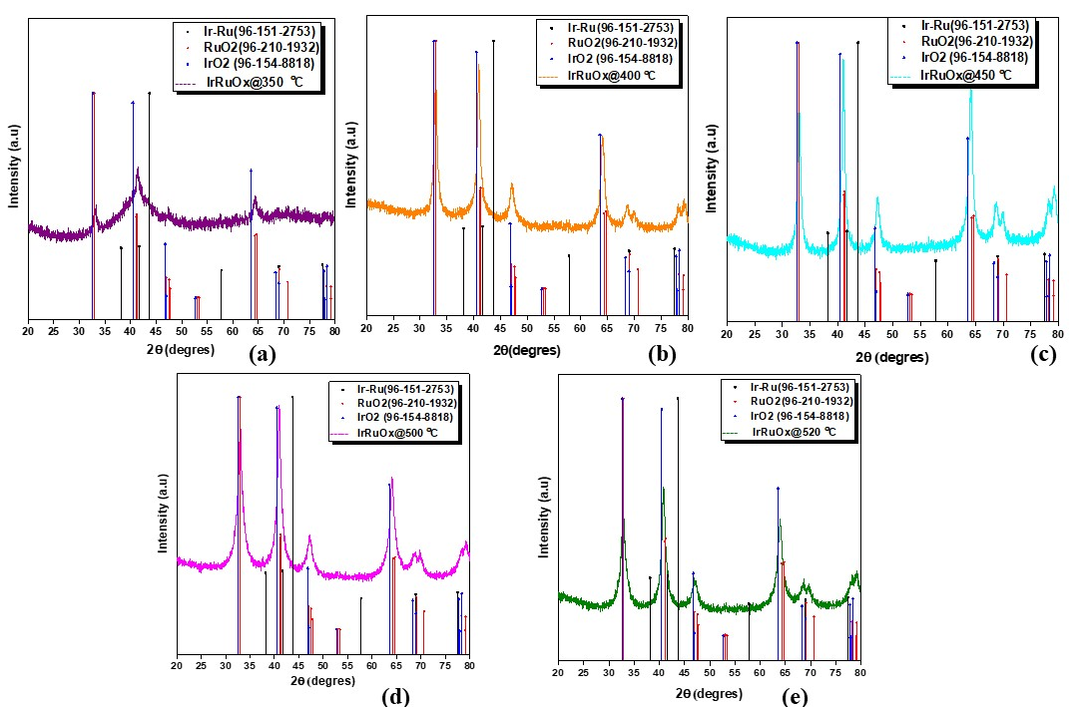

Figure S1. Powder XRD patterns of IrRuOx samples. Phase indices are shown for the rutile unit cell.

Figure S2. SEM images of catalyst@350

Figure S3. SEM images of catalyst@400

Figure S4. SEM images of catalyst@450

Figure S5. SEM images of catalyst@500

Figure S6. SEM images of catalyst@520

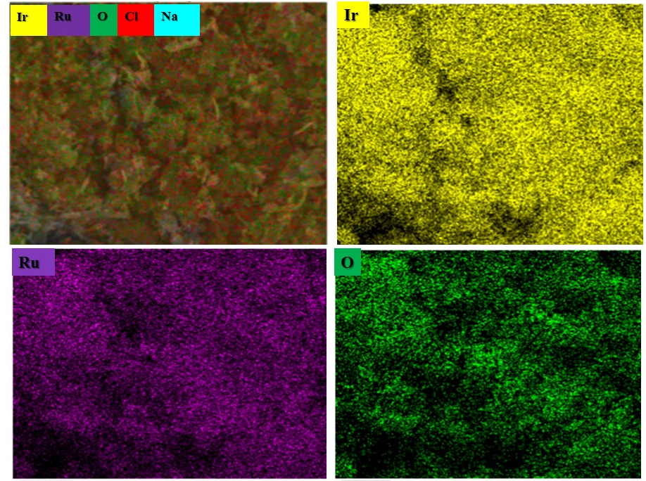
(a)
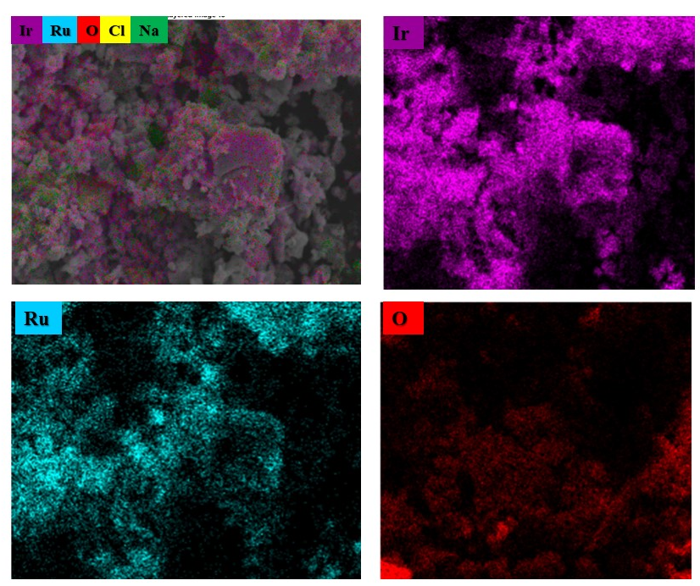

(b)
Figure S7. EDS elemental mapping images of IrRuO_{x} at 350 °C (a) and 450 °C (b)

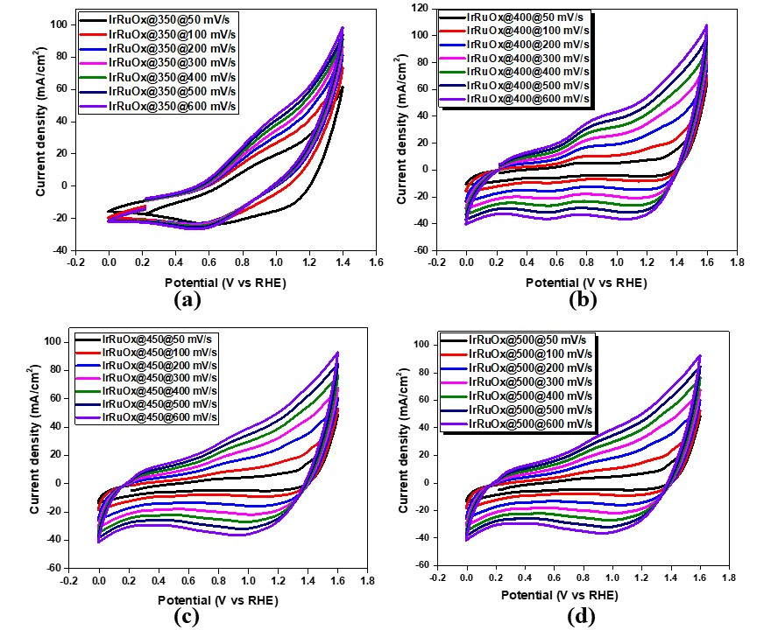

Figure S8. Cyclic voltammograms of IrRuO_{x}@350 °C (1) and IrRuO_{x}@400 °C (2), IrRuO_{x}@450 °C (3), IrRuO_{x}@500 °C (4), and IrRuO_{x}@520 °C (5) in 0.5 M H₂SO₄ under N₂ atmosphere at a scan rate of 50-600 mV/s

Table S1: Electrochemical data of IrRuOx@T recorded at a scan rate of 5 mV/s in 0.5 M H₂SO₄.
Electrocatalysts | Means of crystalline sizes (nm) | ɳ@10 (mV vs RHE | Tafel Potential  (mV/dec) | Cdl  (F/cm²) | ECSA  (cm²) | Mass loading  (g)
IrRuO_{x}@350 ºC | 16.3 | 251 | 68.97 | 2.75 | 78.57 | 0.0035±0.001
IrRuO_{x}@400 ºC | 18.09 | 242 | 45.47 | 20.03 | 572.29 | 0.0010±0
IrRuO_{x}@450 ºC | 20.7 | 335 | 58.60 | 32.23 | 920 | 0.0019±0.0001
IrRuO_{x}@500 ºC | 22.25 | 220 | 24.41 | 31.63 | 903.71 | 0.0038±0.001
IrRuO_{x}@520ºC | 16.04 | 254 | 42.70 | 0.63 | 18 | 0.0041±0.001

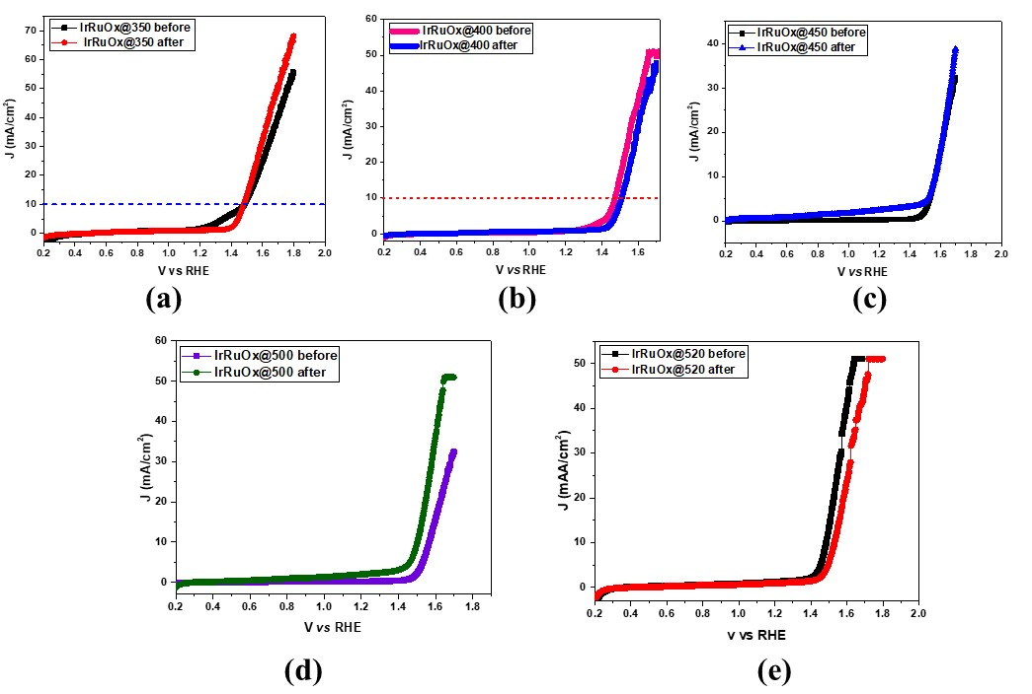
Figure S9. Before and after LSV curves of IrRuO_{x}@350 °C (1) and IrRuO_{x}@400 °C (2), IrRuO_{x}@450 °C (3), IrRuO_{x}@500 °C (4), and IrRuO_{x}@520 °C (5) in 0.5 M H₂SO₄ under N₂ atmosphere at a scan rate of 5 mV/s

