Supplementary data
S1. Total Phenolic Content
The total phenolic content (TPC) of different Phyllanthus species (Phyllanthus amarus, P. rheedei, P. urinaria, and P. sikkimensis) was determined using the Folin–Ciocalteu reagent (FCR) method.
Briefly, 1 mL of methanolic extract (1250 µg/mL for all samples except P. rheedei, which was prepared at 500 µg/mL) was mixed with 2 mL of Folin–Ciocalteu reagent (10% v/v in deionized water) and 2 mL of sodium carbonate solution (7% w/v in deionized water). The reaction mixture was then made up to a final volume of 10 mL with deionized water, thoroughly mixed, and incubated for 30 minutes at room temperature. For the calibration curve, gallic acid (GA) was used as the reference standard. Standard solutions of gallic acid at concentrations of 1, 2, 3, 4, and 5 µg/mL were prepared and treated in the same manner as the samples, along with a reagent blank.
The absorbance of the resulting blue-coloured complex was measured at 765 nm using a UV–Visible spectrophotometer. The total phenolic content of the extracts was calculated from the calibration curve constructed using gallic acid and expressed as µg gallic acid equivalents (GAE) per mg of dry sample.

S2. Total Flavonoid Content
The total flavonoid content (TFC) of different Phyllanthus species (Phyllanthus amarus, P. rheedei, P. urinaria, and P. sikkimensis) was determined using the aluminium chloride (AlCl₃) colorimetric assay. The details Quercetin and rutin were used as reference standards for the estimation of total flavonoid content. Calibration curves were constructed using quercetin at concentrations of 5, 10, 20, 32, and 100 µg/mL, and rutin at concentrations of 10, 20, 40, 64, and 80 µg/mL. For sample analysis, 4 mL of methanolic extract (5000 µg/mL) was transferred into a 10 mL volumetric flask containing 0.2 mL of saturated potassium acetate solution (1 M). After a few minutes, 0.2 mL of aluminium chloride solution (10% w/v in deionized water) was added, and the volume was made up to 10 mL with distilled water. The reaction mixtures were mixed thoroughly and incubated in the dark for 30–60 minutes at room temperature. A similar procedure was followed for the preparation of standard and blank solutions. The absorbance was measured at 436.5 nm using a Shimadzu UV–Visible spectrophotometer. The total flavonoid content was calculated from the calibration curves and expressed as µg quercetin equivalents (QE)/mg and µg rutin equivalents (RE)/mg of dry sample.
S3. Details HPLC data
P. amarus HPLC chromatogram
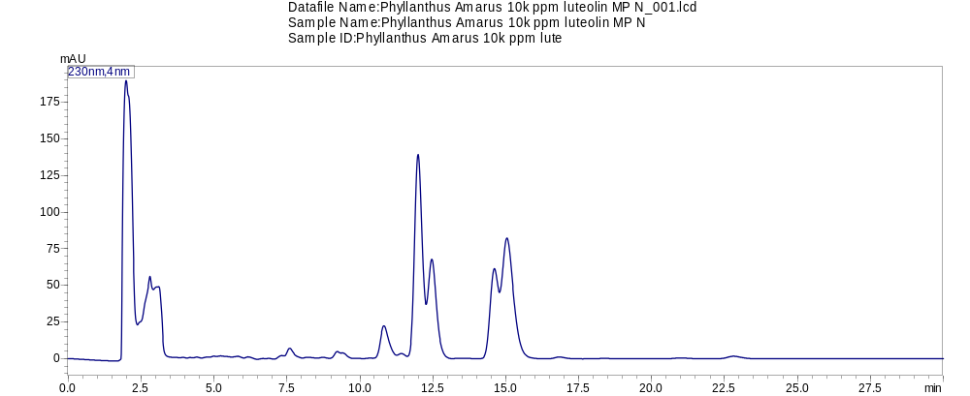
Column1 | Column2 | Column3 | Column4 | Column5 | Column6 | Column7
Peak# | Ret. Time | Area | Height | Area% | Height% | A/H
1 | 1.986 | 3508316 | 182807 | 41.192 | 36.764 | 19.191 | Gallic acid
2 | 2.808 | 153301 | 13771 | 1.8 | 2.77 | 11.132 | Ellagic acid
3 | 3.103 | 281496 | 22941 | 3.305 | 4.614 | 12.27
4 | 3.942 | 2130 | 325 | 0.025 | 0.065 | 6.556
5 | 4.178 | 1734 | 284 | 0.02 | 0.057 | 6.099
6 | 4.409 | 4380 | 518 | 0.051 | 0.104 | 8.448
7 | 4.819 | 2371 | 98 | 0.028 | 0.02 | 24.267
8 | 4.994 | 2671 | 391 | 0.031 | 0.079 | 6.825
9 | 5.22 | 6891 | 451 | 0.081 | 0.091 | 15.294
10 | 5.819 | 9706 | 828 | 0.114 | 0.166 | 11.724
11 | 6.16 | 14105 | 1010 | 0.166 | 0.203 | 13.963
12 | 6.675 | 2638 | 278 | 0.031 | 0.056 | 9.493
13 | 6.882 | 1768 | 256 | 0.021 | 0.051 | 6.917
14 | 7.326 | 9932 | 758 | 0.117 | 0.152 | 13.108
15 | 7.592 | 79957 | 5675 | 0.939 | 1.141 | 14.089
16 | 8.189 | 8912 | 581 | 0.105 | 0.117 | 15.33
17 | 8.733 | 6960 | 603 | 0.082 | 0.121 | 11.545
18 | 9.223 | 24411 | 2329 | 0.287 | 0.468 | 10.481
19 | 9.41 | 8065 | 731 | 0.095 | 0.147 | 11.033
20 | 10.828 | 402454 | 21228 | 4.725 | 4.269 | 18.959
21 | 11.426 | 17406 | 1574 | 0.204 | 0.317 | 11.057
22 | 11.996 | 1845816 | 117607 | 21.672 | 23.652 | 15.695 | may be phyllanthin
23 | 12.468 | 620727 | 41564 | 7.288 | 8.359 | 14.934 | may be Hypophyllanthin
24 | 14.61 | 471896 | 31174 | 5.541 | 6.269 | 15.138 | may be Nirtetralin
25 | 15.041 | 1029034 | 49460 | 12.082 | 9.947 | 20.805 | may be Niranthin

P. urenaria HPLC chromatogram

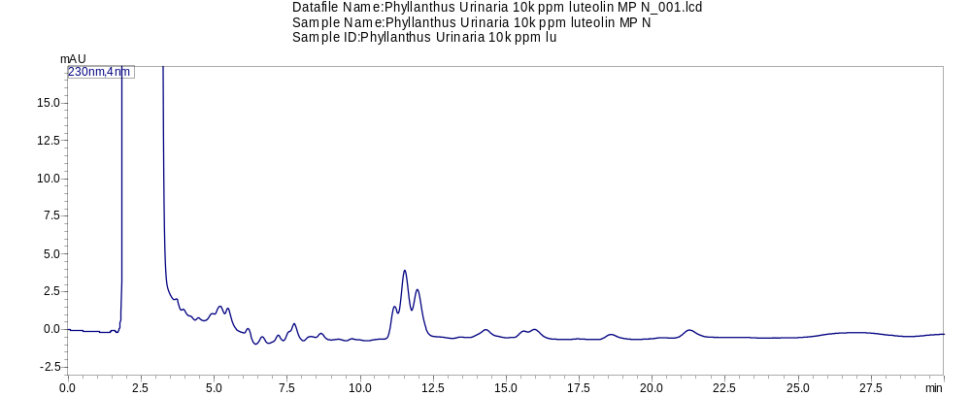
Peak# | Ret. Time | Area | Height | Area% | Height% | A/H
1 | 1.99 | 10977594 | 570018 | 95.564 | 94.341 | 19.258 | Gallic acid
2 | 2.813 | 362172 | 23567 | 3.153 | 3.901 | 15.368 | Ellagic acid
3 | 3.703 | 2234 | 311 | 0.019 | 0.051 | 7.191 | Ellagic acid
4 | 5.201 | 4629 | 438 | 0.04 | 0.072 | 10.578
5 | 5.466 | 5281 | 596 | 0.046 | 0.099 | 8.867
6 | 6.151 | 4776 | 508 | 0.042 | 0.084 | 9.401
7 | 6.639 | 4589 | 424 | 0.04 | 0.07 | 10.826
8 | 7.19 | 4151 | 407 | 0.036 | 0.067 | 10.187
9 | 7.739 | 8117 | 735 | 0.071 | 0.122 | 11.044
10 | 8.655 | 3185 | 284 | 0.028 | 0.047 | 11.209
11 | 11.173 | 12113 | 1023 | 0.105 | 0.169 | 11.84
12 | 11.526 | 36023 | 2713 | 0.314 | 0.449 | 13.278
13 | 11.957 | 26138 | 1801 | 0.228 | 0.298 | 14.513
14 | 14.298 | 8130 | 398 | 0.071 | 0.066 | 20.448
15 | 15.845 | 2082 | -8 | 0.018 | -0.001 | -246.19
16 | 15.962 | 3049 | 192 | 0.027 | 0.032 | 15.881
17 | 18.583 | 7896 | 308 | 0.069 | 0.051 | 25.603
18 | 21.27 | 15005 | 494 | 0.131 | 0.082 | 30.402

P. sikkiminises HPLC chromatogram

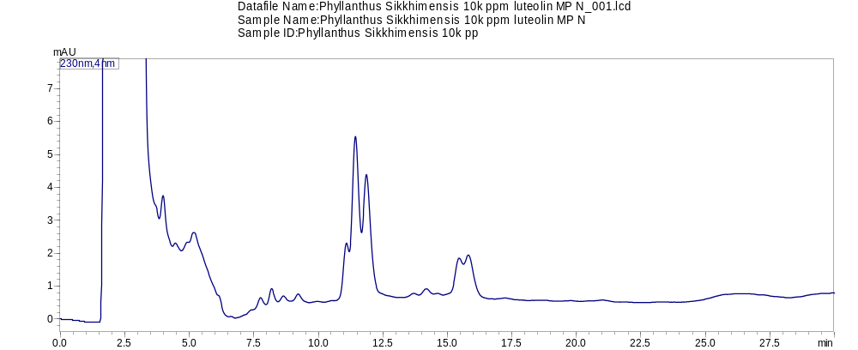

Peak# | Ret. Time | Area | Height | Area% | Height% | A/H
1 | 2.09 | 17903323 | 916283 | 95.035 | 90.894 | 19.539 | Gallic acid
2 | 2.809 | 460725 | 42634 | 2.446 | 4.229 | 10.807 | Ellagic acid
3 | 3.122 | 331820 | 39138 | 1.761 | 3.882 | 8.478 | Ellagic acid
4 | 3.983 | 9779 | 965 | 0.052 | 0.096 | 10.138
5 | 5.164 | 12441 | 521 | 0.066 | 0.052 | 23.893
6 | 7.76 | 3615 | 278 | 0.019 | 0.028 | 12.997
7 | 8.189 | 5075 | 432 | 0.027 | 0.043 | 11.753
8 | 8.649 | 1564 | 138 | 0.008 | 0.014 | 11.307
9 | 9.213 | 3236 | 221 | 0.017 | 0.022 | 14.664
10 | 11.09 | 7927 | 685 | 0.042 | 0.068 | 11.567
11 | 11.44 | 43250 | 3189 | 0.23 | 0.316 | 13.561
12 | 11.867 | 34913 | 2296 | 0.185 | 0.228 | 15.209
13 | 13.705 | 1091 | 72 | 0.006 | 0.007 | 15.077
14 | 14.193 | 2826 | 173 | 0.015 | 0.017 | 16.354
15 | 14.623 | 316 | 30 | 0.002 | 0.003 | 10.399
16 | 15.46 | 6764 | 449 | 0.036 | 0.045 | 15.06
17 | 15.818 | 9960 | 573 | 0.053 | 0.057 | 17.378

P. Rheedi HPLC chromatogram
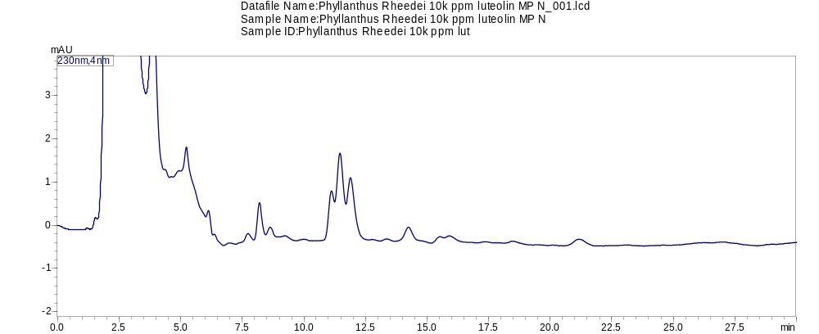

Peak# | Ret. Time | Area | Height | Area% | Height% | A/H
1 | 2.117 | 1517883 | 78167 | 75.032 | 64.911 | 19.419 | Gallic acid
2 | 2.814 | 124201 | 11166 | 6.14 | 9.272 | 11.123 | Ellagic acid
3 | 3.117 | 263339 | 23036 | 13.017 | 19.13 | 11.431 | Ellagic acid
4 | 3.884 | 43352 | 2656 | 2.143 | 2.205 | 16.324
5 | 4.283 | 283 | -1 | 0.014 | -0.001 | -236.827
6 | 5.072 | 326 | -11 | 0.016 | -0.009 | -31.003
7 | 5.227 | 5156 | 555 | 0.255 | 0.461 | 9.294
8 | 6.124 | 2326 | 299 | 0.115 | 0.248 | 7.774
9 | 6.375 | 362 | 61 | 0.018 | 0.051 | 5.914
10 | 6.976 | 610 | 41 | 0.03 | 0.034 | 14.818
11 | 7.727 | 2138 | 164 | 0.106 | 0.137 | 13.009
12 | 8.195 | 9697 | 792 | 0.479 | 0.658 | 12.244
13 | 8.629 | 2246 | 190 | 0.111 | 0.158 | 11.805
14 | 9.236 | 1152 | 65 | 0.057 | 0.054 | 17.858
15 | 10.003 | 628 | 36 | 0.031 | 0.03 | 17.264
16 | 11.12 | 5812 | 506 | 0.287 | 0.42 | 11.483
17 | 11.467 | 15027 | 1152 | 0.743 | 0.957 | 13.044
18 | 11.896 | 12519 | 831 | 0.619 | 0.69 | 15.068
19 | 12.496 | -2 | -1 | 0 | -0.001 | 2.257
20 | 13.369 | 732 | 47 | 0.036 | 0.039 | 15.504
21 | 14.243 | 6265 | 307 | 0.31 | 0.255 | 20.422
22 | 15.519 | 1057 | 69 | 0.052 | 0.057 | 15.388
23 | 15.903 | 1328 | 69 | 0.066 | 0.057 | 19.252
24 | 17.366 | 438 | 23 | 0.022 | 0.019 | 18.896
25 | 18.506 | 1130 | 53 | 0.056 | 0.044 | 21.245
26 | 21.178 | 4965 | 149 | 0.245 | 0.124 | 33.27

S4: GC-MS/MS report of hexane extract of P.sikkimensis
