Supporting Information
Quantifying Structural and Elemental Contributions to Local Electric Fields on Metal Nanoclusters with Interpretable Machine Learning
Runze Zhao, Jiaqi Yang, Qiang Li, Fanglin Che*
Department of Chemical Engineering, Worcester Polytechnic Institute, Worcester, MA 01609, USA
* Corresponding author: fche@wpi.edu

S1. Ir-aligned modeling dataset

S1.1 Dataset scope
All analyses use the Ir-aligned modeling dataset summarized in Table S1. Alignment retains only site-label and cluster-size combinations represented for Ir, enabling matched-site comparisons across metals. The final distribution by cluster size is shown in Figure S1.
Table S1. Scope of the Ir-aligned modeling dataset used in all analyses.
Dataset item | Value
Metals | Co, Cu, Fe, Ir, Ni, Pd, Pt, Rh, and Ru
Cluster sizes (atoms) | 20, 25, 30, 40, 45, 50, 60, 65, 70, 75, 80, and 90
External fields | -0.5 to +0.5 V/Å in 0.1 V/Å steps (11 values)
Alignment rule | Retain site-label and cluster-size pairs represented for Ir
Retained adsorption sites | 1,477
Final site-field records | 15,851
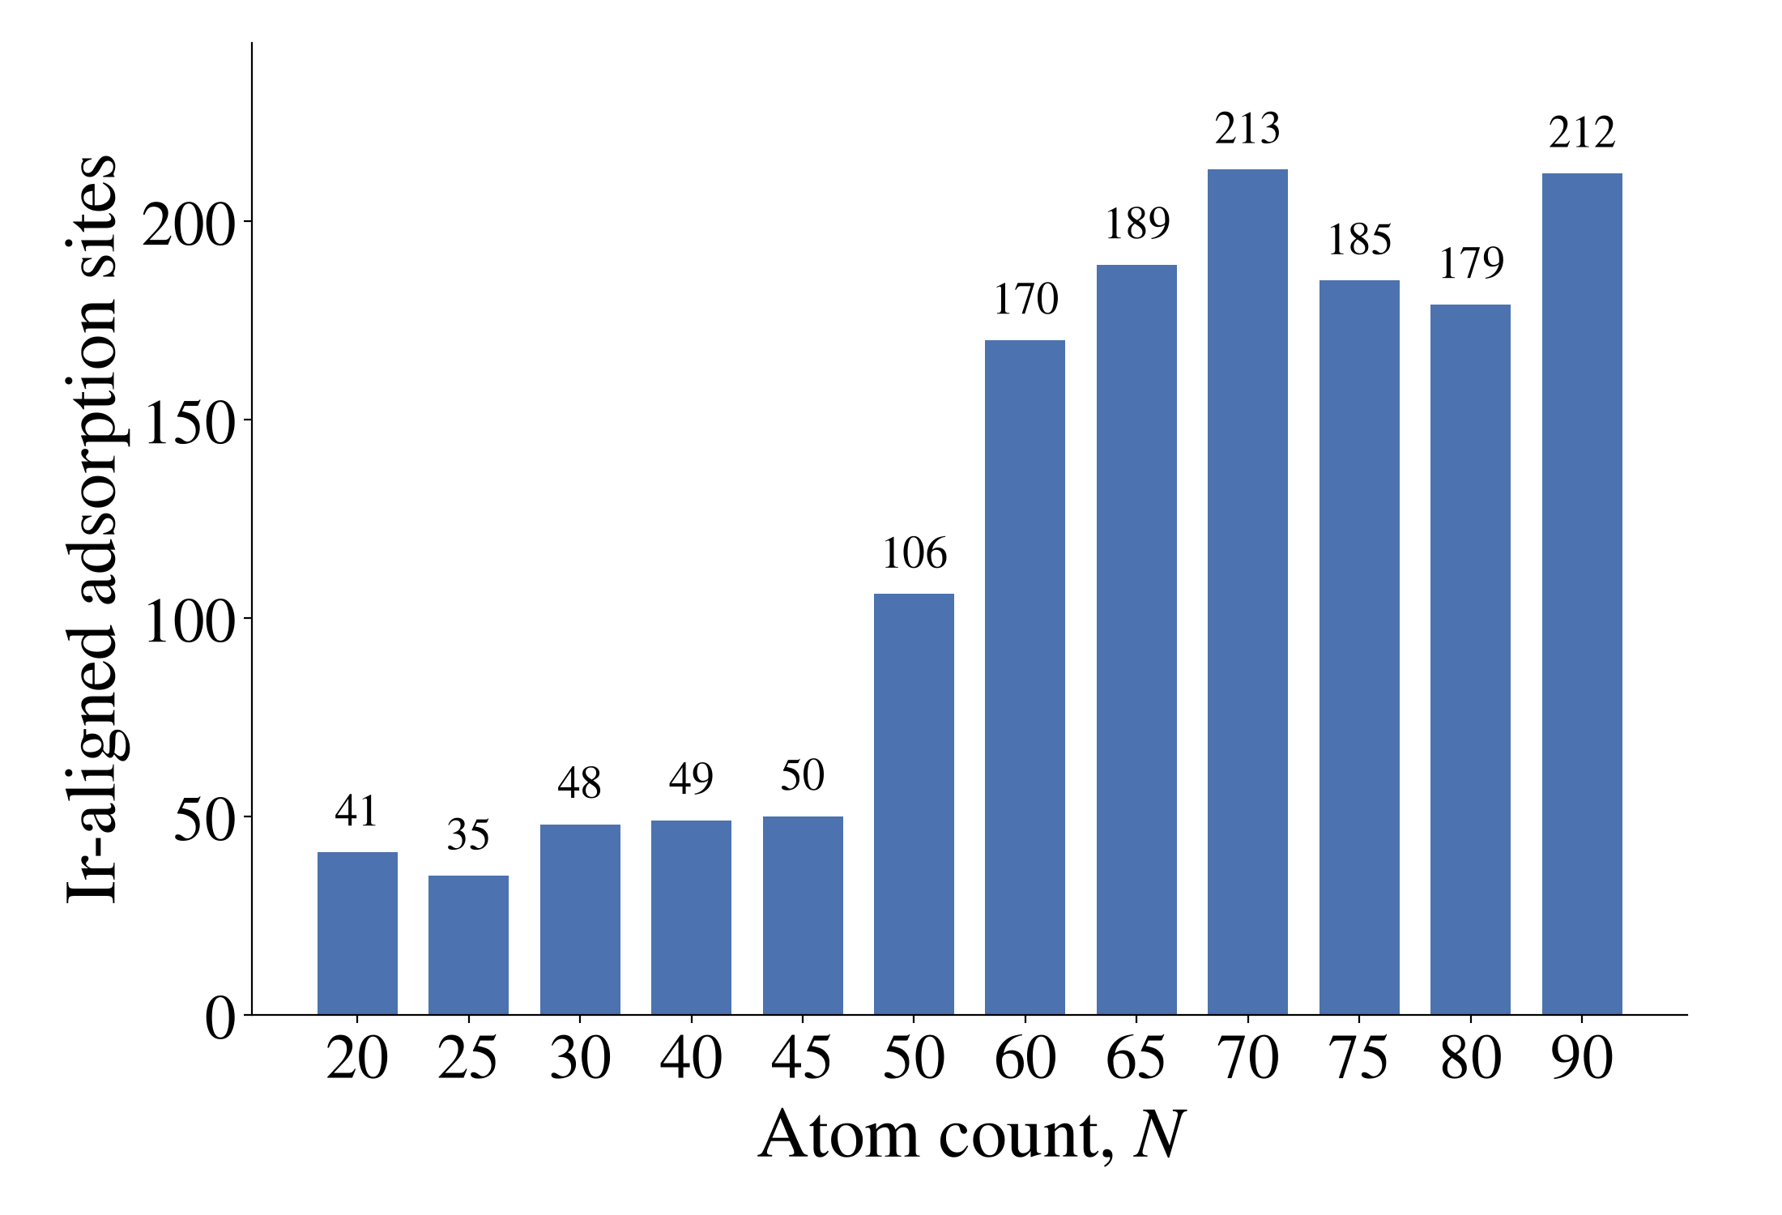

Figure S1. Ir-aligned adsorption-site counts by cluster size (1,477 sites total).

S2. Structural-similarity filtering with per-size distance cutoffs
Structural redundancy was evaluated within each metal-size group using fourteen standardized geometric descriptors. A sequential sweep retained the first unmerged site and removed later sites within distance τ. The size-specific cutoffs were selected by preliminary ΔLEF cross-validation and are therefore target-informed preprocessing parameters (Table S2).
Table S2. Per-size structural-similarity cutoffs and the preliminary ΔLEF cross-validation R² values used to select them.
Atom count | Distance cutoff τ | Selection score R² (%)
20 | 1.75 | 96.5
25 | 0.35 | 97.9
30 | 0.05 | 89.8
40 | 2.20 | 88.7
45 | 1.90 | 81.5
50 | 0.30 | 90.0
60 | 0.80 | 86.8
65 | 1.10 | 87.7
70 | 0.70 | 88.5
75 | 1.20 | 85.1
80 | 1.60 | 85.5
90 | 1.20 | 85.9

S3. Descriptor definitions
Descriptors are grouped as global cluster, local site, elemental, and site-resolved electronic inputs (Table S3); definitions and formulas are listed in Table S4. For compactness, the electronic rows in Table S3 denote the corresponding s-, p-, and d-band quantities and their spin-resolved variants used in the model.

Table S3. Descriptors used to encode each site, grouped into the global, local, and elemental families. CM: center of mass; CN: coordination number; GCN: generalized coordination number; DOS: density of states
Family | Descriptor | Definition | Units
Global | Atom_Count | Number of atoms in the nanocluster | count
Global | Cluster_Diameter_at_COM | Cluster diameter measured in the CM plane | Å
Global | Tip_Height | Height of the highest atom above the CM | Å
Global | Surface_Atoms_Ratio | Fraction of cluster atoms exposed at the surface | —
Global | Surface_Area_to_Volume_Ratio | Ratio of cluster surface area to volume | Å⁻¹
Global | Radius_of_Gyration | Root-mean-square distance of atoms from the CM | Å
Global | Shape_Anisotropy | Shape anisotropy derived from the gyration tensor | —
Global | Fractal_Dimension_DB | Box-counting fractal dimension of the cluster | —
Global | Avg_Distance | Mean interatomic distance in the cluster | Å
Global | Distance_STD | Standard deviation of the interatomic distances | Å
Global | Max_Pair_Distance | Largest interatomic distance in the cluster | Å
Local | Height | Height of the site above the CM along the field axis | Å
Local | Distance_to_Center | Distance from the site to the cluster center | Å
Local | Radial_Distance_to_COM | Lateral distance of the site from the cluster axis | Å
Local | Adsorption_Site | Categorical site label, one-hot encoded; only top sites are included | category
Local | Anchor_First_Neighbor_Count | Number of first-shell neighbors of the site | count
Local | Anchor_Second_Neighbor_Count | Number of second-shell neighbors of the site | count
Local | Anchor_First_Neighbor_Distance_Mean | Mean first-neighbor distance of the site | Å
Local | Anchor_First_Neighbor_Distance_STD | Standard deviation of the first-neighbor distances | Å
Local | Anchor_First_CN_Mean | Mean first-shell CN of the site neighbors | —
Local | CN_1 | CN of the adsorption site in the first shell | count
Local | GCN | GCN, normalized by CN_max = 12 | —
Elemental | band_center | First moment of the projected density of states | eV
Elemental | band_width | Second moment (width) of the projected density of states | eV
Elemental | band_filling | Integrated occupancy of the band | electrons
Elemental | electron_count | Number of electrons in the band | electrons
Elemental | band_skewness | Third standardized moment of the DOS | —
Elemental | band_kurtosis | Fourth standardized moment of the DOS | —
Elemental | band_upper_edge | Upper energy edge of the band | eV
Elemental | band_lower_edge | Lower energy edge of the band | eV

Table S4. Mathematical definitions of the computed descriptors. $r_{i}$: atomic positions; $r_{cm}$: center of mass; $ρ(E)$: projected DOS; $E_{F}$: Fermi level. The global, local, and elemental family are marked with light blue, green, and purple, respectively.
Descriptor | Formula | Notes
Radius_of_Gyration | Rg=1Ni​|ri-rcm|2 | $N$ = number of atoms
Shape_Anisotropy | $$κ^{2}=1-3 \frac{λ_{1}λ_{2}+λ_{2}λ_{3}+λ_{3}λ_{1}}{(λ_{1}+λ_{2}+λ_{3})^{2}}$$ | $λ_{i}$ = eigenvalues of the gyration tensor $S$
Gyration_tensor | Sab=1Ni​(ri,a-rcm,a)(ri,b-rcm,b) | Auxiliary 3×3 tensor; its eigenvalues λ1, λ2, λ3 enter Radius_of_Gyration and Shape_Anisotropy. rcm: center of mass; a, b: Cartesian axes.
Surface_Area_to_Volume_Ratio | $$A/V$$ | surface area and volume of the cluster convex hull
Fractal_Dimension_DB | $$D=-\frac{\text{ln}N(ε)}{\text{ln}ε}$$ | $N(ε)$ = number of boxes of edge $ε$ needed to cover the atoms (box-counting)
Avg_Distance | ⟨d⟩=2N(N-1)i<j​|ri-rj| | mean over all atom pairs
Distance_STD | $$σ_{d}=\sqrt{⟨d^{2}⟩-⟨d⟩^{2}}$$ | interatomic distances spread
Max_Pair_Distance | $$d_{\text{max}}=\underset{i,j}{\text{max}}|r_{i}-r_{j}|$$ | largest interatomic distance
Tip_Height | $$h_{tip}=\underset{i}{\text{max}}(z_{i}-z_{cm})$$ | z measured along the field axis
Surface_Atoms_Ratio | $$N_{surf}/N$$ | $N_{surf}$ = atoms with below-bulk coordination
Height | $$h=z_{s}-z_{cm}$$ | site height above the COM along the field axis
Radial_Distance_to_COM | $$ρ=\sqrt{(x_{s}-x_{cm})^{2}+(y_{s}-y_{cm})^{2}}$$ | lateral distance of the site from the cluster axis
Distance_to_Center | $$|r_{s}-r_{cm}|$$ | site-to-COM distance
CN_1 | CN1=j≠s​Θ(rc-|rs-rj|) | $Θ$ = Heaviside step; $r_{c}$ = first-shell cutoff
GCN | GCN=1CNmaxj∈nn(s)​CNj | generalized coordination number; $CN_{\text{max}}$ = 12
Anchor_First_Neighbor_Distance_Mean | ⟨d1⟩=1CN1j∈nn1​|rs-rj| | mean first-shell neighbor distance
Anchor_First_Neighbor_Distance_STD | $$σ_{d_{1}}=\sqrt{⟨d_{1}^{2}⟩-⟨d_{1}⟩^{2}}$$ | first-shell neighbor distances spread
band_center | $$ε_{c}=\frac{∫E ρ(E) dE}{∫ρ(E) dE}$$ | first moment of the projected DOS $ρ(E)$
band_width | $$W=\sqrt{\frac{∫(E-ε_{c})^{2}ρ dE}{∫ρ dE}}$$ | second central moment (standard deviation)
band_skewness | $$s=\frac{∫(E-ε_{c})^{3}ρ dE}{W^{3}∫ρ dE}$$ | third standardized moment
band_kurtosis | $$k=\frac{∫(E-ε_{c})^{4}ρ dE}{W^{4}∫ρ dE}$$ | fourth standardized moment
band_filling | $$f=\frac{\int_{-∞}^{E_{F}}{ρ} dE}{∫ρ dE}$$ | $E_{F}$ = Fermi level
electron_count | $$n=\int_{-∞}^{E_{F}}{ρ}(E) dE$$ | occupied states in the band
band_upper_edge / band_lower_edge | $$ρ(E_{u})=ρ(E_{l})=ρ_{thr}$$ | band edges; each band also resolved into spin-up and spin-down

S4. Projected density of states and its size dependence
The d-band center is site specific: it varies across adsorption sites and cluster sizes but is invariant across the external-field replicas of a given physical site in the modeling matrix. Figure S2 removes the field replicas and reports, for each metal and atom count, the mean over retained physical sites in the selected cluster structure. Representative s- and p-projected densities of states evolve from discrete cluster peaks toward broader distributions with increasing size (Figure S3). Together with the site-resolved d-band-center trends in Figure S2, these results motivate inclusion of higher-order band-shape moments and band edges, which provide information beyond the conventional d-band center and allow the machine-learning analysis to test whether electronic contributions to the LEF are encoded in more complex DOS characteristics.

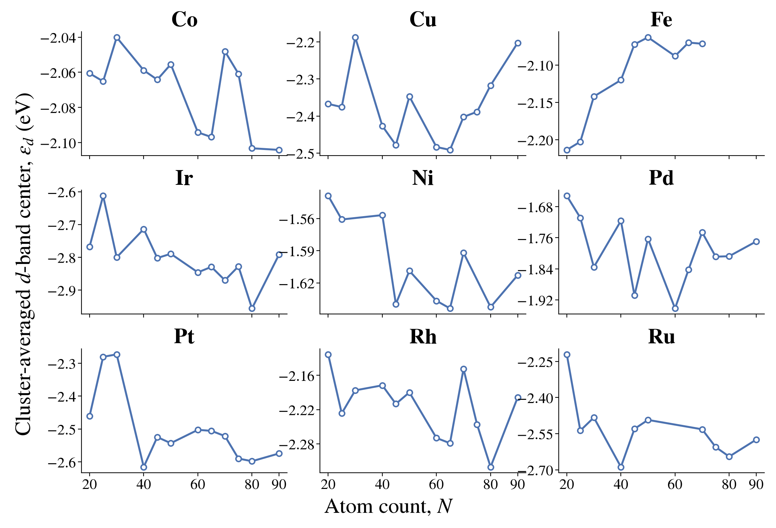
Figure S2. Cluster-averaged d-band center for the final selected structure at each atom count. Each point is the mean over retained Ir-aligned physical sites after external-field replicas are removed. Lines connect available means; missing values are not imputed.

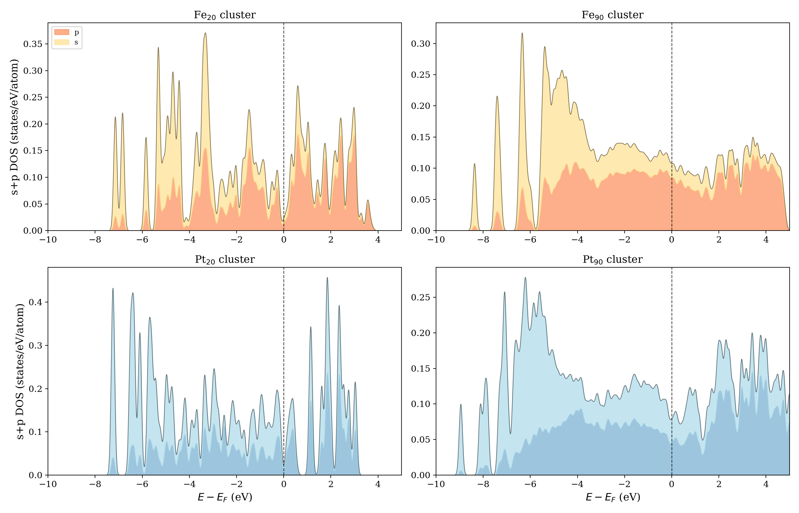
Figure S3. Representative projected s- and p-band densities of states for Fe₂₀, Fe₉₀, Pt₂₀, and Pt₉₀ clusters.

S5. Machine-learning pipeline and training-test protocol
The absolute-LEF matrix contains 15,851 records and 117 inputs; its feature composition and evaluation protocol are summarized in Table S5. The split unit is an individual site-field record, so records from one physical site may occur in both training and test subsets. Reported errors measure interpolation within represented sites and fields rather than unseen-site generalization. Thirteen regressors were implemented with scikit-learn and XGBoost.¹ Hyperparameters were selected once by five-fold grid search on the curated modeling matrix and then fixed for the ten record splits. TreeExplainer SHAP values used 1,000 sampled records.²
Table S5. Absolute-LEF modeling and evaluation protocol.
Item | Absolute-LEF protocol
Target / records | LEF / 15,851 site-field records
Inputs | 60 electronic + 22 geometric + external field + 34 site-label indicators = 117
Partition | 80:20 record split; 12,680 training and 3,171 test records
Repeated evaluation | 10 random seeds; model table reports mean metrics
Pipeline | Mean imputation, standardization, estimator
Model set | 13 regressors: linear, neighbor, kernel, neural-network, and tree families
Tuning | Five-fold grid search on the full curated modeling matrix; settings then fixed
Displayed split | Highest test R² among the ten XGBoost seeds
SHAP | TreeExplainer; 1,000 randomly sampled records

S6. ΔLEF model: benchmark and cross-cluster check
ΔLEF = LEF(M) - LEF(Ir) compares each metal with Ir at the matched site and size. The response therefore represents substitution-associated variation within the matched dataset rather than a geometry-free elemental observable (Table S6).

Table S6. ΔLEF sample definitions and XGBoost errors (MAE in V/Å). The 90-atom benchmark is shown in Figure S4; XGBoost was retained for consistency with the absolute-LEF analysis.

Cluster size | Field (V/Å) | Samples | Inputs | Training MAE | Test MAE
90 atoms | +0.5 | 180 | 72 | 0.0070 | 0.0133
60 atoms | +0.5 | 148 | 72 | 0.0192 | 0.0276

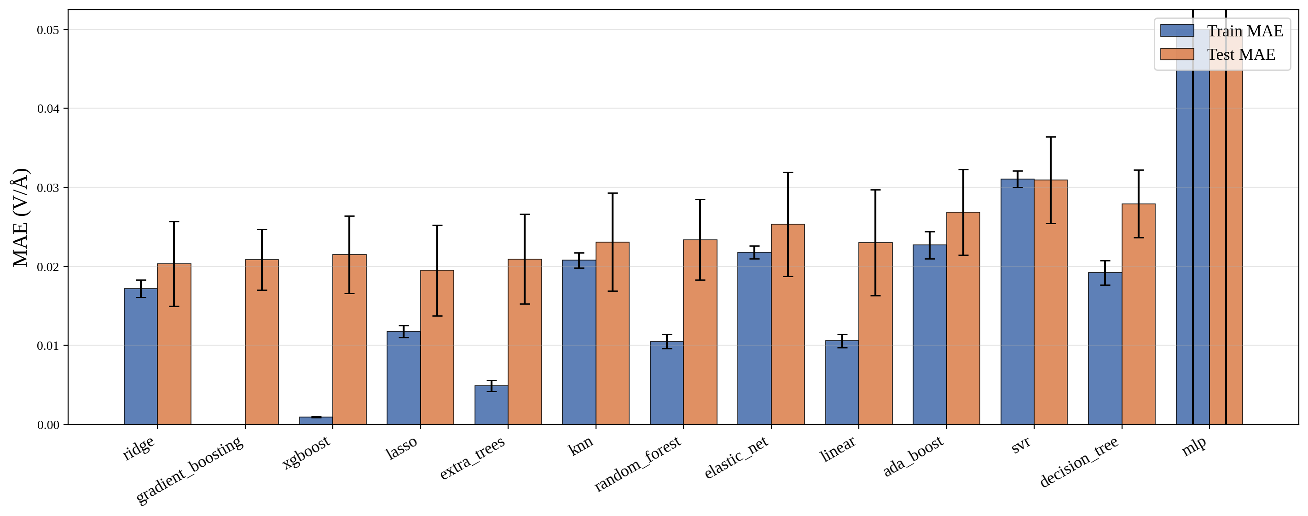

Figure S4. Training and test accuracy of the thirteen regression models for the ΔLEF model (error bars over ten seeds). The 60-atom cross-check gives training and test MAEs of 0.0192 and 0.0276 V/Å and preserves the geometry-dominated SHAP ranking (Figure S5).

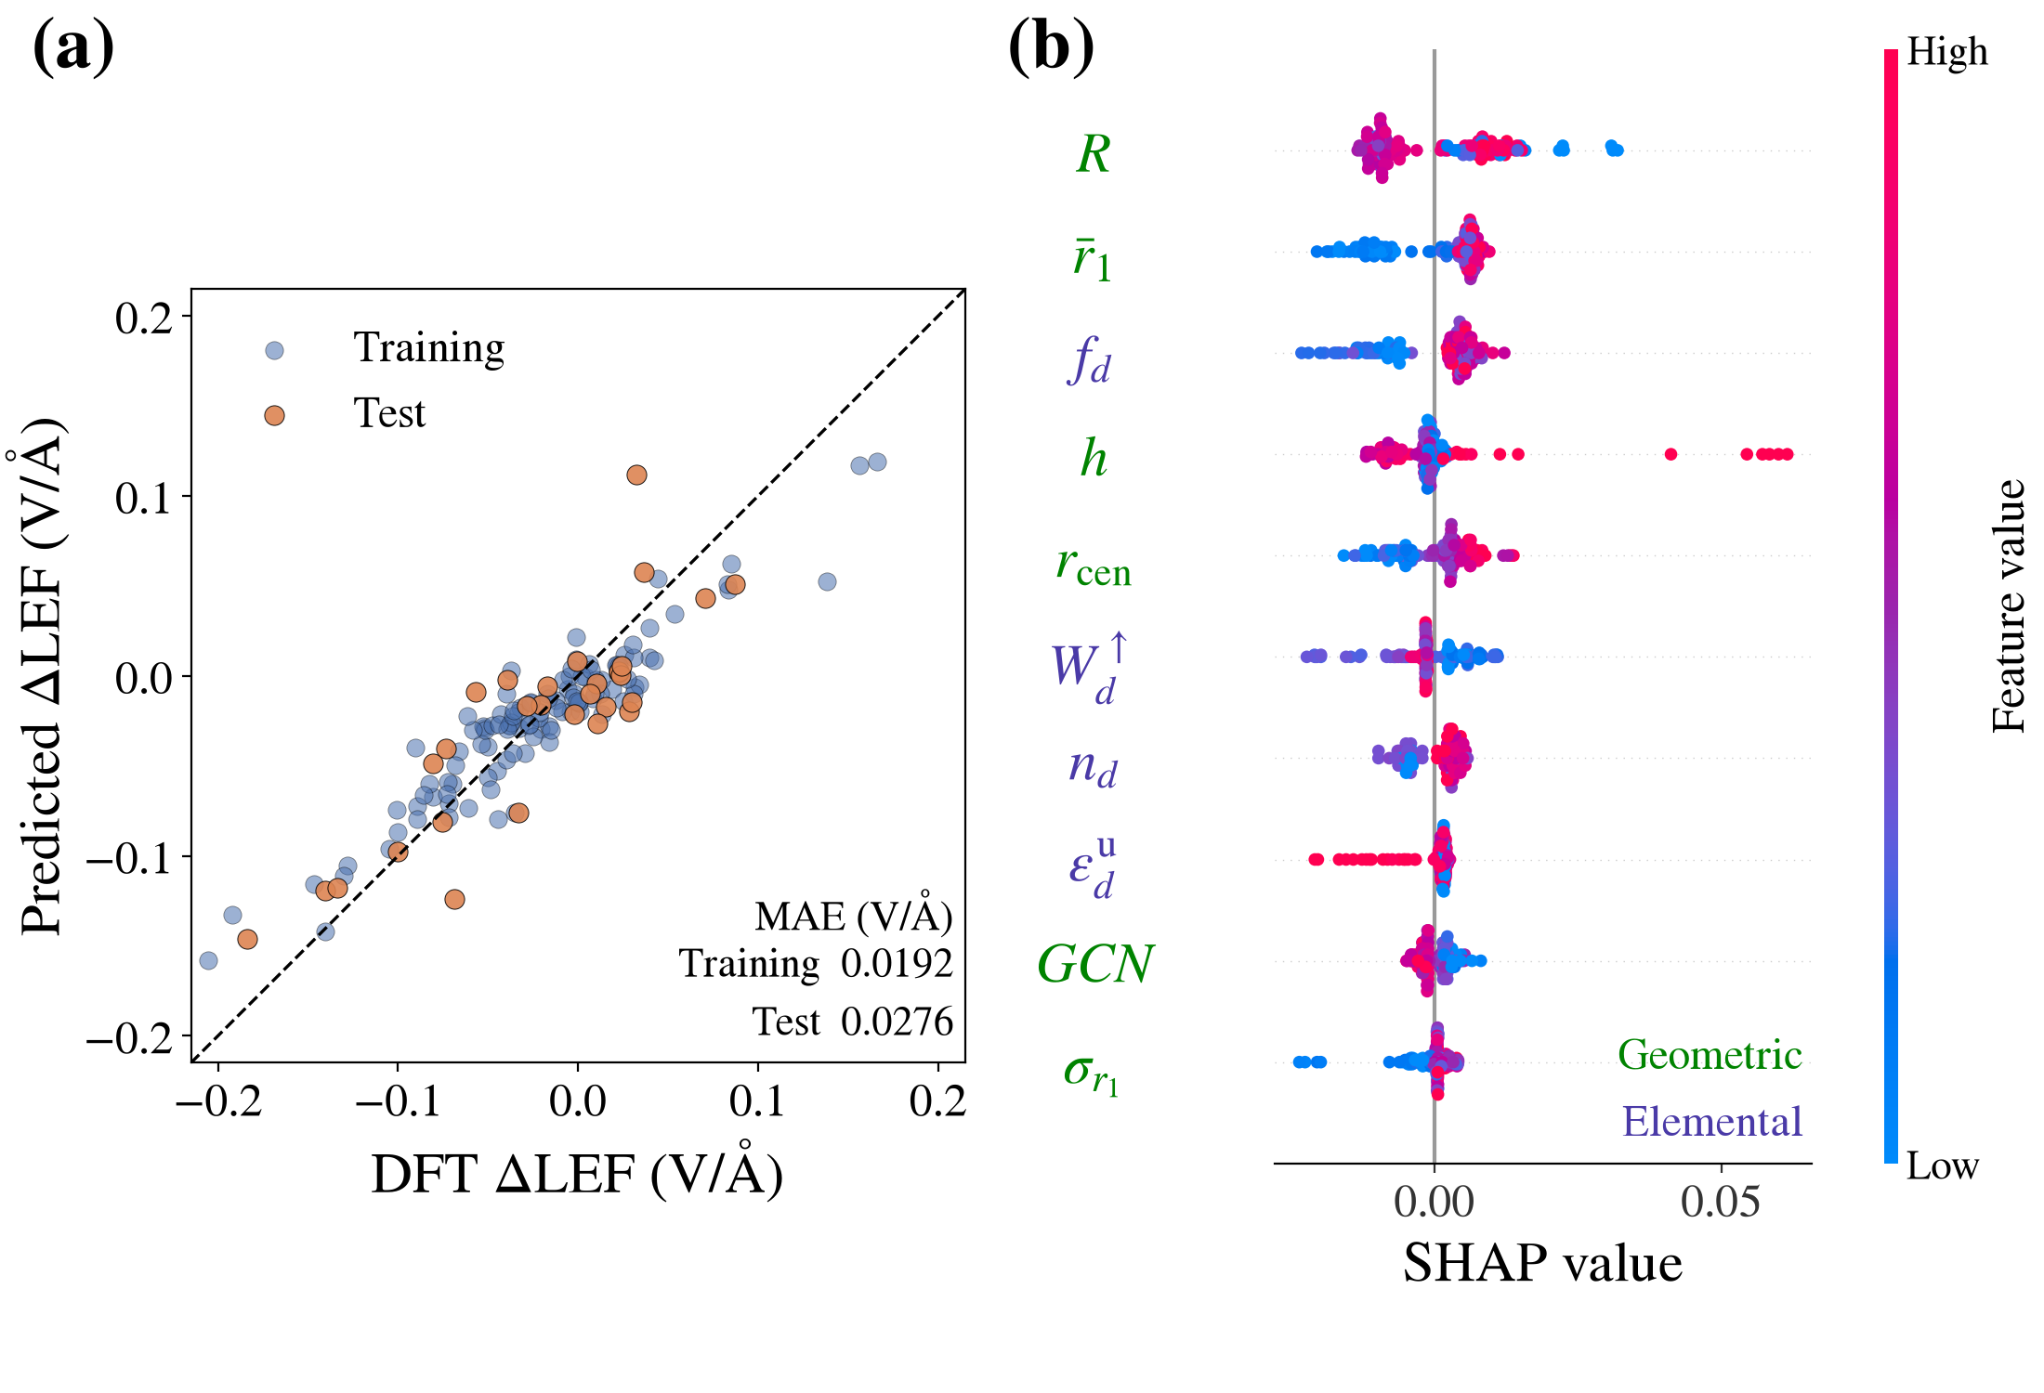

Figure S5. Independent 60-atom ΔLEF check. (a) XGBoost predictions for the training and test subsets. (b) Top-10 SHAP ranking for the same model; site labels omitted. For the 90-atom ΔLEF model, radial distance to the center of mass is the leading SHAP descriptor, while electronic contributions enter mainly through band-shape moments.

S7. Absolute-LEF model: benchmark and hyperparameters
The absolute-LEF benchmark uses the protocol in Table S5. Seed-averaged metrics are in Table S7 and Figure S6; Table S8 gives the selected XGBoost settings.
Table S7. Seed-averaged test accuracy of the thirteen models for absolute-LEF prediction
Model | R² (test) | Test MAE (V/Å)
XGBoost | 0.995 | 0.0132
Gradient boosting | 0.994 | 0.0141
Extra trees | 0.991 | 0.0166
Random forest | 0.990 | 0.0182
Multilayer perceptron | 0.990 | 0.0205
Decision tree | 0.980 | 0.0264
Support vector regression | 0.976 | 0.0363
AdaBoost | 0.892 | 0.0822
k-nearest neighbors | 0.790 | 0.0929
LASSO | 0.703 | 0.1205
Elastic net | 0.704 | 0.1207
Ridge | 0.701 | 0.1224
Linear regression | 0.699 | 0.1232

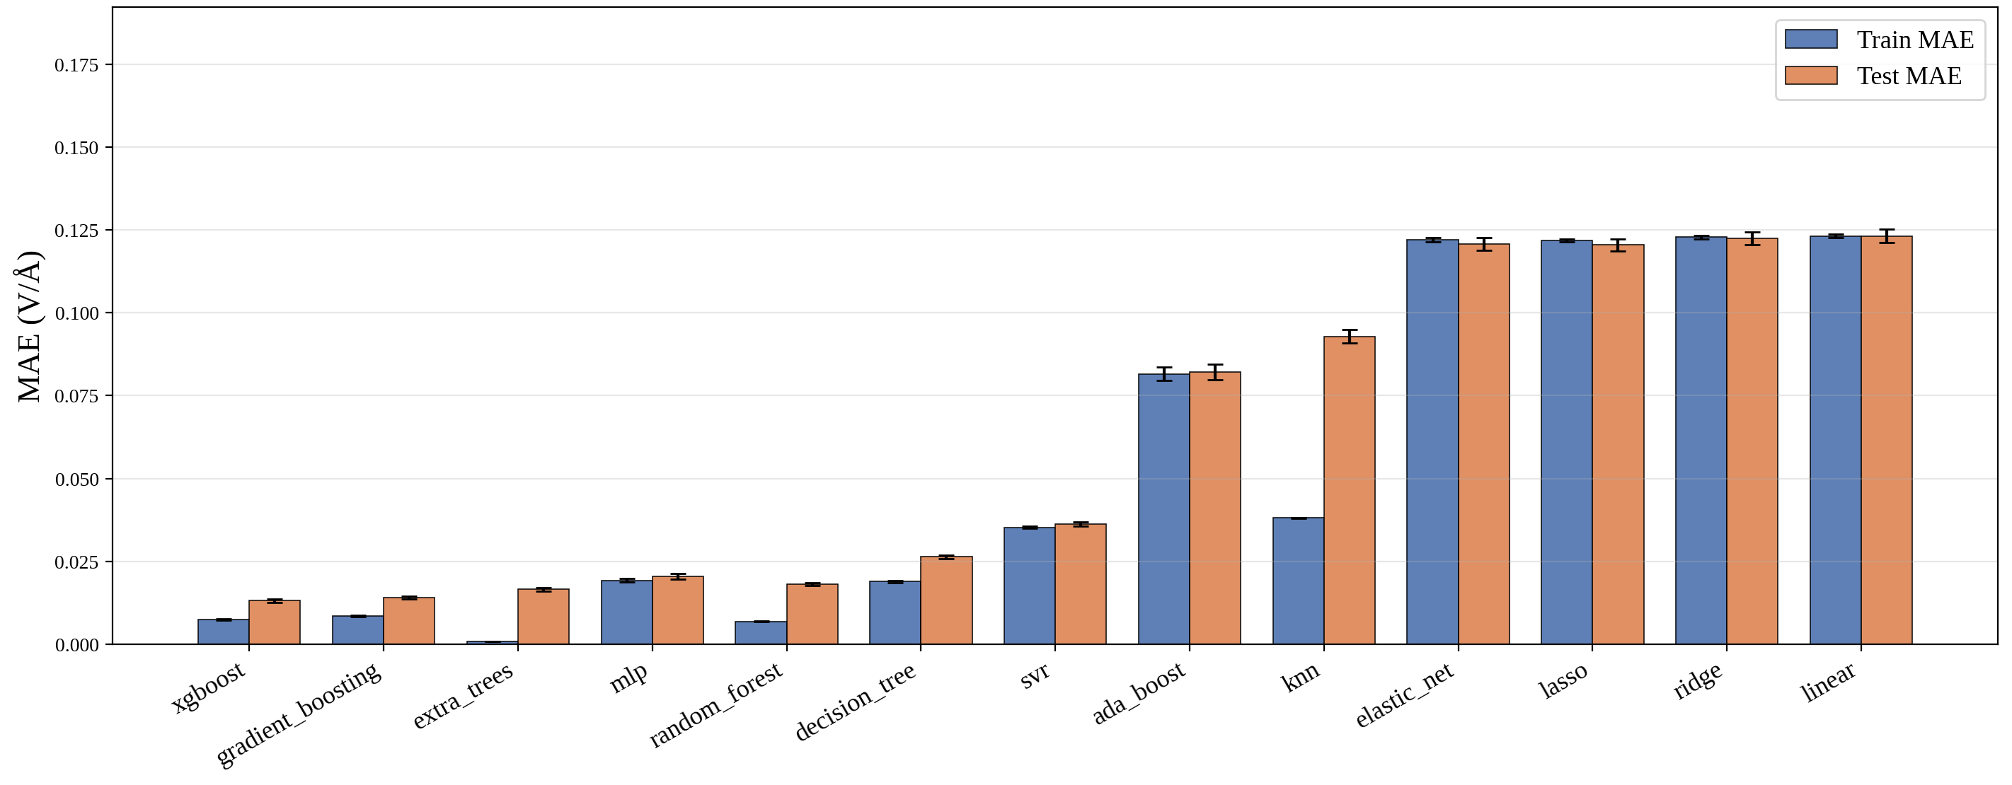
Figure S6. Training and test accuracy of the thirteen regression models for the absolute LEF (MAE; error bars over ten seeds). XGBoost has the lowest mean test MAE (0.0132 V/Å) and highest mean test R2 (0.995); gradient boosting is second (Table S7).

Table S8. XGBoost hyperparameter grid and the values selected by five-fold cross-validation. Absolute-LEF SHAP ranks geometry above elemental electronic descriptors once the external field and site-label indicators are omitted from the displayed ranking.
Hyperparameter | Search grid | Selected value
n_estimators | 100, 200, 300 | 300
max_depth | 3, 5, 7 | 7
learning_rate | 0.05, 0.1, 0.3 | 0.05
tree_method | exact (fixed) | exact

S8. Supplementary SHAP analyses
Figure S7 shows the absolute-LEF SHAP analysis with the external electric field retained. As expected, the applied field F is the dominant predictor of the absolute LEF. Because its substantially larger SHAP magnitude compresses the relative contributions of the remaining descriptors, F is omitted from the displayed ranking in Figure 3b of the main text to resolve the hierarchy among catalyst-dependent geometric and electronic descriptors. Accordingly, this descriptor analysis is to identify which catalyst-dependent characteristics govern variations in the LEF under the applied-field conditions represented in the dataset.
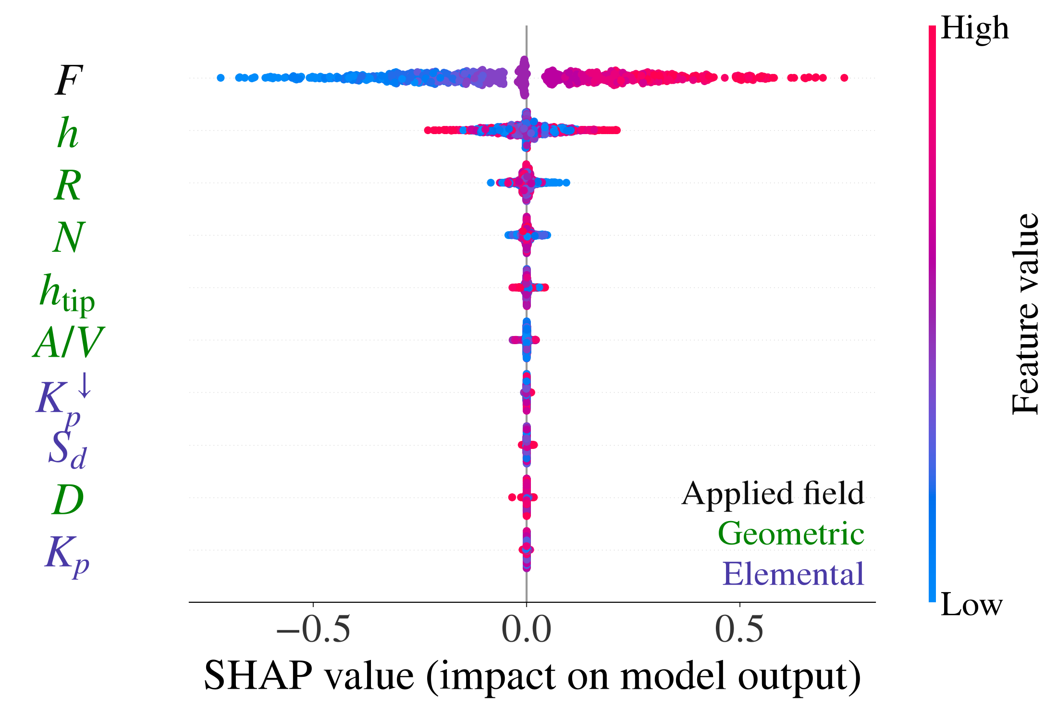
Figure S7. Absolute-LEF SHAP ranking with the external field retained; site labels omitted.

S9. Symbolic regression: feature selection and Pareto front
Features were added in XGBoost SHAP order, with the external field forced first and site-label indicators excluded. The same record-level test split guided feature-count selection; its error is therefore a model-selection metric. Four variables were retained: F, h, htip, and R. PySR³ settings and the selected complexity-12 result are summarized in Table S9. The full Pareto front is listed in Table S10 and visualized in Figure S8.
Table S9. Symbolic-regression settings and selected model.
Setting | Value
Variables | F, h, htip, R
Binary operators | +, -, *, /
Unary operators | exp, log, sqrt, square, cube
Loss | Mean squared error
Long-run search | 200 iterations; 10 populations; maximum size 30
Selection | Complexity 12 on the record-level test split
MAE | 0.0297 training; 0.0306 test (V/Å)
Input convention | h, htip, R normalized by 1 Å; F entered in V/Å

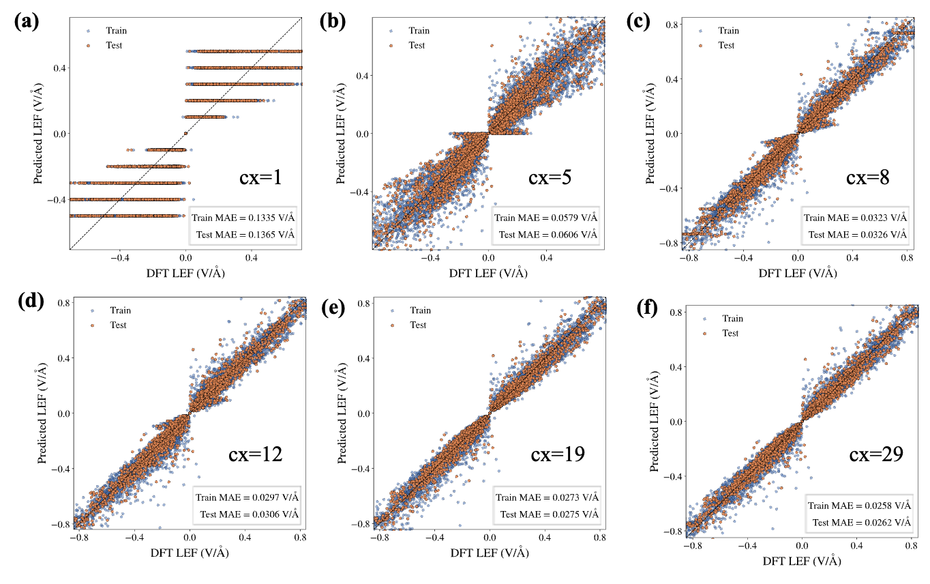
Figure S8. Equation-vs-DFT LEF parity at complexity 1, 5, 8, 12, 19, and 29.

Table S10. Closed-form equations along the PySR Pareto front
Complexity | MSE | Equation
1 | 3.13 × 10⁻² | $$LEF=F$$
3 | 2.85 × 10⁻² | $$LEF=\frac{F}{1.205}$$
4 | 2.69 × 10⁻² | $$LEF=\frac{F}{\sqrt{R}}$$
5 | 8.51 × 10⁻³ | $$LEF=\frac{F h}{3.166}$$
7 | 4.15 × 10⁻³ | $$LEF=\frac{F h}{\frac{h_{tip}}{1.66}}$$
8 | 2.75 × 10⁻³ | $$LEF={\left(\frac{h}{h_{tip}}+0.3567\right)}^{2} F$$
10 | 2.53 × 10⁻³ | $$LEF=F \left({\left(\frac{h}{h_{tip}}\right)}^{2}+0.162\right) 1.655$$
12 | 2.29 × 10⁻³ | $$LEF={\left(\frac{h}{h_{tip}+\frac{R}{h_{tip}}}+0.4311\right)}^{2} F$$
16 | 2.20 × 10⁻³ | $$LEF=F \left(\frac{h}{h_{tip}}+{\left(\frac{h}{h_{tip}+\frac{R}{h_{tip}}}\right)}^{3}+0.1308\right)$$
17 | 2.06 × 10⁻³ | $$LEF={\left(\frac{\sqrt{h_{tip}}}{h_{tip}}+\frac{h}{\frac{R}{h_{tip}-1.438}+h_{tip}}\right)}^{2} F$$
19 | 1.99 × 10⁻³ | $$LEF=\left({\left(\frac{0.6033}{e^{h}}+\frac{h}{h_{tip}+\frac{R}{h}}\right)}^{2}+\frac{h}{h_{tip}}\right) F$$
21 | 1.98 × 10⁻³ | $$LEF=F \left(\frac{h}{h_{tip}}+{\left(\frac{0.6053}{e^{h}}+\frac{h}{\frac{R}{-0.8162+h_{tip}}+h_{tip}}\right)}^{2}\right)$$
22 | 1.96 × 10⁻³ | $$LEF=F \left(\frac{h}{h_{tip}}+{\left(\frac{{\left(-0.7496\right)}^{2}}{e^{h}}+\frac{h}{h_{tip}+\frac{R}{-0.8162+h_{tip}}}\right)}^{2}\right)$$
23 | 1.93 × 10⁻³ | $$LEF=\left(\frac{h}{h_{tip}}+{\left(\frac{h}{\frac{R}{F+h}+h_{tip}}\right)}^{2}+\frac{0.6061}{{\left(h+1.347\right)}^{2}}\right) F$$
24 | 1.91 × 10⁻³ | $$LEF=\left({\left(\frac{h}{\frac{R}{h+F}+h_{tip}}\right)}^{2}+\frac{0.5986}{1.555+h_{tip} h}+\frac{h}{h_{tip}}\right) F$$
25 | 1.87 × 10⁻³ | $$LEF=F \left(\frac{0.5234}{h h_{tip}+1.374}+\frac{h}{h_{tip}}+{\left(\frac{h}{{\left(\frac{R}{h_{tip}-1.096}\right)}^{2}+h_{tip}}\right)}^{2}\right)$$
26 | 1.87 × 10⁻³ | $$LEF=F \left(\frac{e^{-0.6381}}{1.374+h h_{tip}}+\frac{h}{h_{tip}}+{\left(\frac{h}{{\left(\frac{R}{h_{tip}-1.096}\right)}^{2}+h_{tip}}\right)}^{2}\right)$$
27 | 1.82 × 10⁻³ | $$LEF=F \left(\frac{h}{h_{tip}}+\frac{0.5283}{h_{tip} h+1.374}+{\left(\frac{h}{{\left(\frac{R}{h_{tip}+F-1.096}\right)}^{2}+h_{tip}}\right)}^{2}\right)$$
29 | 1.82 × 10⁻³ | $$LEF=\left(\frac{0.5234}{h h_{tip}+1.374}+\frac{h}{h_{tip}}+{\left(\frac{h}{\frac{R}{h_{tip}-0.9769}+h_{tip}}+{\left(F 0.6805\right)}^{3}\right)}^{2}\right) F$$

S10. Computational details

S10.1 DFT setup
The verified electronic-structure and field settings are collected in Table S11.
Table S11. DFT, smearing, and external-field settings.
Item | Setting
Code / method | VASP⁴; PAW⁵; PBE⁶ generalized-gradient approximation
Plane-wave cutoff | 400 eV
Brillouin-zone sampling | Γ-centered 1 × 1 × 1 mesh
Electronic convergence | 1 × 10⁻⁵ eV
Geometry convergence | Residual forces below 0.03 eV/Å
Relaxation smearing | Methfessel-Paxton, 0.1 eV
Field/DOS smearing | Gaussian, 0.05 eV
Vacuum | At least 10 Å in each direction
External field | -0.5 to +0.5 V/Å in 0.1 V/Å steps
Dipole correction | IDIPOL = 3; field along z
Field sign | Eext = -EVASP
Field geometries | Zero-field relaxed geometry; fixed-geometry field single points

S10.2 External electric field implementation
The field implementation⁷, sign convention, and fixed-geometry protocol are specified in Table S11.

S10.3 Cluster geometry generation
Nine metals were modeled at twelve atom counts from 20 to 90 using the most stable Ni cluster at each size as a common starting template, rescaled by the relaxed FCC lattice constant in Table S12 before relaxation.
The FCC-template choice enables matched structural comparisons but limits transfer to native non-FCC phases, especially bulk-ground-state Co, Ru, and Fe.

S10.4 Extraction of the local electric field
For each top adsorption site, LEF was obtained from the z gradient of the site-specific electrostatic-potential profile sampled along the local vertical line through the adsorption-site coordinates and evaluated at the center-of-mass height of a CO probe.⁸ Only top sites above the cluster center-of-mass plane were retained.

Table S12 lists the relaxed FCC lattice constants used to generate the templates.
Table S12. Relaxed FCC lattice constants used to build the metal nanoclusters
Metal | Relaxed FCC lattice constant a₀ (Å)
Co | 3.545
Cu | 3.615
Fe | 3.590
Ir | 3.839
Ni | 3.524
Pd | 3.891
Pt | 3.924
Rh | 3.803
Ru | 3.820

References

(1) Chen, T.; Guestrin, C. Xgboost: A scalable tree boosting system. In Proceedings of the 22nd acm sigkdd international conference on knowledge discovery and data mining, 2016; pp 785-794.
(2) Lundberg, S. M.; Allen, P. G.; Lee, S.-I. A Unified Approach to Interpreting Model Predictions; https://github.com/slundberg/shap.
(3) Cranmer, M. Interpretable machine learning for science with PySR and SymbolicRegression. jl. arXiv preprint arXiv:2305.01582 2023.
(4) Kresse, G.; Furthmüller, J. Efficient iterative schemes for ab initio total-energy calculations using a plane-wave basis set. Physical Review B 1996, 54 (16), 11169-11186. DOI: 10.1103/PhysRevB.54.11169.
(5) Blöchl, P. E. Projector augmented-wave method. Physical Review B 1994, 50 (24), 17953-17979. DOI: 10.1103/PhysRevB.50.17953.
(6) Perdew, J. P.; Burke, K.; Ernzerhof, M. Generalized gradient approximation made simple. Physical Review Letters 1996, 77 (18), 3865-3868. DOI: 10.1103/PhysRevLett.77.3865.
(7) Neugebauer, J.; Scheffler, M. Adsorbate-substrate and adsorbate-adsorbate interactions of Na and K adlayers on Al (111). Physical Review B 1992, 46 (24), 16067. DOI: 10.1103/PhysRevB.46.16067.
(8) Zhao, R.; Li, Q.; Yang, J.; Zhu, C.; Che, F. Integrating Physical Principles with Machine Learning for Predicting Field-Enhanced Catalysis. JACS Au 2025, 5 (3), 1121-1132. DOI: 10.1021/jacsau.4c00901.

