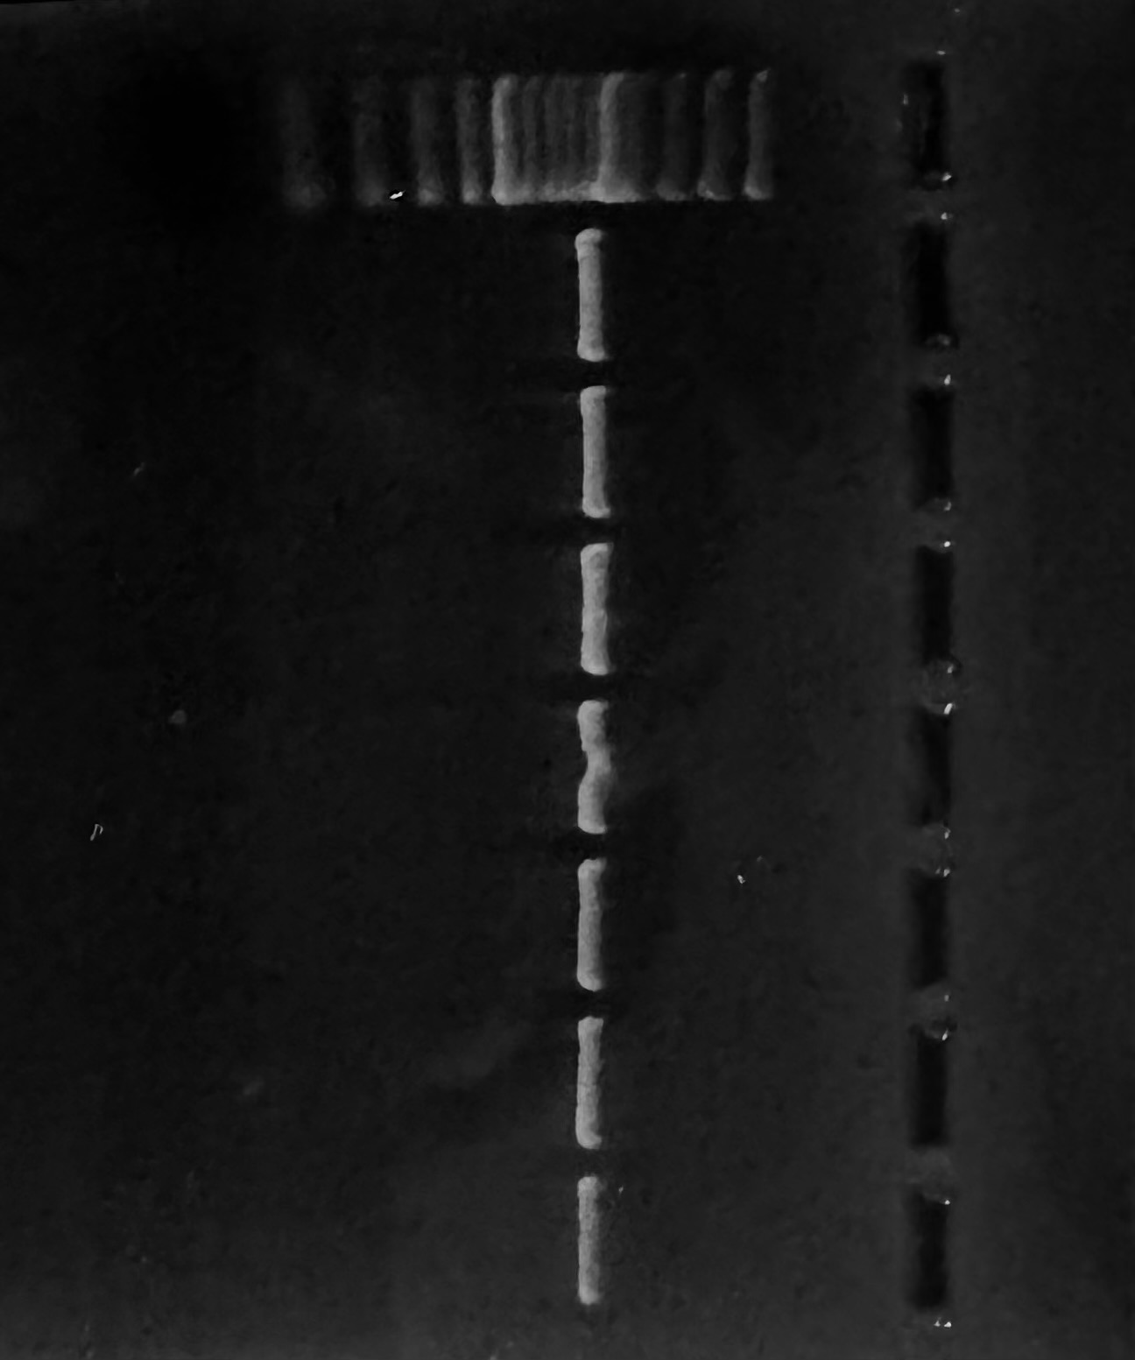

Lane: 1-7 Ladder: 100 bp

Fig. 1 PCR amplified product of exon 1 region of PGLYRP-1 gene in Sahiwal Cattle

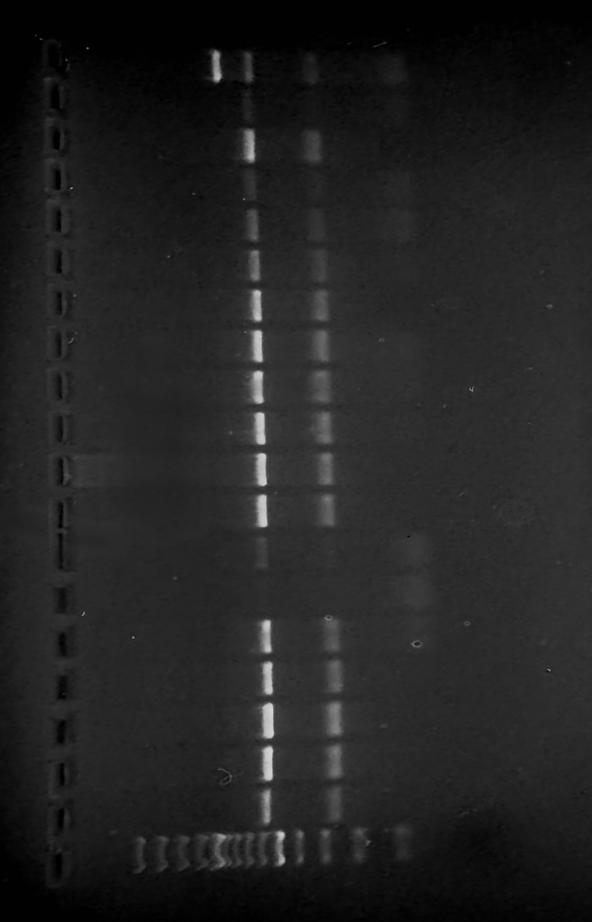

Lane: 1-19 Ladder: 100 bp

Fig. 2 PCR-RFLP amplified product of exon 1 region of PGLYRP-1 gene (Apal) in Sahiwal Cattle
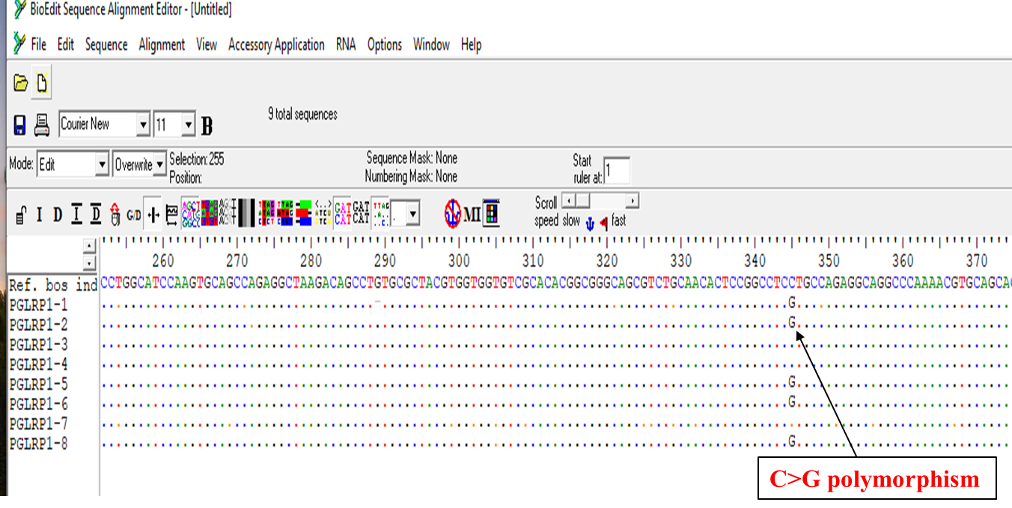
Fig. 3 Clustal W analysis of amplified PGLYRP-1 gene sequence in Sahiwal Cattle compared with reference sequence of Bos indicus (JN085440.1)

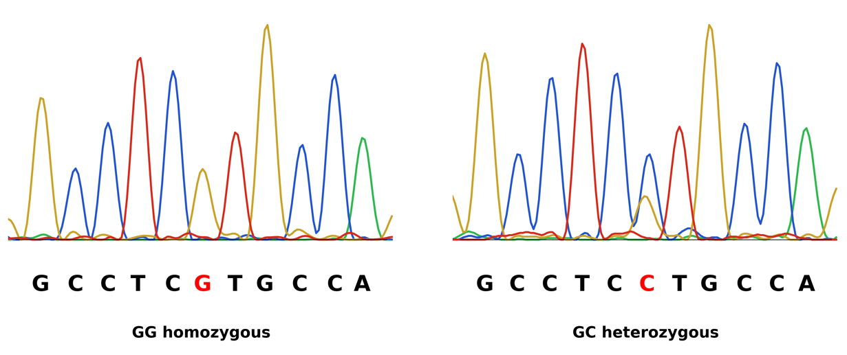

Fig. 4 Chromatograms showing the g.345C>G substitution in exon 1 of PGLYRP-1 in Sahiwal cattle

