Additional file 1
Supplementary methods and results
Changes in handgrip strength and incident edentulism among middle-aged and older adults in China
Contents: Tables S1–S5 and Figs. S1–S2.
Table S1. Variable definitions and coding
Variable | Analysis field | Definition
Outcome | event2018 | Self-reported edentulism in 2018; 1 = all natural teeth lost, 0 = natural teeth retained.
Grip strength | grip1 / grip3 | Maximum recorded left/right grip strength in 2011/2015, kg; values <0 or >100 treated as missing.
Grip strength decline | grip_decline_sd | (2011 grip − 2015 grip) / SD of change; one SD = 7.36 kg. Positive values indicate decline.
Low grip strength | low_grip1 / low_grip3 | Grip <28 kg for men or <18 kg for women, at the corresponding assessment.
Low grip strength status change | grip_pattern | Persistently non-low; recovered (low to non-low); incident low (non-low to low); persistently low.
Age | age | 2011 age, years; continuous in the main model.
Sex | gender | 0 = women; 1 = men.
Residence | rural | 0 = urban; 1 = rural.
Education | edu | 1 = less than primary; 2 = primary; 3 = junior high; 4 = senior high or above.
Marital status | marry | 0 = other; 1 = married.
Current smoking | smoken | 0 = no; 1 = yes.
Current alcohol use | drinkl | 0 = no; 1 = yes.
Hypertension | hibpe | 0 = no; 1 = yes.
Diabetes | diabe | 0 = no; 1 = yes.
Health insurance | ins | 0 = no; 1 = yes.
All covariates refer to 2011. Grip strength change used for descriptive quartiles is 2015 minus 2011; the continuous decline exposure reverses that sign. Field names identify the derived analysis variables. Low grip strength is a measure of strength and does not by itself establish sarcopenia.
Table S2. Availability of oral status and grip strength by wave
Year | Variable | Available, n | Missing, n | Available, %
2011 | Oral status | 17568 | 140 | 99.21
2011 | Grip strength | 13588 | 4120 | 76.73
2015 | Oral status | 20929 | 168 | 99.20
2015 | Grip strength | 16106 | 4991 | 76.34
2018 | Oral status | 19739 | 77 | 99.61
These counts describe all records in each corresponding wave of the study data extract, before application of the longitudinal eligibility criteria. Wave samples contain different participants and should not be interpreted as the follow-up completion rate of the final cohort. The 2011, 2015 and 2018 totals were 17708, 21097 and 19816, respectively.
Table S3. Missing grip measurements by subsequent edentulism status
Assessment year | No incident edentulism  (n = 9663), % | Incident edentulism  (n = 639), %
2011 | 18.72 | 17.84
2015 | 17.53 | 15.49
The denominator is the 10302 participants with natural teeth in 2011 and 2015 and recorded oral status in 2018, before excluding missing grip measurements or covariates. Percentages describe missingness at each assessment separately and must not be added across assessments. These data do not describe the 7005 complete cases.
Table S4. Subgroup associations and interaction tests
Stratum | N / events | OR (95% CI) | P value | Interaction P | BH-adjusted  interaction P
Age: ≥65 years | 1351 / 156 | 1.19 (0.96–1.46) | 0.107 | 0.546 | 0.988
Age: 45-64 years | 5654 / 283 | 1.42 (1.22–1.64) | <0.001 | 0.546 | 0.988
Sex: Men | 3238 / 192 | 1.20 (1.01–1.43) | 0.038 | 0.751 | 0.988
Sex: Women | 3767 / 247 | 1.32 (1.11–1.57) | 0.002 | 0.751 | 0.988
Residence: Rural | 4646 / 324 | 1.25 (1.09–1.44) | 0.002 | 0.775 | 0.988
Residence: Urban | 2359 / 115 | 1.31 (1.02–1.69) | 0.033 | 0.775 | 0.988
Education: Less than primary | 3124 / 255 | 1.25 (1.06–1.47) | 0.007 | 0.988 | 0.988
Education: Primary or above | 3881 / 184 | 1.26 (1.05–1.53) | 0.015 | 0.988 | 0.988
Diabetes: Yes | 396 / 23 | 1.53 (0.88–2.66) | 0.129 | 0.804 | 0.988
Diabetes: No | 6609 / 416 | 1.25 (1.11–1.42) | <0.001 | 0.804 | 0.988
Estimates are per SD (7.36 kg) greater grip strength decline. Models adjusted for the primary covariate set with the stratifying covariate omitted. Age models omitted continuous age; education models omitted four-category education. Other strata omitted sex, residence or diabetes, respectively. Interaction P values use Wald tests of exposure-by-subgroup terms in the combined sample. BH denotes Benjamini–Hochberg adjustment; each interaction is repeated across its two strata for readability. These are exploratory analyses.
Table S5. Mean grip strength at each assessment by status-change group
Group | N | 2011, mean (SE), kg | 2015, mean (SE), kg
Persistently non-low | 5922 | 35.05 (0.12) | 32.76 (0.11)
Recovered | 315 | 17.54 (0.32) | 27.50 (0.36)
Incident low | 561 | 29.37 (0.31) | 18.68 (0.24)
Persistently low | 207 | 18.69 (0.38) | 17.42 (0.43)
SE, standard error. Values are descriptive means in groups defined by the two measurements. They do not estimate an adjusted within-person change or a group-by-time interaction. For the group definitions, see Table S1.
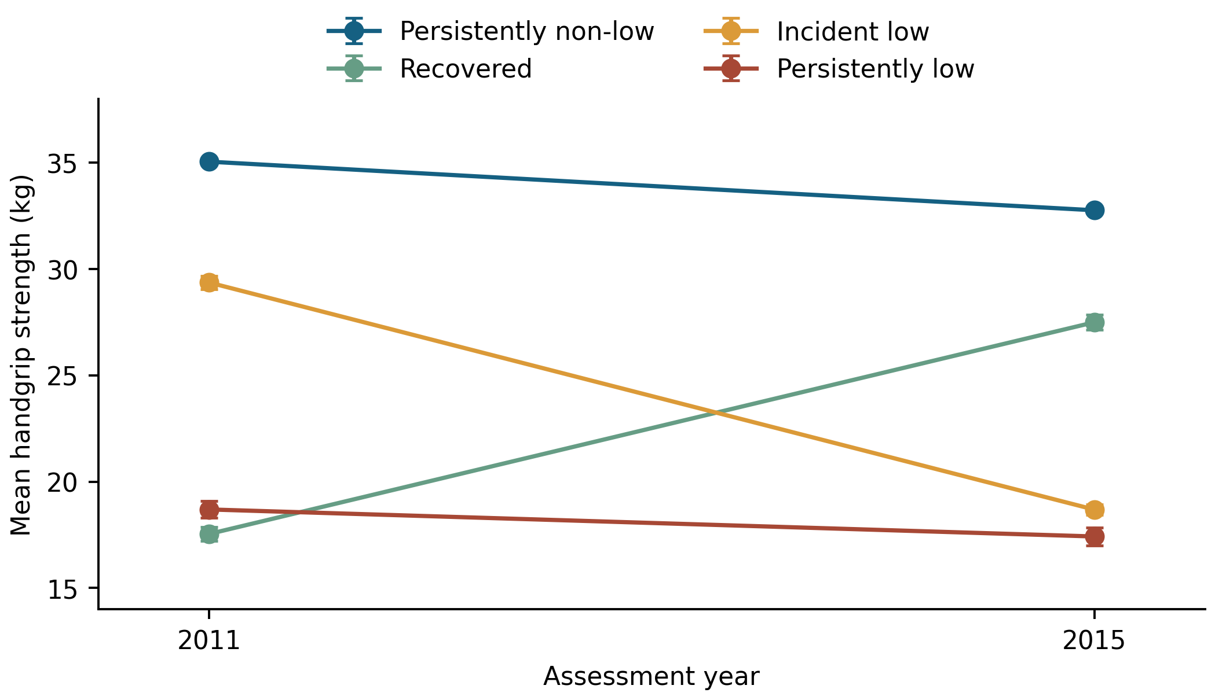
Fig. S1. Mean handgrip strength by low grip strength status. Points show group means in 2011 and 2015, with error bars indicating one standard error. Groups were defined from the two grip measurements using sex-specific low grip strength thresholds. Lines connect descriptive means and do not represent fitted trajectories. Group sizes were 5922, 315, 561 and 207 for persistently non-low, recovered, incident low and persistently low grip strength, respectively. Values are provided in Table S5.
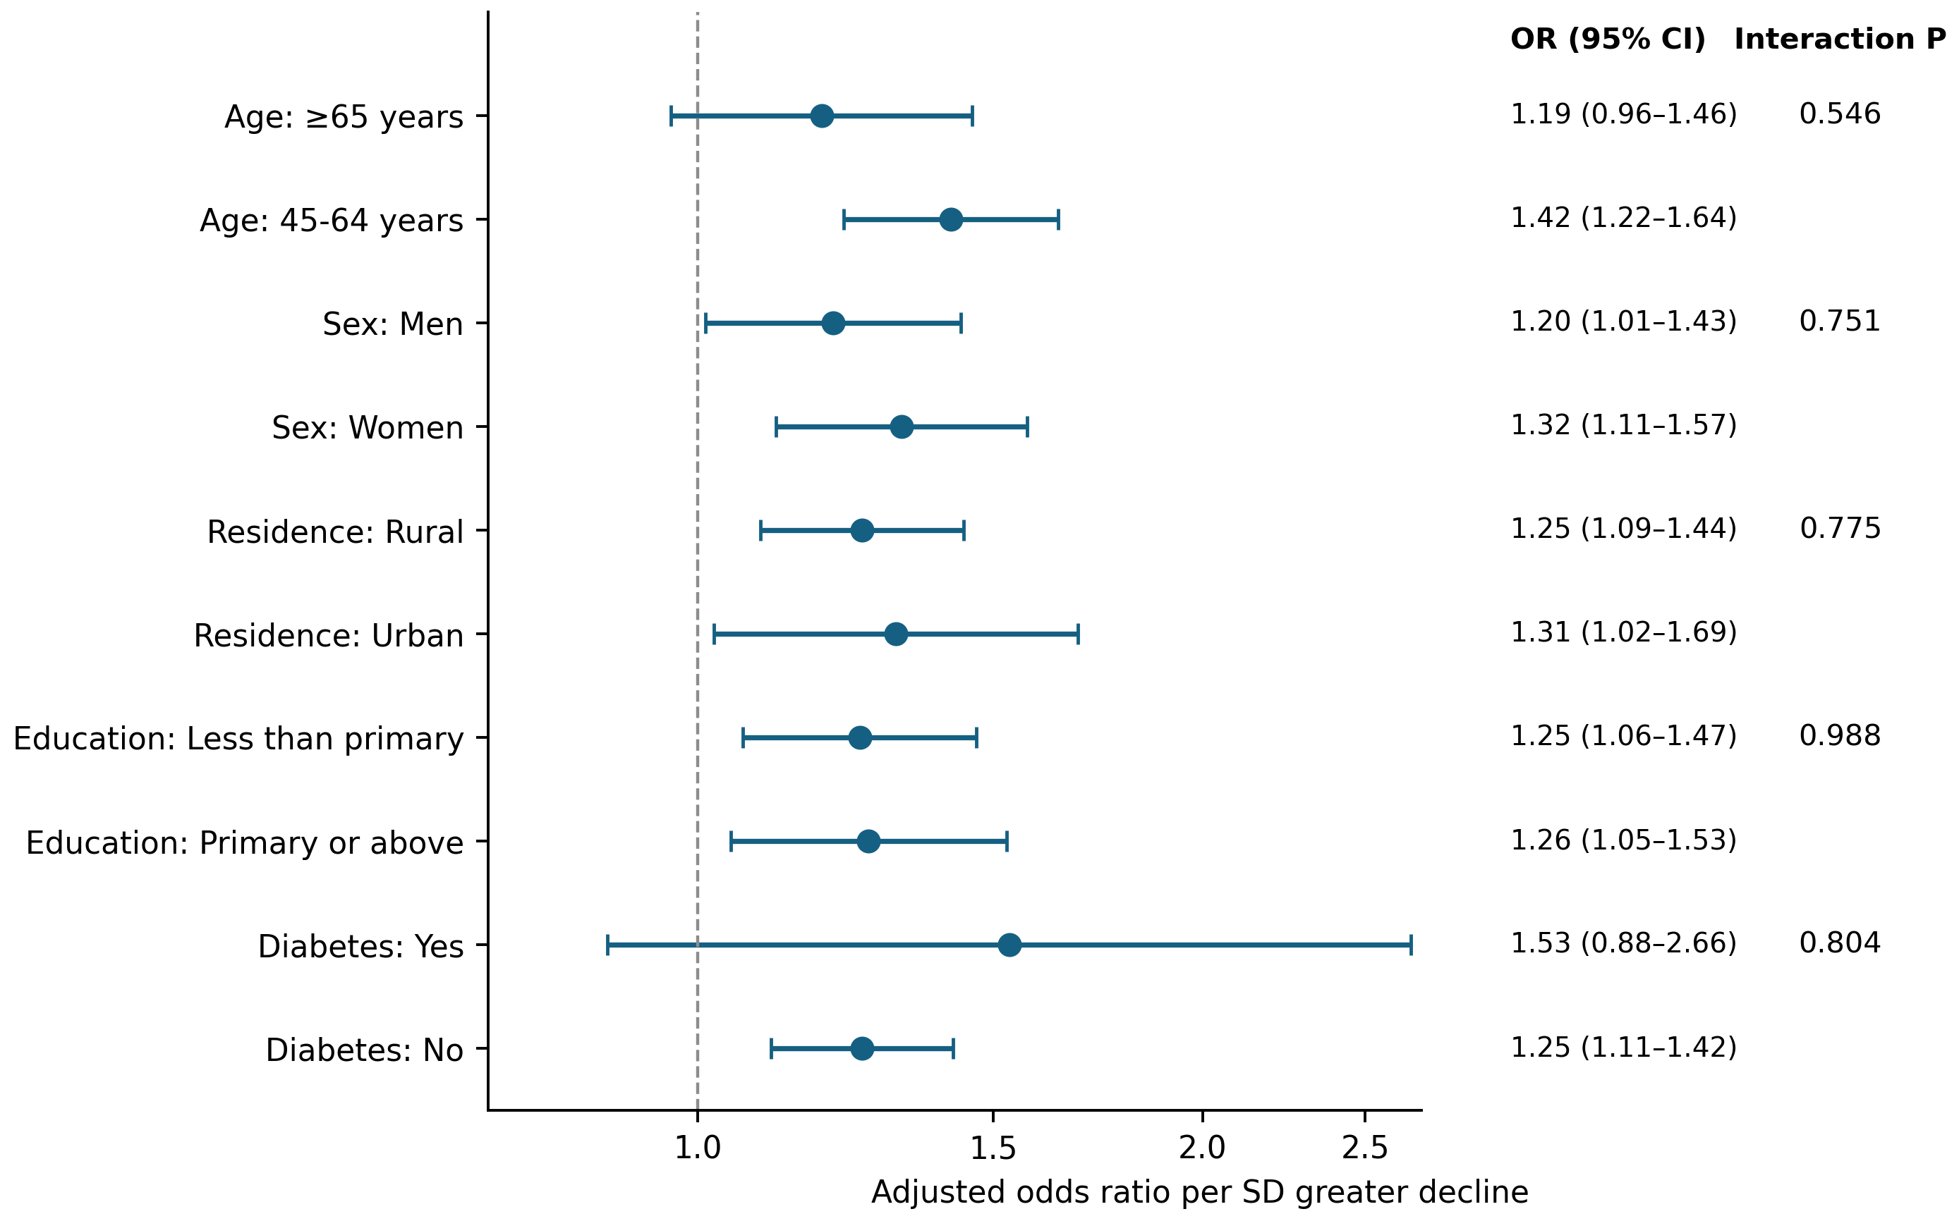
Fig. S2. Subgroup associations of grip strength decline with incident edentulism. Points and bars indicate odds ratios and 95% confidence intervals per standard deviation (7.36 kg) greater decline. Interaction P values are from Wald tests of exposure-by-subgroup terms; they are not the within-stratum P values. Models used the main covariate set with the stratifying covariate omitted, as detailed in Table S4. Age strata were not additionally adjusted for continuous age. The broad education strata were not additionally adjusted for four-category education.

