Supporting Information
Differences in Pigment Composition Between Differently Seeded Cultivated and Wild Soybeans
Qi Yu^{a#}, Xin Yinª, Li Zhangª, Zhentao Ren^{c}, Laipan Liuª, Wenjing Shenª, Zhixiang Fangª, Lanzhi Han^{d}, Xiaojing Wang^{b*}, Biao Liu^{a*}
ªNanjing Institute of Environmental Sciences, Ministry of Ecology and Environment of China, Nanjing 210042, China.
^{b}Hinggan League Institute of Agricultural and Husbandry Sciences (Inner Mongolia Innovation Center of Biological Breeding Technology), Ulan Hot 137400, China.
^{c}Institute of Food and Nutrition Development, Ministry of Agriculture and Rural Affairs, Beijing 100081, China
^{d}Institute of Plant Protection, Chinese Academy of Agricultural Sciences, Beijing 100193, China

*Corresponding author:
Assoc. Prof. Xiaojing Wang Ph.D
Hinggan League Institute of Agricultural and Husbandry Sciences (Inner Mongolia Innovation Center of Biological Breeding Technology), Ulan Hot 137400, China.
Email: Wxiaojing0216@163.com
Prof. Biao Liu Ph.D
Nanjing Institute of Environmental Sciences, Ministry of Ecology and Environment of China, Nanjing 210042, China.
Email: liubiao@nies.org; Tel.: +86-25-85287064; Fax: +86-25-85287064

Supporting Information—Figures
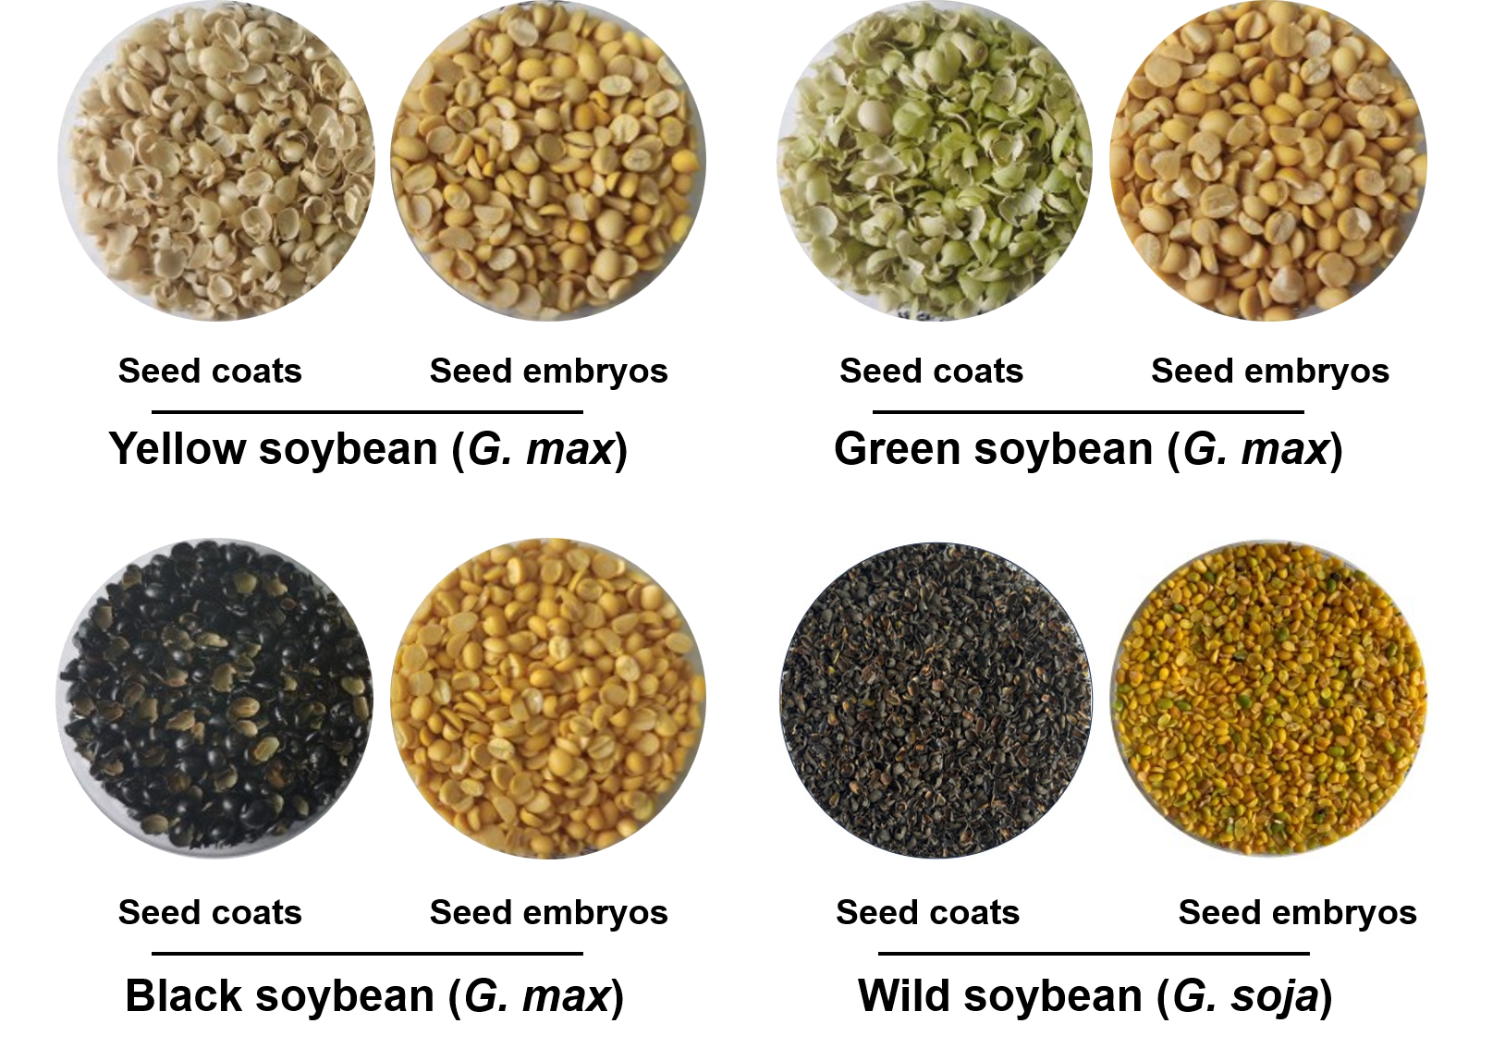
Supporting Information Figure S1. Morphology of YS, GS, BS, and WS used for comparative metabolomics.

Supporting Information—Tables
Supporting Information Table S1. Information of YS, GS, BS, and WS, including species, 100-seed dry weight, provenance/variety name, and seed coat color.
Species | Sample ID | 100-Seed Dry Weight (g)* | Provenances/  Varieties Name | Seed Coat Colors
G. max | Yellow soybean (YS) | 16.68 ± 0.32 | ZH13 | Yellow
G. max | Green soybean (GS) | 17.01 ± 0.43 | TZ50 | Green
G. max | Black soybean (BS) | 19.67 ± 0.59 | HDZ | Black
G. soja | Wild soybean (WS) | 1.27 ± 0.01 | Jiangsu Province | Black
Note: “*”: mean ± SEM (n=100).

