Supplementary material to
Characteristics and atmospheric drivers of hiatus events during Indian summer monsoon progression

*Stella Jes Varghese¹, K H Usha^{1,2} and Madhavan Nair Rajeevan¹
¹Centre for Climate Change, Atria University, ASKB Campus, Anandnagar, Bengaluru
²CSIR Fourth Paradigm Institute, NAL Belur, Windtunnel Road, Bengaluru

*Corresponding author email: stella.varghese@gmail.com

This document contains the following

Figures S1-S2
Table S1

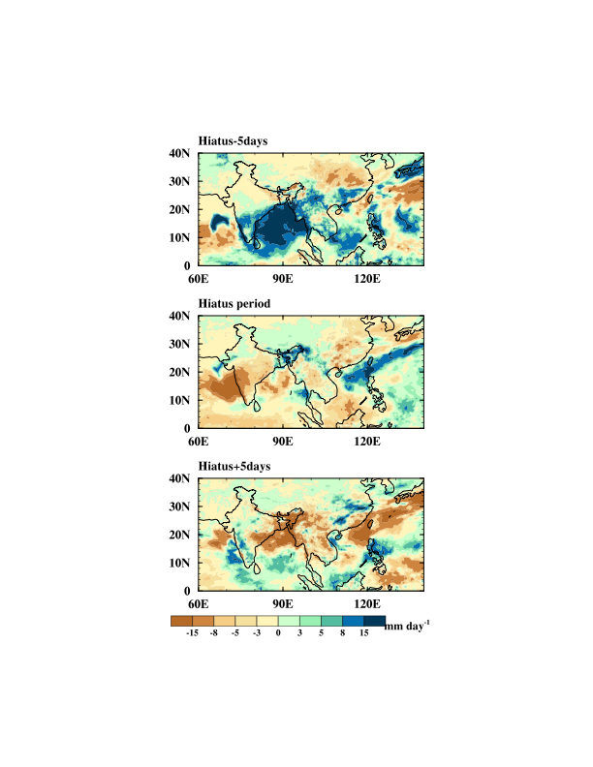
Fig S1 Composite anomaly of rainfall Average of 5 days preceding the onset of hiatus, average of hiatus days and average of 5 days following the end date of hiatus from ERA5 rainfall.

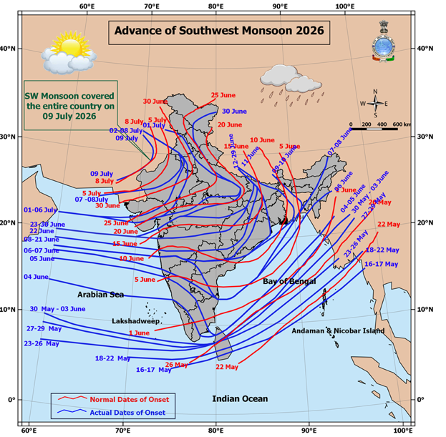

Fig S2 The advance of southwest monsoon 2026 indicating its northern limit

Table S1: Monsoon onset hiatus periods identified based on the objective criteria. For each year, the table lists the date of monsoon onset over Kerala (MOK), monsoon onset over central India (MOCI), the start and end of the hiatus, and the corresponding number of hiatus days. Years with hiatus duration equal to or exceeding 9 days (the 75th percentile of the hiatus duration distribution) are highlighted in bold and are referred to as “long duration hiatus”. A total of 14 such events were identified during the period 1971-2025.
Year | MOK | MOCI | Start of hiatus | End of hiatus | Number of hiatus days
1971 | 25 May | 1 June | 25 May | 27 May | 3
1972 | 17 June | 22 June | NA | NA | 0
1973 | 3 June | 10 June | NA | NA | 0
1974 | 25 May | 16 June | 27 May | 7 June | 12
1975 | 31 May | 17 June | 6 June | 12 June | 7
1976 | 30 May | 6 June | 30 May | 1 June | 3
1977 | 28 May | 21 June | 28 May | 6 June | 10
1978 | 27 May | 15 June | 27 May | 8 June | 11
1979 | 12 June | 21 June | 12 June | 18 June | 7
1980 | 29 May | 12 June | 29 May | 31 May | 3
1981 | 28 May | 21 June | 28 May | 2 June | 6
1982 | 1 June | 20 June | 2 June | 9 June | 8
1983 | 10 June | 24 June | NA | NA | 0
1984 | 1 June | 10 June | 1 June | 6 June | 6
1985 | 23 May | 24 June | 23 May | 1 June | 10
1986 | 12 June | 19 June | NA | NA | 0
1987 | 1 June | 16 June | 1 June | 7 June | 7
1988 | 2 June | 20 June | 2 June | 5 June | 4
1989 | 4 June | 12 June | NA | NA | 0
1990 | 18 May | 12 June | NA | NA | 0
1991 | 2 June | 6 June | 2 June | 4 June | 3
1992 | 5 June | 18 June | 5 June | 9 June | 5
1993 | 3 June | 15 June | 3 June | 8 June | 6
1994 | 28 May | 10 June | 28 May | 31 May | 4
1995 | 10 June | 20 June | 10 June | 13 June | 4
1996 | 9 June | 17 June | NA | NA | 0
1997 | 13 June | 18 June | NA | NA | 0
1998 | 10 June | 14 June | NA | NA | 0
1999 | 20 May | 14 June | 28 May | 9 June | 13
2000 | 26 May | 6 June | 28 May | 30 May | 3
2001 | 26 May | 8 June | 26 May | 3 June | 9
2002 | 2 June | 21 June | NA | NA | 0
2003 | 13 June | 18 June | NA | NA | 0
2004 | 16 May | 11 June | 19 May | 29 May | 11
2005 | 16 June | 22 June | NA | NA | 0
2006 | 23 May | 5 June | NA | NA | 0
2007 | 6 June | 14 June | 10 June | 12 June | 3
2008 | 2 June | 7 June | NA | NA | 0
2009 | 20 May | 28 June | 23 May | 5 June | 14
2010 | 5 June | 16 June | 5 June | 9 June | 5
2011 | 28 May | 14 June | 28 May | 1 June | 5
2012 | 5 June | 17 June | 7 June | 10 June | 4
2013 | 31 May | 10 June | NA | NA | 0
2014 | 5 June | 18 June | 8 June | 13 June | 6
2015 | 16 June | 16 June | NA | NA | 0
2016 | 18 May | 23 June | 20 May | 28 May | 9
2017 | 29 May | 21 June | 1 June | 3 June | 3
2018 | 24 May | 7 June | 24 May | 31 May | 8
2019 | 10 June | 21 June | 15 June | 19 June | 5
2020 | 18 May | 3 June | 18 May | 31 May | 14
2021 | 15 May | 9 June | 23 May | 29 May | 7
2022 | 15 May | 16 June | 22 May | 2 June | 12
2023 | 10 June | 23 June | 10 June | 22 June | 13
2024 | 18 May | 21 June | 20 May | 2 June | 14
2025 | 17 May | 15 June | 31 May | 8 June | 9

