Supplementary Material
HrpNEA Seed Treatment Is Associated with Improved Stand Establishment, Nitrogen and Antioxidant Metabolism, and Grain Yield in Maize under Rainfed, Drought-Prone Field Conditions
Table S1. Effect of HrpNEA seed treatment on 21 agronomic, physiological, and biochemical traits of maize.
Trait | Description (unit) | Control (mean ± SE) | HrpNEA (mean ± SE) | Δ (%) | F | P | q (FDR)
Growth & biomass
Stand | Plant stand (plants m⁻¹) | 3.65 ± 0.10 | 4.15 ± 0.08 | +13.7 | 15.0 | 0.012 | 0.020
PH | Plant height (cm) | 117.6 ± 0.8 | 115.9 ± 0.7 | -1.4 | 1.5 | 0.276 | 0.290
RDM | Root dry matter (g) | 13.29 ± 0.62 | 19.53 ± 1.24 | +47.0 | 39.1 | 0.002 | 0.004
SDM | Shoot dry matter (g) | 108.4 ± 1.8 | 122.7 ± 1.1 | +13.3 | 66.6 | <0.001 | 0.001
TDM | Total dry matter (g) | 121.7 ± 2.4 | 142.3 ± 1.5 | +17.0 | 244.6 | <0.001 | <0.001
RDM-SDM | Root:shoot dry-matter ratio (ratio) | 0.122 ± 0.004 | 0.159 ± 0.010 | +30.1 | 14.7 | 0.012 | 0.020
Photosynthetic status
SPAD-V4 | Relative chlorophyll (V4) (SPAD units) | 38.60 ± 0.54 | 42.77 ± 0.71 | +10.8 | 69.7 | <0.001 | 0.001
SPAD-VT | Relative chlorophyll (VT) (SPAD units) | 53.20 ± 2.73 | 57.48 ± 1.07 | +8.1 | 2.0 | 0.220 | 0.257
N & protein metabolism
NR | Nitrate reductase activity (see Methods) | 0.800 ± 0.022 | 1.33 ± 0.03 | +66.1 | 114.2 | <0.001 | <0.001
PROT | Total soluble protein (mg g⁻¹ FW) | 25.97 ± 0.85 | 23.09 ± 0.71 | -11.1 | 13.3 | 0.015 | 0.022
Oxidative stress
SOD | Superoxide dismutase (see Methods) | 2.23 ± 0.26 | 3.89 ± 0.14 | +73.9 | 89.6 | <0.001 | <0.001
POD | Peroxidase (see Methods) | 0.361 ± 0.011 | 0.432 ± 0.016 | +19.4 | 15.6 | 0.011 | 0.020
PROL | Proline (µmol g⁻¹ FW) | 1.31 ± 0.03 | 1.41 ± 0.05 | +8.0 | 4.0 | 0.101 | 0.125
MDA | Malondialdehyde (nmol g⁻¹ FW) | 13.55 ± 0.68 | 11.19 ± 0.42 | -17.4 | 10.6 | 0.022 | 0.031
Root architecture
RTL | Total root length (cm) | 692.5 ± 25.0 | 1206 ± 43 | +74.1 | 87.7 | <0.001 | <0.001
RTA | Root surface area (cm²) | 179.8 ± 3.6 | 215.2 ± 6.6 | +19.7 | 20.5 | 0.006 | 0.013
Yield components
NRE | Rows per ear (count) | 17.73 ± 0.40 | 17.27 ± 0.12 | -2.6 | 1.2 | 0.315 | 0.315
NKR | Kernels per row (count) | 32.17 ± 1.40 | 34.67 ± 0.89 | +7.8 | 4.8 | 0.080 | 0.105
NKE | Kernels per ear (count) | 571.0 ± 29.8 | 598.6 ± 16.4 | +4.8 | 1.6 | 0.264 | 0.290
KWT | Individual kernel weight (g) | 0.247 ± 0.007 | 0.300 ± 0.003 | +21.5 | 43.8 | 0.001 | 0.003
GY | Grain yield (kg ha⁻¹) | 7404 ± 209 | 9001 ± 165 | +21.6 | 138.7 | <0.001 | <0.001
n = 6 blocks per treatment (randomized complete block design). Control = untreated; HrpNEA = seed treatment with the harpin elicitor. Δ (%) = percentage change relative to control. F and P are from the block-model ANOVA (treatment + block); with two treatments this is equivalent to a block-paired t-test. q (FDR) = Benjamini-Hochberg false-discovery-rate-adjusted P across the 21 traits; bold q-values are significant at q < 0.05 (15 of 21 traits). Units for the biochemical assays (NR, SOD, POD) are as defined in Materials and Methods. q-values in this table were computed over all 21 variables; because TDM, RDM-SDM and NKE are arithmetic functions of other columns (TDM = RDM + SDM; RDM-SDM = RDM/SDM; NKE = NRE × NKR), the primary FDR family in the main text comprises the 18 independently measured traits (13 of 18 significant; Table S8).

Table S2. Principal component analysis of the standardized 21-trait matrix: variance explained.
Component | Variance explained (%) | Cumulative (%)
PC1 | 56.5 | 56.5
PC2 | 14.4 | 70.9
PC3 | 8.5 | 79.4
PC4 | 7.0 | 86.4
PC5 | 3.9 | 90.2
PCA on the z-scored 21-trait matrix (12 experimental units). The first two components together explain 70.9% of the total variance. Only the first five components are shown.
Table S3. Loadings of the 21 traits on the first two principal components (PC1, PC2).
Trait | Module | PC1 | PC2
Stand | Growth & biomass | +0.210 | -0.256
PH | Growth & biomass | -0.125 | -0.136
RDM | Growth & biomass | +0.254 | -0.035
SDM | Growth & biomass | +0.261 | -0.049
TDM | Growth & biomass | +0.271 | -0.046
RDM-SDM | Growth & biomass | +0.229 | -0.033
SPAD-V4 | Photosynthetic status | +0.232 | -0.131
SPAD-VT | Photosynthetic status | +0.156 | +0.340
NR | N & protein metabolism | +0.275 | -0.091
PROT | N & protein metabolism | -0.202 | -0.240
SOD | Oxidative stress | +0.266 | +0.055
POD | Oxidative stress | +0.240 | +0.115
PROL | Oxidative stress | +0.148 | -0.303
MDA | Oxidative stress | -0.196 | -0.152
RTL | Root architecture | +0.272 | -0.143
RTA | Root architecture | +0.238 | -0.113
NRE | Yield components | -0.082 | +0.383
NKR | Yield components | +0.155 | +0.382
NKE | Yield components | +0.105 | +0.503
KWT | Yield components | +0.256 | -0.001
GY | Yield components | +0.248 | -0.037
Largest absolute PC1 loadings: NR, RTL, TDM, SOD, SDM. The full Pearson correlation matrix (21 × 21) is available in the associated data repository (see Data availability).

Figure S1.
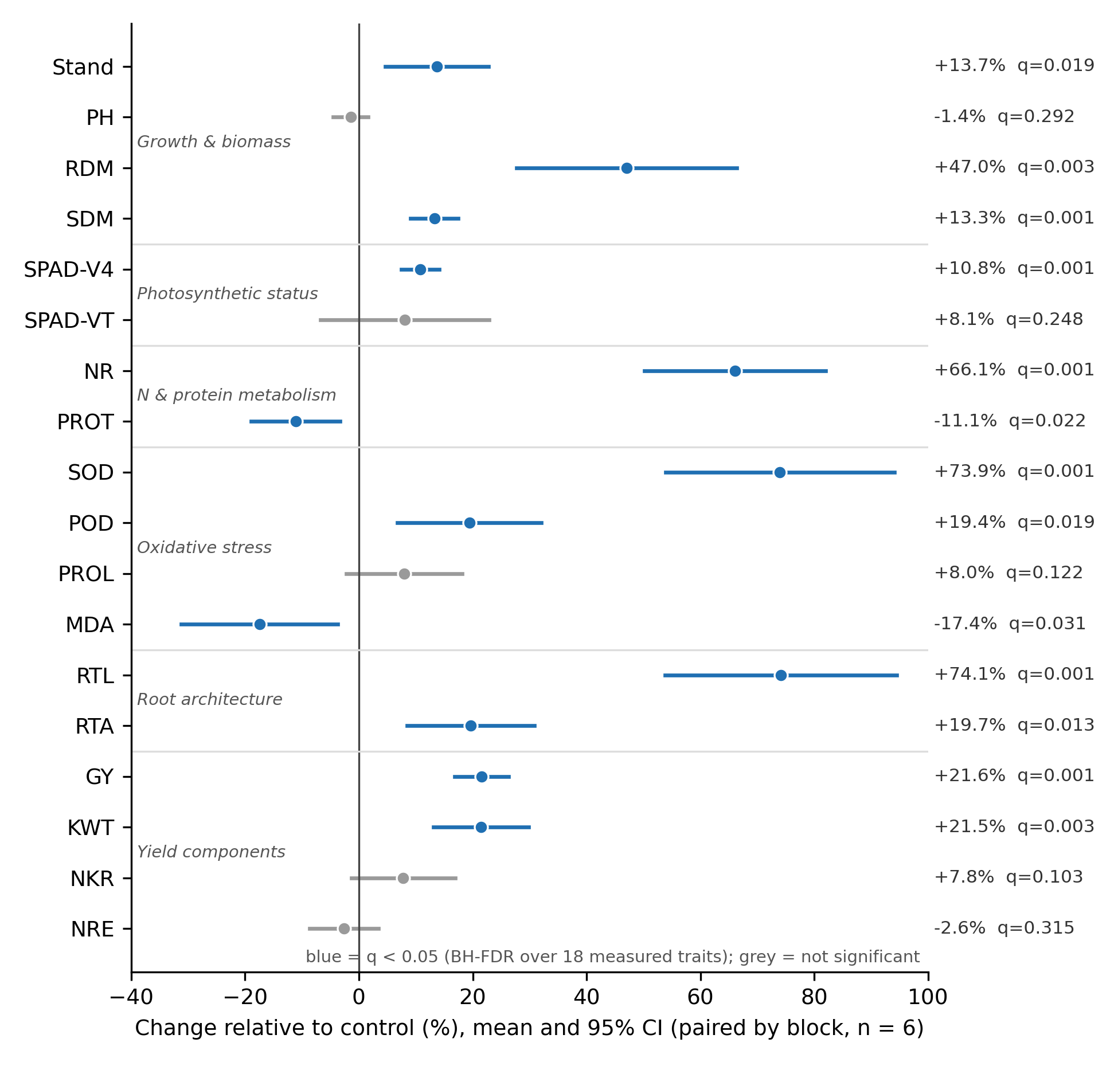
Figure S1. Paired effect of HrpNEA seed treatment on the 18 measured traits, grouped by physiological module. Points are the mean percentage change relative to the control and bars the 95% confidence interval of the within-block difference (n = 6 blocks); blue denotes traits significant after Benjamini-Hochberg FDR correction over the 18 measured traits (q < 0.05), grey non-significant traits. Symbol legend: Stand (plants per linear metre); PH (plant height); RDM (root dry matter); SDM (shoot dry matter); SPAD-V4 and SPAD-VT (relative chlorophyll at V4 and at flowering); NR (nitrate reductase activity); PROT (total soluble protein); SOD (superoxide dismutase activity); POD (peroxidase activity); PROL (proline content); MDA (malondialdehyde content); RTL (total root length); RTA (root surface area); NRE (rows per ear); NKR (kernels per row); KWT (individual kernel weight); GY (grain yield).

Figure S2.
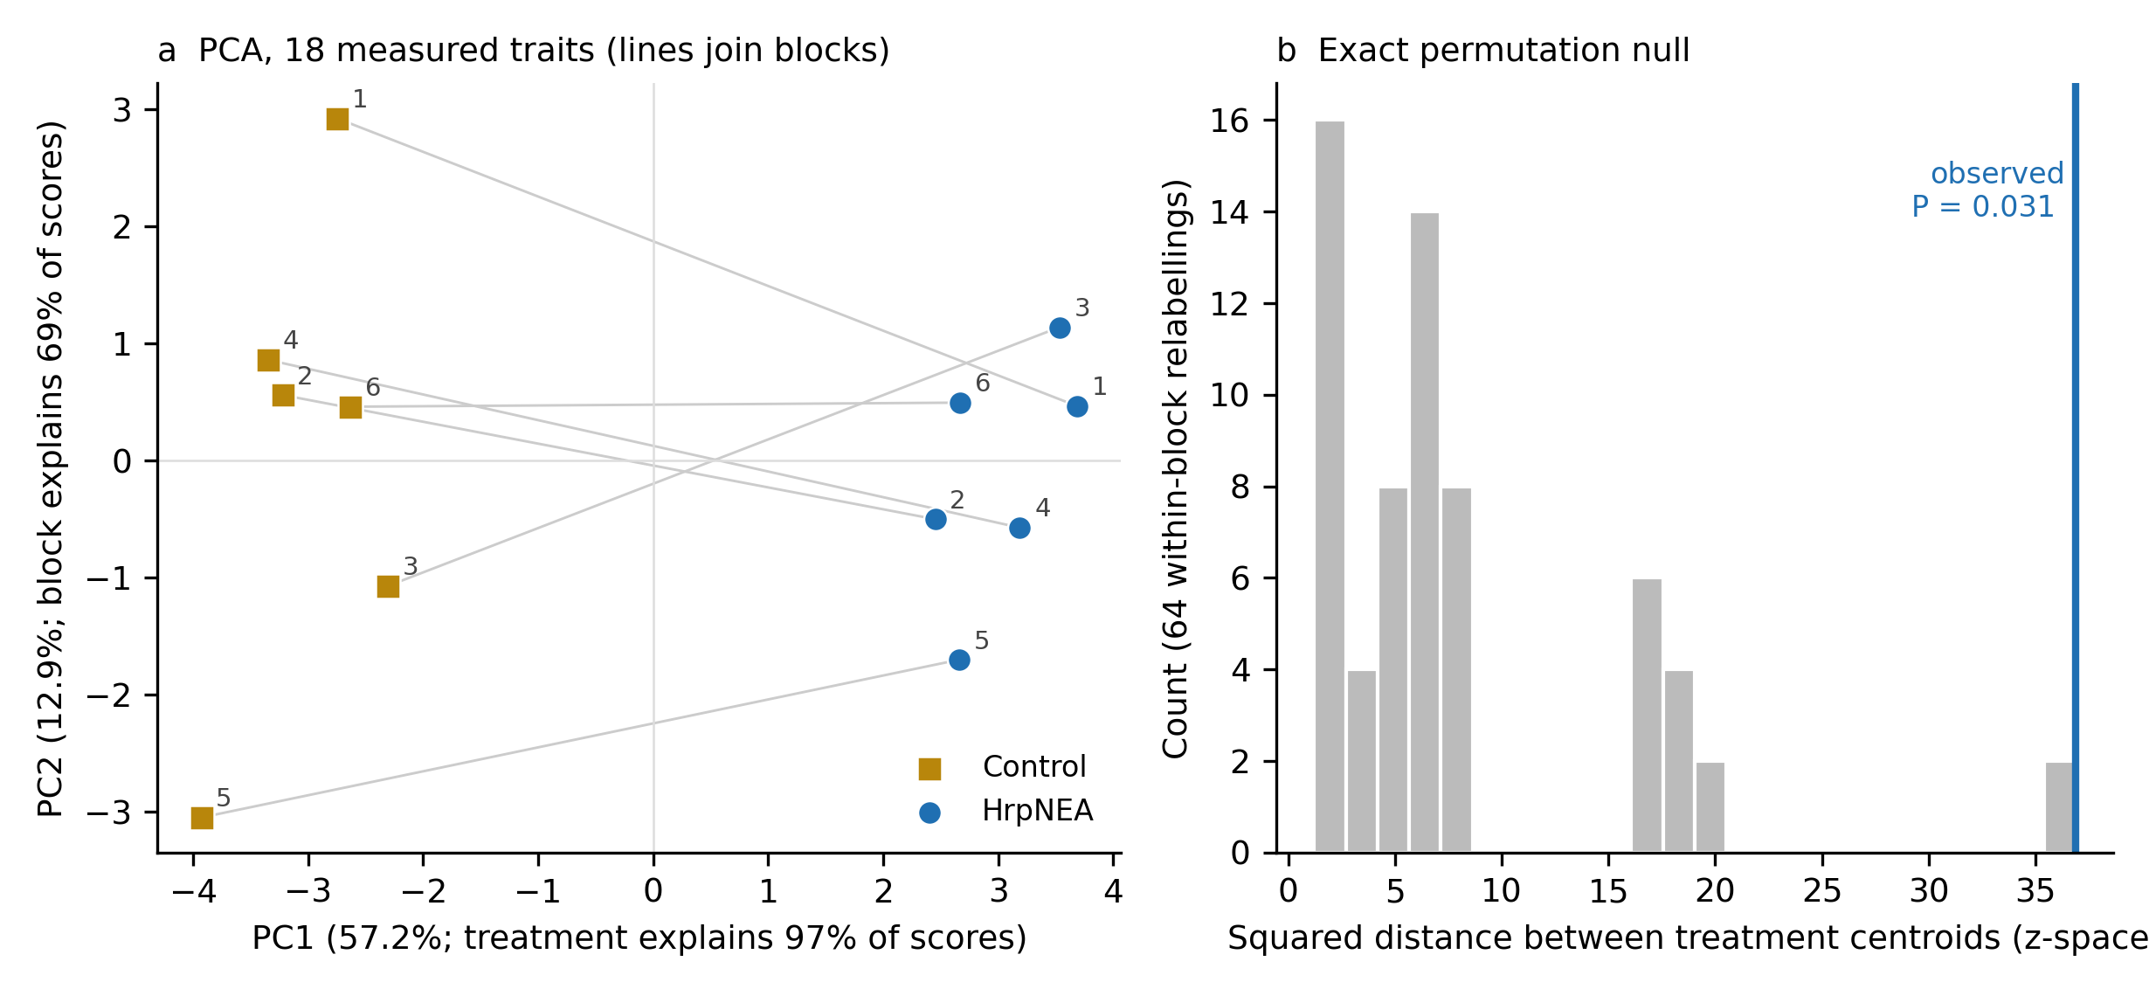
Figure S2. (a) Principal Component Analysis of the 18 measured, standardized traits across the 12 plots (2 treatments × 6 blocks); grey lines join the two plots of each block and numbers indicate block identity. PC1 (57.2% of variance) separates HrpNEA-treated from control plots completely; treatment explains 97% of the variance in PC1 scores and block explains 69% of the variance in PC2 scores. (b) Exact permutation null distribution of the squared Euclidean distance between treatment centroids in z-space, obtained by exchanging treatment labels within blocks in all 2⁶ = 64 possible ways; the observed value (blue line) is exceeded or equalled by 2 of 64 relabellings (P = 0.031, the smallest two-sided value attainable with six blocks).

Figure S3.
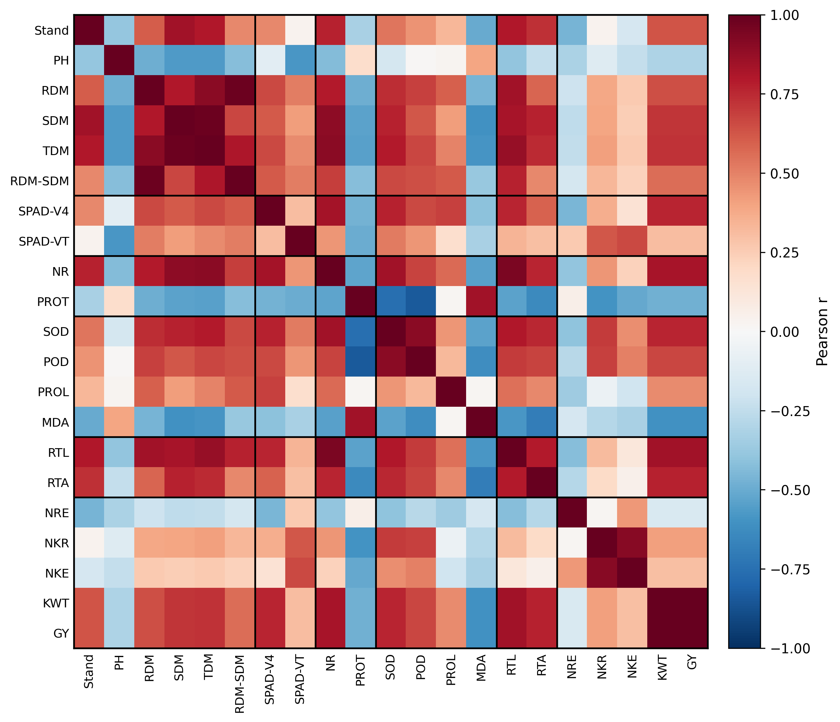
Figure S3. Pearson correlation matrix of all 21 traits, ordered by physiological module (black gridlines mark module boundaries: growth and biomass; photosynthetic status; nitrogen and protein metabolism; oxidative stress system; root architecture; yield components). Symbol legend: Stand (number of plants per linear meter); PH (plant height); RDM (root dry matter); SDM (shoot dry matter); TDM (total dry matter); RDM-SDM (root-to-shoot dry matter ratio); SPAD-V4 (chlorophyll content at the V4 growth stage); SPAD-VT (chlorophyll content at flowering); NR (nitrate reductase activity); PROT (total soluble protein content); SOD (superoxide dismutase activity); POD (peroxidase activity); PROL (proline content); MDA (malondialdehyde content); RTL (root length); RTA (root surface area); NRE (number of rows per ear); NKR (number of kernels per row); NKE (number of kernels per ear); KWT (individual kernel weight); GY (grain yield). Note that correlations computed across the 12 plots are dominated by the treatment contrast: after centring each treatment group on its own mean, the mean absolute correlation among the 18 measured traits falls from 0.52 to 0.25 and no pair remains significant after FDR correction (see Fig. S4c and main text, Section 3.8).

Table S4. Module-level summary of trait significance and contribution to the primary axis of covariation (PC1).
Module | Traits (n) | Significant, q < 0.05 (n) | Mean |PC1| loading | Top-loading trait
Growth & biomass | 6 | 5 | 0.225 | TDM
Photosynthetic status | 2 | 1 | 0.194 | SPAD-V4
N & protein metabolism | 2 | 2 | 0.239 | NR
Oxidative stress | 4 | 3 | 0.213 | SOD
Root architecture | 2 | 2 | 0.255 | RTL
Yield components | 5 | 2 | 0.169 | KWT
Total | 21 | 15 | - | -
Module-level summary derived from Tables S1 and S3. "Significant" counts traits with Benjamini-Hochberg FDR-adjusted q < 0.05 (15 of 21 traits overall). Mean |PC1| loading is the mean absolute PC1 loading of the traits in each module (from Table S3); higher values indicate a stronger contribution to the primary axis of covariation. The top-loading trait is the module member with the largest absolute PC1 loading. Root architecture and N & protein metabolism contribute most strongly to PC1.

Table S5. Sensitivity of the principal component analysis to the trait set and to block centring, and loadings of the 18 measured traits.
Analysis | PC1 (%) | PC2 (%) | PC1 + PC2 (%)
21 traits (raw) | 56.5 | 14.4 | 70.9
18 measured (raw) | 57.2 | 12.9 | 70.1
18 measured (block-centred) | 71.8 | 12.2 | 84.0
PCA on z-scored data (12 experimental units). 'Block-centred' = each plot expressed as a deviation from its block mean before standardization, so that the ordination reflects within-block (treatment + residual) variation only.
Trait | Module | PC1 (18 traits) | PC2 (18 traits) | PC1 (block-centred)
Stand | Growth & biomass | +0.229 | -0.222 | +0.237
PH | Growth & biomass | -0.124 | -0.273 | -0.121
SPAD-V4 | Photosynthetic status | +0.253 | -0.182 | +0.271
SPAD-VT | Photosynthetic status | +0.158 | +0.401 | +0.152
NR | N & protein metabolism | +0.297 | -0.093 | +0.272
PROT | N & protein metabolism | -0.219 | -0.295 | -0.242
RDM | Growth & biomass | +0.262 | -0.012 | +0.264
SDM | Growth & biomass | +0.277 | -0.009 | +0.263
SOD | Oxidative stress | +0.286 | +0.026 | +0.272
POD | Oxidative stress | +0.258 | +0.092 | +0.250
PROL | Oxidative stress | +0.158 | -0.371 | +0.199
MDA | Oxidative stress | -0.214 | -0.258 | -0.230
RTL | Root architecture | +0.293 | -0.132 | +0.272
RTA | Root architecture | +0.263 | -0.078 | +0.254
NRE | Yield components | -0.096 | +0.480 | -0.126
NKR | Yield components | +0.161 | +0.343 | +0.191
KWT | Yield components | +0.279 | +0.007 | +0.263
GY | Yield components | +0.271 | -0.043 | +0.270
Loadings are eigenvector coefficients; PC1 signs were fixed so that HrpNEA-treated plots score positively. Largest absolute PC1 loadings (18 traits): NR, RTL, SOD, SDM, KWT.

Table S6. Module eigentrait analysis: treatment effect on the first principal component of each physiological module.
Module | Traits (n) | Variance explained by module PC1 (%) | Loadings | Δ eigentrait (HrpNEA − Control) | Cohen's dz | P (paired t) | q (BH, 6 tests)
Growth & biomass | 4 | 71.8 | Stand +0.50; PH -0.41; RDM +0.51; SDM +0.57 | +2.87 | 3.57 | 0.0003 | 0.0006
Photosynthetic status | 2 | 65.2 | SPAD-V4 +0.71; SPAD-VT +0.71 | +1.69 | 1.63 | 0.0105 | 0.0105
N & protein metabolism | 2 | 76.4 | NR +0.71; PROT -0.71 | +2.18 | 4.78 | <0.0001 | 0.0005
Oxidative stress | 4 | 63.2 | SOD +0.60; POD +0.60; PROL +0.29; MDA -0.45 | +2.72 | 2.73 | 0.0011 | 0.0014
Root architecture | 2 | 89.7 | RTL +0.71; RTA +0.71 | +2.42 | 3.68 | 0.0003 | 0.0006
Yield components | 4 | 56.8 | GY +0.62; KWT +0.64; NKR +0.43; NRE -0.17 | +2.62 | 3.38 | 0.0004 | 0.0006
Each module eigentrait is the first principal component of the z-scored member traits (sign fixed so that the first listed trait loads positively; analogous to the module eigengene of weighted correlation network analysis). Treatment effects were tested with block-paired t-tests (n = 6) and corrected across the six modules with the Benjamini–Hochberg procedure. Derived variables (TDM, RDM-SDM, NKE) were excluded.
Module pair | r (raw, n = 12) | r (treatment-centred)
Growth - Photo | +0.63 | -0.18
Growth - N/prot | +0.76 | -0.29
Growth - Oxid | +0.70 | -0.43
Growth - Root | +0.83 | -0.03
Growth - Yield | +0.70 | -0.54
Photo - N/prot | +0.79 | +0.34
Photo - Oxid | +0.78 | +0.32
Photo - Root | +0.65 | -0.35
Photo - Yield | +0.78 | +0.28
N/prot - Oxid | +0.95 | +0.71
N/prot - Root | +0.87 | -0.02
N/prot - Yield | +0.85 | +0.11
Oxid - Root | +0.87 | +0.20
Oxid - Yield | +0.85 | +0.22
Root - Yield | +0.83 | -0.22
Pearson correlations among module eigentraits computed across the 12 plots (raw) and after centring each treatment group on its own mean (treatment-centred, 10 residual df). None of the treatment-centred correlations is significant after FDR correction.

Table S7. Multiplicative decomposition of the grain-yield response to HrpNEA seed treatment.
Term |  | Mean ln(HrpNEA/Control) |  | 95% CI |  | Equivalent % change |  | Share of ln(yield ratio) (%)
Plant stand |  | +0.129 |  | +0.044 to +0.215 |  | +13.8 |  | 66
Kernels per ear |  | +0.053 |  | -0.049 to +0.154 |  | +5.4 |  | 27
Individual kernel weight |  | +0.196 |  | +0.117 to +0.276 |  | +21.7 |  | 100
Observed grain yield |  | +0.196 |  | +0.147 to +0.246 |  | +21.7 |  | 100
Unaccounted (harvest population, ears per plant, ear sampling) |  | -0.182 |  | -0.287 to -0.076 |  | -16.6 |  | -92
Treatment | Block |  | Plants ha⁻¹ |  | Observed yield (kg ha⁻¹) |  | Predicted from components (kg ha⁻¹) |  | Observed / predicted
HrpNEA | 1 |  | 62,857 |  | 9,098 |  | 11,924 |  | 0.76
HrpNEA | 2 |  | 60,000 |  | 8,519 |  | 10,923 |  | 0.78
HrpNEA | 3 |  | 55,714 |  | 9,012 |  | 10,465 |  | 0.86
HrpNEA | 4 |  | 57,143 |  | 9,693 |  | 10,117 |  | 0.96
HrpNEA | 5 |  | 58,571 |  | 9,001 |  | 9,744 |  | 0.92
HrpNEA | 6 |  | 61,429 |  | 8,684 |  | 10,615 |  | 0.82
Control | 1 |  | 50,000 |  | 7,381 |  | 7,834 |  | 0.94
Control | 2 |  | 55,714 |  | 7,451 |  | 7,707 |  | 0.97
Control | 3 |  | 51,429 |  | 7,380 |  | 7,474 |  | 0.99
Control | 4 |  | 48,571 |  | 8,214 |  | 8,476 |  | 0.97
Control | 5 |  | 57,143 |  | 7,404 |  | 5,866 |  | 1.26
Control | 6 |  | 50,000 |  | 6,595 |  | 6,577 |  | 1.00
Per block, ln(GY_HrpNEA / GY_Control) = ln(stand ratio) + ln(kernels-per-ear ratio) + ln(kernel-weight ratio) + residual; means and t-based 95% CI over the six blocks. Predicted yield = plants ha⁻¹ (stand × 10,000/0.70) × kernels per ear × kernel weight. The component product reproduces the control yield (mean observed/predicted = 1.02) but over-predicts the HrpNEA yield (0.85), i.e. the early stand advantage was not carried proportionally into harvested yield.

Table S8. Paired effect sizes for all 21 variables: mean within-block difference, percentage change with 95% confidence interval, Cohen's dz, and FDR-adjusted q over the 18 measured traits.
Trait | Module | Derived | Δ (HrpNEA - Control) | Δ (%) | 95% CI of Δ (%) | Cohen's dz | P | q (18 traits) | Shapiro–Wilk P (differences)
Stand | Growth & biomass |  | +0.5 | +13.7 | +4.6 to +22.8 | +1.58 | 0.0117 | 0.0192 | 0.57
PH | Growth & biomass |  | -1.7 | -1.4 | -4.5 to +1.6 | -0.50 | 0.2757 | 0.2920 | 0.29
SPAD-V4 | Photosynthetic status |  | +4.17 | +10.8 | +7.5 to +14.1 | +3.41 | 0.0004 | 0.0013 | 0.78
SPAD-VT | Photosynthetic status |  | +4.28 | +8.1 | -6.7 to +22.8 | +0.57 | 0.2201 | 0.2476 | 0.23
NR | N & protein metabolism |  | +0.529 | +66.1 | +50.2 to +82.0 | +4.36 | 0.0001 | 0.0011 | 0.96
PROT | N & protein metabolism |  | -2.88 | -11.1 | -18.9 to -3.3 | -1.49 | 0.0147 | 0.0221 | 0.71
RDM | Growth & biomass |  | +6.25 | +47.0 | +27.7 to +66.4 | +2.55 | 0.0015 | 0.0034 | 0.81
SDM | Growth & biomass |  | +14.4 | +13.3 | +9.1 to +17.4 | +3.33 | 0.0004 | 0.0013 | 0.41
TDM | Growth & biomass | yes | +20.6 | +17.0 | +14.2 to +19.7 | +6.38 | <0.0001 | - | 0.38
RDM-SDM | Growth & biomass | yes | +0.0369 | +30.1 | +10.0 to +50.3 | +1.57 | 0.0121 | - | 0.88
SOD | Oxidative stress |  | +1.65 | +73.9 | +53.9 to +94.0 | +3.86 | 0.0002 | 0.0011 | 0.88
POD | Oxidative stress |  | +0.0701 | +19.4 | +6.8 to +32.0 | +1.61 | 0.0109 | 0.0192 | 0.79
PROL | Oxidative stress |  | +0.104 | +8.0 | -2.2 to +18.2 | +0.82 | 0.1013 | 0.1215 | 0.54
MDA | Oxidative stress |  | -2.36 | -17.4 | -31.2 to -3.7 | -1.33 | 0.0224 | 0.0310 | 0.07
RTL | Root architecture |  | +513 | +74.1 | +53.8 to +94.5 | +3.82 | 0.0002 | 0.0011 | 0.41
RTA | Root architecture |  | +35.4 | +19.7 | +8.5 to +30.9 | +1.85 | 0.0063 | 0.0125 | 0.10
NRE | Yield components |  | -0.467 | -2.6 | -8.7 to +3.4 | -0.46 | 0.3155 | 0.3155 | 0.84
NKR | Yield components |  | +2.5 | +7.8 | -1.3 to +16.9 | +0.89 | 0.0799 | 0.1027 | 0.93
NKE | Yield components | yes | +27.6 | +4.8 | -5.0 to +14.7 | +0.51 | 0.2641 | - | 0.50
KWT | Yield components |  | +0.053 | +21.5 | +13.1 to +29.8 | +2.70 | 0.0012 | 0.0030 | 0.99
GY | Yield components |  | +1.6e+03 | +21.6 | +16.9 to +26.3 | +4.81 | <0.0001 | 0.0011 | 0.80
Block-paired t-tests (n = 6). Cohen's dz = mean difference / SD of the within-block differences. The three derived variables are not part of the primary FDR family; their q-values over the 21-variable family are given in Table S1.
Figure S4.
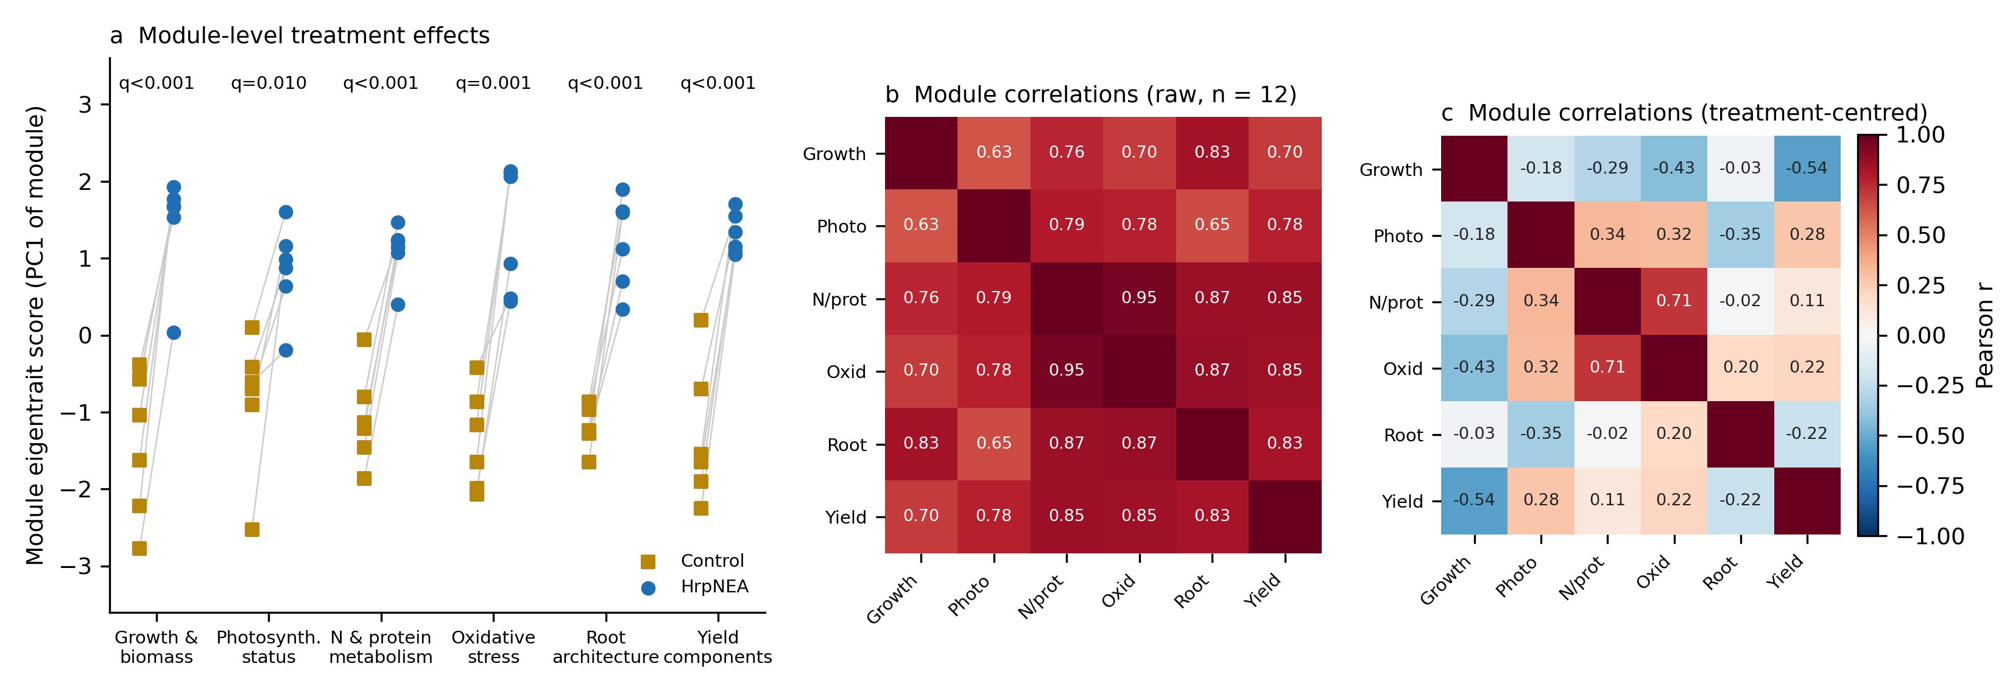
Figure S4. Module-level analysis. (a) Module eigentrait scores (first principal component of each physiological module) for control and HrpNEA-treated plots; grey lines join the two plots of each block; q-values are Benjamini–Hochberg-adjusted P-values of block-paired t-tests over the six modules. (b) Pearson correlations among module eigentraits across the 12 plots. (c) The same correlations after centring each treatment group on its own mean, showing that the strong raw correlations are generated by the common treatment shift.

Figure S5.
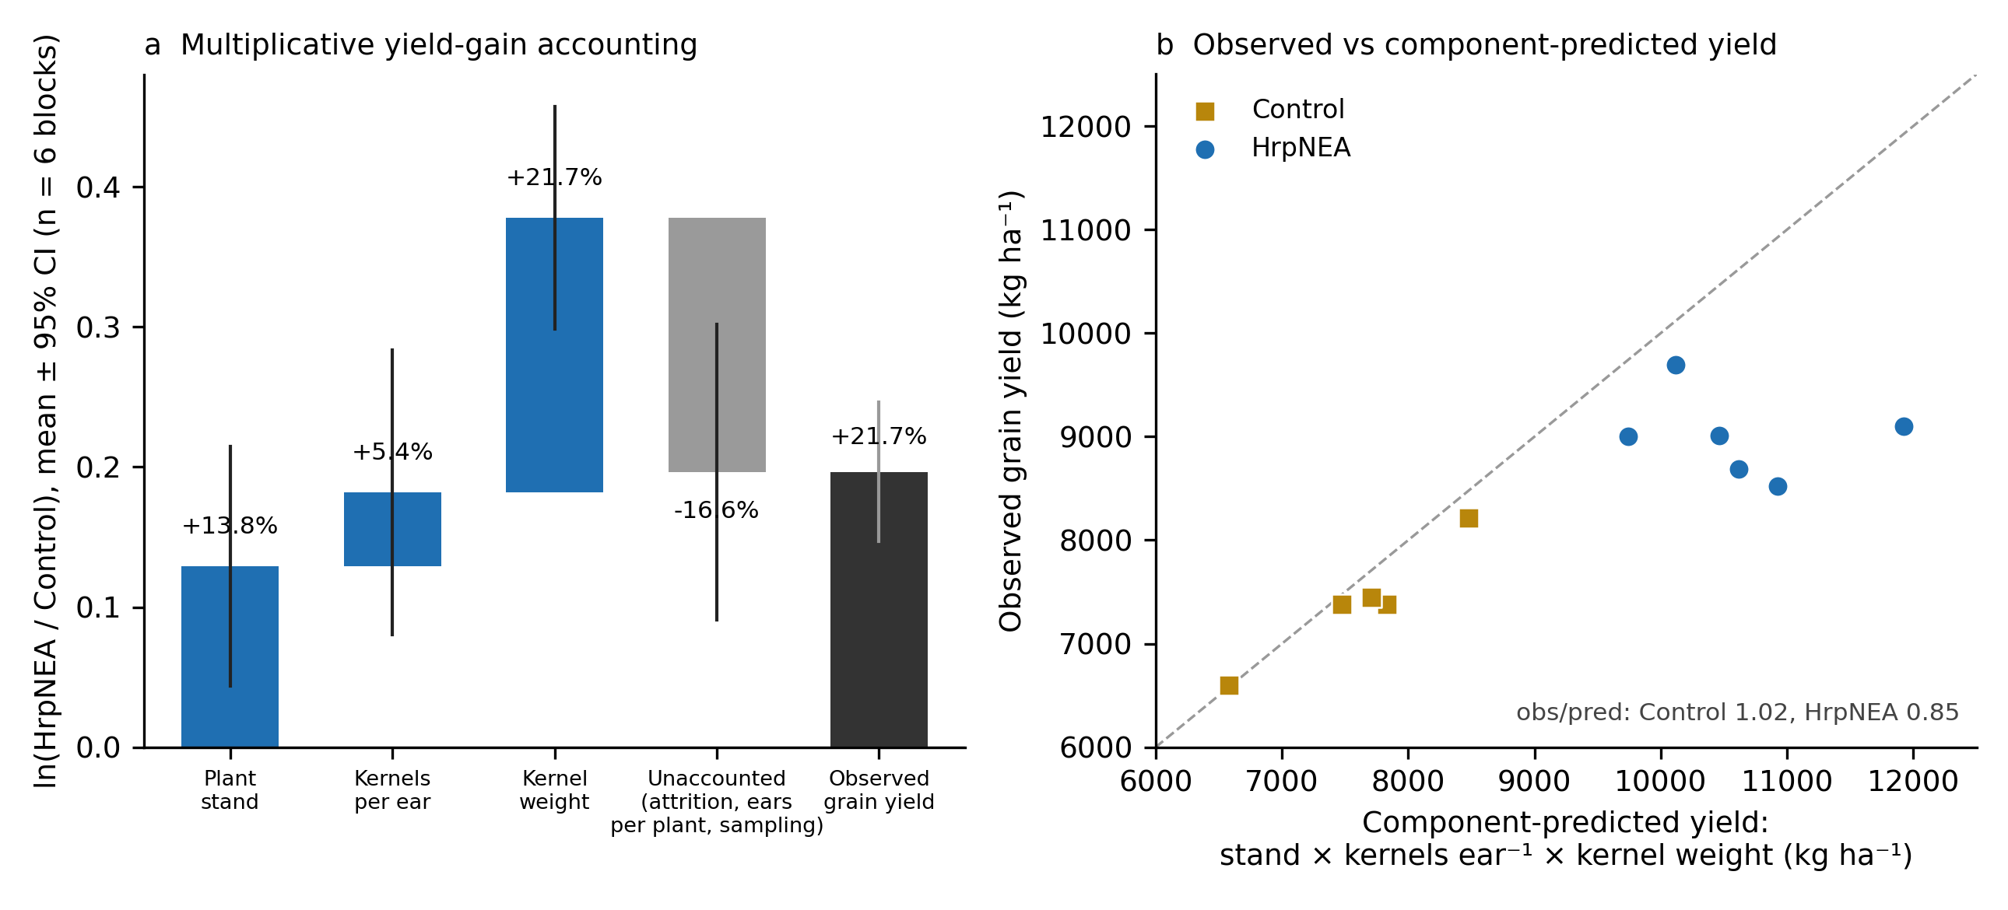
Figure S5. Multiplicative accounting of the grain-yield response. (a) Contribution of plant stand, kernels per ear and individual kernel weight to ln(HrpNEA/Control grain yield), with the unaccounted remainder (harvest population, ears per plant and ear-sampling error); bars are means and lines 95% confidence intervals over six blocks, and percentages are the equivalent multiplicative changes. (b) Observed plot yield against yield predicted from stand × kernels per ear × kernel weight; the dashed line is 1:1.

