Supplementary Information

Supplementary Figure S1. Sample-level neutrophil ROS-, NADPH-oxidase-, and NETosis-associated expression patterns.
The heatmap included 15 neutrophil genes associated with ROS generation, NETosis and neutrophil activation, comprising NADPH oxidase-associated genes (Cybb, Ncf1, Ncf2, Ncf4 and Rac2), NETosis-associated effector genes (Padi4, Mpo, Elane, Ctsg, Prtn3 and Gsdmd), and additional neutrophil activation/oxidative-stress-associated genes (S100a8, S100a9, Camp and Nos2).

Supplementary Figure S2. Heterogeneous responses of monocyte/macrophage NET-processing-associated genes without coordinated upregulation after LPS exposure.
The heatmap includes genes associated with extracellular-material recognition and uptake/efferocytosis (Mertk, Axl, Lrp1, Cd36, Itgav, Itgb3, Mfge8, Gas6, Scarb1, Fcgr1, Fcgr2b and Fcgr3); phagosome–lysosome trafficking, acidification and proteolysis (Lamp1, Lamp2, Rab5a, Rab7, Ctsb, Ctsd, Ctsl, Atp6v1a, Atp6v1b2 and Atp6v0d1); intracellular DNA degradation and lysosomal regulation (Dnase2a, Trex1 and Tfeb); extracellular nuclease-associated DNA degradation (Dnase1 and Dnase1l3); and additional macrophage metabolic/inflammatory-resolution-associated genes (Lpl, Abca1, Apoe, Nr4a1, Socs3, Tgfb1 and Il10). Rows represent genes and columns represent individual samples. Expression values are shown as gene-wise Z-scores of logCPM values.

Supplementary Figure S3. Six-day colloidal stability of mPDA-based formulations.
Hydrodynamic diameter (A) and zeta potential (B) of mPDA, DNase I@mPDA, and DNase I@mPDA@NM were monitored over 6 days to assess colloidal stability.

Supplementary Figure S4. Histological assessment of major organs following nebulized inhalation of material formulations.
Representative hematoxylin and eosin (H&E)-stained sections of the heart, liver, spleen, lung, and kidney after administration of PBS or the indicated material formulations were examined for histopathological changes (n = 3 mice per group). Scale bars, 20 μm.
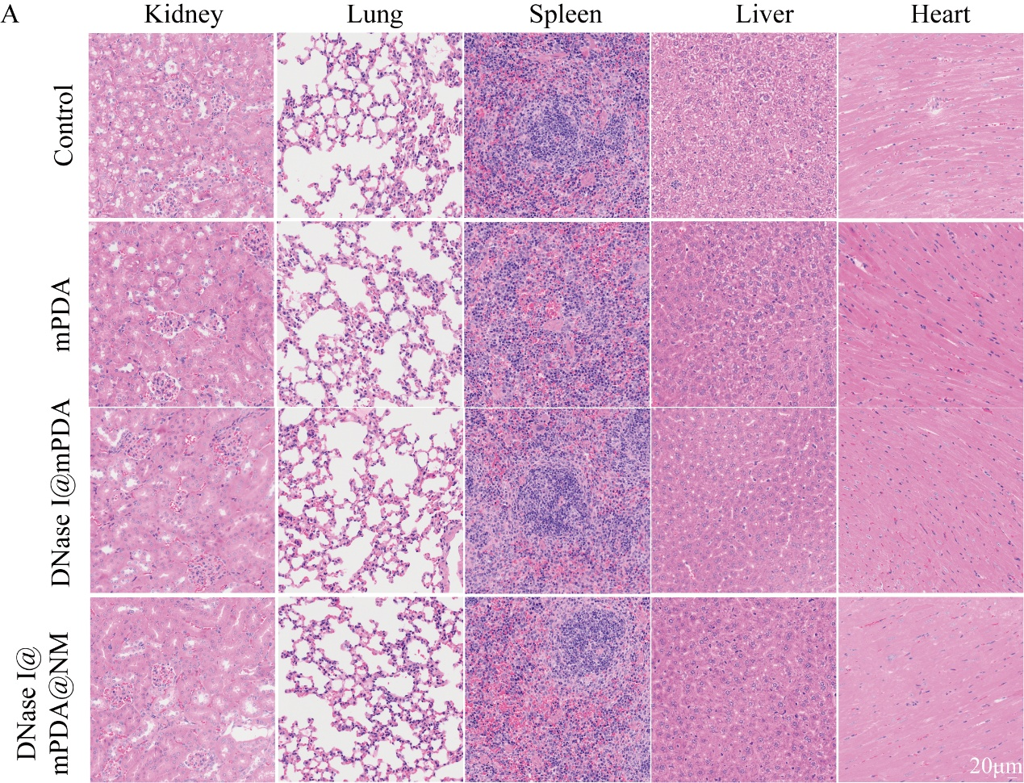

Supplementary Figure S5. Hematological parameters following nebulized inhalation of material formulations.
Hematological parameters were measured after administration of PBS or the indicated material formulations to evaluate systemic biocompatibility. Data are presented as mean ± SD (n = 3 mice per group).

Supplementary Figure S6. Liver- and kidney-function indices following nebulized inhalation of material formulations.
Serum levels of alanine aminotransferase (ALT), aspartate aminotransferase (AST), blood urea nitrogen (BUN), and creatinine (CREA) were measured after administration of PBS or the indicated material formulations. Data are presented as mean ± SD (n =3 mice per group).

Supplementary Figure S7. Baseline DNase I-mediated dsDNA degradation in PBS.
(A) Representative agarose gel electrophoresis showing DNA degradation by DNase I@mPDA@NM, DNase I@mPDA, and free DNase I in PBS, with mPDA and PBS serving as DNase I-free controls. (B) Densitometric quantification of relative DNA-degrading activity calculated from the residual DNA signal, with the PBS control defined as 0% degradation. Data are presented as mean ± SD (n = 3). Data were analyzed by one-way ANOVA followed by Tukey’s multiple-comparisons test. Statistical significance is indicated in the figure. #P < 0.05, ##P < 0.01, and ###P < 0.001 versus PBS; ns, not significant.

Supplementary Figure S8. Neutrophil viability after hydrogen peroxide exposure.
Neutrophils were treated with H₂O₂ (25–200 μM) for 4 h, followed by assessment of cell viability using a CCK-8 assay. Data are presented as mean ± SD (n = 6). Statistical significance was determined by one-way ANOVA followed by Tukey’s multiple-comparisons test. *P < 0.05, **P < 0.01, and ***P < 0.001; ns, not significant.

Supplementary Figure S9. Validation of hydrogen peroxide concentrations for the ROS-rescue experiment.
(A) Representative fluorescence images of intracellular ROS in neutrophils exposed to H₂O₂ at 0, 25, 50, or 100 μM, assessed using DCFH-DA (green) 1 h after H₂O₂ exposure, with nuclei counterstained with Hoechst (blue). (B, C) CitH3 and supernatant MPO–DNA levels, respectively, after H₂O₂ exposure. Data are presented as mean ± SD (n = 3). Statistical significance was determined by one-way ANOVA followed by Tukey’s multiple-comparisons test. *P < 0.05, **P < 0.01, and ***P < 0.001; ns, not significant.

Supplementary Figure S10. Quantification of SYTOX Green-positive extracellular DNA area in Figure 4L.
Quantification of the SYTOX Green-positive extracellular DNA area in the fluorescence images shown in Figure 4L. The cfDNA-positive area was calculated as the percentage of SYTOX Green-positive extracellular DNA area relative to the total image area. Data are presented as mean ± SD (n = 3). Statistical significance was determined by one-way ANOVA followed by Tukey’s multiple-comparisons test. #P < 0.05, ##P < 0.01, and ###P < 0.001 versus Control; *P < 0.05, **P < 0.01, and ***P < 0.001 versus PMA; +P < 0.05, ++P < 0.01, and +++P < 0.001 versus PMA + DNase I; ns, not significant.

Supplementary Figure S11. DNase I-containing formulations degrade preformed NET material.
DNase I and DNase I@mPDA@NM reduced MPO–DNA in preformed NET preparations, whereas mPDA did not. (A) Schematic of the preformed NET degradation assay. Neutrophils were stimulated with PMA for 4 h to induce NET formation, followed by treatment with mPDA, free DNase I, or DNase I@mPDA@NM for an additional 4 h. Preformed NET material was subsequently assessed by SYTOX Green staining and MPO–DNA ELISA. (B) Representative fluorescence images of SYTOX Green-positive extracellular DNA after the indicated treatments. Scale bar, 100 μm. (C) Quantification of the SYTOX Green-positive extracellular DNA area in (B), calculated as the percentage of SYTOX Green-positive extracellular DNA area relative to the total image area. (D) MPO–DNA concentrations in the corresponding supernatants measured by ELISA. Data are presented as mean ± SD (n = 3). Statistical significance was determined by one-way ANOVA followed by Tukey’s multiple-comparisons test. *P < 0.05, **P < 0.01, and ***P < 0.001 versus PMA; ns, not significant.

Supplementary Figure S12. Validation of endothelial–epithelial barrier formation using 4-kDa FITC–dextran.
Apparent permeability of the alveolar–capillary barrier to 4-kDa FITC–dextran. FITC–dextran permeability was assessed after 60 min, and the apparent permeability coefficient (Papp=(Cr*0.6)/(Cd*0.33*3600)) was calculated from the amount of tracer transported into the lower receiver compartment. Data are presented as mean ± SD (n = 3). Statistical significance was determined using a two-tailed unpaired Welch’s t-test. #P < 0.05, ##P < 0.01, and ###P < 0.001; ns, not significant.

Supplementary Figure S13. Quantification of pulmonary MPO⁺/CitH3⁺ colocalized area and H&E histopathological scores in LPS-induced ALI.
(A) Quantification of the MPO⁺/CitH3⁺ colocalized area in lung sections, expressed as the percentage of the analyzed lung tissue area. (B) Histopathological lung injury scores based on H&E-stained lung sections. n = 6 mice per group. Data are presented as mean ± SD. Statistical significance was determined by one-way ANOVA followed by Tukey’s multiple-comparisons test. #P < 0.05, ##P < 0.01, and ###P < 0.001 versus Control; *P < 0.05, **P < 0.01, and ***P < 0.001 versus ALI; +P < 0.05, ++P < 0.01, and +++P < 0.001 versus ALI + DNase I; †P < 0.05, ††P < 0.01, and †††P < 0.001 versus ALI + DNase I@mPDA; ns, not significant.

Supplementary Figure S14. KEGG pathway enrichment analysis of ALI-associated and treatment-responsive differentially expressed genes.
(A) KEGG pathway enrichment analysis of genes upregulated in ALI lungs relative to control lungs. (B) KEGG pathway enrichment analysis of genes downregulated in DNase I@mPDA@NM-treated lungs relative to untreated ALI lungs. Bubble size represents the number of genes assigned to each pathway, and color indicates −log10(adjusted P value). Dashed boxes highlight the NF-κB signalling pathway.

